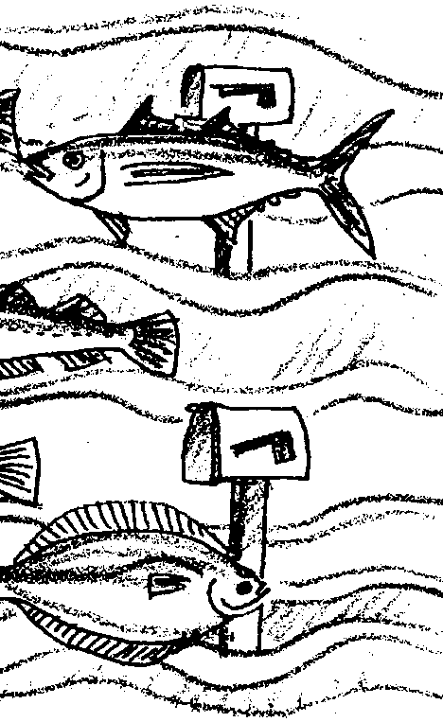
Ocean Address

Key Concepts
1. Finfish are important natural resources for food, income, and cultural traditions.
2. Some important finfish such as salmon, halibut, albacore, and “bottomfish” have interesting life histories and special habitat needs.

Background

The destruction of wetlands, estuaries and near-shore coastal areas by increased pollution, development, dredging, and water diversions is destroying valuable fish habitat. Siltation and destruction of riparian (stream-side) vegetation by poor timber practices, road building, and land management practices is destroying more. Many fishery, conservation, and environmental organizations are joining forces to educate policy makers and the public about how to protect coastal habitat. The Pacific States Marine Fisheries Commission (PSMFC), and Fishermen Involved in Saving Habitat (F.I.S.H.), are two such organizations committed to ending the destruction of coastal habitats and protecting our valuable fishery resources.

PSMFC’s F.I.S.H. Habitat Education Program prepared the following habitat summaries for commercially and recreationally important species to provide information on the habitats different fish utilize during their life stages. As you look around your home and community, we encourage you to be aware of actions harmful to fish habitat and become involved in protecting this precious resource. We all can play an invaluable role by helping to increase awareness about the value of clean water and healthy wetlands and estuaries. Letters to the editor about ways to conserve water or prevent pollution around the home and yard, or asking your local newspaper to feature a different fish species profile once a week, is a good way to begin building the public concern that will help protect our marine resources.

Materials

For the class:

• 1 Map of the Pacific Ocean and the north Pacific Rim nations

• Guides to fishes of the Pacific Ocean

For each student or small group of students:

• “Ocean Address” student activity pages including set of fish drawings and descriptions

• scissors

• glue

• crayons, paints, or markers

• tagboard or recycled file folders to stiffen fish (popcicle sticks can be used instead)

• string or fish line

• single-hole hole punch

• 2 reeds, dowels, pencils or coat hangers for hanging fish

• tape

Teaching Hints

In “Ocean Address”, students make a “mobile” of some common and important fish by way of introduction to these fish and their saltwater habitats. The mobile displays the fish at their respective depths in the ocean. Background information about the fish and their value is found below and, in abbreviated form, in the student text. Note that the fish included in this activity are primarily found in the Pacific Ocean. Atlantic or Gulf fish may be substituted to localize the activities.

In addition, the guides listed below will be helpful in the identification and description of the life histories of some Pacific fishes:

The Audubon Society Field Guide to North American Fishes, Whales, and Dolphins, Alfred A. Knopf, New York, Latest Edition.

McClane, A.J., McClane’s Filed Guide to Saltwater Fishes of North America, Henry Holt and Co., New York, 1974.

Lamb, Andy, and Edgell, Phil, Coastal Fishes of the Pacific Northwest, Harbour Publishing Co., Madiera Park, British Columbia, Canada, 1986.

Procedure
1. On heavy paper or card stock, make copies of the fish mobile masters (included in the student pages for this activity). You will need a set for each student or group of students.

Note: The fish need to be relatively stiff for the mobile to be an effective teaching tool. If you cannot copy the fish onto card stock or other stiff paper, consider other approaches to add stiffness. For example, have students trace the outline of each fish drawing on tag board or a recycled file folder. Cut each one out and glue it to the matching fish drawing. If further stiffness is needed, students could glue a popcicle stick or pipe cleaner between the fish and its backing. A pipe cleaner can be bent to give the fish the appearance of being in motion.

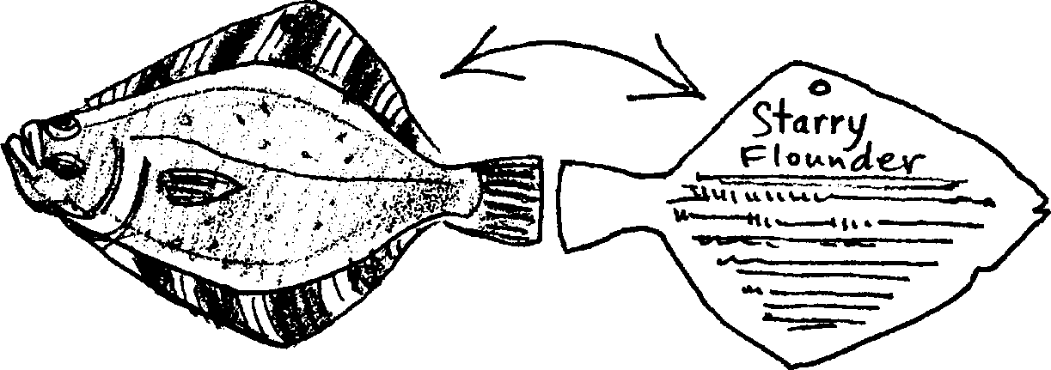
2. Distribute a set of fish, fish information sheets, and an “Ocean Address” activity sheet to each student or group of students. Have them use the information on the sheets to answer the questions in the student activity and to record their “fishy facts” on the back of each fish card.

3. Color or paint one or both sides of the fish. Refer to student text for correct coloration. Field guides or color pictures are helpful supplementary materials for this step.

4. Have students carefully cut out the fish.

5. To begin the mobile, have students punch a hole through the top of each fish. Next, have them thread different lengths of string or fishing line through the holes at the tops of the fish. The length of a string is determined by where in the ocean the fish spends most of its time. Fish that live near the surface would have the shortest strings, etc. Knot the threads securely. The primary locations of the fish shown on the cards are:

Bottom Middle WatersSurface
Starry flounder Walleye pollock Coho salmon
English sole Pacific hake Sockeye salmon
Pacific halibut Albacore tuna
Lingcod

6. Have students tape the two reeds, dowels, coat hangers, or similar items together so that they form a equally spaced cross.

7. Tie the free ends of the threads to the equally spaced cross to hold the hanging. Show students how to balance their mobile by moving the fish along the hangers.

8. Hang the finished mobiles from the ceiling. Have students write or tell a description about the theme of their mobile (life histories, habitat, value, etc.).

Key Words

eelgrass beds - areas where the eelgrass plant grows

estuary - a place where fresh water meets salt water

finfish - fish that have fins; as opposed to shellfish

fisher - a person who fishes for sport or commerce

habitat - environment, place where one lives

life history - the changes in an organism from birth to death

mobile - a piece of sculpture having delicately balanced parts which can move independently

resources - in this case, property that can be converted into money

Extensions

1. Have individuals or small groups make mobiles with other themes such as:
Salmon of the Pacific Ocean,
Bottomfish of the Pacific or Atlantic Ocean,
Fish in Pacific or Atlantic Estuaries

2. For a more in depth look at these fish and others, write for the 330 page book entitled: Distribution and Abundance of Fishes and Invertebrates in West Coast Estuaries. Vol II. Species Life History Summaries (similar ones are available for Southeast and Gulf Coast Estuaries) NOAA, Strategic Environmental Assessments Branch, 6001 Executive Blvd., Rm. 220, Rockville, MD 20852. (301) 443-8921. Or contact:

F . I . S . H. Habitat Education Program, PSMFC
2501 S.W. 1st Avenue, Suite 200
Portland, Oregon 97201
(503) 326-7025
You might also wish to contact your state’s fishery and environmental protection departments, or the regional offices of the following federal agencies: National Marine Fisheries Service, National Sea Grant College Program, U.S. Fish and Wildlife Service, and Environmental Protection Agency.

Answer Key

1. The following table details the weights and lengths found on the fish cards:
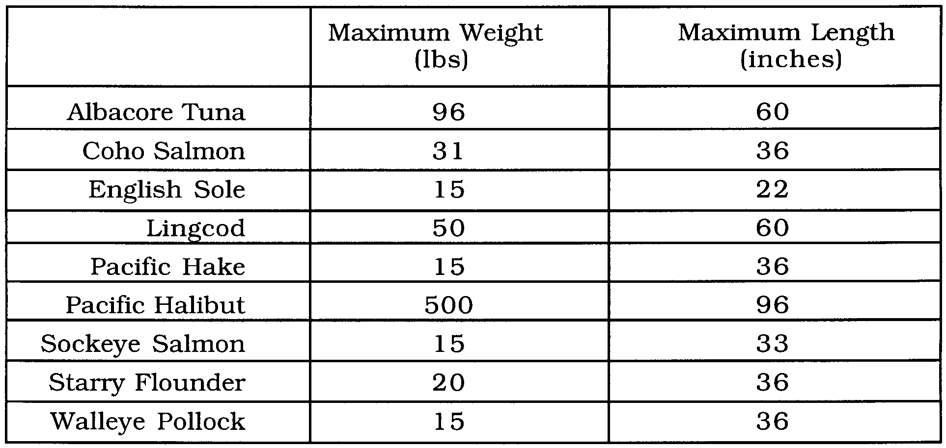
2. a. Albacore tuna has the greatest maximum weight.

b. Four fish that have the same maximum weight include: English sole, Pacific hake, Sockeye salmon, Walleye pollock.

c. The Albacore tuna has a weight about twice as great as the lingcod.

Challenge: The weight of the Pacific Halibut is 10 times greater than that of the lingcod.

3. On the following page is a correctly completed bar graph displaying the length information in the table from question 1.

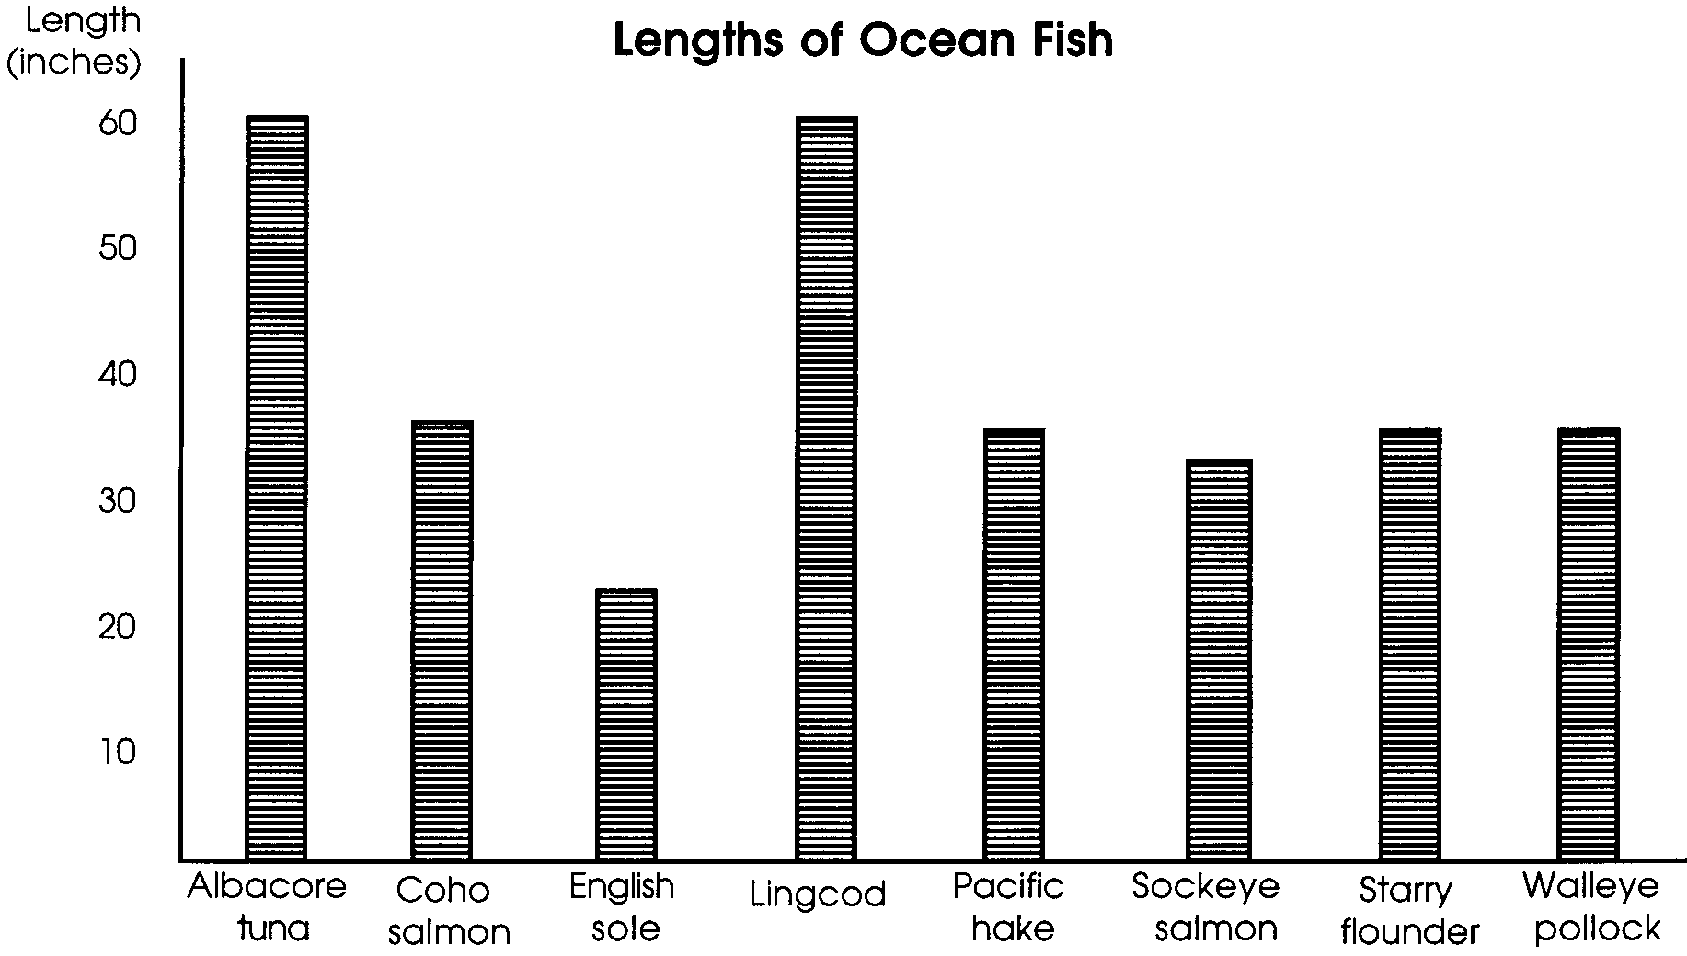

4. The above graph yields the following answers:

a. The Albacore tuna and the lingcod are tied for the greatest maximum length at 60 inches.

b. Four fish which have the same lengths include: Coho salmon, Pacific hake, Walleye pollock, and starry flounder

c. No, the four fish with the same lengths are not the same as the four with the same weights. Three of the four (Coho salmon, Pacific hake, Walleye pollock) are the same (Starry flounder differs from English sole).

d. The longest fish (Albacore tuna) and the second longest (lingcod) are tied for the honor of the heaviest fish.

e. Two fish that have the same length but different weights include: Coho salmon (36", 31#) and Pacific hake (36", 15#); Starry flounder (36", 20#) and Walleye pollock (36", 15#). Other combinations of these fish also yield correct answers.

5. The list below indicates where the fish spend most of their lives:

Bottom Middle WatersSurface
Starry flounder Walleye pollock Coho salmon
English sole Pacific hake Sockeye salmon
Pacific halibut Albacore tuna
Lingcod

b. The Pacific halibut spends time in the deepest water (i.e., 3,600 feet)

7. The Coho salmon and the Sockeye salmon are most likely to be affected by road building since each fish spends part of its life cycle in freshwater.

8. Starry flounder, English sole, and lingcod are most likely to affected by pollution in the mud of estuaries since each fish spends part of its life on the bottom in an estuary.

9. This question calls for some interpretation of the data. From the information given, the Starry flounder seems to have the least economic value.

COHO SALMON
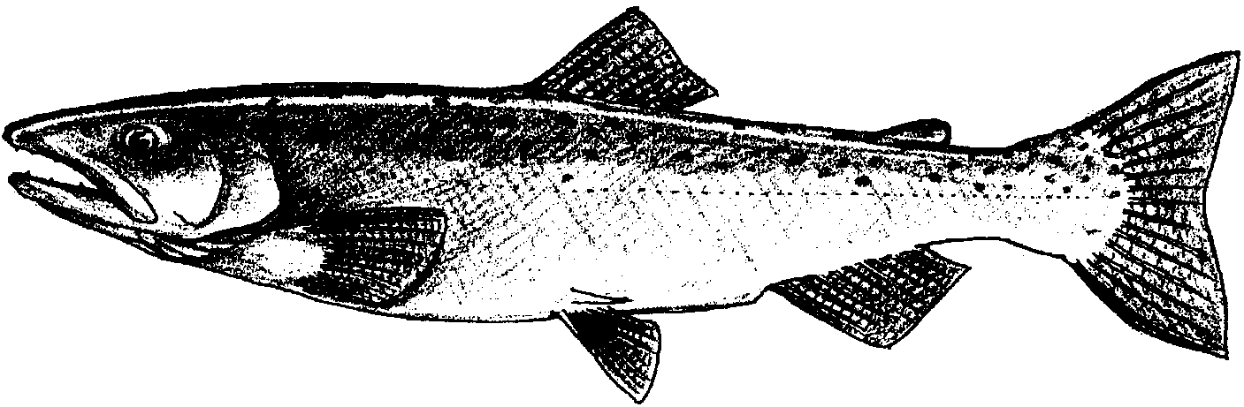

DID YOU KNOW? The coho salmon was introduced from Pacific waters into the Great Lakes and is now abundant there.

SCIENTIFIC NAME: Oncorhynchus kisutch, from the Greek roots onkos (hook), rynchos (nose) and kisutch, the common name in Siberia and Alaska.

COMMON NAMES: Silver salmon, hook nose salmon, blueback salmon, jack salmon, salmon trout, silverside salmon and white salmon.

DESCRIPTION: The coho salmon is bluish-black with silver sides in saltwater; black spots on the back and upper part of the caudal fin. Smaller and slimmer than the Chinook salmon; the inside of the mouth is gray or black with white gums. Coho salmon reach up to 38.5 inches in length and weigh up to 31 pounds; although they usually weigh between 6 to 12 pounds.

LlFECYCLE: Spawning occurs from November to January, with the eggs hatching the following spring. Coho fry remain in streams for over a year. Moving seaward the following spring, most cohos return to spawn when they are three years old. The mature male fish which return after two years are known as “jacks” and in Oregon and Washington, the abundance of “jacks” are used to predict the next year’s three year old return.

HABITAT AND ECOLOGY: Coho salmon utilize freshwater, near-shore and offshore environments during its lifecycle. Coho salmon spawn in the same environment as Chinook salmon; however, coho prefer lower stream velocity, shallower water and smaller gravel. Most coho fry stay in the stream for over a year feeding on aquatic insects, zooplankton and small
fish. Adequate stream cover is important to fry survival, as is high dissolved oxygen levels.

Mortality is especially high during freshwater life stages, often a result of poor forest and agricultural management practices that lead to siltation, which may ruin spawning beds or smother the eggs. Migrating coho salmon also face physical obstacles and high water temperatures resulting from dams, inadequate water flows due to diversions for irrigation and impoundment of water for power generation.

Once reaching the estuaries, coho salmon fall prey to a number of other species and may be impacted by human changes, such as shoreline development, residential drainage and the filling of marine wetlands. The time spent in this habitat is critical to the development of the species and their ability to survive in the offshore environment.

RANGE: Coho salmon spawn in coastal streams from Northern Japan to the Anadyr River and from Monterey Bay in California and Point Hope in Alaska. This species can also be found in the ocean from Baja, California, to the Bering Sea in Alaska. Major U.S. spawning grounds are in Alaska, Washington and Oregon.

ECONOMIC VALUE: The fourth most abundant salmon species, coho salmon is a culturally and economically important resource, and an important subsistence fish. Coho salmon is commercially fished from Northern California north to Norton Sound in Alaska; 75% of the total U.S. catch comes from Alaska.
SOCKEYE SALMON
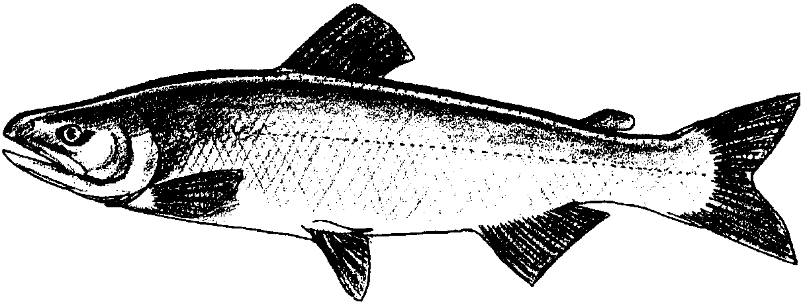

DID YOU KNOW? Sockeye is unique among the Pacific salmon in that juveniles rear for at least a year or two in lakes before migrating to saltwater.

SCIENTIFIC NAMES: Oncorhynchus nerka, from the Greek words onkos (hook), rynchos (snout), and Nerka, the Russian name for the species.

COMMON NAMES: Red salmon, blueback, “silver trout” and kokanee (land locked form).

DESCRIPTION: The sockeye salmon is greenish-blue with fine black specklings on back; no large dark spots. Spawning males have pale green heads, dark jaws, pale undersides and bright red bodies. Spawning females look generally the same, except for more subdued coloration. Up to 33 inches in length and weigh up to 15 pounds.

LIFE CYCLE: One of the only species of salmon that spawn in streams headed by lakes, sockeye salmon spend from 1 to 2 years in freshwater, a significant portion of which is spent in lakes. Once beginning the journey downstream, sockeye salmon progress steadily toward the ocean. After 1 to 2 years offshore, sockeye return to spend 1 to 8 months in the lake prior to spawning.

HABITAT AND ECOLOGY: Sockeye salmon rely on stream, lake and estuarine habitat as well as offshore waters during their lifecycle. They feed on small planktonic (drifting) organisms and a variety of terrestrial and aquatic insects. Eggs are laid in fine gravel and need cool water and good water flow (to supply oxygen) to survive. After emerging from the redd (nest) they move upstream or downstream into a nursery lake or estuary. Once in lakes, young sockeye live for approximately 1 month in the littoral (shoreside) zone before moving out into open lake waters where they reside until they migrate out to sea.

Because young sockeye spend a significant portion of their lives within lakes or estuaries --places where humans also tend to concentrate their populations -- they are particularly susceptible to human induced changes to water quality and habitat threats. Poor timber and agricultural management practices can lead to siltation in streams and lakes which may ruin spawning beds or smother the eggs. Additionally, migrating salmon in the Columbia, Skagit, and Fraser Rivers face the physical obstacles and high water temperatures resulting from dams, inadequate water flows in rivers and streams due to water diversions for irrigation, and the impoundment of water for power generation.

RANGE: In North America, important spawning populations occur from the Columbia River northward. Stocks originate primarily from tributaries and lakes in Bristol Bay, Alaska and the Fraser River in British Columbia. Two sockeye runs originate in Puget Sound -- in Lake Washington and Baker Lake -- and two on the Northern Washington coast -- in Lake Quinault and Lake Ozette. Columbia River runs originate in Lake Wenatchee and Osoyoos Lake.

ECONOMIC VALUE: The third most abundant salmon species, sockeye salmon is a culturally and economically important resource to commercial fishermen throughout Alaska, British Columbia, Washington and Oregon. Sockeye salmon rank second in commercial landings to the pink salmon; but first in value. They are also an important subsistence fish and a valuable recreational resource. Significant economic losses to coastal communities resulted from the taking of sockeye in Japanese high seas driftnet fisheries. Over a 20 year period, this fishery is estimated to have taken over 46 million North American sockeye. Additionally, the landlocked kokanee is a very important freshwater sport fish throughout the west coast.

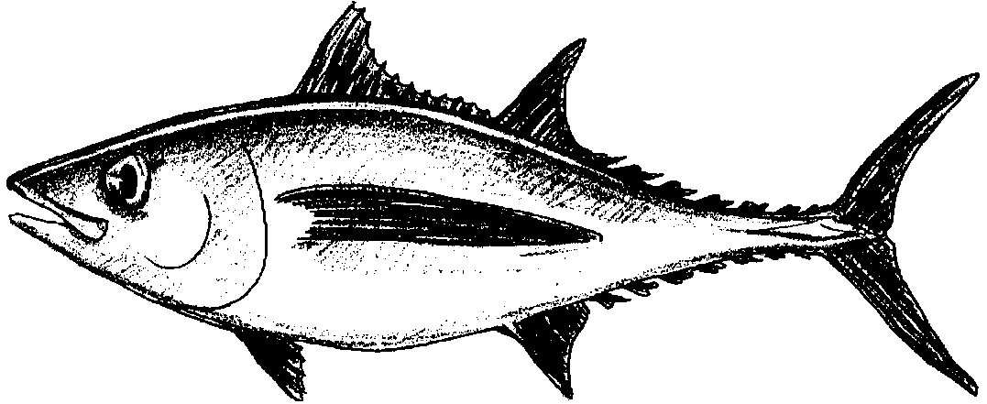
ALBACORE

DID YOU KNOW? An albacore tuna tagged just off Los Angeles was recaptured 11 months later 550 miles southeast of Tokyo. It had traveled 4,900 miles in that time.

SCIENTIFIC NAME: Thunnus alalunga.

COMMON NAMES: Albacore, germon.

DESCRIPTION: Albacore tuna are powerful, streamlined fish with large wing-like pectoral fins. The tail is strongly sickle shaped. They are metallic steely blue on the back and sides, silvery below. The fins are dark with a metallic sheen. The largest weigh up to 96 pounds. They can grow up to 5 feet in length.

LIFE CYCLE: Eggs are laid from January to June in the warm ocean between Hawaii and Japan. Young albacore spread out throughout warm Pacific waters. They return as adults to lay their eggs.

RANGE: Albacore are open ocean fish and highly migratory. They are found in the Atlantic, Pacific and Indian Oceans. In the eastern Pacific, they are found from the Gulf of California to the Gulf of Alaska and offshore and through the intervening waters to Japan.

HABITAT AND ECOLOGY: Albacore tuna spend all of their lives in warm areas of the open sea. They are usually found near the surface and at middle depths. During the summer, young, immature albacore are found off of British Colombia. They appear to be part of a seasonal movement guided largely by the movement of masses of warmer water.

There seems to be a single population through the temperate North Pacific, with fish tagged off of the Hawaiian Islands being recaptured off both Japan and North America. Young are widely dispersed after spawning in the tropical and subtropical waters of the North and South Pacific.

Albacore eat a wide variety of marine animals such as: sardines, herring, anchovy, small rockfishes and other fishes, squid and krill. Albacore feed night and day. Most feeding occurs near the surface.

Albacore is widely fished. When albacore fishing is good it is extremely fast. So fishers use barbless hooks and reel in lines very quickly, balancing any loss in fish against the time lost in removing fish from the hooks.

ECONOMIC VALUE: Albacore is the highest grade of tuna. It is a very important resource for fishers. It is commercially fished between Baja California, Mexico and Vancouver Island, Canada. Most of the catch is frozen for subsequent canning although the fresh fish is excellent.

WALLEYE POLLOCK
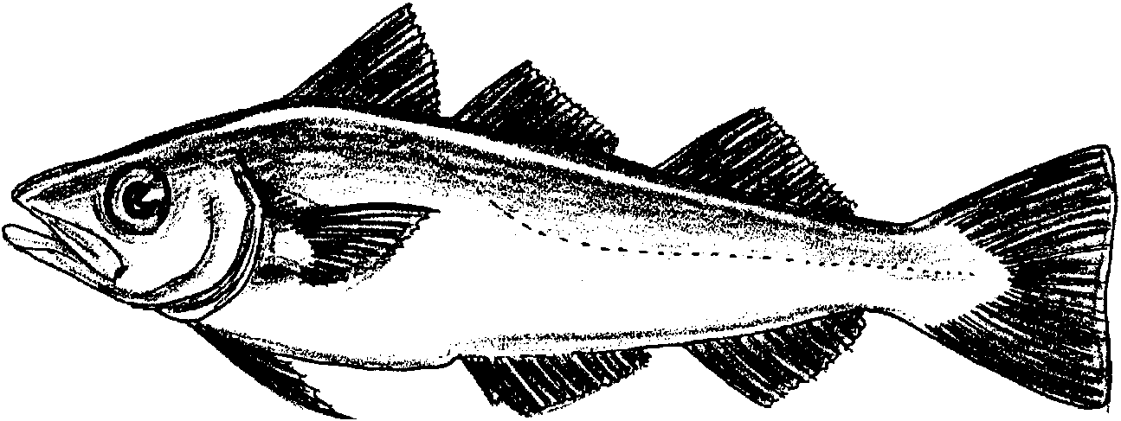

DID YOU KNOW? Only small quantities of pollock used to be fished as scrap fish for mink food. Now great quantities of this fish are harvested and processed into frozen fish products, imitation crab, and Fish Protein Concentrate (a tasteless and odorless high protein food additive made from ground fish)

SCIENTIFIC NAME: Theragra chalcogramma

COMMON NAMES: Pollock, bigeye

DESCRIPTION: Walleye Pollock are olive green or brown on the back, frequently blotched or mottled. They have silvery sides and white or yellow undersides. Their fins are dusky to black. They grow to 3 feet in length. They may weigh 15 pounds.

LIFE CYCLE: Little is known about the life history of these fish. The eggs are laid at sea, probably in April. Walleye Pollock may not lay eggs before they are 7 years old.

RANGE: Central California near Carmel through the Bering Sea to Kamchatka, Okhotsk Sea, and Southern Sea of Japan.

HABITAT AND ECOLOGY: Walleye Pollock spend all of their time in the ocean. They occur from the surface to below 600 feet in depth.

Walleye Pollock eat shrimps, sand lance, herring, smelt, and krill. They are eaten by fur seals.

ECONOMIC VALUE: Until recently, these fish had little economic value. They are now heavily fished for frozen fish products (fish sticks, etc.).

PACIFIC HAKE
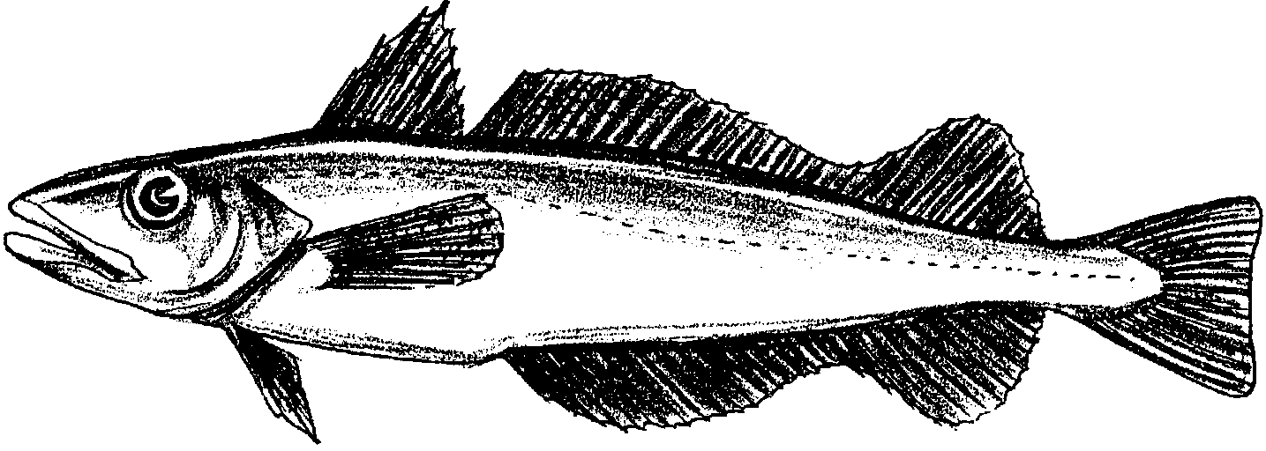

DID YOU KNOW: A 27 inch Pacific hake may lay as many as 496,000 eggs, each with a single oil globule in the yolk. The oil helps the eggs float as they develop.

SCIENTIFIC NAME: Merluccius productus

COMMON NAMES: Hake, sea pike

DESCRIPTION: Pacific hake are dark silver gray on the back, They are bright silvery below. They have two dorsal fins and their pectoral fins are brown. They grow to 3 feet in length. They may weigh 15 pounds.

LIFE CYCLE: Eggs are laid at sea from January to June. They hatch in 3 days or less. Larvae fish feed on copepods which are members of the zooplankton. Pacific hake may not lay eggs before they are 7 years old.

RANGE: Gulf of California to the Gulf of Alaska

HABITAT AND ECOLOGY: Pacific hake spend all of their time in the ocean. They are usually found from the surface to 2,950 feet of depth.

The food of adult Pacific hake consists primarily of krill, sand lance, herring, smelt, anchovy, other fishes, and shrimp on which they feed at night. They in turn are eaten by dogfish sharks.

ECONOMIC VALUE: Until recently, these fish had little economic value. They are now heavily fished for frozen fish products (fish sticks, etc.).

STARRY FLOUNDER
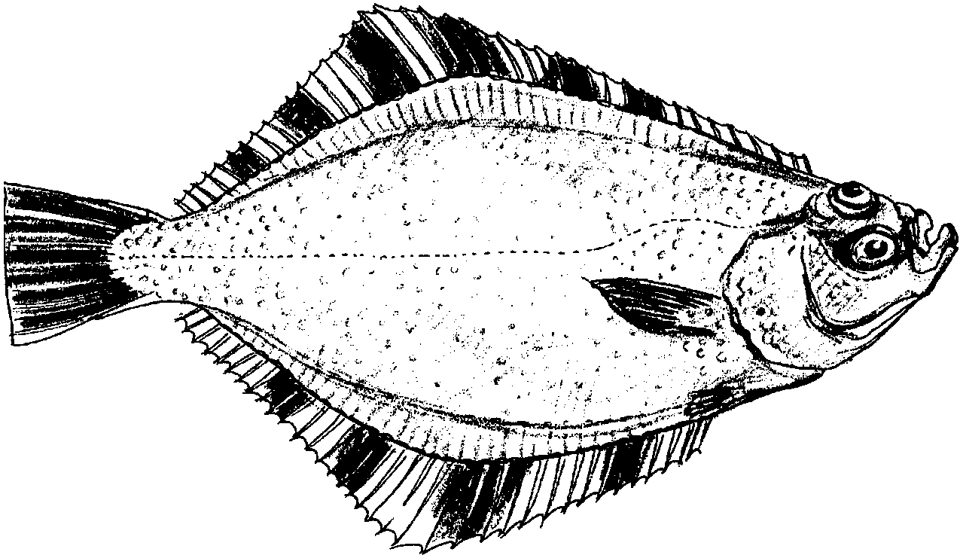

DID YOU KNOW? Along the coasts of Washington, Oregon and California, 50% of all Starry flounder are right-eyed and 50% are left-eyed. However, along the Alaskan coast, 70% are right-eyed. And in Japan, 100% are left-eyed.

SCIENTIFIC NAME: Platichthys stellatus.

COMMON NAMES: California flounder, grindstone flounder, roughjacket, sole and diamond flounder.

DESCRIPTION: Starry flounder may be either right or left-eyed with oblique dark bars alternating with yellowish-orange bars on dorsal, anal and caudal fins. The eyed side is mostly brown to black and the blind side white. Up to 3 feet in length and 20 pounds in weight.

LIFECYCLE: Starry flounders spawn near river mouths and sloughs with juveniles found exclusively in estuaries. Often times, this species finds its way up river, but it is estuarine dependent. Adults can be found in marine waters up to 1150 feet in depth.

RANGE: The Starry flounder is found throughout the eastern Pacific ocean -- from the Santa Ynez River in California, to the Bering and Chukchi Seas in Alaska, to Bathurst Inlet in Arctic Canada.

HABITAT AND ECOLOGY: Starry flounder feed on zooplankton, copepods, crustaceans and amphipods primarily. To reduce predation, the Starry flounder will change its coloration to blend in with the bottom. Nonetheless, it falls prey to birds and marine mammals.

Because the Starry flounder is dependent on estuaries, it is negatively affected by pollution and the destruction of wetland and estuarine habitat. Starry flounder is impacted by wetland draining and filling for shoreline developments, by polluted run-off from urban and agricultural lands, and by municipal and industrial waste discharges. Additionally, the Starry flounder has a demonstrated tendency to accumulate many contaminants it is exposed to in its environment, which can impair reproductive success.

ECONOMIC VALUE: Most of the commercial catch of Starry flounder comes from the Puget Sound in Washington as well as the coastal areas of Washington and Oregon. This species is also an important sport fish; caught primarily in estuaries and near-shore shallow waters. It is the most abundant flatfish in many estuaries north of San Francisco Bay.

ENGLISH SOLE
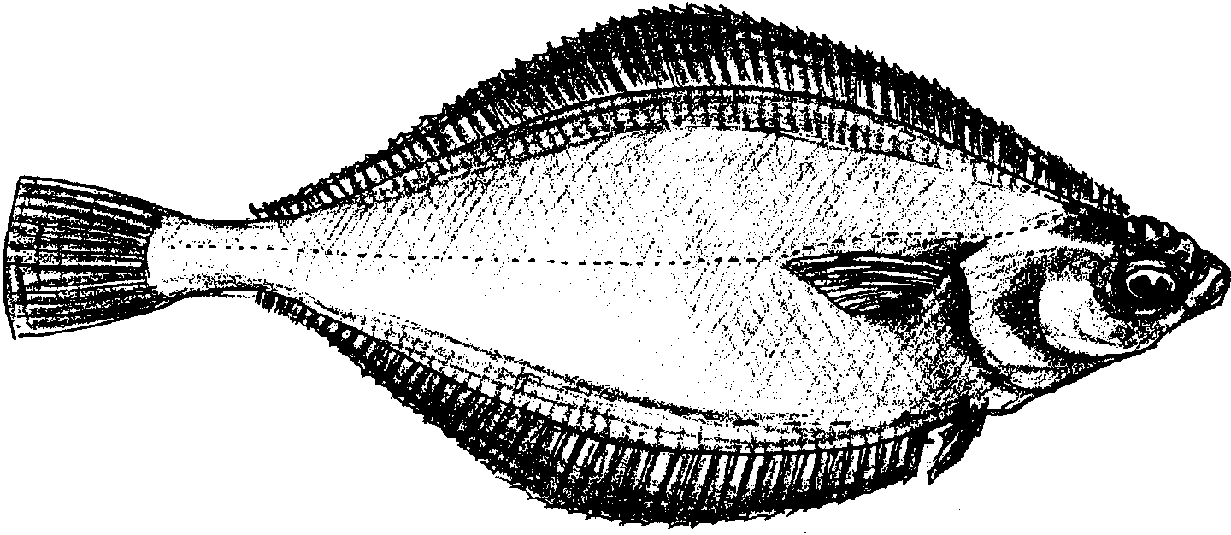

DID YOU KNOW? English sole rely on tidal currents to move into and out of the estuaries.

SCIENTIFIC NAME: Pleuronectes (or Parophrys) vetulus.

COMMON NAMES: California sole, lemon sole, pointed nose sole, and sharp nose sole.

DESCRIPTION: The English Sole is right-eyed with a pointed snout. The eye is set high and is visible from the blind side. The side with the eye is brown and other side is white to pale yellow, tinged with reddish brown. Up to 22.5 inches in length.

LIFECYCLE: English sole generally spawn at depths of 150-225 feet over soft mud bottoms. The young depend heavily on estuaries and shallow near-shore waters for food and shelter. Adults are found in near-shore coastal waters and make only limited migrations.

RANGE: English sole is found from Mexico to Alaska. The most abundant flatfish in Puget Sound, Washington, the English sole is an important flatfish in many shallow-water and estuarine environments.

HABITAT AND ECOLOGY: The English sole is very susceptible to changes in its environment. Relying heavily on estuaries for rearing, the English sole is impacted by pollution and habitat alteration. Often the dumping grounds for industrial and municipal wastes, bay waters and sediments also collect contaminants running off our streets and farms. In Puget Sound, for example, the many toxins English sole are exposed to accumulate in their tissues, resulting in high levels of contaminants which can cause disease, tumors, and reduced reproductive success.

The English sole generally feeds on crustaceans and polychaetes. Piscivorous (fish-eating) birds, such as the blue heron, are among the English sole’s main predator. Others include larger fishes, marine mammals, and sharks.

ECONOMIC VALUE: A moderately important commercial fish, the English sole is caught primarily by trawls and marketed as filet of sole. It is ranked second in terms of pounds of flatfish landed on the Pacific Coast; the Dover sole ranks first.

PACIFIC HALIBUT
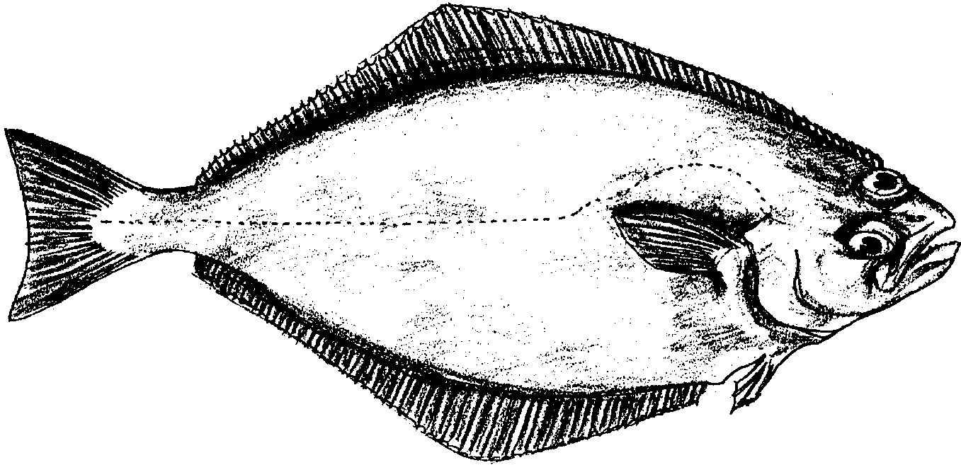

DID YOU KNOW? Female halibut mature at 12 years of age. As a result, halibut populations which are overfished may take a long time to recover.

SCIENTIFIC NAME: Hippoglossus stenolepis

COMMON NAMES: Halibut

DESCRIPTION: Pacific Halibut have both eyes on one side of the head. The side with the eye is dark brown or gray marbled with paler shades.. The blind side is white. The largest females weigh up to 500 pounds and may be 8 feet 9 inches in length. Males are considerably smaller with the largest at 4 feet 7 inches.

LIFE CYCLE: Pacific Halibut lay their eggs in shallow water. A large female produces 2 to 3 million eggs each year. The eggs may be encountered anywhere from 132 to 3066 feet of depth. They drift for 4 to 5 months as they develop. At about six inches of length, the eye on the left side of the head begins to show signs of migrating so that its top can be seen from the right side. The young fish are carried inshore by currents and settle to the bottom. As they grow, they move into deeper water. After about 12 years, a halibut is able to lay eggs.

RANGE: From Southern California to the Bering Sea to Kuril Islands, Kamchatka, northern Sakalin Island, and Okhotsk Sea to Hokkaido and northeastern Japan.

HABITAT AND ECOLOGY: Pacific Halibut spend time most of their time in the ocean. They are found on the bottom in waters up to 3,600 feet in depth but are most common on the bottom at depths between 180 feet and 1350 feet.

Halibut eat fishes, crabs, clams, squids, and other invertebrates.

About 1931, halibut fishing reached a point where accumulated stocks of fish had all been caught off and increasing fishing effort no longer lead to greater production: more fish were being caught than were being replaced by natural reproduction. In 1932, the halibut fishery came under the regulation of the International Fisheries Commission. The populations of halibut have gradually recovered.

ECONOMIC VALUE: The Pacific Halibut is an important resource for fishers. It is caught all along the Pacific coast and has been since long before the first Europeans visited the Pacific coast of North America.

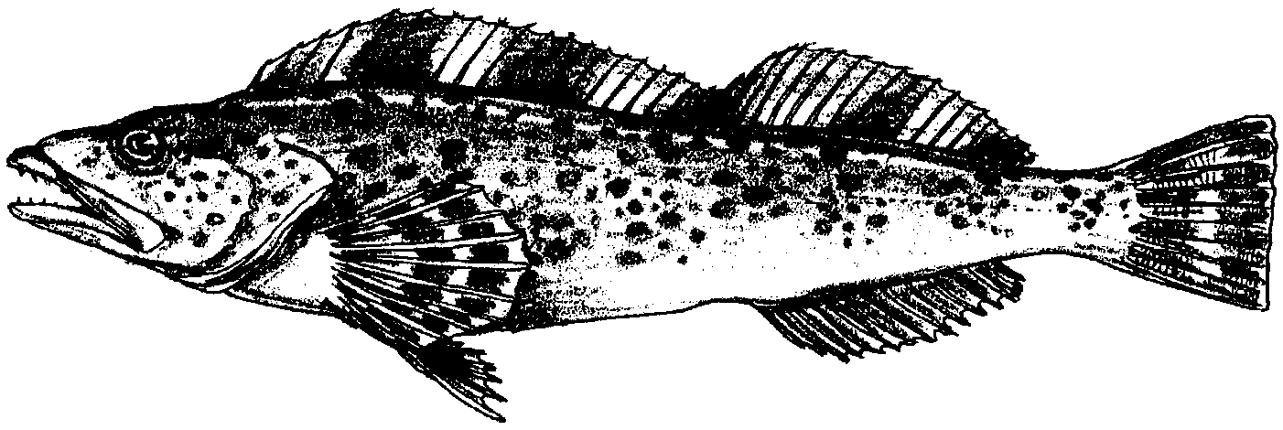
LINGCOD

DID YOU KNOW? Lingcod populations are easily impacted by changes in their environment because they are slow growing and nonmigratory.

SCIENTIFIC NAME: Ophiodon elongatus.

COMMON NAMES: Cultus cod, blue cod, bluefish, green cod, buffalo cod, and white cod.

DESCRIPTION: Lingcod is a large, elongate fish with spinous and soft-rayed parts separated by a notch. Gray to brown or greenish-blue from above, with darker and lighter spotting.

LIFECYCLE: Lingcod begin life in near-surface marine waters and estuarine areas. As juveniles, lingcod primarily use estuaries, while adults are usually found in marine waters of 300-450 feet deep.

RANGE: Lingcod are found along the Pacific coast from Baja California to the Shumigan Islands in the Gulf of Alaska; although most abundant from Pt. Conception, California to Cape Spencer, Alaska.

HABITAT AND ECOLOGY: Lingcod lay eggs requiring well-oxygenated water in rocky, marine-subtidal areas in crevices and overhangs. Larvae are found in the near-surface marine waters and estuarine areas. In this lifestage, lingcod primarily feed on copepods, eggs and other crustaceans. As it matures, lingcod is commonly found in shallow, intertidal areas of bays near algae and seagrass beds. Mature lingcod primarily eat other fish and smaller lingcod.

Because of its tendency to live around rocky coastal areas, with good water movement and plentiful food, the lingcod is susceptible to petrochemical spills and can accumulate concentrations of heavy metals. Human impacts in estuaries, such as dredging shoreline for development, alteration and filling of wetlands, and runoff of nutrients from residential and agricultural areas, also pose a threat to the lingcod.

ECONOMIC VALUE: The lingcod is an important commercial species in Washington, Oregon, California and Alaska. In Puget Sound, lingcod is the eighth most important commercial species. In addition to its commercial value, lingcod is a valued sport fish because of its excellent taste.

Several of the above fish sheets, compiled by Lori Oliver, were prepared by the Pacific States Marine Fisheries Commission, F.I.S.H. Habitat Education Program. The F.l.S.H. (Fishermen Involved in Saving Habitat) Education Program unites sports and commercial fishing groups, conservation organizations, and others to preserve fisheries habitat and water quality through community outreach. Funding for the sheets comes in part from the National Fish and Wildlife Foundation and Sport Restoration Funds.

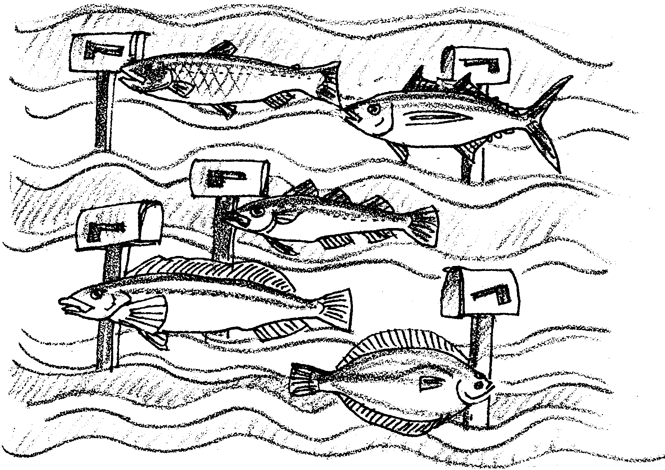
Ocean Address

Different kinds of fish live in different places in the oceans. Some fish spend their time on the bottom. Some spend their time at the surface. Some spend their time in the middle layers of the oceans. People catch fish from all of these areas to eat. Let’s see what we can learn about some of these fish.

Here’s what you’ll need:
• “Ocean Address” activity pages
• scissors
• glue
• crayons, paints, or markers
• string or fish line
• single-hole hole punch
• 2 hangers for hanging fish
• tape

Here’s what to do:

Part I - Fish Facts

1. Use your set of fish drawings to complete the following table:

Maximum Weight Maximum Length

Albacore Tuna

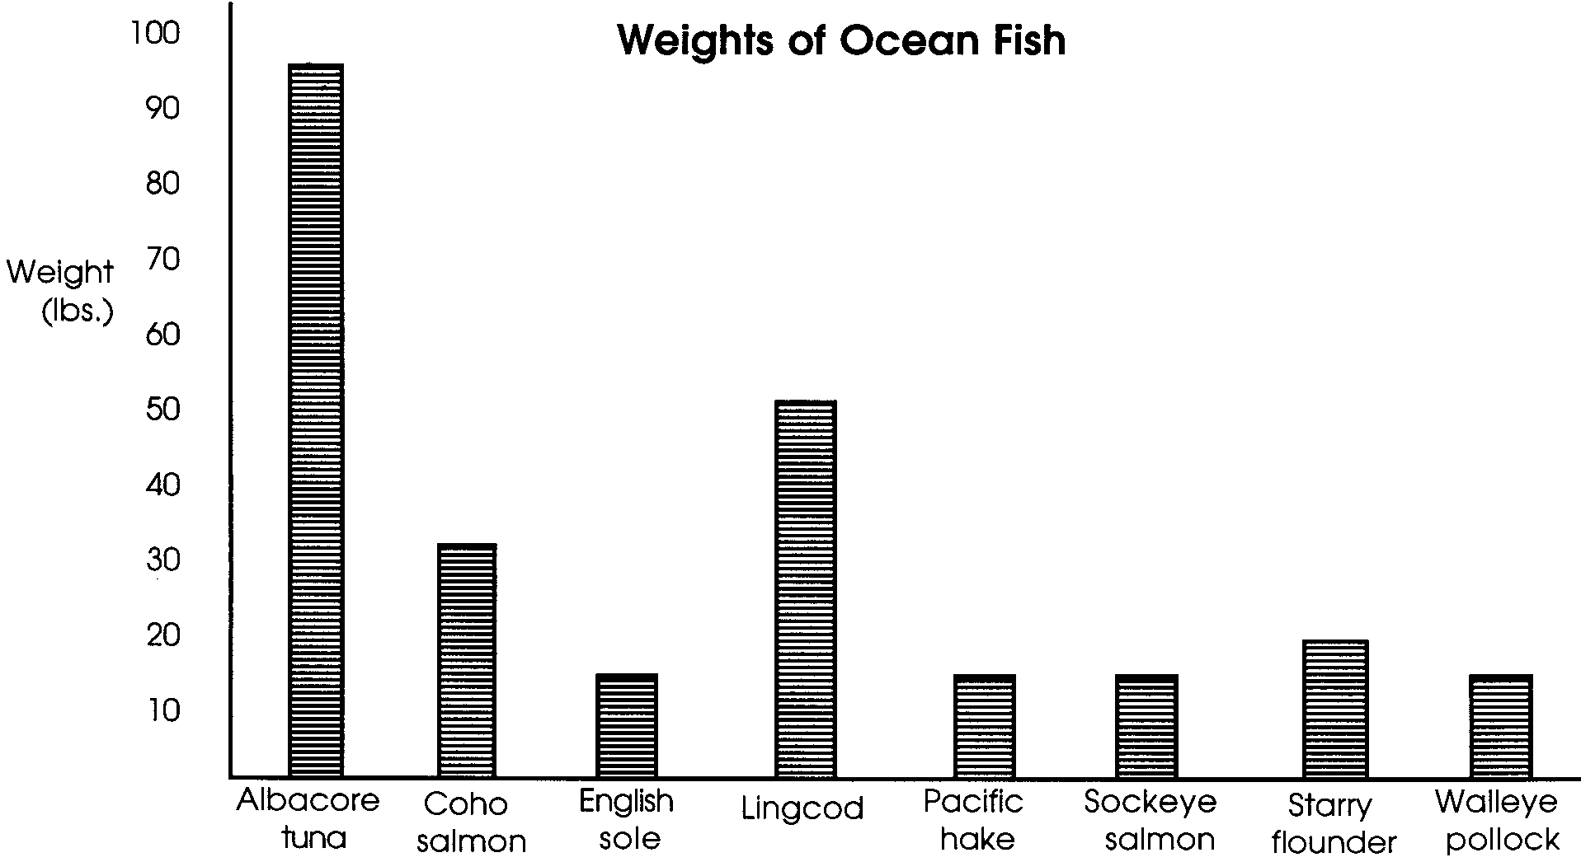
Coho Salmon

English Sole

Lingcod

Pacific Hake

Pacific Halibut

Sockeye Salmon

Starry Flounder

Walleye Pollock

Here is a bar graph of the fish weights.

2. Use the graph to answer the following questions.

a. Which fish has the greatest maximum weight?

b. Which four fish have the same maximum weight?

c. Which fish has a weight about twice as great as the lingcod?

Challenge: The Pacific Halibut is not on your graph. Look at the table you made. How many times greater is the weight of the halibut than that of the lingcod?

3. Now use the length information in the table to make a bar graph. The first fish is done for you.
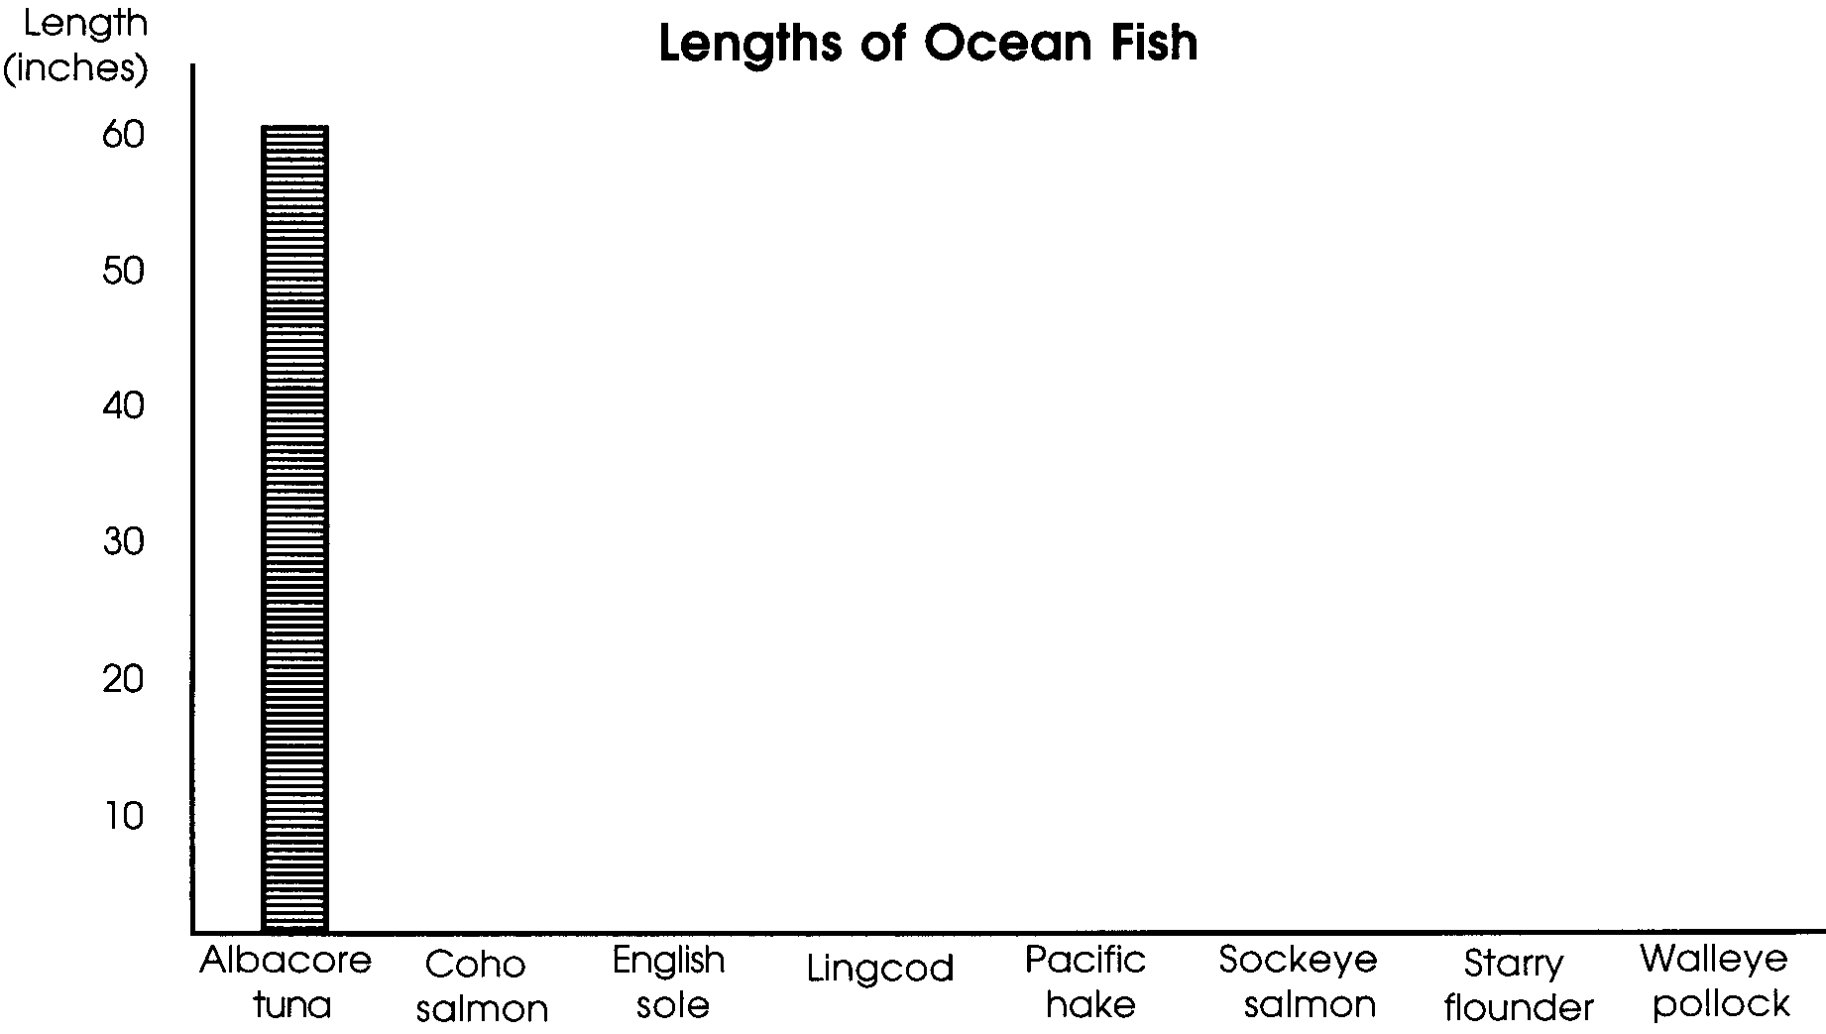

4. Use the graph to answer the following questions.

a. Which fish has the greatest maximum length?

b. Which four fish have the same lengths?

c. Are the four fish with the same lengths, the same as the four with the same weights? If not, which are different?

d. Look at both graphs. Is the longest fish also the heaviest?

e. Which two fish have the same length but different weights?

5. List the fish that spend most of their lives in each of these parts of the sea. If two parts of the sea are given, choose the first listed.

Bottom Middle Waters Surface

b. Which fish spends time in the deepest water?

6. Road building can add soil to stream waters. Which fish are most likely to be affected by road building? (Hint: Which fish spend part of their life cycle in freshwater?)

7. Many kinds of pollution end up on the bottom of estuaries. Which fish are most likely to affected by pollution in the mud of estuaries? (Hint: Which fish spend part of their lives on the bottom in estuaries?)

8. Which fish has the least economic value?

Part II - Fish Mobile

Follow these instructions to make a fish mobile.

1. Add these “fishy facts” to the back of your fish:

Ocean Address:

Size:

Weight:

Life Cycle:

Economic Value:

(Hint: Your set of fish drawings will be helpful.)

2. Color or paint one or both sides of the fish. (Be sure you can still read your “fishy facts”.) The information on your set of fish drawings will give you some help. Field guides or color pictures are helpful, too.

3. Carefully cut out the fish.

4. Punch a hole through the top of each fish.

5. Cut lengths of the strings that match where in the ocean the fish spends most of its time. Fish that live near the surface would have the shortest strings.

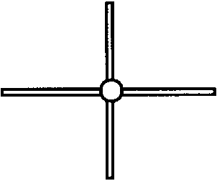
6.Thread the correct length of string through the hole at the top of each fish. Knot the threads tightly.

7. Tape the two hangers together to form an equally spaced cross.

8. Tie the free ends of the threads to the cross. Balance your mobile by moving the fish along the hangers.

9. Hang the finished mobiles from the ceiling.

10. Write or tell a description about your mobile.

COHO SALMON

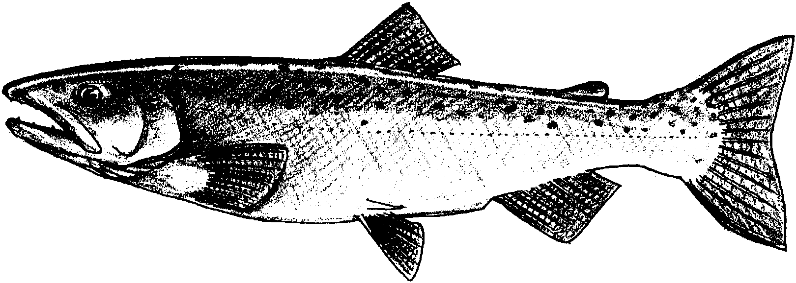

Fish Facts: Coho salmon are bluish-black with silver sides. They have black spots on the back and upper part of the caudal fin. Coho salmon usually weigh between 6 to 12 pounds. The largest weigh up to 31 pounds. They may be over 3 feet long.

Life Cycle: Eggs are laid in streams in the fall. The eggs hatch the following spring. The young fish stay in streams for over a year. Then, they swim to the sea where they stay for three years. After that, they return to the streams to lay their eggs.

Ocean Address: Coho salmon spend time in freshwater and ocean environments. They usually are found near the surface.

Economic Value: Coho salmon is an important resource to fishers. It is commercially fished from northern California to Alaska.

SOCKEYE SALMON

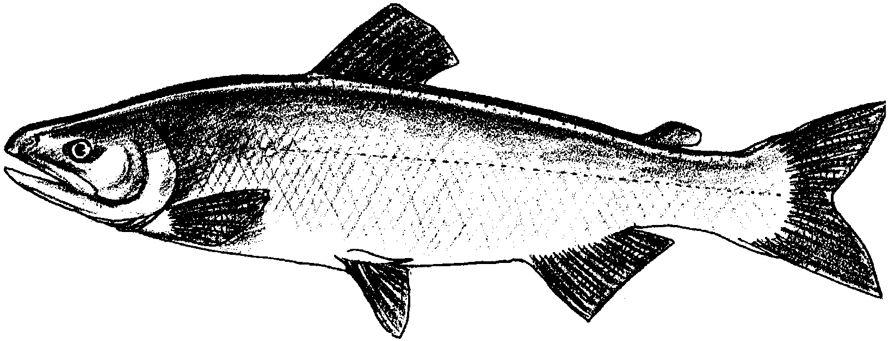

Fish Facts: The sockeye salmon is greenish-blue. It has small black speckles on its back. Spawning fish have green heads and red bodies. Most sockeye salmon weigh 6 pounds. Large ones may weigh up to 15 pounds. They grow up to 33 inches in length.

Life Cycle: Sockeye salmon spawn in streams headed by lakes. They spend from 1 to 2 years in the lakes. Then, they swim to the sea where they spend one or two years. After that, sockeye return to the lake. There they spend 1 to 8 months before spawning.

Ocean Address: Sockeye salmon spend time in streams, lakes and ocean waters. They are usually found near the surface.

Economic Value: Sockeye salmon is an important resource to fishers. It is commercially fished from Oregon north to Alaska.

ALBACORE TUNA

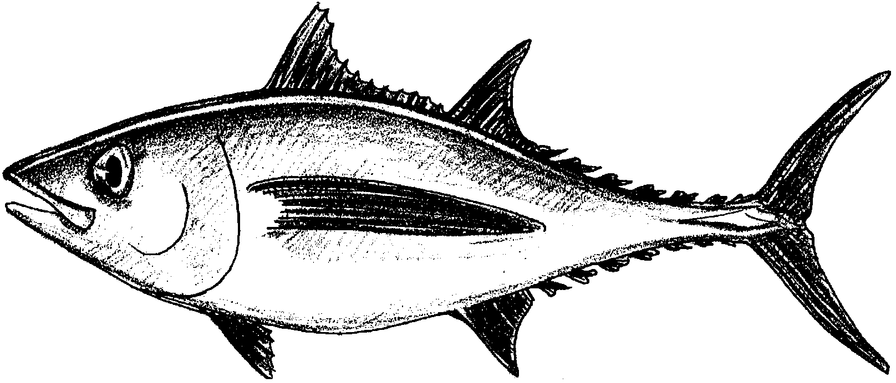

Fish Facts: The largest Albacore tuna weigh up to 96 pounds. They can grow up to 5 feet in length.

Life Cycle: Eggs are laid from January to June in the warm ocean between Hawaii and Japan. Young albacore spread out throughout warm Pacific waters. They return as adults to lay their eggs.

Ocean Address: Albacore tuna spend all of their lives in warm areas of the open sea. They are usually found near the surface and at middle depths.

Economic Value: Albacore is the highest grade of tuna. It is a very important resource for fishers. It is commercially fished between Baja California, Mexico and Vancouver Island, Canada.

WALLEYE POLLOCK

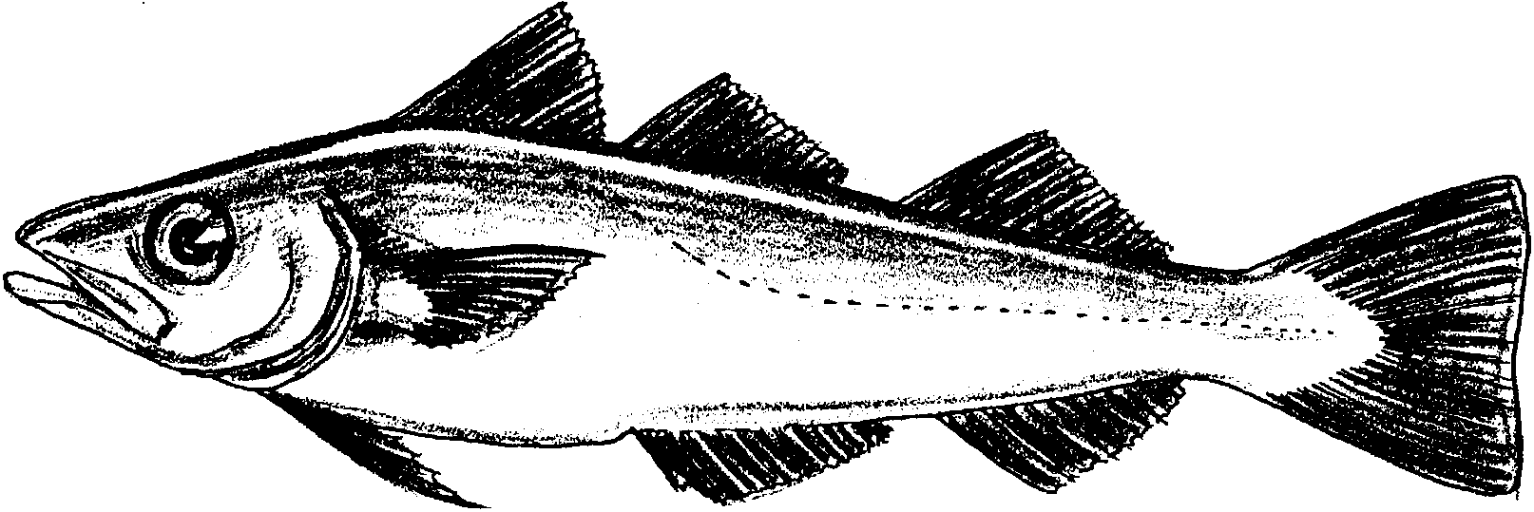

Fish Facts: Walleye pollock are olive green or brown on the back. They have silvery sides and white or yellow undersides. They grow to 3 feet in length. They may weigh 15 pounds.

Life Cycle: Little is known about the life history of these fish. The eggs are laid at sea. Walleye pollock may not lay eggs before they are 7 years old.

Ocean Address: Walleye pollock spend all of their time in the ocean. They are usually found in the middle waters or near the surface.

Economic Value: Until recently, Walleye pollock had little economic value. They are now heavily fished for frozen fish products (fish sticks, etc.).

PACIFIC HAKE

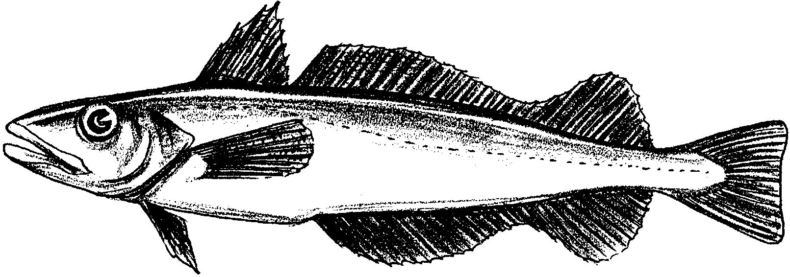

Fish Facts: Pacific hake are dark silver gray on the back. They are bright silvery below. Their pectoral fins are brown. They grow to 3 feet in length. They may weigh 15 pounds.

Life Cycle: Eggs are laid at sea from January to June. They hatch in 3 days or less. Pacific hake may not lay eggs before they are 7 years old.

Ocean Address: Pacific hake spend all of their time in the ocean. They are usually found in the middle waters or near the surface.

Economic Value: Until recently, Pacific hake had little economic value. They are now heavily fished for frozen fish products (fish sticks, etc.).

STARRY FLOUNDER

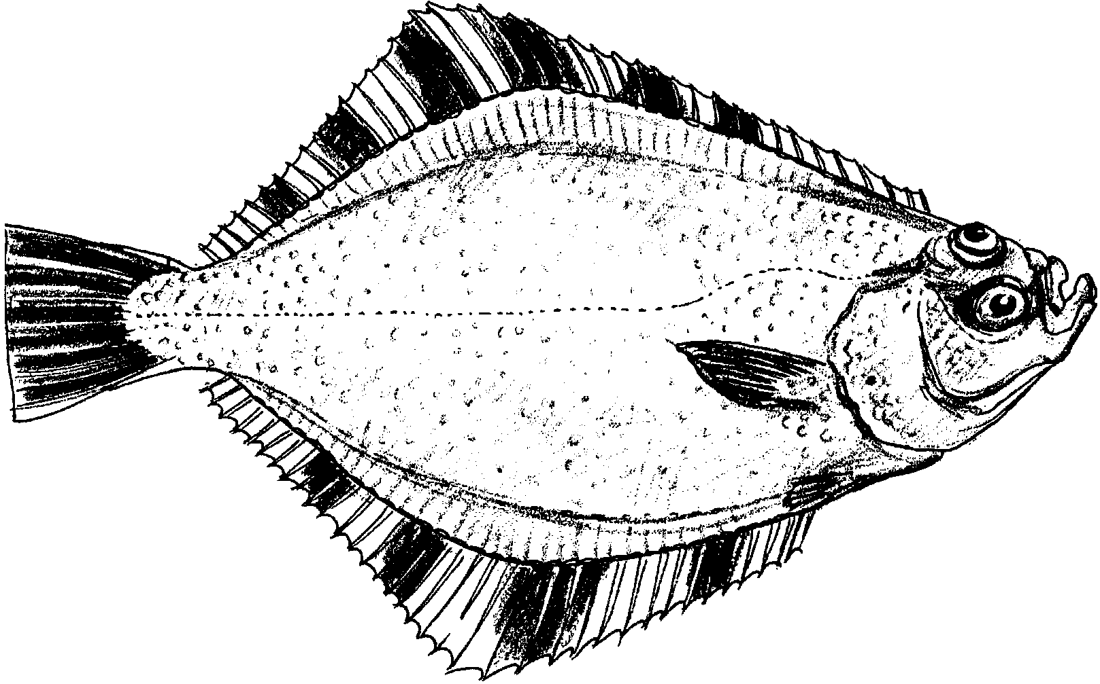

Fish facts: Adult starry flounder have both eyes on one side of the head. They have black and yellowish-orange bars on their dorsal, anal and caudal fins. The eyed side is mostly brown to black. The blind side is white. The largest weigh up to 20 pounds. They may be 3 feet in length.

Life Cycle: Starry flounders lay eggs near river mouths. The young spend time in estuaries. (An estuary is the place where a river meets the sea.) Adults spend most of their lives in the ocean. They return to the estuaries to spawn.

Ocean Address: Starry flounder spend time most of their time in the ocean. They are found on the bottom in waters up to 400 feet in depth.

Economic Value: A small number of starry flounder are commercially fished in some areas of Washington and Oregon. However, lots of starry flounder are caught by sport fishers.

ENGLISH SOLE

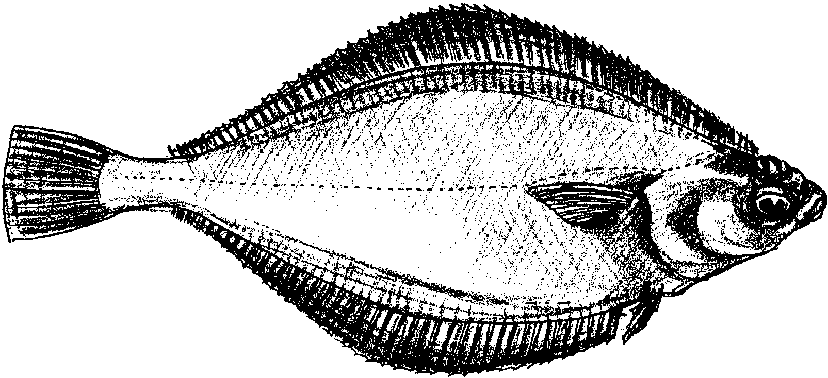

Fish Facts: Adult English sole have both eyes on one side of the head. The side with the eye is brown. The blind side is white to pale yellow. The largest weigh up to 15 pounds. They may be 22 inches in length.

Life Cycle: English sole lay their eggs on the ocean bottom at depths of 150 to 225 feet. The young feed and find shelter in estuaries. Adults are found in ocean waters between 1800 feet of depth and the surface.

Ocean Address: English sole spend time most of their time in the ocean. They are found on the bottom in waters up to 100 feet in depth.

Economic Value: The English sole is an important resource for fishers. It is sold as filet of sole. It is caught all along the Pacific Coast.

PACIFIC HALIBUT

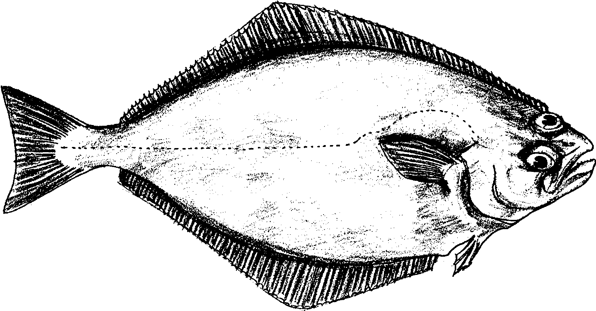

Fish Facts: Pacific halibut have both eyes on one side of the head. The side with the eye is dark brown. The blind side is white. The largest weigh up to 500 pounds. They may be over 8 feet in length.

Life Cycle: Pacific halibut lay their eggs in shallow water. The eggs drift as they develop. The young fish settle to the bottom. As they grow, they move into deeper water. After about 12 years, a halibut is able to lay eggs.

Ocean Address: Pacific halibut spend time most of their time in the ocean. They are found on the bottom in waters up to 3,600 feet in depth.

Economic Value: The Pacific halibut is an important resource for fishers. It is caught all along the Pacific Coast.

LINGCOD

Fish Facts: Lingcod are gray to brown or greenish-blue on top. They are white or pale yellow below. Adults grow up to 5 feet in length. They may weigh over 50 pounds.

Life Cycle: Lingcod lay eggs in rocky areas near shore. Young lingcod live in shallow, intertidal areas of bays near algae and seagrass beds. As they grow older, lingcod move to deeper water.

Ocean Address: Young lingcod spend time in estuaries. Adults are usually found on the bottom in ocean waters up to 450 feet deep.

Economic Value: The lingcod is an important resource for fishers. It is fished commercially from California to Alaska.

