Fins

Key Concepts
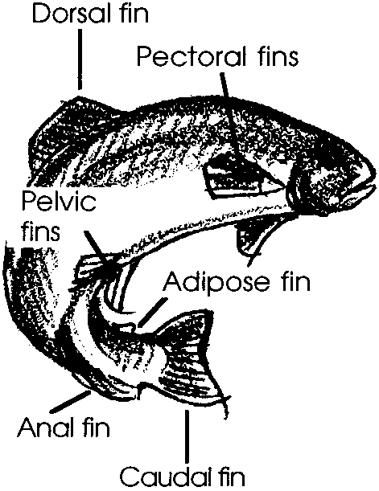
1. Marine animals such as fish are adapted to their environment.
2. The form or shape of marine animal body parts is related to their function.
3. Fins have specific functions. Fin shapes and arrangements vary for each fish species. Each fin has a special job to do.
4. Much information can be learned about the life history of an animal through observation of its physical features.

Background

Fish are amazingly well adapted creatures. Fish fins often show special adaptations and arrangements to help fish survive.

Most fish have at least one dorsal fin, a caudal fin, an anal fin, a pair of pelvic fins, and a pair of pectoral fins. Often the first dorsal fin will have hard, sharp spines, while the other fins will have soft, flexible fin rays. The fin spines and rays are connected by a thin, fleshy material. Some fish (trout and salmon) have a small fleshy adipose fin located between the dorsal and caudal fins. Those which were tagged for study at a hatchery will have had the adipose fin removed so that the fish can be identified as one which is tagged.

A fish’s fins help it to move and maneuver in the water while providing the serious observer with clues about its habits and habitat. For example, schools of sardines, which are sleek and streamlined swimmers, appear as silvery flashes in the midwater habitat. Forked tails give them speed and power and their evenly distributed fins provide stability and maneuverability. They are constantly on the move, feeding on plankton.

While the fins help a fish move, a fish’s main power comes from contractions of the muscles along the sides of its body. Most fish have the following types of fins:

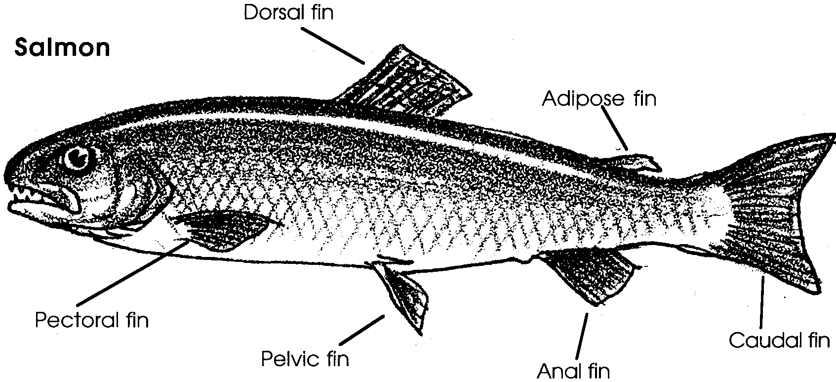

Fin Function
dorsal and used as keels to keep the fish
anal fins upright in the water

pectoral and help the fish turn, brake and,
pelvic fins sometimes, back up

caudal fin or provides power and steering
tail

The number of each kind of fin varies according to the fish species. For instance, a fish might have one, two, or no dorsal fins.

Materials

For the class:

• pictures of fish

For each student or pair of students:

• “Fins” activity pages

• a real fish if possible

Teaching Hints

“Fins” is designed to show how the fins on a fish are arranged and how they help the fish to survive. “Fins” provides a natural connection to the activities “Gyotaku - Japanese Fish Printing” and “Name that Fish”. It is best to observe a real fish if possible. Students can do this activity before they print their fish or as a follow up by observing the fins on the prints.

Make a display of pictures of a variety of fish. Try to find different views of the fish that show fins and their functions. You might laminate some pictures for students to use during this activity. Laminated pictures can be used again in other activities, such as “Name that Fish” in which students key out fish.

In the student text, students examine a salmon. If possible, try to buy a whole fresh salmon with gills at your grocery. A trout can be used. Trout are very similar to salmon. Try to find other species of whole fresh fish with different body forms and fin arrangements for comparisons.

Before beginning the exercise with your class, read the student activity and study the diagrams of the fish. The function and location of each fin will be found in the text. Duplicate the student text pages. You might want to make an overhead transparency of the above labeled drawing to help clarify student understanding.

Key Words

adipose fin - a small fin on the back of salmon and trout, near the tail

anal fin- a fin under the body and between the anus and tail

caudal fin - tail fin

dorsal fin - a fin on the back of the animal

fins - projections attached to various parts of the body of fish, used for propulsion, steering, or balancing

pectoral fins - fins on the side of the fish and near its head

physical features - bodily/structural characteristics

species - a group of organisms which have certain characteristics in common and which are able to interbreed freely in nature and produce fertile offspring; a scientific classification below a genus

Extensions

1. Have students design an imaginary fish and write a short description of how its body form and fins help it to survive. Encourage them to be creative but to be practical about size, shape, and the placement of fins.
Answer Key

1. The salmon has eight fins total.

2. The pelvic fins and the pectoral fins are paired.

3. The salmon has six kinds of fins.

4. Predictions about the role of the various fins will vary. Any reasonable prediction should be considered valid.

5. a. The accuracy of the predictions made in question 4 will vary. Use this opportunity to discuss the role of predictions, emphasizing that predictions provide areas for experimentation and learning.

b. caudal fin: the tail fin or caudal fin is used for steering and power.

c. pectoral fins: the pectoral fins on the fish’s side are used like an airplane’s wings to control the fish’s ups and downs.

d. dorsal, anal and adipose fins: the dorsal, anal and adipose fins are used to keep the fish from rolling over. They also help in steering the fish. In some fish these fins may have spines which aid in protection.

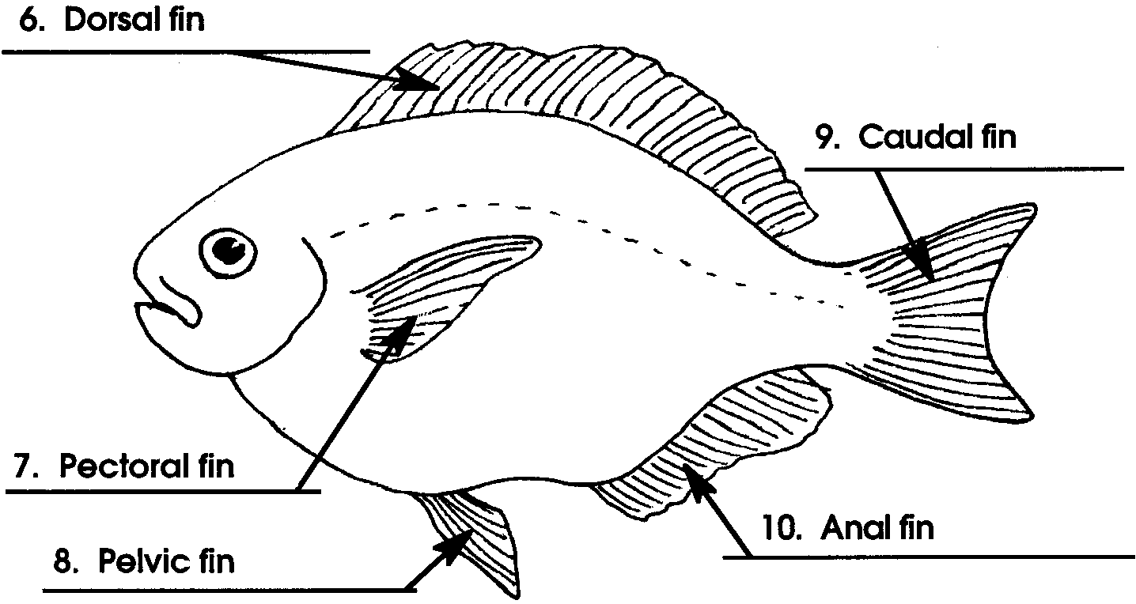
6-10. A correctly labeled ocean perch follows:

11. The adipose fin is missing on the ocean perch.

12. This is somewhat debatable since both are well streamlined.

13. There are lots of possible advantages to streamlining: speed for escaping enemies or catching food; reduced energy needs in swimming (easier to swim); etc. Reward originality.

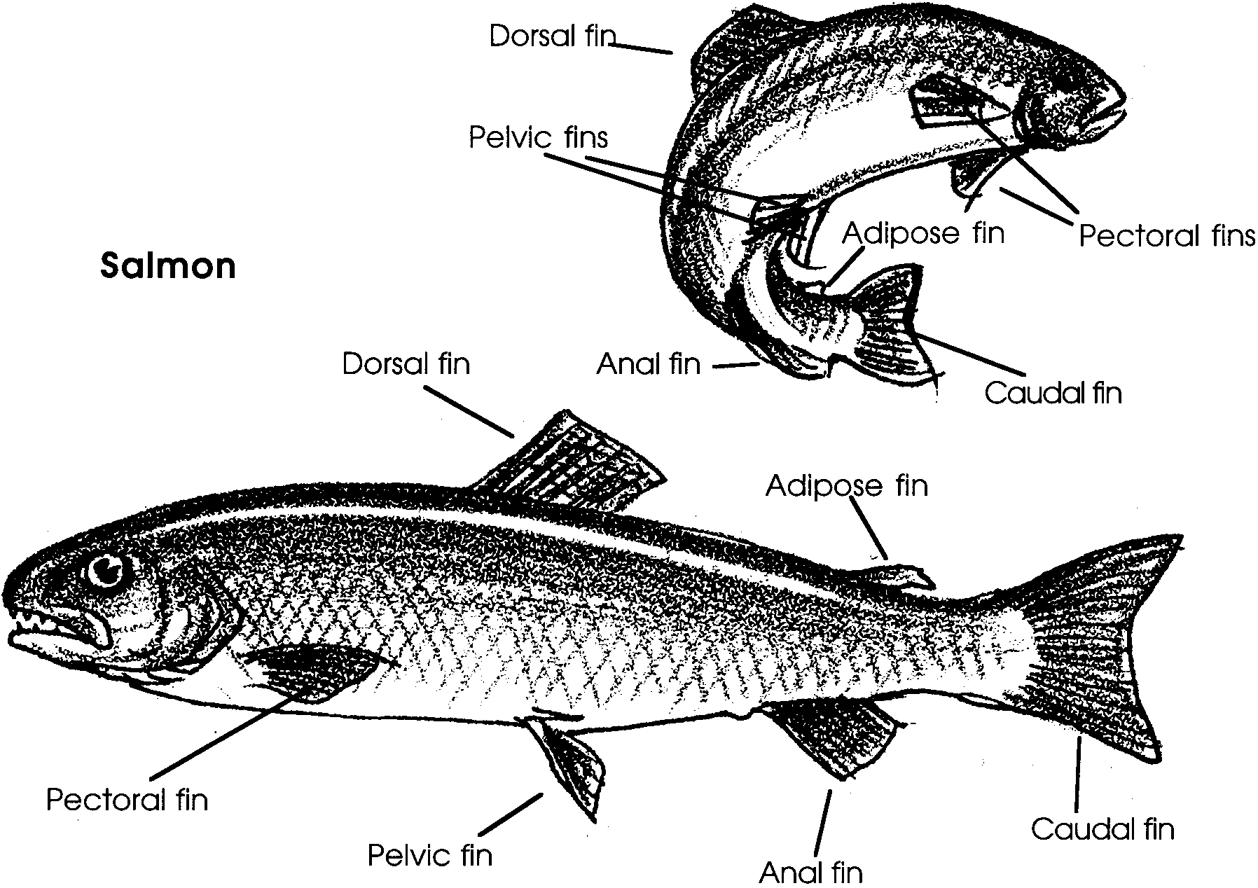
Fins

Fish are amazing. A swimming fish can hold itself in one place or speed away with a slight flick of a fin. Fish seem to have lots of fins. What is a fin? Where are the fins on a fish? How do they work to help the fish survive? Observe a fish to find out.

Let’s look at a drawing of a salmon. Notice that some of the fins go together in groups of two or pairs, but others do not. Some fins are large, others are small.

Use the drawing above to answer the following questions.
1. How many fins does the salmon have?

2. Which two kinds of fins are paired?

3. How many kinds of fins does the salmon have?

Each fin has its own job to do. Some fins are used for steering and power. Others are used like an airplane's wings. They control the fish's ups and downs. Others are used to stabilize the fish and to keep it from rolling over.

4. Look at the drawing of the salmon and predict the jobs of each of the following fins:

a. caudal fin

b. pectoral fins

c. dorsal, anal, and adipose fins

The fish uses the tail fin or caudal fin for steering and power. The pectoral fins on the fish's side are used like an airplane's wings. These fins control the fish's ups and downs. The dorsal, anal and adipose fins are used to keep the fish from rolling over. They also help in steering the fish. In some fish these fins may have spines which help protect the fish.

5. Look at your predictions in question 4. Then, look at the paragraph below the predictions. Compare your predictions with that information.

a. How close were your predictions to the information about the jobs of each fin?

Note: If your predictions were not very close, don't worry. Scientists make predictions and test them to increase their knowledge, not to simply show how much they already know!

b. If your predictions were not completely accurate, go back to number 4 and write the actual jobs of the fins below your predictions.

Compared to many sea animals, fish are very fast. The ability to swim rapidly helps them catch their food. It also helps them swim away from their enemies. Although fish may look very different from each other, they usually have similar types of fins. Use the drawing and information about the salmon to name the fins on the ocean perch.
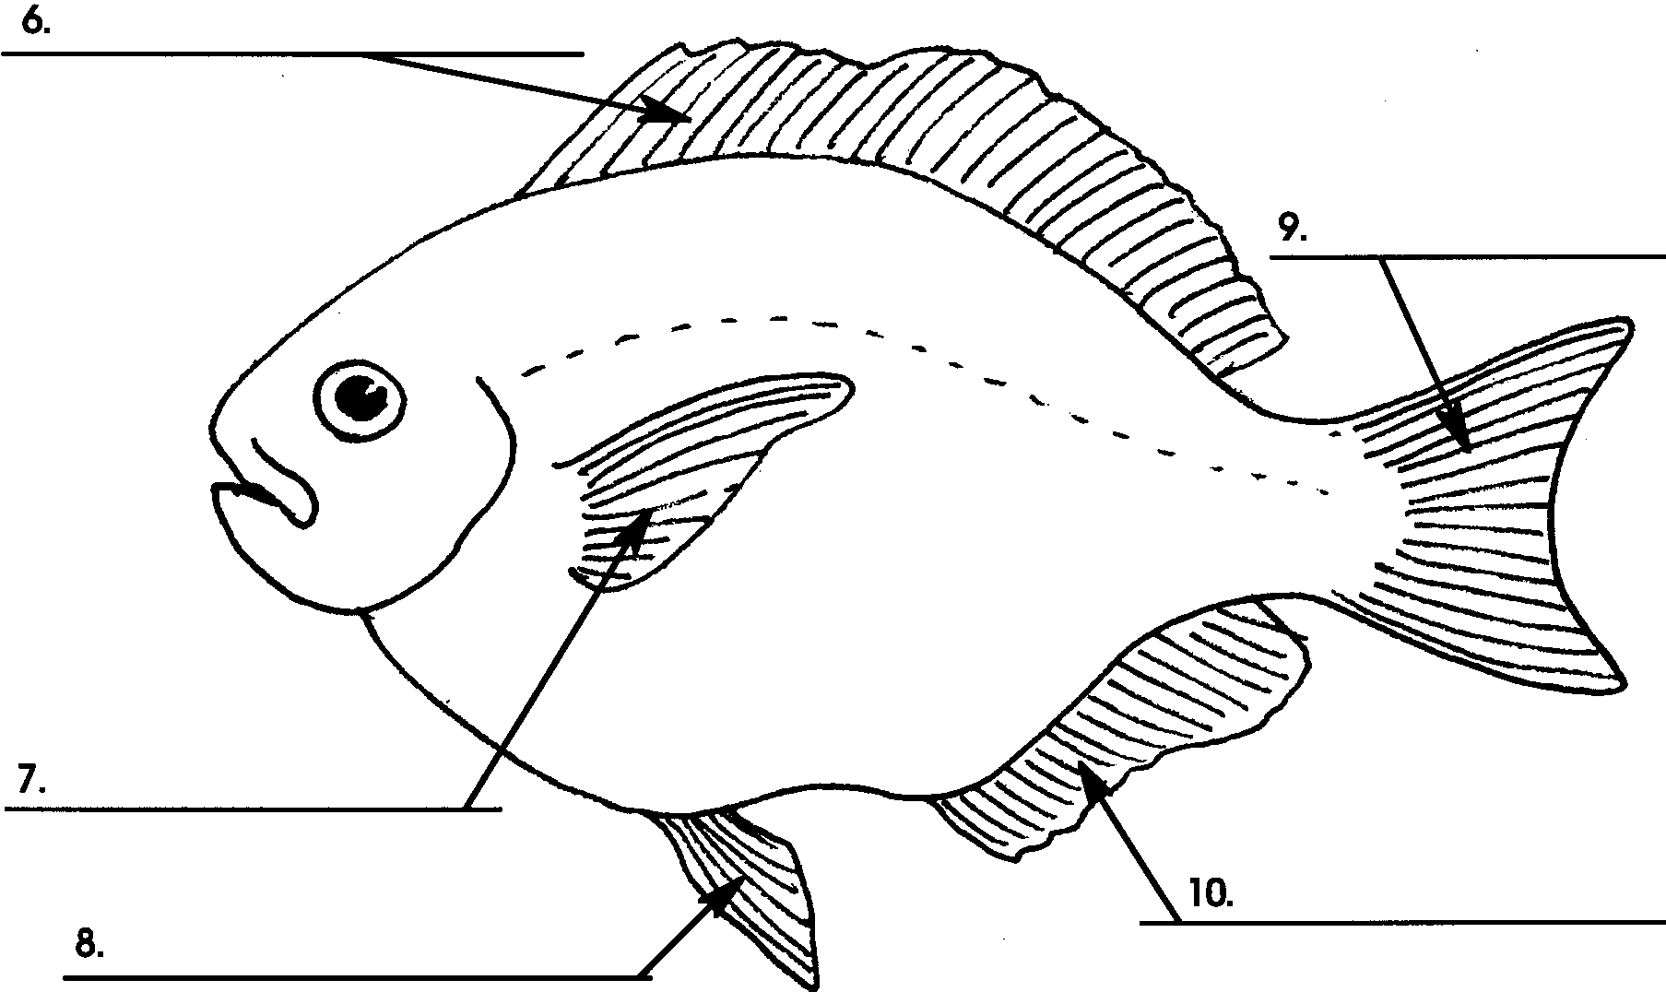

11. Which fin is missing on the ocean perch that is present on the salmon?

12. A streamlined body shape lets fish glide through water easily. Which fish is more streamlined? (Hint: a torpedo is streamlined.)

13. How might streamlining help a fish survive?

a.

b.

