Name That Fish!

Key Concepts
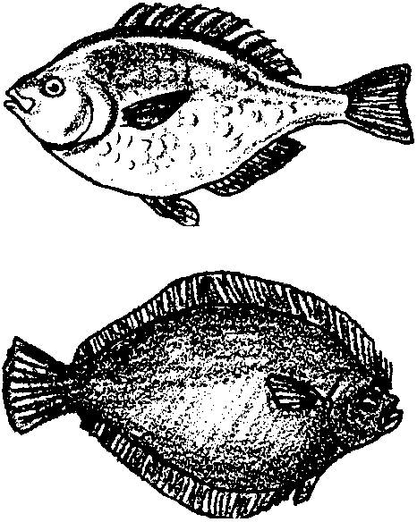
1. Marine animals, such as fish, are adapted to their environment.
2. Form and function are related in living things.
3. The oceans and coasts are a source of food for humans.
4. A dichotomous key is a scientific tool that is used to identify groups and individuals. It can be used to name fish.

Background

Bottomfish are the unsung heroes of the fish world. They make up the bulk of the finfishes of the world and provide the world with most of its fish protein. “Name That Fish!” introduces your students to some of the common “bottomfish”. It also introduces your students to the dichotomous key. This activity complements “Fins” and “Gyotaku Fish Printing”. Students can key out the fish that they are going to print.

Keys
Keys are an important tool in the identification of unfamiliar organisms. In this activity your students will have an opportunity to examine and use a simple key. It is important to emphasize that most keys are restricted to the organisms found in a particular area. Since keys are an artificial construct, different keys can be designed to “key out” the same group of organisms.

The most common type of key and the one introduced in this activity is the dichotomous key, a key with two choices at every level. Ideally, the choices are simple “yes” and “no” items (“the item is red” vs. “the item is not red”) and the discriminating features are things which can be verified by direct observation (“the item is 1/2 inch or longer in length” vs. “the item is less than 1/2 inch in length”). The alternatives should be quantifiable (1/2 inch or longer, rather than “big” or “small”).

Materials

For the class:

• pictures of various fish

• fish keys and guide books

• real fish to observe and identify if possible

For each pair of students:

• “Name That Fish” activity pages

Teaching Hints

In “Name that Fish”, students read about “bottomfish”, cut out a paper one, and discover it’s name by using a dichotomous key. If possible, have real fish for the students to identify. The real fish could be those used in the following activity, “Gyotaku - Japanese Fish Printing”.

A good way to introduce the concept of dichotomous keys is to construct a student key with the class to discriminate between the various members of the class. Use physical characteristics of individuals such as hair color, type of footwear, etc. Be cautious about racial discrimination in your class. Guide students to understand that you are looking for physical features that can be used to identify one group or individual from others. People are all members of the same species, Homo sapiens. Within that group, they exhibit some similar and some dissimilar features. Therefore, even though they are members of the same overall group, they can be divided into subgroups based on other similar or dissimilar features.

In theory, you could make the student key so complete that at the end of each branch you would have one student’s name. In practice, this detail is not necessary, but it is helpful to key at least one student all the way to the end. The steps might be as follows:

l. a) Students male (list all male names) . . . . . . . . . . . . . . . . .Go to 2
b) Students not male (list other students’ names) . . . . . . . . . .

2. a) All those over six feet tall (list all names) . . . . . . . . . . . . .Go to 3
b) Six feet or less in height . . . . . . . . . . . . . . . . . . . . . . . . . . . . . . . .

3. a) Blue eyes . . . . . . . . . . . . . . . . . . . . . . . . . . . . . . . . . . . . It is Bill Bailey
b) Non-blue eyes . . . . . . . . . . . . . . . . . . . . . . . . . . . . . . . . . . . . . . . .

In the above example, you would want to emphasize the fact that the only blue eyed male over six feet tall in the class is Bill Bailey.

For additional practice, or in lieu of using people, you might consider having students create keys for objects such as shoes, pencils, shells, buttons, pine cones, etc.

Duplicate the text pages and activity pages as needed for your students. You may choose to have students work independently on this assignment or in groups. The latter might help to build confidence in the use of the key. Plan to devote some time to a discussion of the importance of bottomfish and to provide the correct names for the various fish species.

Key Words

adaptation - an alteration or adjustment, often hereditary, by which a species or individual improves its condition in relationship to its environment; special changes or modifications which enhance survival

adapted - changed in order to survive in a particular habitat

anal fin - a fin under the fish’s body between the anus and tail

barbel - a barb-like, sharp projection

caudal fin - tail fin

dichotomous key - a tool used to distinguish between members of a group by repeatedly dividing and subdividing the group into two groups

dorsal - situated on or toward the back (top or upper side of whale)

dorsal fin - fin on dorsal or top side

key - a scientific tool/chart used to distinguish between members of a group

pectoral fin - a fin on the side of the body

Extensions

1. Have students create dichotomous keys for objects such as shells, pine cones, buttons, shoes, etc. Then have other students use those keys.

2. Consider introducing taxonomy, the science of naming and classifying organisms, with this activity.

Answer Key

1. Pile Perch (F)

2. Great Sculpin (D)

3. Big Skate (I)

4. Pacific Cod (A)

5. Spiny Dogfish (C)

6. Painted Greenling (H)

7. Lingcod (G)

8. Pacific Herring (E)

9. Alaska Pollock (B)

1O. Starry Flounder (K)

11. Rock Sole (J)

Name That Fish
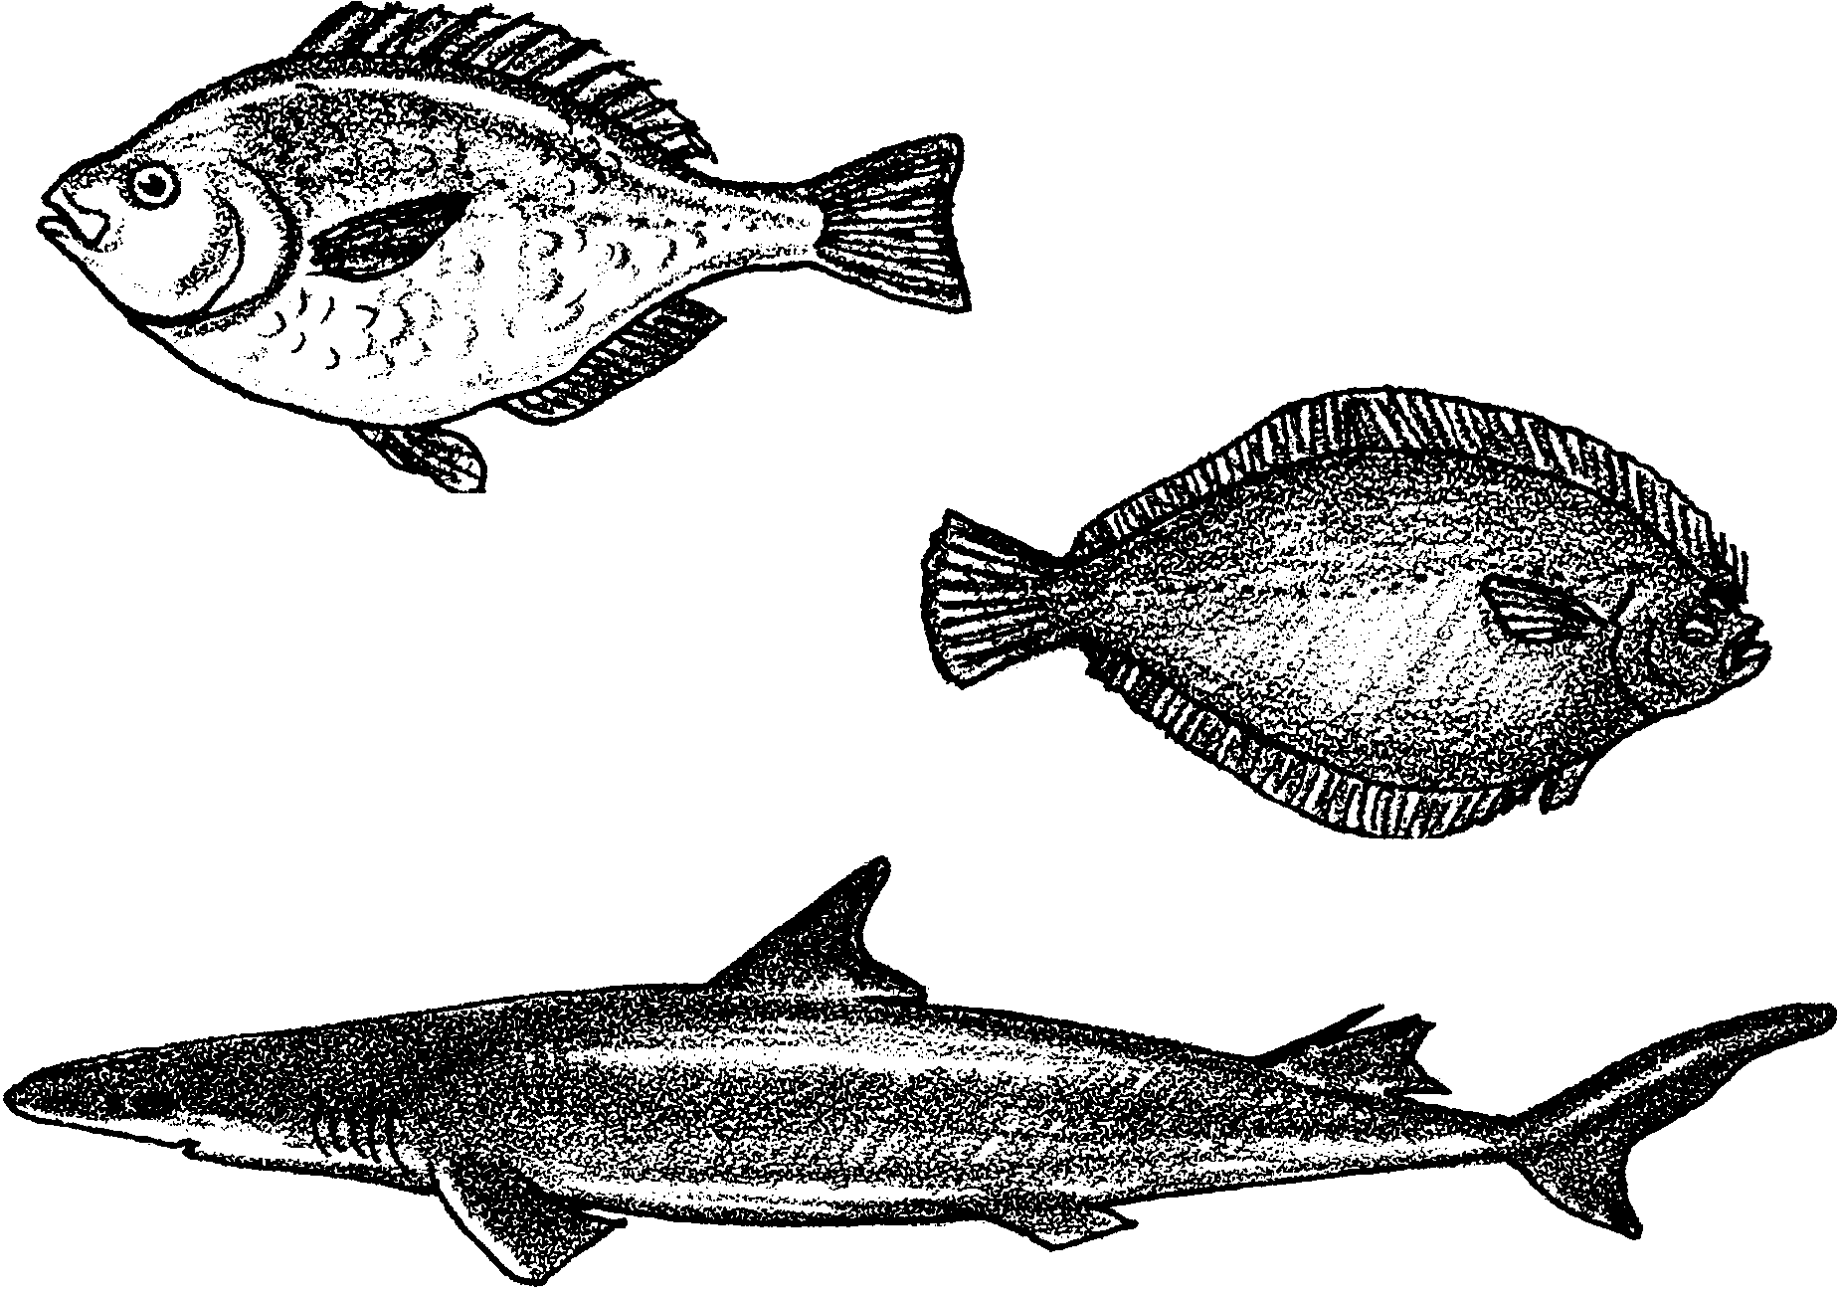
These fish come in all sizes, shapes and colors. They are round, flat, long, fat, yellow, red, green, and speckled. Some have sharp spines on their noses or long pointed tails. Some have wings like a bat. They make up the great bulk of the finfish families of the sea. They are the main food fish of the world.

But what are they? Well, they are often called “bottomfish” or “groundfish”. But they really are not “bottomfish”. Only a few spend their lives at the bottom of the sea. Many of them live at mid-water depth. What they have in common is their tasty white flesh. Fish like these are favorites on the seafood menu. They are made into fish and chips, imitation crab, fish sticks and patties, and other fish dishes. These fish are called “white fish”.

How can we get to know the names of these fish? The easiest way to identify fish is with a “key”. A key is a scientific tool based on a yes/no system. Each step of the key is a two-part description. The parts are labeled a. and b. The idea is to compare your fish with the two-part descriptions. The steps describe different physical features of the fish. The features might be: body shape, number of dorsal fins, spots on the caudal fin (tail) and so on. Choose the description (a. or b.) that fits your fish the best. Then follow the directions on the key until you find the answer.
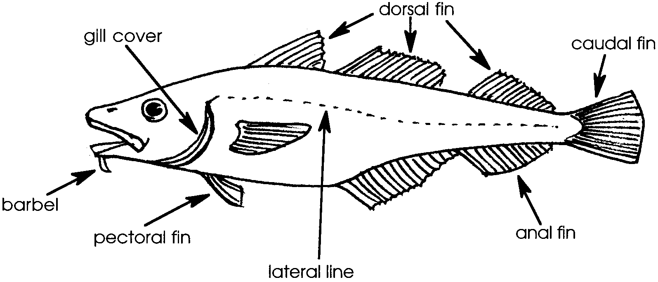

Study the parts of a fish in the drawing above. Cut out each of the following fish along the oval, black line. Then pick one of the fish to identify.

Start by reading 1a and 1b in the key below. Is the fish pictured with one eye? If so, that is because the fish’s body is round like a salmon and the eyes are on each side of the head. Now go to #2 and repeat the process answering yes or no to 2a and 2b. Is the fish pictured with two eyes? If your answer is yes, that is because the fish’s body is flat and both eyes may be on the same side of the head. If this is true, then go to #9 and answer yes or no to 9a or 9b.

When you find the name of your fish, place it in the proper box of the answer sheet. Continue until all your fish are identified. When you are certain about the name of your fish, trim each picture. Then glue it in place so you can read its name.

A Key to Bottomfish

l. a) Fish has one eye in the picture, body is round Go to 2

b) Fish has two eyes in the picture, body is flat Go to 9

2. a) It has 3 separate dorsal fins Go to 3

b) It has less than 3 dorsal fins Go to 4

3. a) It has a barbel(s) (whisker) on its chin Pacific Cod

b) It has no barbel on chin Alaska Pollock

4. a) It has 2 dorsal fins Go to 5

b) It has less than 2 dorsal fins Go to 6

5. a) The caudal fin (tail) has a notch in it; the top half of the
caudal fin is bigger than the bottom half Spiny Dogfish

b) The caudal fin does not have a notch in it; the top half and
bottom half of the caudal fin are equal in size Great Sculpin

6. a) It has one small dorsal fin in the middle of its back Pacific Herring

b) It has one long dorsal fin that is different on the
front and back Go to 7

7. a) The back part of the dorsal fin rises to a peak Pile Perch

b) It has one long dorsal fin with a “V” dip down in
the middle Go to 8

8. a) The fish has clusters of spots on its side Lingcod

b) It has dark bars of color on its side Painted Greenling

9. a) It is a flat fish with circles on its pectoral fins Big Skate

b) It is a flat fish without circles on its pectoral fins Go to 10

10. a) The fins have dark, wide bands of color Starry Flounder

b) The fins do not have dark bands of color Rock Sole

