Fish Gumbo

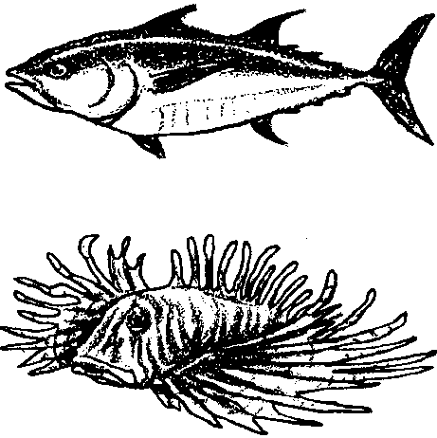
Key Concepts
1. Marine animals such as fish are especially adapted to their environment. Some adaptations include: movement, eating and protection.
2. Form and function are related in living things.

Background

Great diversity is represented in the approximately 20,000 different kinds of fish observed by scientists. From the 50-foot long, ocean-dwelling whale shark to the tiny freshwater gobies that are approximately 1/2 inches long as adults, fish show an amazing variety of adaptations for enduring the many challenges of the water world.

An adaptation is an alteration or adjustment, often hereditary, by which a species or individual improves its condition in relationship to its environment. In other words, adaptations are those structures or behaviors which help plants or animals survive to reproduce. Behavioral adaptations are those specific behaviors that organisms carry out that help them survive; birds building nests, wolves marking their territory are examples of behavioral adaptations. Physical adaptations are body structures or parts that help an organism survive; large eyes, protective coloration, sharp claws are examples of physical adaptations. Fish show an abundance of behavioral and physical adaptations. In the oceans, these adaptations let fish live successfully in a wide variety of habitats from the surface to depths of over six miles!
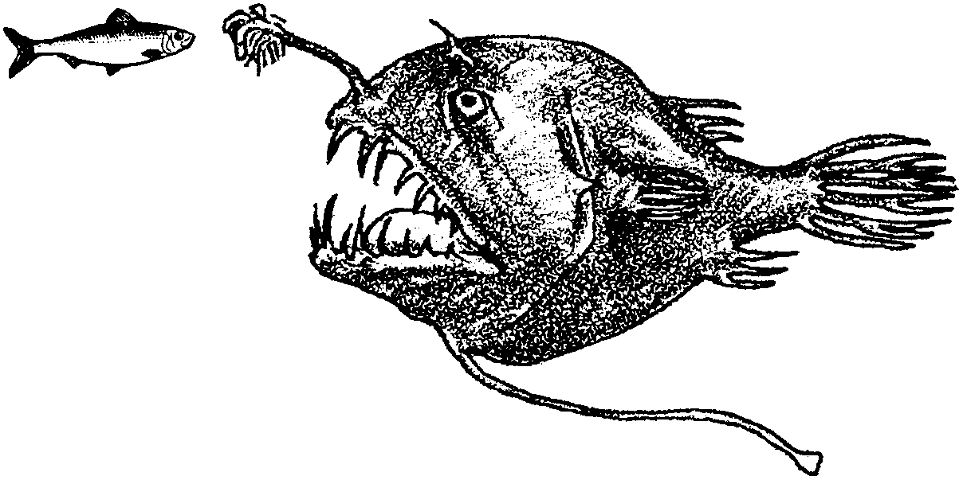

Anglerfish, dwellers of the darkest depths of the ocean, show many examples of behavioral and physical adaptations. On the head of the deep-sea anglerfish is a long, flexible rod with a glowing tip. The anglerfish dangles this glowing lure in front of its mouth. The lure attracts small fish. As they approach the lure, the anglerfish opens its wide mouth. A curious small fish swims closer and closer following the glowing “bait” until the fish disappears into the anglerfish’s toothy mouth. Consider this scene from the standpoint of adaptation. The long, flexible rod, the glowing tip, the wide mouth, and the many teeth are physical adaptations. Dangling the lure, opening the mouth in wait, and snapping the mouth shut on the curious fish are behavioral adaptations. Both type of adaptations are important in assuring the survival of the anglerfish.

Be aware, that the distinctions between behavioral adaptations and physical adaptations are somewhat arbitrary and that these categories and distinctions are made for our convenience - what we call them doesn’t make a bit of difference to the anglerfish! In fact, even though the deep-sea anglerfish depends on the lighted, physical lure to attract its prey, the anglerfish does not make the light itself. The lure is home to a colony of light producing bacteria which find protection and shelter in trade for their light. Is the glowing tip, then, a behavioral adaptation rather than a physical adaptation? Or is it some of each? The point here is that while it is helpful to our understanding to think about adaptations as physical and behavioral, sometimes the distinctions between the two types blur.

Materials

For each student or pair of students:

• “Fish Gumbo” activity pages

Teaching Hints

“Fish Gumbo” begins a unit of activities about finfish. The lessons require some advance planning. Please read through the text and activities before beginning the section on fish. You will need to find a source where you can buy whole fish. Local fish markets are a good place to begin. For these activities, the fish can be fresh or frozen. The “Teacher Background” section for each activity contains specific information which will be helpful to you in preparing to do the activity. The material in this section can be used to stimulate discussions on topics ranging from experiences with fish to conservation of marine resources. Encourage these conversations among your students and lead them towards developing an appreciation of how marine organisms adapt to life in the sea.

The activity “Fish Gumbo” introduces the topic of finfish by focusing on how certain fish eat, move, and protect themselves. It is designed to provide opportunities for assessing your students’ existing knowledge of the topic, to get your students thinking and wondering about how fish survive, and to help your class prepare for the activities that follow in this unit.

Duplicate the text pages and activity pages as needed for your students. Introduce the concept of fish adaptation by asking students to brainstorm and list what they already know. Have them tell you how they would need to change if they were going to live under water. How would they eat, move, keep from being eaten?

Key Words

adaptation - an alteration or adjustment, often hereditary, by which a species or individual improves its condition in relationship to its environment; special changes or modifications which enhance survival

adapted - changed in order to survive in a particular habitat

blood vessels - tubes in the body to carry blood

environment - surroundings, habitat

lure - something that attracts attention, like bait to a fish

mucus - a slimy mixture of compounds serving to protect and lubricate surfaces

scales - hard plates that cover a body

streamline - smooth bodied, shape offers little resistance to air or water, good shape for gliding

Extensions

1. Provide modeling clay or play dough for students to create fish with special adaptations.

2. Make a sea scene on a bulletin board or to hang from your ceiling. Provide construction paper, and objects for students’ fish creations. Objects might include pipe cleaners, glitter, fabrics of interesting textures, pieces of wood, buttons, sequins, Styrofoam packing pieces, etc. Have students tell about the adaptations of their fish creations.
3. As you complete the activities in this unit on finfish, think about supplementing the lessons with one or more of the following:

• Visit your local seafood market. Make an inventory of the various kinds of seafoods you find there and their sources.

• Visit a seafood processing plant and list the steps involved in processing.

• Have a guest speaker from a fishing vessel talk about and demonstrate the knowledge and skills a fisher must have in order to do his/her job.

• Visit an aquarium and observe live fish. Ask if you can watch fish feeding activities.

Answer Key

1. Answers will vary because the question asks students to recall fish they’ve seen. Places they may have seen fish may include: in the wild, in grocery stores, pet shops, aquaria, on television, in the movies, etc.. Use this information as a way of showing the class they already have some knowledge about fish. Share with them that the activities to follow will increase their knowledge and help them answer some of the questions they may have about fish.

2. The specific adaptations your students choose will vary. A behavioral adaptation of the pufferfish is filling itself with water. Structural adaptations include the spines, the flexible skin, and the beak-like mouth.

Use this discussion to help students realize that a lot of information can be learned about how animals and plants do things (function) through observation of how the organism is built (structure).

3. Again, as in question 1, answers will vary because the question asks students to recall fish they’ve seen. Use this information as a way of showing the class they already have some knowledge about fish.

4. The specific adaptations your students choose will vary. The fishing pole and lighted lure are structural adaptations of the anglerfish. Opening its mouth is a behavioral adaptation.

5. Anglerfish use light as a lure to attract other fish which they eat. This question should help students to begin to think about the use of light in the dark, deep ocean environments.

6. Your students are asked to think about ways in which deep ocean fish find each other. Deep ocean fish use a variety of methods for finding each other including light spots in specific patterns, chemicals, sounds, and specific swimming behaviors. It is important that the fish do find each other in order to reproduce, assuring the continuation of the species.

7. The specific adaptations your students choose will vary. The streamlined body and sickle-shaped tail are structural adaptations which can be observed in the drawing.

8. The mucus, or slime, layer on a fish serves several functions including acting as a lubricant to reduce friction and turbulence while swimming. It also acts as a protective covering or boundary layer to reduce risk of infection.

9. The students’ fish drawings are a way to check their understanding of the concept “Adaptation”. Alternatively, have children use modeling materials to create fish. The student should be able to create a fish that can eat effectively, move efficiently and protect itself in a marine environment. If movement is limited, the fish should have an adaptation that protects it since it will not be able to swim away quickly. For example, Rock fish hide in rocky crevices. They raise the spines on their backs to keep themselves from being pulled out of the crevice. This also makes their body larger and spiky; a good protective device.

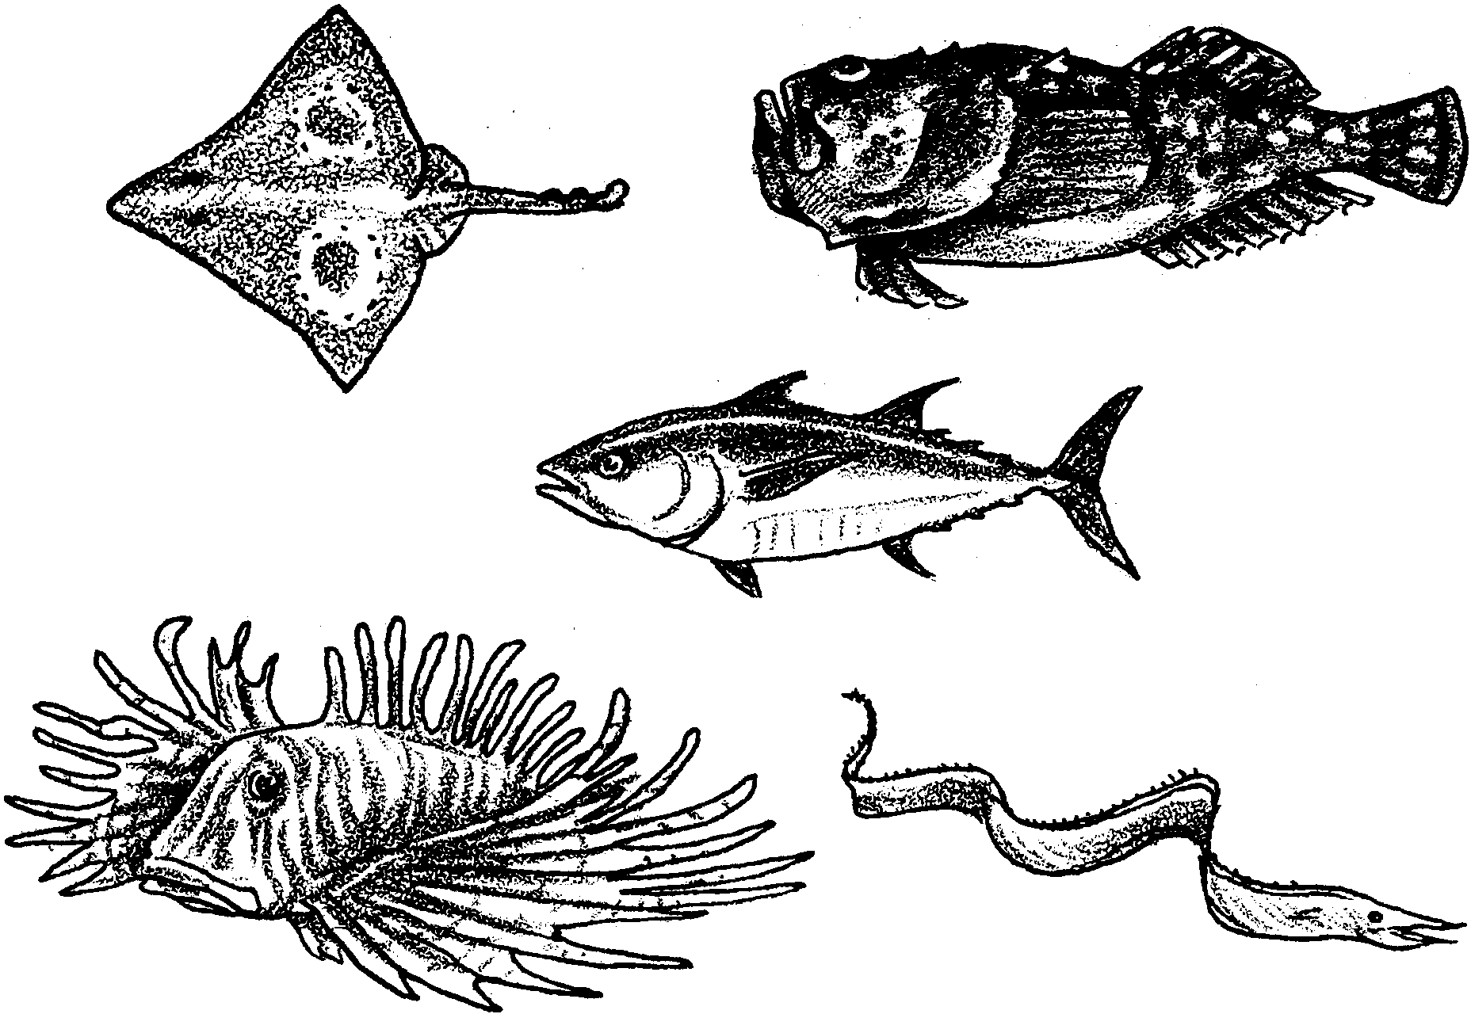
Fish Gumbo

From sharks to goldfish, fish are amazing animals. There are some 20,000 different kinds of fish. The largest is the whale shark. It may weigh several tons and be over 50 feet long. The smallest is the goby. The goby lives in lakes in the Philippines. Full-grown gobies are about 1/2 inch long. Every kind of fish faces many challenges in its water world. They have to find food. They have to move. They have to protect themselves. Fishes meet these challenges in lots of different ways.

1. Think about fish you’ve seen. Describe some ways they eat and move.

Adaptations

The special ways fish eat and move help them to survive. Fish have special body parts to help them eat, move, and protect themselves. These special body parts help them to survive, too. A special body part or way to act may be called an adaptation. An adaptation helps a plant or animal survive to reproduce.
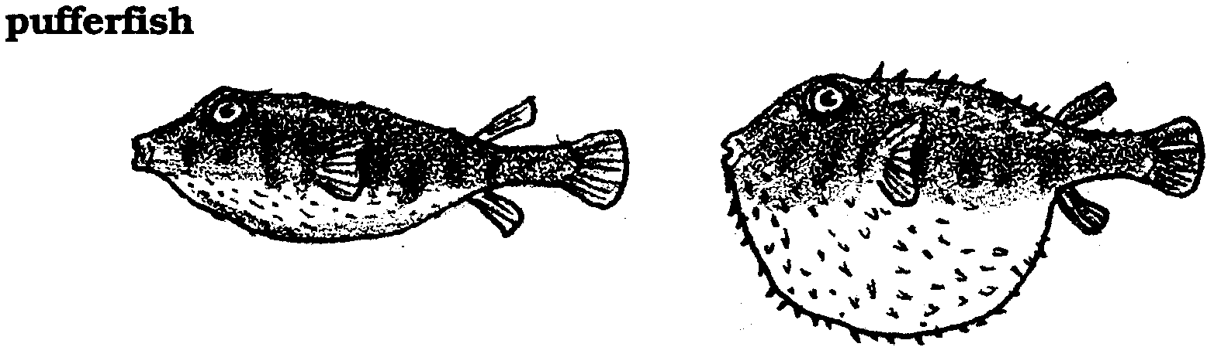
2. Look at the picture of the pufferfish. What do you see that might be an adaptation which helps the pufferfish survive?

Protection

The pufferfish is a small fish and a slow swimmer. It seems as though it would be an easy meal for bigger fish. However, when a pufferfish senses the presence of a big fish, it does not swim away. Instead, it swallows water. It swells until it is the size of a soccer ball. Often, the sudden change causes the big fish to lose interest and swim away. The spiny pufferfish has spines all over its body. When it puffs up, the spines stick out. Not many other animals are interested in eating a spiny soccer ball. Pufferfish have beak-like mouths. They use their hard beaks to eat clams, crabs, and sea urchins.

3. The pufferfish changes shape to protect itself. Think, again, about fish you’ve seen. How do they protect themselves?
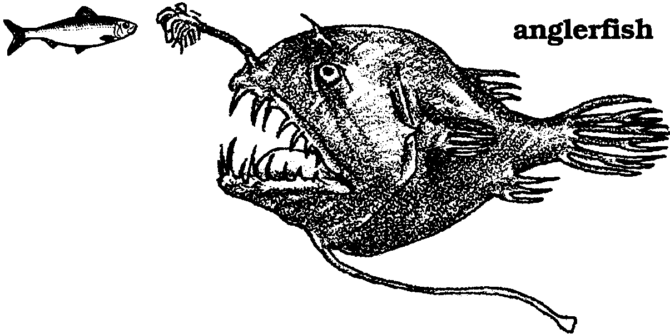

4. Look at the picture of the anglerfish. What do you see that might be an adaptation which helps the anglerfish survive?

Eating

Fish are found at all depths in the ocean. Fish have been seen swimming 35,800 feet below the surface. That is almost seven miles underwater! At these depths there is no sunlight. The amazing anglerfish are found in this darkness. There, the females skillfully capture their food. The males never have to find food. You will see why.

A female anglerfish does her own fishing. A long fleshy rod grows out of the top of her head. The rod looks like a fishing pole. At the tip of the rod, is a lure that produces light. This glowing “bait” dangles in front of her mouth. Hungry or curious fish see the glowing bait. They swim toward the bait. In the darkness, the anglerfish opens her wide mouth. The curious fish swims closer, lured by the bait. The anglerfish snaps her mouth shut. Good-bye curious fish. Hello, dinner.

5. How does the anglerfish use light to help it capture food?

Female anglerfish may grow to be three feet long. But the tiny male anglerfish are only two or three inches long. Males never “fish.” Almost as soon as he is born, a male anglerfish searches for a female. When he finds one, he uses his jaws to fasten onto her side. Soon he is permanently attached. He gets his food through the female’s blood vessels.

6. The deep ocean is very dark. It is hard for fish to find each other. Imagine yourself as a deep ocean fish. What kinds of things could you do to find other fish of your kind?

Moving

Movement in water is different than movement on land. Land animals usually move along the surface of the earth. Fish move more like birds. They can move up and down. They can move toward the surface. They can move away from the surface. They can move along the surface. This is pretty neat for a fish. The fish can escape from enemies by going up or down, left or right and backwards or forwards. However, it is more difficult to move through water than through air.

Try this the next time you are at the beach. Look for a piece of board or other flat object. Lay the board with a flat side facing up. Can you push the board straight down into the water? Turn the board so that an edge is facing up. Now try pushing the board straight down into the water. Which way was easier?
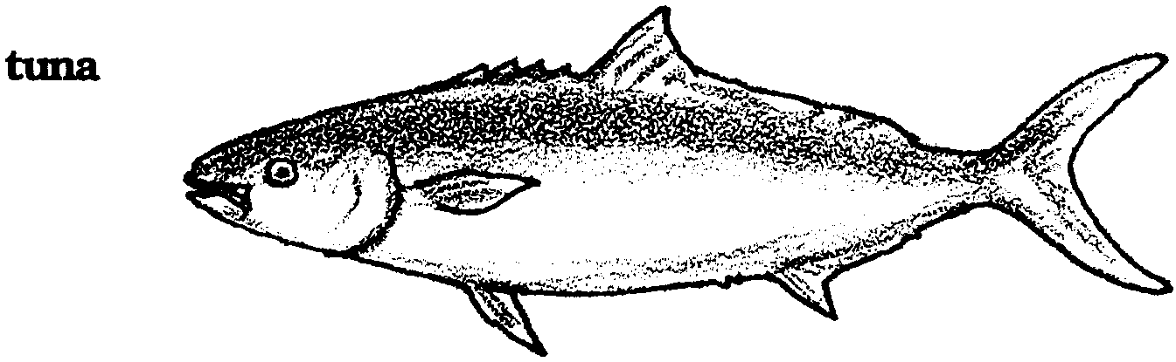
7. Look at the picture of the tuna. What do you see that might be an adaptation which helps the tuna survive?

Shaped for Speed

Fish have developed shapes that help them move through the water. Most fish are streamlined. This means their bodies can move through water smoothly. The fish’s pointed head parts the water. The water flows smoothly along the sides to the wider tail. Fish use their tail to move them about. The tail is moved from side to side to push the fish forward. The other fins are used mostly to keep the fish from rolling over as it moves forward. Tunas, billfish, and some sharks are the speed champions. These fish can reach speeds of 50 miles an hour for a short period of time.

8. Many fish are covered with scales. The scales help protect the body. The scales have a thin layer of mucus on them. The mucus gives fish their “slimy”, slippery feel. How might the mucus help in swimming?

Each of the 20,000 kinds of fish has special ways in which they eat, move, and protect themselves. Remember, these special ways are called adaptations. An adaptation is something an animal or plant has or does that helps it to survive in its habitat. Look for some of these special adaptations in the activities which follow.

9. Design a fish. Draw a picture of it. Show where it lives. Show how it moves. Show how it eats and how it protects itself.

