Open For Business

Key Concepts

1. Humans make choices based on economic decisions.
2. The oceans and coasts are a source of food for humans.
3. To determine which business is the most profitable, one needs to calculate the net profit of each and choose the business with the largest net profit.

Background

The market place influences resource decisions in the marine realm. Aquaculturists are interested in making a return on their investment. This interest influences the choices they make. Additional background information for “Open for Business” is found in the activity “Sea Farming”.

Materials

For each student:

• “Open for Business” activity pages

Teaching Hints

In the activity “Open for Business”, students make some simple economic comparisons as they analyze and compare income and expenses of two hypothetical seafood businesses. Then they choose to own the more profitable one. This exercise reinforces math skills concerning greater and lesser numbers, money, and provides some practice with practical word problems. It effectively follows the “Fish Farmer” game.

As always, the choice is up to you regarding how to handle the activity. You may wish to have students work independently or in small groups. Each student or group will need a copy of the “Open for Business” activity pages. Duplicate the needed materials prior to class use. It is better to duplicate this exercise on two sheets, rather than two sides of one sheet. This will enable students to see the business data without having to turn the paper over for each question.
As with any word problem in math, students will need to read carefully to understand what is being asked, then find the information in the data, and determine how to arrive at the answer. Word problems challenge reading, thinking and math skills.

Key Words

business - a company that sells a product or service

clam bed - a place where clams live

clam spat - the spawn of clams, young clams to be grown

economic decisions - choices based on having enough supply to meet the demand

expenses - costs

income - money earned from sales or labor

investment - money, time or resources spent to make a gain

net profit - the amount earned after deductions

salmon farm - raising salmon in a hatchery or in nets

Answer Key

1. The total income of the SeaSalmon Farms, Inc. for one year is $3,000 (i.e., 1,500 lbs/year x $2.00/lb. = $3,000/year).

2. The total income of the Waterbed Clam Co. for one year is $2,400 (i.e., 800 lbs/year x $3.00/lb. = $2,400/year).

3. From the total incomes, SeaSalmon Farms, Inc. looks like the best investment.

4. The total expenses for SeaSalmon Farms, Inc. for one year are $1,550 (i.e., $250 + $1,000 + $300 = $1,550).

5. The total expenses for Waterbed Clam Co. for one year are $875 (i.e., $75+ $200 + $600 = $875).

6. SeaSalmon Farms has the greatest expenses for one year.
7. The net profit for SeaSalmon Farms, Inc. for one year is $1,450 (i.e., $3,000 total income - $1,550 total expenses = $1,450 net income).

8. The net profit for Waterbed Clam Co. for one year is $1,525 (i.e., $2,400 total income - $875 total expenses = $1,525 net profit).

9. Waterbed Clam Co. has the largest net profit.

10. The best investment is the Waterbed Clam Co.

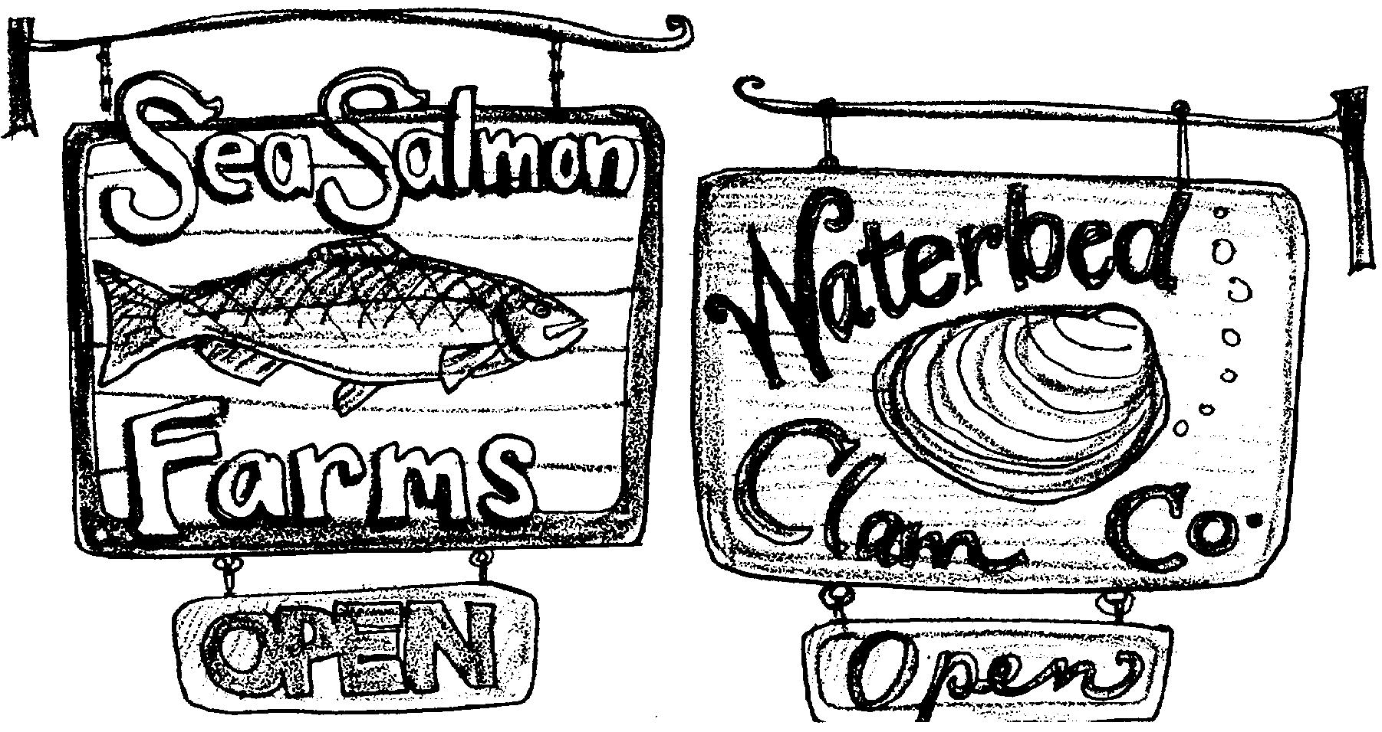
Open For Business

Lucky you! You have just won one thousand ($1,000) dollars in the Skipper’s “Name That Fish Dish” contest. Since you are now a rich person, all of your friends want to help you spend your money. You have decided to start a business. There are two choices which sound good to you. One is a salmon farm. The other is an clam bed. Use the information below to pick which business to buy.

SeaSalmon Farms, Inc.

Income:

Pounds of salmon sold per year 1,500 pounds
Price per pound $ 2.00

Expenses:

5,000 salmon eggs $250.00
Fish food $1,000.00
Packing and delivery $300.00

Waterbed Clam Co.

Income:

Pounds of clam meat sold a year 800 pounds
Price per pound $3.00
Expenses:

Clam spat (baby clams) $75.00
Harvesting equipment $200.00
Packing and delivery $600.00

PLEASE SHOW YOUR WORK

l. What is the total income of the SeaSalmon Farms, Inc. for one year? (Hint: Multiply the number of pounds times the price per pound.)

2. What is the total income of the Waterbed Clam Co. for one year?

3. From the total incomes, which business looks like the best investment?

4. What are the total expenses for SeaSalmon Farms, Inc. for one year? (Hint: Add each expense item to find the total.)

5. What are the total expenses for Waterbed Clam Co. for one year?

6. Which business has the greatest expenses for a year of operation?

As president, your salary will be the NET PROFIT from the operation of your business. Net profit is the total income minus the total expenses.

7. What is the net profit for SeaSalmon Farms, Inc. for one year?

8. What is the net profit for Waterbed Clam Co. for one year?

9. Which business has the largest net profit?

10. Which business is the best investment?

GOOD LUCK AND DON’T FORGET TO HAVE A GRAND OPENING SALE!

