Seafood Festival

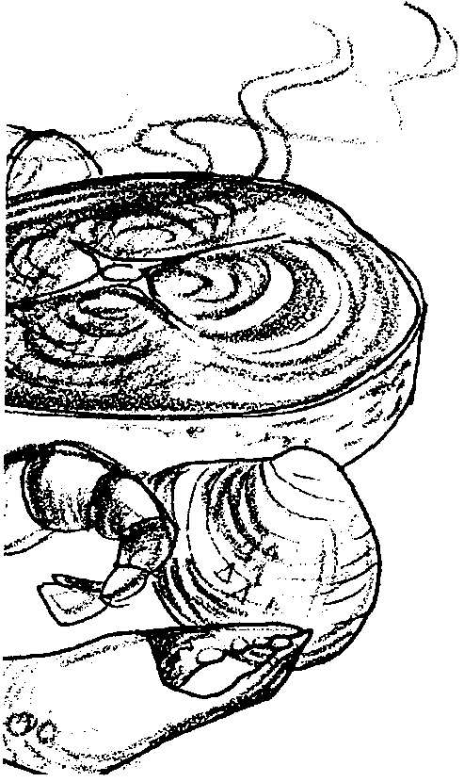
Key Concepts

1. The oceans and coasts are a source of food for humans. These seafoods fall into two main categories: shellfish and finfish.
2. Seafood can play an important dietary role for humans.
3. To write a seafood recipe book, one needs to follow certain steps that include: collecting the material, organizing the material, writing rough and final drafts, illustrating the recipe and learning ways to attract people to the recipe.

Background

For all of our history, seafood has played an important dietary role. There are a number of nutritional qualities about seafood that make it a good alternative to other meats. Many nutritionists feel that Americans eat too much meat. They say we should eat more fish, cereals and grains as sources of protein that are healthier than beef, pork, and poultry. Unlike most cereals and grains, seafood is a complete protein. An average serving of most seafoods furnishes more than enough complete protein to meet the daily needs of the body.

Seafood may be classified into two main categories: shellfish (mollusks and crustaceans) and finfish (swimming fish like salmon). Seafoods contain a generous amount of such nutrients as calcium, iron, potassium, phosphorus, copper, iodine, magnesium, cobalt and other minerals. Fish products provide adequate amounts of the B family of vitamins and are also a good source of vitamins A and D. The fat content of seafood is very low when it is cooked by means other than frying. A 3 1/3 oz. serving of finfish has 101 calories; crab 81; shrimp 158; pork chops 198; and beef 303. The small amount of fat in seafood is unsaturated, low in cholesterol, easily digested and is easily used by the body tissues.

Materials

For the class:

• pictures of seafood dishes and the sea animals

• advertisements of seafood products, dishes, restaurants

• menus from restaurants that sell seafood

• cookbooks

• field guides to shellfish and finfish

• books and articles about food fish

• seafood cookware and utensils

• seafood harvesting equipment (fishing pole, net, shovel)

For each student or pair of students:

• “Healthy Heart Food” activity page

• “Recipe and Fish Tale” forms: rough draft and final draft

Teaching Hints

In “Seafood Festival” your students evaluate the nutritional benefits of eating foods from the sea. They create and publish a class cookbook of seafood dishes with recipes and fish tales they collect from family or community members. Collecting recipes and tales and creating a book increases skills in listening, research, home economics, oral history, writing directions, illustration, categorizing, proofreading, and publishing.

The published cookbook with each child’s contribution makes a family treasure and is a good public relations project for your class. You might consider selling additional copies as a fund raiser for a field trip or to obtain science equipment.

You can further celebrate resources from the sea by holding a Seafood Festival with decorations and dishes prepared at home or in class. Remember, the best way for your children to appreciate seafood is by tasting.

Preparation

Gather materials and display them on bulletin boards and counters or tables in your classroom. Make the room look and feel like a seafood restaurant or store. Have students help design the displays as much as possible. You might wear an apron and carry a cookbook or utensil while you introduce this activity.

Consider the best way to complete this activity with your class. You might choose to introduce the concept and skills, then allow students a week in which to collect a recipe and tale for the book. They could write and illustrate a rough draft when they research the information. The next week you might have them proofread one day, and peer edit the following. Next, students would hand in the rough draft to you. You would suggest revisions and return the papers and assign the final draft (neat, correct writing and illustration) as homework or as an in-class assignment. As part of the final writing, students might need to check with the person who provided the information or research references for clarification and accuracy.

When all the writing was ready, you could assign an editorial team to determine the order in which to place the pages. This team can write the table of contents and design the cover pages. The class should determine the title for this cookbook. You will need to supervise the work or ask a parent volunteer to do this. The final copy can be made directly from students’ handwritten pages or on a computer word processor. You might make one book for the classroom and an individual copy for each author.

This activity can be done simultaneously with other activities in this unit and completed as a celebration/closure for aquaculture themes.

Consider having a “Seafood Festival” as part of your celebration. Students can decorate the room and prepare dishes for the party.

Procedure

1. Introduce the activity with a “Quick Write”. Begin by brainstorming and briefly sharing ideas about seafood:

• what kinds of seafoods do people eat?

• favorite dishes kids have eaten

• how is seafood prepared? (baked, steamed, fried, smoked, raw, flavorings and sauces)

• is it cooked indoors or outdoors?

• how is it served? (fancy plate, fingers, outdoors)

• special memories or occasions (the first fish I caught, my dad likes raw oysters, in Germany Oyster Stew is eaten on Christmas Eve, “First Salmon Ceremony” for Native Americans)

After brainstorming have students do a 10 minute silent writing about the topic “seafood”. Students can write in any form they wish about anything they know about seafood or describing a special memory they have of the topic. If they have little experience with saltwater seafood but more with freshwater sources, let them write about that. Then have them share their writing in small groups.
2. After the sharing tell them that the best stories and books are written from the author’s own experiences. Tell them that your class is going to put together a “cookbook” of recipes and fish tales from their own experiences and those of people they know. Each student will be the author of one entry in the book.

Have students brainstorm tasks they will need to do in order to complete this project. Write their ideas on the board. Have the class sequence the ideas according to what they will have to do first, next, last. Write the list of things to do on a wall chart (butcher paper) and check them off as they are completed.

3. In small groups have students examine cookbooks to find out what a recipe looks like, how the directions are written, what invites the reader to want to try it.

4. Practice writing a recipe together. Write directions on the board as students tell you about the ingredients and procedures for making a tuna sandwich. Proofread and revise it together. Discuss how to put it on a page to make it look interesting to the reader.

5. Ask students to tell you an interesting tale (story) about an experience with tuna sandwiches, or about the tuna fish. It might be a suggestion for how to serve the dish, a recollection about making up a new tuna sandwich recipe with a favorite friend or family member, etc. The tale will be a note to the reader that will appear as an aside.

6. Have a student interview you. The student should explain why you are being interviewed and how the information will be used (to write a cookbook). The interviewer should ask how you would prepare a favorite recipe for a seafood dish. Then she should ask for a story about: the animal in the recipe, harvesting that animal, or a special memory this dish brings to you. After your interview have students practice interviewing a partner.

7. Assign the “Healthy Heart Food” page so students know why seafood is good to eat. After completion, allow time to discuss key words and concepts.

8. Give students a form for the rough draft of their recipe and tale. The form should include a space for:

• student’s name

• name of the recipe

• name of the person interviewed for the recipe

• recipe category: finfish or shellfish

• box is for an illustration about the recipe or tale

• list of ingredients, including quantities

• directions for preparing the dish, including cooking temperature and time

• a fish tale about the animal in the recipe, harvesting that animal, or a special memory the dish.

Tell them to interview a family member or friend as you modeled for them. Remind them to tell the person why they are being interviewed and how the information will be used. Give them a due date for their rough draft. It might be a good idea to send a note home to inform parents about this activity.

9. Have students proofread, peer edit, and revise their rough draft.

10. Have students write and illustrate their final copy. The final copy should have the same elements found on the rough draft form. Compile copies into a cookbook. Write the table of contents. Make a book cover and bind the book. Students could make individual book covers or you can make one to copy for the whole class.

11. Have fun preparing dishes and eating healthy seafood!

Key Words

calories - a unit of energy supplied by the food we eat

cholesterol - a white crystal-like substance found in animal fat

dietary - referring to food or nutrition

finfish - fish that have fins

peer edit - to have a classmate or peer check your writing

protein - a needed compound found in the cells of plants and animals

recipe - instructions for preparing something, especially food

seafood - plants and animals from the sea that are eaten

shellfish - animals with shells, not fins or scales

Extensions

1. For enrichment students might prepare one or more of the seafood recipes in their cookbook.

2. Design advertisements and menus for seafood products and restaurants.

3. Design serving dishes and cooking accessories with seafood themes. For example, make a plate or hot mitt shaped like a fish or decorate napkins or an apron with shellfish. Try fish printing on an apron with fabric paint, instructions are in this guide in the activity “Gyotaku - Japanese Fish Printing”.

4. Consider writing other types of books about marine life.

Answer Key

1. Three and one half ounce, or 100 gram, servings are being compared.

2. a. Raw trawlfish has the least cholesterol per 100 gram serving. Note: the foods are compared raw because of the variation in substances added in cooking (oil, sauces, spices, etc.).

b. Raw salmon has the second lowest cholesterol content.

c. Low cholesterol diets are probably high in fish. (The correct answer is underlined).

3. a. Cheddar cheese has the most protein per 100 gram serving.

b. Cheddar cheese also has the most fat per 100 gram serving.

c. If one wanted a lot of protein with little fat the foods chosen from the list might include shrimp (note cholesterol), chicken breast, trawlfish, and salmon.

4. a. One hundred grams of cheddar cheese would make the highest calorie snack.

b. Raw trawlfish has the fewest calories.

5. Answers will vary but, in general, nutritionists might think its healthy to eat lots of fish because of its low cholesterol content, high protein content, low fat content, and low calorie content.

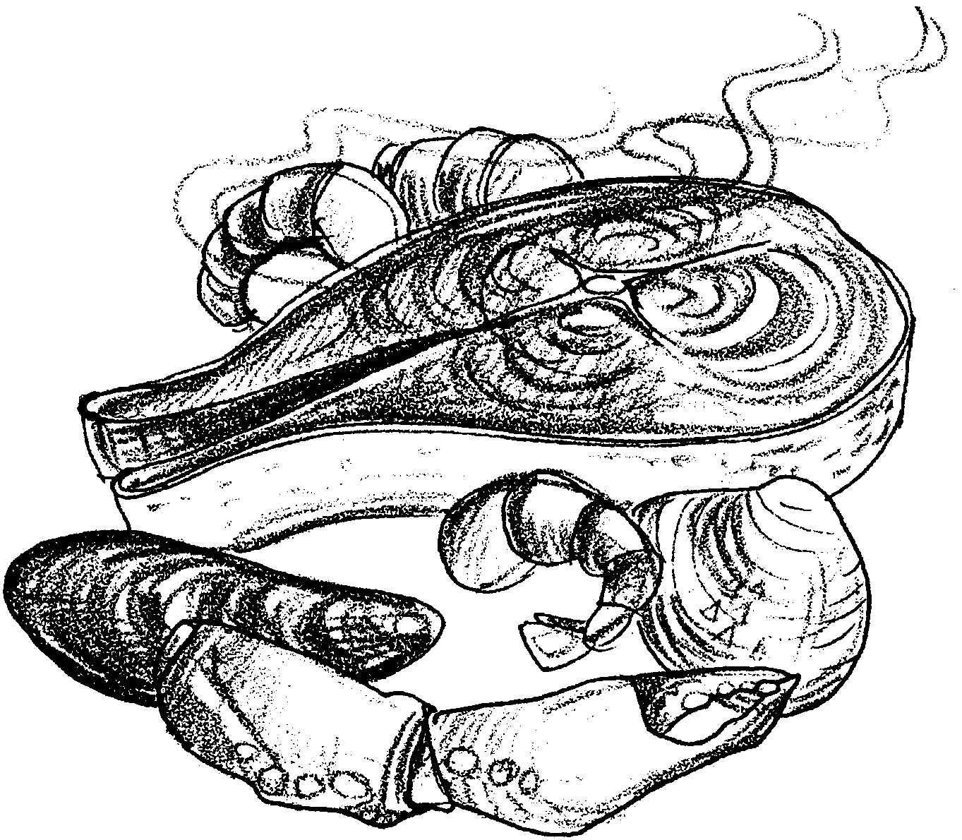
Seafood Festival

Part I - Healthy Heart Food

“Every forkful of fish and shrimp is loaded with nutrition”. People marketing seafood use lines like this in their advertising. The chart below compares fish to other foods. Just how healthy is it to get hooked on fish? The chart below will give you some facts. “g” means grams. “kcal” means kilocalories. “mg” means milligrams.

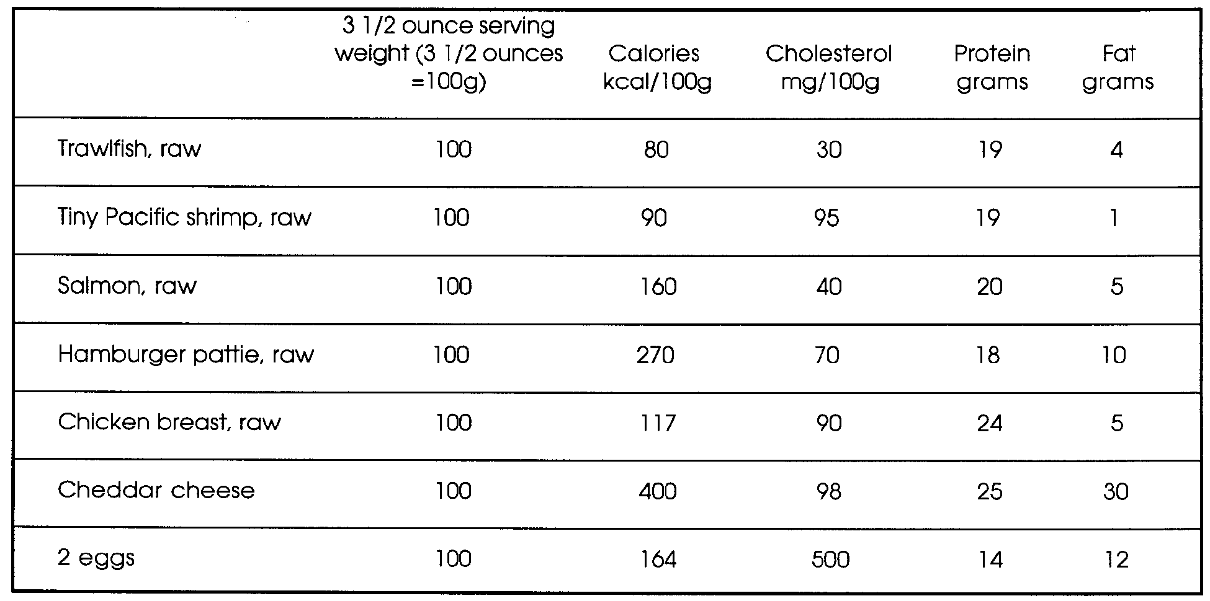

Use the chart to answer the following questions:

1. What is the size of the serving that is being compared? (Hint: Notice the title of the first category at the top of the chart.)

2. Cholesterol is a fat found in many foods. People are concerned about the danger of heart attacks. Because of this many people often eat low cholesterol diets.

a. Which food has the least cholesterol per serving?

b. Which food has the second lowest cholesterol content?

c. Low cholesterol diets are probably high in fish / eggs. (Circle the underlined word that is correct)

3. Protein is needed to build and maintain our bodies. Consider the protein in the foods listed in the chart. Answer the following:

a. Which food has the most protein?

b. Which food has the most fat?

c. Many people watch the amount of fats they eat. Which three foods give you high protein and low fat?

A.

B

C.
4. a. Jogger Jerry burns up many calories each day. Which food listed makes the highest calorie snack?

b. Slender Sam always worries about his weight. Which food listed has the fewest calories?

5. Some doctors recommend eating seafoods seven times a week. Why might they think it is healthy to eat so much fish?

Part II - A Seafood Cook book

In the next activity you will create your own seafood cook book. Your teacher will help you. The book will be full of tails and tales. Have fun and eat well!

ROUGH DRAFT
Student’s Name

Recipe from the person you interviewed:

Their Name

Recipe Category: Finfish or Shellfish (Please circle one)

Name of dish

Drawing of dish:

Ingredients: (List of things you need and how much of each)

To Prepare Recipe: (include directions for preparing the dish and cooking temperatures, if needed)

A Fish Tale About Your Recipe Animal:

FINAL DRAFT
Name of dish:
Category: Finfish or Shellfish

Recipe from
Student's Name
Ingredients:

(Ingredients continued.)

To Prepare Recipe:

A Fish Tale:

