Food Web

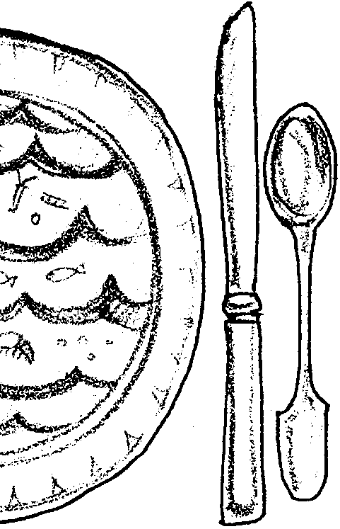
Key Concepts
1. A food web of marine organisms is a model depicting the inter-relationship of marine organisms, nutrients and energy.
2. Damage to a specific organism or group of organisms can have a major or minor effect on the food web. However, damage to the phytoplankton will certainly have a major effect on the entire food web.
3. Humans are part of the food web.

Background

A food chain is a linear relationship that shows who eats whom or, more importantly, how energy is transferred in the food system. Phytoplankton serve as the basis for most ocean food chains. Most life in the ocean depends directly or indirectly upon the phytoplankton’s ability to harness energy from sunlight. The energy passes to the animals that consume the phytoplankton and then to the animals that feed on these consumers.

As an interesting aside, it has been estimated that about two thirds of the oxygen produced by plants is produced by phytoplankton. As such, we can say that life on land is also dependent upon the work of the phytoplankton!

A food web is a complex weaving of food chains. It shows the variety of organisms one animal might consume and the complex cycles through which nutrients are transferred from one organism to another through consumption. Many organisms receive nourishment by eating several kinds of prey. All eventually decay, returning nutrients to the water for use by the phytoplankton and detritus eating organisms.

Materials

For each student or small group of students:

• “Food from the Sea”, “The Food Chain”, “Links in the Food Web”, and “The Pyramid of Numbers” activity sheets

• glue

• scissors

• crayons or markers

• additional paper cut in strips 3 cm wide (see “Links in the Food Web” sheet as an example)

Teaching Hints

In “Food Web”, your students read background information and then physically construct a food chain model. They add pieces to the chain to create a food web. With this hands-on activity, students experience the interdependence of links in the chain and understand the interrelationship of elements that are connected to each other, although they are not directly dependent upon each other. Ultimately students should arrive at the conclusion that plants and animals are connected, through the transfer of food energy, as links in a chain and cross-connected like a web.

Your students will have the opportunity to observe the food chain in action as they grow brine shrimp to feed the clams in their “World in a Jar”. “Food Web”, is designed to clarify their observations and to stress the idea that people get a valuable resource (i.e., food) from the sea. In subsequent activities, students will investigate various shellfish, finfish, and marine mammals that are part of the ocean food web. Background information they learn in “Food Web” will be useful in those activities.

Preparation

Please read the activity beforehand and understand the answers to the questions. A more complete discussion of food webs and food chains may be found in most introductory biology and ecology texts. Detailed life history information for Pacific Herring and Bay Shrimp, two members of the food chain discussed, is provided at the end of this teacher background section.

Duplicate the “Food from the Sea”, “The Food Chain”, “Links in the Food Web”, and “The Pyramid of Numbers” activity sheets
.
Procedure

1. Distribute the student worksheet “Food From the Sea”. Allow time for completion and discussion of student responses.
2. Distribute “Links in the Food Web” sheet. Discuss the materials for constructing the web, then place them out for easy access. Have students follow instructions in “Part II - The Food Chain” to construct the food chain and web.

Help students identify the energy (trophic) level of the marine organisms (i.e., producer, first order consumer, etc.) and discuss the importance of sunlight and nutrients in the web. Talk about the role of humans in an ocean food chain and the idea that our decisions and actions can impact the food web. After all, we humans are part of the food web and consume food from the sea.

3. Once each student has finished making his/her food web, form small groups and have students combine their webs.

4. Distribute “A Pyramid of Numbers” sheet and have students work independently or in small groups to complete the reading and questions.

5. Consider concluding the whole activity by having students link their food webs with each other’s. When the whole class has connected all their webs into one, hang the web across the ceiling of your room. Leave it there while you do other activities in this curriculum. You can use this concrete model to redirect students’ attention to the concept of food web. In addition, relate the concept to the animals in “World in a Jar” and other activities that demonstrate the ocean food web. For example, as you teach about clams, halibut, or dolphins, you might add representative strips to the food web. Your classroom ceiling will end up looking like an ocean full of animals connected in a web.

Key Words

consumer - an organism that eats other organisms or food particles to get the energy needed to survive

decompose - decay, rot, disintegrate

decomposer - an organism that obtains nourishment by breaking down dead organic matter

food chain - a line model that shows who eats whom and how the energy is moved through the food system

food pyramid - a diagram or model in the shape of a pyramid showing how energy is moved from one trophic level to another

food web - food chains connected to form a web reflecting the relationships among the producers, consumers, and decomposers of a community

model - an object, usually built to scale, that represents some existing object

nitrogen - an odorless, tasteless and colorless gas that forms about 80% of the air

nutrients - chemicals essential to the health and growth of living organisms

phytoplankton - plant plankton, usually microscopic, which flow with the currents: primary producers of the oceans (one phytoplankton is called a phtyoplankter)

plankton - organisms that drift or have weak swimming abilities and are moved by currents

producer - an organism, such as a green plant or certain algae or bacteria that makes its own food by photosynthesis or chemosynthesis and which is commonly a source of food for other organisms

trophic level - energy level in a food chain or web

zooplankton - animal plankton; weakly swimming animals, usually microscopic, which flow with the currents (one zooplankton is called a zooplankter)

Extensions

1. Do a “Food Chain Lap Sit”. Here’s how. Everyone stands in a circle. All turn right and make the circle tighter as they put hands on the shoulders of the one in front. Be sure toes are against heels of the one in front so the circle is snug. Have each, in turn, name a piece of the food chain. Begin with the sun, then phytoplankton (plant plankton). When you have reached humans add other sea life to the food web and tell what it might eat. When all have named something, give the signal and slowly sit on the knees of the one behind. Everyone will be sitting on knees, while someone sits on their knees. Looks like everything works in this food chain, but watch what happens to the chain when you ask all the plankton (or some other member) to stand out of the circle. Discuss how the parts are interdependent.

2. Make a food web with a ball of yarn or lightweight cord that will not cut into hands as it is gently tugged. Have students sit or stand in a circle. One starts as the sun, holding the ball and the beginning end of the string. The sun passes the ball across the circle but keeps hold of the end of the string. The one who receives the ball names something that gets its energy directly from the sun (e.g., phytoplankton), and holds the string and passes the ball across the circle. The next catcher names what eats phytoplankton for energy, holds a piece of the string and passes the ball across the circle. Play continues until all have a hold on the string and have named a part of the ocean food web connected with something named by the person before them. (A connection may be a plant or animal that eats or that is eaten by the last player.)
When the play ends, have all the seals give a little tug on the string they hold. The tug will be felt by anyone who would be affected if the seals were removed from the food chain. Call out different parts. When you call the sun, everything will be affected. The closer to the sun the more the loss will be felt. Ask kids to solve the problem of rolling the string back into a ball.

3. Create your own food chain games. Use the following guidelines to have small groups of students develop a game based on food chains (or food webs). Games can be active like tag or quieter like board games or those that use manipulatives. After your students have developed their games, have them teach the other students how to play.

a. Establish the objective of the game and write this out (e.g., the person who collects the most points is the winner).

b. A game should have game parts which have a function and rules (e.g., a food chain is represented by three cards together).

c. A player has a role and rules to follow (e.g., a player must roll the dice before her or his turn).

4. Add a predator or prey to your “World in a Jar” to observe the food chain working. A Red Rock crab will eat a clam. What else might a clam eat? If you don’t want your clams to be eaten, start another “World in a Jar” with predators and prey.

Answer Key

Part I - Food From the Sea

1. The correctly completed sentence reads: Phytoplankton in the sea are eaten by zooplankton, which are eaten by shrimp, which are eaten by herring, which are eaten by salmon.

2. Phytoplankton get the nutrients from the seawater in which they live. They get the energy they need from the sun.

3. a. If Fisher A caught a shrimp for dinner, he would be a third order consumer. He is eating a second order consumer, the shrimp.

b. If Fisher B caught a herring for dinner, he would be a fourth order consumer. He is eating a third order consumer, the herring.

c. If Fisher C caught a salmon for dinner, she would be a fifth order consumer. She is eating a fourth order consumer, the salmon.

4. Bacteria and other decomposers break down detritus and dead organisms, releasing nutrients necessary for phytoplankton growth. Phytoplankton are a necessary food source at the beginning of food chains.

5. a. Salmon, seals and humans are affected if herring disappear.

b. The top consumers (i.e., humans and seals) can be removed with the least impact.

c. Removal of the phytoplankton will have the greatest impact on the food web because it is the basic food source to support the web. It is the beginning of the food chains and food web.

6. Accept all reasonable answers as long as they are well-supported by previous information. Lead students to understand that phytoplankton support all life in the sea because they, directly or indirectly, are food for all of the animals in the sea. They are at the beginning of almost all food chains and food webs.

Part II - The Food Chain

2. The primary producer makes its food from the sun and nutrients in the water. This question is designed to cause your students to refer back to Part I and recognize that they will need to do so periodically.

4. The first order consumer is the zooplankton. The zooplankton eats the phytoplankton which is the primary producer.

7. If a virus killed all the shrimp in this food chain, the phytoplankton would survive because they could continue to produce their own food. The zooplankton, which feeds on the phytoplankton, would also survive. Herring, which feed on the shrimp, would disappear, as would the salmon, which feed on the herring. If the person fishing only ate salmon, she would also disappear.

9. Nothing would survive if the sun disappeared, because the sun is the original source of energy used by the phytoplankton.

16. a. The number of links in the food webs will vary from student to student.

16. b. Removing one link from a food chain is usually

more destructive/less destructive

than removing one link from a food web. (The correct answer, underlined here, should be circled).

17. a. If the salmon disappear, the plants and any animals that still have a food source in the food web will survive.

b.If the phytoplankton disappear, nothing survives.

Part III - Pyramid of Numbers

1. To get the most of the original sun energy, we should eat phytoplankton.

2. This is an open-ended question. The first problem is to collect a sufficient amount of phytoplankton. Then you might have planktonburgers, plankton-shakes, etc. The idea of changing cultural eating patterns should be discussed.

Parts of “Food From the Sea” are adapted from an activity prepared for Makahiki Kai '77 by the
Sea Grant College Program of the University of Hawaii (publication UNIHI - SEAGRANT - MR-77-01).

PACIFIC HERRING

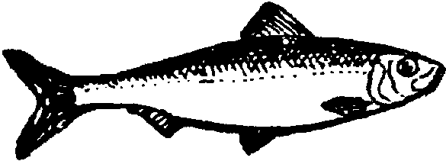

DID YOU KNOW? Over 90% of the Pacific herring caught is for the roe fishery.

SCIENTIFIC NAME: Clupea pallasi

COMMON NAMES: California herring, eastern herring and kara herring.

DESCRIPTION: Pacific herring is a compressed, silvery fish from below and bluish green to olive above; no black spots on sides. Up to 18 inches in length and weigh over one pound.

LIFECYCLE: After reaching maturity at two years of age, Pacific herring spawn annually on vegetation -- eelgrass, algae, grass, and brush -- in the intertidal and subtidal areas. Pacific herring move onshore and offshore in schools to feed. This species moves onshore during winter and early spring, residing in “holding areas” before returning to natal spawning areas.

RANGE: Pacific herring can be found from Baja California to the Beaufort sea to Coronation Gulf to the Chukchi Sea to the Siberian Arctic.

HABITAT AND ECOLOGY: Pacific herring primarily feed on copepods, amphipods, fish larvae and molluscs. One of the most abundant species in the food chain, Pacific herring often serve as food for many other marine species, including salmon, marine mammals and seabirds. Because Pacific herring spawn in protected coastal habitats and estuaries, their eggs are especially susceptible to human actions, such as shoreline development, residential drainage and the filling of marine wetlands. Researchers believe that egg mortality is the major determinant of population size.

ECONOMIC VALUE: Pacific herring has been harvested for sale, fresh or salted, for a number of years, as well as used for fish meal. Taking advantage of the Pacific herring’s near-shore spawning cycle, fishermen have built a multi-million dollar fishing industry. Most U.S. harvests come from Washington, California and Alaska. In addition, Pacific herring is an important bait fish.

BAY SHRIMP
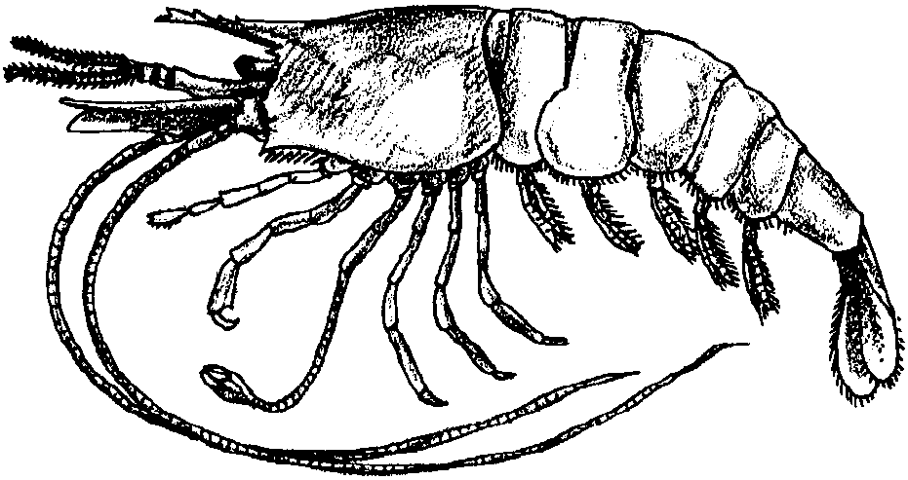

DID YOU KNOW? The bay shrimp is the most common shrimp in most Pacific coast estuaries.

SCIENTIFIC NAME: Crangon franciscorum

COMMON NAMES: Sand shrimp, grass shrimp, common shrimp, black shrimp, California shrimp and black tailed shrimp.

DESCRIPTION: Stout, depressed body with a thin shell and smooth surface. Color tends to be a dark and light yellowish gray with salmon colored eyes.

LIFECYCLE: The bay shrimp is sensitive to temperature and salinity changes during its lifecycle. During reproductive periods, bay shrimp move toward more saline areas of the estuaries to spawn. In their early life stages, juveniles utilize the upper parts of estuaries as nurseries, preferring the lower salinity there. As they grow and mature, bay shrimp move to the more saline areas of the estuary and offshore. Water temperature is especially critical to the bay shrimp as a regulator of life functions.

RANGE: Common in most Pacific coast estuaries from San Francisco to Puget Sound, although the bay shrimp is also found south of San Francisco to San Diego. The bay shrimp is abundant in bays with mud and sandy bottoms and offshore in deeper waters.

ECOLOGY AND HABITAT: As the most dominant shrimp in Pacific coast estuaries, the bay shrimp is an important part of the food chain. The predominant food of many sport and recreational fish, including striped bass, sturgeon, Dungeness crab and Pacific tom cod, the bay shrimp feeds on bottom dwelling animals, amphipods and plant material. In search of food, bay shrimp agitate the bottom and cycle nutrients into coastal systems. It is a short lived species that is sensitive to pollution in estuaries. Because of the bay shrimp’s preference for different levels of salinity during its lifecycle, freshwater inflow into estuaries strongly influences distribution, survival and abundance. Maintaining the flow of freshwater into estuaries is critical because of its impact on water temperature, salinity and landward currents. Because estuaries play a critical role in the bay shrimp’s life history, alteration of this habitat directly affect its populations.

ECONOMIC VALUE: Commercially fished since the 1800's, the bay shrimp is presently commercially fished only in San Francisco Bay with landings ranging from 2 - 25 tons per year. It is fished mainly for bait. Some is used for human consumption, though shelling and marketing bay shrimp is not economically lucrative because of its small size.

Information sheets prepared by the Pacific States Marine Fisheries Commission,
F.I.S.H. Habitat Education Project.

Food Web
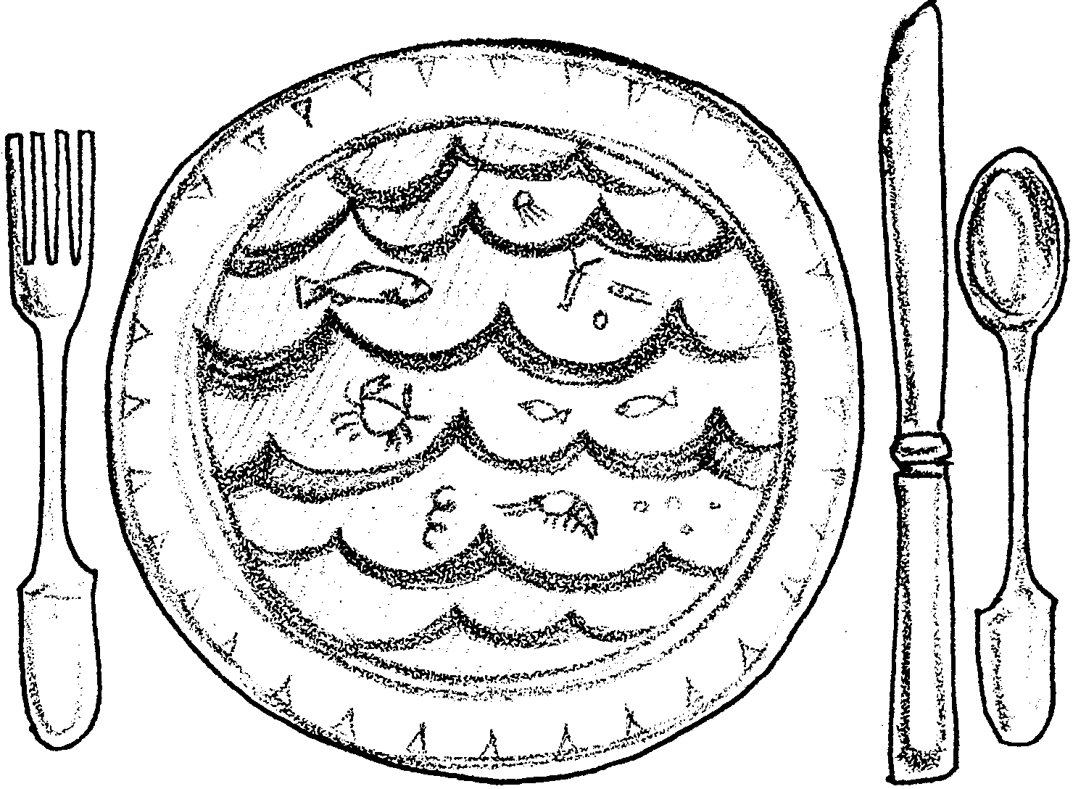

Part I - Food from the Sea

The sea is full of things to eat. There are crabs, clams, oysters, shrimp and many kinds of fish. Not all of the food, however, is food for humans. Let’s take a look at some of the food in the sea.

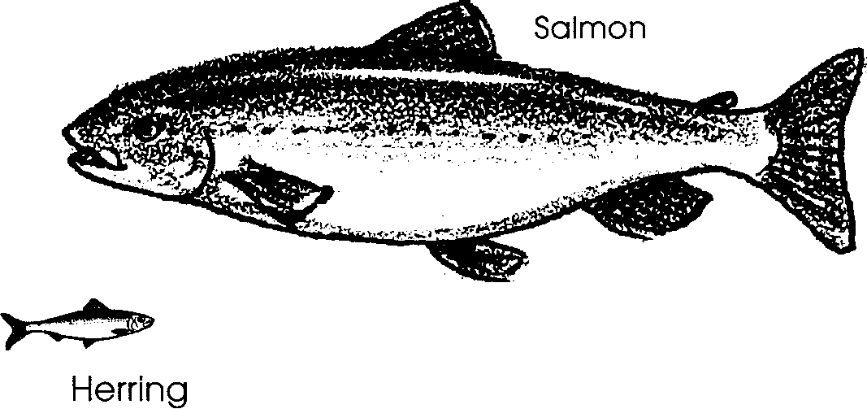
Fishers prize the great SALMON. These fish are hunted near the mouths of rivers. There the salmon gather before traveling upriver to spawn. The salmon are large and well fed. They have swum thousands of miles in the ocean. As they swam, they feasted on smaller marine animals, such as herring.
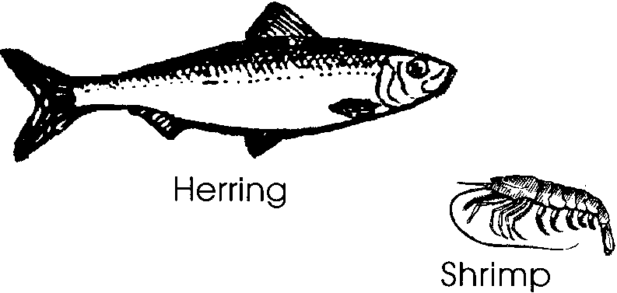
The small, silvery colored HERRING swim together in great schools. As they swim, they search for their favorite food, shrimp. Fishers watch to see the ocean froth and bubble as herring feast on the pink shrimp.
The SHRIMP are much smaller than the herring. They hunt for even smaller prey. Shrimp eat ZOOPLANKTON. Zooplankton are microscopic animals that drift in the ocean.
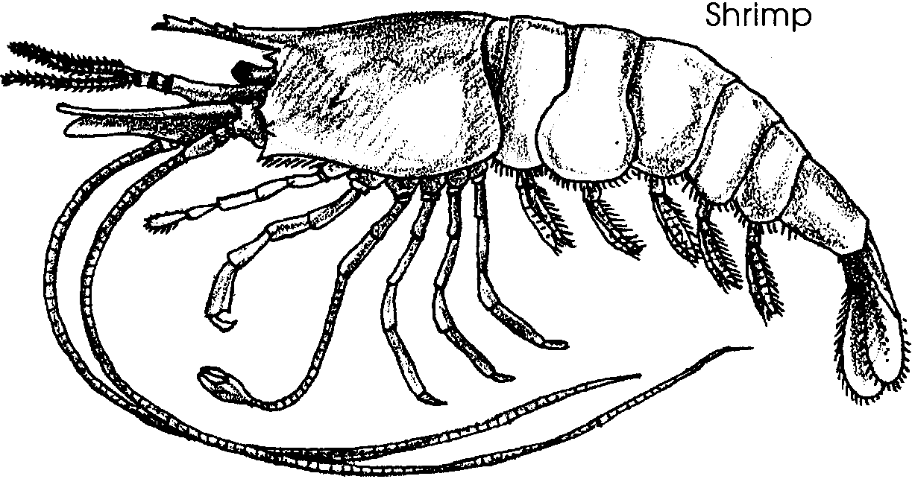
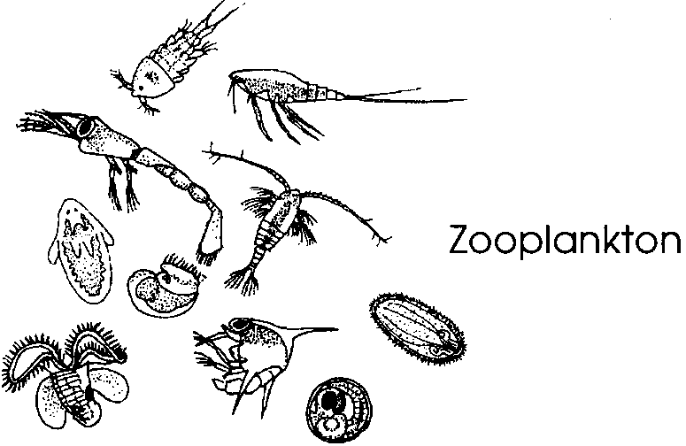

What is in the ocean for zooplankton to eat? The zooplankton collect food that is even smaller than they are. They eat PHYTOPLANKTON. Phytoplankton are microscopic marine plants. They drift in the ocean, too, floating close to the surface of the water.
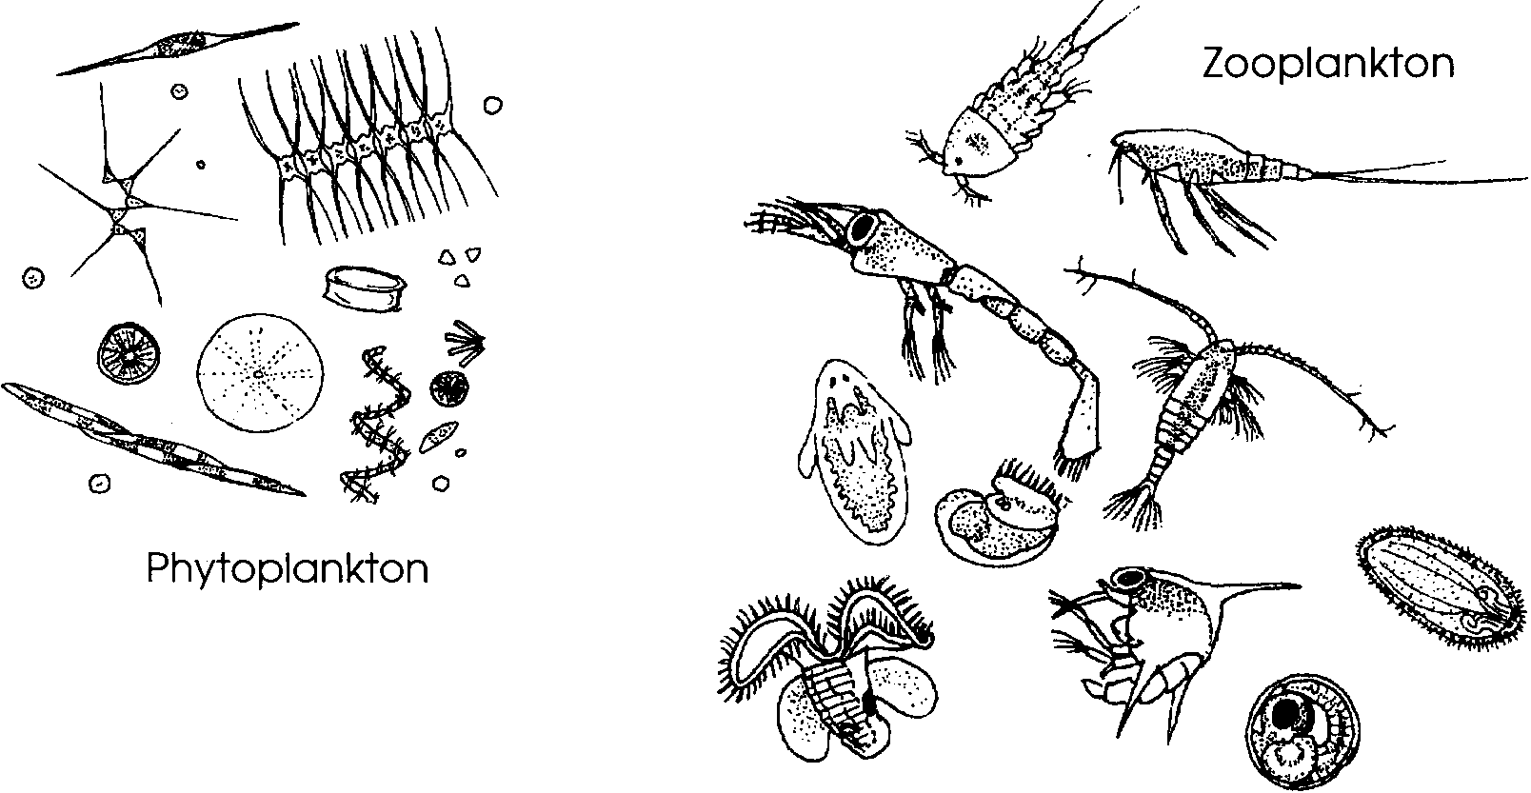

Phytoplankton do not consume other sea life. Instead, like plants on land, they make their own food.

1. You have seen a little bit about who eats whom in the sea. Fill in the missing animals in the following sentence:

Phytoplankton in the sea are eaten by which are eaten by
, which are eaten by which are eaten by salmon.

Phytoplankton need raw materials, or nutrients, to make their food. They also need some energy so they can put the raw materials together. They take in the nutrients from the seawater they live in. Phytoplankton take in carbon dioxide and water and put them together to make sugar. They also take in nutrients such as nitrogen, phosphorus and potassium. They use them as building blocks to make body parts. The energy to do this building comes from the sunlight.

2. Where do phytoplankton get the nutrients and energy they need to make their food?

Imagine that you are a tiny phytoplankter. You take your food nutrients from the sea and get energy from the sun. Marine scientists call you a producer because you make or produce your own food. Along comes a zooplankter. It gobbles you up! The zooplankter is a first order consumer. It is the first organism to eat you. There is a shrimp swimming by. It eats the zooplankter. The shrimp is a second order consumer. A herring eats the shrimp. The herring is a third order consumer. The salmon eats the herring and becomes a fourth order consumer. You, the tiny phytoplankter, end up feeding a salmon! We call this series of “eatings” a food chain.
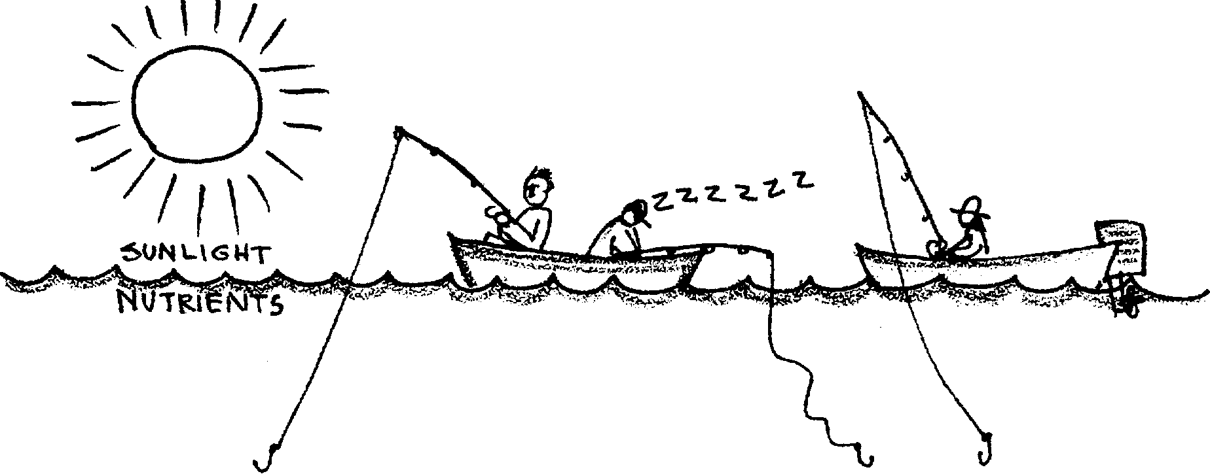
3.

PHYTOPLANKTON- > ZOOPLANKTON -> SHRIMP -> HERRING -> SALMON
Primary 1st Order 2nd Order 3rd Order 4th Order
Producer Consumer Consumer Consumer Consumer

Now let’s think about our fisher. Where does the fisher fit in this food chain? She can eat the shrimp, herring, or the salmon. Humans can fit in several places in this food series.
a. If Fisher A caught shrimp for dinner. What order consumer is Fisher A?

b. If Fisher B caught a herring for dinner. What order consumer is Fisher B?

c. If Fisher C caught a salmon for dinner. What order consumer is Fisher C?

But where do the nutrients the phytoplankton need come from? Many of them come from the decay of waste products from animals. They also come from dead plants and animals. Salmon, herring, shrimp, and zooplankton do not use all of what they eat. What they don’t use, they get rid of as waste products. The decayed waste products and dead organisms is called detritus. Bacteria live on the detritus. They break it apart and release its nutrients. The bacteria also grow on dead animals and plants. When the herring, shrimp, zooplankton and phytoplankton die, the bacteria decompose their bodies. This means they break them apart into nutrients.

4. How do bacteria and other decomposers help food chains of plants and animals in the sea?

The tiny phytoplankton is gobbled up by the zooplankter. The zooplankter is eaten by the shrimp. The shrimp is consumed by the herring. The salmon eats the herring. Finally, the decay of all these living things when they die provides nutrients for more phytoplankton. The tiny phytoplankter feeds a salmon and also provides food for future phytoplankton.

What we really have is a FOOD WEB made up of many interlocking food chains.

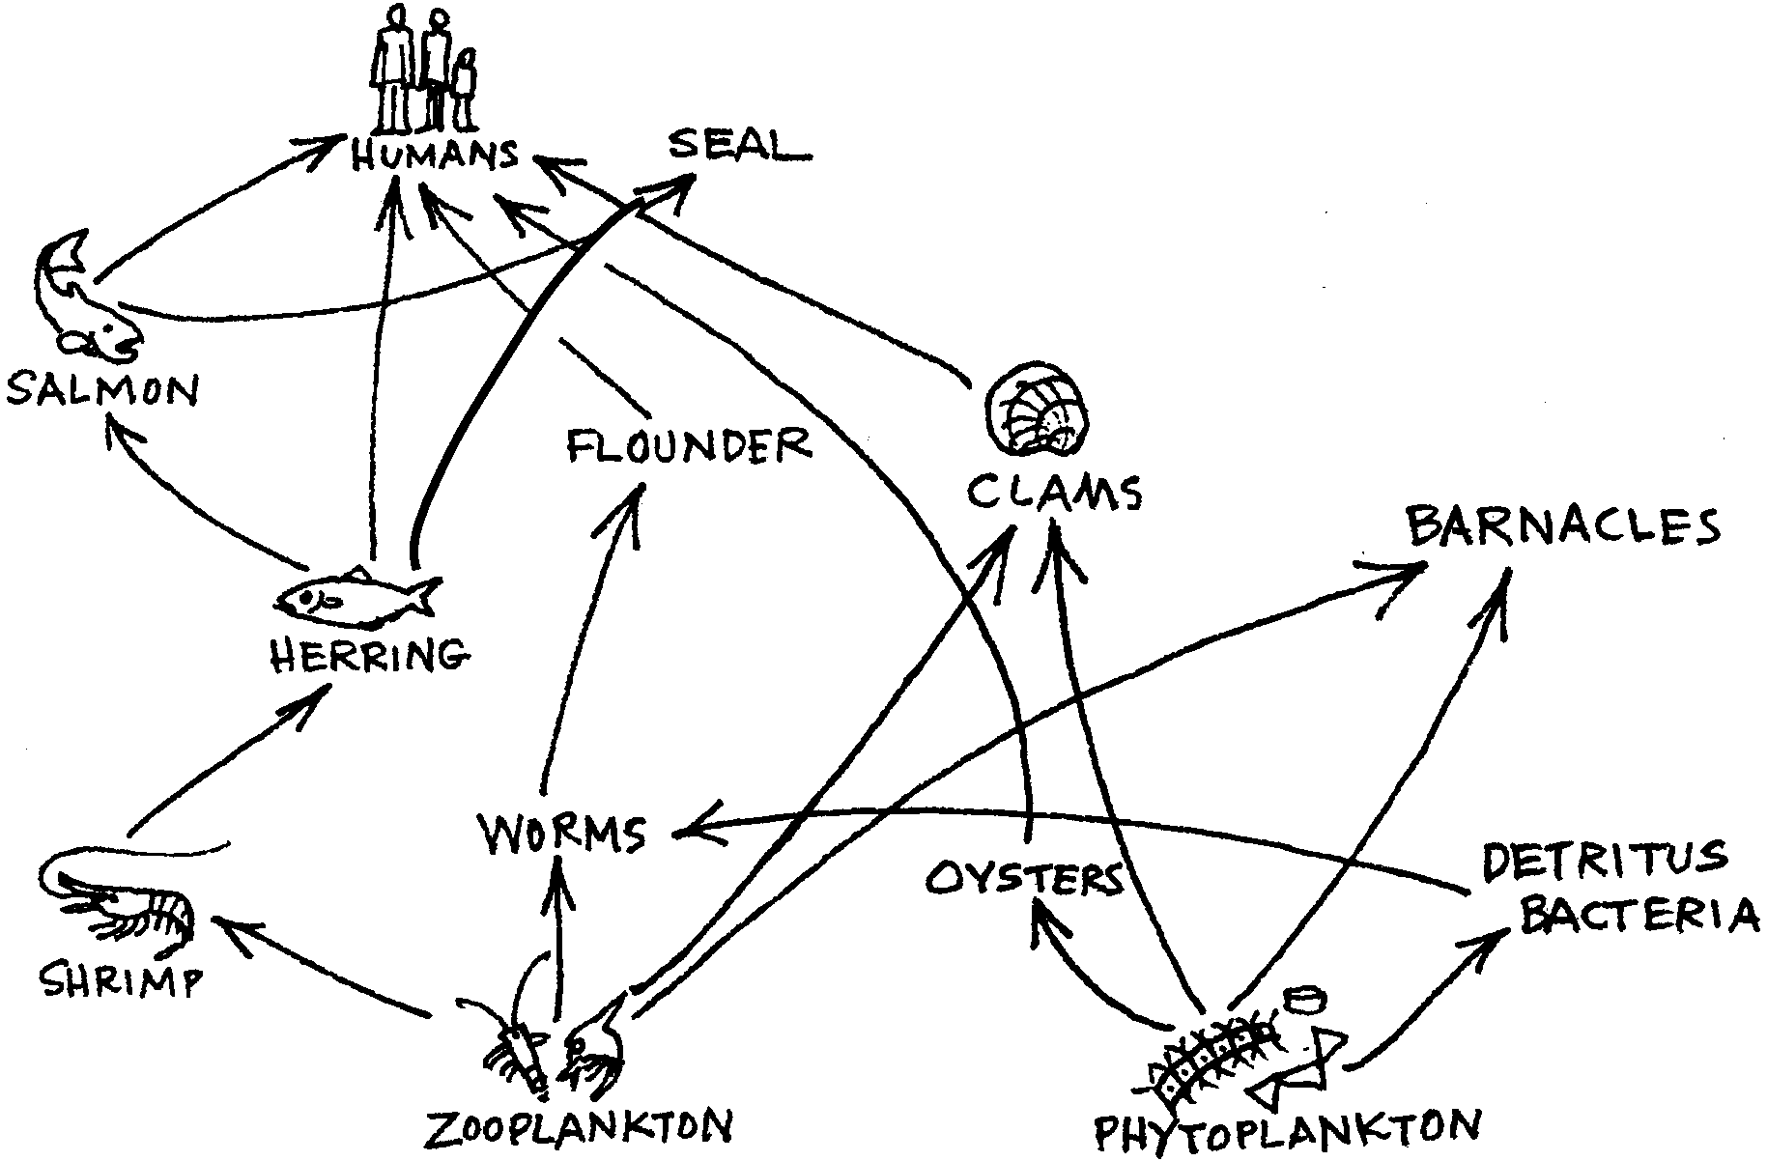
Many marine animals are connected to each other in the food web. Harm done to one may hurt many others. However, the web may be so complicated that the animals can find different animals to eat. The loss of salmon, for example, means there is less food for seals. However, the seals may choose to eat more herring instead of salmon.

5. In the food web shown above:

a. Which organisms are affected if herring disappear?

b. Which organism can be removed with the least impact on the food web?

c. The removal of which organism will cause the greatest impact on the food web?

The larger animals may eat many different things. However, the plankton are at the heart of the food web. Without the phytoplankton, producing their food from nutrients and sunlight, the rest of the creatures in the sea would have nothing to eat.

6. Can we say that phytoplankton support all life in the sea? Why do you think this?

Part II - The Food Chain

Now that you know some of the plants and animals of the sea, make a food chain.

Here’s what you’ll need:
• “Links in the Food Web” sheet
• colored pencils, crayons, or felt pens
• scissors
• paste/staples
• paper strips

Here’s what to do:

1. Get a copy of “Links In the Food Web” sheet. Use it to answer questions and to do the following activity.

2. Color the producer green. How does the producer get its food?

3. a. Obtain a pair of scissors and a stapler or paste.

b. Cut out the strip labelled PHYTOPLANKTON (the primary producer).

c. Match the dots on it to make one link. Staple or paste the link at the dots.

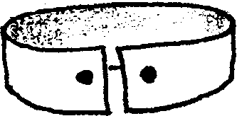

4. Which animal is the first order consumer? (Hint: It eats the primary producer)

5. Now add the link showing the animal that would eat the primary producer.
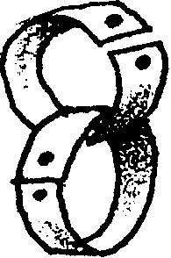
6. Keep adding links. Stop when you have a chain with five links. Be sure your links are in the correct order. They should show who eats whom in the food chain.

7. You now have a food chain. Imagine that a virus kills all of the shrimp. Which plants and animals would be able to survive if all the shrimp died? List them here:

8. We need to add the sun to the food chain. Here is how:

a. Obtain another paper strip.

b. Draw the sun on the blank strip.

c. Write the word “SUN” on the strip.

d. Add the sun strip at the beginning of your food chain.

9. Which plants and animals in your food chain would survive if the sun disappeared?

10. We really haven’t finished our food chain yet. What is missing? Let’s add the nutrients and bacteria to the food chain.

Obtain two more strips of paper. Label one “NUTRIENTS” and the other “BACTERIA”. Add them to your chain in their correct places.
11. Our food chain is starting to look more like a spider’s web than like a chain. Once we start adding all the parts we can think of to our food chain, we end up with a FOOD WEB. Let’s add some more animals to the web.

12. Cut another blank strip and label it “SEAL”. Seals eat salmon. Place the seal strip in its correct location in your food web.

13. Cut some more blank strips. Decide what animals could be added to the web. Label the strips. Add them to your food web in the correct places.

14. Now add some humans to the food web. Cut out some strips and label them “HUMANS”. Add your new “Humans” strips in the correct places.

15. Our food web is really even more complicated than it looks. Many animals eat more than one food. For example, salmon not only eat herring, they eat shrimp too. Seals eat herring, other fish and salmon.

a. Obtain another strip and label it “SALMON”. Add it to the shrimp link in the food web. Now you have salmon in two places.

b. Obtain another strip and label it “SEAL”. Add it to the herring link in the food web. Now the “seal” has two places, too.

c. Look at some of the other animals in your food web. What else do they eat? Make some new strips. Label them and add them to your web in the correct places.

16. a. How many links do you have in your food web?

b. Removing one link from a food chain is usually

more destructive/less destructive

than removing one link from a food web. (Circle the correct answer).

17. You have turned your food chain into a complicated food web. Consider how the loss of one organism might affect the food web:

a. pollution, overfishing, and destruction of spawning areas have reduced the number of salmon. Remove the salmon from your food web. Name some plants and animals in your food web that would survive. (Hint: they still have something to eat even though they cannot eat salmon)

b. An oil spill is killing the phytoplankton. Remove the phytoplankton from your food web. Which plants and animals in your food web could survive?

18. Put your name on your food web. Display it proudly!

Part II - The Food Chain - Links in the Food Web

Food chains are sometimes hard to picture. Use the strip drawings below to begin to make your own food chain model.

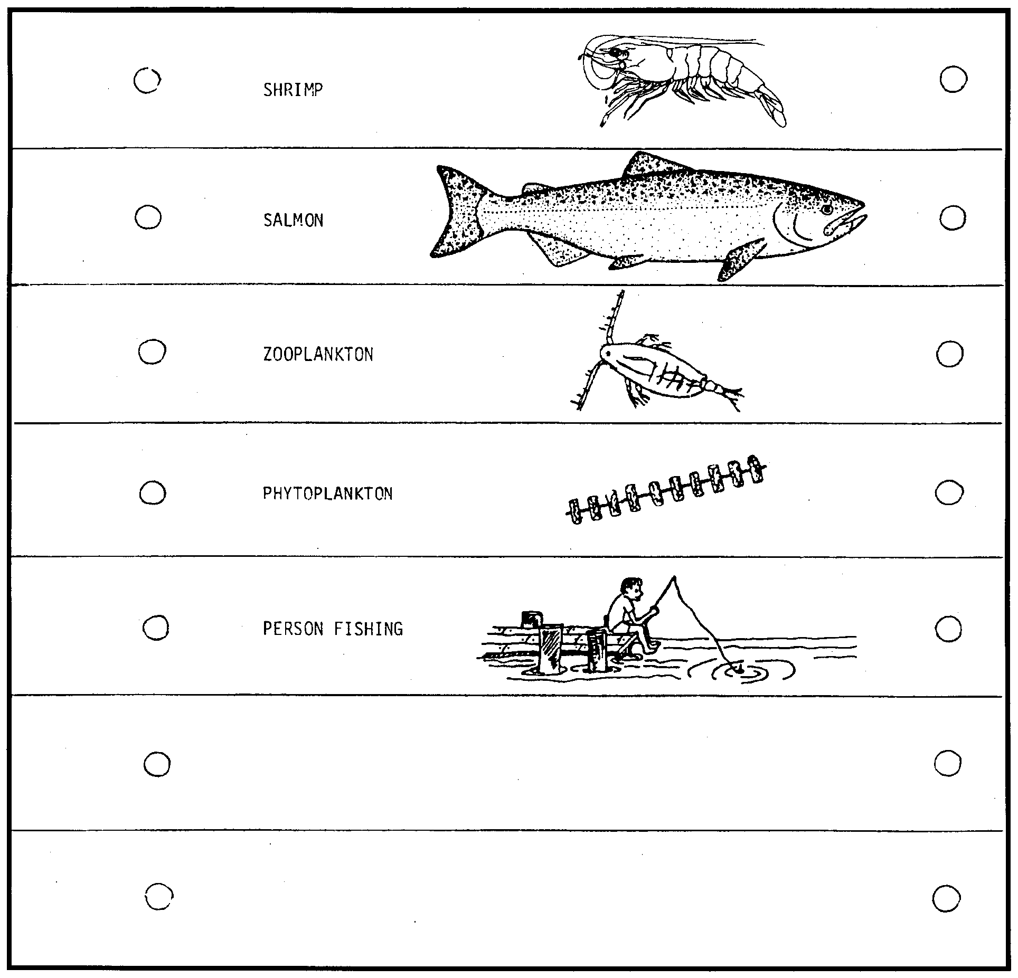

Part III - The Pyramid of Numbers

We have learned something about food chains and food webs. We started with this food chain.
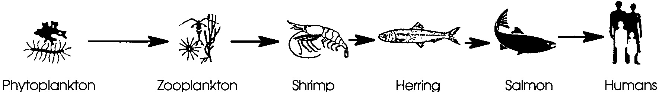

Of course, a zooplankter eats more than one phytoplankter. The amount of food each animal needs to eat can be shown in a model called a FOOD PYRAMID. See the one shown below.
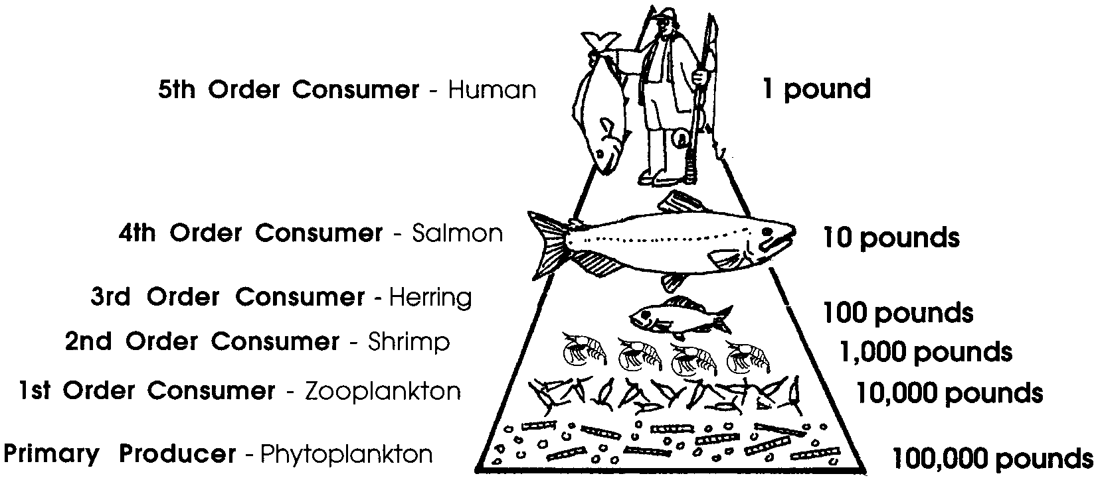
Energy is lost at each step of the pyramid. It takes 100,000 pounds of phytoplankton to feed 10,000 pounds of zooplankton. It takes 10,000 pounds of zooplankton to feed 1,000 pounds of shrimp. These 1,000 pounds of shrimp can feed 100 pounds of herring. The 100 pounds of herring can feed a 10 pound salmon. And 10 pounds of salmon would feed only 1 pound of a human. One person may weigh 185 pounds! She or he can get more of the original sun energy by eating herring instead of salmon. This is because it takes less energy (pounds of food) to feed a herring. Look at the food pyramid above to understand this.

1. What should humans eat to get the most of the original sun energy? (Hint: Which foods get their energy/food directly from the sun’s energy.)

More people require more food. We get more food energy by eating farther down on the pyramid. Animals or plants farther down are closer to the sun’s energy.

2. How could we gather and eat plankton? Be creative in your ideas.

