Raising Salmon

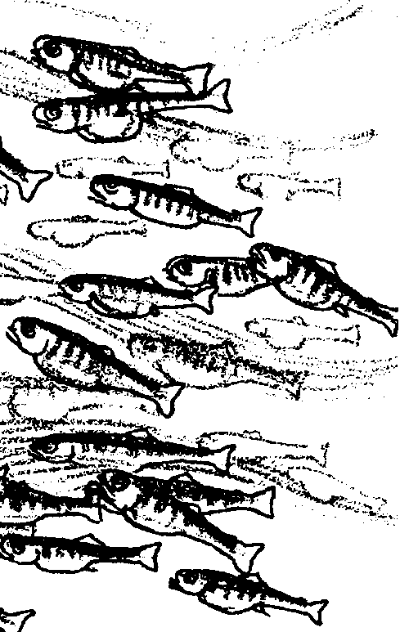

Key Concepts
1. Some finfish are raised in aquaculture programs for food or to restore natural fish populations.
2. Raising salmon in aquaculture programs is done in three different ways: hatchery released, sea ranching, sea farming.
3. A hatchery must control the beginning of the life cycle of a salmon.

Background

Shellfish such as clams and oysters are farmed and so are some kinds of finfish. Finfish are farmed for food and to restore natural populations of the fish species. Finfish raised in aquaculture programs grow in hatcheries or in net pens.

Salmon are one of the most popular fish to eat. Many people like to sports fish for salmon. Lots of restaurants and stores sell salmon. Some of these salmon are wild, or raised in a natural environment, while others are raised in hatcheries by aquaculturists. Salmon raised by aquaculturists add to those raised naturally. Many people are involved in growing these salmon.

Salmon can be raised by aquaculture in three ways:

1. Hatchery released. Young salmon raised by hatchery aquaculture can be released into streams and rivers. Many of these will be caught by fishers in the ocean or near the river when they return to spawn.

2. Sea ranching. Young salmon from hatcheries can be grown in net pens in the ocean, then released from the pens into the ocean to mature. They will not go to a river. They will be harvested by aquaculturists when they return to the net pens. Many of these salmon will be caught by fishers in the ocean or near the net pens when they return.

3. Sea farming. Young salmon can be raised by hatchery aquaculture, then grown in net pens in the ocean. These salmon are not released into streams or into the ocean to mature. They spend their lives in the net pens. They are “harvested” directly from the net pens by the aquaculturists. Only a few that may have escaped from the pens are caught by fishers.
Materials

For each student:

• 1 set of student readings (“A Hatchery Operation”, “Sea Ranching”, and “Sea Farming”)

Teaching Hints

In the connected readings, “A Hatchery Operation”, “Sea Ranching”, and “Sea Farming”, students read information and answer questions about three methods for raising salmon through aquaculture: hatchery released, sea ranching and sea farming.

Read through the student text and background information. The information presented here will be reinforced in the simulation tag game, “Harvest Race”. You might choose to use the student questions for group discussion rather than having students answer on paper or assign questions to small groups. The groups can prepare a response to present to the class for discussion.

Plan to take a few days to study this material. Help students make charts and diagrams as you read about each method of raising salmon. One way to help students understand the “life cycle” of a salmon, is to make a sign for each step of the life cycle on a 5x8 index card. Give one card to each child until you run out. Then have the students arrange themselves in a circle in order of the activity indicated on their card. Point out that a cycle, like a circle, has no end but continues. The ending is also the beginning. Other students can start anywhere along the circle and walk by the stages to demonstrate this concept.

Duplicate the text and questions. It is helpful for students to each have a role in recording answers when working in a small group. For this reason we suggest that each student should have a copy of the material.

Key Words

adapt - to alter the structure or function of an organism by natural selection; an adapted organism is better able to survive and multiply in its environment

adipose fin - a small fin on the back of salmon and trout, near the tail

aquaculture - growing living things in water

aquaculturist - one who grows living things in water

alevin - young fish nourished by the yolk-sac attached to them

coded wire (in snout) - gives information to researchers

eyed-egg - a fish egg in which the eye can be seen

feed pellets - food in the form of pellets

finfish - fish with fins, as opposed to shellfish

fingerling - a fish about as long as a finger, a “smolt”

fishers - people who try to catch fish

fry - a stage of fish development

harvest - to gather a crop

hatchery - a place where fish are raised

hatchery cycle - the life cycle of fish grown in a hatchery

hatchery released - fish that are released from a hatchery

imprint - to identify with or remember a particular place or thing

incubate - in this case, to maintain fertilized eggs in favorable conditions promoting development before they hatch

natural cycle - a cycle in nature like the life cycle of the salmon

migrate - to move from one place to another

minerals - a non-living substance found in the earth or soil

milt - sperm cells of male fish that are found in their milky fluid

net pen - pens in water made of net material for holding fish

oxygen - a colorless and odorless gas forming 1/5 of the air

predator - a living thing that kills a prey such as a cat kills a rat

polluting - making dirty or filling with poisonous material

populations - groups of things

sea farming - raising salmon in floating net pens; not releasing them into the ocean

sea ranching - raising salmon in floating net pens until releasing them into the ocean

seafood processor - a place where seafood is made ready for market

smolt - a young fish changing from a freshwater to a saltwater fish

spawn - to reproduce or lay eggs

tote box - a very large container to hold many fish

wild - in this case, raised in nature and not by people

yoke-sac - a small skin sack found on the belly of each young salmon and that holds the yoke on which it feeds

Extension

1. Have students find the locations of nearby hatcheries, net pen, or other aquaculture projects. Try to arrange a visit.

Answer Key

Introduction

1. An aquaculturist is a farmer who raises aquatic life. The definition comes from context and from knowledge of the word “aquaculture” which was defined in the preceding activity.

Hatchery Released Salmon

2. This is a thinking skills question and as such you should evaluate students responses accordingly. Basically, from the text, students should see that the idea behind hatcheries is to produce more fish for food and to restore natural populations to streams.

3. Aquaculturists must control some variables such as the following in the hatchery environment in order to incubate eggs and grow small fish:
water flow for oxygen
water temperature
clean water
recycling water
cleaning used water before returning it to the river
keeping raceways clean
disease and bacteria
predators
food content and supply
overcrowding in ponds
sorting fish by species, sex, and development

4. When salmon first hatch from eggs they live in freshwater.

5. In the hatchery cycle, salmon young hatch in trays.

6. The yolk sac provides nourishment (food) for the alevin.
7.Salmon would be fed 56 times on May 31. If the sun rises at 6:00 a.m. and sets at 8:00 p.m., there are 14 hours of daylight on May 31. Since the salmon are fed every fifteen minutes or four times per hour, the work might look like the following:

6:00 a.m. to 8:00 p.m. = 14 hours of daylight on May 31. There are four(4) 15-minute periods in 1 hour. There are 14 hours. Therefore, 14 hours X 4 feedings/hr = 56 feedings on May 31.

8. Both hatchery salmon and wild salmon grow to adulthood in the ocean.

9. Answers will vary. Reasons people might want to move the smolts early would center around their desire to have the salmon imprint on other waters (e.g., streams in need of restocking or net pens).

10. If not released into streams, smolt are sent to sea ranches and sea farms for continued growth.

11. Students may have difficulty determining where to begin the life cycle of the salmon. A cycle is a circle and really has no beginning or ending. This is like asking which came first, the hen (salmon) or the egg? Accept anywhere they choose to begin as long as it is reasonable and the sequence is in order. Here is a sample that describes the life cycle of a salmon:
4 alevin
3 eyed egg
6 young salmon migrating down stream
2 spawning
5 smolt
7 swimming in the ocean and becoming adult salmon
1 adults migrating up stream

12. Your students will think of many possible questions for scientific study. Accept reasonable responses. Some questions for scientists to study about the effects of fish hatcheries include:
Do hatchery fish deplete the wild fish food source?
Do hatchery fish overcrowd the streams and rivers?
Do hatchery fish adapt to changes in the habitat?
Do hatchery fish know how to avoid predators?
Do hatcheries pollute rivers?
Do hatcheries produce more food protein at a lower cost to consumers?
Do hatcheries really restore wild populations?
Can hatchery fish become wild fish?
Do hatchery fish breed with wild fish?
Do hatchery fish always return to the same river in which they were released?

13. This thinking skills question requires students to make a decision and support their response. Evaluate student responses according to how well they defend the theory.

Sea Ranching

1. Though not directly stated in the text, students may make educated guesses as to where the eggs come from. Sea ranchers obtain eggs from their returning salmon or from state and federal hatcheries.

2. Imprinted sea ranch salmon return to the net pens from which they were released.

3. Accept all reasonable answers but lead students to understand that the returning salmon will be shiny and bright because they do not have to fight their way up river to spawn.

4 a. A hatchery expects 1 or 2 salmon to return for every 100 salmon released. (1% to 2%)

b. A sea ranch expects 2 to 4 salmon to return for every 100 salmon released. (2% to 4%) This is a business model. A sea ranch expects a 1% to 6% return but for business estimates they use a 2% to 4% model.

c. A sea ranch expects a better return rate. This is because the salmon face less hazards if they do not approach shore too closely or enter rivers. Hazards include fishers, predators, water levels in the rivers, natural disasters, obstacles such as dams.

5. Some changes in salmon harvesting relate to techniques and locations for capture. Some suggestions are found below. Your students will undoubtedly have more ideas.
• Salmon would no longer be caught in rivers or near shores as they approach rivers.

• Bait would not be used to catch salmon.

• Techniques would concentrate on retrieving salmon from the net pens.

• Regulations would be needed to prevent fishers from capturing salmon near the sea ranch net pens.
Sea Farming

1. Sea ranching releases salmon into the ocean. The salmon return to the floating net pens as adults. They are harvested from the pens at their return.

Sea farming does not release salmon into the ocean. The sea farmed salmon spends its entire life cycle in captivity. Workers harvest adult salmon from the floating net pens but the salmon are not returning from the ocean.

2. The correct sequence is shown below:
5 “Mini-salmon” are marketed
3 salt water cultivation
1 incubation
2 fresh water cultivation
4 harvest

3. Possible answers are:

• Workers are needed to feed and care for the fish.

• Biologists monitor for disease and mix and administer medications.

• Some people monitor water quality and the sea bottom near the net pens.

• Some people maintain the nets and guard against predators.

• making and delivering orders

• keeping records

• cleaning and maintaining equipment.

4. a. It takes 15 “plate-size” Chinook salmon to equal one fully grown Chinook salmon.

(i.e., 30 pound adult/ 2 pound “plate size” fish = 15 “plate-size” fish)

b. It takes 5 “pan-size” Chinook salmon to equal one fully grown Chinook salmon.

(i.e., 30 pound adult/ 6 pound “pan size” fish = 5 “pan-size” fish)

5. This question asks students to use information they have gained about the life cycle, habits, and habitat needs of salmon. They must support their reasoning. Scientist do not yet know what effects the escapement of Atlantic salmon into the Pacific Ocean may have upon the ecosystem there. This question has led to many “debates” among sports and commercial fishers in the field. Encourage your students to look for scientific effects without making value judgements at this time. It is important for scientists to be objective rather than emotional in the scientific process.
Here are some possible effects:

• The Atlantic salmon may begin to breed in rivers flowing into the Pacific Ocean and therefore compete with native and hatchery fish for food and habitat in the rivers, streams, lakes, estuaries and the Pacific Ocean.

• The Atlantic salmon may bring disease from the Atlantic Ocean into the Pacific Ocean,

• The Atlantic salmon may feed on smaller Pacific salmon.

• Sports and commercial fishing may change to accommodate populations and prices for Atlantic salmon in the Pacific Ocean.

• Atlantic salmon may replace native species.

6. a. The brand name of the product is “DomSea”.

b. The salmon are b. frozen but taste a. fresh.

7. Because aquaculture is presently providing food for gourmets and not for masses of people, it is not likely to be an answer to world hunger. This concept may change in the future if aquaculture products can be raised to produce more food at a lower cost to consumers. Allow students to explore the question and their thoughts about the solution. As well as stretching students’ writing skills, this would be a good topic for a short oral presentation, debate or class discussion.

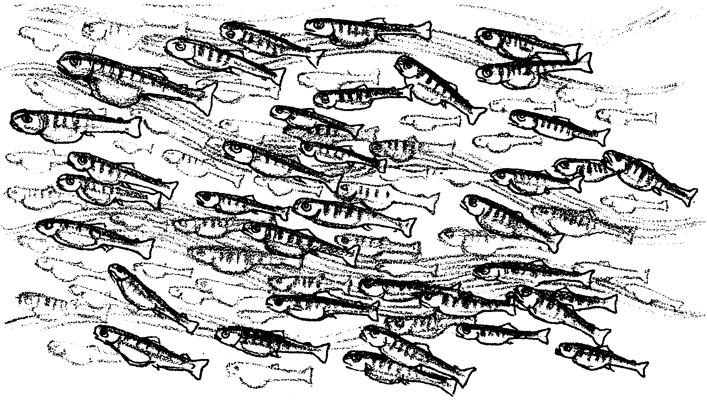
Raising Salmon

Introduction

Salmon are one of the most popular fish to eat. Nature has been raising salmon for a long time. Humans are now raising salmon, too. The salmon raised by aquaculturists add to those raised by nature. Salmon are raised by aquaculture in three ways: hatchery released, sea ranching and sea farming.

1. What is an aquaculturist?

Hatchery Released Salmon

Let’s begin by looking at a hatchery operation. A hatchery is a place where salmon eggs grow to small fish. Usually, the small fish are released into a river. Sometimes, the small fish are sold to other fish farmers who grow the young fish. For these salmon, their life cycle begins at a hatchery.

2. What do you think is the purpose of hatcheries?

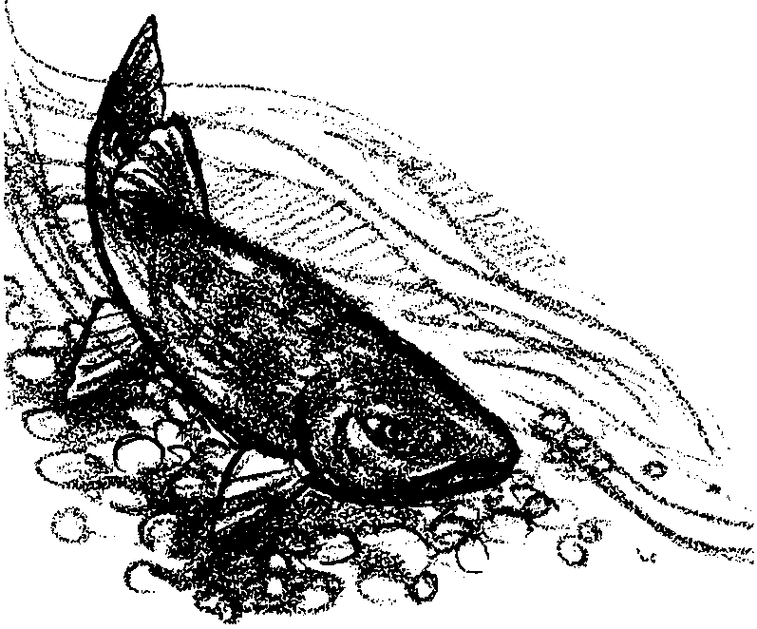

Mature salmon return to their home river or stream. Usually, this is where they hatched. They return to “spawn”, which means to lay and fertilize their eggs.

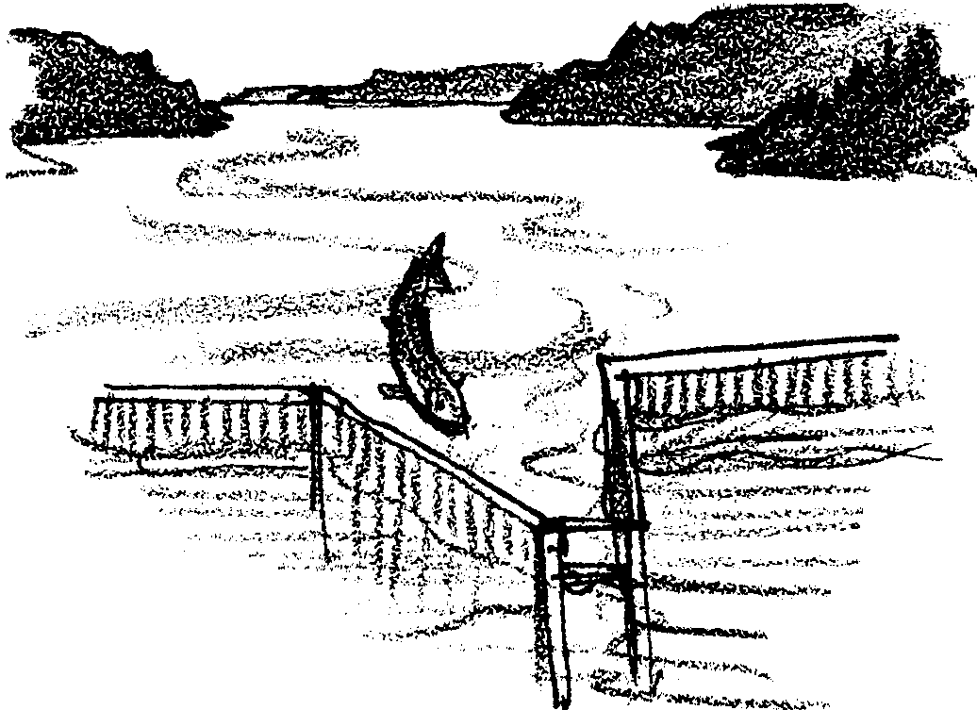

Before they spawn, the salmon are turned into a channel that leads to the hatchery.

3. Aquaculturists must control the environment at the hatchery. What might need to be controlled to incubate eggs and to grow small fish? Hint: water temperature is one thing. Name at least three others.

a.

b.

c.


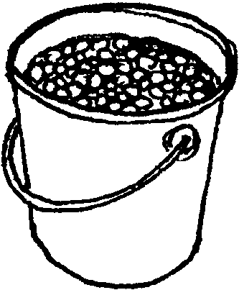
Salmon are kept in a pond. Cold, clean water from the river runs through the hatchery ponds. When the females are ready to lay their eggs, they are sorted from the males. Next, the salmon are killed. This may seem cruel. But, in nature, most adult salmon die soon after they spawn.

Salmon eggs are taken from a female salmon. The eggs are fertilized with “milt” squeezed from a male salmon. Then another pair of salmon are used to fertilize more eggs. This continues until all the adult salmon in the pond have been used.

The pink eggs are incubated (grown) in hundreds of trays. The trays are kept in darkness until they hatch. Cold, clean freshwater from the river runs through the trays. The water keeps the eggs at the proper temperature. It also provides the eggs with oxygen.

4. When salmon first hatch from eggs, they live in fresh/salt water. (Circle the correct answer)
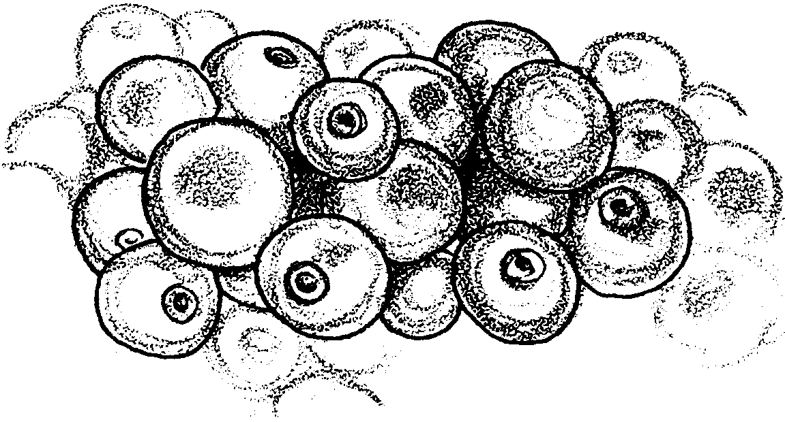
Workers keep the eggs from being covered by fine dirt (silt). The silt could smother the eggs. Every day, dead eggs are carefully removed. The dead eggs might pollute the rest of the eggs in the tray. Medicine is added to the water to prevent disease.

5. In the natural cycle, salmon young hatch in the gravel. In the hatchery cycle, salmon young hatch in _______________.

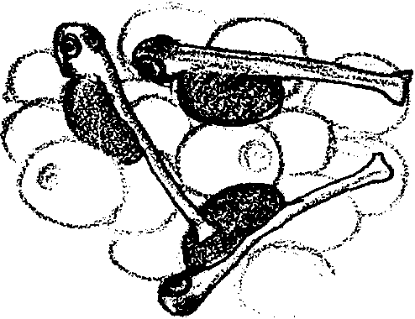
The eggs hatch into tiny fish called alevins. They still have part of the egg yolk attached to their stomachs. The yolk sack continues to feed the alevins until it is gone. Then they begin feeding on food provided by hatchery workers. The young fish must be fed very often.
6. What does the yolk sac provide for the young fish?

7. The young salmon eat from sunrise to sunset. They are fed every fifteen minutes. On May 31, the sun rises at 6:00 a.m. and sets at 8:00 p.m. How many times would the salmon be fed on May 31? Please show your work. (Hints: How many times are they fed each hour? How many daylight hours are there on May 31?)

When they have grown a little larger, they are moved into tanks. There, they are fed special fish food and medicine while they grow larger. Soon they grow too large for the tanks. Then, the small fish, called “fry” are kept in freshwater ponds. The fish keep growing. When they are about as long as a finger, they are called “fingerlings”. At that size, they begin to get ready to migrate (move) to the ocean.

The freshwater stream and the saltwater ocean are very different. The fingerlings must change from freshwater animals to saltwater animals before they go to the ocean. This changing is called “smolting”. Among other changes, the smolts lose their scales and get a smooth skin. More changes happen inside the fish.

8. In which water environment do both natural and wild salmon become adults?

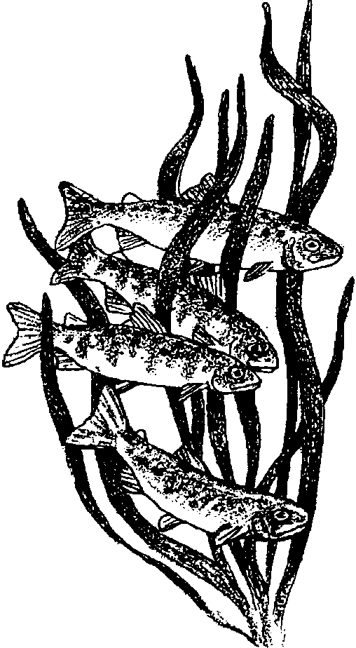
The hatchery keeps the smolts for a while. During this time they learn to remember which stream to return to when it is time to spawn. This remembering is called “imprinting”. Imprinting is not completely understood. Research shows that smell is important in this remembering.

The smolts leave the hatchery. But, they don’t swim away. Many of them are moved by trucks, barges, or helicopters. Most of the smolts are released into streams and rivers. They will migrate downstream to the ocean. Some are released in floating nets, called pens, in saltwater. These fish are for fish farming or sea ranching. When they are mature adults, the salmon will return to the hatchery stream to spawn.
9. If the smolts are moved earlier, they imprint on the stream where they are released. Why might people sometimes want to move the smolts early?

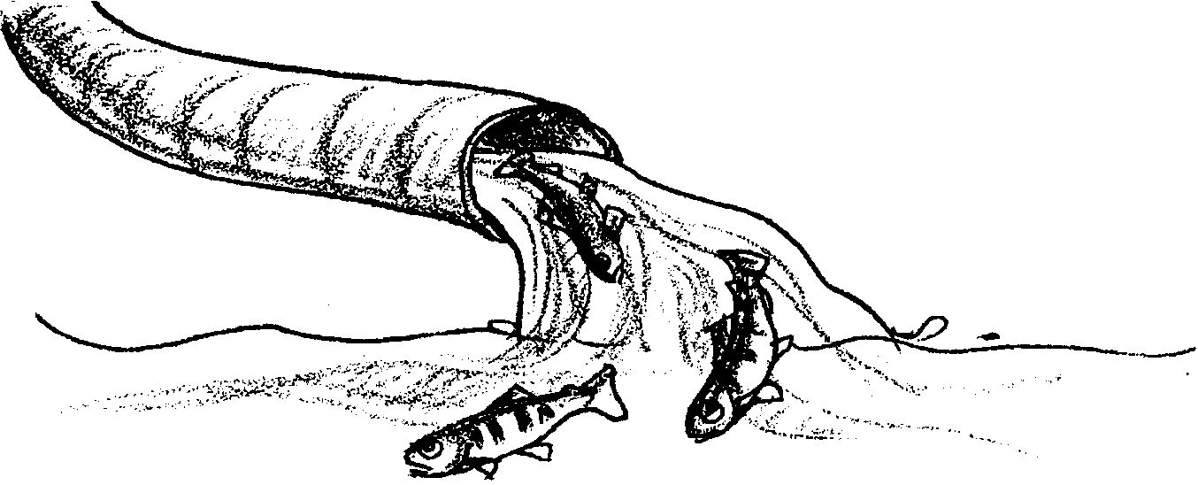
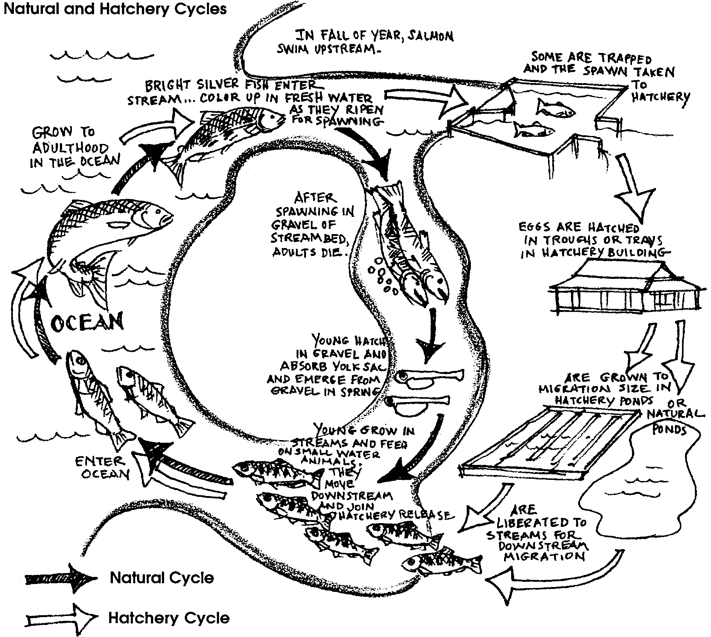
10. If not released into streams, where are smolts sent?

11. Number the following words in order. The order will describe the life cycle of a salmon.

alevin

eyed egg

young salmon migrating down stream

spawning

smolt

swimming in the ocean and becoming adults

adults migrate up stream

Why Have Hatcheries?

Some scientists think that hatchery fish have a better chance of survival. Fry hatched in the wild are smaller than those in hatcheries. Many are eaten by predators. Hatchery fish are larger when released into streams. Many of them are eaten, too. But fewer of the hatchery fish are eaten than of the wild salmon.

Scientists study salmon released from hatcheries. Some hatchery salmon are marked. They have a coded wire inserted into their snout. Marked salmon have their adipose fin cut off. This does not hurt the salmon. Fishers can identify them as a hatchery salmon by the missing fin. The fishers return the head of marked salmon to fish scientists. The scientists study the head to find out where the fish goes in the ocean and how it spends its adult life.

Still, not everyone supports the idea of hatcheries. Some scientists believe the hatchery salmon harm wild salmon. They may eat the food of the wild salmon. They also may reduce the salmon’s ability to “adapt” or change. This ability to change helps salmon to survive natural disasters or changes in their habitat.

12. Millions of salmon are raised in hatcheries each year. Salmon from hatcheries have helped restore fish populations. Even so, some people worry about hatcheries. They wonder if the wild fish populations are harmed. Scientists are studying about these things. Their research can help answer some questions. Write three questions for scientists to study about fish hatcheries.

a.

b.

c.

13. Which do you think is better? Salmon raised in a hatchery (hatchery salmon) or salmon raised in nature (native salmon)? Why do you think this?

Sea Ranching

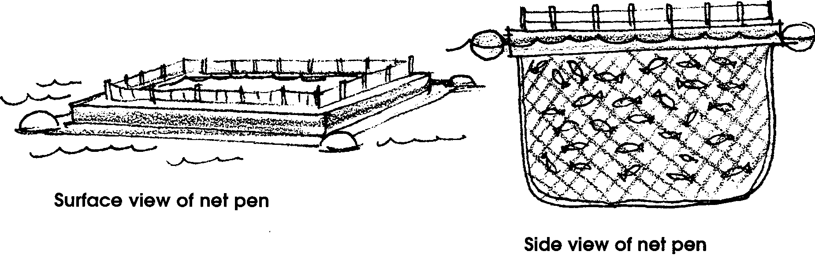
Hatchery raised salmon are usually released into streams. Once in the streams, they join wild salmon. From there on, they face all the same hazards. “Sea ranching” uses a different approach.

Some sea ranchers buy smolts from a hatchery. Other sea ranchers raise them from eggs to smolts in their own hatcheries. They hold the smolts in floating net pens in salt water. The young salmon eat feed pellets. The pellets are made from fish scrap, shrimp or crab waste, vitamins and minerals.

1. Where do you think a sea ranch hatchery gets salmon eggs?

In 7 to 35 days, the smolts imprint to the pens. “Imprinting” is how fish remember where to return to when it is time to spawn. After imprinting, the fish are released into the ocean.

2. To where do you think the net pen salmon return?

3. Do you think the returning sea ranch salmon will be battered or shiny? Please explain your answer.

In the ocean, the fish grow to adult size. As shiny bright adults they return toward shore to spawn. The sea ranch salmon return to the salt water pens instead of to a stream. When they are in the pens, they can be easily harvested.

4. “Return rate” refers to the number of fish coming back to the hatchery or sea ranch. For a 1% return rate, one fish returns for every 100 released.

a. A hatchery expects a 1% or 2% “return rate”. How many fish per hundred are expected to return to the hatchery?

b. A sea ranch expects a 2% to 4% “return rate”. How many fish per hundred are expected to return to the net pen?

c. Which aquaculture operation (hatchery or sea ranch) expects a better return rate of salmon?

Why Have Sea Ranches?

Sea ranchers think they have the answer to raising salmon. In a floating net pen, the salmon smolts are raised in clean ocean water. They are protected from the predators found in rivers and the ocean. They don’t have to swim around dams. Plus, all the returning salmon are about the same size and age. Finally, they are easier to harvest from the pens than to catch in the wild.

5. Salmon ranching is a new type of business. If it is successful, it may change salmon harvesting as we know it. Describe two ways that you think sea ranching may change salmon harvesting.

a.

b.

Sea Farming

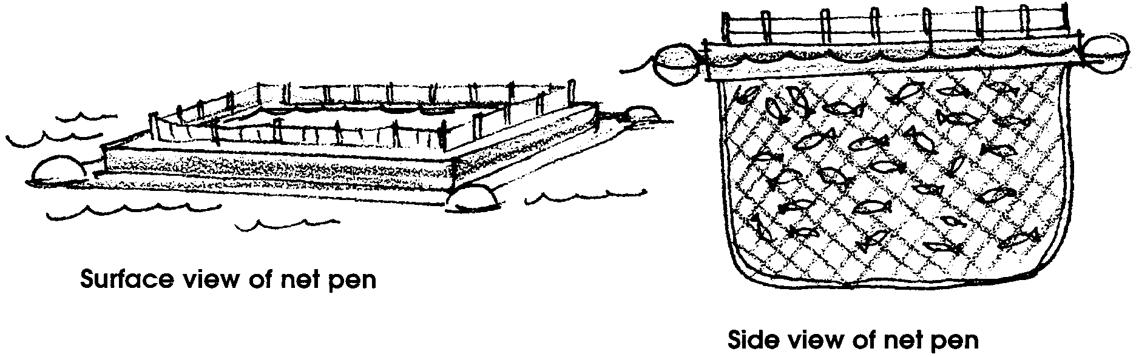
Hatchery raised salmon are usually released into a river. Sea ranch raised salmon are released from floating net pens into the ocean. “Sea farming” is another way to raise salmon in floating net pens. Sea farmed salmon are not released from their pens. Sea farmers use floating net pens in a different way.

1. Explain the difference between sea ranching and sea farming.

Sea farming aquaculture raises “plate-sized” or “pan-sized” salmon. These salmon spend their entire life cycle in captivity. They do not grow to maturity. They are harvested as young or “mini” salmon. After harvest these small “pan-sized” salmon are sold.

The captive life cycle has four stages:
1) incubation
2) freshwater growing
3) saltwater growing
4) harvest

Salmon eggs are incubated in a hatchery on freshwater. There they grow until they become smolts. When the smolts are ready, they are moved to floating net pens in salt water.

In the saltwater pens, the fish are fed and cared for daily. They are fed a special diet with vitamins, minerals, and medicine. They are fed five times a day. Biologists watch for disease. Workers check the quality of the water. They also check the sea bottom near the net pens. Other workers take care of extra nets. The extra nets protect the small fish from predators such as birds, dogfish sharks, and seals. These nets go over or around the net pens.
When the salmon are the right size, they are harvested. The size depends on the kind of salmon being raised. It also depends on the size of fish the seafood market wants from the sea farmer.

2. The following list shows the stages in sea farming salmon. Write the number one in the space in front of the first stage. Continue with the second and following stages.
“plate size salmon” are marketed
saltwater cultivation
incubation
freshwater cultivation
harvest

3. Describe 3 tasks workers must do in the saltwater cultivation stage.

a.

b.

c.

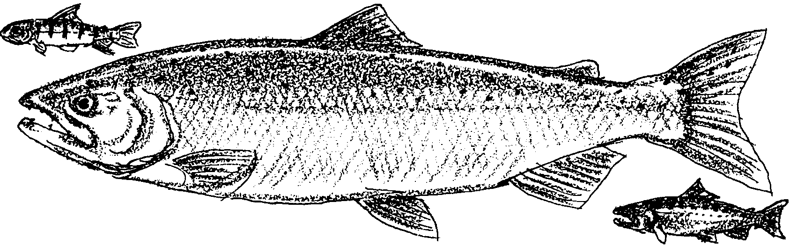

Coho Salmon
Coho salmon are harvested when they are "plate-size". They weigh about three-fourths of a pond. It takes about two and one half years to reach this size.

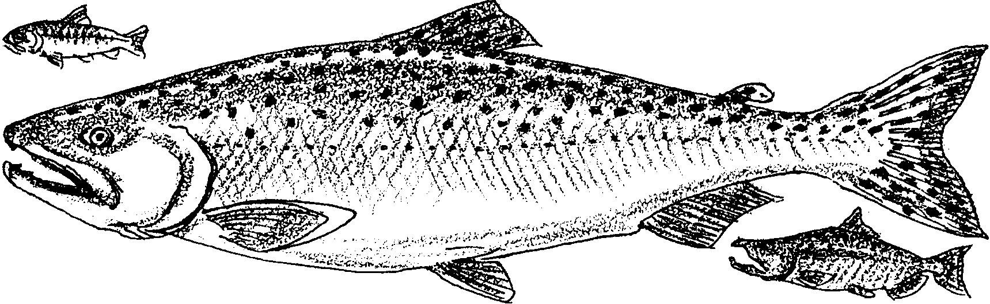
Chinook Salmon
Chinook salmon are harvested when they, too, are "plate-size". They weigh about 2 pounds. It takes about two years to grow Chinook salmon to this size. Chinook salmon may also be harvested at "pan-size", about 6 to 9 pounds. (A fully grown Chinook salmon weighs about 30 pounds.)

4 a. How many "plate-size" Chinook salmon have to be harvested to equal one fully grown Chinook salmon? Please show your work.

b. How many "pan-size" Chinook salmon have to be harvested to equal one fully grown Chinook salmon? (Hint: Use 6 pounds for "pan-size") Please show your work.

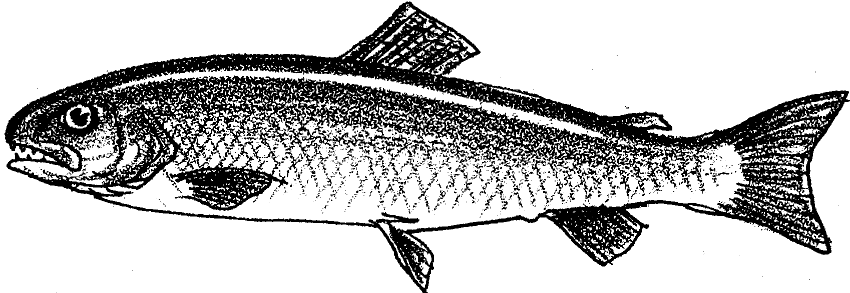

Atlantic salmon

Atlantic salmon are harvested when they are 6 to 16 pounds. They are sent whole to the fish market. Sea farmers say the bigger the better for the Atlantic salmon. It takes 3 years for pen raised Atlantic salmon to grow from eggs to harvest size. Atlantic salmon do well in the pens.

Atlantic salmon come from the Atlantic Ocean and its rivers. They are being raised in pens in the Pacific Ocean. Some of them have escaped from their pens. Some have been caught in Pacific waters by fishers. Scientists do not know what effect the Atlantic salmon will have in the Pacific Ocean and its rivers.

5. Tell three things that might happen if Atlantic salmon escape into the Pacific Ocean. Tell why you think this.

a.

b.

c.

Sea farmers raise other types of fish, too. Steelhead salmon are raised in the freshwater of the Columbia River. They are harvested when they weigh about 3 to 4 pounds. Sturgeon are raised in the Sacramento River. They are harvested for their eggs. The eggs are sold to hatcheries and seafood markets all over the world. Other sea ranchers are trying to raise halibut and lingcod.

Sea farm raised salmon are easy to harvest. Workers pull in part of the nets. This makes them smaller and "bunches up" the fish. Then they put a huge vacuum hose into the pen. The fish are sucked up from the nets and put into the hold of a boat. The boat takes them to a dock. There, the fish are sucked from the hold into "tote boxes". The boxes are filled with sea water. The live fish are trucked to a seafood processor. At the seafood processor, workers clean the salmon. The cleaned salmon are weighed and frozen. Trucks and airplanes carry the frozen salmon to markets across the United States and to other countries.

6. The following ad is from a Washington, D.C. magazine. Use the ad to answer these questions.
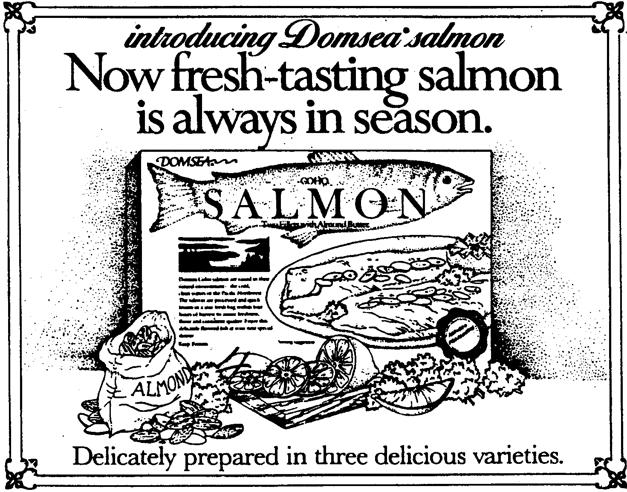
a. What is the brand name of the product?

b. The salmon are a. fresh/b. frozen but taste a. fresh/b. frozen (circle "a." or "b." in each pair of words to show the correct answer.)
Why Have the Sea Farms?

Sea farmers think that they have the answer to raising salmon for food. Salmon raised in sea farms are all the same size. They can be grown to the size the seafood markets need. They do not face the hazards of fish that are released into rivers and oceans. More sea farm fish survive to be harvested than native, hatchery released, or sea ranched salmon. Salmon farmed in net pens can be produced continuously. This means that one crop is being started while another crop is ready for harvest.

7. Raising salmon requires much work. After harvesting and processing, the cycle starts all over again. Most of today's aquaculture projects are small. Aquaculture is quite costly.

Think about this: What will it mean to the future if the raising of fish, shellfish, and plants is successful? Will aquaculture provide enough food for everybody? Or, will it only provide food for gourmets (people who love expensive fancy foods)? What will happen as methods improve? Will aquaculture help provide lower cost, protein-rich food? Can it solve food problems in a world with so many people?

Write about this: Do you think aquaculture will be an important source of food for the future? Why?

