Farming the Sea

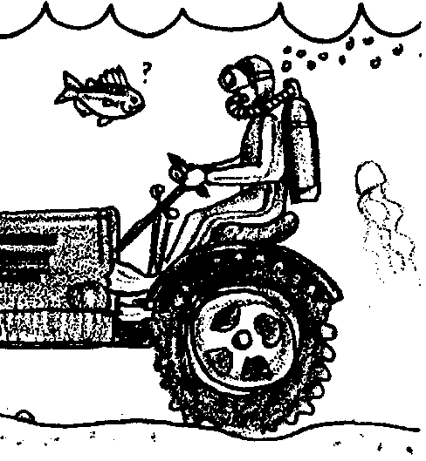
Key Concepts
1. People culture marine animals and plants for food and to help restore native populations.
2. Life cycles of marine animals are predictable.
3. Humans use knowledge of life cycles in culturing marine animals.
4. Aquaculture and mariculture require a controlled environment.

Background

Aquaculture and mariculture
With greater awareness that seafood is important for good health, American consumers have increased their diet of foods from the sea. Seafood supplies are limited due to the harvest of fishery resources at, or over, maximum sustainable yield levels and the degradation of rearing habitats along seashores and in streams. The supply of seafood has been drastically reduced while the human population continues to grow in its numbers and consumer demands.

World demand for seafood is also growing. At the present, the scarcity of the resource makes seafood a gourmet dish rather than a protein source that can satisfy world hunger. Industries and nations compete for seafood supplies. In 1988, ten percent of the world’s seafood production came from aquaculture. By the year 2,000, some expect that the proportion will increase to 25 percent. International trade in seafoods binds the nations of the world in a network of interdependence as we struggle to share the resources of the world ocean and its coastal regions.

Seafood supplies can be greatly increased with the controlled production and harvest of aquatic plants and animals. The terms “aquaculture” and “mariculture” refer to the raising of plants and animals in water environments. Mariculture refers specifically to these efforts in saltwater environments while aquaculture produces seafood either in salt or fresh water. The farming of finfish, shellfish, and algae has expanded with new developments in technology.

Aquaculture requires the best of water conditions. A combination of clean water, proper currents and suitable temperatures must be maintained.

When discussing this topic with your students, it is important to heed the words of a salmon mariculturalist, Jon M. Lindberg:

If the mariculture of fish, shellfish, and plants is successful, what does this mean to the world of the future? Statesmen of note have pronounced that, between farming of seafood and more efficient harvesting of what is found in the wild, the oceans are the answer to the population explosion. That is a short-sighted and most dangerous illusion. Wild harvests now seem to be close to their maximum sustained yield. Mariculture, in its infancy, is quite costly. It provides food for the gourmets, but not for the masses.

So at present, mariculture provides a welcome addition to the diets of those who enjoy and appreciate seafood. As techniques and efficiency improve, it may provide lower-cost protein which may give us a little more time to learn to stabilize our world population. But to accept mariculture as a panacea to population expansion is simply to pass this most crucial of problems on to our children. Such procrastination is simply to encourage still more people to a day when there is no new ocean to exploit.

Materials

For each student or pair of students:

• “Farming the Sea” student text

Teaching Hints

Following “World in a Jar”, which gives your students practice in maintaining a controlled salt water environment, “Farming the Sea” introduces your students to raising animals, shellfish and finfish, in a controlled environment. The subsequent activities in this unit are concerned with life cycles and rearing parameters of sea animals. Students explore the challenges of producing clams and salmon and making economic decisions. They find out about nutritional values of seafood and discover seafood dishes.

“Farming the Sea” is a brief reading and discussion activity that gives background for these subsequent activities. Preview the activities about raising clams and salmon and divide it in a manner that works for your class. You might decide to use some or all of the activities. If you are maintaining clams in the “World in a Jar” activity, the section in this about raising clams will be very appropriate. Salmon will appear in activities in Unit 4 “Finfish” and again in Unit 5 “Marine Mammals”. The life cycle introduced here will be useful background material for those units.

Regardless of the approach, plan to allow time for discussion of the concepts developed here. Duplicate the text pages as necessary for your class.
Key Words

aquaculture - growing plants and animals in water

aquaculturist - a person who grows living things in water

controlled environment - directed by people, not nature

culturing - growing plants or animals

harvest - a crop or to gather a crop

life cycle - birth, adulthood, reproduction, death, birth

mariculture - salt water farming

marine animals - animals that live in salt water

mature - adult

native fish - fish grown in a natural environment, not “human-made”

natural environment - one that is not controlled by people

seafood - food from the sea

water quality - conditions of water such as: cleanliness, temperature, saltiness, flow and amount of oxygen

Extensions

1. Supplement this introduction with media about hatcheries and aquaculture projects. Ask store and restaurant managers for display materials about seafoods they market. If possible arrange a field trip to a nearby aquaculture project. Freshwater aquaculture might include pen raised trout in a lake (McCall, Idaho), sturgeon in the Columbia River, and catfish and trout hatcheries in other regions.

2. Note that the FOR SEA grade 3 curriculum contains several lessons which might be used to supplement “Farming the Sea” including “Harvesting Clams” which consists of four activities: “Gooey Ducks” which gives your students an idea about the physical features, production and harvesting of the world’s largest temperate water clam; “Insides Out” which provides students the opportunity to put together a model of a living clam as they learn about clam anatomy and physiology; “Open Sesame”, a hands-on activity in which students get their hands on and inside a clam; and, “A Creative Clam” which allows students to be creative in writing about clams.

Answer Key

1. a. Answers will vary, depending upon the experiences of your students. Some kinds of shellfish people eat are clams, mussels, oysters, shrimp, lobsters.

b. Some finfish people eat are salmon, trout, tuna, halibut, “white fish”.

2. The numbers of the fish decrease when fishing occurs at levels greater than natural reproduction. This point is made in the text. Some of your students may follow the logic to its conclusion and note that the fish could decrease to the point of extinction.

3. a. The difference between native seafood and aquacultured seafood is that native seafood is raised entirely in the natural environment while aquacultured seafood is raised in an environment controlled by people.

b. The difference between maricultured seafood and aquacultured seafood is that maricultured seafood is raised in salt water only but aquacultured seafood is seafood raised in salt water or seafood raised in fresh water. Mariculture is a subset of aquaculture.

4. A sea farmer must control water conditions of temperature, flow, oxygen, chemical content and mineral content. S/he must also control: pollution, food supply, disease, predation, natural disasters, habitat degradation, siltations from flooding, and damage from sea storms. Any four of these parts will suffice.

5. The correct order for these parts of the life cycle are:
1. Eggs hatch.
2. Young ones grow.
3. Adult animals are harvested and sold for food.
4. Some adult animals are used to reproduce new eggs.

The life cycle is like a circle. Mature (adult) animals are needed to generate the eggs for the next generation. However, students may begin anywhere along the sequence above and follow it. That is okay because who knows which came first: the salmon or the eggs?

6. A farmer needs to know how to sell his/her fish in order to bring in money for the business.

7. Aquaculture and mariculture might help to restore native populations of sea life by offering protection during some or all parts of their life cycle. This might add to the numbers of eggs, young or mature stock.
8. How is your “World in a Jar” project like an aquaculture project? This question is included to start your students thinking about the challenges facing people who raise plants or animals in a controlled aquatic environment. It relates the simulation of maintaining a “world in a jar” to real life experiences of aquaculturists and mariculturists.

Farming the Sea
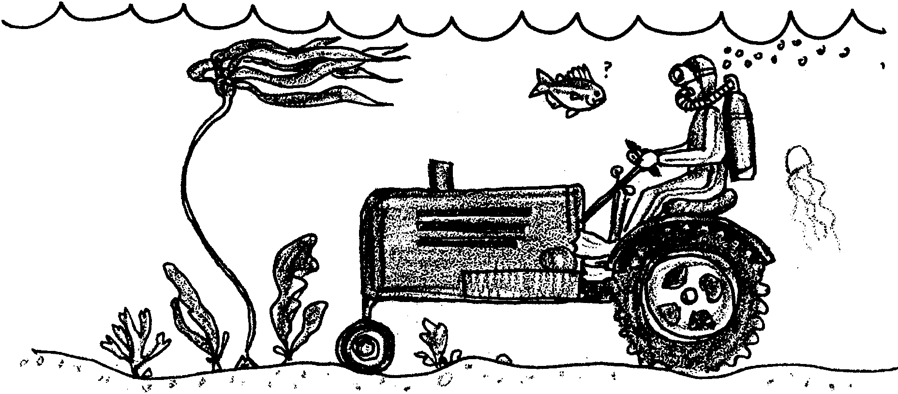

People have eaten food from the sea for thousands of years. Today, we still gather shellfish and catch fish. We gather and catch in much the same ways that our ancestors did. But, the number of people eating seafood increases each year. More people are gathering and catching seafood. Sometimes we catch as many fish as nature can replace. Sometimes we catch more. Then, the numbers of shellfish and fish get smaller each year. The natural environment cannot replace fish fast enough to keep up with our use of seafood.

1. Think about food from the sea.

a. What are some kinds of shellfish people eat?

b. Finfish are fish that have fins. Name some finfish people eat.

2. Sometimes we catch more fish than nature can replace. What happens to the numbers of these fish?

In many different parts of the world, people are working on this problem. Some are working to bring back native populations of sea life. Others are working to increase the supply of food from the sea. A new type of farming, called aquaculture or mariculture, raises aquatic (water) plants and animals. “Culture” means to grow something. “Aqua” means water and “mari” means sea or salt water. So mariculture is a type of farming done only in salt water. Aquaculture is farming in either fresh water or salt water.
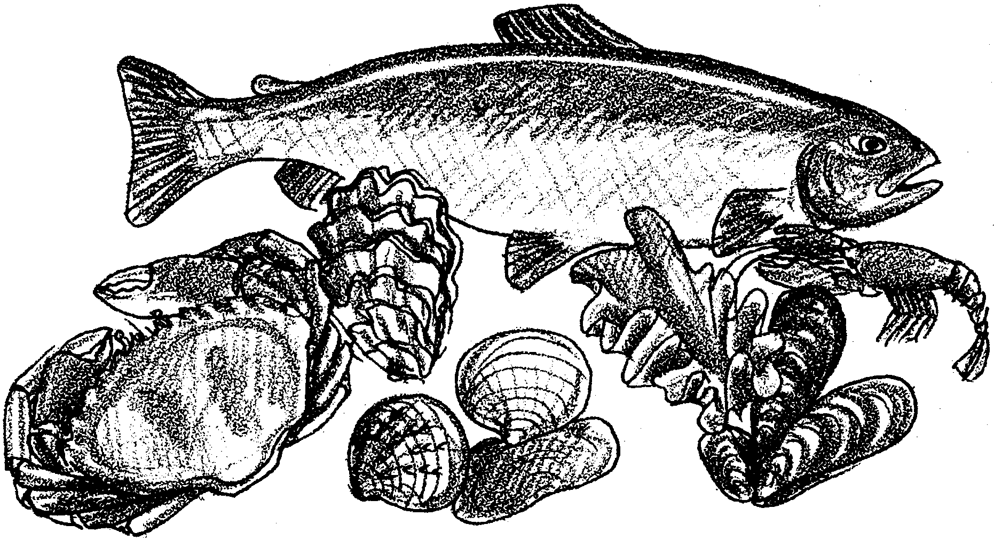
3. a. What is the difference between native seafood and aquacultured seafood?

b. What is the difference between aquacultured seafood and maricultured seafood?

Aquaculture projects need certain things for success. The farmers control the water environment. They control the temperature, oxygen, flow, and cleanliness of the water. They also control the food for the animals or plants in the farming project. Aquaculturists and mariculturists (sea farmers) must know how to control diseases. They must know about other dangers to the plants and animals they are growing. The animal or plant being raised must be protected from predators. The growing area must be protected from damage by storms or moving water. Special equipment is often necessary. All of these things present challenges to the farmers.

4. List four parts of the aquatic (water) environment a sea farmer must control:

a.

b.

c.

d.

From before birth to death, the life cycle of the plant or animal takes place in the controlled environment. The farmers must know how the plant or animal reproduces. They must know how to raise the young ones until they are adults. They need to know how to harvest, or gather, the adults.

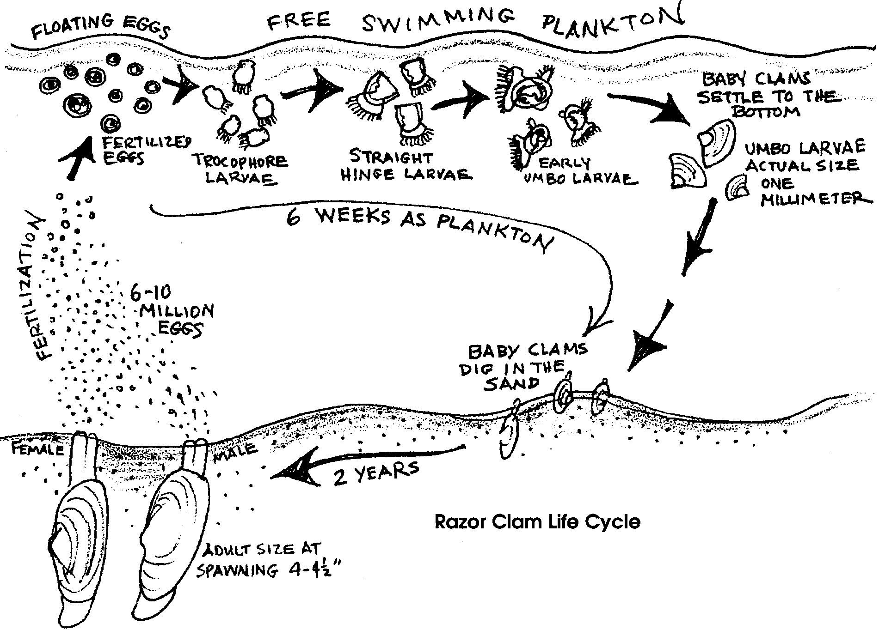

5. Put these parts of a life cycle in order. Number them from 1 to 4. Let 1 be the beginning and 4, the end of the life cycle).
Adult animals are harvested and sold for food.
Young ones grow.
Eggs hatch.
Some adult animals are used to reproduce new eggs.

Farmers also have to know how to sell what they raise. The sales make the money needed to keep the business going. Some people sell only the eggs or the young. Other farmers raise the eggs or young to adults. Some farmers let the young or adults loose into the natural environment. Some people sell the adults to seafood stores or restaurants.

6. Why might a farmer need to know how to sell fish?

Raising plants and animals in a controlled environment is a challenge. Let’s see how people have met those challenges. In following activities you will learn how clams and salmon are raised in mariculture and aquaculture projects.

7. How might aquaculture help to restore native populations of sea life?

8. How is your “World in a Jar” project like an aquaculture project?

