World In a Jar


Key Concepts
1. Plants and animals require a suitable habitat for survival.
2. It is challenging to design and maintain a balanced ecosystem.
3. Living and non-living factors influence ecosystem stability.
4. Saltwater ecosystems need certain physical parameters.

Background

“World In a Jar” provides your students with a chance to experience a microcosm of some of the problems encountered in maintaining a balanced, stable saltwater environment. In this activity, students make inexpensive saltwater aquaria out of gallon jars and raise sealife in a controlled environment. By monitoring the physical parameters of a saltwater environment and solving problems that arise in the process, your students will experience the challenge of marine biology, oceanography, and aquaculture. They will have an opportunity to become familiar with clams and aquaculture. “World In a Jar” introduces a life support system and gives you a living platform from which to make similar analogies to earth. It is also the bridge that connects the concepts presented in activities from Unit1-Watersheds and Unit 2-Salmon with concepts about saltwater ecosystems and marine life. You can use “World In A Jar” to link together concepts related to land and sea.

Materials
For each group of four students:
• glass gallon jar of seawater (synthetic sea salt mix or real seawater)
• air pump
• filter plate
• airlift tube
• airline tubing
• crushed oyster shells or gravel
• turkey baster (for cleaning, can be shared)
• brine shrimp eggs
• 1 - 4 live clams from grocery store or beach
• non-iodized salt (from grocery store for growing brine shrimp)
• extra jars for growing brine shrimp and mixing new sea water
Teaching Hints

In “World in a Jar”, students set up and maintain a saltwater microcosm in a jar. They collect data and experience some of the problems related to raising sealife in a controlled environment, as they try to maintain a stable and balanced habitat for their clams. Read through the following instructions for obtaining materials which can be purchased at a pet store. Assembling the “worlds” is a process with many steps which lends itself to completion over several days. While the individual steps are straightforward, the activity benefits from adult guidance and synthesis.

Preparing for the Lab
This activity is designed to be done with clams in a salt water environment. If you are unable to obtain salt water and saltwater animals, please consider doing the activity with fresh water and feeder goldfish. Feeder goldfish are raised to feed other, larger fish. They are quite inexpensive. Because carp fish are raised commercially, completing this activity with goldfish (a member of the carp family) is not unreasonable.

Salt water can be “created” from a sea salt mix purchased at a pet store. If you live near the sea, fresh salt water may be easy to obtain. Clams on ice can be purchased or ordered from most grocers. These clams are still alive in their shells. If you cannot get clams from your grocer, try calling a commercial clam operation on the ocean coast and ask them to ship you some fresh, live clams.

All of the materials can be purchased from pet or hardware stores. You may find many of them in the science supplies at your school or other schools in your district. By pooling equipment you can run this lab efficiently and cost effectively. The “World in a Jar” lab can be shared with other schools by rotating the equipment from one classroom to another when not in use by you.

The Tank
An advantage to using gallon jars for aquariums is that one large air pump can supply several jars, and teams of students can maintain their own aquariums. With a series of gang valves, you can run ten of the gallon jars off of one large, silent-type air pump. Although this type of pump is relatively expensive (about $20.00), it tends to last a long time, runs quietly, and can aerate a large quantity of water. To collect glass gallon jars, check your school cafeteria or delicatessens and restaurants.

Note: Plastic jars are not suitable for aquariums.

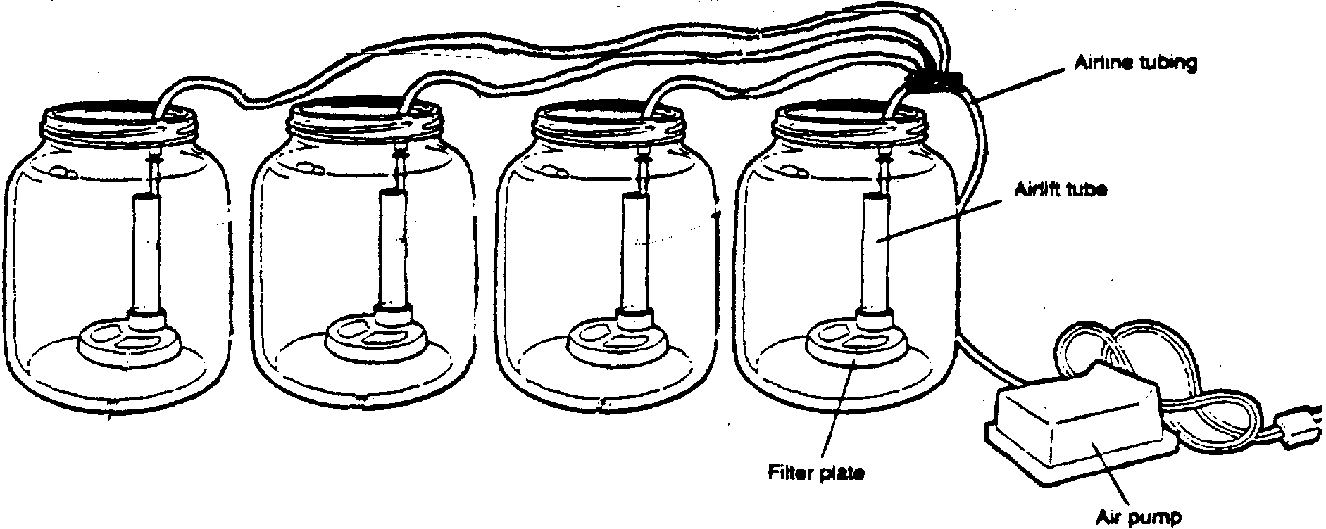
Donations of fish tanks and equipment might come through other schools or by placing an ad in the school or local newspaper. With a letter on school stationery to acknowledge the contribution, the donor can take a tax deduction, and the teacher gets a free aquarium. Or you might consider building your own aquariums and asking parent volunteers to help. You can get construction instructions at a pet stores and public aquariums.

To prepare the jar, rinse it with clean water. Do not use soap or cleansers. If it needs to be cleaned with something stronger than clear water, use baking soda or salt and rinse the jar well.

Location
To begin the lab, place aquariums away from algae-producing light and volatile substances. Later you can have students conduct experiments by introducing these locations and analyzing the results.

When selecting a site for your tank, remember that incandescent lights produce more heat than fluorescent lights. A fluorescent lamp will stimulate the growth of algae on the walls of the tank without increasing the temperature of the water which should be kept at relatively cool temperatures. The algae can then be scraped off the sides of the jar and studied under a microscope.

Volatile substances dissolve quickly in salt water. Fumes from paint and proximity to animals such as hamsters or mice can kill your marine animals. The waste products from these animals diffuse into the air and subsequently find their way into your aquarium.

The Water
You can either use natural sea water for your aquarium or eliminate the problems of hauling water from the shore by using one of the synthetic sea salts that are available in pet stores. Sea water contains many types of salts in a delicate balance, so do not try to improvise with table salt.

If you want to collect your own sea water, carry it in a plastic pail lined with a plastic trash bag. When the pail is full, simply close the top of the bag with a twist tie to keep the water from sloshing. Try to collect your water as far out from the shore as possible because water near the shore tends to be more polluted.

If you use synthetic salts, follow the directions of the package. These synthetic salts do not contain the microscopic life and organic material essential to a healthy aquarium. The two week run-in period is designed to provide these materials. During this period the only tenants in the tank are a few clams. Marine organisms produce ammonia as a waste product. In the open ocean, the poisonous ammonia is harmless because it is diluted by the great amount of water and broken down by marine bacteria. In a small tank, ammonia can build up and kill the organisms. Clams, which are extremely resistant to this buildup, can survive where other organisms would die. To eliminate chlorine in the water, let the tap water in your tank sit for two days. Likewise, when you mix new saltwater to replenish the water in the tanks, mix it ahead of time in water that has been sitting for two days. New tanks can also be started simply by seeding it with some gravel from another older tank that has already built up a population of bacteria.

Have your students fill the gallon jars only to their widest point. This will allow the maximum exchange between air and water, and thus provide the best aeration.

Filtration and Aeration
Because salt water tends to hold less oxygen than fresh water, a saltwater aquarium must have a good source of oxygen. Oxygen not only allows the fish to breathe, but also allows for the buildup of aerobic (oxygen-using) bacteria, which break down poisonous waste materials in the tank. Without these friendly bacteria, your tank would quickly poison itself. One type of bacteria, Nitrosomas, breaks the ammonia down into nitrites. A second type of bacteria, known as Nitrobacter, changes the nitrites to harmless nitrates. Most marine animals are relatively tolerant to the buildup of nitrates, but the level should be reduced by changing about one-fifth of the water every two weeks.

The goldfish bowl filter recommended fits neatly into a one gallon jar. This type of under-gravel filter works as a biological filter system. The air pump forces air bubbles into the water. This air-water mixture is lighter than the plain water in the jar. The lighter air-water mixture rises to the top and forces the plain water down through the filter. Large waste particles are trapped by the gravel as the water passes through.

If your tanks include clams, mussels, barnacles, or sea anemones, avoid a system that filters all materials from the water. These animals are natural filters and will starve to death if the tank filters are too effective.
Substrate
Substrate is the material that covers the bottom of the tank. A good substrate for a marine tank is dolomitic limestone, which is available at pet stores. You can also use crushed oyster shells which you can make yourself. If you are going to crush your own oyster shells, put the shells between a few sheets of newspaper and crush them with a hammer. The newspaper will make it easy to clean up and it will prevent any pieces of shell from flying up into your eyes. Be sure the crushed pieces are too large to fit through the openings in the filter. Also, there must be space for water under the filter. If the crushed pieces are too small, cover the filter plate with a piece of nylon stocking to reduce the size of the openings.

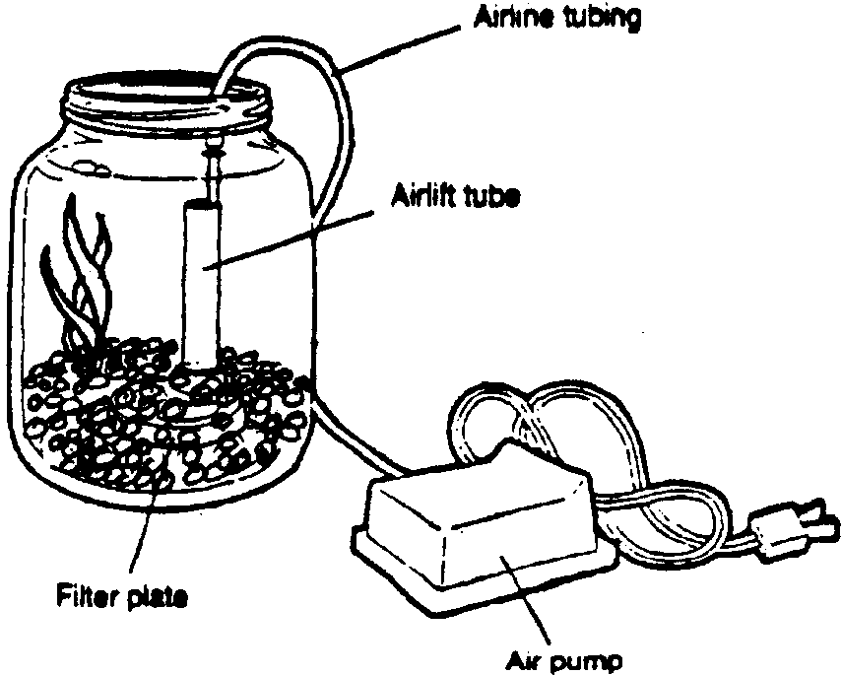
Before putting the gravel into the tank, rinse it with tap water until the runoff is clear. The layer of substrate should be about two inches deep. In the natural environment, clams dig into the substrate and stretch their siphon tubes to the surface to take in water and food and to expel wastes. You might want the substrate to be deep enough in your tanks so that students can observe this function. Be careful to leave plenty of space for water so that you will have an adequate supply of oxygen for the animals. Most people have poor success trying to maintain marine plants, so you are better off without these. However, you should provide some plastic plants that are made for aquariums. These will provide hiding places for the animals.
Temperature
Most intertidal marine organisms tolerate a temperature range from 40-70 degrees F. They can tolerate gradual temperature changes that occur naturally as the tide levels change daily. Clams grow in waters that average 45-50 degrees F.

Try to pick the coolest location possible and turn your heaters down during the day and off at night. You can place the jars in a refrigerator over night. Aeration will not be needed for overnight cooling because at lower temperatures, the clam’s body functions slow down. To aerate the jars for longer storage in the refrigerator you can use air stones with pumps and close the door on a cord that goes to an outlet.
pH Level
Scientists use the abbreviation of pH to tell how acidic or basic something is. Vinegar and lemon juice are examples of acids. Baking soda and ammonia are examples of bases. The pH scale runs from O to 14. Water with a pH of 7.0 is neutral. As the pH drops below 7, we say the substance is acidic. The lower the number, the more acidic it is. As it rises above 7, it becomes increasingly basic. For example, if a chemical has a pH of 13, it is base. A pH of 3 would make a substance an acid.

The pH of the water in your tank should range from 7.5 to 8.3. As the water in the tank ages, it has a tendency to become more acidic. The dolomitic limestone or crushed oyster shell used as a substrate is important in maintaining the proper pH of your tank. It provides what scientists call a buffer. A buffer is a chemical that helps to keep the pH constant.

If you find that the pH of your tank is dropping, add a small piece of chalk or a little baking soda. Both of these substances are buffers. You can test the water by using pH paper or a pH test kit obtained from aquarium shops. Consider providing this equipment for your students. This will give them a chance to improve their observation and recording skills .

Density-Salinity
The density of something is how much a certain amount of that substance weighs in relation to its volume. Lead, for example, has a high density; a cube that measures one inch on each side is heavy. Cotton, on the other hand, has a low density; a cube that measures one inch on each side is light.

A hydrometer is a device used to measure density. It is a glass tube weighted at the bottom so that it floats at a certain level in the water. Inexpensive hydrometers may be purchased at aquarium shops. Density becomes greater with increased saltiness. The saltier the water, the higher the hydrometer will float. The numbers on the hydrometer scale run from 1.000 to 1.025.

Before reading the hydrometer, unplug the air pump to calm the surface of the water. Density is also affected by temperature . Use the chart below to find the appropriate density of sea water at each temperature.

If the water is too salty (that is, if the hydrometer reading is higher than the number on the chart), add fresh water until the hydrometer floats at the correct level. In nature salinity is effected by flow of freshwater from land, rain, and ice melts. Fresh water and salt water may flow in layers of currents. They mix slowly by friction. You can demonstrate the mixing or separation by adding food coloring to fresh water and observing what happens when you carefully add it to salt water.

Temperature Density

60° 1.0240-1.0245

65° 1.0235-1.0240

70° 1.0230-1.0235

75° 1.0225-1.0230

80° 1.0220-1.0225

Feeding
Most marine animals thrive on a diet of frozen fish, crabs, or clams. Filter feeding animals, such as clams, eat plankton and waste that they filter from the water. Feed clams brine shrimp. You can purchase eggs from a pet store and grow the shrimp yourself. Follow the directions on the package. Generally, you will need to mix salt water from non-chlorine water (tap water that has been sitting for two days) and non-iodized table salt. You add the eggs and keep them warm under a lamp (about 80 degrees F.) Wait for them to hatch and grow. Then suck them up in a dropper and drop some into the clam tank. Students can easily raise the brine shrimp themselves.

Overfeeding can be a major problem. Whatever animals you keep in a tank, they should be able to clean up all their food in about five minutes. If your food is chunks cut from fresh or frozen fish, be careful not to allow excess fish oil into the tank. Remove any leftover food particles before they foul the tank. They can be removed with a turkey baster, a less expensive alternative to an aquarium vacuum. Fish oil will contaminate the water and you will have to drain most of the water and replace it with clean water.

General Maintenance
A gallon jar aquarium can generally support two or three animals, depending upon their size. Don’t put more than four clams in a gallon jar. If any animal looks sick, remove it immediately to a “hospital tank”.

Algae can be carefully scraped off the walls of the tank with a nylon sponge or single-edged razor blade and sucked out with the kitchen baster. Wear rubber or plastic gloves so that oil from your skin does not contaminate the water.

Cloudy water generally indicates an unwanted growth of bacteria. The best thing to do in this case is to start the tank over again with new water.

Tank water can easily become poisoned. Make sure that no metal ever comes in contact with the water. If you suspect that the tank has been poisoned, dilute the poison by changing about half of the water immediately.
Weekly, exchange about half the water in the jar in order to dilute ammonia that will build up. By changing half the water you will maintain some of the old familiar environment and proper salinity. Discard the used water that you drain by siphoning through tubes or by bailing with cups. If you are getting your salt water from the natural environment, this exchange will provide new plankton for filter feeders. If you are mixing salt water from synthetic sea salts from a pet store, mix it ahead of time in another jar with tap water that you have allowed to sit for two days. Keeping sea water prepared and raising brine shrimp can become classroom jobs for some of your students. You can relate these jobs to tasks that marine biologists and aquaculturists must do. Some of the following activities will introduce jobs of aquaculturists.

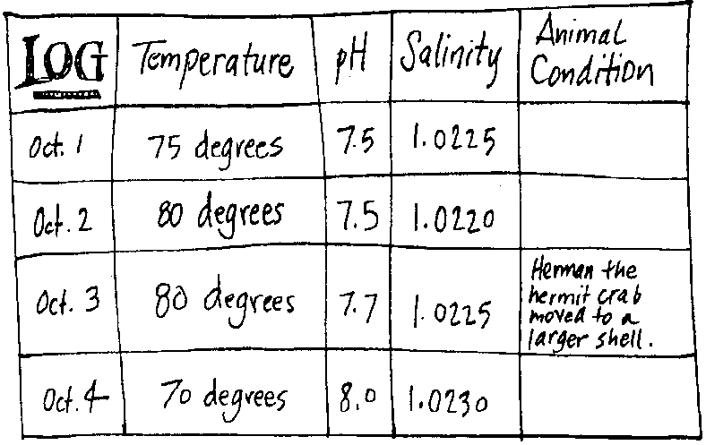
Monitoring
Have your students keep a daily log of their tank. Have them record information about water quality parameters: pH, temperature, salinity, turbidity (clearness) and any changes that they observe in the animals.

A sample log might look like this:

Procedure
Start with a simple plan. Later you may see opportunities to expand your strategies. If rounding up all the equipment and monitoring small groups seems too complex at first, consider starting one “World in a Jar” to use as a demonstration for the whole class. Later, add jars as materials become available and you and your students gain experience and confidence. Take time with each step of building the life support system in a jar.

Students will benefit most from the real hands-on experience of building and managing their own “World in a Jar”. Have them work in small groups or individually.

To introduce the concept of a life support system, have students brainstorm the components of a life support system (e.g., space, air, food, moisture, climate, waste disposal; i.e., those things necessary to support life). List students’ ideas. Then tell them they could supply the parts of a life support system within the controlled environment of a gallon jar. Three or four living creatures will be able to live there. Have students describe ways they can build a life support system and control the environment (i.e., climate, air, space, etc.) within the jar.

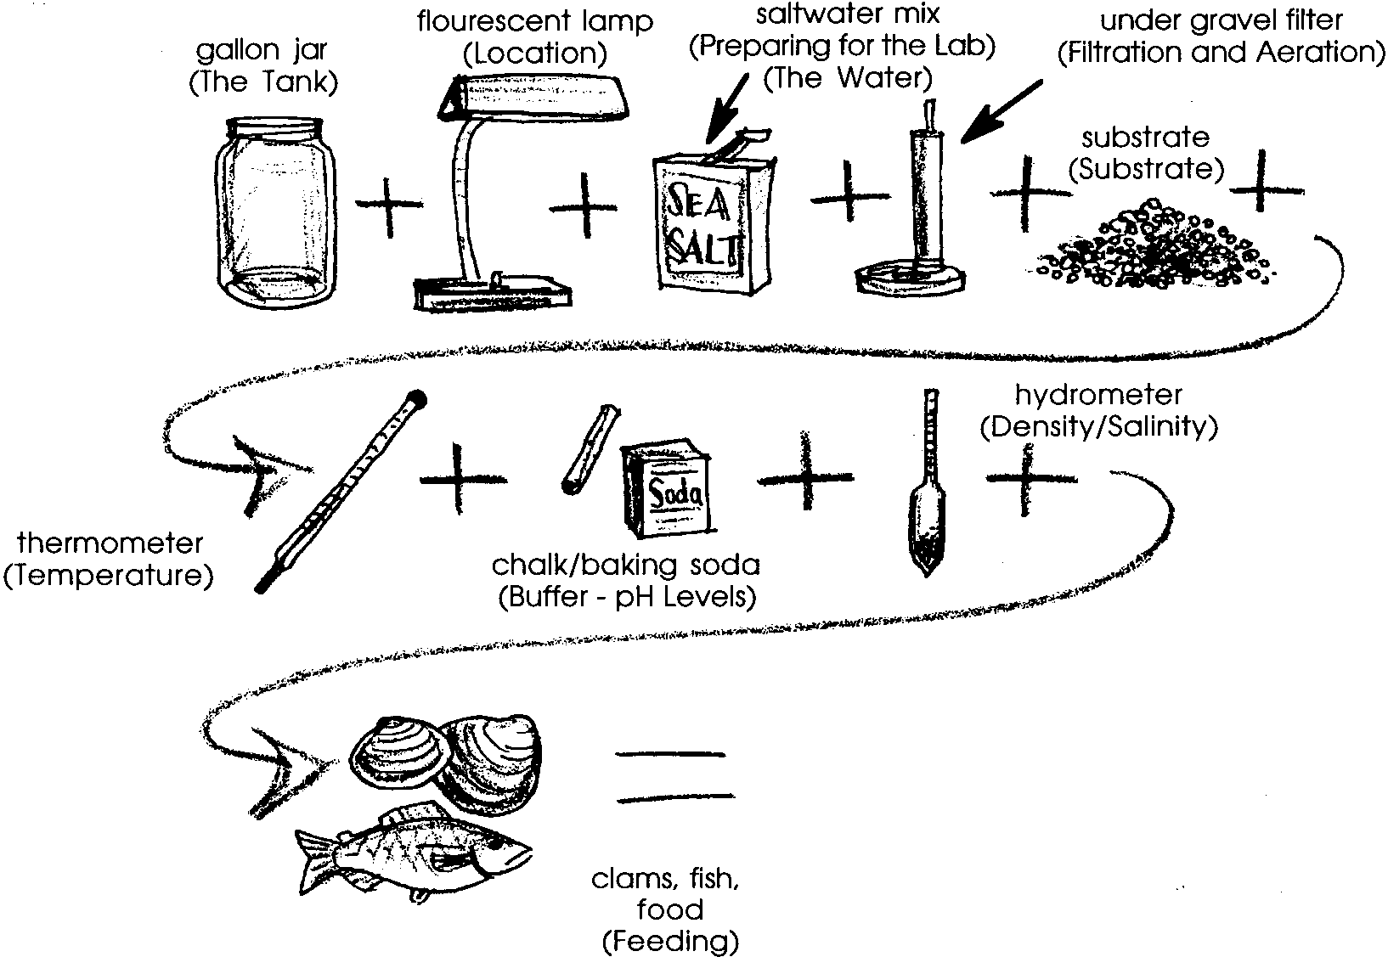
Have students clean their jars. Then lead them through the steps of building the controlled environments by following the steps provided in the previous paragraphs of this “Teaching Hints” section or by following the steps in the student section. The illustration below summarizes the basic steps to create a “world in a jar”:

After the “World in a Jar” is built, introduce the clams. Students will probably know a little about them and their natural environment. Explain about their adaptation for travel; i.e., their ability to live in their tightly closed shell in a suspended state until reintroduced into their natural environment. They “clam up” and with the help of ice to cool them, their metabolisms and life functions slow down. Tell students that these clams are alive and that they must be handled carefully.

Have students carefully place the clams in their “World in a Jar”. Then observe the clams over a period of time. Students may wish to name their clams. To watch the clams filter water and food, place several in small containers with some of their water. Then drop milk or food coloring near their siphons. Watch the movement of the colored water currents. Observe the way the clams move, and dig into the substrate with their feet.

From this introduction, students will be able to make comparisons and contrasts with other closed systems on earth. Each creature on earth is adapted to its habitat. Themes such as the following may emerge: 1) many life support systems exist, 2) ecosystems are interdependent, 3) earth is a closed life support system.

Have students keep logs as they monitor and manage their “World in a Jar”. Have them draw conclusions, make predictions, create experiments and learn from failures and disasters. Disasters happen in the natural environment. Scientists study disasters to learn important principles and to try to avoid reoccurrence. You can use these closed systems to experiment with some of earth’s problems like overpopulation, pollution, waste disposal, global warming, watershed management, disease. You can see the food chain in process. As you lead your students through the rest of the activities in this guide, use the “World in a Jar” to stress concepts in aquaculture, physical parameters of saltwater at shorelines and in oceans, sealife adaptations (clams, fish, mammals), and management challenges people face concerning the oceans and the earth.

Aquaculture (raising water animals and plants) is a tricky business. Stress this concept with your students. Keeping the animals alive and healthy is most important.

Some of this Teacher Background material and the crossword puzzle are adapted from “A Saltwater World In a Jar” by Linda J. O’Dierno, New York Sea Grant; 111 Broadway, 17th Floor; NY 10006.

Key Words

aeration - mixing air and water to provide oxygen

algae - plants that grow in water

aquaculture - growing plants and animals in water

aquatic - in this case, having to do with the water environment

filter/filtration - strains and purifies water

hydrometer - in this case, a tool that measures water density

invertebrates - animals with no spine or back bones

marine biologist - a scientist who studies aquatic life

microcosm - a small world

oxygen - a colorless, odorless gas forming about 1/5th of the air

salinity - saltiness

tenant - one who rents or lives in a space

Extensions

1. Contact your county extension agent for information about local aquaculture projects. Arrange to visit those nearby.

2. Try aquaculture in your classroom. Contact your state fish and wildlife department for information about raising salmon or other fish in the classroom. Contact shellfish aquaculturists for information about raising shellfish in the classroom or at a beach, if you live near saltwater.

3. Visit a salmon raising project or a freshwater fish hatchery. Try to visit different types: hatchery, sea ranching, pen ranching.

4. Visit a fish hatchery, fish ladder, or salmon stream during the spawning season.

5. Visit a shellfish aquaculture project or an aquarium where animals are kept in tanks.

Answer Key

1 through 3. Answers will vary depending upon students’ observations and data. There could be many variables that influence survival. In general, the heartiest animals will be those still surviving. Encourage students to make hypotheses.

4. The most challenging part about maintaining the aquarium will vary with individual students.

5. Other things that aquaculturists have to watch are: salinity, temperature, overfeeding, and sunlight.

6. Aquaculturists face lots of problems in raising their crop. These include: predators, disease, providing food, feeding, marketing, harvesting, and maintaining water chemistry. This question is designed to encourage your students to reflect upon what they have previously learned about aquaculture.

Crossword Answer Key is on the following page.
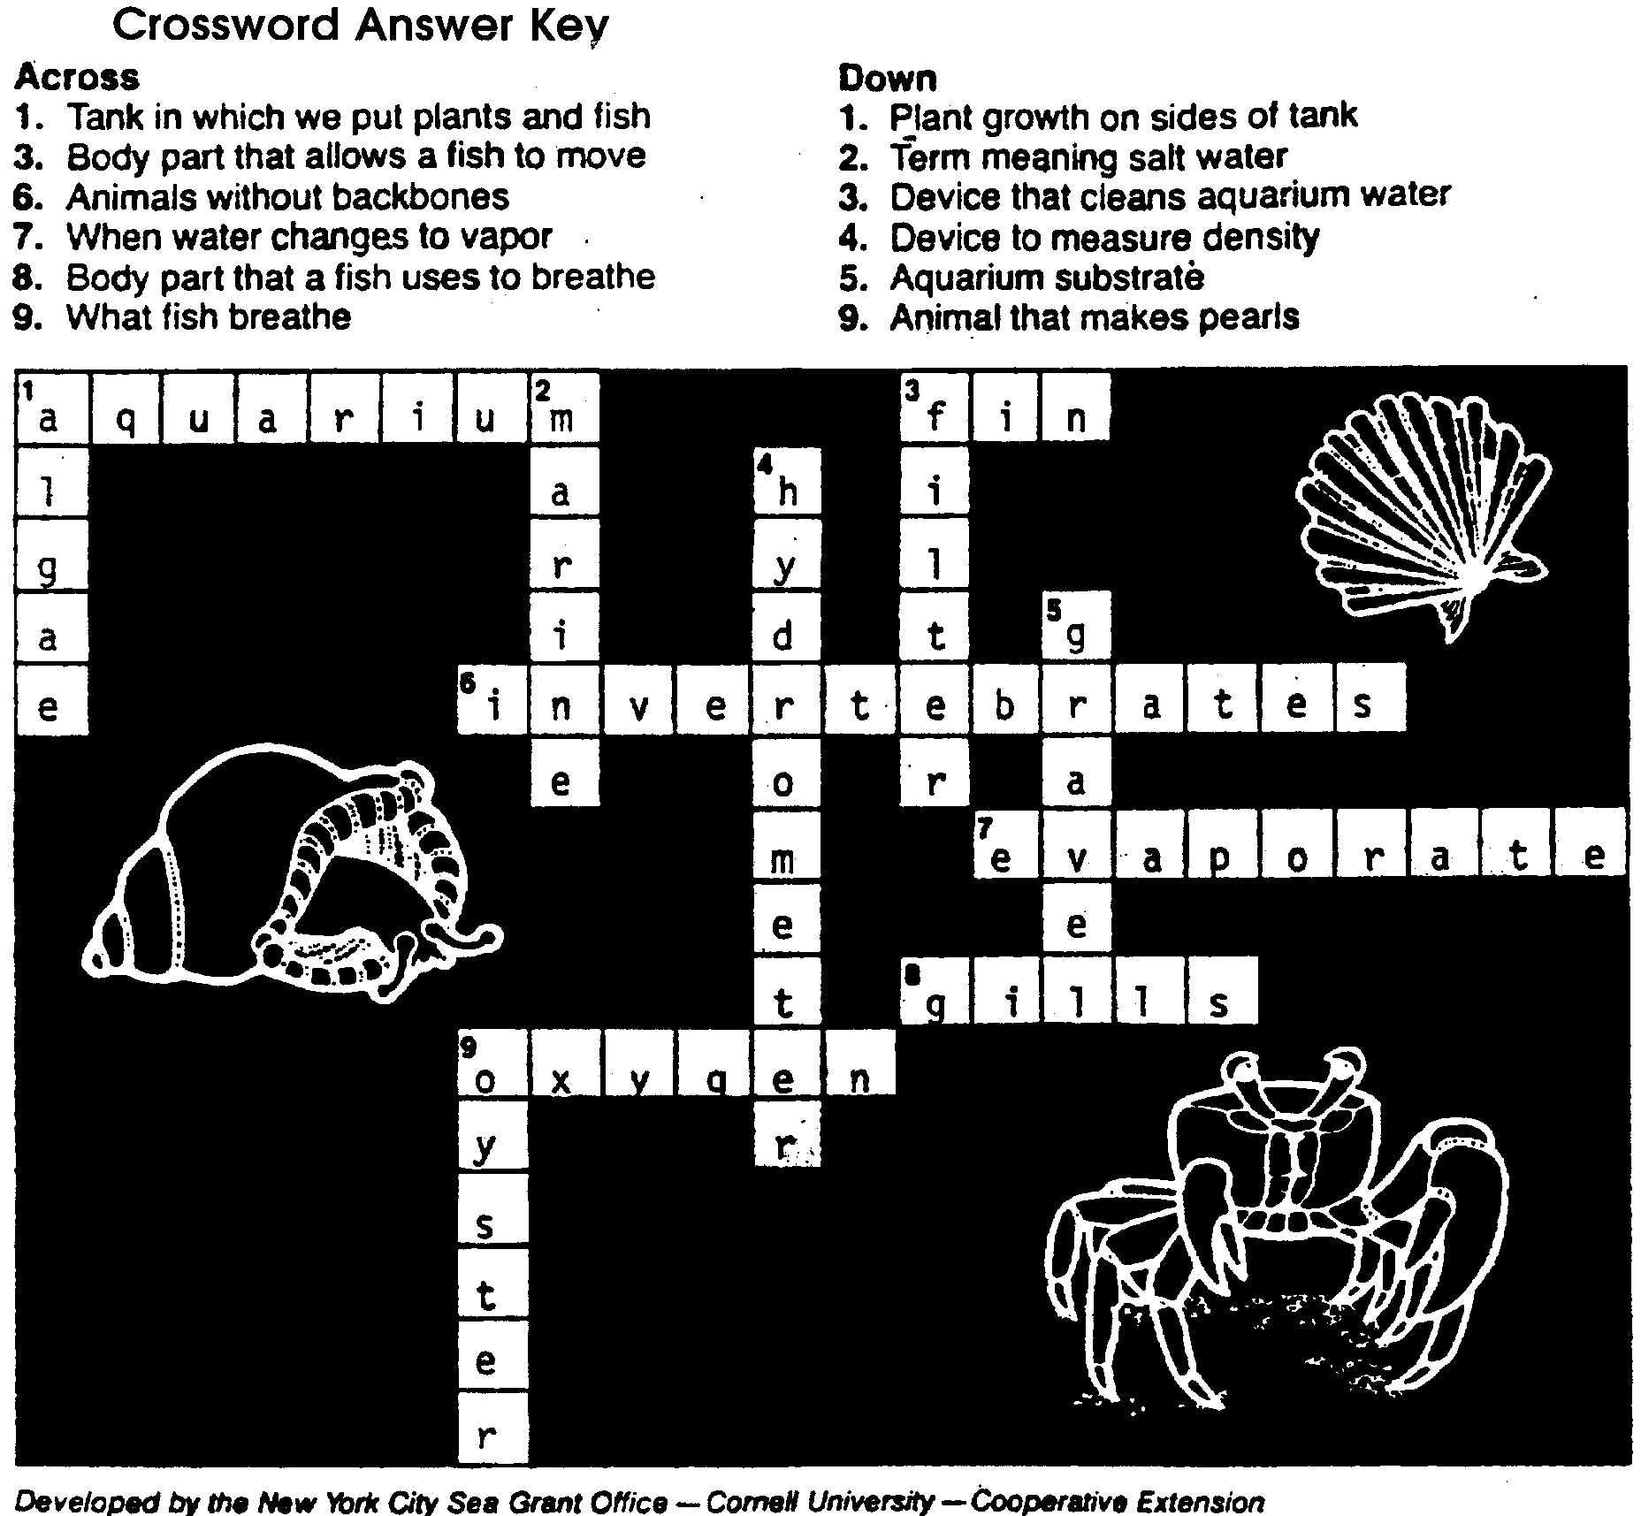
Crossword Answer Key

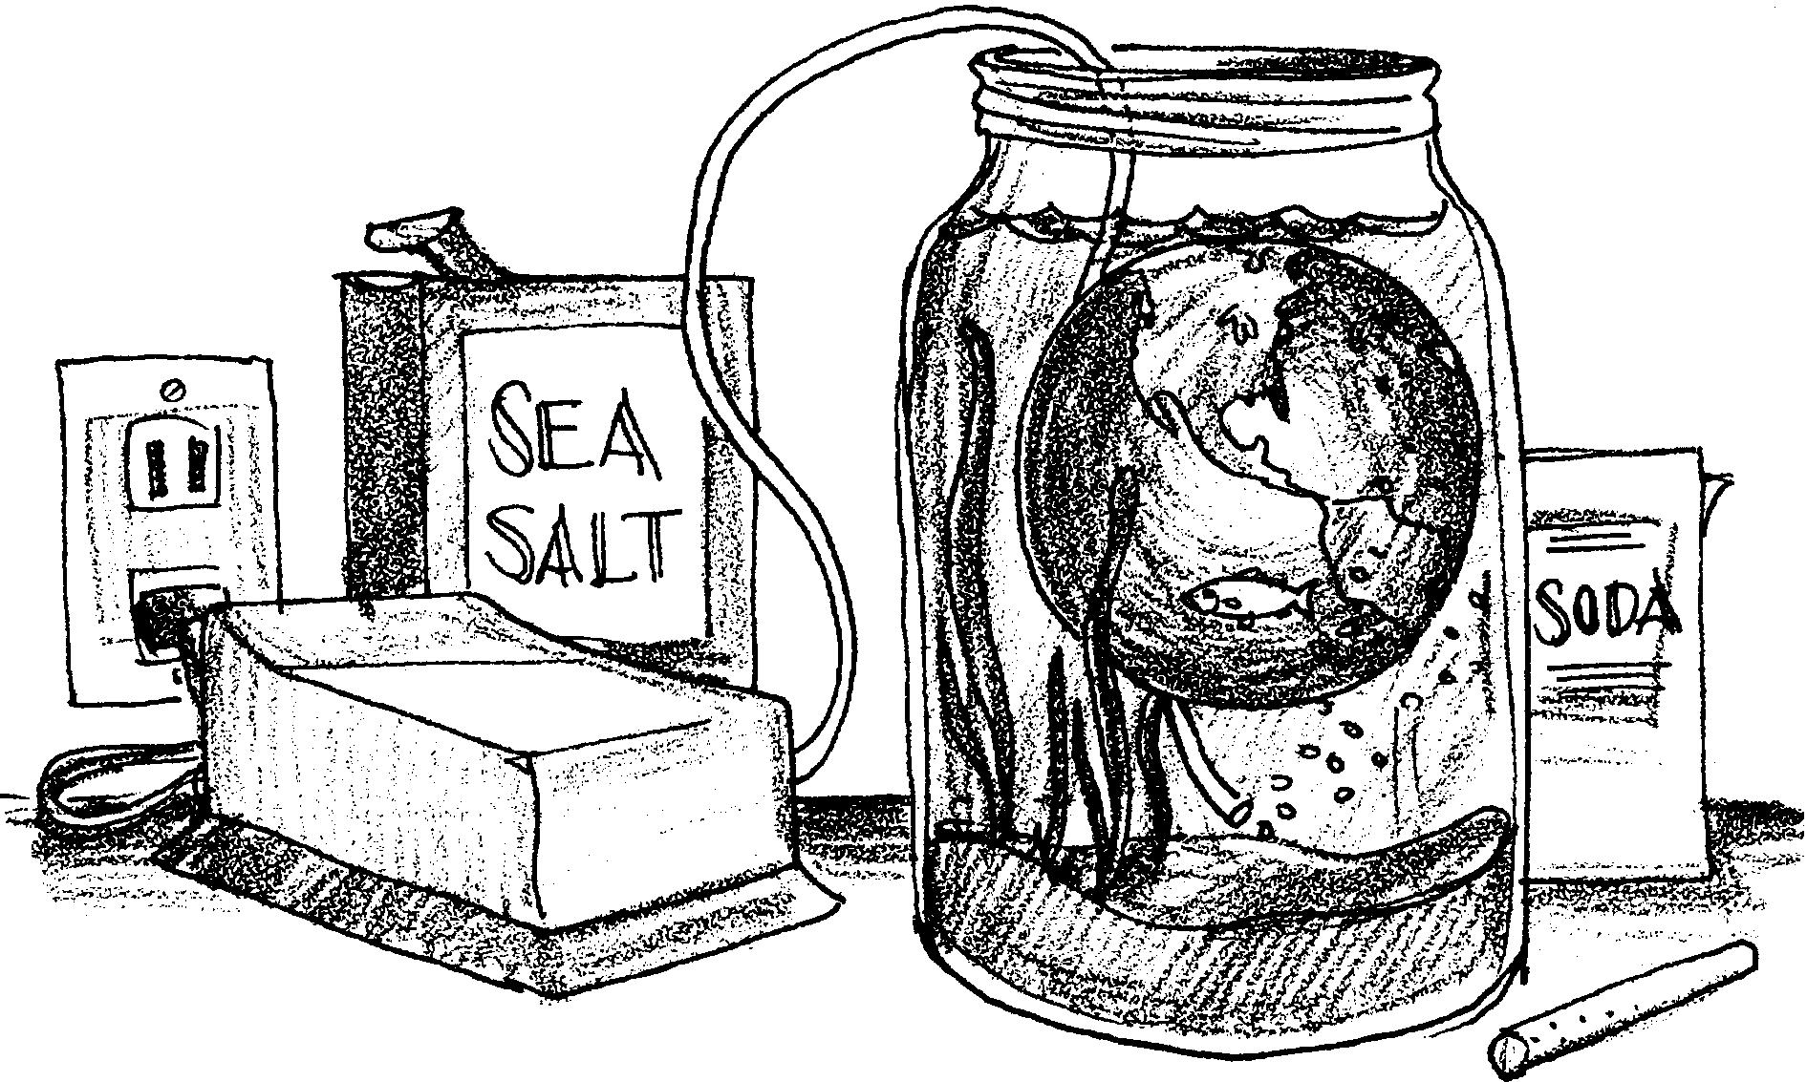
World in a Jar

Fish need lots of things to survive. They need clean water and a place to hide. People who raise fish for a living have to think about these things. Keeping the animals alive and healthy is most important. Here is your chance to raise and care for marine animals. Who knows? Maybe this will become your career. Good luck.

Materials - Here is what you will need:
• glass gallon jar
• seawater
• air pump
• filter plate
• airlift tube
• airline tubing
• gravel
• brine shrimp eggs
• live clams

Procedure - Here is what to do:

Step 1: Find a large glass jar with a wide opening at the top.

Here’s how: A one-gallon jar works well. Your teacher may have one for you. If not, jars can often be obtained at your school cafeteria. Or, you might be able to find jars at nearby restaurants.

Step 2: Clean the jar carefully.

Here’s how: DO NOT USE ANY SOAP. Soap will hurt marine animals. You can use baking soda or salt instead of soap.

Step 3: Find a good place to put your jar.

Here’s how: Pick a sturdy table or counter top. It should be away from heaters and direct sunlight. Too much sun causes algae to grow in your jar aquarium. The cooler the site, the better. The saltwater animals you will raise prefer cool water. The animals breathe the oxygen that is dissolved in the water. More oxygen can be dissolved in cooler water than in warm water. The animals take the water in through their mouths. Then they pass the water over their gills . The gills remove the oxygen from the water. The oxygen is used by the body tissues of the animal for such things as energy and growth.

Step 4: Place an aquarium filter in your jar.

Here’s how: To keep the oxygen level high, you will need an air pump. Use a goldfish bowl filter. The air pump forces air bubbles into the water. The air bubbles move the water.

Step 5: Place two inches of gravel over the filter plate at the bottom of the jar.

Here’s how: Crushed oyster shells or aquarium gravel work well. Bubbles from the air pump move the water through the gravel. The gravel filters out waste materials that collect in the jar.

Step 6: Add sea water to your jar.

Here’s how: If you live near salt water you could get seawater there. Try to collect the water a little ways from the shore where the seawater is usually cleaner. You can also make seawater. If you do, follow the directions on the bag or your teacher’s instructions.

Place a paper towel over your gravel. Carefully pour seawater into your jar. The towel will help keep the gravel in place. Fill the jar to its widest point. Leave room for air at the top of the jar. Remove the towel.

Step 7: Connect airline tubing from the airlift tube to the air pump.

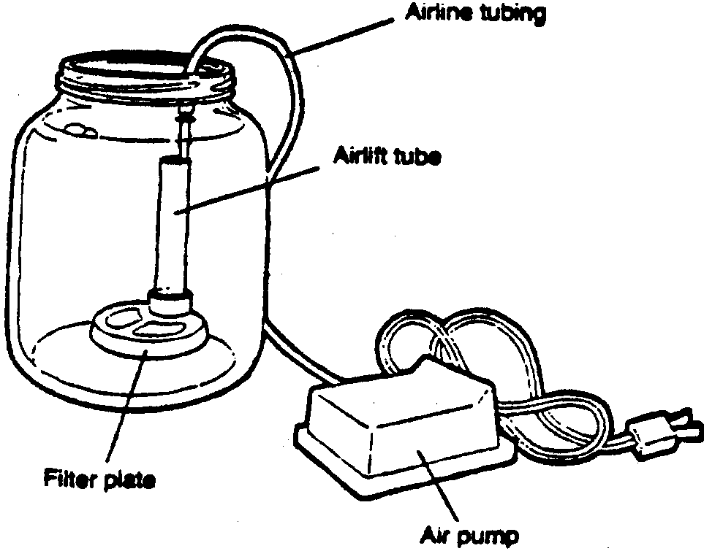
Here’s how: Push one end of the tubing over the air lift tube. Push the other end onto the air pump. Plug in the air pump. Bubbles should leave the airlift tube.

Step 8: Place a clam in the jar to condition the water. Feed the clam brine shrimp.

Here’s how: Your teacher will give you a live clam. Live clams can be found at the beach or a seafood store. At first, the clam will be your only tenant.

Feed the clam brine shrimp. You can raise your own brine shrimp. Follow the directions on the bag of eggs from the pet store.

Overfeeding is a problem. Only feed what your clam can eat in about five minutes. This keeps the jar from becoming overcrowded with sea life. Remove excess brine shrimp. You can do this by sucking them out with a turkey baster.

Step 9: Once a week take out about half the water and replace it with new seawater.

Here’s how: Mark the level of the water on your jar. Then pour out about half of the water. Add water that you have mixed or have collected from the seashore. Add enough water to bring the level up to your mark.

Step 10: After two weeks you can add other animals.

Here’s how: Your jar can support two or three small animals. No more than four clams should be in a jar at one time. Usually invertebrates (animals without backbones) are the best tenants for a small aquarium like your jar. Hermit crabs are a good choice. You will need to give them some larger shells for new homes to move into. If any of your animals look sick, remove them at once. You can place them in a “hospital tank”.

Step 11: Check the temperature of your water every day.

Here’s how: Put a thermometer in the jar. After two minutes read the temperature. Write it down along with the date. The best temperature is the one the animal is used to in its natural habitat. This is usually cooler than room temperature. If the temperature of your “World In A Jar” becomes too warm, try adding an ice cube to the water every morning. This cools the water. You can insulate your jar to keep it cooler, too.

Step 12: Add fresh water to keep the water level constant.

Here’s how: Over time, water will evaporate from your jar. When water evaporates, the salt is left behind. The water becomes more salty. Add fresh water to bring the water level up to your water mark. You can measure the “saltiness” (salinity) with a tool called a hydrometer. Use a hydrometer once a day to measure the salinity. Your teacher will give you the correct hydrometer reading for your water temperature. Record your results.

Step 13: Keep a daily log of your tank.

Here’s how: Record information by writing down the temperature and salinity measurements you took. Note any changes that you observe in the animals. Here is a sample log. Use the sample to make your own log form.
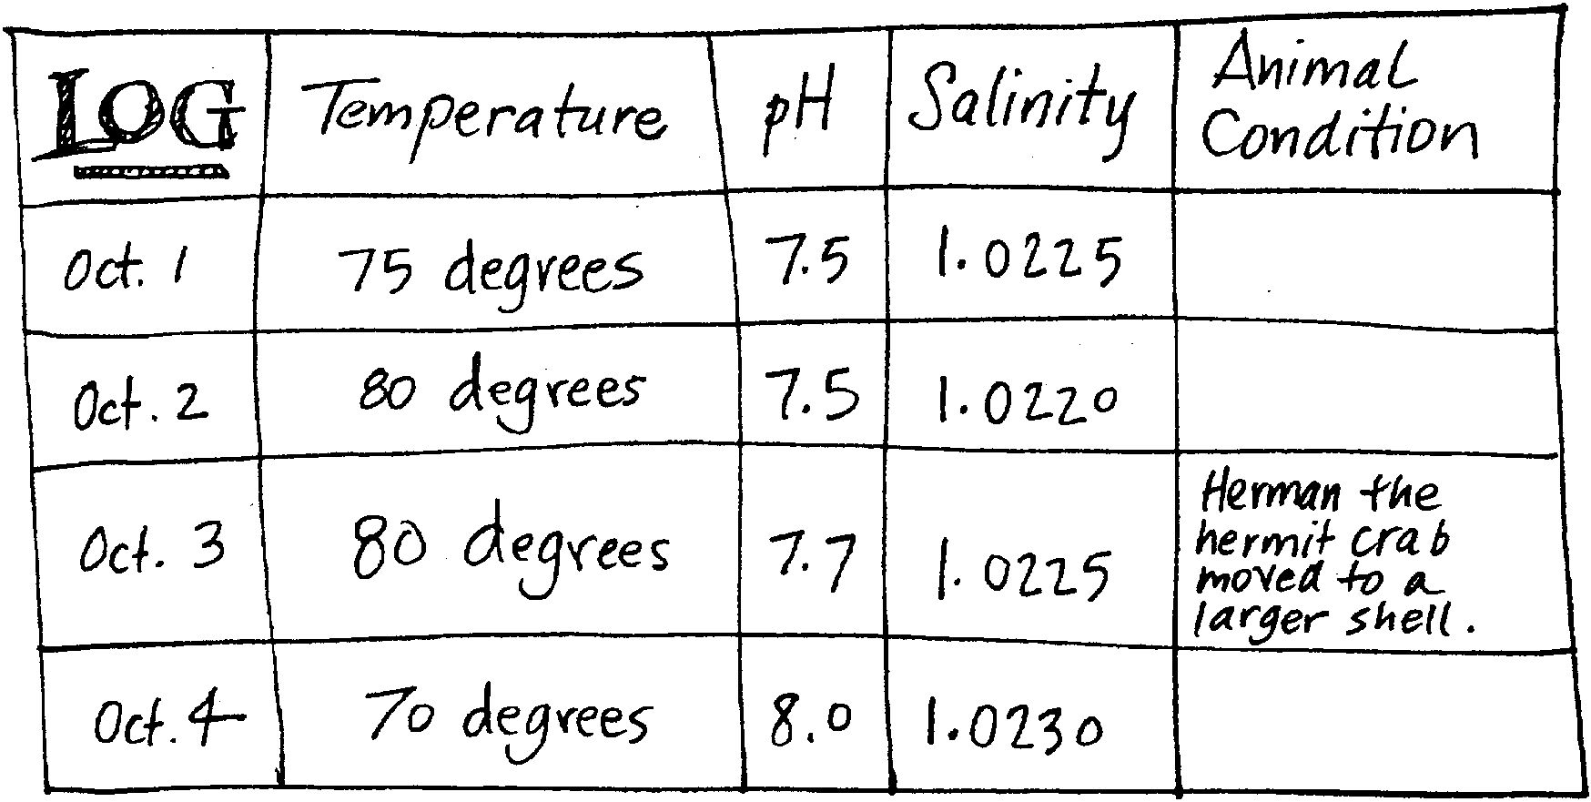
Results - Here is what happened

After three weeks of keeping your aquarium, answer these questions.

1. Have all of your animals survived? If not, which ones survived and which ones did not?

2. Which ones survived the best and why do you think they did?

3. Why do you think some of the animals did not survive?

4. What was the most challenging part about keeping your aquarium?

5. People who raise marine animals have to notice many things. They have to watch the oxygen level of the water. What are two other things they have to watch?

a.

b.

6. What are some problems that people who raise marine animals might face in raising their crops?

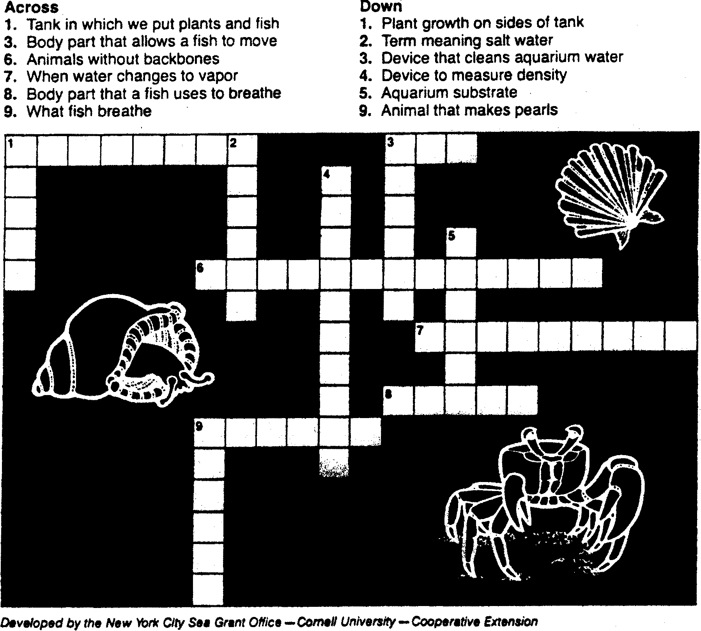
HERE IS A CROSSWORD TO HELP YOU REMEMBER WHAT YOU HAVE LEARNED!

