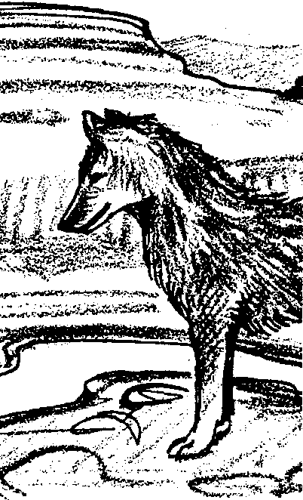
Columbia River Salmon: Legends and Stories of the 23rd Century
Adapted from a lesson by Kris Pfaff
FOR SEA/NSF Puget Sound Marine Habitats Institute

Key Concepts
1. Hope for the future is often expressed in stories.
2. Facts, knowledge and understanding of natural resources can be used creatively to shape solutions to natural resource problems.

Background

Many stories and legends have been told about the salmon of the Columbia River. Most of these stories originate with Native Americans of the region. One such story tells how Coyote, the greatest of the animal people, created the Columbia River and “peopled” it with salmon:

How Salmon Came to the Columbia River*

Speelyi, the Coyote god, felt sorrow in his heart for the Indian people. They lived along the great Wauna, the river we call the Columbia. They lived too on the bays and small streams along the coast, as well as the inland plains. Coyote was sorry for the Indian people because they spent so much time being hungry.

The Wauna had a stream bed but no water. Coyote asked Neahcanie (who built the world) if he could put water in the dry channel. Neahcanie told him it was perfectly all right. Coyote put water in the river. But this did not satisfy Coyote. Still the people did not have food. They had no way of saving their food. They could kill game, but the game spoiled.

Coyote thought of these things. Then he thought of salmon. There was the answer. Salmon could be dried. It would keep. The Indians in the hot interior through which flowed the Wauna could pound it with berries to make pemmican on the hot rocks. Yes, salmon was needed by the people. So Coyote put salmon in the river. They swam to all the other rivers and out to the sea and to other bays along the coast. So everywhere there was salmon.

*From a story recorded in William K. Peery’s book, And There Were Salmon, Binfords and Mort, Portland, OR, 1949.
Materials

For the class:

• microphone and recorder (or simulated ones)

• stools for the readers

• material for props as needed by the students.

Teaching Hints

In “Columbia River Salmon: Legends and Stories of the 23rd Century”, students use a “Readers’ Theater” to develop reading and speaking skills. They write original material for the theater, using what they have learned about watersheds and salmon in a highly creative way.

In Readers’ Theater, students are assigned reading parts from a written script. The parts are read rather than memorized. The students sit on stools or stand in front of the class to do this. You could use a microphone as though they were broadcasting the story over the radio. You might consider using props for sound effects, and masks and other props for visual effects, or making actual recordings of their reading!

This activity is designed to be the summarizing event in your study of salmon and watersheds. Students listen to the teacher read a Native American story about how salmon came to be in the Columbia River. They then listen and participate in reading a story designed for Readers’ Theater. Then they are asked to create their own story of the future, about how Columbia River salmon were saved and came back in abundance from present day numbers. Or they could create a story about how all the watersheds became healthy once again, free of pollution, erosion, and home to abundant fish and wildlife. The story could involve real scientists, spirits and imaginary beings, aliens, animals or plants, natural or human-made objects, or ordinary people. The idea is to let them stretch their creative talents to the limit.

Once the story line is written, have them write it for the Readers’ Theater, using a narrator and any characters they wish. Refer to the example “Why the Salmon Return Each Year”.

Finally, hold a Readers’ Theater. Use props as suggested above, or do it without props.

READERS’ THEATER EXAMPLE

WHY THE SALMON RETURN EACH YEAR

Reading Parts:
(1) Narrator
(2) Raven
(3) The Fog Princess
(4) Raven’s Friend

NARRATOR: Raven liked to eat fish. But in order to eat fish he must first catch them. On this day, Raven is fishing in his canoe with his friend, Gitsanuk.

RAVEN: Look at this, Gitsanuk! Another Bullhead! More bones to choke on! With all the water in this stream, one would hope for better fish.

GITSANUK: Look Raven, the fog approaches quickly. We should head for shore.

RAVEN: It is too late. I cannot see to guide the canoe. The fog surrounds us.

FOG PRINCESS: Do not be afraid. I will see you safely to shore.

RAVEN: Who are you? How did you get in our canoe?

FOG PRINCESS: Give me your hat.

NARRATOR: Raven and Gitsanuk watched in amazement as the Fog Princess (for that is who she was) gathered all the fog in Raven’s hat. When the fog was all contained, the sun shone again and Raven beached the canoe safely.

RAVEN: You have saved us with your magical powers. There is no one as good or beautiful as you. Will you stay with us and be my wife?

FOG PRINCESS: Yes, Raven. I will be your wife and my wedding gift to you shall be a new fish so delicious that you have never tasted another like it. Gitsanuk, bring a bucket of water. Now watch as I dip my fingers into it.

GITSANUK: Look, a golden fish. I shall build a fire.

RAVEN: Yes, we must cook it at once.

GITSANUK: See how well the new fish roasts. The smell is truly wonderful.

RAVEN: And the taste is more wonderful still. Wife bring us more of these fish.

FOG PRINCESS: Your hunger is now cared for. I cannot produce that which is not needed.

RAVEN: I said I want more fish! Unless you produce them at once, I shall be angry at you!

NARRATOR: Just then, where the day had been still, a wind rose and shook the leaves from the trees. Raven and Gitsanuk were soon so covered with leaves that they could not see. Then, as quickly as it had begun, the wind stopped and the leaves floated to the ground. When Raven looked up, he saw that the Fog Princess had gone.

GITSANUK: Raven, look to sea. The fog disappears there and the Princess with it. There, she is gone! Your selfishness has cost you dearly.

NARRATOR: And Raven hung his head in shame. But as we know, a wonderful thing did happen! Even today, the salmon return to the Indian streams once each year and it is said that the Fog Princess brings them... just enough each year to keep the tribe from hunger.

The End

Key Words

erosion - the natural process of moving soil and rock material from any part of the earth’s surface

pristine - original, pure and uncorrupted

Extensions

1. Have students make masks to use in their Readers’ Theater presentations. Hold a presentation for the entire school, or for special community events.

2. Have a professional storyteller come to your school and tell stories to your class, the entire school, or hold a story-telling workshop for the teaching staff.

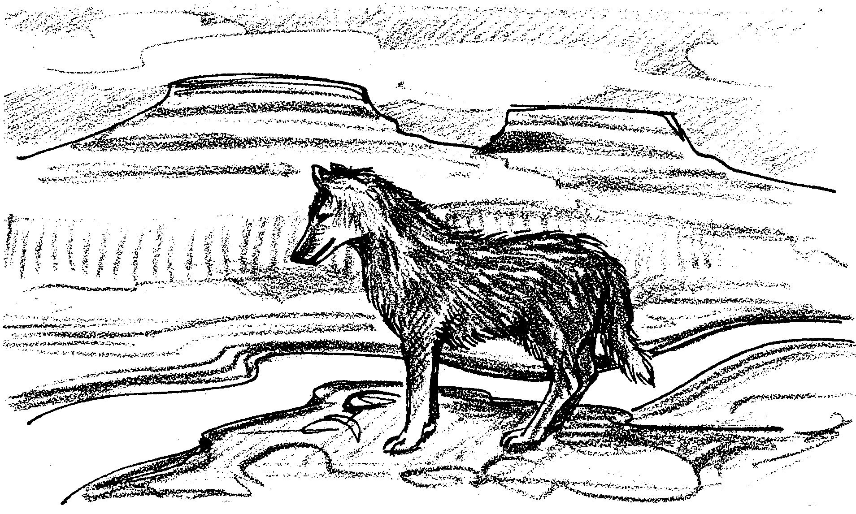
Columbia River Salmon: Legends and Stories of the 23rd Century

For hundreds of years, people have lived in the watershed of the Columbia River. All that time they have told stories and legends about salmon. What stories and legends will people tell about the salmon in the 23rd century? How will the salmon be saved? Will the watershed once again be as it was? Will it be free of pollution? Will it be full of salmon and other fish?

Writing Your Own Play

Think about these questions. Then write a short story about how the salmon and the watershed will be saved. Start by making an outline of your story. Then, make up characters for the story. They can be real or imaginary. They can be animals or plants. They can be magic and powerful beings, or objects that come alive. They can be aliens, scientists, ordinary people, or anything and anyone you can think of. Use your knowledge of salmon and watersheds to guide your imagination.

When you have outlined a story, write it with speaking parts. Use “Why The Salmon Return Each Year” as a guide. We will hold a Readers’ Theater later to present your stories.

