Investigating a Declining Resource:

Salmon on the Columbia

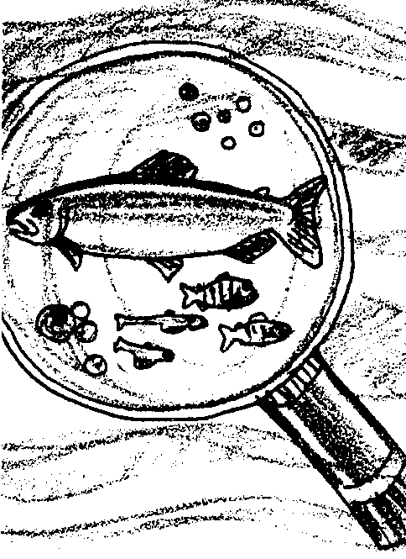
Key Concepts
1. Salmon have complex life cycles that depend on good quality habitat for successful completion.
2. Many factors contribute to the decline of salmon in the Columbia River watershed.
3. Humans can do things that contribute positively to the recovery of Columbia River salmon.
4. Groups of students can solve problems and accomplish tasks if they respect each other’s right to speak and take part in a solution.

Background

The Columbia River begins as a tiny stream that empties into Windermere Lake, a body of water wedged between the Selkirk and Rocky Mountains in British Columbia, Canada. From these mountains and this lake, the Columbia emerges as a full river, heading toward Washington State and Oregon. On its 1250 mile course, it collects the flow of at least 150 tributaries, many of which are complex river systems in their own right. At the mouth, the river is two and one-half miles wide, carrying more water on average than any river system in North America, except the Mississippi, MacKenzie, and Saint Lawrence. Its 259,000 square mile watershed drains large parts of British Columbia, Washington, Oregon, Idaho, and smaller parts of Montana, Wyoming, Utah, and Nevada.

Columbia River Drainage System
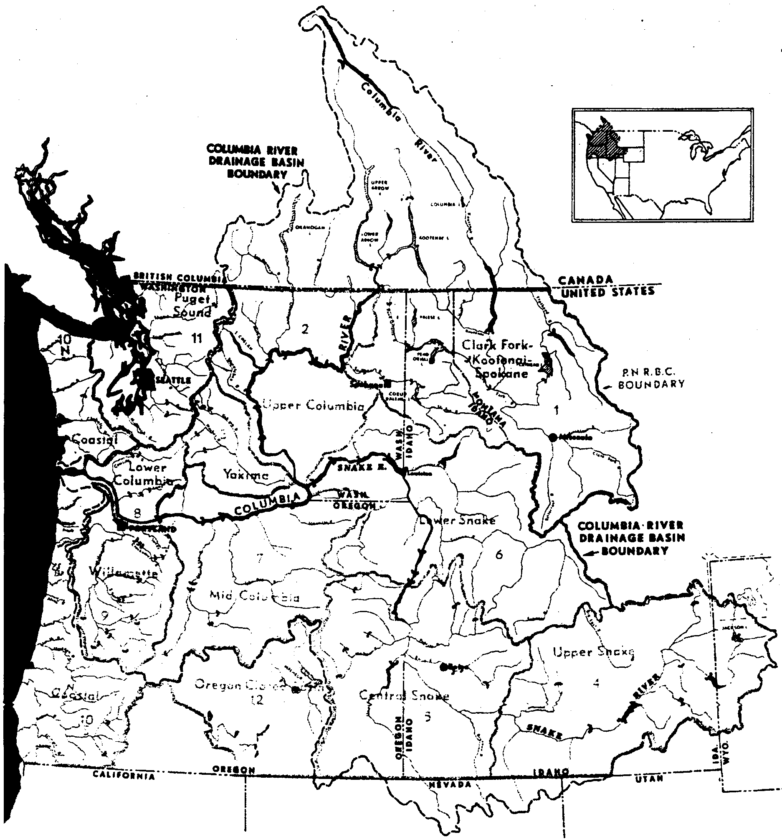
The Columbia River System is synonymous with salmon. Originally there were more Chinook, coho, and steelhead trout in the Columbia watershed than in any other system in the world. Captain Clark of the Lewis and Clark Expedition noted, on his journey down the Columbia near the site of Celilo Falls, “The multitude of this fish is almost inconceivable. The water is so clear that they can readily be seen at the depth of fifteen or twenty feet, but at this season they float in such quantities down the stream, and are drifted ashore, that the Indians have only to collect, split and dry them on the scaffolds.”

Biologists believe that the Columbia River system supported 15 million wild salmon and steelhead trout in the 1860s. Today, the total run is about 2 million fish, most of which are from hatcheries. What happened to these vast wild runs? What can be done to halt the decline and begin to improve the odds for salmon?

The construction of dams has gradually reduced the areas accessible to anadromous fish, those fish that spend part of their lives in freshwater and part in salt water. This is especially true in the valuable salmon-producing tributaries of the upper watershed of the Columbia.

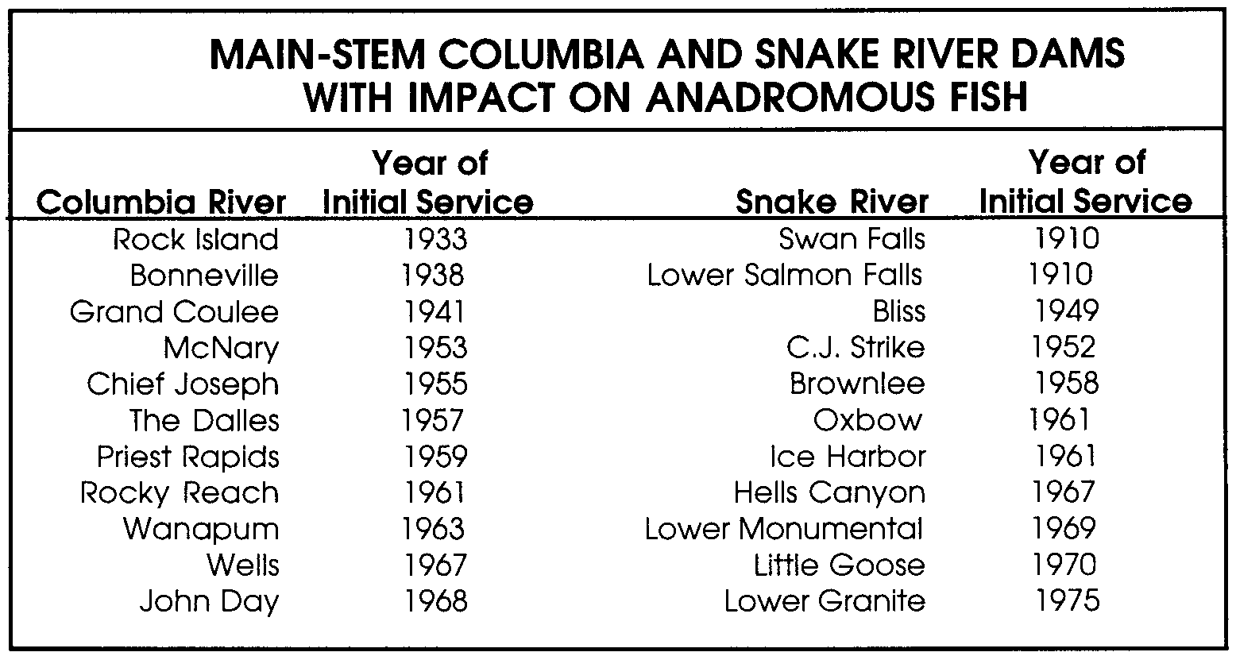
While irrigation and hydroelectric dams were built on the upriver tributaries early in the 20th century, hydroelectric development of the main-stem Columbia and Snake rivers did not get underway until construction of Rock Island Dam in 1933. Access to over 500 miles of the upper Columbia River, excluding tributaries, was blocked by the construction of Grand Coulee Dam in 1941. Another 52 miles of the main stem were lost with the building of Chief Joseph Dam, the present upstream limit of salmon and steelhead in the upper Columbia River. Over 50% of the originally inhabited main stem of the Snake River is no longer accessible to anadromous fish. Hells Canyon Dam now limits access to the lower 247 miles of this stream. In the Columbia River only 50 miles of free-flowing stream remain near Pasco, Washington. The main stem Snake River has also been impounded, and presently only 100 miles of natural stream remain between Lower Granite and Hells Canyon dams. Location, completion dates, and description of major main stem Columbia and Snake dams appear in the table below.

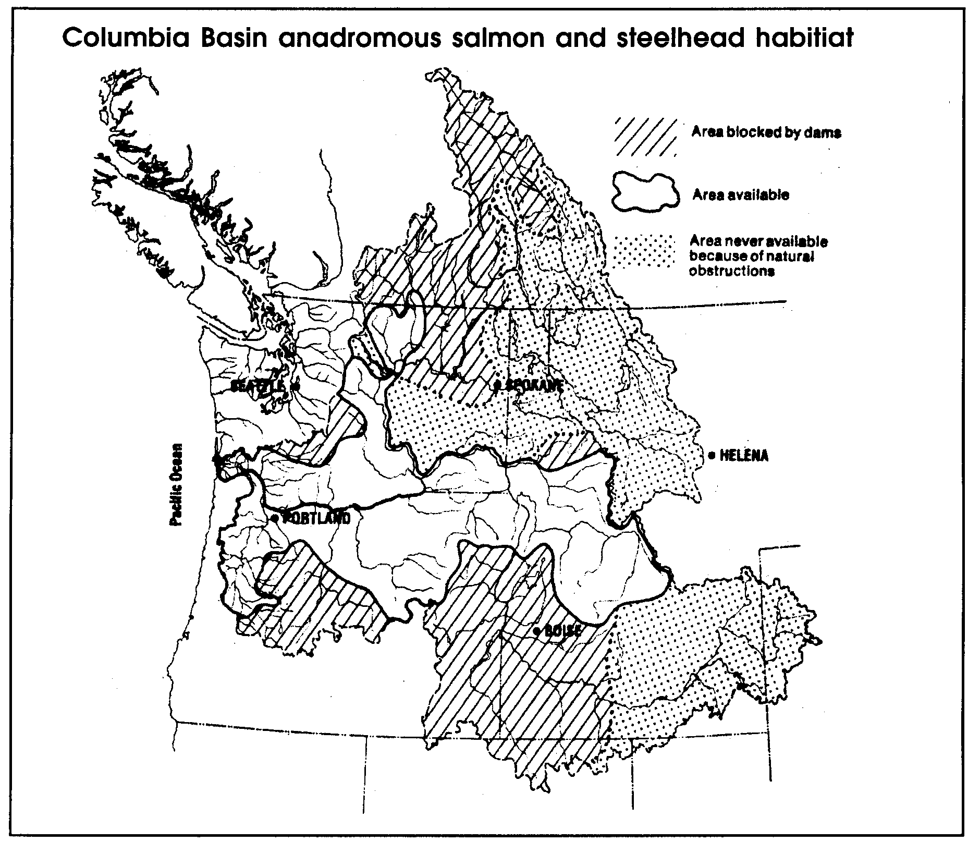

Main stem dams further reduced production of salmon and steelhead by creating reservoirs that inundated natural streams and by causing mortality of downstream migrating juveniles and upstream migrating adults. The reservoirs which slow the water flow have increased water temperatures to levels that at times are detrimental to salmon. The reservoirs and slow water flows have also favored the increase of populations of fish predators, especially the northern squawfish. Dam-related causes of mortality include delay of migrating adults, turbine injury and death to juveniles; and, in periods of high water and spill, nitrogen super-saturation which gives fish the “bends”.

Historically, all salmon and steelhead were wild fish produced in the natural stream environment. As compensation for the loss of wild salmonid production, many artificial propagation facilities (hatcheries) were built throughout the basin. Artificial production now accounts for about three-quarters of all fish returning to the Columbia River System.

A great deal of debate now centers on the benefits and drawbacks of hatchery production. Each year, millions of young salmon are raised in hatcheries and released into streams. About 80-90% of the eggs raised in hatcheries successfully hatch. Since a large number of eggs are successfully raised from just a few parent fish, the offspring are genetically very similar. Hatchery salmon are generally abundant in the ocean and rivers, although in some years even hatchery fish don’t survive well.

On the other hand, many wild salmon stocks are seriously low in numbers. Many biologists believe, wild salmon are more likely to survive and reproduce than hatchery salmon. They say that wild salmon show greater genetic diversity and would therefore be better able to withstand catastrophic changes in their environment.

At sea and in rivers, hatchery salmon and wild salmon usually swim together. At the spawning grounds, hatchery salmon can mate with wild salmon. This leads to the loss of some of the traits in wild salmon that help them live long enough to reproduce.

In addition, hatchery fingerlings dumped into a stream can disrupt a population of wild fingerlings, competing with them for food, and forcing them out of the area thereby reducing the chances of survival for the wild fish.

In some locations, wild salmon are captured to provide hatcheries with eggs and sperm that will produce fish that can survive to become adults. Biologists are trying to maintain the genetic diversity of the wild populations but obtain the survival rates of hatchery populations. It is not an easy balance to obtain.

While these trials and studies go on, people still want to fish for salmon. You might guess correctly that trying to protect wild salmon while allowing fishing for hatchery salmon is a major problem to fishery managers.

Additional information may be found in the following:

Netboy, Anthony, The Salmon: Their Fight for Survival, Houghton Mifflin Co., Boston, 1974.

Washington Department of Fisheries and Oregon Department of Fish and Wildlife, Status Report: Columbia River Fish Runs and Fisheries, 1938-91, July, 1992.

Materials

For the class:

• Group A, B, C, D, and E clue cards in sets, one for each group.

• Large map showing Columbia River Watershed, or reproduced map from “Background” section.

Teaching Hints

“Investigating a Declining Resource” allows students to engage in fact-finding discussions in small groups, evaluate generalizations about Columbia River salmon stocks, determine possible causes of declines in these fish, and plan and deliver a presentation to the rest of the class on their findings and solutions.

This activity will build on their understanding of the salmon life cycle from previous studies in this unit, and reinforce the concept that all watersheds must be healthy in order to support fish and the rest of the ecological community in the watershed.

Note that the statements on the clue cards are generalizations of a very complex life cycle and equally complex environmental factors. Not all ramifications of the decline of Columbia River salmon are dealt with in this activity.

Procedure
1. Divide the class into five groups: (you can use more than one group per salmon life cycle stage in larger classes)
Group A - Spawning, Hatching, and Rearing in Streams
Group B - The Journey Downstream
Group C - The Ocean
Group D - The Journey Upstream and Back Home
Group E - Salmon Hatcheries

The first four groups represent stages in the life cycle of salmon, and the last group represents the part hatchery salmon play in the story of Columbia River Salmon.

2. Have the members of each group sit together. Pass out the clue cards as far as they will go. Some students may get more cards than others. Give students time to read over their clue cards.

3. Have the groups work independently to determine:

a. What problems can they find in the clue cards that could be important in the decline of Columbia River salmon?

b. Which problem do they think is most important?

c. What solutions do they think might work to solve this problem?

4. Ask each group to report to the class:
• the problems they found
• the problem they picked as most important, and
• possible solutions.

5. If time permits, have the groups develop murals to aid in the report. Or, have the group act out the problem in a skit.

Key Words

fish ladder - a series of ascending pools constructed to enable salmon or other fish to swim upstream around or over a dam

gene - the unit of genetic information passed along from generation to generation through mating

habitat - an area that provides an organism’s needs for water, food, shelter, and space

migration - traveling between seasonal habitats

predator - an animal that eats another animal

run - a population of fish that returns from the ocean at about the same time headed for the same place

spawn - the act of egg laying by the female and fertilization by the male

turbine - in this case, a machine with a revolving rotor with blades driven by moving water from a dam

Also, see “Key Words” in preceding activity, “The Long Wet Journey”

Extensions

1. The following activity, “Columbia River Salmon: Legends and Stories of the 23rd Century”, can be used as an extension of this activity.

2. Using all the information in the reports, have students make a circle diagram of a salmon life cycle, with all the obstacles and problems listed for each phase of the cycle. On the outermost border of the circle, have students write what must be done to solve those problems.

3. Have students do research in the school library or elsewhere to find out more about the problems uncovered and the solutions proposed.

4. Make up clue cards for a local watershed and fish. Your state or federal fish and wildlife agency may be able to assist you in selecting a relevant local example.

Answer Key

Answers will vary depending upon how students group the cards and what problems they feel are most significant. As with most complex problems, there is no one right answer. Encourage critical thinking and expect groups to be able to defend their choices. Additional life history information is found in the preceding activity, “The Long Wet Journey”.

Clue Cards Clue Cards
GROUP A: Spawning, Hatching, GROUP A: Spawning, Hatching,
and Rearing in Streams and Rearing in Streams

• Salmon lay their eggs in clean gravel on the stream bottom.
• Cool water running through the gravel brings oxygen to the growing eggs.

Clue Cards Clue Cards
GROUP A: Spawning, Hatching, GROUP A: Spawning, Hatching,
and Rearing in Streams and Rearing in Streams

• Young salmon need to find pools in the stream. In the pools, they can eat and grow.
• For many years, humans removed logs from streams. These streams had few pools in which young salmon could eat and grow.

Clue Cards Clue Cards
GROUP A: Spawning, Hatching, GROUP A: Spawning, Hatching,
and Rearing in Streams and Rearing in Streams

• Logs, and boulders in the stream form pools. The pools catch gravel for spawning.
• Clearing trees and shrubs away from the stream warms the water. Warm water can’t carry as much oxygen.

Clue Cards Clue Cards
GROUP A: Spawning, Hatching, GROUP A: Spawning, Hatching,
and Rearing in Streams and Rearing in Streams

• Poor logging, farming and road building lets soil wash into the stream gravel.
• Sometimes people keep salmon from spawning by chasing them in the shallow water.

Clue Cards Clue Cards
GROUP A: Spawning, Hatching, GROUP A: Spawning, Hatching,
and Rearing in Streams and Rearing in Streams

• Laws have been passed to protect streams from poor farming and logging.
• Salmon die after they spawn.

Clue Cards Clue Cards
GROUP A: Spawning, Hatching, GROUP B: The Journey
and Rearing in Streams Downstream

• People are building pools and gravel spawning areas. They are also making it easier for salmon to swim up and downstream.
• Young salmon swim downstream to the ocean. Salmon spend most of their lives in the ocean.

Clue Cards Clue Cards
GROUP B: The Journey GROUP B: The Journey
Downstream Downstream

• Many dams have been built on salmon streams. The dams hold water for farmers and make electricity.
• Dams slow the flow of water to the ocean. Northern squawfish can now live in the pools behind the dams. Northern squawfish eat young salmon.

Clue Cards Clue Cards
GROUP B: The Journey GROUP B: The Journey
Downstream Downstream

• Young salmon depend on the help of the river’s current. It carries them quickly to the ocean.
• Today, flushing lots of water over the dams is one way to help young salmon get to the ocean.

Clue Cards Clue Cards
GROUP B: The Journey GROUP B: The Journey
Downstream Downstream

• Water flowing through dams pushes the blades of turbines. The turbines make electricity. Young salmon are killed as they pass through these dams. As many as 95 out of every 100 young salmon die.
• Many dams have screens that help young salmon find a way around the turbines.

Clue Cards Clue Cards
GROUP B: The Journey GROUP B: The Journey
Downstream Downstream

• Young salmon may swim into irrigation canals. Sometimes they can’t get back to the river.
• Birds often eat the salmon as they leave the raceway after swimming around the dam.

Clue Cards Clue Cards
GROUP B: The Journey GROUP C: The Ocean
Downstream

• When salmon enter the ocean, they need lots of small animals to eat.
• Screens help keep young salmon from swimming into irrigation canals.

Clue Cards Clue Cards
GROUP C: The Ocean GROUP C: The Ocean

• A rich supply of floating plants means lots of food for the animals which salmon eat.
• Sometimes the weather brings cold water to the surface. The cold water helps a rich supply of floating plants to grow.

Clue Cards Clue Cards
GROUP C: The Ocean GROUP C: The Ocean

• Sometimes, the cold water stays near the ocean bottom. Then, few plants grow.
• In the ocean, salmon are eaten by other fish, birds, and marine mammals.

Clue Cards Clue Cards
GROUP C: The Ocean GROUP C: The Ocean

• Humans are a major predator of salmon in the ocean.
• Salmon may swim over 4,000 miles in their 2-5 year stay in the ocean.

Clue Cards Clue Cards
GROUP C: The Ocean GROUP C: The Ocean

• In the ocean, salmon are sometimes caught in illegal drift nets. The nets may be over a mile long.
• To protect the salmon, laws tell salmon fishers when and how they may fish.

Clue Cards Clue Cards
GROUP D: The Journey Upstream GROUP D: The Journey Upstream
and Back Home and Back Home

• Salmon use clues such as the smell or taste of the water. The clues help them to return to the stream in which they were born.
• Salmon have to battle strong currents, waterfalls, and dams to return to their home streams.

Clue Cards Clue Cards
GROUP D: The Journey Upstream GROUP D: The Journey Upstream
and Back Home and Back Home

• Salmon often travel hundreds of miles from the ocean to their home streams.
• Salmon have to find ways around dams to return to their home streams and spawn.

Clue Cards Clue Cards
GROUP D: The Journey Upstream GROUP D: The Journey Upstream
and Back Home and Back Home

• Grand Coulee Dam on the Columbia River has no fish ladder. This means that 500 miles of the upper river is blocked to salmon spawning.
• Most dams have fish ladders to help fish get around the dam. A fish ladder is a series of steps with water running through them.

Clue Cards Clue Cards
GROUP D: The Journey Upstream GROUP D: The Journey Upstream
and Back Home and Back Home

• It is hard for fish to pass a dam if the fish ladder is poorly designed.
• Salmon may not be able to reach their spawning streams in years with little rain or snow.

Clue Cards Clue Cards
GROUP D: The Journey Upstream GROUP D: The Journey Upstream
and Back Home and Back Home

• Humans catch salmon as the salmon swim upstream to their home streams.
• There are laws to protect salmon runs that are low in number.

Clue Cards Clue Cards
GROUP E: Fish Hatcheries GROUP E: Fish Hatcheries

• In hatcheries, about 80-90% of the eggs hatch.
• Millions of young salmon are raised in hatcheries each year. Most of these fish are released into streams.

Clue Cards Clue Cards
GROUP D: The Journey Upstream GROUP D: The Journey Upstream
and Back Home and Back Home

• Young hatchery fish and young wild fish eat the same food in the stream.
• Wild salmon are more likely to survive and reproduce than hatchery salmon.

Investigating a Declining Resource:

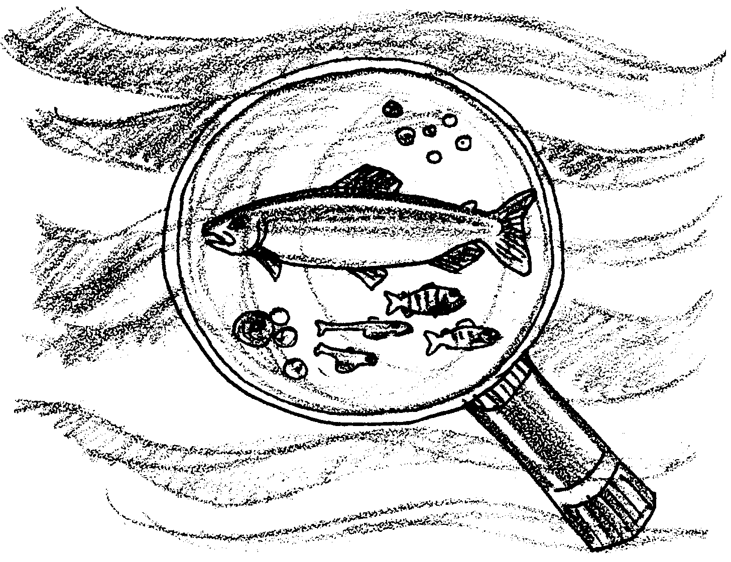
Salmon of the Columbia

Student Team Instructions

You will be a member of one of five groups. Each group will study a stage in the life cycle of Columbia River salmon.

The number of Columbia River salmon has been getting smaller. Scientists aren’t completely sure why. It may be from one cause, or from many causes.

Your group will be given a set of clue cards for a part of the life cycle. Your job is to use the clue cards to decide what problems are faced by Columbia River salmon.

Here’s What You Will Need:

• clue cards for each group

Here’s What to Do:

Procedure
1. Look at your group’s cards. Separate the cards into three groups:

Group I - Facts about Salmon

Group II - Problems Facing Salmon

Group III - Possible Solutions to the Problems Facing Salmon

2. Think about your group’s part of the salmon life cycle. Take turns reading the “Facts about Salmon” cards.

3. Now look at your “Problems Facing Salmon” cards. Spread out the cards so that all group members may read them. Take turns reading the cards. Which of the problems does your group think is the most serious? (Try to come up with one on which everyone can agree.) As you talk about the problems, be sure to let everyone in the group speak. Work out a way to be sure group members don’t interrupt each other.

4. Once you have all agreed on a problem, work out some solutions to it. The “Possible Solutions to the Problems Facing Salmon” cards may help. Again, let everyone speak if they want to. Have someone in the group keep a record of your solutions.

5. Make a summary report to the rest of the class. Be sure to report:
• the problems you came up with
• the problem your group thought was the most serious, and
• your solutions to the problem.

Decide which of you (more than one person is fine) will give the report.

