Hooks and Ladders

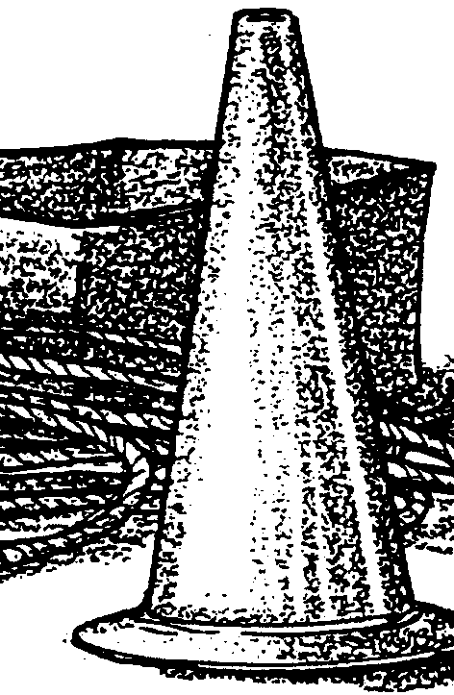
Key Concepts
1. Migration is part of the salmon’s life cycle.
2. Pacific salmon face many hazards as they go through their life cycle. These hazards are limiting factors on their survival.
3. Humans can help Pacific salmon survive by attempting to control some of the limiting factors from beginning to end of the salmon’s life cycle.
4. Limiting factors control populations of all living things.

Background

See “Teacher Background” sections for the previous three part activity, “The Long Wet Journey”.

Materials

For the class:

• large playing area (100 feet X 50 feet)

• about 500 feet of rope, string or six traffic cones for marking boundaries (masking tape can be used indoors)

• two cardboard boxes

• 100 tokens (3" X 5" cards, poker chips, etc.)

• a jump rope

Teaching Hints

In “Hooks and Ladders”, students simulate Pacific salmon and the hazards faced by salmon as they portray the life cycle of these fish. It is a highly active game that connects well to other activities (particularly “The Long Wet Journey”) in this unit.

You will want to run the activity several times, changing the conditions each time to get better salmon survival. The conditions that are changed can be related to changes fish managers might make in regulations to help fish survive to spawn.

On a playground, students could get dirty as they get down on all fours to simulate the fish ladder.

Procedure
1. Begin by asking the students if they know any fish that migrate in their area (mullet, shad, lake trout, striped bass, suckers, carp, and salmon are examples of fish that migrate to spawn). In this activity, students will learn about some of the characteristics of one species of fish that migrates as a part of its life cycle - the Pacific salmon.

2. This is a physically involving activity! Set up a playing field as shown in the diagram below, including spawning grounds, reservoir, downstream, upstream, and ocean areas. The entire game area needs to be about 100 feet by 50 feet. Assign roles to each of the students. Some will be salmon, others will be potential hazards to the salmon. Assign the students roles as follows:

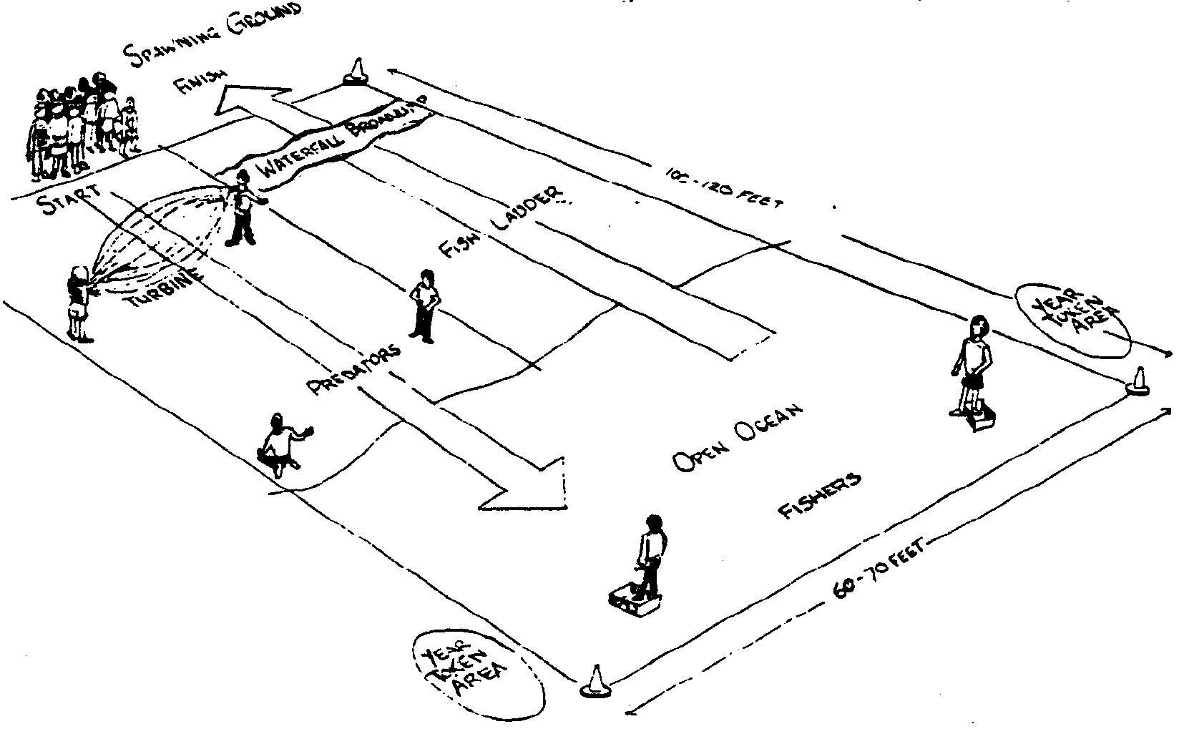
• Choose two students to be the turbine team. These are the ones who operate the jump rope which represents the turbines in a hydroelectric dam. Later in the simulation, when all the salmon have passed the turbine going downstream, these students move to the upstream side to become the waterfall-broadjump monitors (see diagram).

• Choose two students to be predatory wildlife. At the start of the simulation, the predators will be stationed in the reservoir above the turbines to catch the salmon fry as they try to find their way out of the reservoir and downstream. Often, fry that make their way through a dam raceway or spillway are momentarily stunned - this is when gulls and other predators can pick them off the surface easily. The students will represent these predators. Later in the activity, when all the salmon are in the sea, these same two students will patrol the area above the “broadjump” waterfall. There they will feed on salmon just before they enter the spawning ground, as bears might (see diagram of playing area).

• Choose two students to be humans in fishing boats catching salmon in the open ocean. These students in the fishing boats must keep one foot in a cardboard box to reduce their speed and maneuverability.

• All remaining students are salmon.

Note: These figures are based on a class size of 25 to 30. If the group is larger or smaller, adjust the number of people who are fishing and predators accordingly.

3. Begin the activity with all the salmon in the spawning ground. The salmon first move into the reservoir above the dam. They must stay in the reservoir while they count to 30. This simulates the disorientation that salmon face due to lack of current in the lake to direct them on their journey. During this time, the predators may catch the salmon and escort them ONE AT A TIME to the fish ladder area to become part of the fish ladder. The salmon then start their journey downstream.

A major hazard is the turbines at the dam. At most dams there are escape weirs or screens to guide migrating salmon past the turbines. The student salmon CANNOT GO AROUND the jump rope swingers, but they can SLIP UNDER the swingers’ arms if they do not get touched while doing so. A salmon dies if it is hit by the turbine blades (jump rope). The turbine operators may change the speed at which they swing the jump rope.

Note: Any salmon that “dies” at any time in the activity must immediately become part of the fish ladder. The student is no longer a fish, but becomes part of the physical structure of the human-made ladder now used by migrating salmon to get past barriers such as dams. The students who are the fish ladder must kneel on the ground as shown on the next page, a body-wide space between them.

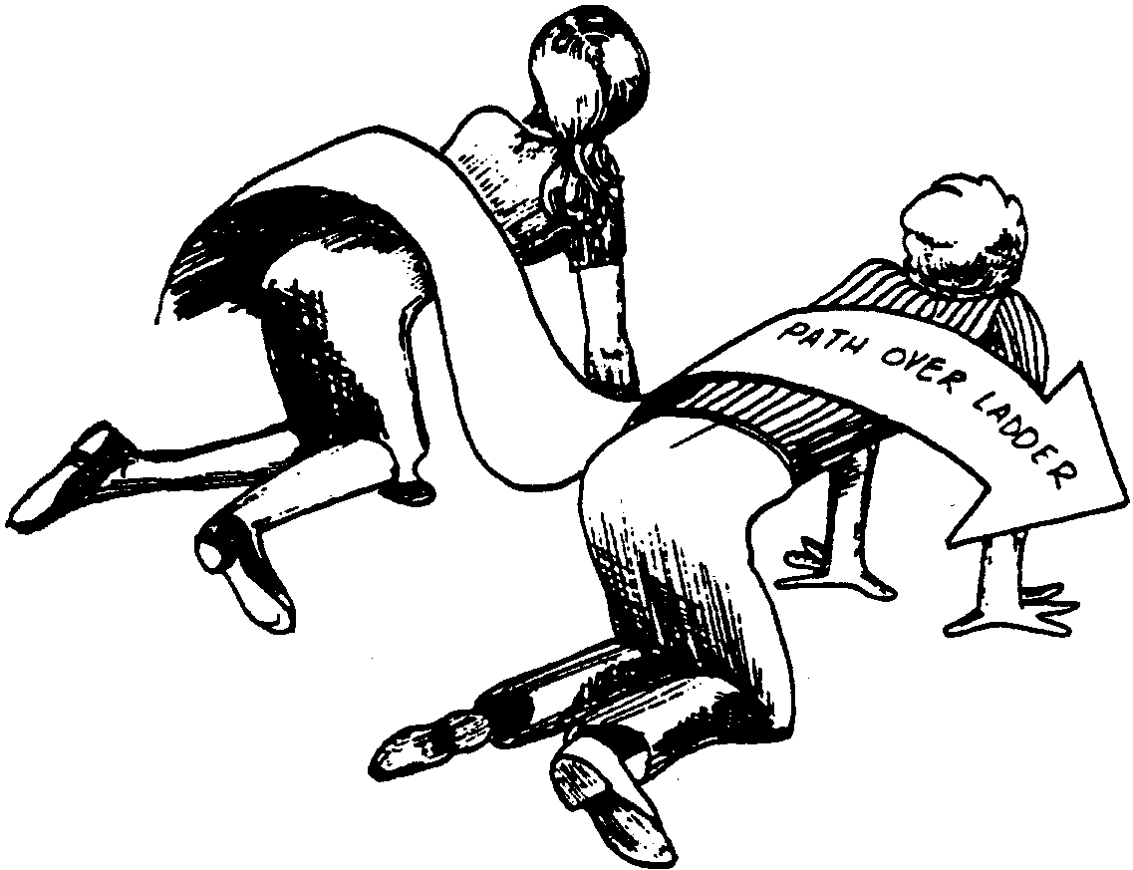
4. Once past the turbines, the salmon must get past the predators waiting for them below the dam. The predators must catch the student salmon WITH BOTH HANDS - tagging isn’t enough. Dead salmon are escorted by the predator to become part of the fish ladder. Later, the salmon who survive life in the ocean will use the structure of the fish ladder - by passing over it - to return to the spawning grounds.

Note: Both predatory wildlife in the last downstream area and the people fishing in the open ocean MUST TAKE DEAD SALMON TO THE FISH LADDER SITE. This gets the predators and fishing boats off the field regularly, helping to provide a more realistic survival ratio.

5. Once in the ocean, the salmon can be caught by fishing boats. The salmon must move back and forth across the ocean area in order to gather four tokens. Each token represents one year of growth. Once each fish has four tokens (representing four year’s growth), that fish can begin its upstream migration. The tokens can only be picked up one token at a time on each crossing. Remember, the salmon must cross the entire ocean area to get a token. The “four years” (or four crossings) make the salmon more vulnerable and thus they are more readily caught by the fishing boats. For purposes of this simulation, the impact of this limiting factor creates a more realistic survival ratio for the population before the salmon begin the return migration upstream.

6. Once four of the year tokens are gathered, the salmon can begin traveling upstream. The salmon must walk through the entire pattern of the fish ladder. This enforced trip through the ladder gives the students a hint of how restrictive and tedious the upstream journey can be. IN THE FISH LADDER, THE PREDATORS MAY NOT HARM THE SALMON.

7. Once through the ladder, the salmon faces the broad jump waterfall. The waterfall represents one of the natural barriers the salmon must pass through on the upstream journey. Be sure the jumping distance is challenging but realistic. The two former turbine students will monitor the jump. The salmon must jump the entire breadth of the waterfall to be able to continue. If the salmon fails to make the jump, then it must return to the BOTTOM OF THE FISH LADDER and come through again.

Note: To reduce the risk of accidents on hard floors when playing indoors, the broad jump waterfall may be changed into a stepping stone jump defined by masking tape squares.

8. Above the falls, the two predators who started the simulation as the predators below the turbines are now the last limiting factors faced by the salmon. They represent bears - one example of predatory wildlife. Again, remember that the predators must catch the salmon with both hands. If they do catch a salmon, they must then take the student caught to become part of the fish ladder.

9. The activity ends when all the salmon are gone before the spawning ground is reached - or when all surviving salmon reach the spawning ground.

10. Engage the students in a discussion, exploring such topics as:

• the apparent survival-mortality ratio of salmon

• the students’ feelings throughout the activity

• the role of the barriers

• the role of the predatory wildlife and the people fishing

• where the losses were the greatest and least

• what the consequences would be if ALL the eggs deposited made it to adulthood and completed the journey

• what seemed realistic about the activity and what did not

11. Ask the students what they could change to assure more survival of salmon (e.g., eliminate some of the predators - which might mean having to open a hunting season on them, place new rules on the people fishing or adjust the number of people fishing, stop the turbines for a time, etc.). Adjust the activity and run it again. Compare the number of survivors. Did the strategy result in more salmon? Why or why not? What are some of the disadvantages to your strategies?

12. If you are using this activity with the preceding activity, “The Long Wet Journey”, ask the students to finish the story of Tyee the Lucky at this time. Have some or all of the students read the finish of their stories aloud to the class.

13. Ask the students to summarize what they have learned about the life cycle of salmon, the salmon’s migration and limiting factors that affect salmon. Make sure the students have a clear working definition of limiting factors. Encourage the students to make the generalization that all animals - not just Pacific salmon - are affected by limiting factors. Ask the students to give examples. They might mention: availability of suitable food, water, shelter and space; the effects of disease, weather, and predation; and, changes in land use and other human activities.

Variation: Atlantic Salmon

This activity can easily be adapted to feature Atlantic rather than Pacific salmon. The most significant difference between these is that the Atlantic salmon can spawn more than once. Many Atlantic salmon make their migratory journey and spawn two or three times. All Pacific salmon die after their first spawning. To adapt the activity for Atlantic salmon, students are to make as many complete migratory trips as possible. After the activity is finished, ask students to report how many times they successfully completed the migratory cycle. Graph the data. Have the students explain how age influences mortality rates and susceptibility to limiting factors.

Key Words

fish ladder - a series of ascending pools constructed to enable salmon or other fish to swim upstream around or over a dam

limiting factor - factors that reduce the populations of living organisms

migration - traveling between seasonal habitats

navigate - to find one’s way on a journey between one place and another

predator - an animal that eats another animal

run - a population of fish that returns from the ocean at about the same time headed for the same place

spawn - the act of egg laying by the female and fertilization by the male

turbine - in this case, a machine with a revolving rotor with blades driven by moving water from a dam

Also, see “Key Words” in preceding activity, “The Long Wet Journey”

Extensions

1. Visit fish hatcheries that spawn migratory fish and find out how the hatcheries operate.
2. Develop a matrix comparing the life histories of various kinds of salmon, such as Chinook (king), coho (silver), chum (dog), pink (humpback), sockeye (red), and Atlantic.

3. Compare a local fish that migrates with the Pacific salmon. What are the similarities and differences?

4. Visit a dam to find out how migrating fish get around the dam.

5. Consider trying the activity with this twist:

In the last 100 years, salmon have experienced many new, human-caused limiting factors. Dams, commercial fishing, timber harvest and road construction have had tremendous impact on salmon populations. In 1991, the Snake River sockeye salmon was placed on the federal endangered species list. In the past, tens of thousands of sockeye would make the 900 mile return trip from the sea to Idaho’s mountain streams and lakes. There they would spawn and die. Their offspring would hatch and begin their early development in freshwater. The actual migration to the Pacific Ocean could be completed in as few as nine days. Today, that trip takes over 60 days. In 1991, only four Snake River sockeye salmon returned to their spawning ground.

To simulate these increases in salmon limiting factors, play several rounds of “Hooks and Ladders”. Allow each round to represent the passage of 25 years. Start in 1850. In that year, do not include dams or commercial fishing in the scenario. As time passes, add the human commercial fishing operations. Build dams (jump ropes) as the scenario progresses into the 20th century.

Describe some of the possible effects on salmon from increased limiting factors as a result of human activities. Discuss possible positive and negative effects on both people and salmon from these increases in limiting factors affecting salmon. When the activity reaches “the present”, predict what might happen to salmon in the future. Approaching this as a complex dilemma, discuss possible actions, if any, that might be taken to benefit both people and salmon.

6. Try adding “a sense of smell” to the activity. Divide the students into groups, simulating fish from different tributaries. Give each student group a container with an unfamiliar smell in it. Have the students in the group smell it, marking the bottom of the container by naming the creek they are from. The smell is the special odor that identifies their own “home stream”. Once they complete the cycle successfully, they have to “find” their home stream by smell without looking at the bottom of the container to see if it is theirs.
It is best to use smells that are fairly difficult to put a name to. Many spices work well for this. Be sure not to use any substances that produce toxic fumes. Construct the containers as shown below.
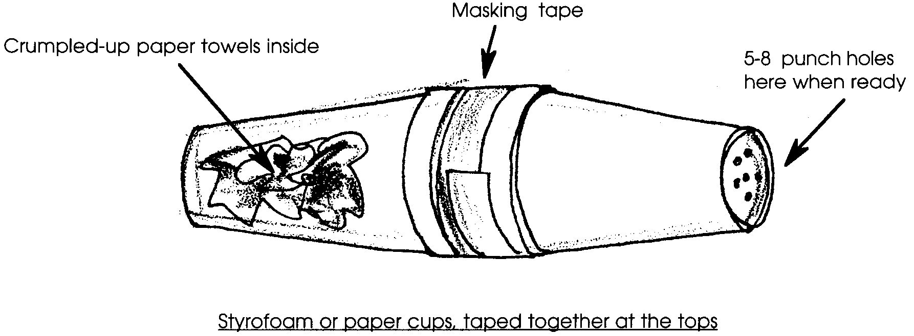
The crumpled-up paper towels inside serve to block any dry material from coming out of the cups, and absorb any liquid used to create the smell. Leave the cups taped together until you are ready to begin the activity, then punch holes in one end so the smells can escape.

Once the student groups have smelled the cup and named it, collect the cups. As they go through the life cycle, place the cups randomly on a table or in a box. This simulates a salmon having to “remember” the odor or taste of its home stream until the end of its life cycle.

Rewritten and adapted with permission from:

• “Hooks and Ladders”, Aquatic Project WILD, Revised Edition, U.S. Fish and Wildlife Service, Washington, D.C., and Western Regional Environmental Education Council, Inc., 1992, 1987.

• “The Comings and Goings of Coho: Life Cycle of the Salmon”, Water, Water Everywhere..., Oregon State University Sea Grant Program, Corvallis, OR, 1982.

