The Long Wet Journey: Race to the Redd

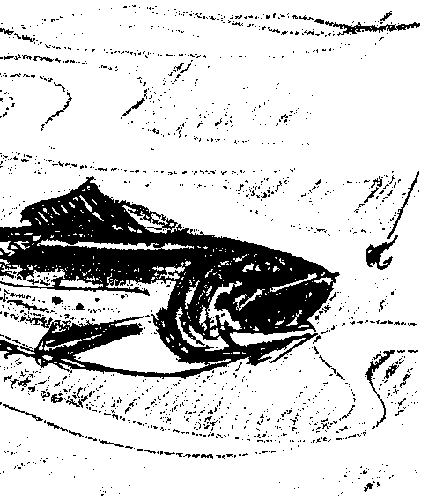
Key Concepts
1. Salmon have a complex life cycle that takes them thousands of miles from fresh water to the oceans and back again.
2. Salmon are faced with many hazards to their survival during their life cycle.
3. From thousands of eggs that are laid in redds, a very small number of salmon complete their life cycle.
4. People have caused problems for salmon, but they are working to solve many of those problems.

Background

Pacific salmon are an example of one of the most spectacular of those many fish that live part of their lives in one habitat and then migrate to another. This activity continues an investigation of the life cycle of Pacific salmon.

Background for “The Long Wet Journey: Race to the Redd” is found in the previous activity, “The Long Wet Journey: The Cycle Begins”.

Materials

For each group of three or four students:

• “Hazardous Journey” game board and cards

• single die

• salmon markers

• stopwatch or clock

• “Hazardous Journey” activity sheet

For each student or pair of students:

• “The Long Wet Journey: Moving Downstream” story reading pages

Teaching Hints

“The Long Wet Journey: Race to the Redd” continues the introduction to the life cycle of Pacific salmon begun in the previous activity, “The Long Wet Journey: The Cycle Begins”. A story reading centers around the upstream migration phase of the life cycle of a female Chinook salmon. The “Hazardous Journey” activity, a migration simulation board game, complements the story reading.

The “Hazardous Journey” activity requires the duplication of the included game board. Salmon markers will need to be cut out prior to beginning the game. Use the game as a way to review and summarize the life cycle of Pacific salmon.

Key Words

fertilize - to provide sperm for eggs. One sperm unites (fertilizes) one egg to create a complete set of genetic instructions (genes) and a new organism is created.

fry - recently hatched fish, after the yolk sac has been absorbed

habitat - an area that provides an organism’s needs for water, food, shelter, and space

oxygen - a gas essential for life

pesticide - a substance that is poisonous to certain animals that are considered by humans to be pests

spawn - the act of egg laying by the female and fertilization by the male

sperm or milt - milky substance used by the male salmon to fertilize eggs

storm drain - drains from streets and parking lots that channel rain water directly into streams

Extensions

1. Create a class, group, or individual salmon life cycle mural based on the story.

2. The activities “Salmon of the Columbia” and “How the Columbia River Salmon Were Saved” are natural extensions of this activity.

Answer Key

“The Race to the Redd” story reading
1. A correctly labeled drawing of the salmon life cycle is found at the end of this Answer Key section.

2. This question calls for an opinion. While people are not really sure why salmon strike at lures as they swim upstream, many believe the salmon strike out of anger - the lure is a nuisance. Regardless of how your students answer the question, ask them to think of ways their answers could be tested.

3. Answers will vary but should include some of the following hazards from silt from mining, cattle in stream, pesticides, lack of shade, warm water, careless road building or logging, turbines in dams, dam spillways, irrigation canals, locks, and waterfalls.

4. A correctly labeled drawing of the salmon life cycle is shown below.

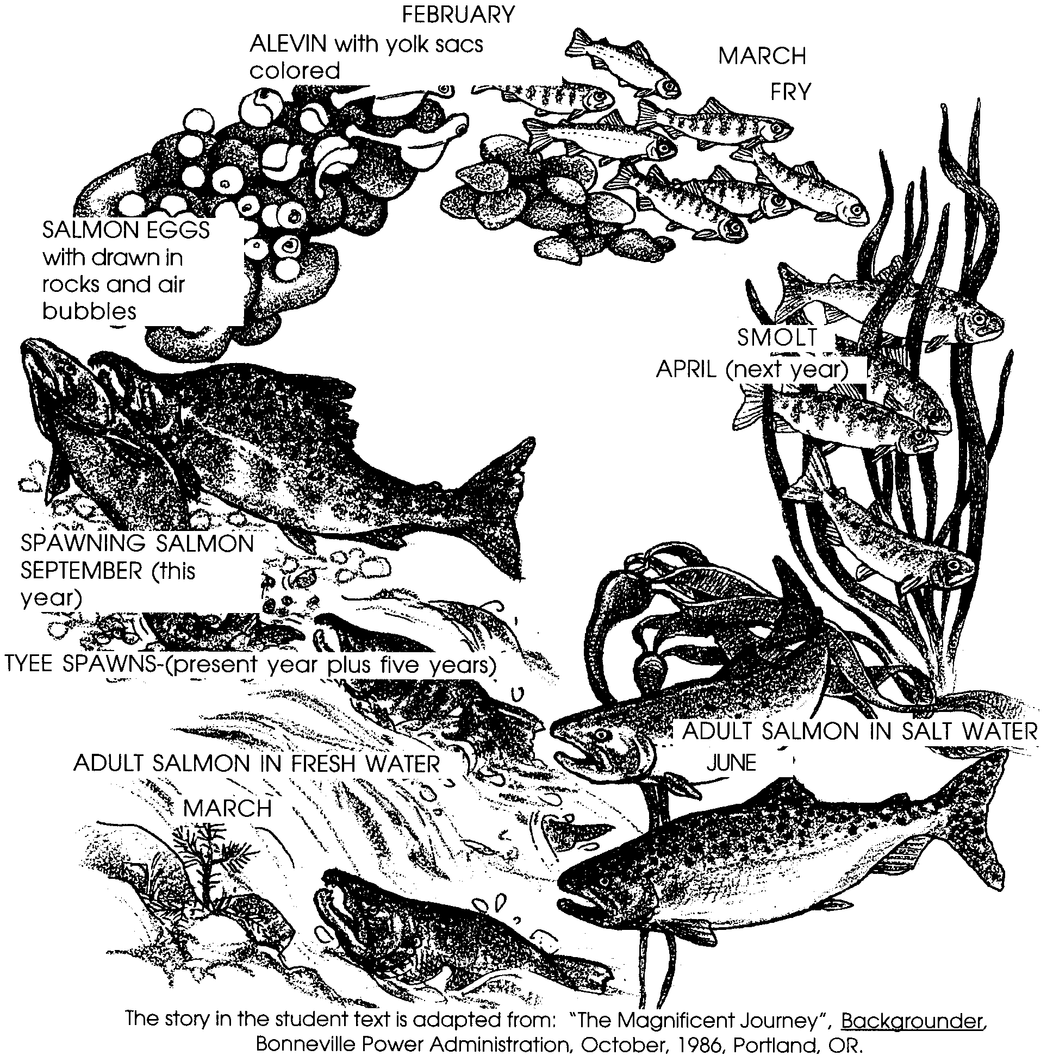

Downstream Card

Careless road building adds fine dirt to stream. Tyee has trouble breathing.
Lose one turn.

Downstream Card

State laws, passed to protect streams, improve water flow. Tyee swims through area. Go ahead 2 spaces.

Downstream Card

Logging on stream banks removes shade. Stream water warms. Tyee is tired from the heat. Lose one turn.

Downstream Card

Logging on stream banks removes shade. Stream water warms. Tyee is tired from the heat. Lose one turn.

Downstream Card

Farmers build fences to keep cattle from destroying stream bank. Tyee swims through area. Go ahead 2 spaces.

Downstream Card

Pesticides used on farm crops flow into stream. Tyee feels ill.
Lose one turn.

Downstream Card

Tyee's stream banks protected by laws passed to save salmon habitat.
Go ahead 3 spaces.

Downstream Card

Fine dirt from mining buries parts of Tyee's redd. Some of Tyee's redd-mates die from lack of oxygen.
Lose one turn.

Downstream Card

Extra water is released from upstream dams. Tyee is sped on her way by the faster water flow. Go ahead 2 spaces.

Downstream Card

Citizens vote for new taxes to protect stream water from pollution.
Move ahead 3 spaces.

Downstream Card

Sqawfish, walleye and bass lurk in the slower water created by the dams. Tyee takes evasive action to avoid being eaten,
Lose one turn.

Downstream Card

Better fish screens installed at dam. Tyee is safely carried past dam.
Go ahead one space.

Downstream Card

Locks allow barges carrying goods to pass by dams. Tyee rides one of these water elevators past the dam.
Go ahead 3 spaces.

Downstream Card

Water flow slows behind dam. Tyee's ride on the current almost stops.
Lose one turn.

Downstream Card

State laws, passed to protect streams, improve water flow. Tyee swims through area. Go ahead 2 spaces.

Downstream Card

Tyee takes a wrong turn and enters an irrigation canal. She spends a day finding her way back to the stream.
Lose one turn.

Upstream Card

Logging on stream banks removes shade. Stream water warms. Tyee is tired from the heat. Lose one turn.

Upstream Card

Careless road building adds fine dirt to stream. Tyee has trouble breathing.
Lose one turn.

Upstream Card

Citizens vote for new taxes to protect stream water from pollution.
Move ahead 3 spaces.

Upstream Card

Fine dirt from mining buries part of Tyee's redd. Some of Tyee's redd-mates die from l;ack of oxygen. Lose one turn.

Downstream Card

Fertilizers and pesticides from lawns and gardens pollute the stream. Tyee is confused about where to go.
Lose one turn.

Downstream Card

Volunteers have planted trees and shrubs along the banks. They keep the water cool and provide food for the insects that live in the stream. Cool water and more food make Tyee feel great. Go ahead 2 spaces.

Downstream Card

Runoff from paved streets adds pollution to the stream. Tyee is confused about where to go. Lose one turn.

Downstream Card

Detergent from washing cars enters a storm drain and pollutes the stream. Tyee is confused about where to go.
Lose one turn.

Upstream Card

Antifreeze, carelessly poured in a storm drain, pollutes the stream. Tyee is confused about where to go.
Lose one turn.

Upstream Card

Antifreeze, carelessly poured in a storm drain, pollutes the stream. Tyee is confused about where to go.
Lose one turn.

Upstream Card

Native Americans, state governments and citizen groups agreed to work together to improve this stretch of stream. The water now flows faster and is cleaner.
Go ahead 3 spaces.

Upstream Card

Runoff from paved streets adds pollution to the stream. Tyee is confused about where to go. Lose one turn.

Upstream Card

The population of the Pacific Northwest increases. More "fisherpeople" than ever are trying to catch salmon. Tyee has to be very careful not to run in to nets or hooks.
Lose one turn.

Upstream Card

Native Americans, state governments and citizen groups agreed to work together to improve this stretch of stream. The water now flows faster and is cleaner.
Go ahead 3 spaces.

Upstream Card

Careless road building adds fine dirt to stream. Tyee has trouble breathing.
Lose one turn.

Upstream Card

Sqawfish, walleye and bass lurk in the slower water created by the dams. Tyee takes evasive action to avoid being eaten,
Lose one turn.

Ocean Card

U.S., Japanese and Canadian governments stop netting salmon in the ocean. Tyee doesn't have to worry about this kind of fishing. Go ahead 2 spaces.

Ocean Card

U.S., Japanese and Canadian governments stop netting salmon in the ocean. Tyee doesn't have to worry about this kind of fishing. Go ahead 2 spaces.

Upstream Card

A five foot waterfall looms ahead. Tyee leaps over and reaches home stream.
Go ahead 2 spaces.

Ocean Card

U.S., Japanese and Canadian governments stop netting salmon in the ocean. Tyee doesn't have to worry about this kind of fishing. Go ahead 2 spaces.

Upstream Card

Tyee finds the entrance to the fish ladder. Go ahead 2 spaces.

Upstream Card

Lures from anglers do not interest Tyee. She continues to swim upstream.
Go ahead three spaces.

Upstream Card

Detergent from washing cars enters a storm drain and pollutes the stream. Tyee is confused about where to go.
Lose one turn.

Upstream Card

Fertilizers and pesticides from lawns and gardens pollute the stream. Tyee is confused about where to go.
Lose one turn.

Ocean Card

Sea lions are looking for food. Tyee's coloring keeps her from being seen.
Go ahead one space.

Ocean Card

Sea lions are looking for food. Tyee's coloring keeps her from being seen.
Go ahead one space.

Ocean Card

Orca whales are looking for food. Tyee's coloring keeps her from being seen.
Go ahead one space.

Ocean Card

Sea lions are looking for food. Tyee's coloring keeps her from being seen.
Go ahead one space.

Ocean Card

Orca whales are looking for food. Tyee's coloring keeps her from being seen.
Go ahead one space.

Ocean Card

Orca whales are looking for food. Tyee's coloring keeps her from being seen.
Go ahead one space.

Ocean Card

U.S., Japanese and Canadian governments stop netting salmon in the ocean. Tyee doesn't have to worry about this kind of fishing. Go ahead 2 spaces.

Ocean Card

Orca whales are looking for food. Tyee's coloring keeps her from being seen.
Go ahead one space.

Ocean Card

Fishing season is closed. Tyee doesn't have to avoid fishers.
Go ahead 2 spaces.

Ocean Card

Fishing season is closed. Tyee doesn't have to avoid fishers.
Go ahead 2 spaces.

Ocean Card

Orca whales are overhead. Tyee takes evasive action to avoid being seen.
Lose one turn.

Ocean Card

Fishing season is closed. Tyee doesn't have to avoid fishers.
Go ahead 2 spaces.

Ocean Card

Orca whales are overhead. Tyee takes evasive action to avoid being seen.
Lose one turn.

Ocean Card

Orca whales are overhead. Tyee takes evasive action to avoid being seen.
Lose one turn.

Ocean Card

Orca whales are overhead. Tyee takes evasive action to avoid being seen.
Lose one turn.

Ocean Card

Orca whales are overhead. Tyee takes evasive action to avoid being seen.
Lose one turn.

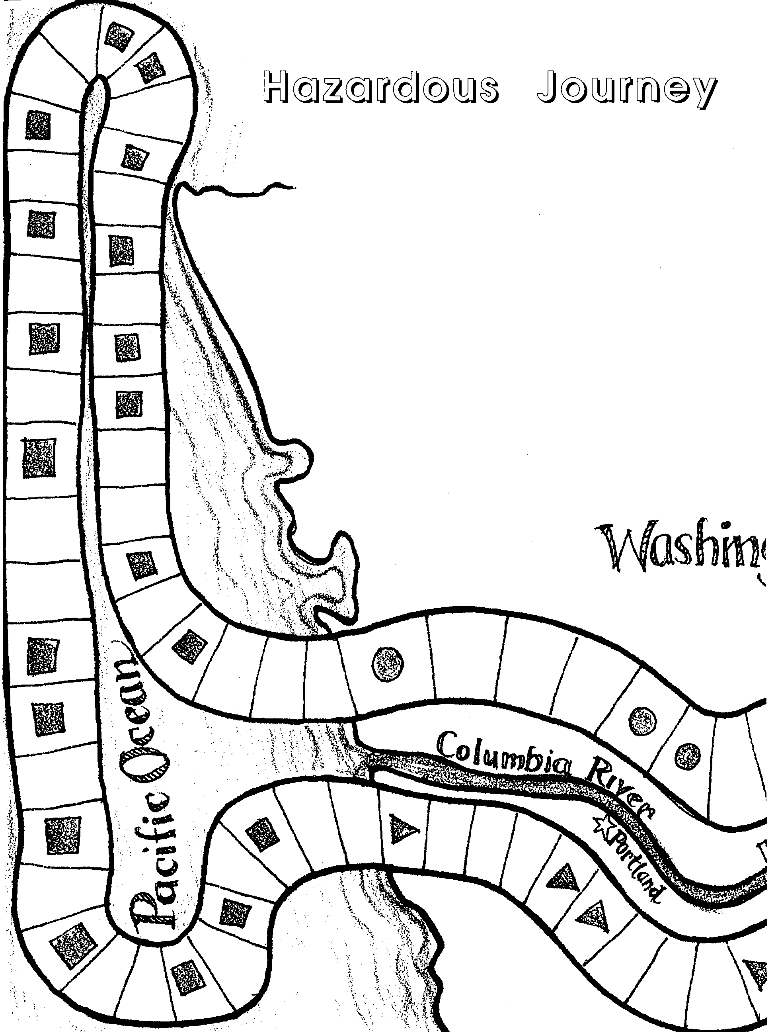
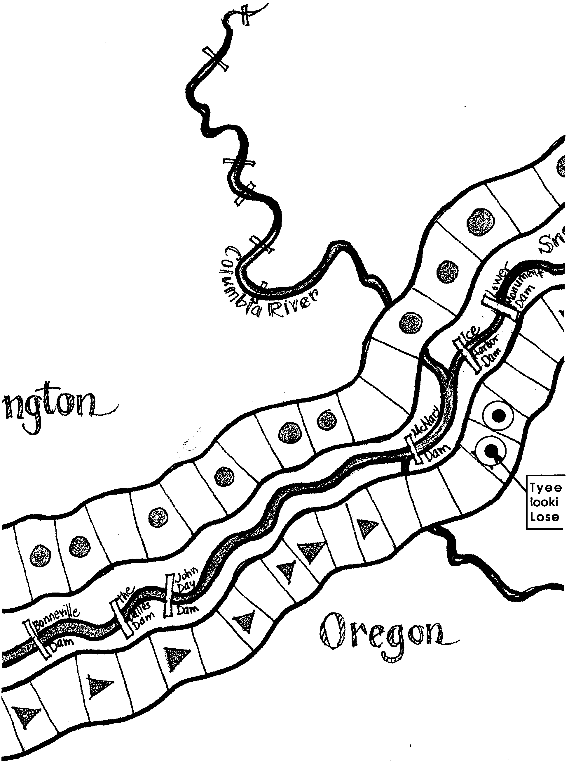
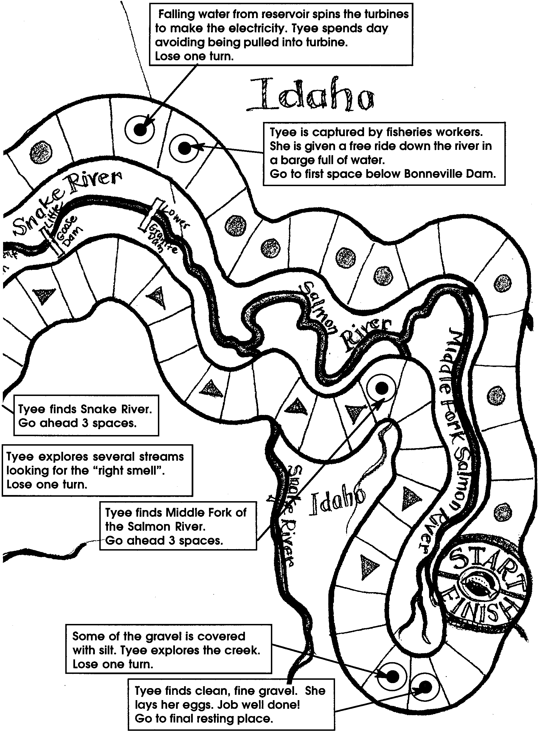
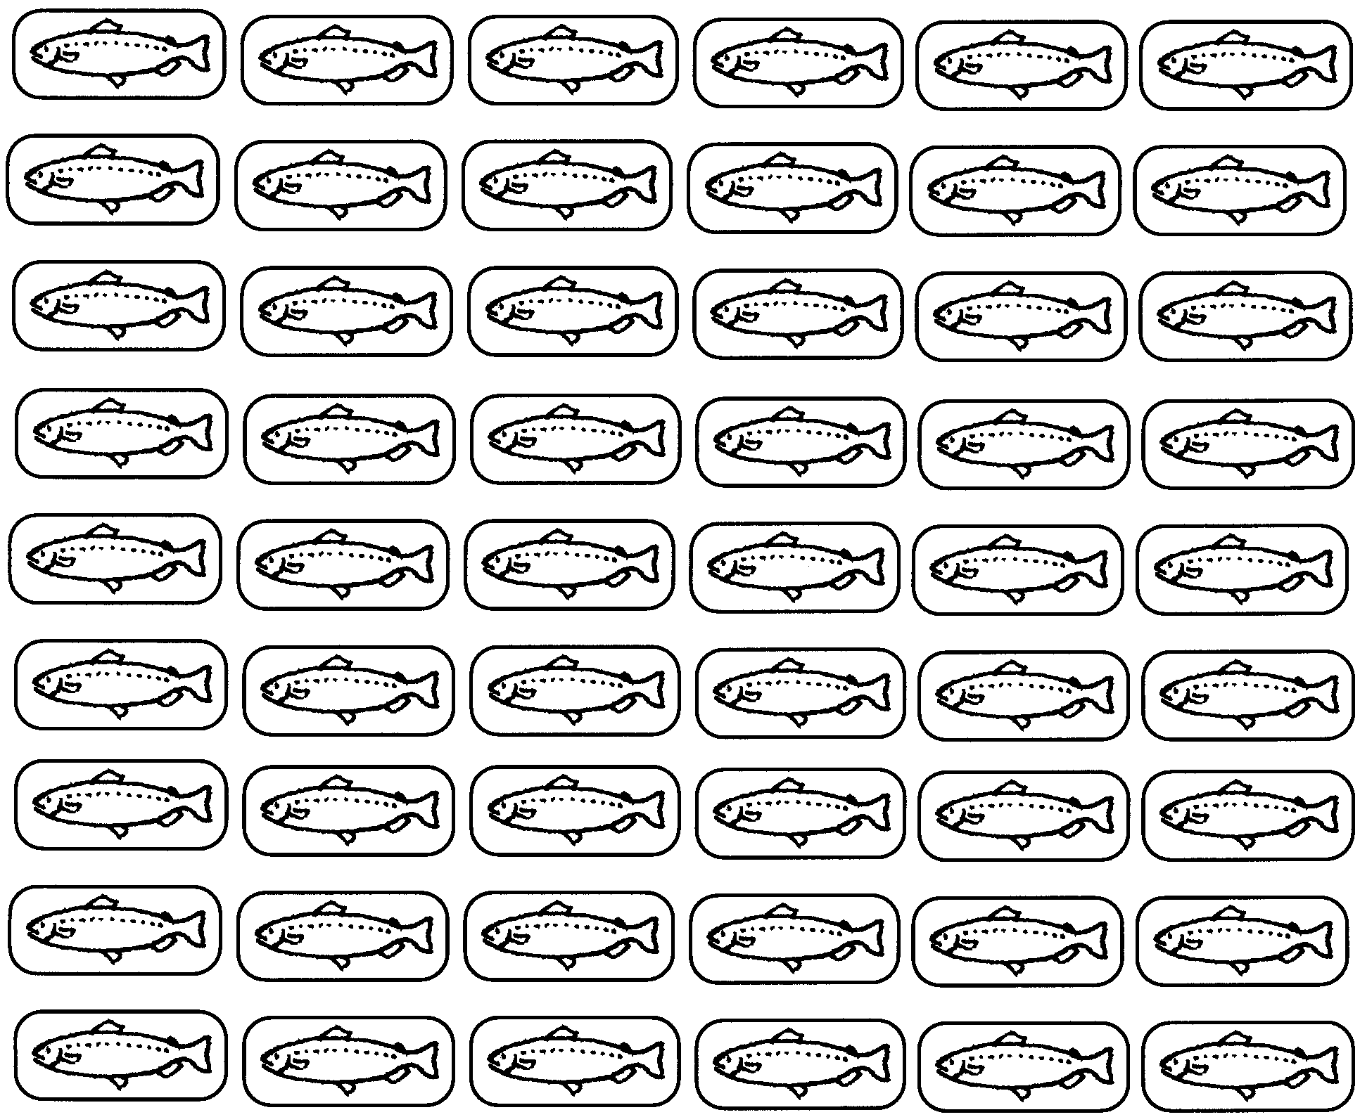

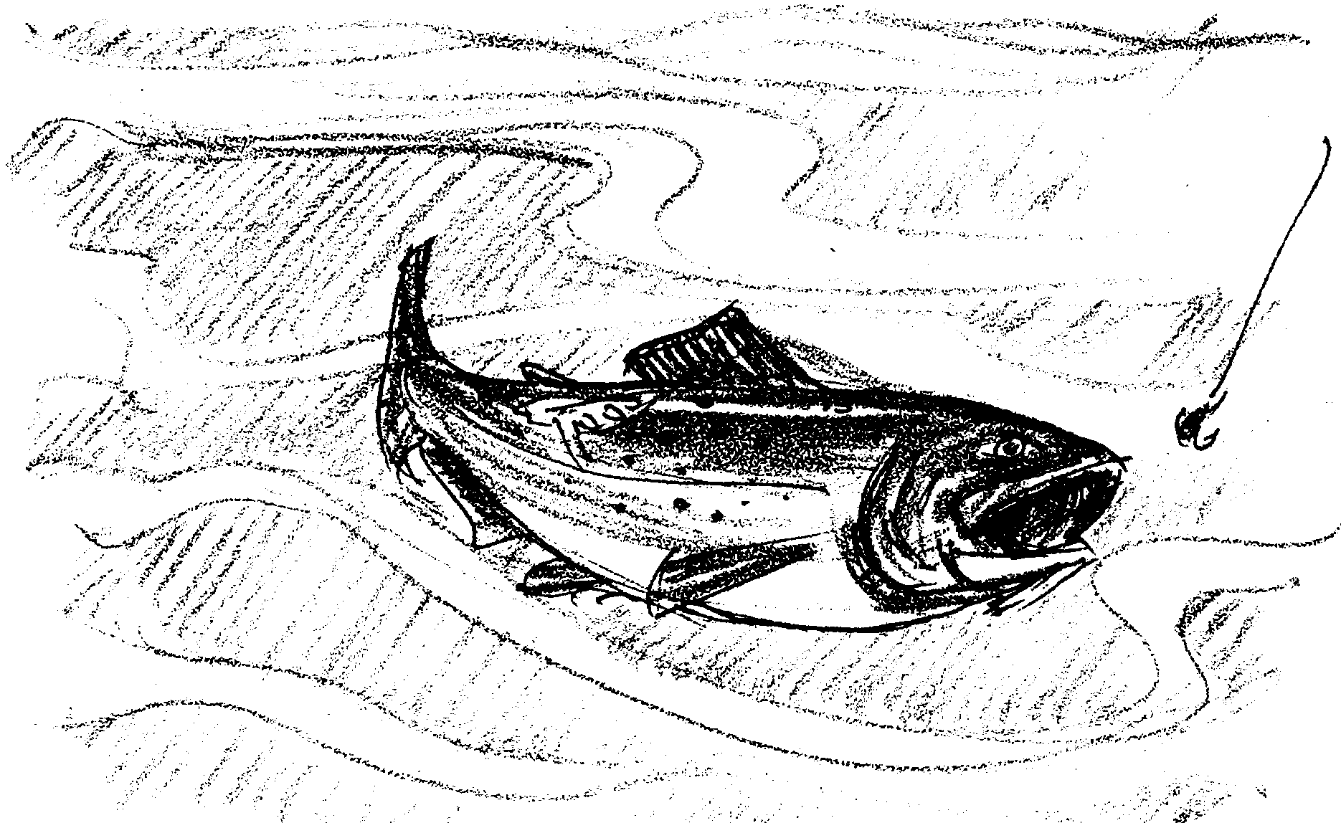
The Long Wet Journey: Race to the Redd

Tyee is a spring Chinook. It is now March of her third year at sea. She returns to the Columbia River mouth and enters. She is at the prime of her life. She weighs 28 pounds and is almost three feet long. She is not the biggest fish there, but she is large. She carries scars from her adventures in the ocean. Tooth marks on her back show where a sea lion just missed. Today, she is strong and healthy.

1. Find the drawing of the salmon life cycle from “The Cycle Begins”. Label the adult salmon in fresh water. Next to the drawing, write the month in which Tyee re-enters the Columbia River.

As Tyee moves into the river, people are fishing along the shore. Tyee would be a prize catch. She snaps at an anchovy. The anchovy has two hooks in it. A line is attached. Her first reaction is to dive deep. She tries to swim away from the pull of the line. The hook goes deeper in her jaw.

Her deep dive doesn’t seem to work. She rises to the surface, slashing and twisting. She jumps out of the water. When she rests, she can feel getting pulled closer to the boat. She dives again, then rises, trying to get loose. The hook is working loose.
After 20 minutes, Tyee is very tired. Perhaps her luck has run out. The boat is close now. She can see a large silver and green net moving towards her. With one mighty leap and a twist of her body, Tyee rises out of the water. The hook tears loose. She lies on the surface for a moment. Slowly, she rolls and swims down with what little strength she has left. She becomes “the big one that got away”. Tyee the Lucky.

Tyee wastes no more time in the lower Columbia River. The rains have swelled the river, urging Tyee on a race upriver. She has one purpose - to get back to her home stream and spawn. Eggs are growing inside of her.

She is no longer interested in food. She has stored up enough energy to make it all the way to Idaho. Now, it is time to use that energy.

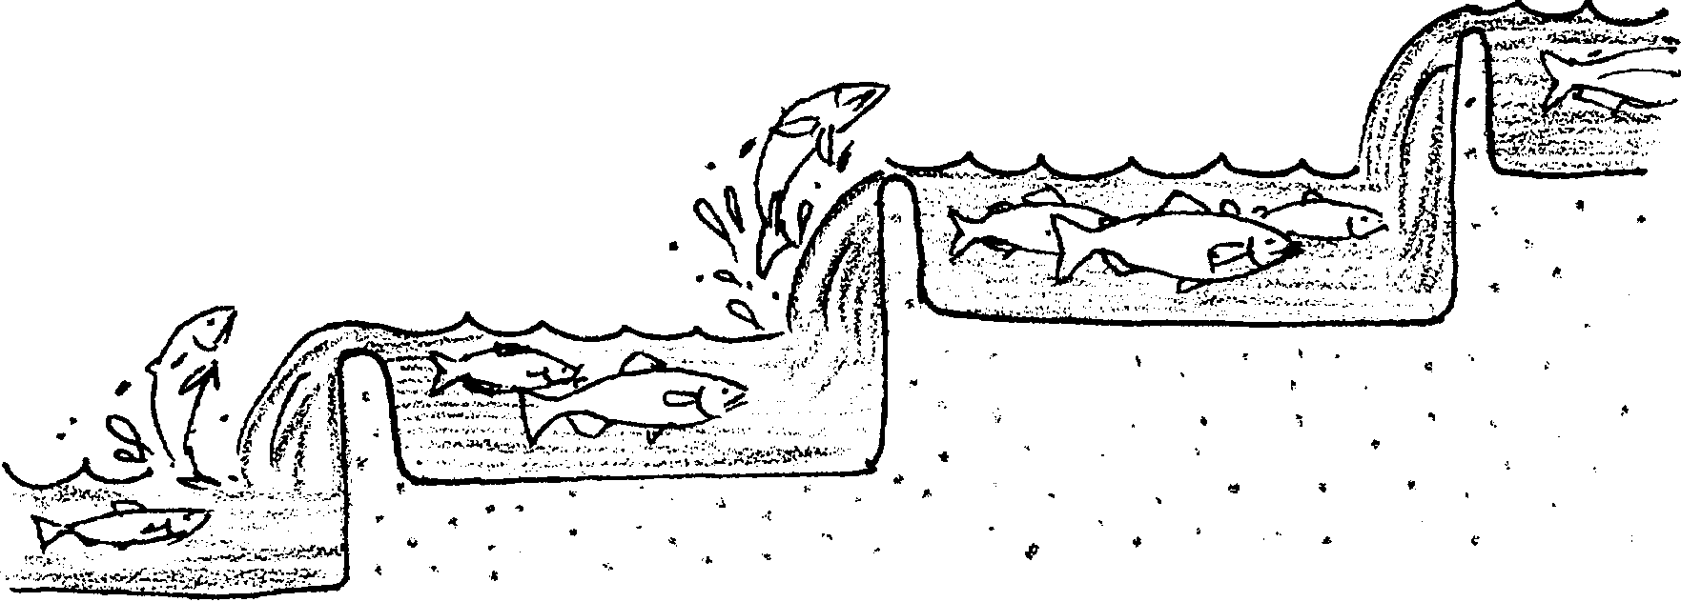
In late April, she reaches Bonneville Dam. She climbs the fish ladder’s stairs of water. A human watching through an underwater window counts her as Chinook number 61,346. There will be more Chinook behind her.

2. Salmon swimming upstream have stored enough energy for their trip. Yet, anglers catch them on lures. Why do you think salmon snap at the bright lures?

She passes into the reservoir. The slack water confuses her for a time. She heads for the ladder at The Dalles Dam. Along the way, there are more anglers and nets. She avoids both. As she uses her energy reserves, she gets skinnier.

She passes forks of rivers and streams. At each, she uses her homing instincts to show her the way home. She says “no” to the Deschutes, John Day and the Umatilla Rivers. The Snake River “smells” right to her, and she leaves the Columbia. One hundred and fifty miles later, she comes once again to the Salmon River. She waits a few days for rain to make the river “right”. Inside her, eggs are ripening. Her stomach is empty from not eating for a month.

Tyee turns into the Middle Fork of the Salmon. A week later, she finds her creek without a name. She has traveled 900 miles downstream, 4,000 miles in the ocean, and another 900 miles to return here. She has returned home with a precious cargo: her eggs.

A five-foot waterfall is all that stands in the way of reaching her goal. The waterfall is almost twice her length. After all that’s happened, it seems impossible that Tyee could leap the waterfall. But she does.

Four of her redd-mates have already arrived. She is the last. Only nine adults from the original 1200 fry made it back to the Columbia River. Two of those ran into a fish net, and couldn’t back out. Another was caught by an angler’s hook. And another became confused by a dam. He died of exhaustion trying to find a way through the concrete.

The five are not only the luckiest, they are also the fittest. They will pass on these traits to the next generation of Chinook.

3. Sometimes a salmon’s trip is called the “hazardous journey.” What were four of the hazards faced by Tyee?

a.

b.

c.

d.

The Final Event: Spawning

Males and females pair off to spawn. Three males and two females are left. There is much chasing and nipping. The males try to get a good position around the females. One of the Chinook males is a jack. Jacks return to spawn earlier than other adults. He is smaller than the other males. Jacks only spawn if the full-sized males don’t make it back to the spawning area.

The big males are dark and blotchy and have hooked snouts. They think the jack is nothing but a bother. When he drifts into their areas, they send him scampering upstream. After a while, he gets the idea that he is not wanted here.
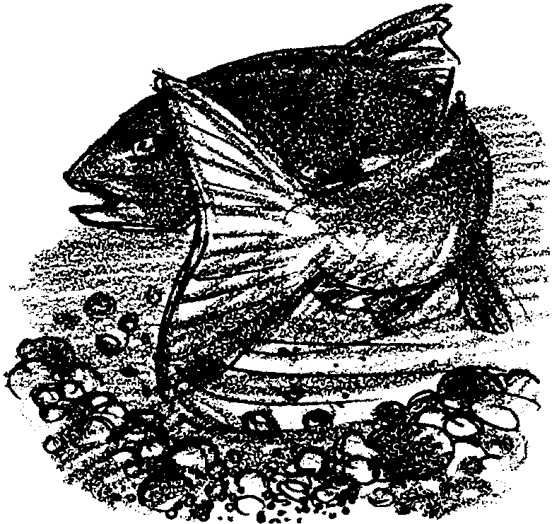
Tyee ignores all this action. She has her own job. She builds a redd.

She chooses a spot where the gravel is fine and clean. With her tail, she begins sweeping gravel aside. She scoops out a redd. It is in the shape of her body and twice as long. She tests it by settling into the trough. She swishes more gravel around the redd until it feels just right.

Meanwhile, the two males begin a courtship “dance” around Tyee and the other female. They circle slowly. For hours, they come close and move away again. Tyee and her sister rest in their redds.
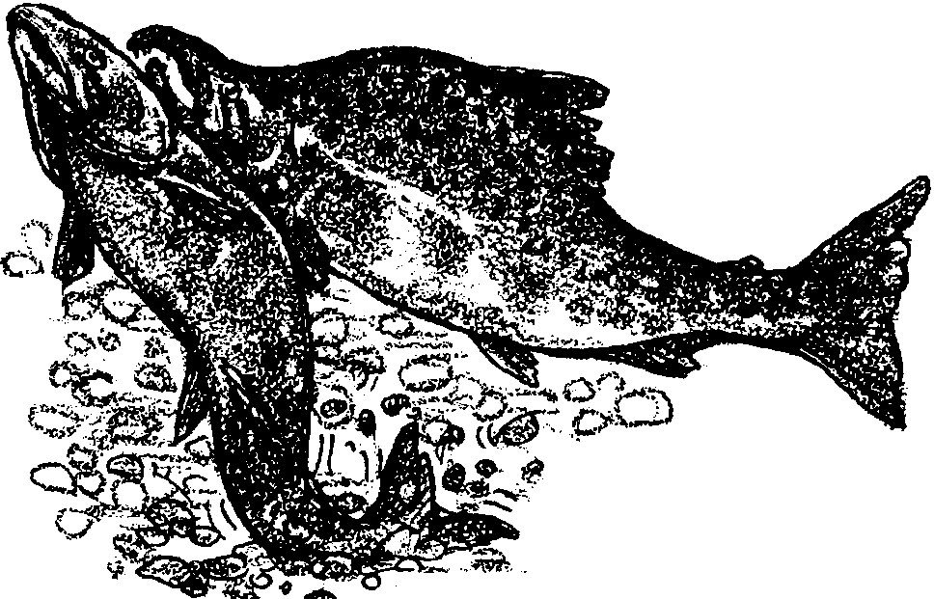
Finally, a male swims beside Tyee and just upstream from her. His body presses hers against the redd. Both seem to shudder. Tyee trembles. Pink eggs come out of her and drift into the redd. Almost immediately, a white cloud of sperm or milt, comes out of the male and covers the eggs. This fertilizes the eggs. The whole cycle begins again.

Tyee, with one last tired effort, rises from the redd. Just upstream, she swishes her tail. The action lifts small pieces of gravel from the bottom. The water carries them into the redd. Fine gravel now covers and protects the eggs.

Leaves on the trees on the stream banks are yellow and brown. It has been five years since our story began. Tyee the Lucky has finally come home. In a few days, she dies. Her body decomposes. It provides food for the smaller animals in the stream. She feeds the offspring of the animals that she once fed on as a fry. The cycle is complete.

With death comes life. The journey of Tyee the Lucky is finished.

4. Find the drawing of the salmon life cycle from “The Cycle Begins”. You have already labeled the spawning salmon. Next to the drawing, write the year in which Tyee spawns.

The Long Wet Journey: Race to the Redd Activity
Hazardous Journey

Many dangers faced Tyee. She made the trip to the ocean and home. Not all salmon do. Play the “Hazardous Journey” game to see if your salmon can.

Here’s what you’ll need:
• “Hazardous Journey” game board
• single die
• salmon marker
• stopwatch or clock.

Here’s what to do:

1. The object of the game is to get as many salmon as possible home safely in a given “salmon life span”.

2. Choose a salmon marker. Your teacher will tell you how to set the stopwatch.

3. Roll the die to see who gets the lowest number. That person goes first. The player to that person’s left goes second and so on.

4. Start the stopwatch. (What? No stopwatch? Use the clock. Write down the time you start. Your teacher will tell you how long to play.)

5. Roll the die. Move the number of spaces equal to the number on the die. Follow the directions, if any, on the square where your marker lands.

6.Play the length of time your teacher tells you or until all salmon return home. The more fish that return home, the better for the salmon population.

7. Vary the game in some way and play it again. For example,

• Try changing the length of time you play. What happens if the time is decreased? Increased?

• Try changing the rules. For example, have salmon “die” (go out of the game) if they land on a “Lose turn” square. Or if they land on two, three, or four “Lose turn” squares.

• Try adding other hazards.

