The Long Wet Journey: Moving Downstream

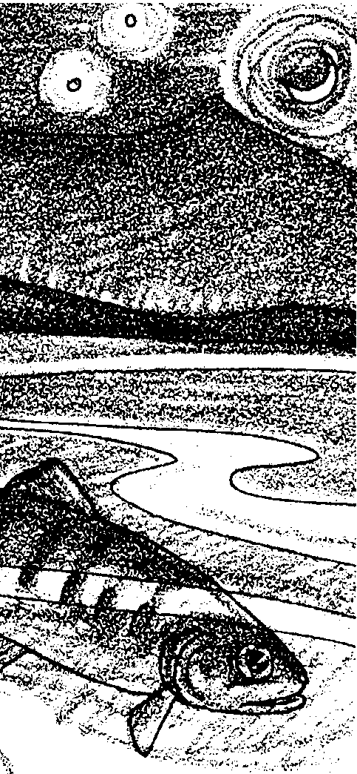

Key Concepts
1. Salmon have a complex life cycle that takes them thousands of miles from fresh water to the oceans and back again.
2. Salmon are faced with many hazards to their survival during their life cycle.
3. From thousands of eggs that are laid in redds, a very small number of salmon complete their life cycle.
4. People have caused problems for salmon, but they are working to solve many of those problems.

Background

Pacific salmon are an example of one of the most spectacular of those many fish that live part of their lives in one habitat and then migrate to another. This activity continues an investigation of the life cycle of Pacific salmon.

Background for “The Long Wet Journey: Moving Downstream” is found in the preceding activity, “The Long Wet Journey: The Cycle Begins”.

Materials

For each student or pair of students:

• “What a Trip!” migration map

• string or yarn, 18"

• pencil

• “What a Trip” activity sheet

• “The Long Wet Journey: Moving Downstream” story reading pages

Teaching Hints

“The Long Wet Journey: Moving Downstream” continues the introduction to the life cycle of Pacific salmon begun in the preceding activity, “The Long Wet Journey: The Cycle Begins”. A story reading centers around the downstream migration phase of the life cycle of a female Chinook salmon. The “What a Trip” activity, in which students manipulate a map to determine distance traveled, complements the story reading.

In question 3, note that, in spite of the stepwise hints provided, some students may need help with percents and rounding.

Key Words

algae - simple plants that grow in water, ranging from microscopic size to plants over a hundred feet long

bar - the area at the mouth of a river where sediments are deposited

estuary - the area where the tides of the ocean meet a river current

fry - recently hatched fish, after the yolk sac has been absorbed

gene - the unit of genetic information passed along from generation to generation through mating

larvae - an immature stage of development in many kinds of organisms

midge - the larval form of any two-winged fly

migration - traveling between seasonal habitats

predator - an animal that eats another animal

smolt - a migrating salmon that has undergone physical changes to prepare for life in salt water

storm drain - drains from streets and parking lots that channel rain water directly into streams

zooplankton - microscopic and other very small animals in the water, many of which are larval forms.

Extensions

1. Create a class, group, or individual salmon life cycle mural based on the story.

2. The activities “Salmon of the Columbia” and “How the Columbia River Salmon Were Saved” are natural extensions of this activity.
Answer Key

“Moving Downstream” story reading

1. A correctly labeled drawing of the salmon life cycle is found at the end of this Answer Key section.

2. The map below shows a circle around Lower Granite Dam. The names of the next seven dams. Her path to Bonneville Dam on the Columbia River is shown by a heavy line.
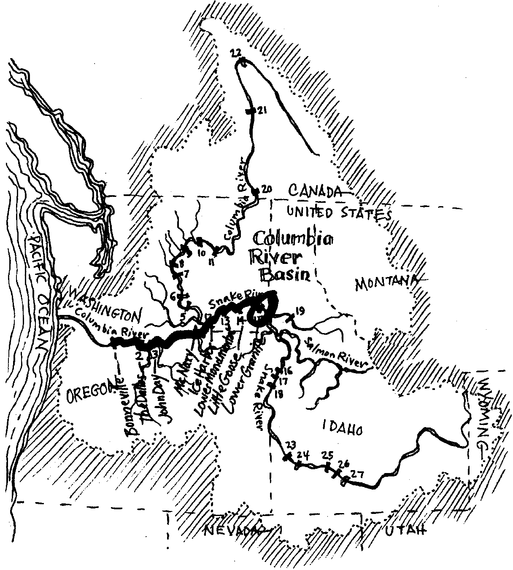
3. a. 90 smolts are alive after Lower Granite Dam (i.e., 100 smolts at dam - 10 smolts lost = 90 smolts left)

b. 81 smolts are alive after Little Goose Dam (i.e., 90 smolts - 9 lost = 81 smolts)

c. 73 smolts are alive after Lower Monumental Dam (i.e., 81 smolts - 8 lost = 73 smolts)

d. 66 smolts are alive after Ice Harbor Dam (i.e., 73 smolts - 7 lost = 66 smolts)
e. 59 smolts are alive after McNary Dam (i.e., 66 smolts - 7 lost = 59 smolts)

f. 53 smolts are alive after John Day Dam (i.e., 59 smolts - 6 lost = 53 smolts)

g. 48 smolts are alive after The Dalles Dam (i.e., 53 smolts - 5 lost = 48 smolts)

h. 43 smolts are alive after Bonneville Dam (i.e., 48 smolts - 5 lost = 43 smolts) j. The following is a completed data table:

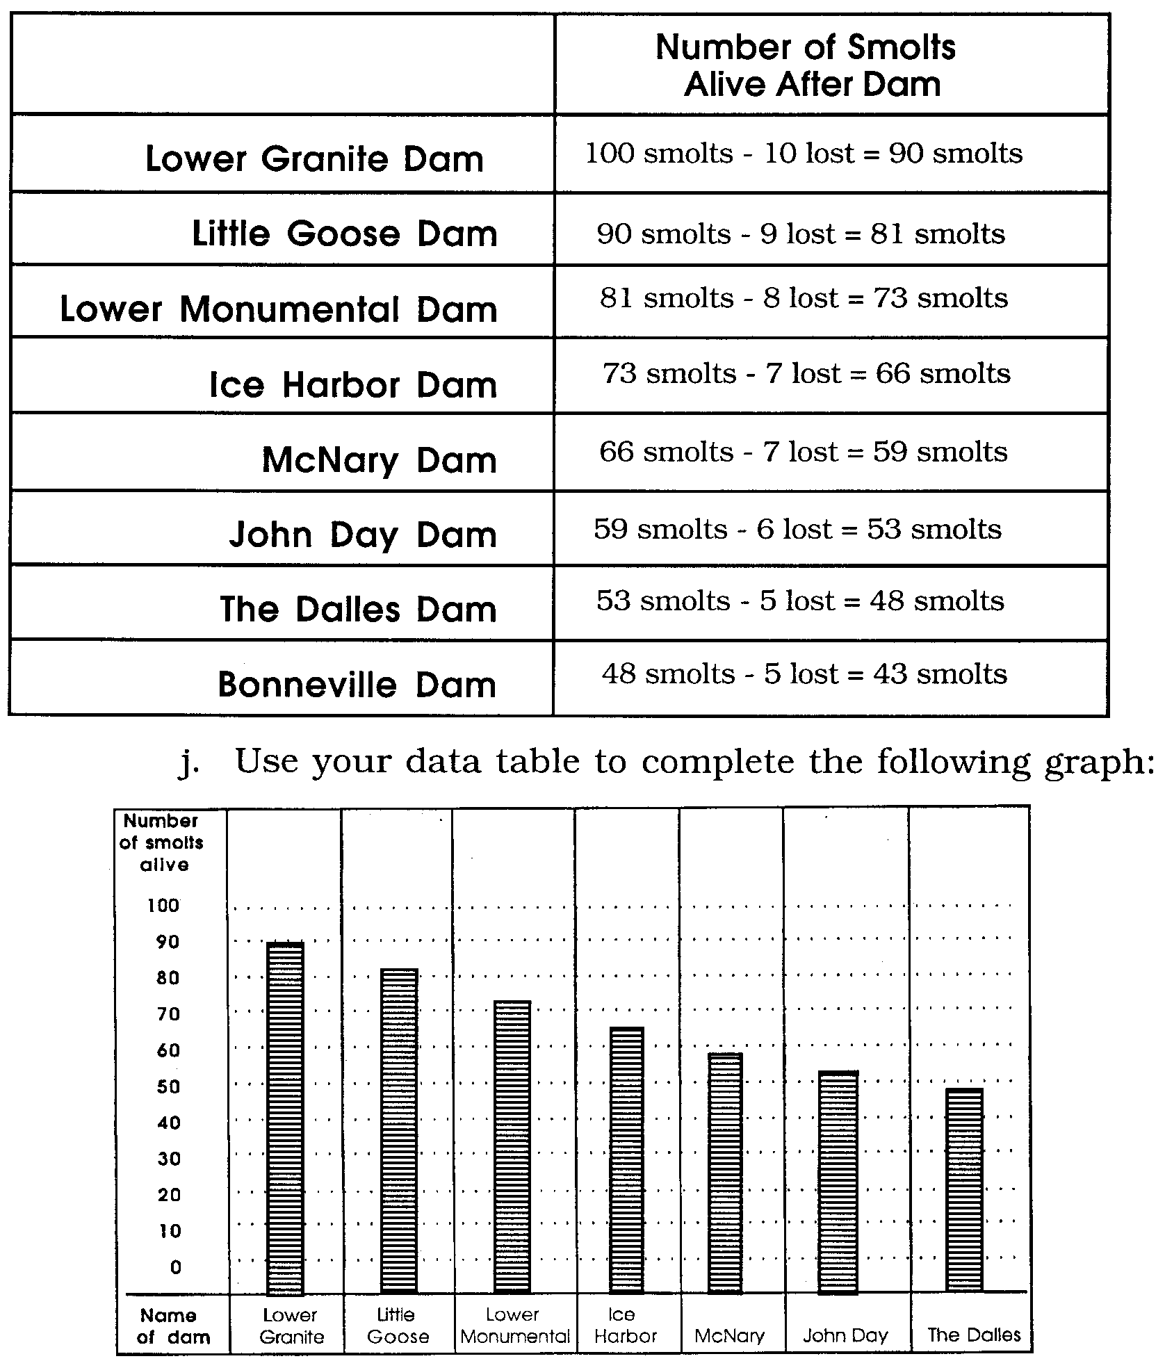
i. The following is a completed data table:

k. Since the question calls for an opinion, answers are likely to vary. Reasons such as dams killing salmon as they go through or over the dams, and dams blocking the path of the salmon to the spawning grounds are common responses.

4. Answers will vary. Encourage students to see that they can be a real part of the solution to improving water quality in their watersheds.

5. A correctly labeled drawing of the salmon life cycle is found at the end of this Answer Key section.

6. Answers will vary. The question is provided for discussion. Being in balance with the salmon is usually taken to mean that, while the Native Americans took enough fish for their needs, their actions did not cause the salmon population to decline. The numbers of people and salmon remained relatively constant over a long period of time.

7. Answers will vary regarding which means of navigation seems most likely. Designing an experiment is a difficult process for many students. As such, answers will vary. The object is to get students thinking logically about the challenge. The question shows how difficult it is to conduct experiments on ocean animals that cover large distances.

8. If Tyee swims 5 miles a day for 2 years, she will swim 3,650 miles (i.e., 5 miles/day x 365 days/year x 2 years).

“What a Trip!” activity

d. Tyee has traveled about 900 miles downstream. Note that answers will vary somewhat depending upon how carefully the technique was employed.

e. 3,650 miles swum in two years at 5 miles each day.

f. Tyee has traveled about 4,550 miles (i.e., 900 miles downstream + 3,650 miles in the ocean).

Life Cycle
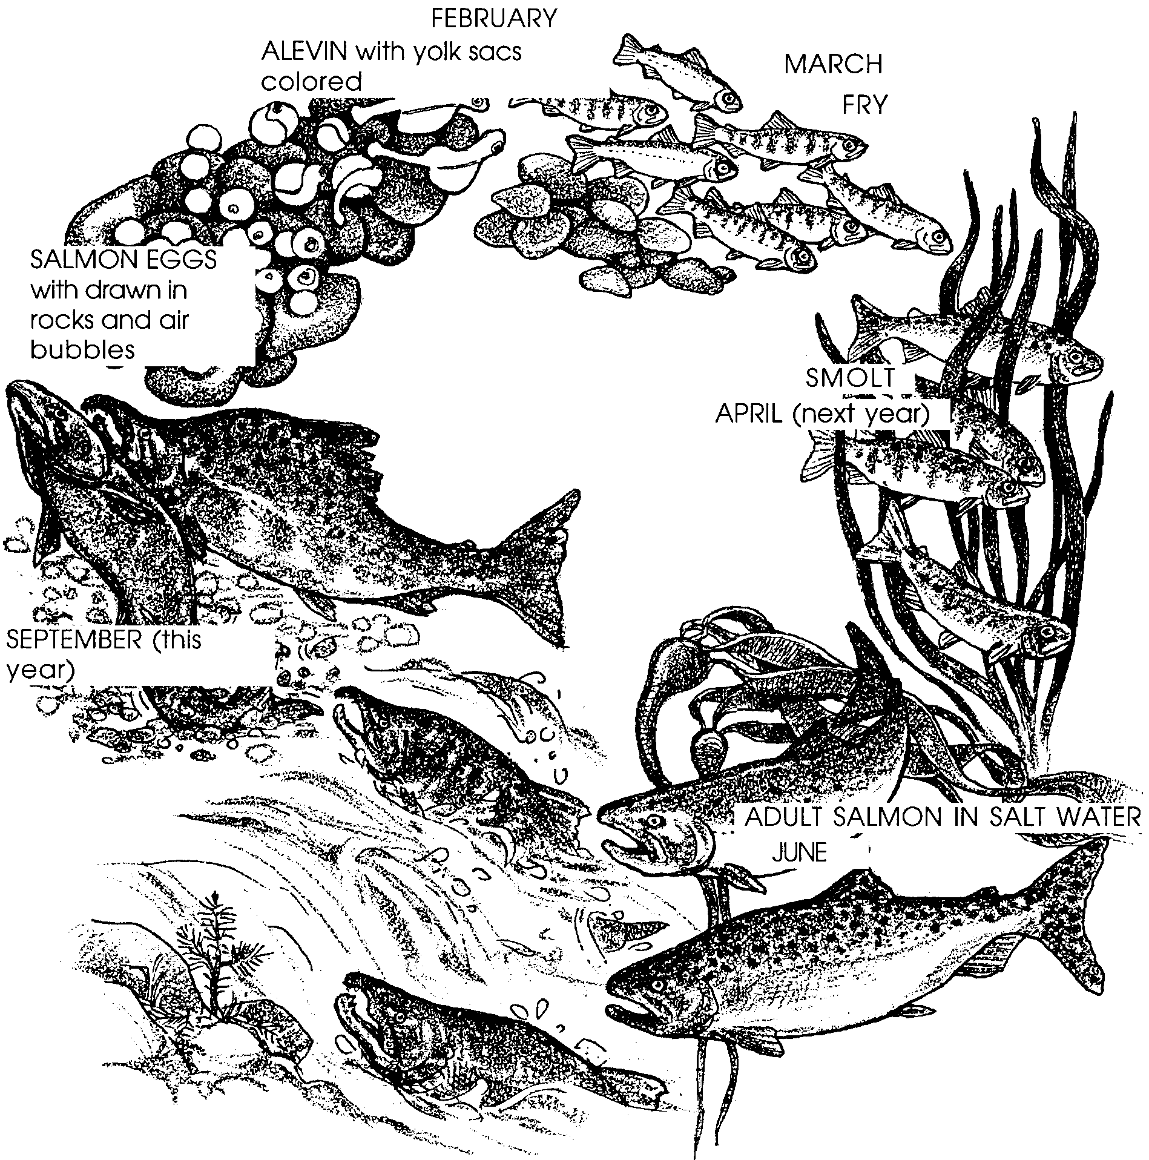
The following drawing shows a correctly labeled life cycle.

The story in the student text is adapted from: “The Magnificent Journey”, Backgrounder, Bonneville Power Administration, October, 1986, Portland, OR.

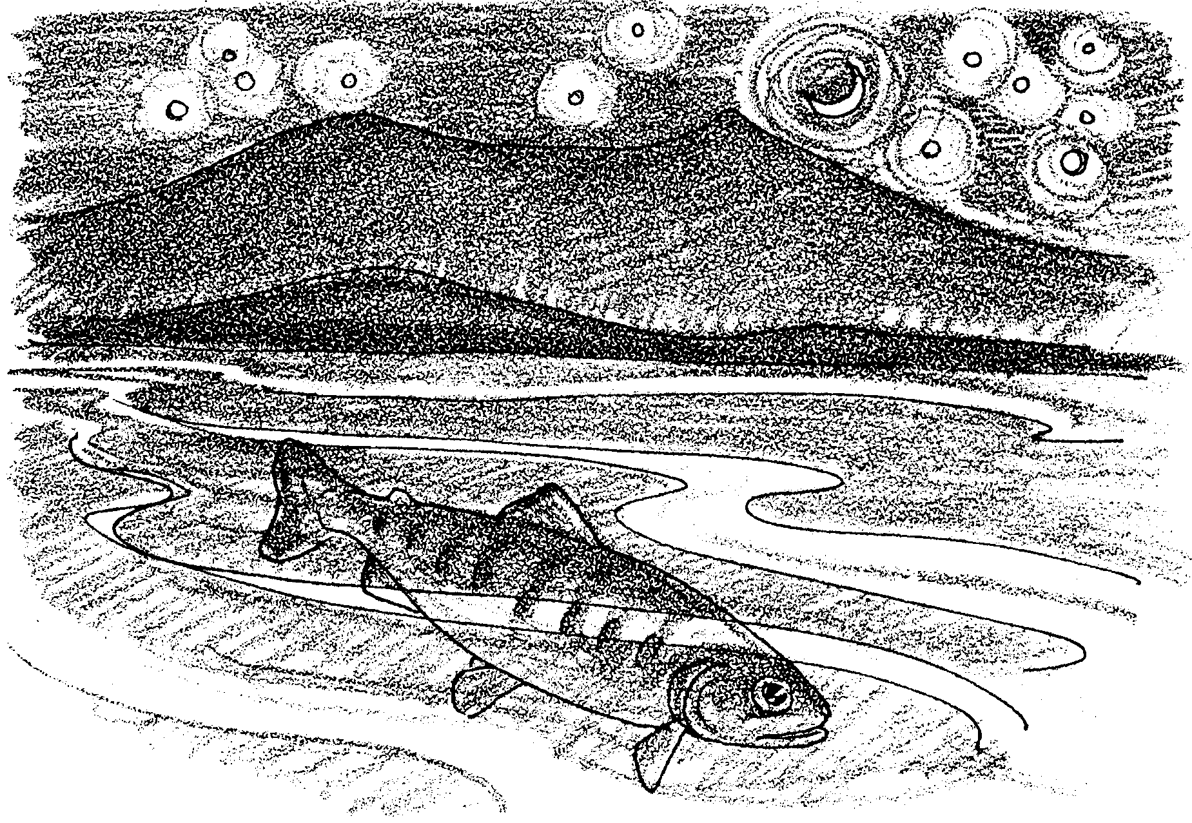
The Long Wet Journey: Moving Downstream

It is now the winter of Tyee’s first year. Her growth slows. There is not as much food. But, she doesn’t seem to be as hungry. As the snow falls, she waits for another spring. In April, it finally comes. Snows begin to melt and spring rains begin. The water level rises. The runoff sweeps young salmon downstream.

Tyee lets the water do the work. She travels with her head upstream. The water carries her toward the unknown. She travels at night to avoid predators. As she goes, she feeds on midges, worms and snails. She is changing both inside and outside. The changes ready her for life in salt water. With these changes, she becomes a smolt.

1. Find the drawing of the salmon life cycle from “The Cycle Begins”. Label the smolt. Next to the drawing, write the month and year in which Tyee becomes a smolt.

She enters the main Salmon River, then the larger Snake River. The Snake forms the border between Idaho and Oregon. Other smolts from other streams join her. Soon there is a mass migration to the sea. The Snake River rushes her along. Suddenly the current is almost gone. Tyee has entered the reservoir for Lower Granite Dam.

This is the first major barrier to her migration to the ocean. Before dams were built, the trip to the ocean might have taken three or four weeks. But the dams have slowed the water. Now, the journey takes closer to two months.

Downstream, other dams await: Little Goose, Lower Monumental, and Ice Harbor on the Snake River. When the Snake joins the Columbia River, four more dams await: McNary, John Day, The Dalles, and Bonneville. All of these dams have been built in the last 60 years. The dams have been good - for people!

2. On the map below, circle Lower Granite Dam. In the blanks, write the names of the next seven dams. (Hint: the names are listed in order from upstream to downstream.) Use a colored pencil or marker to color in Tyee’s path to the Bonneville Dam on the Columbia River.
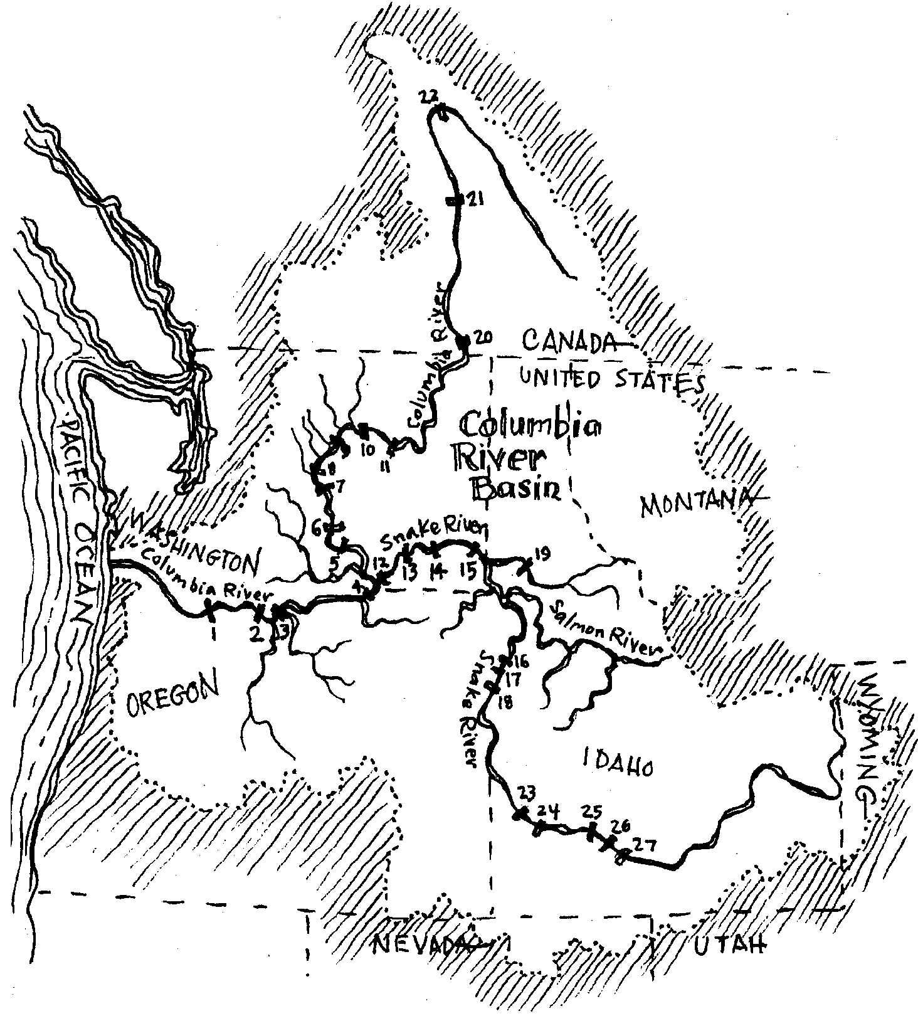
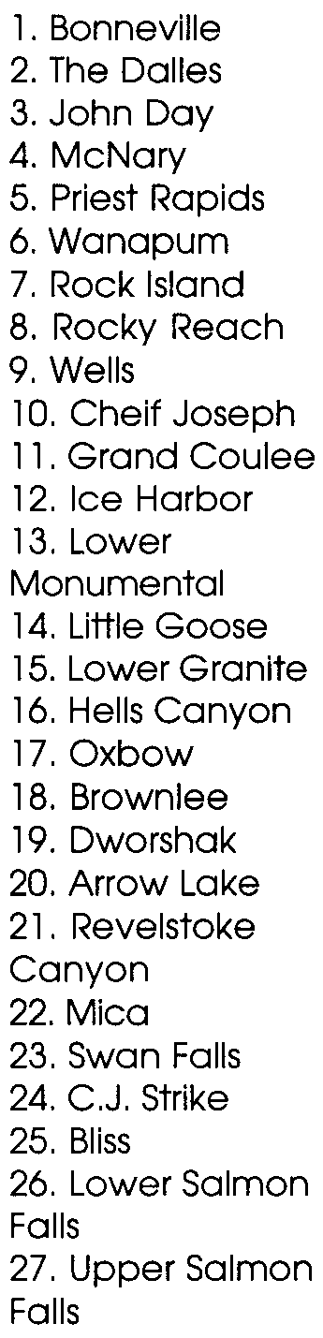

Passing these dams is hard for Tyee. At Lower Granite Dam, a fish screen catches her just in time. It guides her away from the whirling blades of the turbines. The turbines are used to make electricity.

At another dam, the water is high. Water flows over the top through a spillway. Tyee goes over the dam. She is stunned after a fifty-foot drop. She regains her senses just in time to escape from a gull. The gulls wait above the churning water for senseless fry.

Tyee’s luck holds as she travels down the Columbia. Many other salmon were not so lucky. At each of the eight dams she has passed, ten to fifteen percent of the salmon smolts don’t make it.

3. Let’s see what it means to lose 10% of the salmon at each dam. Imagine that Tyee is with a group of 100 smolts at Lower Granite Dam.
10 percent means 10 out of a 100.

a. How many smolts are alive after Lower Granite Dam? Please show you work:

(Did you say, 90? Good job. If you said something else, here’s how to figure out the number: 100 smolts at dam - 10 smolts lost = 90 smolts left)

b. How many smolts are alive after Little Goose Dam?
(Hint: 10% is also the same as 1 out of 10. How many 10s are there in 90? That’s the same as the number of fish lost.)

c. How many smolts are alive after Lower Monumental Dam?
(Hint: round the number of smolts to the nearest 10. For example, 51 smolts would become 50 smolts. But 56 smolts would become 60 smolts)

d. How many smolts are alive after Ice Harbor Dam?

e. How many smolts are alive after McNary Dam?

f. How many smolts are alive after John Day Dam?

g. How many smolts are alive after The Dalles Dam?

h. How many smolts are alive after Bonneville Dam?

i. Complete the following data table:
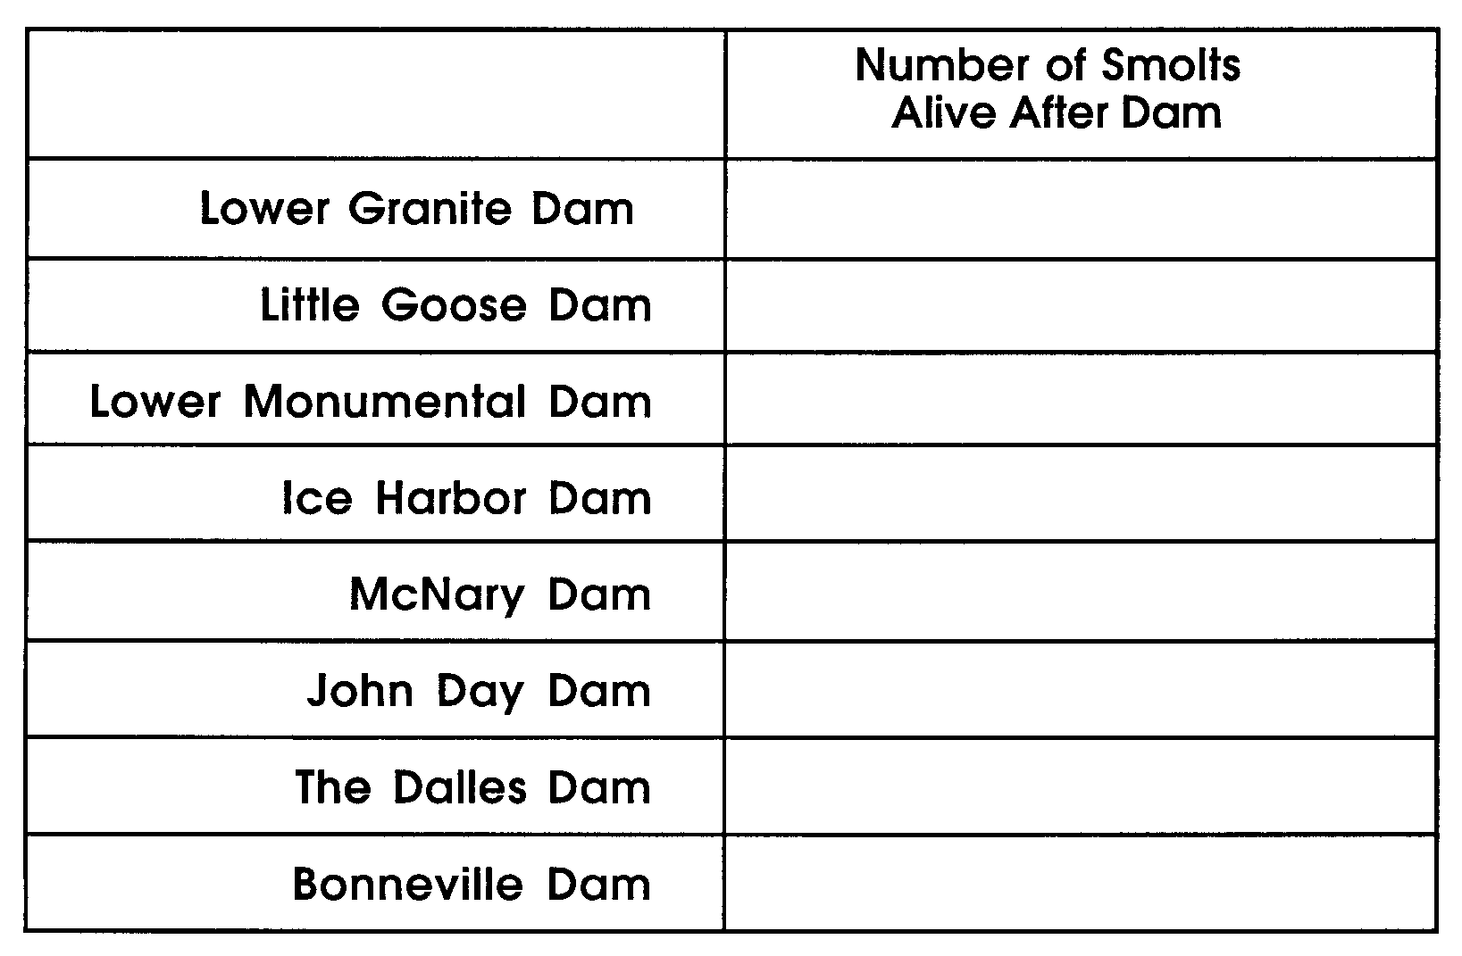
j. Use your data table to complete the following graph:
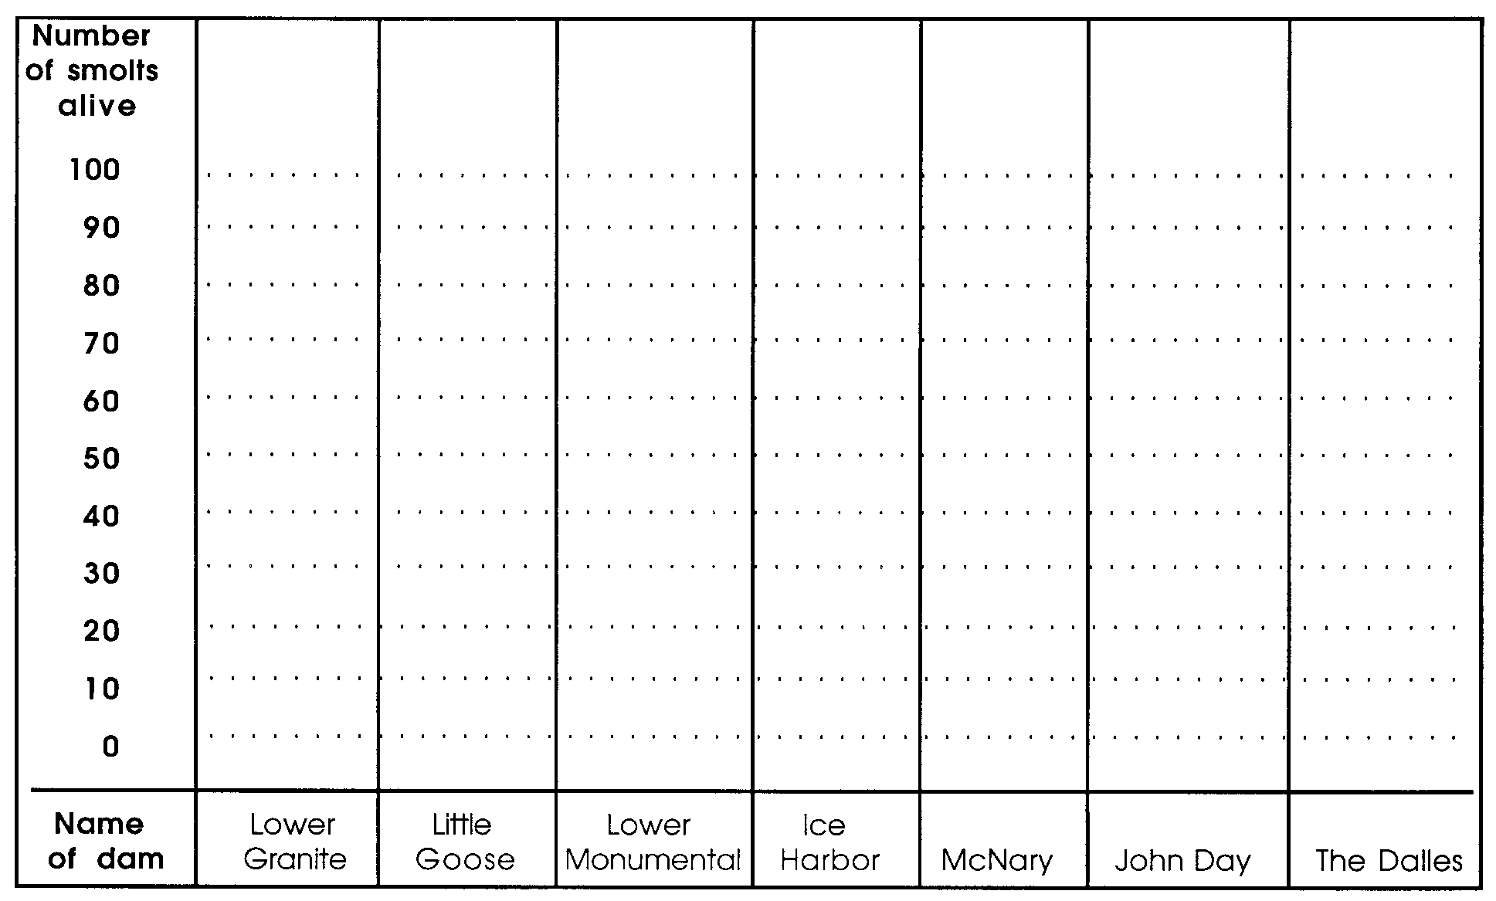

k. Many people say that dams are one reason that the number of salmon is getting smaller. Why do you think they might feel that way?

After passing Bonneville Dam, Tyee finds herself once again in a flowing river. She passes between the cities of Portland, Oregon and Vancouver, Washington. Here, the water tastes different.

In cities, rainwater hits rooftops, paved streets and parking lots. Instead of soaking into the ground, water quickly runs off. It flows into the nearest storm drain. These drains lead directly into rivers and streams. Pollution is often carried with the water. Grit from rubber tires, detergent from washing cars, fertilizers from lawns and gardens, and used anti-freeze and oil from cars is sometimes in the water.

For Tyee, the strange smells are confusing. Her eyes burn and it seems so much more difficult to breathe. Tyee keeps swimming downstream. She is glad to get past this part of her trip. As Tyee travels, more smolts from other rivers and streams join her. They are all on the journey to the sea.

4. What is one thing you can do to keep pollution from washing into storm drains?

What is this!? Suddenly, the current seems to be going the “wrong way”. Again, the water tastes different. Tyee is in the Columbia River estuary. The estuary is where the river meets the ocean. Here, twice each day, the incoming tide pushes sea water up the river. The estuary is rich in new kinds of food. Tyee snaps up algae, crab larvae, shrimp and small fishes.

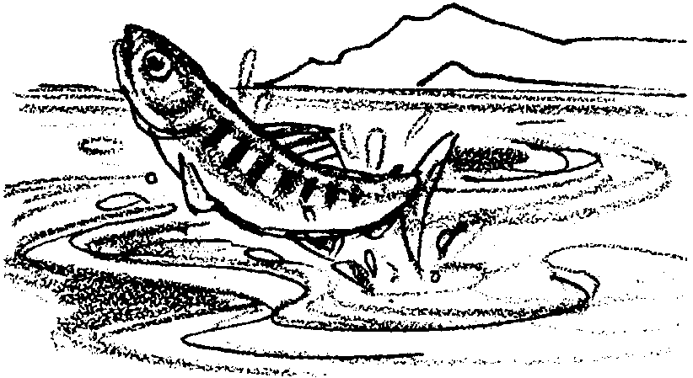
Tyee stays in the estuary for about two weeks. She still has to be careful. She is only about six inches long. Staying out of the way of larger fish takes a lot of her time. Pelicans and other fish-eating birds live in the estuary also. Tyee joins other smolts near the surface of the water. Here, they jump out of the water as high as they can. They are not jumping to catch food. People don’t know why they jump. Perhaps it is to celebrate a lucky trip from their “home streams” to the sea.

Tyee should celebrate. She is one of only 300 left of the 1,200 fry in her redd. Tyee the Lucky.
The Great Ocean

After a warm, clear June day, the night is cool. Tyee has an urge to begin the next stage of her life. She rides the night tide across the Columbia River bar. Out she swims into the great Pacific Ocean. She will not see this place again for three years.

5. Find the drawing of the salmon life cycle from “The Cycle Begins”. Label the adult salmon in salt water. Next to the drawing, write the month in which Tyee swims into the ocean.

In the sea, there is new food to catch. At first, Tyee’s diet is mostly zooplankton. These are tiny animals in the ocean water. Later, she finds shrimp and other animals. Her body takes up the pink color of the shrimp. As it does, the color of her flesh changes from white to pink. Anchovies, herring and other fish are added to her diet.

Sea birds, tuna and larger salmon are everywhere. They would love to make a meal out of Tyee. But she survives and grows. She heads northward, past the Canadian border. She is now about a pound and a half.

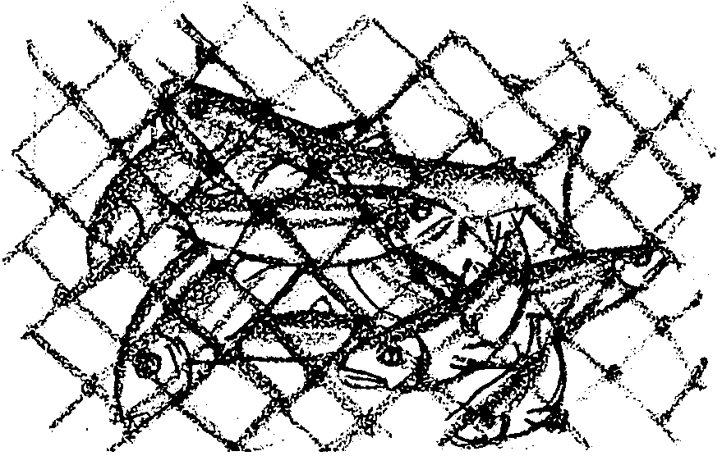
Suddenly, she finds herself in a thick group of all sizes of fish. The group is being drawn together by a huge net. The bottom of a fishing boat can be seen above.

Tyee slithers among the trapped fish in the net. She just manages to slide through one of the openings in the net. She has been saved only by her small size. She has grown large enough to be sought by a new predator - people.

For as long as there have been people and fish, humans have taken fish for their own use. The earliest people in the Pacific Northwest used salmon. To them, the salmon was a spirit. It was a link between the natural world and the world of humans. People say these Native Americans were in balance with the salmon.

6. In what sense were Native Americans “in balance with the salmon”?

Tyee is now a clever hunter. She eats whenever she can. In her first year in the ocean, she doubles her weight every three months. By August of her second year, she passes Sitka, Alaska. She now weighs twelve pounds.

How do these salmon know where to go in the ocean? This is one of the great mysteries of the salmon. Since they haven’t been in the ocean before, they can’t “remember” what their route should be. Scientists tag salmon and track them in the ocean. They have learned that Chinook salmon stay fairly close to shore. We know very little about how they find their way. Tyee may use the angle of the sunlight in the water to find her way. Or maybe she uses water temperatures, the earth’s magnetic field, or ocean currents. It could be that the information needed is imprinted in her genes. She just knows without ever having had to learn.

7. Look at how scientists think salmon find their way. Which way seems most likely to you? What could you do to test your choice?

Tyee swims up to 15 miles each day. After two years in the Pacific - the third year of her life - she passes Anchorage, Alaska.

8. Some days Tyee swims less than 15 miles. How far will she swim in two years if she swims 5 miles each day?

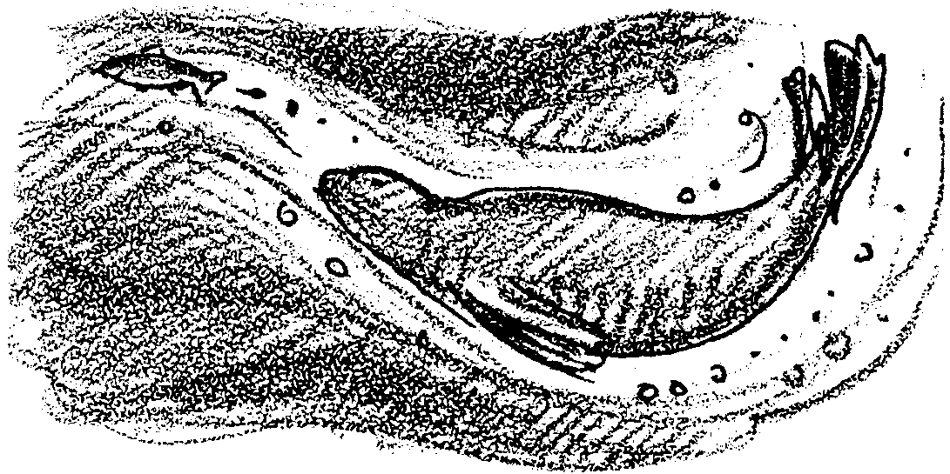
Tyee has become a large adult. She weighs 21 pounds, and is two and one-half feet long. She has a blue-green back and silvery-white belly. Her coloring makes it hard for her enemies to her. Seen from above, she blends with dark ocean waters. From below, she blends with the lighter sky.

By now, she knows sea lions by sight and smell. She has been chased by them often, as well as orca whales. But she survives. Tyee the Lucky.

Tyee is in her third year in the ocean. She turns around and heads south. She is heading back to the Columbia River. As if she were hearing some natural music that only salmon can hear, Tyee knows where to go. Ocean currents help her swimming. She is able to cover about 30 miles each day.
The Long Wet Journey: Moving Downstream Activity
What a Trip!

How many miles has Tyee traveled? The map below and a piece of string will help you find out. Here’s how:

a. Outline Tyee’s downstream travel in colored pencil. (Hints: Remember to look for her “baby picture” and the Pacific Ocean.)

b. Lay a piece of string along the route. Put one end at the beginning of her trip. Cut the string at the end of her trip.

c. Straighten your string out along the mileage scale along the bottom of the map. Put one end at the zero. Read the mileage at the other end.

d. How many miles has Tyee traveled downstream?

e. Tyee has traveled in the ocean, too. How far? Let’s use your answer to question 8 in Part Two. miles swum in two years at 5 miles each day.

f. So, how many miles has Tyee traveled? Write the answer in the space below. (Hint: Add Tyee’s downstream miles to her ocean miles.)
