The Long Wet Journey: The Cycle Begins

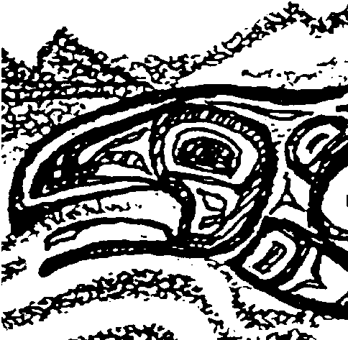
Key Concepts
1. Salmon have a complex life cycle that takes them thousands of miles from fresh water to the oceans and back again.
2. Salmon are faced with many hazards to their survival during their life cycle.
3. From thousands of eggs that are laid in redds, a very small number of salmon complete their life cycle.
4. People have caused problems for salmon, but they are working to solve many of those problems.

Background

Many fish live part of their lives in one habitat and then migrate to another. Some make their migratory journeys to mature and reproduce. Pacific salmon are an example of one of the most spectacular of the migrating species.

Pacific salmon are destined to spawn only once in their lifetime. Within their genetic make up is an encoded instinct that drives them from the time of hatching along a monumental journey from their freshwater spawning beds downstream into the sea. Once in the sea they spend several years reaching the maturity needed for their single return journey to their original hatching ground, or “home stream”.

Salmon must face a myriad of hazards that serve as limiting factors in the completion of their life cycle. Limiting factors are those that reduce populations of living organisms. Sometimes the limiting factors are natural and sometimes they result from human intervention with natural systems.

The female Pacific salmon deposits 2,000 to 13,000 eggs in her freshwater spawn. The eggs are deposited in a shallow gravel depression scooped out by the female. Once deposited, the eggs are fertilized by the male and then the female nudges the gravel back over the eggs to protect them. Within a few days both the male and female salmon have completed their reproduction and soon die.

The eggs, before and after hatching, are susceptible to many limiting factors. Smothering silt can be washed in suddenly from watersheds damaged by a variety of poor land use practices or and natural events. These include erosion following road building, logging, and fires. Predators can eat some of the eggs and damage hatching populations. Dropping water levels can isolate salmon offspring in streamside depressions where they may die as the water warms and the oxygen in the water is used up. After hatching, the small fish - called “alevins” - spend their first two weeks hiding in the gravel. Gradually, they absorb their yolk sac and become known as “fry”. The fry emerge from the gravel and begin foraging for food. In a few weeks, if they survive, they begin their journey. Some head directly for the ocean.

Depending on the species, young salmon may spend several months to as much as a year or more in the river before migrating to the estuary and then to the ocean.

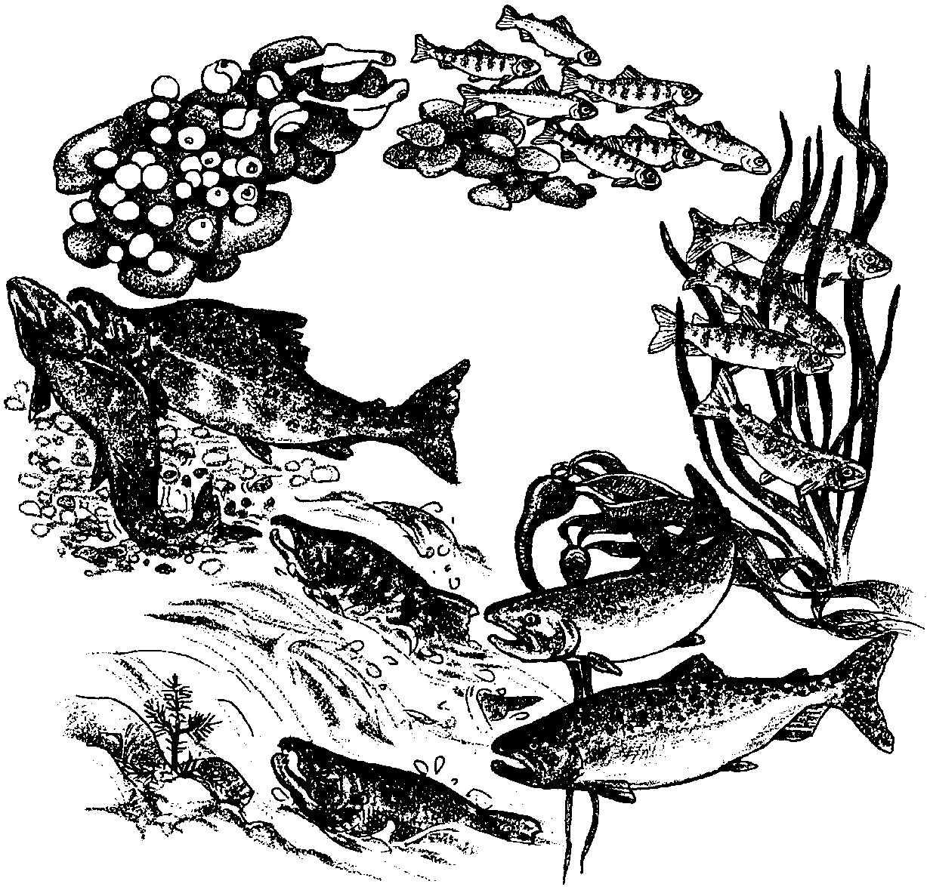
The small, ocean-bound salmon, now called “smolts”, are at once confronted by hazards on their downstream journey. Examples include: dams; low water in streams; predatory birds, mammals, and fish; and anglers that catch them thinking they are trout. Up to 90% of the salmon that hatch never reach the sea.

In the ocean, salmon grow rapidly by feeding on the ocean’s rich food supply. Predators such as sharks, orca whales, and other marine mammals take their toll. Humans also fish for salmon commercially and for sport.

In two to five years, Pacific salmon start the journey that will guide them back to the rivers and streams leading to their own hatching site. The upstream migration from the ocean is also a series of hazards. Dams hinder their journey and would block it completely if fish ladders were not installed. Grand Coulee Dam, which went into operation in 1941 on the Columbia River, had no such ladders, and blocked over 500 miles of river (excluding the tributaries) to salmon. Humans, bears, eagles, and other animals also take some of the salmon along the way. Landslides and log jams provide unexpected new barriers. Natural waterfalls and rapids challenge salmon to get over them.

Once back on the spawning grounds, the life cycle of the Pacific salmon can begin anew when the female lays her eggs and both she and the male soon die after spawning.

Materials

For each group of two or three students:

• quart cottage cheese container (or equivalent)

• tap water (cold and warm)

• ice

• thermometer

• watch or clock with second hand for use by class

• “Cold Water” activity sheet

For each student or pair of students:

• “Introduction” and “The Cycle Begins” story reading pages

Teaching Hints

“The Long Wet Journey” is a three lesson introduction to the life cycle of Pacific salmon. A story reading centering around the life cycle of a female Chinook salmon unites the lessons.

“The Long Wet Journey: The Cycle Begins” provides a brief history of salmon and begins the story of the salmon life cycle by recounting spawning activities. “Cold Water”, an activity involving measuring water temperature, complements the story reading.

A lot of material is covered in the three lessons of “The Long Wet Journey”. While the lessons can be approached in a number of ways, the following is suggested. Have students complete:

day 1 - Introduction

day 2 - “The Cycle Begins” story reading and “Cold Water” activity

day 3 - “Moving Downstream” story reading and “What a Trip!” activity

day 4 - “The Race to the Redd” story reading and “Hazardous Journey” activity

Alternatively, you may choose to:

1. Have students read the entire story as background for the activity, “Hooks and Ladders”.

2. Have students read only part of the story (perhaps through the part where Tyee enters the Columbia on her return journey), complete the activity “Hooks and Ladders”, then have students write the remainder of the story. Note: If you elect to have the students complete the story of Tyee the Lucky, copy only the part you want them to read.

3. Read the story to the class, using the embedded questions as a springboard to discuss each “stage” in the salmon life cycle. One way to summarize each stage during discussion is to list all the things salmon need to complete that stage.

The three lessons in the “The Long Wet Journey” activity provide a springboard for other activities in this unit. Choose the approach that best conveys the information to your class.

Key Words

alevin - newly hatched fish with yolk sac attached

Endangered Species Act - a law that requires special protection for plant and animal populations that are in danger of becoming extinct.

fertilize - to provide sperm for eggs. One sperm unites (fertilizes) one egg to create a complete set of genetic instructions (genes) and a new organism is created.

fry - recently hatched fish, after the yolk sac has been absorbed

gills - the organs that extract oxygen from the water and return carbon dioxide, found in fish and other water-living creatures

oxygen - a gas essential for life

predator - an animal that eats another animal

redd - the spawning area or “nest” of salmon

run - a population of fish that returns from the ocean at about the same time headed for the same place

slime layer - the layer of mucous covering fish that protects it from fungi, parasites, and disease

spawn - the act of egg laying by the female and fertilization by the male

yolk sac - sack attached to a newly-hatched fish containing a balanced diet for its early growth

Extensions

1. Begin the creation of a timeline as a visual representation showing the “milestones” in the life cycle of the salmon. Add additional milestones as you complete the subsequent activities: “Long Wet Journey: Moving Downstream” and “Long Wet Journey: Race to the Redd”.

2. Create a class, group, or individual salmon life cycle mural, puppet show, or play based on the story.

3. The activities “Salmon of the Columbia” and “How the Columbia River Salmon Were Saved” are natural extensions of this activity.

Answer Key

Introduction
1. Answers will vary depending upon the experiences of the students. This question provides an opportunity to informally assess the background knowledge of the class. Among the things that might make a salmon’s trip more dangerous today than before are: dams; many more people fishing; water diversion for irrigation, towns or industry; logging, road building and mining which add silt to the water; removal of brush and trees along stream banks allowing warming of the water; and chemicals including pesticides, detergents, fertilizers, oil and antifreeze which find their way into streams. Avoid dwelling on the individual items at this point since they are explained within the context of the story line.

2.a. To remain the same, two adult fish have to return from the 2,000 to 13,000 eggs laid by a female and fertilized by a male.

b. To increase, the number of adult fish returning has to be greater than
two
.

Although not discussed in the text, some students may point out that the ratio of males to females is also important. Returning fish of only one gender would not allow a population to remain the same or increase over the long run.

3. The things mentioned which make a salmon’s trip more dangerous today than before include: easier catching of salmon; dams which blocked large areas of the wild salmon’s spawning areas; roads and towns developed around salmon streams; logging and farming practices which fouled rivers with sediment; and pollution from cities, factories, and houses.

Again, the individual items are explained within the context of the story line. Extensive discussion is not called for at this point.

4. The question calls for an opinion. Answers will likely vary and provide an opportunity for discussion of survival and extinction. Stress the point that the decrease in diversity that occurs when species go extinct has an impact on the ability of the world ecosystem to support all life, including human life. Living things are connected directly and indirectly through the food chain - who eats whom.

“The Cycle Begins” story reading
1. A correctly labeled drawing of the salmon life cycle is found at the end of this Answer Key section.

2. This question assesses prior knowledge. Some commonly mentioned things which might disturb the eggs include: stepping on them, being driven over by motor vehicles, mothering by silt, predators, pollution, and flooding which can uncover the eggs and wash them away.

3. A correctly labeled drawing of the salmon life cycle is found at the end of this Answer Key section.

4. The yolk sac is important in protecting Tyee because it allows her to remain in the gravel rather than having to venture out into the water to feed. Although a logical extension of the text, the answer requires some thought about where and how Tyee lives in this life stage.

5. A correctly labeled drawing of the salmon life cycle is found at the end of this Answer Key section.

6. This question calls for an opinion. As such, answers will likely vary. Many students will suggest that she will be less visible to predators in the shadows.

7. A correctly labeled drawing of the salmon life cycle is found at the end of this Answer Key section.

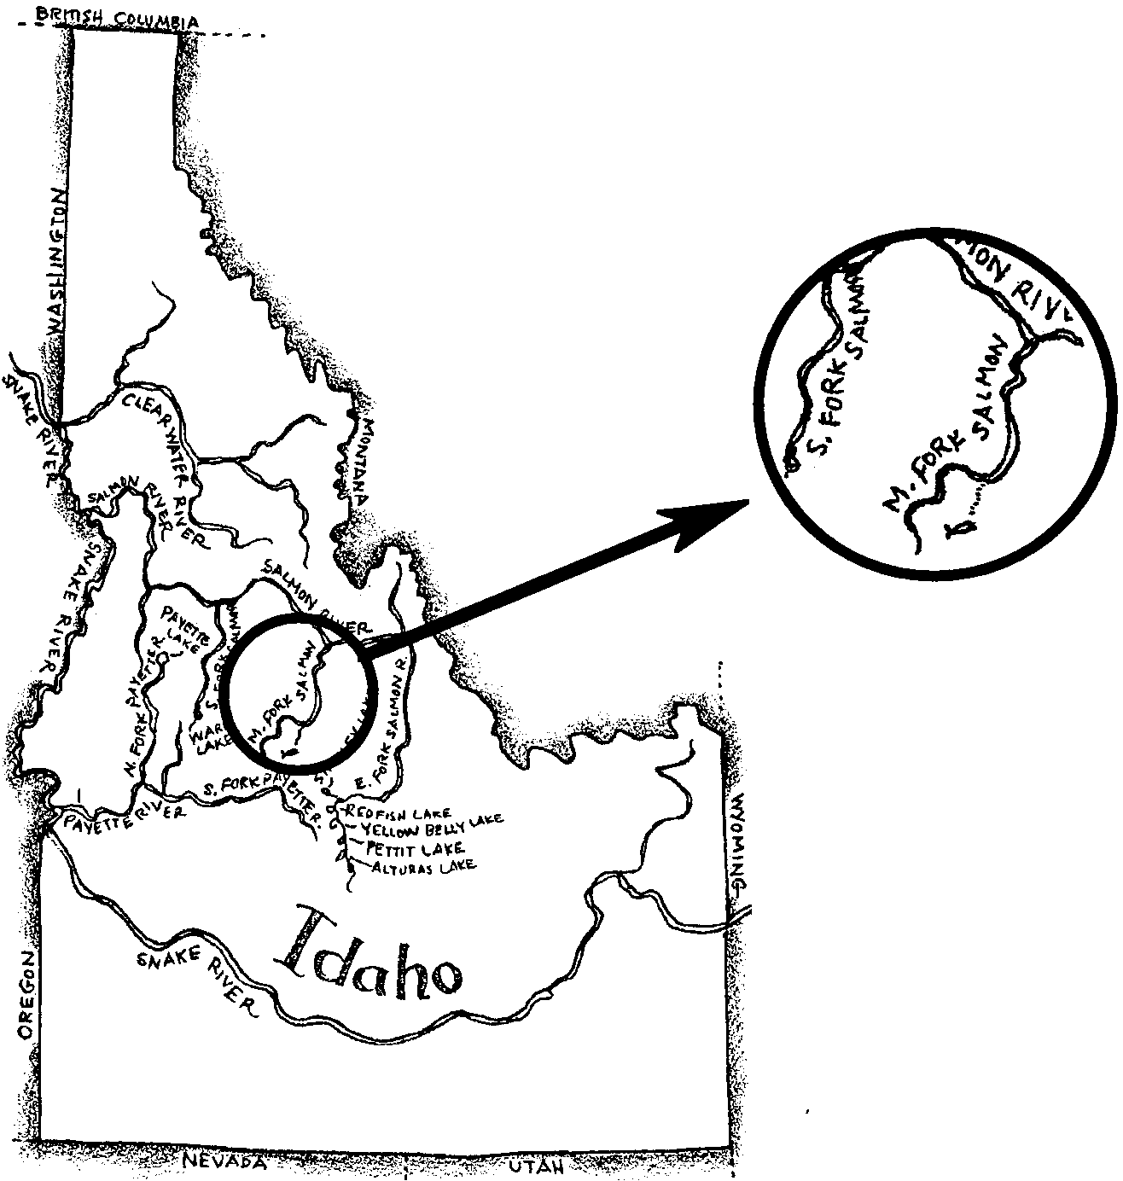
8. The map below shows a circle around Tyee’s birth creek. Her path to the Middle Fork of the Salmon River is shown by a dotted line in the enlarged area.

9. Answers will vary but backgrounds with strong vertical patterns will be those best suited to helping Tyee hide.
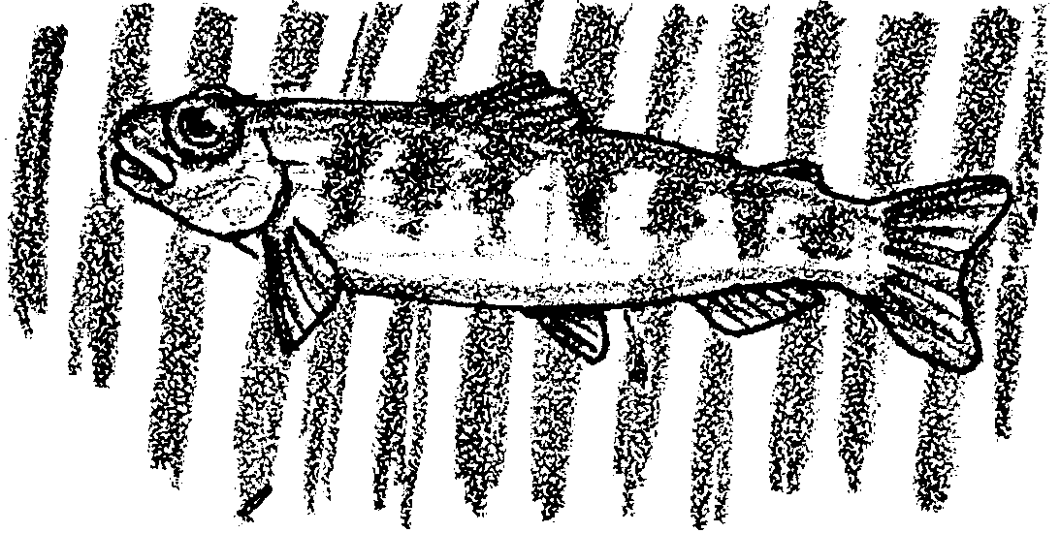

10. Answers will vary depending upon student experiences. Humans directly or indirectly add oil, fertilizers, pesticides, household chemicals, industrial wastes, etc.

11. Only about 15 % of the Tyee’s fellow eggs made it through the fry stage. This means that for every 100 eggs, 85 died along the way.

a. If 10,000 eggs had been laid, 1,500 eggs would have died. Students may need help with setting up these problems. The hint provides the critical first step in one approach to solving the problem (i.e., there are one hundred 100’s in 10,000; 100 x 15 deaths per 100 = 1,500 deaths.)

b. 8,500 would have lived (i.e., 10,000 original eggs - 1,500 deaths).

“Cold Water” activity

f. Answers will vary depending upon individual perceptions of warm and cold. Most will find the water cold.

g. Answers will vary and are dependant upon experimental results.

h. Answers will vary and are dependant upon experimental results.

Answer Key is continued on the next page.
Life Cycle
The following drawing shows a correctly labeled life cycle.

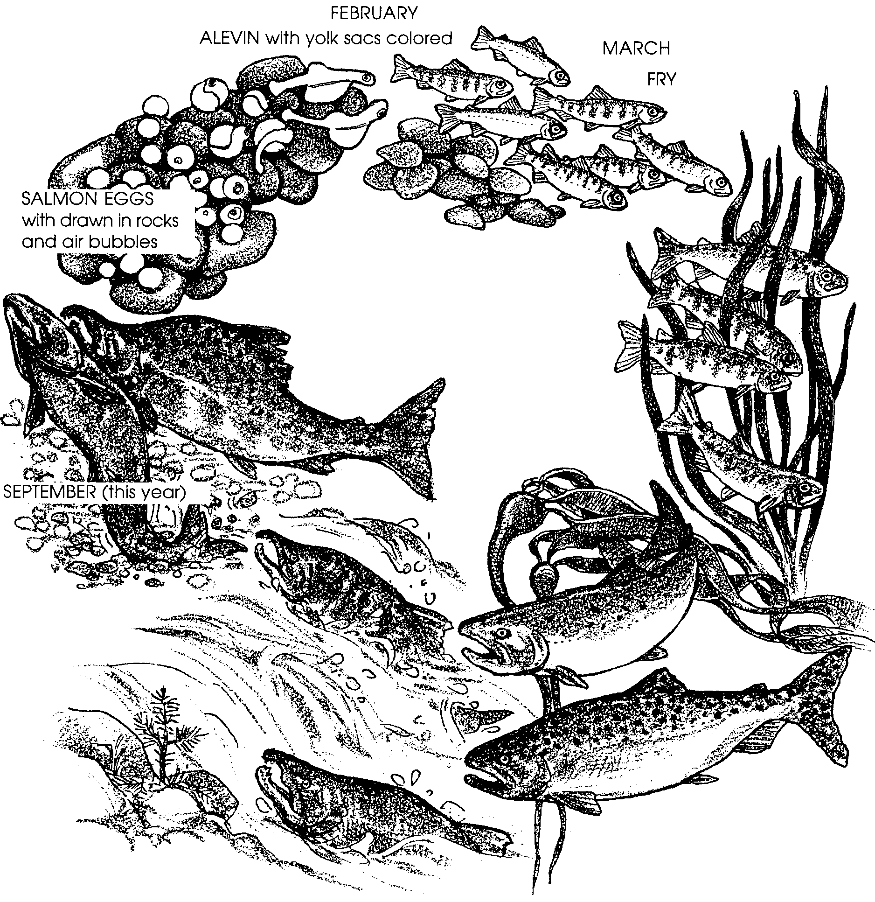

The story in the student text is adapted from: “The Magnificent Journey”, Backgrounder,
Bonneville Power Administration, October, 1986, Portland, OR.

The Long Wet Journey: The Cycle Begins
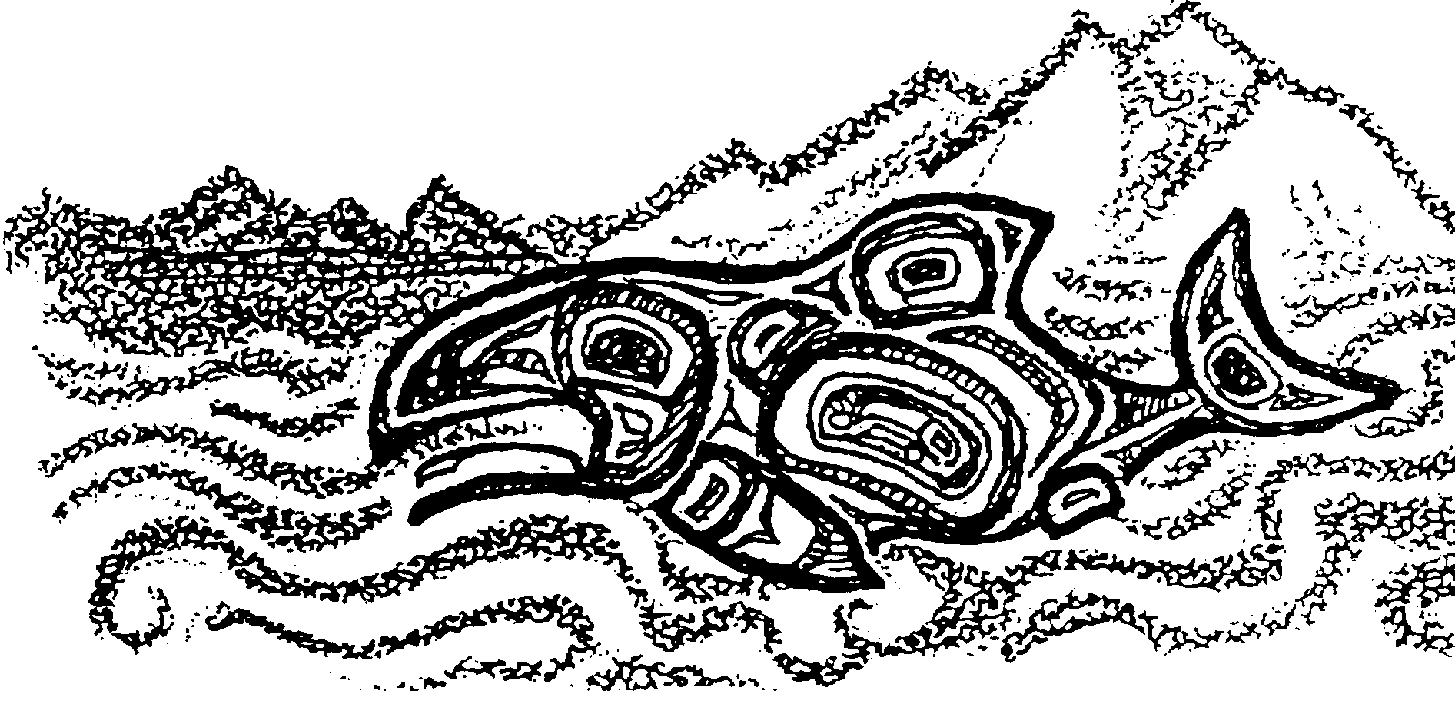
Introduction

A miracle. That’s what Native Americans called the return of salmon. Each year millions of fish returned from a huge ocean to the streams where their lives began. These fish were magical and great spirits. Even today, the life cycle of a salmon still seems a miracle. The long journey that salmon make from stream to the ocean and back is more dangerous than ever.

1. Think about rivers and streams today. What things might make a salmon’s trip more dangerous today than before?

It seems like there should be millions of salmon today, too. A single Pacific salmon can lay between 2,000 and 13,000 eggs. But did you know that usually two or fewer fish return from all those eggs? What can happen to the eggs? Sometimes the water level in a stream drops too low and thousands of eggs are wiped out. Bigger fish, bears, seals and sea lions all take their share of salmon. Salmon survive these losses by laying these thousands of eggs.

2. Today, the number of salmon returning to many streams is growing smaller. People would like the number of salmon in a stream to remain the same or increase.

a. To remain the same, how many adult fish have to return from the 2,000 to 13,000 eggs laid by a female?

b. To increase, the number of adult fish returning has to be greater than
.

But the salmon alone cannot make up for what people have done to the streams. Catching salmon became too easy. Dams blocked large areas of the wild salmon’s spawning areas. Roads and towns developed around salmon streams. Logging and farming practices fouled rivers with sediment. So did pollution from cities, factories, and houses.

3. What things make a salmon’s trip more dangerous today than before? (Did you list these things in your answer to question 1?)

Salmon runs became smaller and smaller. Today, some types of salmon are in danger of disappearing forever. The Pacific Ocean and the great river systems that pour westward into it, don’t seem to be the kind of homes they once were for Pacific salmon.

Humans were slow to see what was happening to the salmon. Good places for salmon to lay eggs and grow were being lost. The long journey from the streams to the ocean and back again was being delayed or blocked. People continued to catch many salmon.

In time, people began to recognize that something had to be done to help salmon. A law called the Endangered Species Act came into being. It helped people to see that many kinds of salmon were in danger of being lost forever. Today, many people are busy trying to help salmon survive. Fishermen, landowners, and government are all part of this work.

What needs to be done to help salmon? To answer this question, people need to know a little bit about the life of a salmon. The story below, about just one female Chinook salmon, “Tyee the Lucky” will help you understand.

4. Do you think it is important that salmon survive? Please explain your answer.

The Cycle Begins

High in the mountains of central Idaho, a creek too small to have a name, runs cold and clear. Thousands of years in the past, great melting ice sheets covered the area. They left a U-shaped valley with a gravel floor. The gravel can still be seen on the creek bottom.

It is September. Leaves are yellow and brown. Frost covers everything along the stream bank. The first snowfall is not far away. A reddish-brown female Chinook salmon lays just under the rushing water’s surface. She is battered and exhausted. She seems to be resting, perhaps waiting for something.

Another salmon appears. He is darker, with cream-colored splotches on his body. He moves next to her, facing upstream as she is. These salmon are mating, or spawning. They are Chinook salmon, also called “tyee” or “king” salmon. They are the largest and live the longest of any Pacific Northwest salmon.

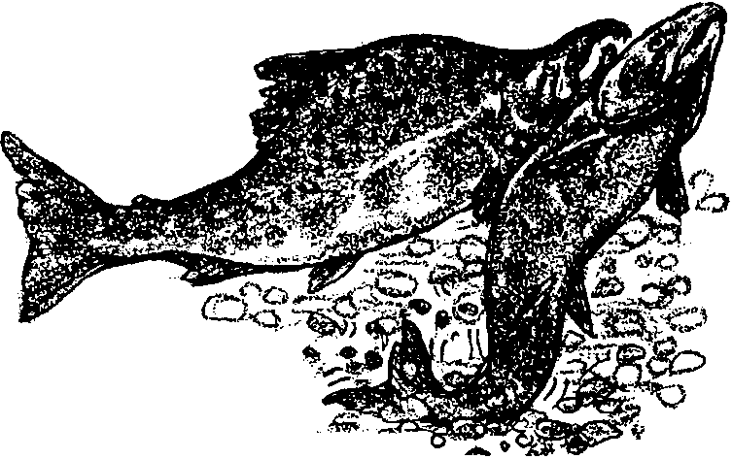
1. Find the drawing of the salmon life cycle on the last page of this activity. Label the spawning salmon. Write “September” and this year next to the spawning salmon.

The female turns on her side and flips her tail. She does this over and over again, scooping out a shallow hole in the gravel. In the hole, called a redd, she lays about 8,000 bright pink eggs. The male fertilizes the eggs. Then, the female swims just upstream. With her tail, she kicks up pebbles. The pebbles drift down over the eggs, hiding and protecting them.

Now the eggs are protected from sunlight, strong currents and hungry animals. For the next four weeks or so, the eggs remain hidden in the gravel. If the redd is not disturbed in some way, they are safe.

2. What kinds of things might disturb the eggs?

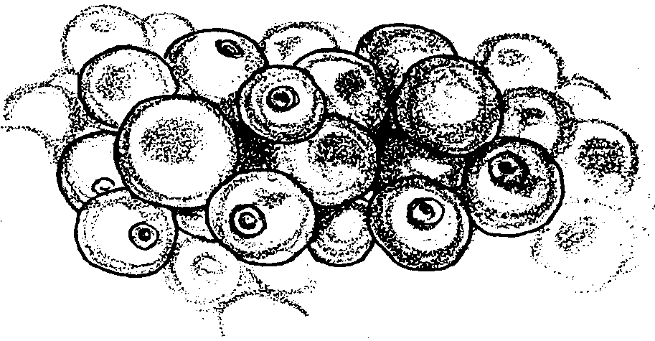
In a few weeks, the eggs begin to change. Inside each living egg, a head, eyes, and a body begin to take shape. Somewhere among these closely-packed lives in the redd lies Tyee. Tyee the Lucky. Salmon don’t usually have personal names, but this female is special. Read on to find out why she is called “Lucky”.

Tyee is lucky that the water rushing through the gravel is cold. It’s about 55°F, perfect water temperature for a salmon. Warmer water could end her life early. She is lucky, too, that there have been no floods. Water from heavy rainfalls could sweep away her gravel protection.

Tyee needs cold water. She also needs oxygen. The oxygen she needs comes from air mixed into the water. Upstream from Tyee’s redd, rocks stick out of the water. The water runs over the rocks mixing air into the water. Without oxygen, the eggs would die.

3. Find the drawing of the salmon life cycle on the last page of this activity. Label the salmon eggs. Draw in some rocks and air bubbles.

Ducks, other birds, raccoons, and larger trout love to eat salmon eggs. But Tyee is hidden and protected in the stream gravel. Tyee the Lucky.

From Egg to Fry

It is winter at Tyee’s redd. Snow covers the ground. All is white but the stream itself. Thin ice sheets cling to the banks of the stream. Little can be heard except the soft gurgle of the stream. Nothing seems to be alive. But in the gravel, things are happening.

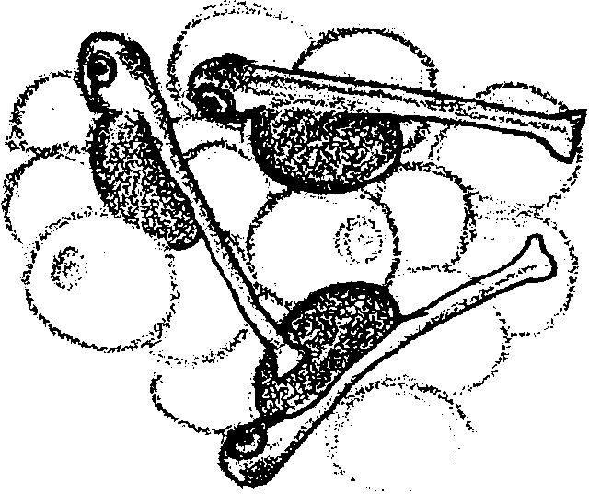
By Valentine’s Day, the eggs remaining alive have hatched. The hatchlings stay under the gravel. Tyee has transformed herself into a young fish called an alevin. Her eyes are huge compared to the rest of her body.

An orange sack, called a yolk sac, hangs from her body. The yolk sac contains all the food she needs to grow. As she grows, the sac gets smaller.

4. How is the yolk sac important in protecting Tyee?
5. Find the drawing of the salmon life cycle on the last page of this activity. Label the alevin. Color the yolk sacs orange. Next to the drawing, write the month in which Tyee becomes an alevin.

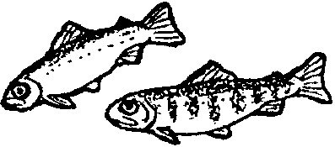
One night in March, Tyee gets an urge to slip upward through the gravel. She emerges into the stream as a tiny fish, called a fry. Her eyes are still bugged out. She is about half the size of a toothpick. She swims in shallow pools near the edge of the creek. There the current is not strong. She can also stay away from the direct sunlight.

6. Why might Tyee want to avoid the sunlight?

7. Find the drawing of the salmon life cycle on the last page of this activity. Label the fry. Draw a fry just coming out of the gravel. Next to the drawing, write the month in which Tyee emerges as a fry.

Tyee darts around feeding on tiny creatures. She is quicker than most. As she feeds, she is easy food for trout and other fish, ducks and herons. It is a good thing she is quick. Tyee the Lucky.

Tyee will be in fresh water for a full year before she has her first taste of salt water. Her birth creek gets shallow in July. Tyee lets the current take her downstream. She is in no hurry. She stops along the way under root wads, fallen trees, and boulders. These places make good resting stops. They are also good places to feed. By the time the first Fall rains come, she is in the Middle Fork of the Salmon River.

8. On the map on the following page, circle Tyee’s birth creek. (Hint: Look for her “baby picture”.) Use a colored pencil or marker to color in her path to the Middle Fork of the Salmon River.

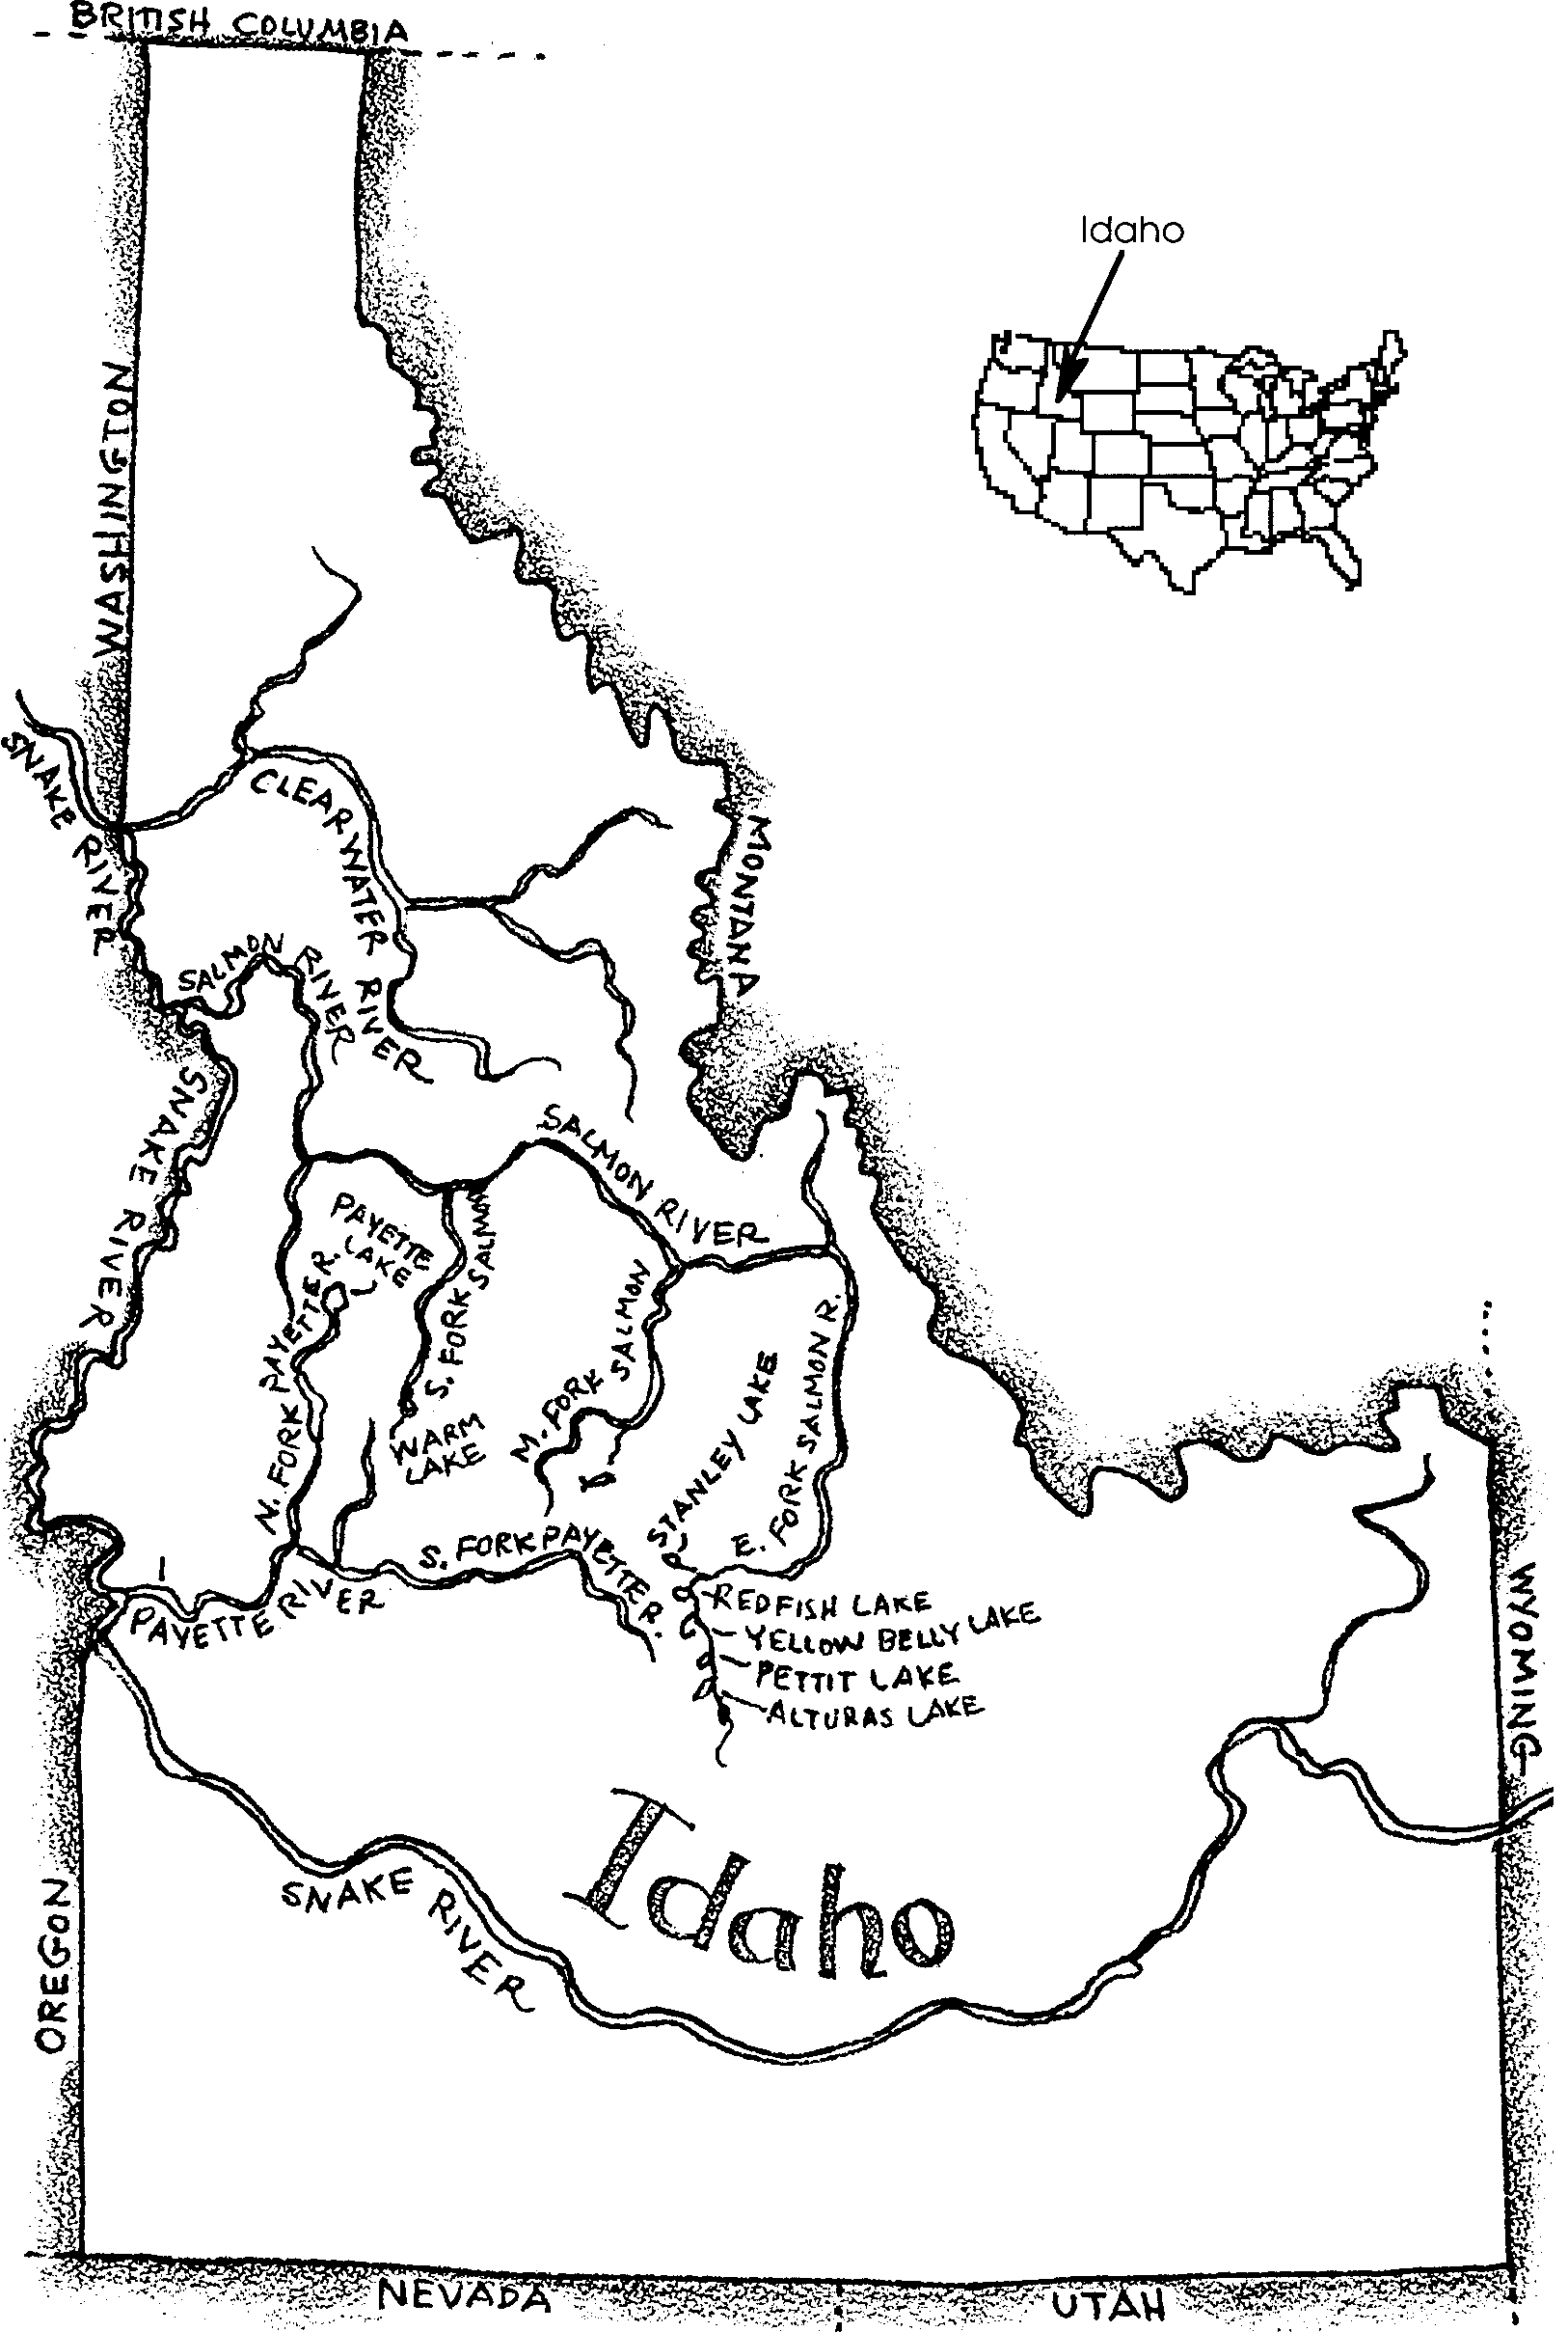

By September, Tyee is well over three inches long. Scales protect the length of her body. Over the scales, a slime layer has formed. The slime protects her from disease. It also helps her slide through the water. She has developed faint bar-shaped marks along her silver-colored sides. The marks help hide her from predators.

9. Here’s a drawing of Tyee. Draw a background in which the bar-shaped marks would help her hide.

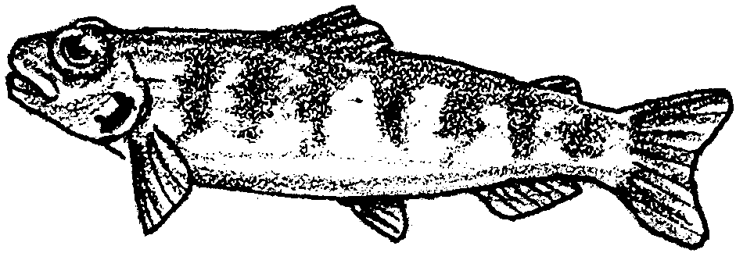

Tyee is big enough now to be a real hunter. She snaps up mosquitos and other insects that come near the water surface. She nabs an ant unlucky enough to have fallen into the water.

Her mouth also helps her breathe. She takes in water through her mouth. She forces the water out through the gills on each side of her head. Like your lungs, the gills take up oxygen from the water.

Salmon also have nostrils and a good sense of smell. They can smell predators and food.

Tyee can smell home too. As she travels from where she emerged from the gravel, she smells the water. The smells she remembers will help her to get back home, years later. Salmon can return to the stream of their birth using this learning. Humans call this homing. We don’t yet understand how it works. Somehow, the smell, taste, or some other thing about the water in Tyee’s stream become part of her memory.

10. Smell seems to be very important in salmon homing. What kinds of things do humans add to streams that might change the smell of the water?

So far, life for Tyee has been good. She has escaped from more than one large fish. In August, a kingfisher perched on a branch above her. The bird took aim and headed straight for her. Thanks to her large eyes and quick reactions, she darted away in time. Not every young salmon is so lucky.

In fact, the end of summer, only 1,200 salmon of the 8,000 eggs were still alive and feeding. And conditions for her brothers and sisters were better that average.

11. Only about 15 % of the Tyee’s fellow eggs made it through the fry stage. This means that for every 100 eggs, 85 died along the way.

a. If 10,000 eggs had been laid, how many eggs would have died? (Hint: How many 100’s are there in 10,000?)

b. How many would have lived?

The Long Wet Journey: The Cycle Begins Activity
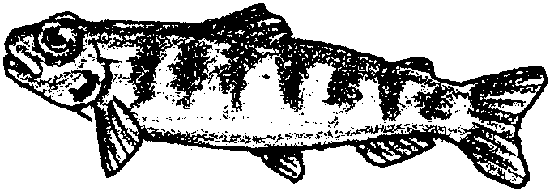
Cold Water

Tyee needs cold, clean water. How warm or cold is 55°F? Why not find out?

Here’s what you’ll need:
• quart cottage cheese container (big enough for your hand)
• tap water
• ice
• thermometer
• watch or clock with second hand

Here’s what to do:

a. Fill container about 1/3 full with tap water.

b. Measure the temperature with a thermometer. Be sure to wait a minute for the thermometer to come to a rest.

c. If your tap water is too cold, add a small amount of hot tap water. If it is too warm, add a small amount of ice.

d. Stir and again measure the temperature.

e. Repeat steps c. and d. until you get a temperature between 52°F and 58°F.
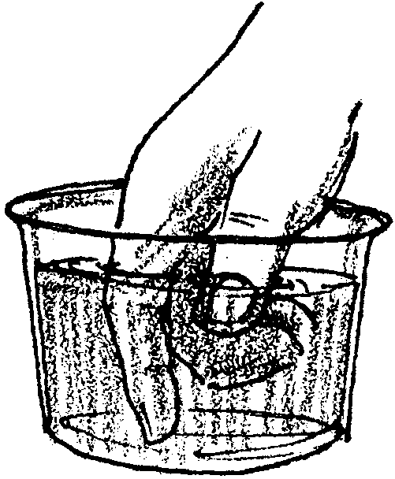
f. Now, dip your hand in the water.

Does it seem warm or cold to you?

g. Next, see how long you can keep your right hand in the water. Record your answer in the data table.

h. See how long you can keep your left hand in the water.
Record your answer in the data table.

Which hand could you keep in the water longer?
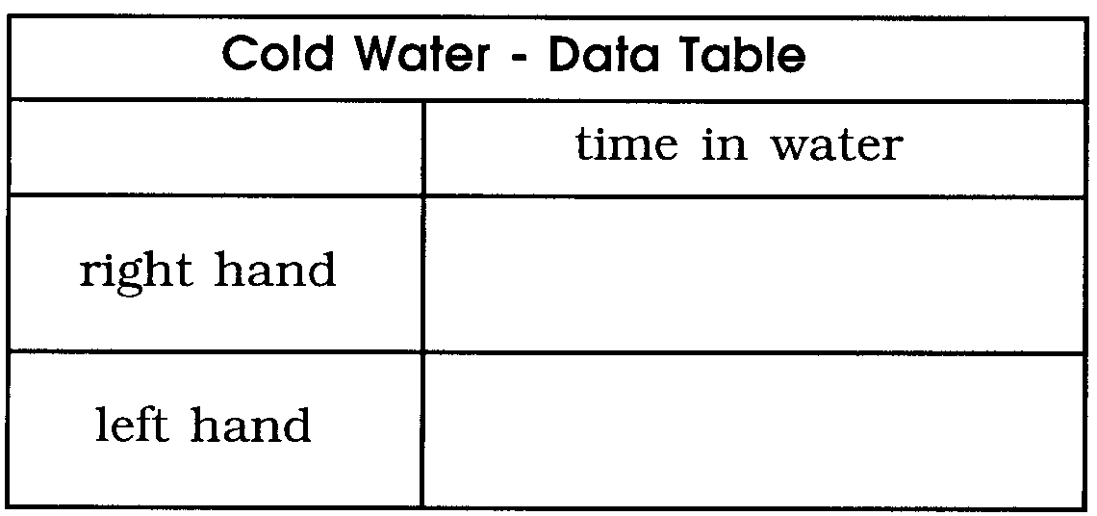

SALMON LIFE CYCLE
