Watershed Woes

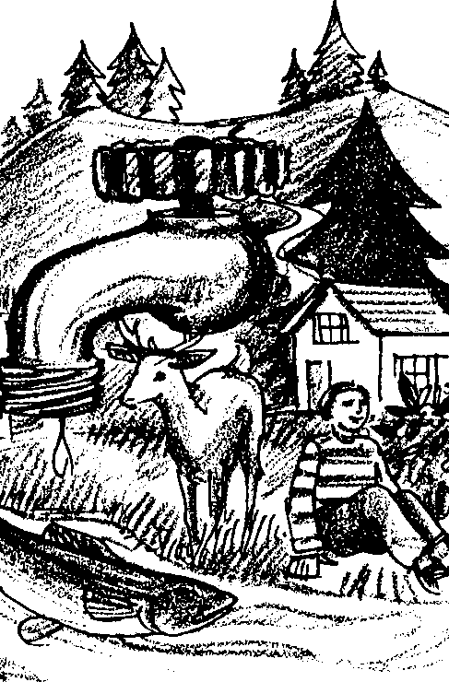
Key Concepts
1. Water in a watershed or stream is used by fish, wildlife, and people.
2. Water in a watershed or stream can be allocated by law to the various users.
3. Water allocation can lead to serious problems if water is scarce or its use increases.
4. People can help ease the demand for water using conservation methods at home.

Background

Allocation of the water in a watershed is a serious business. People that use the water can own the water in a watershed. To do this, they often use a very old system called “water rights”. Such rights specify how much water can be taken from a watershed by the owner of the rights. Priority for water is determined by the most senior owner (that owner with the oldest rights on the watershed). In years of normal and above normal rainfall or snowfall, there is usually enough water to go around. In drought years, water rights are more important, because an owner of the most junior water rights could be denied water. Water rights are sold with property such as ranches and farms. Often, cities own water rights to insure they get enough water for their residents. In some states, Fish and Wildlife Agencies apply for water rights for the fish and other water-dependent creatures living in and around a stream or watershed. This is called “minimum stream flow”, the minimum amount of water that must flow in the stream to keep its creatures alive.

Materials

For each pair of students:

• 32-ounce clear plastic beverage bottle

• approximately 18 inches of one-half inch masking tape

• marker

• water

• one ounce measuring cup (can be made from a paper cup)

For each student:

• “Watershed Woes” activity pages, including “At Home Action Plan”
Teaching Hints

In “Watershed Woes” students create a model of water allocation for a town on a watershed. Growth of the town causes increased use of the water until maximum capacity is reached. Working at home with their family, students then develop a water conservation plan.

Procedure

1. Collect enough clear plastic beverage bottles and paper cups to do the activity.

2. Explain to students that water in a watershed is often allocated (given/distributed) to various users. When the water is completely allocated, and a drought occurs, serious conflicts arise about who will get the water. Disputes are usually settled in the courts, centered around which users have the most senior “water rights”.
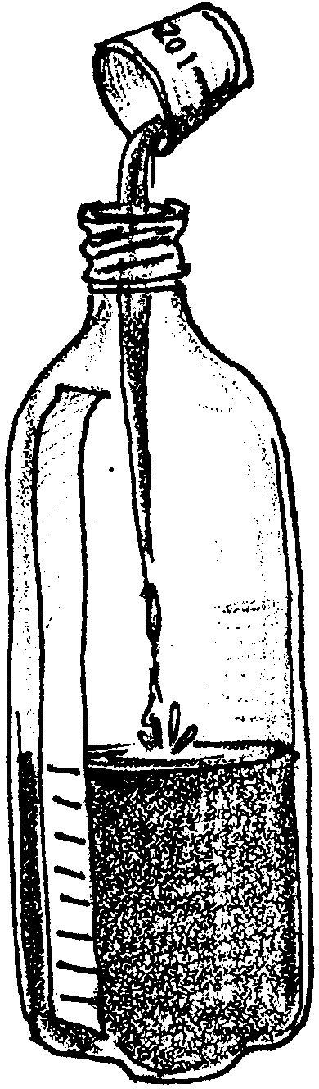
3. Have students work in pairs to calibrate a clear plastic beverage bottle into 32 one-ounce graduations by placing a strip of masking tape along its length and marking the graduations. Have them pour one ounce of water in (measure it first in a separate cup), and then mark the waterline on the masking tape. Have them continue filling and marking the bottle ounce by ounce until the bottle is full. (Note: a different scale of measure can be used if ounces cannot be measured. For example, a single paper cupful of water can be a unit of measurement, but remember to change the amount of water allocated to each use accordingly.)

4. Tell students that the water in the bottle represents the amount of water in a watershed, and that they are in charge of allocating the water for a growing town of 500 households. Before students begin allocating, help them draw up a list of uses for the water in their watersheds. Common ones would include the following: household use, industrial use, irrigation use, and hydroelectric power use. Introduce them to the concept of “minimum stream flow”, the amount of flowing water needed in the streams of the watershed to keep all the land animals, fish and other stream creatures, and plants that live there alive and healthy.

5. Assign an amount of water, in ounces, to be designated for each use. From this, the students calculate the total amount of water used for a given number of households in their growing town. The suggested amounts allow for water allocation up to a certain point, then the students will find that there isn’t enough water in the watershed to supply more growth in the town. While these numbers are arbitrary, they serve to represent the amounts of water needed for the town as it grows.

ALLOCATIONS:

Minimum Stream Flow = 5 ounces

Household Use = 2 ounces per 500 households

Industry Use = 1 ounce per 500 households (as the industry grows, more jobs, and therefore households, are supported)

Irrigation Use = 1 ounce per 500 households (grows food and trade goods for the town)

Hydroelectric Power Use = 2 ounces per 500 households

You can work with other uses or add to this list.

6. Now have the student teams calculate how much of the water is used up in their town of 500 people (11 ounces in the example above). Have them remove that much water from their bottles so that they can see how much is allocated and how much remains.

7. Repeat the operation for a town of 1000 households (17 ounces). 1500 households (23 ounces). 2000 households (29 ounces). 2500 households (35 ounces). For each calculation, have students remove the amount of additional water needed to meet the town’s needs.

8. Once the students reach the limits of the water in the watershed, have them decide what must be done before the town can be allowed to grow more. Options may include:
• drill some wells (this might mean new taxes!)

• pipe water from another watershed (would the people living in that watershed agree?, it would be expensive)

• stop all growth in the town

• cut back water to some of the users (which ones?)

• begin a water conservation program (might include reducing yard watering, car washing, special shower and toilet valves and heads, allowing yard and garden watering on alternate days, etc.)

Have each group come up with as many options as possible. List the pros and cons of each.
9. Ask students what they would do in a year of drought, when the water available to the watershed was seriously reduced.

10. Explain to students that in a real watershed, some of the water can be returned to the watershed after it is used. Discuss each water use with the class. Have students speculate on whether or not the water can be returned to the watershed. Some uses:

• home use (some can be returned via sewers, storm drains)

• industrial use (some can be returned, depending on the industry)

• irrigation use (very little can be returned directly, although some may re-enter streams or groundwater)

• hydroelectric use (all is returned)

• recreational use (all is returned)

In each case, have students decide what must be done with the water before it is returned (removal of pollution by filtering, settling ponds, etc.)

11. Conclude the discussion by helping students list some things they can do at home to help conserve water at their ecological addresses in their watersheds.

12. Distribute one copy of the “At Home Action Plan” to each student. Ask students to take them home and to complete them with their families. Explain that when the plans are completed, students will evaluate the plans in class. Encourage students to collaborate with their families to list things they can do at home to reduce the effect their family has on the watershed. These might include: 1) not dumping oil wastes, car radiator drainage, or any other substance into storm drains; 2) using fertilizers for their lawn sparingly or not at all; 3) avoiding spraying herbicides on lawns and gardens; 4) keeping pet and livestock wastes out of streams; 5) saving household water in various ways. Most public works departments have printed information available that you could use to get additional ideas for the “At Home Action Plan”. Emphasize to students that even one person working alone can contribute to the ecological health of a watershed.

After families have implemented their action plans for several months, invite a local public works official to come in and evaluate the results. If a family effort is made, students should be able to see that their changes have resulted in a significant reduction in water use and pollutants introduced into the watershed.

Key Words

allocation - in this case, the amount of water saved for a particular person’s use

water right - the right to use a specific amount of water

watershed - the region or area drained by a river, stream, etc.; drainage area

Extensions

1. Contact a local water or wildlife official. Ask the official to come to your class to brief the students on the use and health of water in your watershed. When you call, be specific about what you want the official to talk about, what the students already know, and how long the discussion should be.

2. Make a class visit to all or part of your watershed.

3. Investigate the history of your watershed. When was it born? What Native American peoples used the watershed, and how did they use it? When and why did the first European settlers come to the watershed? What industries were built in the watershed that depend on it for water? Make a historical timeline poster on adding machine paper to show the major events in your watershed.

Adapted from “Ecological Address: At Home in Your Watershed”, National Science and Technology Week 1992-1993 Packet, National Science Foundation, Washington, D.C.

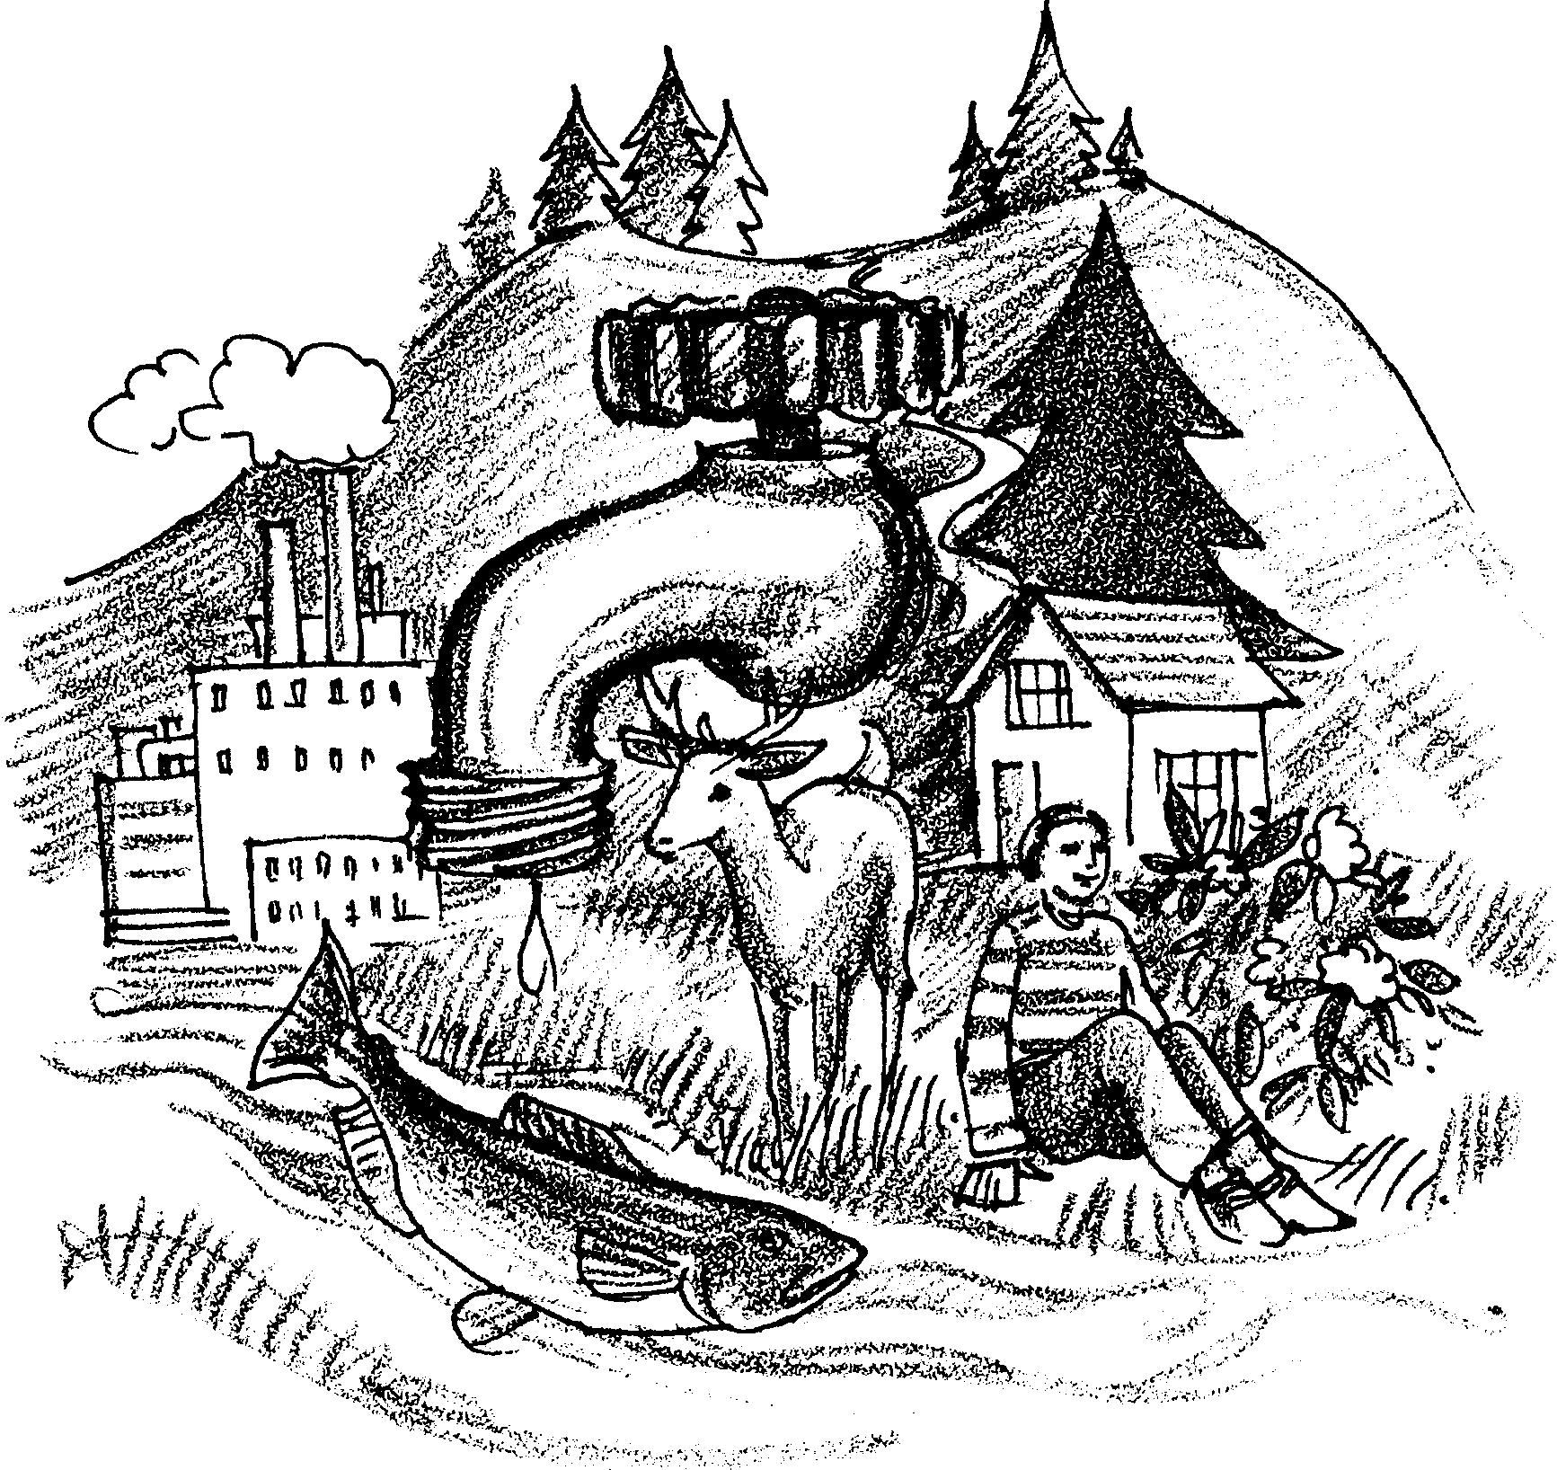
Watershed Woes

Water in a watershed is used by fish, wildlife, and people. All of these “users” need a certain amount of water in order to live where they do. They get it from the streams, rivers, and ground water in the watershed. Lots of “users” want the water. But there is a only so much water in a watershed.

People are given “water rights” in a watershed. Someone with a “water right” may use a certain amount of water. The water right has the force of law.

This way of sharing water usually works well. That is, until there is a drought, or a “user” wants lots more water. When either of these things happen, conflicts may occur. People argue about who gets to use the water. By law, the person with the oldest water right gets to use the water first. The court system sometimes has to decide who has the oldest water rights.

More people in a watershed means more water is used for people’s needs. Lots of things we do use water. We use water in our homes and where we work. Farmers use water for their crops and water is used to make electricity.

Plants and animals need water, too. Many states require a “minimum stream flow”. This is the amount of water needed by all the stream animals and plants to stay alive.

How much water goes to each user? In the following activity, you will decide how the water is to be shared.

Here’s What You Need:
• a 32-ounce clear plastic beverage bottle
• approximately 18 inches of one-half inch masking tape
• marker
• water
• one ounce measuring cup
• “At Home Action Plan”

Here’s What to Do:
Procedure

1. Obtain a plastic beverage bottle. This bottle will form the boundary of a watershed. It will hold all the water available in the watershed. “Dry Gulch” is a make-believe city on that watershed. You are in charge of who gets the water in the watershed (bottle) as the town grows.

2. Mark your watershed bottle in one-ounce units. Here’s how. Place a strip of masking tape along the bottle’s length. Fill your measuring cup with one ounce of water. Pour the water into the bottle. Mark the level of the water on the masking tape with a pen or pencil. Add another ounce of water and again mark the tape. Do this until the bottle is full. Your bottle should look like the drawing to the right.

3. Decide what water uses will occur in your city. Talk these over with the rest of the class or your group. Write in the amounts under each use on your data sheet. Add any other uses the class/group decides are necessary.

4. Today, 500 people live in “Dry Gulch”. Calculate the amount of water needed from the watershed (bottle) for each use. Write the amounts on your data sheet. Add the uses to get a total amount of water needed. Now, remove that much water from your watershed bottle. Be careful not to pour out too much water. Use your marked lines to guide you.

5. “Dry Gulch” is a nice place to live and work. It’s growing fast. Calculate the amount of water needed as the town grows to 1000, 1500, 2000, and 2500 people. Each time, remove only the additional water it would take to support the town - don’t refill the bottle.

6. When you have finished, discuss your watershed with your group. Then discuss your watershed with the class, and your teacher. Ask what each of you can do to save water.

AT HOME ACTION PLAN

You can get your whole family involved in saving water for your watershed. You can also make sure the water you do have is clean. Take this form home. Discuss all the ways your family can save water. Make a plan that tells what your family will do to help. The list below is a good place to start:
• not dumping oil, antifreeze, or any thing else into storm drains
• take showers instead of baths
• use water-saving shower heads
• use lawn and garden fertilizers sparingly or not at all
• avoid spraying herbicides on lawns and gardens
• keep pet and livestock wastes out of streams
• save household water for watering plants
• and (add some of your own ideas) . . . . . . . . . . . . . . . . . . . . . . . . . .

PLEDGE

Our Family Name

Actions That Our Family Ways That The Action
Will Take To Help Watersheds Will Help Watersheds

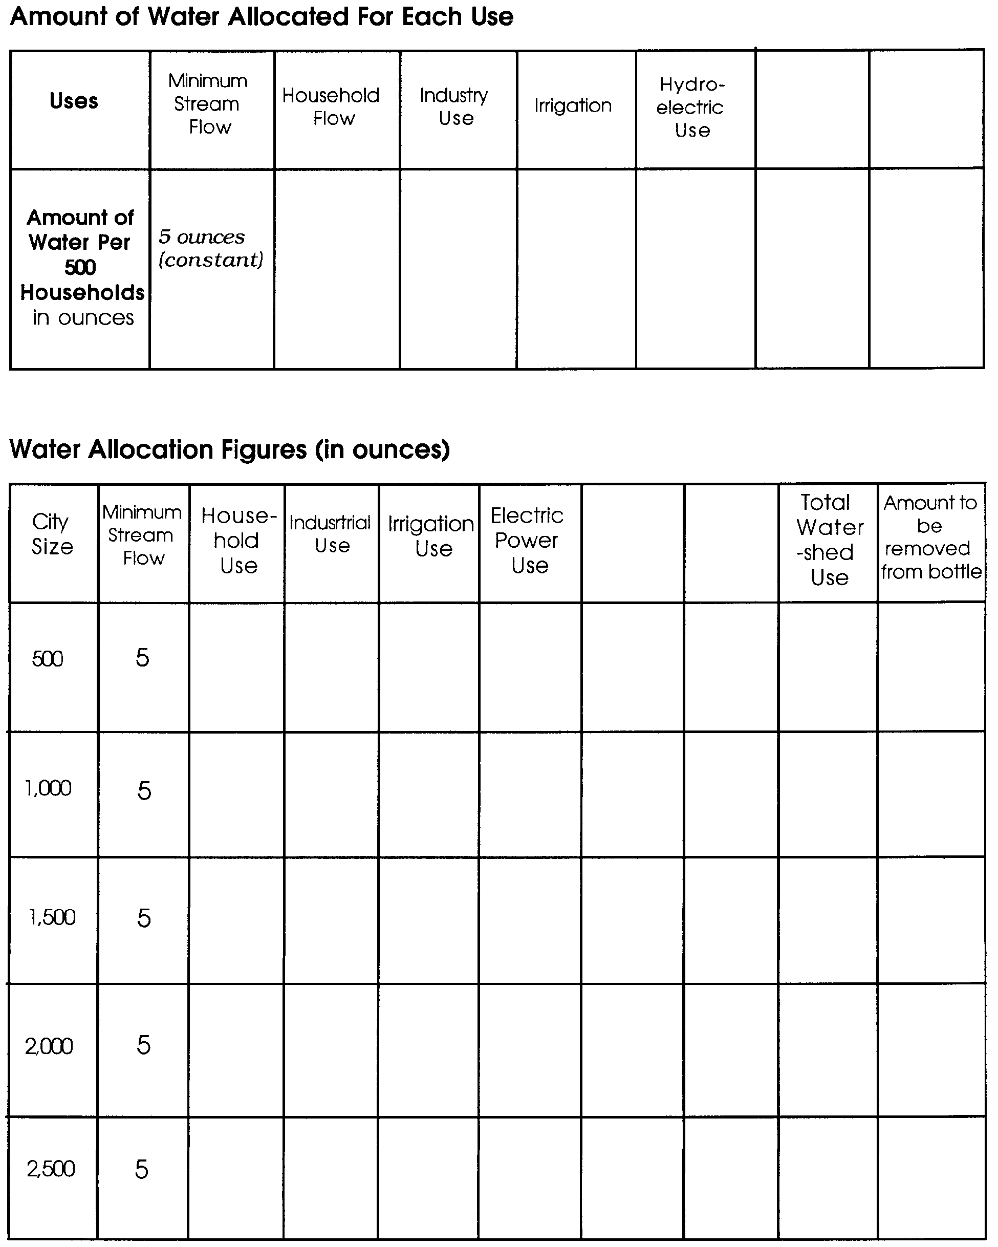
Student Data Sheet

