What Wiggles in Watershed Water?
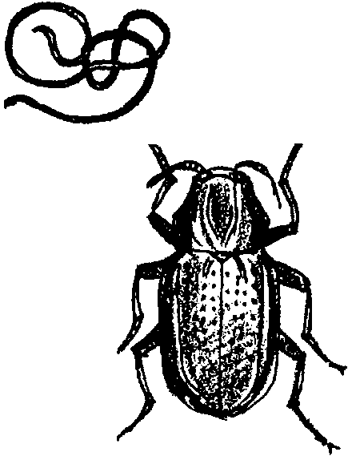

Key Concept
1. Aquatic insects can be used to determine the general quality of stream water in the watershed.

Background

Macroinvertebrates are animals without backbones that are large enough to be seen without a microscope. In streams, most live on the bottom and include worms, clams, snails, crustaceans, and insects. The insects are most abundant, and are usually immature stages of adults, spending most of their time in the water before they “emerge” winged and ready for mating.

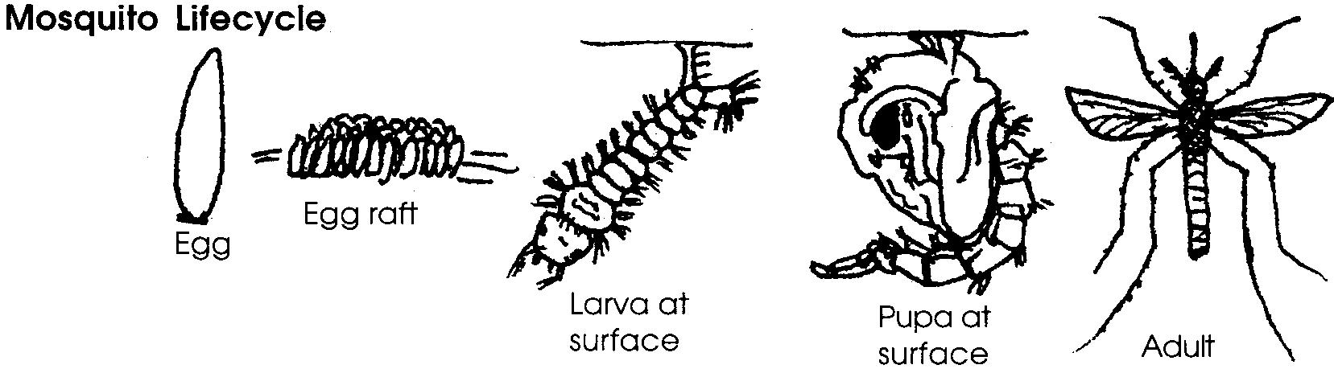
Aquatic insects usually look quite different as larval forms than adults. They change from one form to another through a process called metamorphosis. The flies, beetles, and caddisflies go through complete metamorphosis; beginning their lives as eggs, then metamorphosing into larvae, then pupae, and finally emerging from the water as winged adults. Dragonflies, stoneflies, and mayflies skip the pupae stage, going from larval directly to adult form (called incomplete metamorphosis). All these insects spend most of their lives in the larval stage in the water. In comparison, the adult life span of some insects, such as mayflies, are often as brief as several hours. During this short period, they must find another adult of the same species, mate, and deposit their eggs before they die.

Macroinvertebrates play an important role in streams. They are the main food of fish, and connect the primary producers, such as algae, with the predators, such as trout or birds.

The nature of a stream system or watershed allows the system to absorb pollutants from a single place and have it carried to all parts of the system downstream. Often, we can not see the pollutant.
Macroinvertebrates living in the stream, however, can and do feel the effects of stream pollutants. Unlike fish, they can not move out of the path of the pollutant. Each of the many kinds of macroinvertebrates in the stream has different tolerances for the various pollutants. Their ability to live and reproduce in a stream are directly affected by the pollution in the stream. They have become key indicators of the quality of stream water.

Macroinvertebrates are easy to collect and their identification is much easier than algae (which can also be used to evaluate stream water quality). Fish also are good indicators of water quality. Salmon especially are usually associated with good water quality, but their life cycle is two to five years, a long wait to see if their returning numbers have fallen. Macroinvertebrates, with their relatively short life cycles, give us more immediate indications of stream water quality.

Materials

For each group of 4 students:

• insect nets (“D” frame nets work best)

• white enameled or plastic pans

• tweezers

• small artists’ paint brush

• eye dropper (if available)

• ruler, centimeter

• “What Wiggles In Watershed Water” activity pages

• boots (optional)

Teaching Hints

In “What Wiggles in Watershed Water?” students study aquatic insects in a nearby stream to determine its general water quality. The activity provides students with the opportunity to apply the knowledge they have gained regarding watershed structure.

While this activity may be successfully completed in any flowing body of water, it is best to use shallow, narrow streams no deeper than 12 inches. It is helpful to visit the stream site and go through the procedure yourself before taking students there. While at the site, note any safety hazards. Also, remember that high water flows will make collecting insects impossible, and the stream more dangerous. If collecting in fall and winter, time your trips before heavy rains come.
Recognize that this activity provides a very gross or generalized measurement of stream water quality. Nonetheless, it does provide evidence of a connection between water quality and the stream’s inhabitants.

Key Words

abdomen - in this case, the section of an insect’s body furthest from the head

aquatic - living in water

gill - in this case, feathery body parts used for breathing

indicator - a plant or animal that indicates, by its presence in a given area, the existence of certain environmental conditions

macroinvertebrates - animals without backbones large enough to be seen without the aid of a microscope.

riparian - the area on either side of a stream and its associated plants, including the wet soil areas influenced directly by the stream.

watershed - the region or area drained by a river, stream, etc.; drainage area

Extensions

1. Arrange to send your class results from this activity to your area’s water quality agency. Have an agency expert come to your class and discuss the students’ findings.

2. If possible, have other schools on the stream conduct the same activity and compare results between schools.

3. After examining the stream’s health, arrange for a tour of the stream upstream from the sampling point. You may be able to see reasons for the quality (good or poor) of the water you found. For poor water quality, these could include a pollution source, riparian disturbance caused by natural events or people, or a combination of these reasons. You may also find the reasons for good water quality: a healthy riparian area and upland or fencing to keep animals out of the stream.

Activity adapted with permission from: “Water Wigglers” by Bill Hastie, Oregon Wildlife, Oregon Department of Fish and Wildlife, Portland, OR, July- August, 1991.

Key adapted with permission from: Stream Scene: Watersheds, Wildlife and People,
a secondary level curriculum developed by Oregon Department of Fish and Wildlife, Portland, OR.

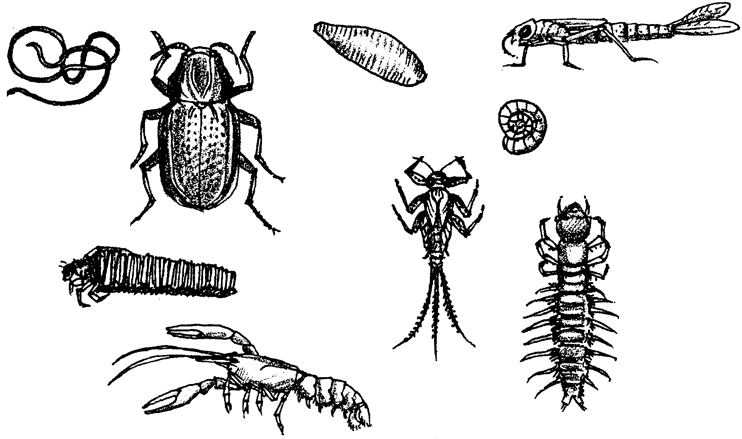
What Wiggles in Watershed Water?

If you have a cough or stomach ache, your parents usually figure that you are sick. If you are really sick, you may need to stay home from school to get better. The cough or stomach ache are indicators. They tell us that something is wrong with your body.

Streams and watersheds get sick too. Poor land use and pollution in a stream’s watershed can lead to a stream health problem. How do biologists know when the stream starts to get sick? What are the indicators of poor stream health?

A stream that supports fewer fish than it once did may be sick. But even before changes in fish are noticed, biologists can tell if a stream is healthy or not. They look at the macroinvertebrates (mac-row-in-vert’-ta-braytes) living in the stream. Wow! What a giant word. “Macro” means “large”. “Invertebrate” means “no backbone”. So, macroinvertebrates are animals without backbones that can be seen without a microscope.

Most macroinvertebrates living in a stream are insects. They spend most of their lives living in the water. After many changes of form, they become adults. The adults live the rest of their lives as flying insects.

A stream with many different kinds of insects living in it is usually considered healthy. But much can be learned about the stream by also looking at the kinds of insects living there. In general, stream insects can be placed in three groups:
Group 1 insects
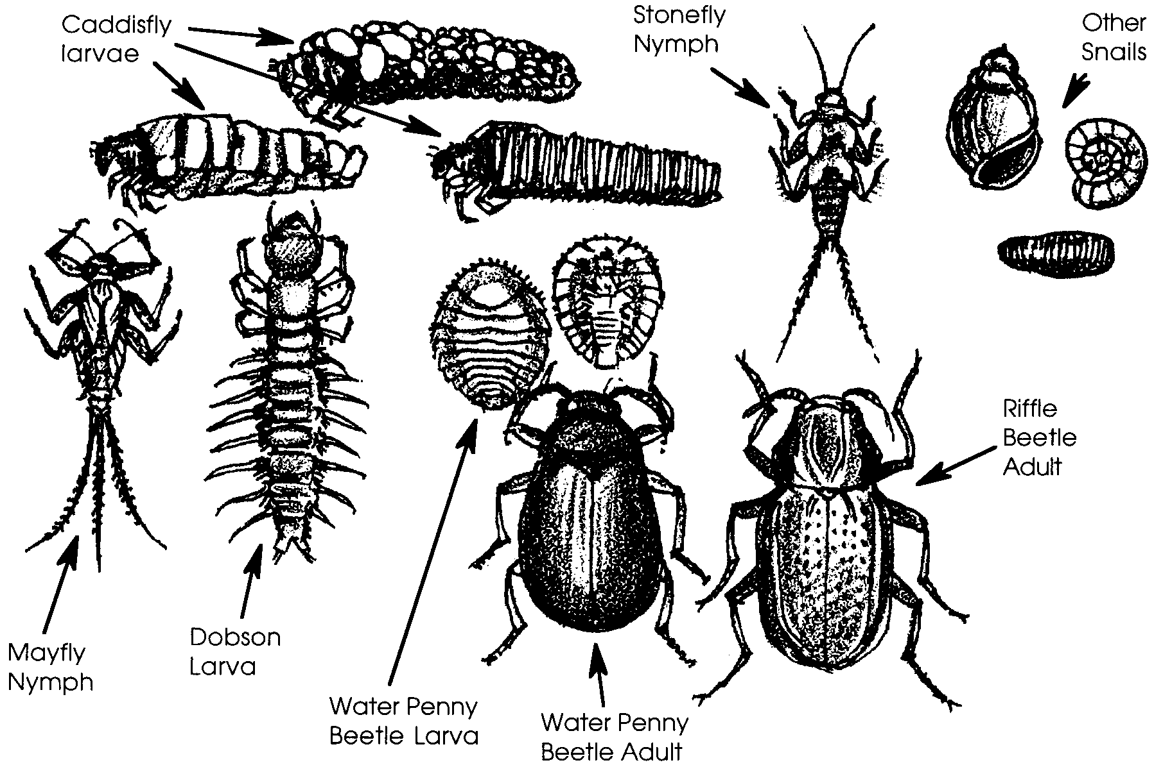
These insects do not tolerate pollution well. Large numbers of these indicate good water quality. This group includes: caddisflies, stoneflies, and mayflies.

Group 2 insects
These insects can tolerate both good and poor water quality. Large numbers of these indicate fair water quality. This group includes: dragonflies, damselflies, beetles, and crane flies.
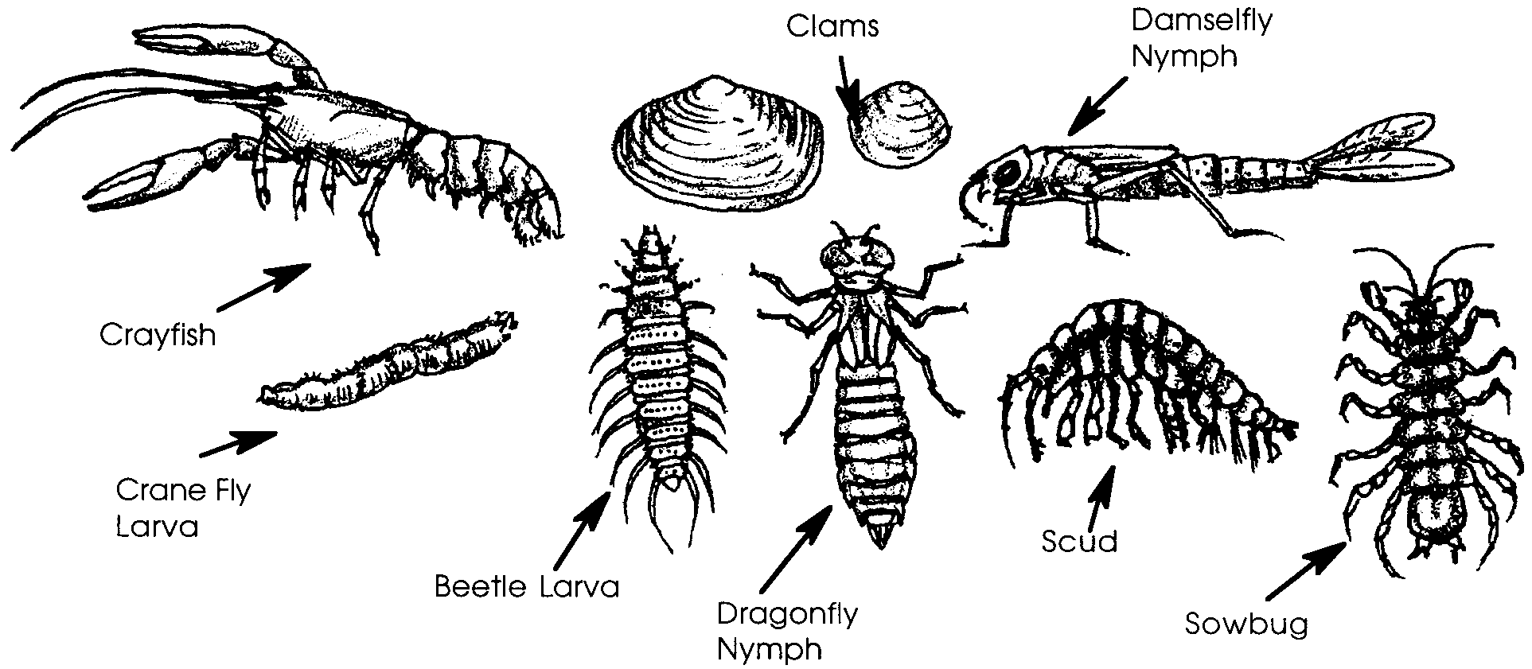

Group 3 insects
These insects can live in polluted water. Large numbers of these indicate poor water quality. This group includes: midges and black flies.
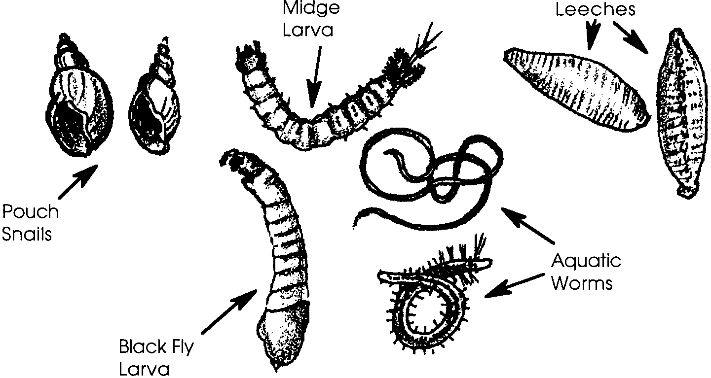
Stream Study

Explore a nearby stream in your watershed. Collect your gear and study the critters in and around the water! The number of insects living there can tell you about its health. Remember to collect data about each of the three groups of insects. Keep the data for future use.

Here’s What You Will Need
• “What Wiggles In Watershed Water” activity pages
• insect nets
• white enameled or plastic pans
• plastic ice tray
• tweezers
• small artists’ paint brush
• eye dropper
• paper and pencils to record your findings
• ruler, centimeter
• boots (optional)

Here’s What You Do

Procedure
1. Collect aquatic insects and other macroinvertebrates. Carefully move bottom material on and under the rocks. Let the current carry it into a fine mesh net. Be sure to hold the net close to the stream bottom. This is easiest in an area where there is good current. You can also collect insects from the rocks. Place a few rocks in one of the white pans. Remember to return the rocks to the stream. Be sure to return them to their original places.

2. Place the material you have collected in the white pan. You will soon be able to see many insects and other macroinvertebrates. Watch for them crawling along the bottom of the pan.

3. Place the insects and macroinvertebrates into one of three the groups above. Record your findings on a data sheet. Then transfer the insects to a plastic ice cube tray. (A small tweezer or artist’s paint brush can help.) Use the key below to help you identify them.

4. Count the number of animals in each group. Determine which group has the largest number of insects and other macroinvertebrates. Record your findings. Using the insects as water quality indicators and the descriptions of water quality for each insect group (1-3), decide how good the water quality is in your stream.

SIMPLE KEY TO AQUATIC INSECTS

• Builds a portable “house” or case to live in (case can
be made of wood, leaves, rocks or sand grains) Caddisfly

• Has two tails, without abdominal* gills* Stonefly

• Has three tails, (sometimes two), with abdominal gills Mayfly

• Worm-like, without true legs
Less than 1 cm long, gills at end of abdomen Midge

More than 1.5 cm long, head small,
usually found in leaf litter Cranefly

Antennae look like tiny fans Blackfly

• Large, 3 pairs of legs, gills at end of abdomen Dragonfly
Damselfly
* abdomen - the section of an insect’s body furthest from the head

* gill - in this case, feathery body parts used for breathing

Remember that this is only one part of determining stream health. The entire watershed needs to be examined before a complete picture of the stream’s health is possible.

