Threats to Your Ecological Address

... or Does the Earth Need a Raincoat?

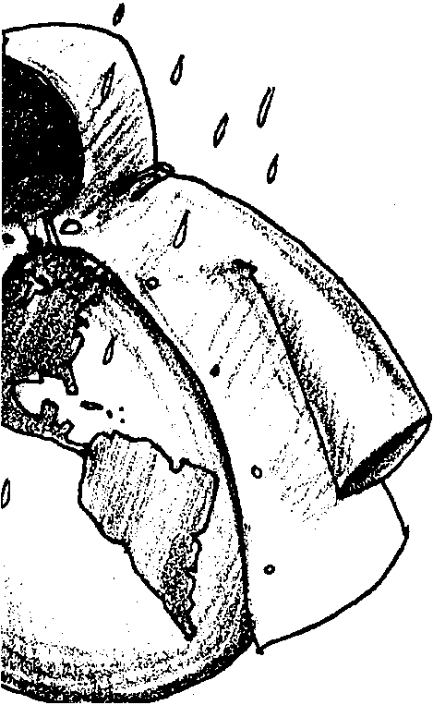
Key Concepts
1. When water falls on the land, some of the water runs downhill on the surface as “runoff”, while some of it is absorbed by the land as “groundwater”.
2. Plants along a stream tend to slow down the flow of water which causes some of the sediments to drop out.
3. Plant removal in a watershed, along with poor land use practices, fire, pollution, mining, and human development, can have a negative effect on the health of the watershed.

Background

“A Short Course on Watersheds”, found in the preceding activity entitled “Finding Your Ecological Address”, provides the background for this activity.

Materials

Part One

For the class:

• rain slicker (plastic or rubberized rain coat)

• wool pull-over sweater

• 3 identical spray bottles of water

• old towels (for floor)

• 3 volunteer rainmakers (one needs to be wearing short sleeves)

• 3 volunteer watersheds

• volunteer rain pacers

Part Two

For each student or pair of students:

• “Does the Earth Need a Raincoat?” student reading material
Part Three

For each student:

• “Threats to Your Ecological Address” activity pages

Teaching Hints

“Threats to Your Ecological Address...or Does the Earth Need a Raincoat?” is a three part activity which investigates some of the factors influencing runoff in a watershed. Part One is a class demonstration that employs student arms as “watersheds”. Part Two is a student reading with embedded questions. In Part Three, students list ways in which the actions of humans or nature can impact a watershed and then propose actions to repair such damage.

Old towels or plastic sheeting may be used to keep the floor from getting wet in Part One. For the activity to be meaningful, students need to watch the water as it flows from the students’ arms. This means that the focus needs to be on the runoff, not on the rainmaking. Setting the proper tone will minimize this problem. Depending upon the group, you may wish to repeat the activity, changing volunteers if desired. While this is a simple model, it is useful in getting students to think about some of the factors influencing runoff in a watershed.

If weather and time permit, consider taking your class outside to chart the course of the rain drop mentioned in Part Two, question 10.

Key Words

nonpoint pollution - pollution that is carried by runoff, and usually from many sources, such as parking lots, farms, lawns, and leaking septic tanks.

point pollution - pollution from specific places, such as sewer plant outfalls or factories.

runoff - the precipitation that runs off into streams and rivers.

sediments - soil and rock particles that are carried and deposited by streams and rivers.

Extensions

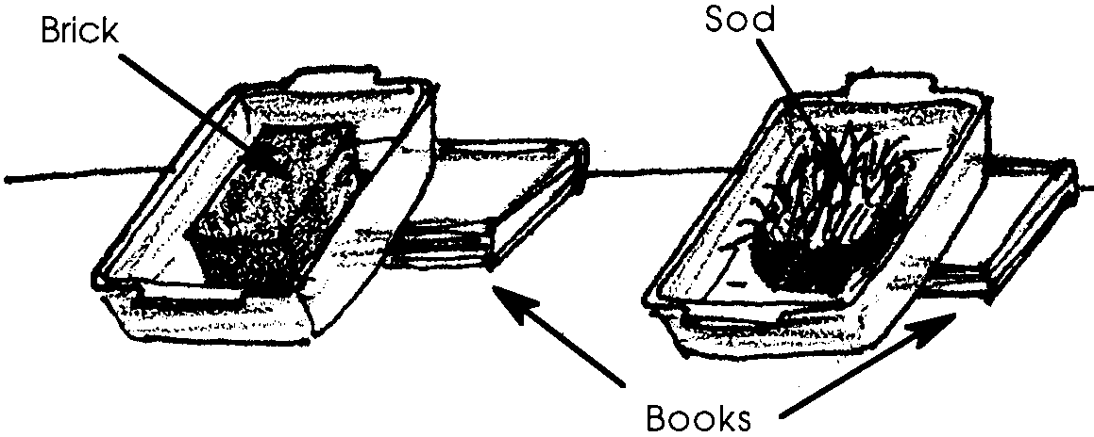
1. A simple demonstration to show the water slowing and holding aspect of vegetation can be achieved as follows. Elevate the ends of two pans (9" x 13" glass baking pans are ideal). In one pan, place a board or brick. In the other, place a clump of sod similar in size to the board or brick. Add the same measured amount of water (1 cup will usually do) to each as students time the runoff. After several minutes, have students measure the quantity of runoff water. Discuss results. To show sedimentation, modify by substituting soil for the board or brick.

2. Arrange a visit to a local water treatment facility, or a tour of a watershed led by your state’s water quality or water resources agency.

3. Complete Activity 5 “Watershed Woes” in this unit.

Answer Key

Part One

6. Answers will depend upon experimental results. Usually the slicker arm has the most runoff.

7. Answers will depend upon experimental results. Usually the arm wearing the wool pull-over sweater does the best job of holding rain water.

8.
bare arm watershed trees, bushes, grass covered watershed

slicker arm watershed grass covered watershed

wool pull-over watershed bare soil covered watershed

Part Two

1. The slicker-arm watershed is most like a watershed with hard soils.

2. Roots, leaves and stems of plants along the stream banks slow the water which causes small soil particles to settle out thus keeping the soil from washing downstream.

3.The question calls for an opinion. Most students will say that the number of plants along the stream will increase. Such is often the case.
4. Answers will vary but may include increasing planting in the watershed and decreasing activities such as logging or road building which add sediment to the water.

5. Answers will vary depending upon experiences of your students but may include: logging, farming, grazing, road building, other construction, and fire.

6. Answers will vary depending upon experiences of your students but may include: logging, grazing, road building, other construction, fire, and mining activities.

7. Answers will vary depending upon experiences of your students but may include: litter, plant debris, pesticides, fertilizers, oil, animals and plants.

8. Drawings will vary but should show a reasonable path which fertilizers might travel from home garden to stream.

9. Answers will vary depending upon experiences of your students but may include: paper mills, slaughter houses, chemical plants, refineries, mines, and sewage treatment plants.

10. Answers will vary. Many students will think laws need to be passed, others will think that education is needed to reduce non-point pollution. The question is included to provide an opportunity to help students realize that the choices all of us make have consequences which impact the watershed for better or for worse.

11. This question integrates the concepts covered in this section.
a., b., c. Answers will vary. If weather and time permit, you may wish to take your class outside to chart the course of the rain drop.

d. The drop could be transpired, evaporate, or be consumed.

e. Answers will vary but should include reducing the plant cover.

f. Answers will vary but should include covering the soil with plants or other absorbent materials.

Part Three

Answers will vary depending upon experiences of your students.

Threats to Your Ecological Address

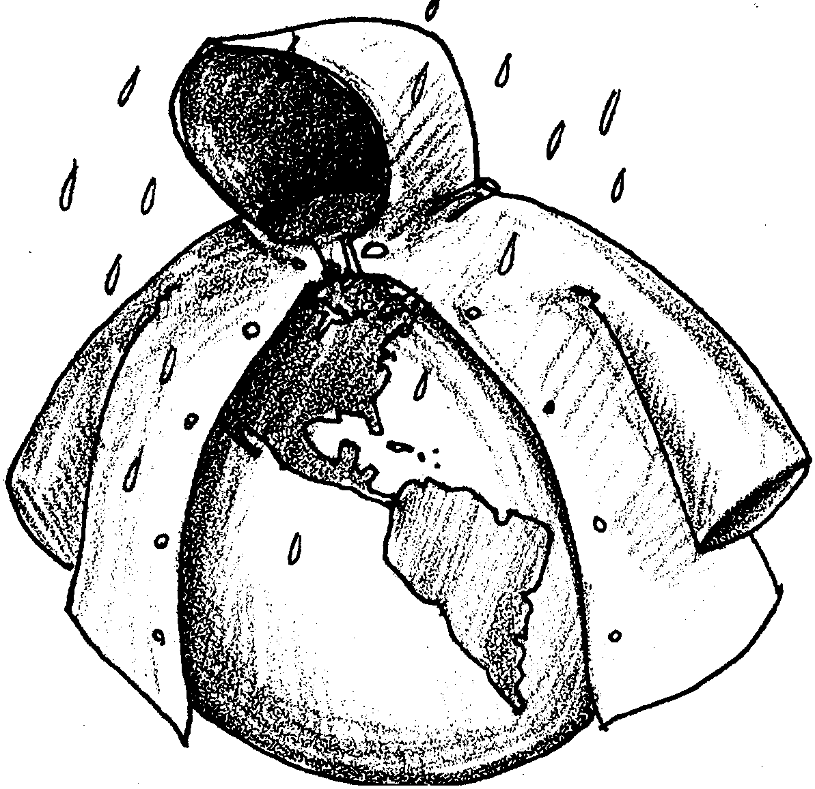
... or Does the Earth Need a Raincoat?

Part One - An Armful of Watersheds

It’s a rainy day in the watershed. Some of the rain that falls soaks into the ground. The rest is runoff. Runoff is important to the health of a watershed. What kinds of things affect the amount of water running off. Let’s begin with a demonstration.

Here’s what is needed:
• rain slicker (plastic or rubberized rain coat)
• wool pull-over sweater
• 3 identical spray bottles of water
• old towels (for floor)
• 3 volunteer rainmakers
• 3 volunteer watersheds (one needs to be wearing short sleeves)
• volunteer rain pacers

Here’s what to do:

1. Remember that watersheds come in all sizes. This demonstration uses arm-sized watersheds. As a class, choose 3 volunteer watersheds and 3 volunteer rainmakers.

2. One volunteer watershed needs to be wearing short sleeves. One of the other volunteer watersheds needs to put on the rain slicker. The other volunteer watershed needs to put on the wool pull-over sweater.

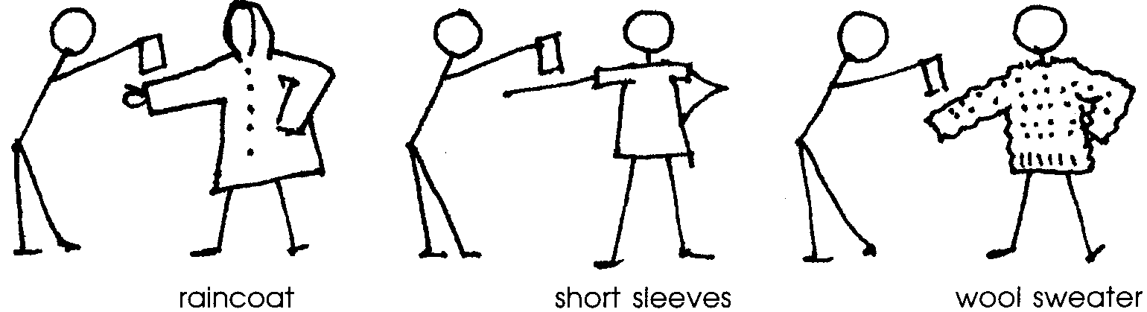
3. Arrange volunteer watersheds and rainmakers in front of class like this:

4. On command, the rainmakers will spray single sprays of water on the arms of the watersheds. (Remember that their arms are our tiny watersheds.) The rest of the class are volunteer rain pacers. The volunteer rain pacers will say “Spray. One thousand one. Spray. One thousand two.” and so on to “Spray. One thousand ten”. As you count, watch to see what happens.

6. Which watershed had the most runoff?

7. Which covering did the best job of holding rain water?

8. Think about real watersheds. Watersheds are covered in lots of things. Draw lines to match your arm-sized watersheds to their real covering:

bare arm watershed trees, bushes, grass covered watershed

slicker arm watershed grass covered watershed

wool pull-over watershed bare soil covered watershed

Part Two
Does the Earth Need a Raincoat?
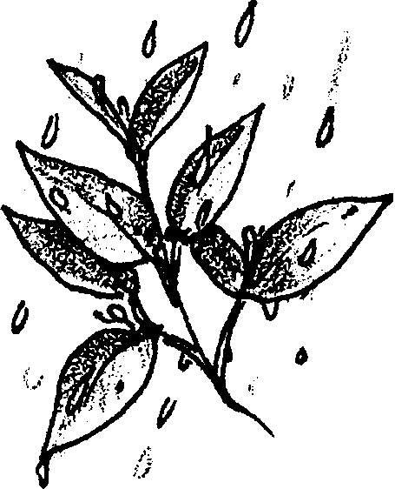
How much the runoff affects the watershed depends on lots of things. The kind of soil is important. Water runs quickly off of hard soils. How much the soil is protected by plants is also very important. The leaves of the trees, bushes, grasses, and other plants give the watershed a kind of “raincoat” for protection. This raincoat softens the fall of the raindrops. It also slows down the raindrops. They don’t end up going down the watershed all at once.

1. Which arm-sized watershed was like a watershed with hard soils?

What happens when the raindrops enter a stream? The raindrops often carry some soil into the stream. Roots, leaves and stems of plants along the stream banks slow the water. Slow water can carry less soil than swift water. Small soil particles settle out of the water. The particles that settle are called sediment.

2. How do plants keep the soil from washing downstream?

3. Plants need soil to grow. What do you think happens to the number of plants along the stream?

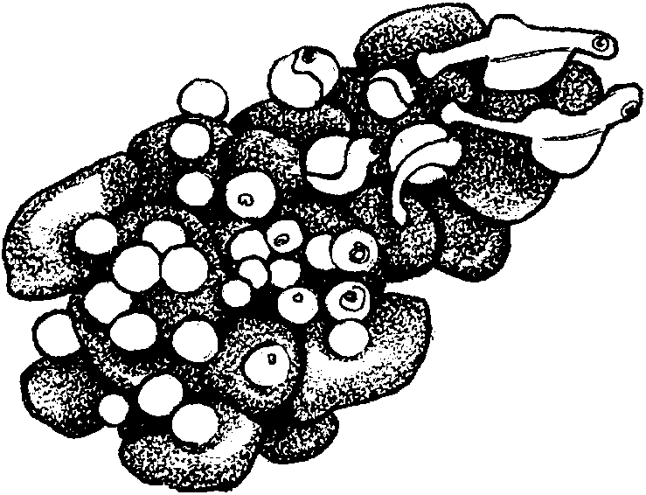

Sediments can help the plants, but they can also harm the fish. Sometimes they cover places where fish, like salmon and trout, lay their eggs. The eggs may suffocate. When the eggs are suffocated, they die.

4. What is one way to keep the sediments out of the stream?

5. What kinds of human actions might increase sediments in streams?

Careless farming and poor road building can cause soil to be lost. Fires, caused by humans or nature, can also increase sediments in streams. Soil in burned areas is often carried away in runoff. Mining streambeds and banks can leave lots of sediments to be carried into the stream.

Plants are very important in preventing sediments from being carried down the watershed.

6. Think about a forest watershed. What kinds of things might affect the plants that cover the watershed?

Logging steep slopes and stream banks removes the plant cover. Cattle and sheep sometimes eat grass all the way to the ground. Fires often remove much of the plant life. These actions can result in very poor health for watersheds and streams. Still, we have not been able to completely stop them.

Do you think the earth needs a raincoat? Raincoats are made to make water run off and not be absorbed by your clothes underneath. If a watershed worked this way, all the water that fell on it would be channeled into streams and rivers, resulting in floods and much erosion. A healthy watershed needs to hold on to the water, at least for a while. Watersheds that have all or at least most of their vegetation help prevent flooding. They slow the water down so that it can soak into the soil. Water on the surface also is slowed when it is caught by tree leaves and needles. Perhaps we can say that the earth doesn’t need a raincoat - it needs a sponge! That’s what a healthy watershed provides.

Watersheds move things downhill. Everything carried in the water may end up in the ocean or a lake. Everything that lives along the watershed is affected by what happens above it in the watershed.

7. What are some types of things that may be carried in the water?

Fertilizers used on lawns and in farming sometimes run off into streams. The fertilizer can cause plants to grow in the water. This seems like a good thing. But these plants can choke the stream. And when they die, their rotting uses up all the stream’s oxygen. When this happens, many fish and other stream animals may die. The same thing can happen if the waste products from grazing animals enter the stream.

8. Draw a picture to show how fertilizers from a home garden can find their way into a stream.

Making homes, farms, roads, and fires destroy the natural plant cover and expose the soils. People in the watershed also cause other problems like pollution. Sewage treatment plants and factories may add pollution to a waterway. These kinds of pollution are called POINT SOURCE POLLUTION. The pollution enters a waterway from a certain point. This kind of pollution can usually be treated as soon as it is identified.
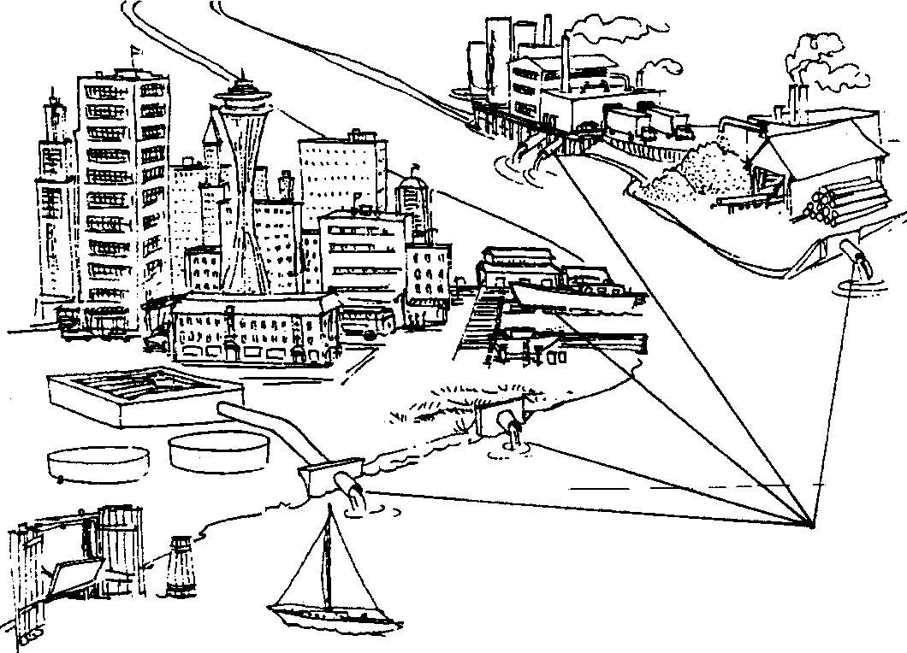

9. What might be another point source of pollution?
NON-POINT SOURCE POLLUTION is more difficult to correct. In most places, it is the biggest pollution problem. It is really a runoff problem. Instead of coming from one place, the pollution comes from many sources. Some sources may be farming, construction, logging, parking lots, lawns, and leaking septic tanks.

10. How can non-point pollution be reduced?

Sometimes we build dams in our watersheds. Dams can reduce flooding, store water, make electricity, and provide water for plants, boating and fishing. Dams can also contribute to poor watershed health. Sometimes the water behind the dam warms. This can make the stream below the dam too warm for some fish.

You can see that there are many things that affect watersheds, and watershed health. Everyone needs to know that the watershed is something to be protected and kept in good condition. Then it will continue to supply clean water for use by humans as well as other creatures. And it will contribute to the health of the land itself. That is what living at a healthy ECOLOGICAL ADDRESS means!

11. Once again, its a rainy day in the watershed. A drop of rain lands on the roof of your school. Make a drawing to show the drop’s path to the lowest point of the watershed.

a. Show where it goes.

b. Where does it move the fastest?

c. Where does it move the slowest?

d. Besides running downhill, what else could happen to the drop?

e. How could you speed the drop’s journey?

f. How could you slow the drop’s journey?

Part Three
Threats to Your Ecological Address

You have learned that you have at least two addresses. Your Post Office gives you one, your postal address. The other is your ecological address. It describes how you “connect” to the land and ecosystem where you live.

What if your postal address (your house) has peeling paint, a leaking roof, or your yard is full of weeds? You could say that it is in need of some repair or work. Some of the work needed takes lots of time and money. Some can easily be done.

Below, list some ways people can damage your home. Then, list some ways nature can damage your home.

DAMAGE CAUSED BY PEOPLE DAMAGE CAUSED BY NATURE

List some things you could do to repair the damage above.

1.

2.

3.

Ecological addresses sometimes need repair too. And like your postal address, some of the work is hard and some easy. It just depends on how badly the watershed that you live in is damaged. What kind of damage?
Like your home, watersheds can be damaged by people or nature.

Below, list some of the causes of the damage.

DAMAGE CAUSED BY PEOPLE DAMAGE CAUSED BY NATURE

List some things you could do to help repair it.

1.

2.

3.

When you have completed your watershed list, compare it to lists of other classmates.

