Finding Your Ecological Address

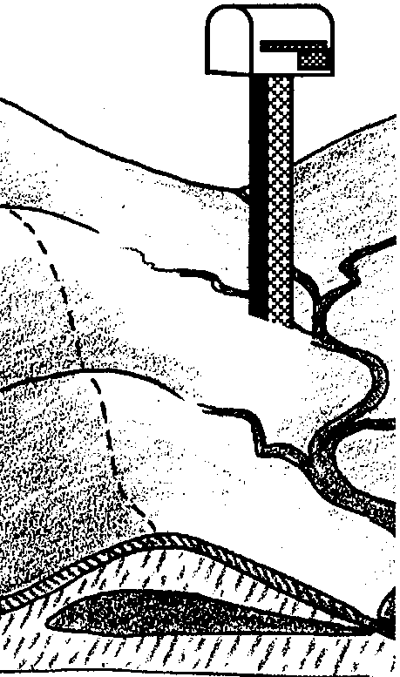
Key Concepts
1. All land on earth is part of a watershed.
2. A watershed is a system that is made up of all the land area from which water, sediment and dissolved materials drain to a common watercourse or body of water.
3. All people live in a watershed.
4. Most activities that are done on the land have some effect on the watercourses that drain the watershed.

Background

If you were to stand in a stream bed and look upstream at all the land the stream drains, you would be looking at the stream’s watershed. Almost all the area of a watershed is land, not water. And almost everything that influences the stream’s ecological health occurs on that land.

A river and its branching collector streams stretch through a watershed area and gather water along their way that contains particulates and pollution that enter the water through, and as a result of, a variety of activities on land. Understanding this process is key to an awareness of how human actions affect water quality, fish, wildlife, and the natural processes within a watershed area. When students are able to perceive (in a concrete way) the connectedness of all the living things within their watershed, they can begin to develop a sense of ecological responsibility.

A more comprehensive introduction to watersheds is found in “A Short Course on Watersheds”, included at the end of this teacher background section.

Materials

For each pair of students:

• “Coastal Drainage Basin” watershed map

• state highway map or other map showing streams and rivers in your local area

• paper for drawing students’ own watershed “maps”

• colored pencils or markers (can be shared by groups of students)

• string or yarn (about one foot per student)

Teaching Hints

“Ecological Address” introduces the concept of watershed and helps students place their local watershed in a larger context. Beginning with the name of the watershed in which students live, each successively larger stream and watershed up to and including the major river from which the largest watershed usually takes its name is identified. They also include the large lakes or the ocean into which that river feeds. During this activity, it is important to emphasize that these are the systems particularly subject to pollution from failing septic tanks, excess lawn fertilizers, carelessly disposed crankcase oil, and other wastes from human activities. These systems are also affected by silt resulting from disturbed soils in the watershed.

In discussions, stress that when people have a greater understanding of their environment, they gain awareness of how their personal actions, local laws and regulations, and everyday business practices affect the integrity and stability of their ecological address and their larger biological community.

Procedure

1. Begin by asking students to share their home mailing or street addresses. Write a few of them on the chalkboard. Explain that these postal addresses have been devised by society and that they are “social” addresses. They are important because people need to be located within their community by family, friends, and services such as the mail, police, fire or ambulance.

2. Now tell students that they all have another kind of address, called an ECOLOGICAL ADDRESS. Invite students to discuss the meaning of the word “ecological”, eliciting from them the understanding that it refers to the relationship between an organism and its environment. Just as a postal address tells people one way that they are connected to a community, the ecological address tells people how they are connected to the land on which they live. In this activity, the ecological address will be based on an ecological feature they have just started learning about—the watershed.
3. Have students read “The Watershed” reading. As a group, discuss the term “watershed”. Let students share their definitions from the student activity page. Try to develop a class definition, which should approximate this: all the land area that drains into a particular body of water. Tell students that they will be locating their own ecological addresses by finding and learning about the watershed where they live.

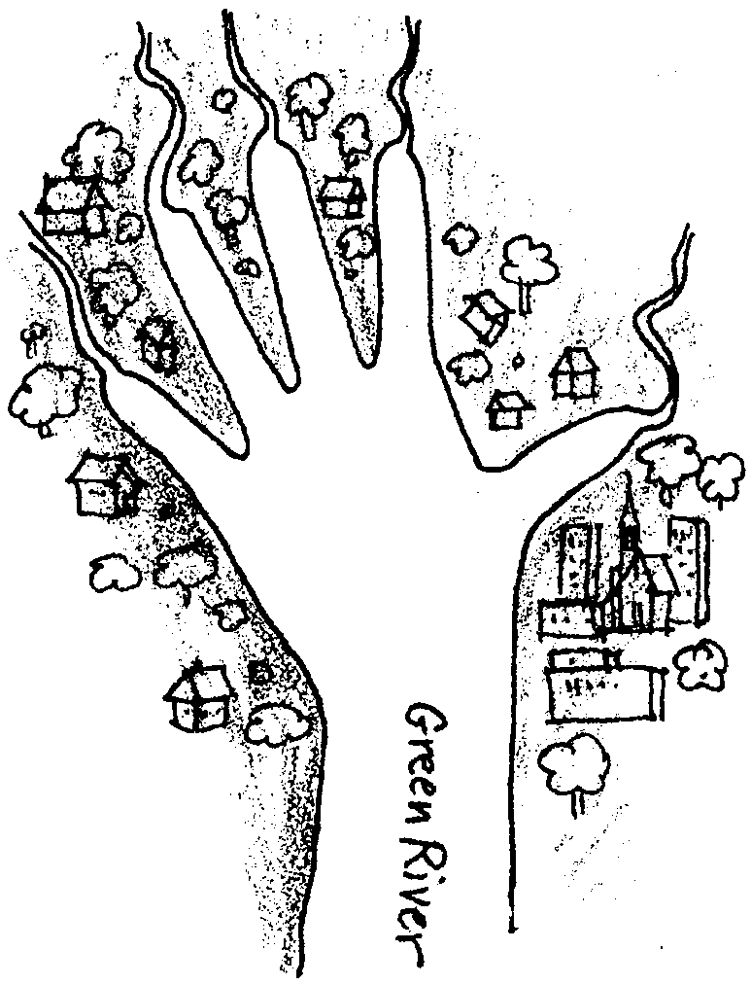
4. To help students understand the concept of watershed, trace the outline of your hand, wrist and part of your arm on the chalkboard. Color in the space between your fingers and label your arm “Green River”, or the name of a river in your area. Tell the students that this outline is a model for a watershed area. Your fingers represent streams that feed into the larger river (your arm). The colored space between your fingers is land, where people live. Let students know that a watershed’s name is usually taken from the stream or river that serves as the main collector of all the water in the watershed. Ask students what the watershed you just drew would be called (The Green River Watershed). Write the name on the board.

5. Ask students how large they think watersheds can be, then ask how small they can be. They should recall some of this from their reading. Impress upon the students that large watersheds include many small watersheds.

6. Students are now ready to work with the “Coastal Drainage Basin” watershed map. Divide the class into pairs of students and give each pair a copy of the watershed map. Have them locate a stream called Five Rivers (Five Rivers runs through the communities of Denzer, Fisher, and Paris. Also have students locate the point where Five Rivers runs into the Alsea River. Explain that the Alsea River runs into the Pacific Ocean.

7. Next have students locate the Crab Creek watershed by drawing a line around it with colored pencil or marker. Then have them locate the Lobster Creek watershed in the same way with another color. With a third color, have them draw a line around the entire Five Rivers watershed.

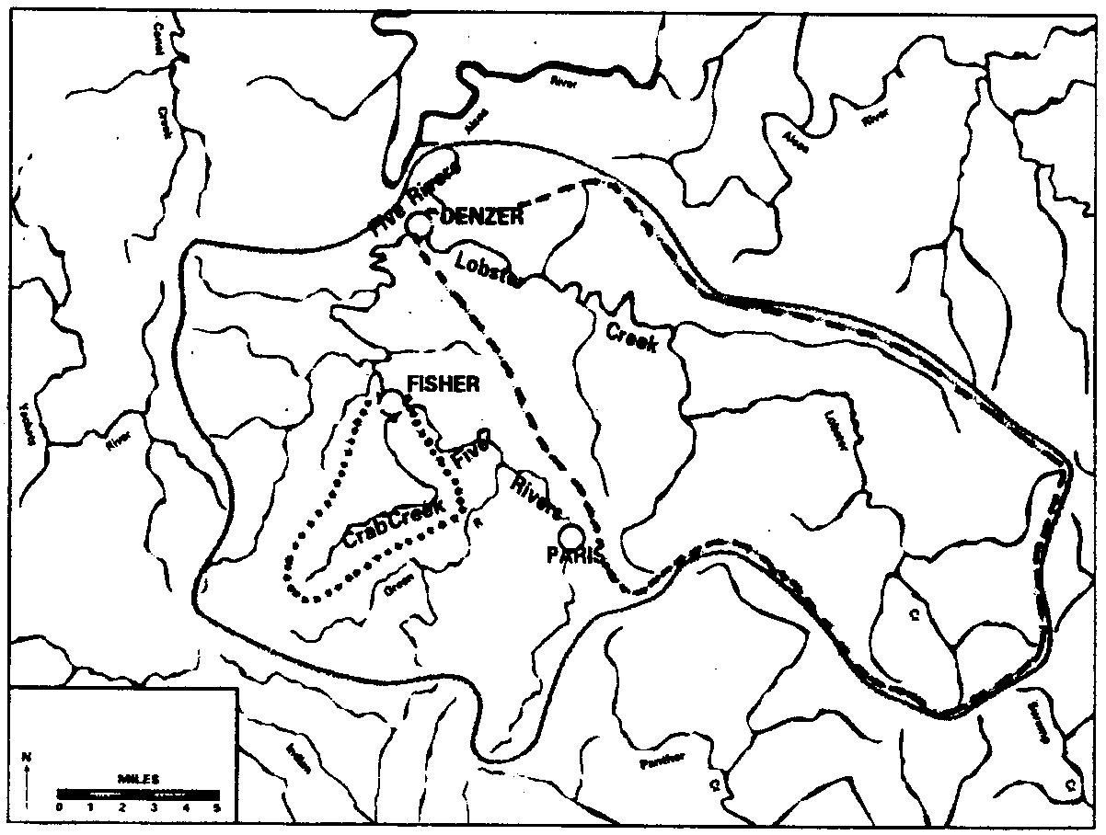
Make sure all teams have correctly identified the watersheds before asking the following questions:

a. If you lived two miles south of the town of Fisher, in which watershed (or sheds) would you live? (You would actually live in the Crab Creek watershed, which is part of the larger Five Rivers watershed.) Remind students that a large watershed is made up of many smaller watersheds, and that both Crab Creek or Five Rivers would be correct answers to the question.

b. If you lived in Paris, in which watershed would you live? (Five Rivers)

8. Suggest that everyone lives in a watershed, and ask students to explain why this is true. (All land has waterways running through it that drain into larger waterways. For example, in most urban areas rainwater feeds into storm drains. The drains then feed into nearby streams or rivers.)

9. Using a state or local map that shows streams and rivers, have each student name the watershed in which he or she lives. Explain that this watershed is the student’s ecological address, and that this address describes how he or she is connected to the land and water system that drains it. In urban areas that are hilly, a city map will be needed to determine the exact watershed in which a house might be found. Depending on the proximity of waterways, the watershed named should reflect students’ ecological addresses which can have several components, i.e.. from the smallest watershed they can observe to a larger watershed of which the smaller one is a part. Have some students share their ecological addresses while other students follow along on their own maps.
10. Have students make a “map” of their ecological address. The map need not be to scale, but it should represent the watershed(s) in which the students live. As an alternative or additional activity, have the entire class make a larger map of the watershed on large sheets of paper.

11. Have students brainstorm a list of what they think can happen to water as it moves through a watershed. Highlight the things that are caused by human activity. These might include actions such as discarding oil or other wastes into a stream, clearing land (removing vegetation), or washing cars with soaps that contain phosphates (non-biodegradable chemicals). Then have students determine how and where these chemicals would travel in their watershed. They can do this by tracing the path from the smallest tributary in the smallest watershed as it empties into larger and larger watershed areas. Have students repeat the activity, this time looking at non-human influences on watersheds, such as heavy rains, wind, and other natural phenomena.

12. Have students calculate the number of miles of stream and river that are in their watershed by using the “scale of miles” on the published map. Using string to follow a curving waterway on the map can make measurement easier and more accurate. This measurement will help make clear to students the amount of area impacted by human activities affecting the watershed system.

Key Words

ecological - concerning the interrelationship of living creatures with their environment.

watershed - the region or area drained by a river, stream, etc.; drainage area

Extensions

1. Have students create a clay or baker’s dough watershed. Let them trace the flow of water in their model watershed.

2. For more detailed maps of your watersheds, contact your local water district.

Adapted from:
The Stream Scene: Watersheds, Wildlife and People by Patty Farthing et al, Oregon Department of Fish and Wildlife, Portland, Oregon, 1990.

“Ecological Address: At Home in Your Watershed”, National Science and Technology Week 1992-1993 Packet, National Science Foundation, Washington, D.C.

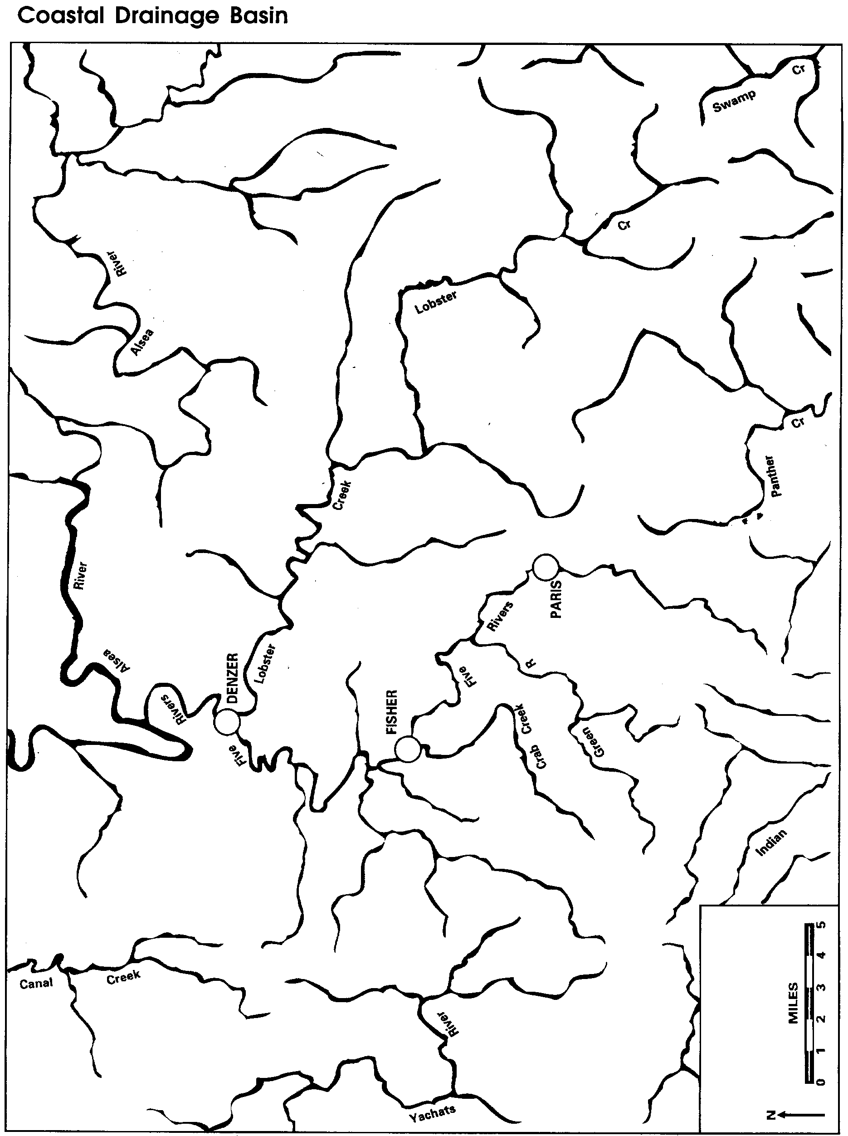

A Short Course on Watersheds

“The study of rivers is not a matter of rivers, but of the human heart.”
- Tanaka Shozo

All land on earth is a watershed. Humans and their activities play an important and essential role in watersheds, yet few people understand them. Still fewer know the dynamics and boundaries of the ones in which they live.
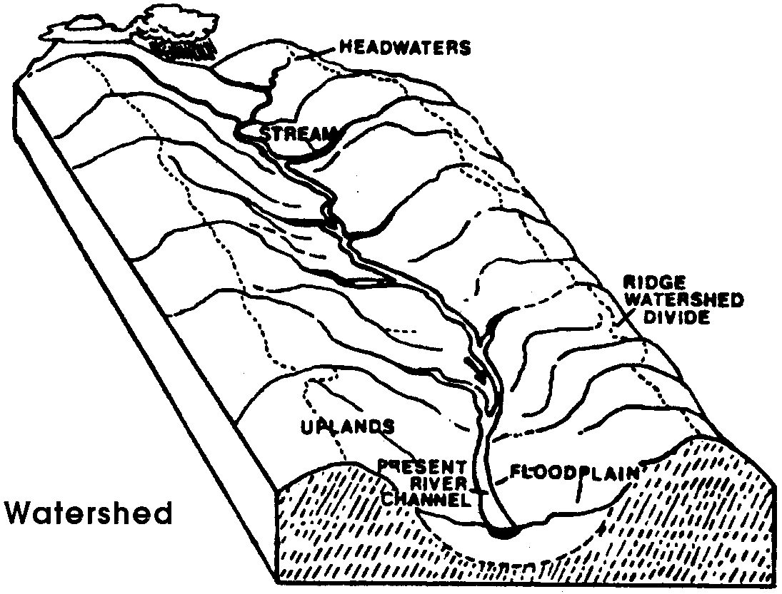
A watershed is a system. It is the land area from which water, sediment, and dissolved materials drain to a common watercourse or body of water. For each watershed there is a drainage system that conveys rainfall to its outlet. A watershed may be the drainage area surrounding a lake that has no surface outlet, or a river basin as large as that of the Columbia River. Within a large watershed are many smaller watersheds that contribute to overall stream-
flow.

All land on earth
is a watershed.

The point where two watersheds connect is called a divide. A watershed is drained by a network of channels that increase in size as the amount of water and sediment they must carry increases. Streams are dynamic, open-water systems with channels that collect and convey surface runoff generated by rainfall, snowmelt, or groundwater discharge to the estuaries and oceans. The shape and pattern of a stream is a result of the land it is cutting and the sediment it must carry.

A watershed is almost like a domicile, a mini-biosphere, with halls of hills and mountains, a floor of river or lake, and a roof of rain clouds.

Stream orders

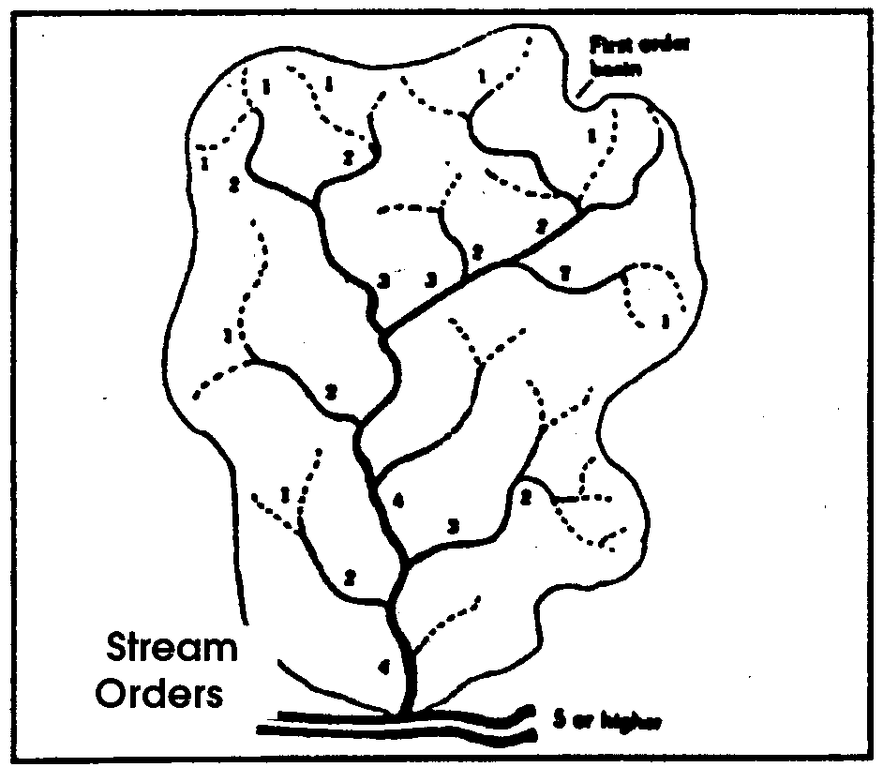
In most cases, a watershed system is almost entirely hillsides. Only about one percent of a watershed is stream channels. The smallest channels in a watershed have no tributaries and are called first-order streams. When two first-order streams join, they form a second-order stream. When two second-order channels join, a third-order stream is formed, and so on (figure below). First- and second-order channels are often small, steep, or intermittent. Orders six or greater are larger rivers.

Channels change by erosion and deposition. Natural channels of rivers increase in size down-stream as tributaries enter and add to the flow. A channel is neither straight nor uniform, yet its average size changes in a regular and progressive fashion. In upstream reaches, the channel tends to be steeper. Gradient decreases downstream as width and depth increase. The size of sediments tends to decrease, often from boulders in the hilly or mountainous upstream portions, to cobbles or pebbles in middle reaches. More sand or silt are found downstream. In some cases, large floods cause new channels to form, leaving once-productive streams dry and barren.

Streamflow types

Besides the ordering system previously described, streams may be classified by the period of time during which flow occurs.

• Perennial flow indicates a nearly year-round flow (90 percent or more) in a well-defined channel. Most higher order streams are perennial.

•Intermittent flow generally occurs only during the wet season (50 percent of the time or less).

• Ephemeral flow generally occurs during and shortly after extreme precipitation or snowmelt conditions. Ephemeral channels are not well defined and are usually headwater or low order (1-2) streams.

The physical, chemical, and biological make-up of a stream relates to surrounding physical features of the watershed and geologic origin. Analysis of these features aids understanding of stream-watershed relationships and predicts effects of human influences on different stream types.

Factors affecting watersheds

Climate

Land and water are linked directly by the water cycle. Solar energy drives this and other cycles in the watershed. Climate—the type of weather a region has over a long period of time—is the source of water. Water comes to the watershed in seasonal cycles, principally as rain or snow. In some areas, condensation and fog- drip contribute water. The seasonal pattern of precipitation and temperature variation control streamflow and water production.

Some precipitation infiltrates the soil and percolates through permeable rock into groundwater storage and recharges areas called aquifers. Natural groundwater discharge is the main contributor to streamflow during dry summer and fall months. Without groundwater discharge, many streams would dry up.

Pumping water from an aquifer for industrial, irrigation, or domestic use reduces the aquifer’s volume. Unless withdrawals are modified or recharge increased, the aquifer will eventually be depleted. A drained aquifer can collapse from the settling of the overlying lands. Many such “sink holes” are visible in Florida and Arizona.

Collapsed underground aquifers no longer have as much capacity to accept and hold water. Recharge is difficult, volume is less, and yields are considerably reduced. Springs once fed from the water table also dry up.

Land and water are linked
directly by the water cycle.

Climate affects water loss from a watershed as well as providing water. In hot, dry, or windy weather, evaporation loss from bare soil and from water surfaces is high.

The same climatic influences that increase evaporation also increase transpiration from plants. Transpiration draws on soil moisture from a greater depth than evaporation because plant roots may reach into available moisture supply. Transpiration is greatest during the growing season and least during cold weather when most plants are relatively dormant.

Wind may cause erosion, control the accumulation of snow in sheltered places, and be a significant factor in snowpack melting. Soil erosion can occur wherever wind is strong and constant, or where soil is unprotected by sufficient plant cover.

Physical features

The area of a watershed affects the amount of water produced. Generally, a large watershed receives more precipitation than a small one, although greater precipitation and runoff may occur on a smaller watershed in a moist climate than on a large watershed in an arid climate.

Shape and slope of a watershed and its drainage pattern influence surface runoff and seepage in streams draining the watershed. The steeper the slope, the greater the possibility for rapid runoff and erosion. Plant cover is more difficult to establish and infiltration of surface water is reduced on steep slopes.

Orientation of a watershed relative to the direction of storm movement also affects runoff and peak flows. A rainstorm moving up a watershed from the mouth releases water in such a way that runoff from the lower section has passed its peak before runoff from the higher sections has arrived. A storm starting at the top and moving down a watershed can reverse the process.

Orientation of a watershed relative to sun position affects temperature, evaporation, and transpiration. Soil moisture is more rapidly lost by evaporation and transpiration on steep slopes facing the sun. Watersheds sloping away from the sun are cooler, and evaporation and transpiration are less. Slopes exposed to the sun usually support different plants than those facing away from the sun. Orientation with regard to the prevailing winds has similar effects.

The area of a watershed affects
the amount of water produced.

Soils and geology

Soil is a thin layer of the earth’s crust. It is composed of mineral particles of all sizes and varying amounts of organic materials. It is formed from breakdown of parent rocks to fine mineral particles. This occurs by:

• Freezing and thawing in winter

• Heating expansion and cooling contraction in summer

• Wind and water erosion

• The grinding action of ice

• Gravity rockfall and avalanche movement

• Rock minerals in rain and snowmelt water

• Chemical action of lichens and other plants

Soils are of two types. Residual soils are those developed in place from underlying rock formations and surface plant cover. Transported soils include those moved into an area by gravity, wind or water. Characteristics of residual soils are closely related to the parent material from which they were formed.

Soil is the basic watershed
resource ... to be carefully
managed and protected.

Climate, particularly precipitation and temperature, strongly affects soil formation. Rainfall causes leaching—movement of dissolved particles through soil by water. Temperature affects both mechanical breakdown of rocks and breakdown of organic material. Soil bacteria, insects, and burrowing animals also play a part in breakdown and mixing of soil components. Soil often determines which plants will establish a protective vegetative cover. Plants also modify and develop soil. Plant roots create soil spaces. Plant litter adds organic matter to soil. Plant litter slows surface runoff and protects the soil surface from rainfall’s beating and puddling effects which tend to result in compaction of the soil. Soil depths and moisture-holding capacities are usually less on steep slopes, and plant growth rates are often slower.

Forage (food for grazing animals), timber, and water are all renewable resources. Water is renewed by cycles of climate. Forage and timber are renewed by growth in seasonal cycles. The availability of these resources is dependent upon soil. Soil is, except over long periods, a non-renewable resource. It may take more than a century to produce a centimeter of soil and thousands of years to produce enough soil to support a high-yield, high-quality forest, range, or agricultural crop. Soil is the basic watershed resource. Careful management and protection is necessary to preserve its function and productivity.

Vegetative cover

Grasses, forbs (small, broad-leafed plants that grow with grasses), shrubs and trees make up the major plant cover types. All four types build up organic litter and affect soil development. They usually develop under differing climatic conditions and all are important to watershed management.

A forest usually includes, in addition to trees in various stages of growth, an understory of shrubs and a low ground cover of forbs and grasses. While all plants in a forest have some effect on water, trees are the most important.

Tree-litter fall protects the soil’s surface. Tree roots go deep into the soil and help bind it, and tree crowns provide the most shade. The effects of shrubs and grasses are similar to those of trees including increased protection for soil against the beating action of rain and drying action of the wind.

Plant cover benefits a watershed. The canopy intercepts rain and reduces the force with which it strikes the ground. The canopy and stems also reduce wind velocity. When leaves and twigs fall, they produce litter, which decomposes and is eventually incorporated into the soil. Litter protects the soil surface, allows infiltration and slows down surface runoff.

Stems and roots lead water into the ground. Roots open up soil spaces for water retention and drainage as well as add organic materials to the soil. The movement of minerals from roots to canopy provides recycling.

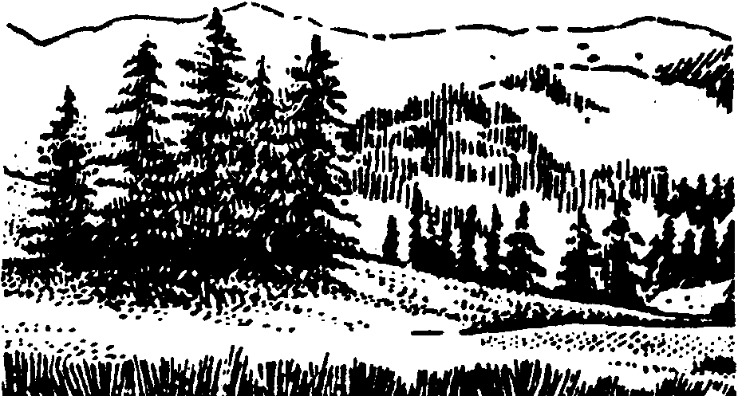
Windbreaks of trees and shrubs protect crops and reduce moisture losses from evaporation.

Grasses, trees, and shrub stems along riverbanks trap sediments and floating debris during high waterflows. Roots bind and stabilize stream banks and slopes to reduce slides and slumps.

While all plants in a forest have
some effect on water,
trees are the most important.

Management considerations

Water quality is largely determined by the soils and vegetation in a surrounding watershed. Accordingly, human activities have pronounced impacts on watershed quality. These activities include timber harvesting, livestock grazing, agriculture, recreation and urban or industrial development.

Timber harvest

Timber harvest opens and reduces plant cover density. The impacts of timber harvest on a watershed can be mitigated if slope and soil are carefully considered and plant cover rapidly restored. In snow zones, timber harvest can improve snow catch and modify snowmelt rate. Several states have passed laws called Forest Practices Acts to ensure consideration of soil and water resources during timber harvest.

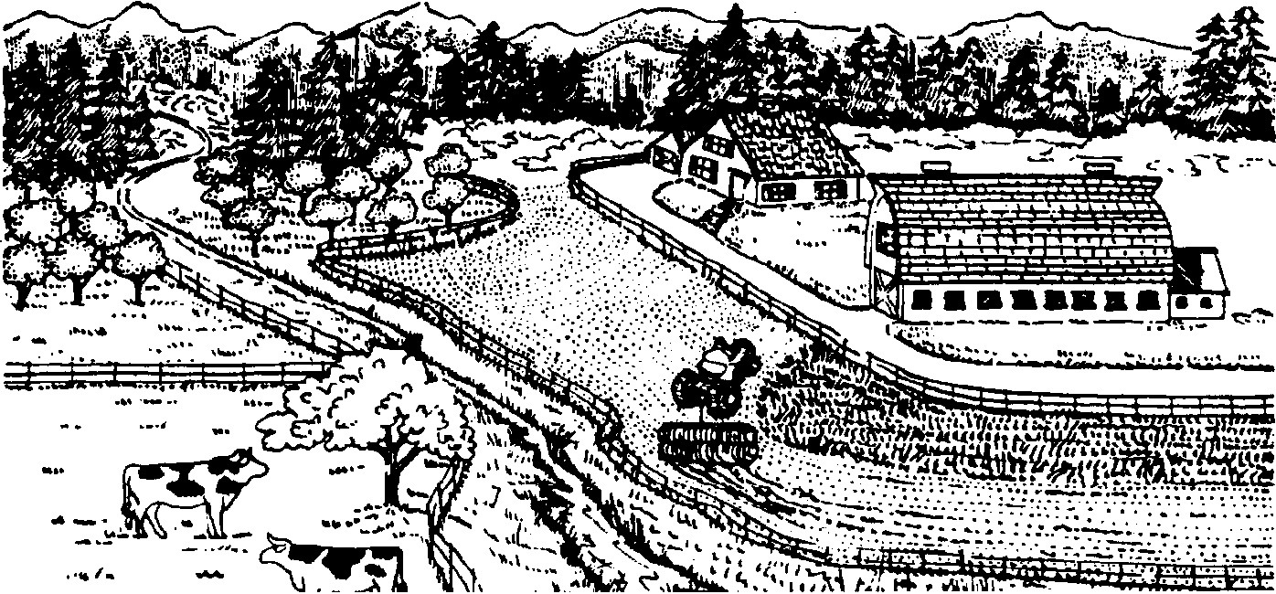
Agriculture

Domestic livestock tend to concentrate in specific areas when grazing. Concentrated grazing impacts plant cover and soil. Grass cover can be improved by removing some of the annual growth, but forage productivity can be greatly reduced if overgrazing occurs.

Improperly timed grazing, grazing too many animals, or grazing for too long a time can change vegetation over a period of years to species of lower value. Overuse of rangelands by native grazing animals can also seriously damage plant cover.

Excessive trampling by grazing animals can contribute to soil compaction, accelerated runoff, and erosion problems. Trampling can also help scatter seeds and incorporate them into the soil for regeneration.

Management of livestock and grazing wildlife species can enhance watershed values, but is limited by the carrying capacities of the land and the forage species it will support. Management must consider timing, density, and duration of animal use to capitalize on the positive aspects of grazing. Generally, recovery does not occur if vegetation is thinned to less than 70 percent of the natural cover. Without management practices such as reseeding, degradation will continue.

Crop production usually involves removal of the original plant cover and tilling the soil for seedbed preparation. Crop cover is usually seasonal and less dense than natural cover. This provides less protection for the soil. Erosion by both wind and water may remove the finer soil particles as well as many nutrients , thereby reducing land productivity. Agricultural operations based on careful appraisal of soil, slope, and climatic conditions include erosion control and are compatible with watershed management.

Plant cover affects water through growth and transpiration. Shade and mulch formed by plant litter reduce evaporation of soil moisture. Plant roots can take up available soil moisture to a greater depth than evaporation.

An example is accelerated brush encroachment, particularly juniper, on central and eastern Oregon uplands. Increased juniper stands have, in part, decreased summer streamflows. Juniper competes more successfully than other vegetation for available moisture. This reduces ground cover and may cause increased runoff and less infiltration to groundwater storage. In addition, juniper roots can tap groundwater storage. Juniper’s high transpiration rate leaves less water for stream runoff as summer progresses.

Fire

Fire is often one of the most widespread and destructive agents affecting plant cover. Under certain conditions, fire can nearly remove cover and organic litter, and, in extreme cases, sterilize and change the chemistry of the surface soil. Under other conditions, fire can be an effective tool in watershed management. Burning converts organic materials in plant cover, litter, and topsoil to gases and soluble nutrients, encouraging rapid plant grow.

However, severe fire produces quantities of readily leached ashes that can make acid soils alkaline. In these cases, damage to soil varies, but it may take several seasons for soil conditions to return to normal.

Fire is one of the most
widespread and destructive
agents affecting plant cover.
Fire can also be beneficial to a
watershed when it is managed.

Without a protective canopy and litter, the soil surface is rapidly puddled and sealed by the first rains. Infiltration is greatly reduced, making runoff and erosion more rapid. Debris-laden floods often occur within fire-denuded watersheds during only slightly abnormal rainfall. Most of the water falling on a burned landscape is lost by rapid runoff. Water that infiltrates is probably lost by evaporation.

Streams from burned watersheds at first carry a heavy load of salts dissolved from ashes, floating debris, and erosion sediments. Water quality may soon return to normal, except for sediment-laden high flows. Water levels fluctuate and become less dependable. These conditions may continue for several years until the plant cover becomes re-established on the watershed.

Fire can be beneficial to a watershed when it is carefully managed. It can reduce available fuel and prevent more destructive fires. Fire thins trees for available moisture. Open forest types such as ponderosa pine are maintained by fire.

Beavers

The effects of beavers on a watershed can be both positive and negative. Their actions change watershed hydrology as well as damage cover. A beaver dam changes energy flow in its immediate area by turning part of a stream environment into a pond or swamp. If high beaver populations coincide with heavy livestock use, the results can be devastating to streams. On the other hand, their dams can be beneficial as sediment traps and fish habitat. Water held behind a beaver dam is released more slowly over a longer period of time.

Mining

Mining requires opening the earth to remove mineral resources. It is done by stripping off the surface soil and rock layers or by drilling tunnels into the earth to reach minerals.

With either method, quantities of waste material are left on the surrounding land. This waste material is subject to erosion, adding to the sediment load of streams draining the mined area. Surface changes include altered topography and drainage. Drainage from mined areas may contain toxic mineral salts harmful to the aquatic habitat. To prevent degradation of the watershed, waste material disposal must be controlled.

Development

Urban development involves:

• Clearing, leveling and filling land surfaces

• Constructing buildings with impermeable roofs

• Paving roads and sidewalks with impervious materials

• Installing sewage disposal systems

Such development greatly changes infiltration and runoff, reduces recharge to underground water and increases runoff to produce rapidly fluctuating streamflows.

High-quality water is described as cool, clear, clean, colorless, odorless, tasteless, oxygenated, free of floating and suspended materials, and carrying only limited amounts of dissolved materials. As quality is degraded, water becomes less and less useful for most purposes. Urbanization decreases water quality.

Point source pollutants enter waterways from a specific point. Common point source pollutants are discharges from factories and municipal sewage treatment plants. This pollution is relatively easy to collect and treat.

Non-point source pollution, on the other hand, is really a new name for an old problem—runoff and sedimentation. Non-point source pollution runs off or seeps from broad land areas as a direct result of land use. It comes from a variety of sources such as agriculture, urban construction, residential developments, timber harvest, roadsides, and parking lots. Sediment, fertilizers, toxic materials, and animal wastes are major non-point source pollutants. The diffuse source of these pollutants makes them more difficult to quantify and control than point source pollutants.

Non-point pollution causes more than half the water pollution problems in many states. The impact of non-point source pollutants on water quality is variable. Some are potential health hazards or harmful to fish and other aquatic organisms. Streams do have an absorption and disposal capacity for limited amounts of pollutants, but these limits are too often exceeded.

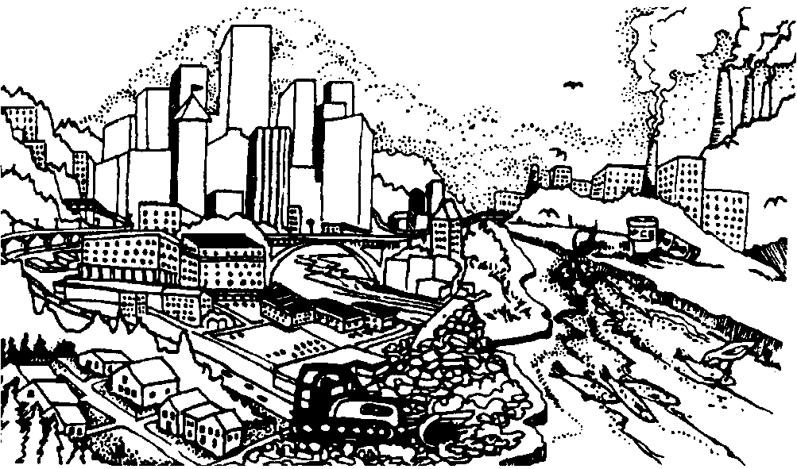
Urban air pollution, especially photochemical smog caused by internal combustion gasoline engine emissions and industrial smokes, has contributed to acid rain. This has had a subsequent effect on vegetation, streams, and lakes within watersheds, especially on the east coast and in Canada. The problem continues to grow, however, and the Pacific Northwest is not immune to the effects of acid rain.

Communication and transportation developments include roads, railroads, airports, power lines and pipelines. All of these may involve disturbance of plant cover, soil, and topography. Road and highway networks, with their impermeable paving and rapid drainage systems may radically change the runoff characteristics of their immediate area. They also require changing the natural topography and drainage, and moving huge amounts of soil and rock. Often these networks are responsible for extensive sediment production and may become the source of other water pollutants.

Railroads and airports have similar effects. Power lines and pipelines require open paths through the watershed and access roads for construction and maintenance.

Impoundments

Flood control dams, lined stream channels, dikes and levees to restrict the spread of floodwaters, and channel bed stabilization techniques are all installations that modify channel capacity as well as the rate and volume of streamflow. All are the consequence of human

• Control floods

• Store water for irrigation or other consumptive use

• Regulate flow for navigation

• Provide power generation

Effects on streamflow and aquatic habitat are similar regardless of purpose. Impoundments if shallow, allow water to warm, and, if deep, preserve cooler water. As streamflow peaks are reduced and low flows increased, streamflow generally becomes more regular from season to season and year to year regardless of climatic variations.
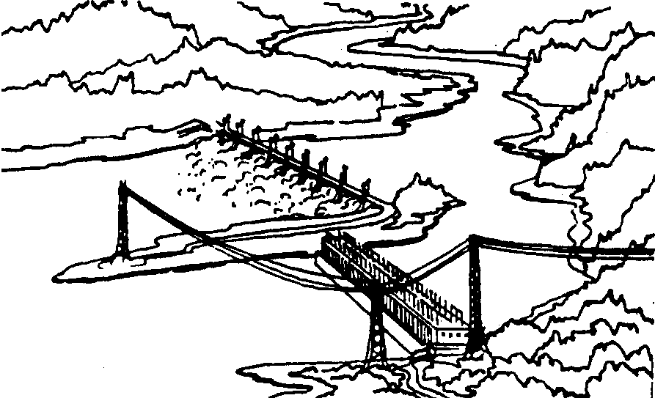
In many cases, reservoirs have added water based recreation and new fisheries, although their construction may have destroyed stream habitat used by wild fish. A watershed under good managementÑwhere water storage occurs in the soils and riparian areasÑlessens the need for reservoirs, particularly small headwater impoundments.

Water is often seasonally diverted from impoundments and streams for irrigation in agricultural areas. This reduces streamflows during the warm growing season. Some water
is returned to the stream by drainage from the irrigated fields. These return flows are warmed and may contain soil salts, fertilizers, and pesticides leached from the fields.

Management objectives

The objective of managing a watershed is to maintain a useful vegetative cover and soil characteristics beneficial to regulation of a quality water yield. The usefulness and productivity of the land will be enhanced for other resources and uses. When the non-renewable soil resource is protected and maintained in good condition, the dependent renewable resources, wildlife habitat, and recreational opportunities can be supported. Timber, forage, minerals, food, and wildlife represent important considerations. Problems arise when development and use of these resources conflict with the primary objective of regulating water yield and maintaining water quality and watershed integrity. These must be considered as part of watershed management, and their use and development must be integrated with management that produces and protects water supplies.

Rivers, hillsides, mountain tops,
and flood-formed bottom-lands
are all part of one system.

Ownership is the principal institutional control of watersheds. A private individual or public management agency may be free to apply whatever measures believed necessary or desirable on their own land. They may regulate access and prevent use and development of associated resources.

Many watersheds are in public or state ownership. Unless segregated and protected by specific legislation or agreement, most are used and developed to take advantage of all resources available for the general public benefit. It is in these multiple-use watersheds that management may face the most serious conflicts and challenges. Here it becomes necessary to attain a balanced use and development to provide maximum benefits with the least disruption of the water resource.

Legislation and government edicts also provide controls that can aid water resource management. These laws may include:

• Land use planning

• Zoning

• Permitted and prohibited land uses or types of development

• Restrictions on water use

• Limitations on water development

• Pollution control

Watershed users need to be aware that private actions have public consequences on water quality and quantity.

Summary

Rivers, hillsides, mountain tops, and flood-formed bottom-lands are all part of one system. All are integrated with each other. Hillside shape controls the energy expenditure rate of water flow. All biotic elements in the watershed interact with and modify the energy flow through the system. So it follows that the shape of the watershed is a function of what lives there. The combination of climatic conditions, soil types, topography, vegetative cover, and drainage system define the particular character of each watershed.

In an unaltered state, a watershed is in a state of equilibrium. This equilibrium may or may not be the most suitable for the overall quality and contribution of the watershed to the entire picture.

Rivers do not stop at state lines. The effects of natural and human processes in a watershed are focused at its outlet, wherever it may be, even if it crosses another state or country's borders. Each watershed is a part of a larger watershed whose downstream portion may suffer from upstream influences.

Adapted from W.E. Bullard, "Watershed Management Short Course," Oct. 1975, and used with permission.
Bibliography

Borton, Wendy et al., Clean Water, Streams, and Fish: A Holistic View of Watersheds, Seattle: Municipality of Metropolitan Seattle, no date available.

Brown, George W., Forestry and Water Quality, 2nd ed., Corvallis: Oregon State University Bookstores, Inc., 1985.

Carry, Robert, "Watershed Form and ProgressÑThe Elegant Balance," Co-Evolution Quarterly, Winter 76/77, p. 15-17.

Dunne, Thomas and Luna B. Leopold, Water in Environmental Planning, San Francisco: W.H. Freeman & Co., 1978.

Environmental Education Project, "Understanding Watersheds," Clearing: Environmental Education in The Pacific Northwest, Spring, 1983, pp. 8-10.

Horton, R.E. "Erosional Development of Streams and Their Drainage Basins: Hydro- physical Approach to Quantitative Morphology," Geological Society of America Bulletin, Vol. 56, 1945, pp. 275-370.

Kentucky Natural Resources and Environmental Protection Cabinet, A Field Guide to Kentucky Rivers and Streams, Water Watch, Division of Water, May 1985.

MacKenzie Environmental Education Center, Stream Investigations, Poynette, Wisconsin: Wisconsin Department of Natural Resources, no date available.

Rude, Kathleen, "Watersheds: The World's Biggest Bathtubs," Ducks Unlimited, September/October, 1985, pp. 62-63.

State of Oregon Water Resources Board, "Mid-Coast Drainage Basin Map," Salem, OR, 1964.

State of Oregon Water Resources Board, "Umatilla Drainage Basin Map," Salem, OR, 1962.

State of Oregon Water Resources Department, John Day River Basin Report, Salem, OR, 1986.

Strahler, A.N., "Quantitative Geomorphology of Drainage Basins and Channel Networks," Section 42 in ed. Vente Chow, Handbook of Applied Hydrology, New York: McGrawHill, 1964.

Sullivan, Peter L., What is Happening to Our Water? Washington: National Wildlife Federation, 1979.

Toews, D.A., and M.J. Brownlee, A Handbook for Fish Habitat Protection on Forest Lands in British Columbia, Government of Canada Department of Fisheries and Oceans, Vancouver, B.C., 1981.

U.S. Department of Agriculture, Soil and Water Conservation Activities for Scouts, PA-978, Washington, D.C.: U.S. Government Printing Office, 1977.

U.S. Department of Agriculture, Water Intake by Soil, PA-925, Washington, D.C.: U.S. Government Printing Office, 1963.

U.S. Department of Agriculture, Forest Service, Forests and The Natural Water Cycle, FS-99, Washington, D.C., 1970.

U.S. Department of Agriculture, Forest Service, Forests and Water, FS-48, Washington, D.C., 1968.

U.S. Department of Agriculture, Forest Service, "Water Investigation,"Investigating Your Environment Series, Washington, D.C., 1978.

U.S. Department of Agriculture, Forest Service, Your Water Supply and Forests, PA-305, Washington, D.C., 1972.

Warshall, Peter, "Streaming Wisdom,"Co-Evolution Quarterly, Winter 76/77, pp. 5-10.

Wisconsin Department of Public Instruction, Local Watershed Problem Studies, Vicki K. Vine, Project Director and Charles Brauer, Editor, 1981.

Young, Carolyn et al., Oregon Environmental Atlas, Oregon Department of Environmental Quality, 1988.

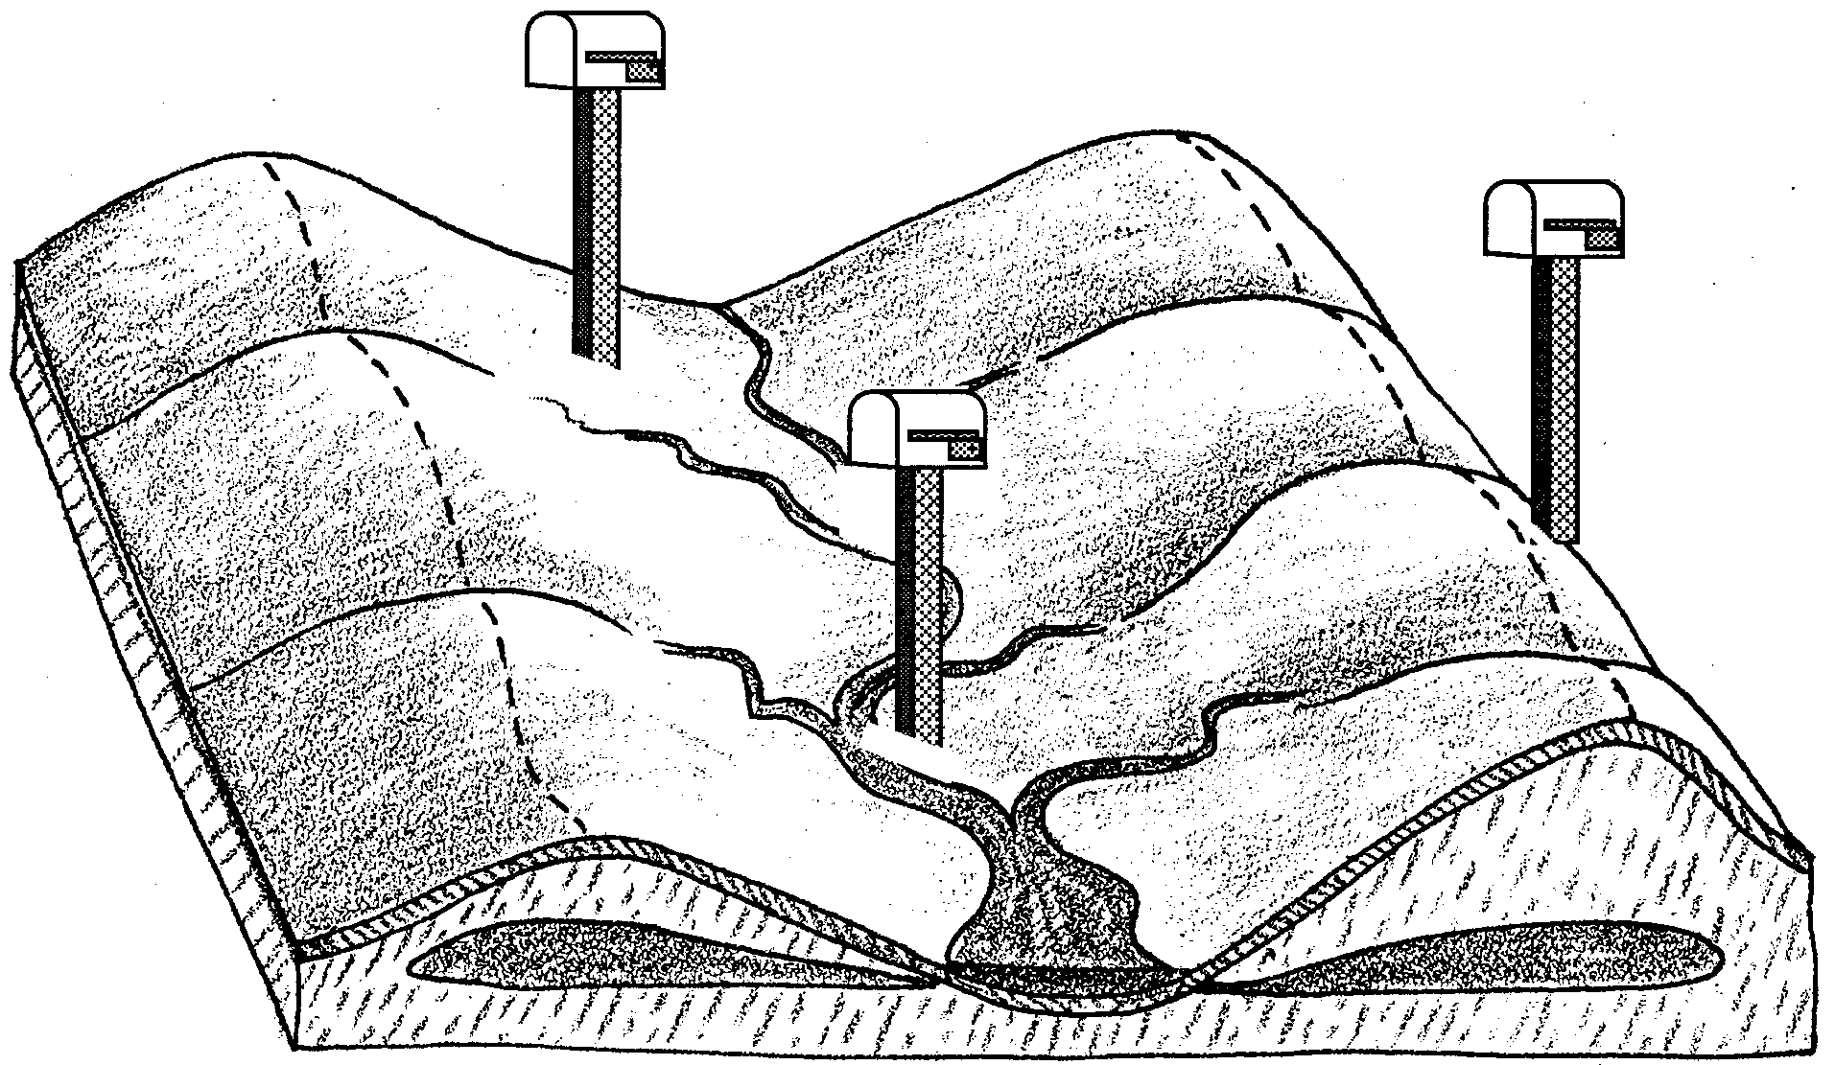
Finding Your Ecological Address

The Watershed

Water runs downhill. We all know that, don’t we? Well, now we do. The instant that a drop of rain hits the earth, it begins its journey to the ocean. Of course, not all water drops make it to the ocean. Some are taken up by the roots of plants. These drops return to the air through the plant’s leaves. Some evaporate from puddles, or other areas that hold water. Some filter down into underground areas. These drops move slowly downhill. But most water drops end up as runoff. Runoff is the water that finds its way into creeks, streams and rivers.

This journey to the ocean takes place within a watershed. Imagine you are standing in a stream bed. Look upstream at all the land the stream drains. You are looking at the stream’s watershed. Almost all of the area of a watershed is land - not water! And almost everything that effects the stream that drains the watershed happens on that land.

Watersheds can be big or small. All land on earth is in a watershed. A mud puddle has a watershed of only a few square feet. The Columbia River has a watershed that is 258,000 square miles. The biggest watershed in the country is that of the Mississippi River. It drains all the land between the Rocky Mountains and Appalachian Mountains!

Watersheds are separated by ridges, called “divides”. The Continental Divide is an example. It is in the Rocky Mountains. All the rain and snow falling on the west side of the divide flows into the Pacific Ocean. Rain and snow falling on the east side of the divide ends up in the Atlantic Ocean.
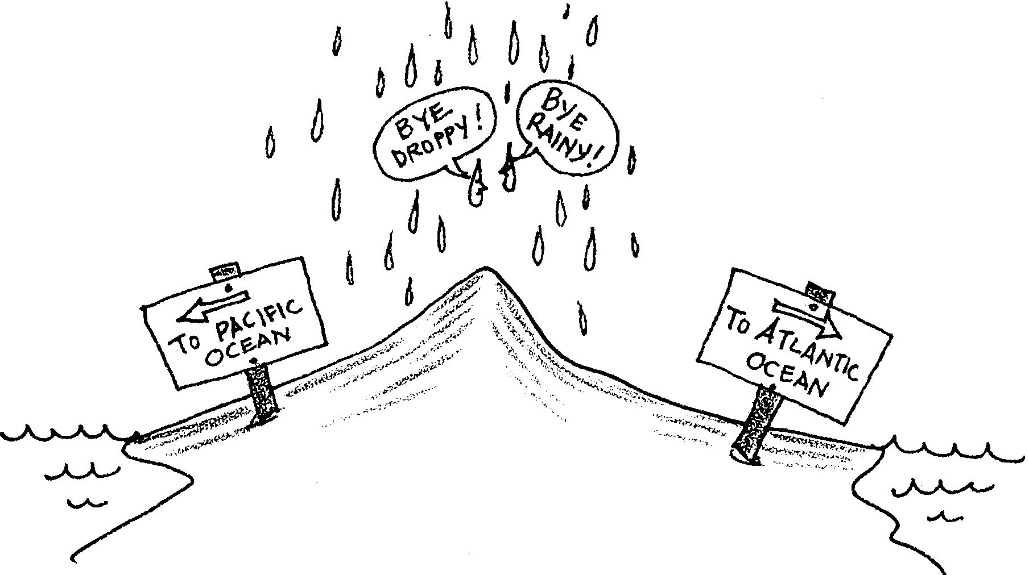

Now, write your own definition of a watershed:

