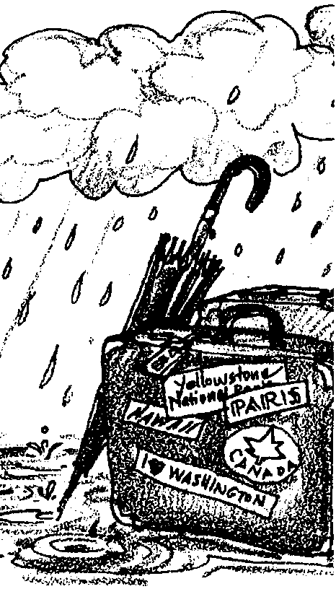
Water: The Constant Traveler

Key Concepts
1. Water travels through an earth system called the water cycle.
2. The water cycle has many paths for water to follow through the system.
3. The water cycle is powered by the sun. The ocean is the cycle’s major reservoir.

Background

Water is the priceless resource on which all growing things depend. Water covers about three-quarters of the earth’s surface. Of this, only a small amount is fresh water, less than one-third of which is usable by humans. The rest is locked in the polar ice caps and in glaciers.

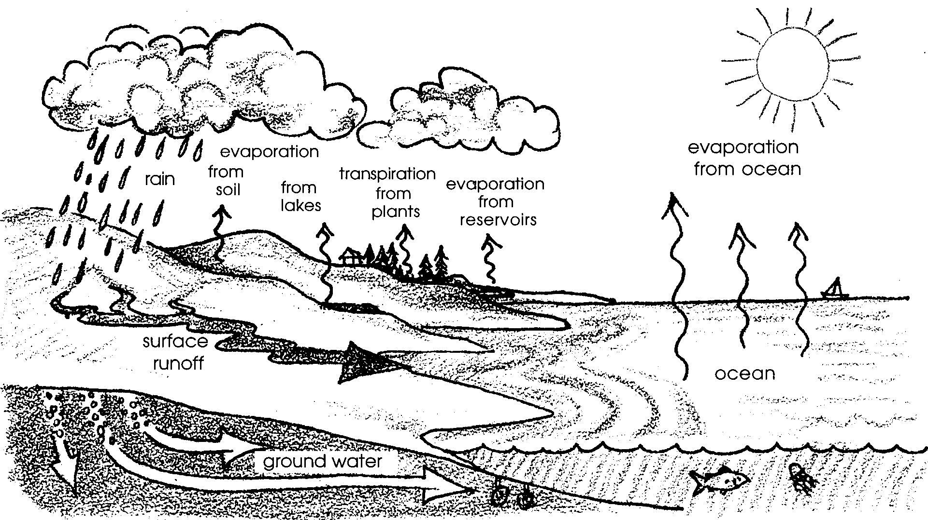
Water is continually recycled and transported by the water or hydrologic cycle. The energy for driving this cycle comes from the sun. Water is moved into the atmosphere through evaporation or plant transpiration.

This atmospheric vapor is transported by wind, condensed into clouds, and then returned to the earth as precipitation. It is estimated that every nine to 12 days, all moisture in the atmosphere falls to earth, making water our most recycled resource.

The water cycle is the foundation for examining water in any form. While this process transports and purifies water, its effectiveness may be reduced by such factors as vegetation removal (reducing transpiration) and atmospheric pollution (adding contaminants to otherwise pure vapor).

The water cycle is also influenced by local geography. For example, in Oregon, moisture-laden clouds move from the Pacific Ocean inland. As clouds rise over the Coast Range, their water vapor cools, condenses into drops, and falls as rain. Precipitation continues as the clouds move east, leaving more moisture as they rise over the Cascade Range. Until the clouds reach the Blue, Wallowa, Steens and other distinct mountain ranges, they are no longer forced to climb into cooler air. The amount of rainfall drops dramatically. Because the Cascades intercept most of the precipitation, a rain-shadow effect is created in eastern Oregon, making it more arid than the western part.
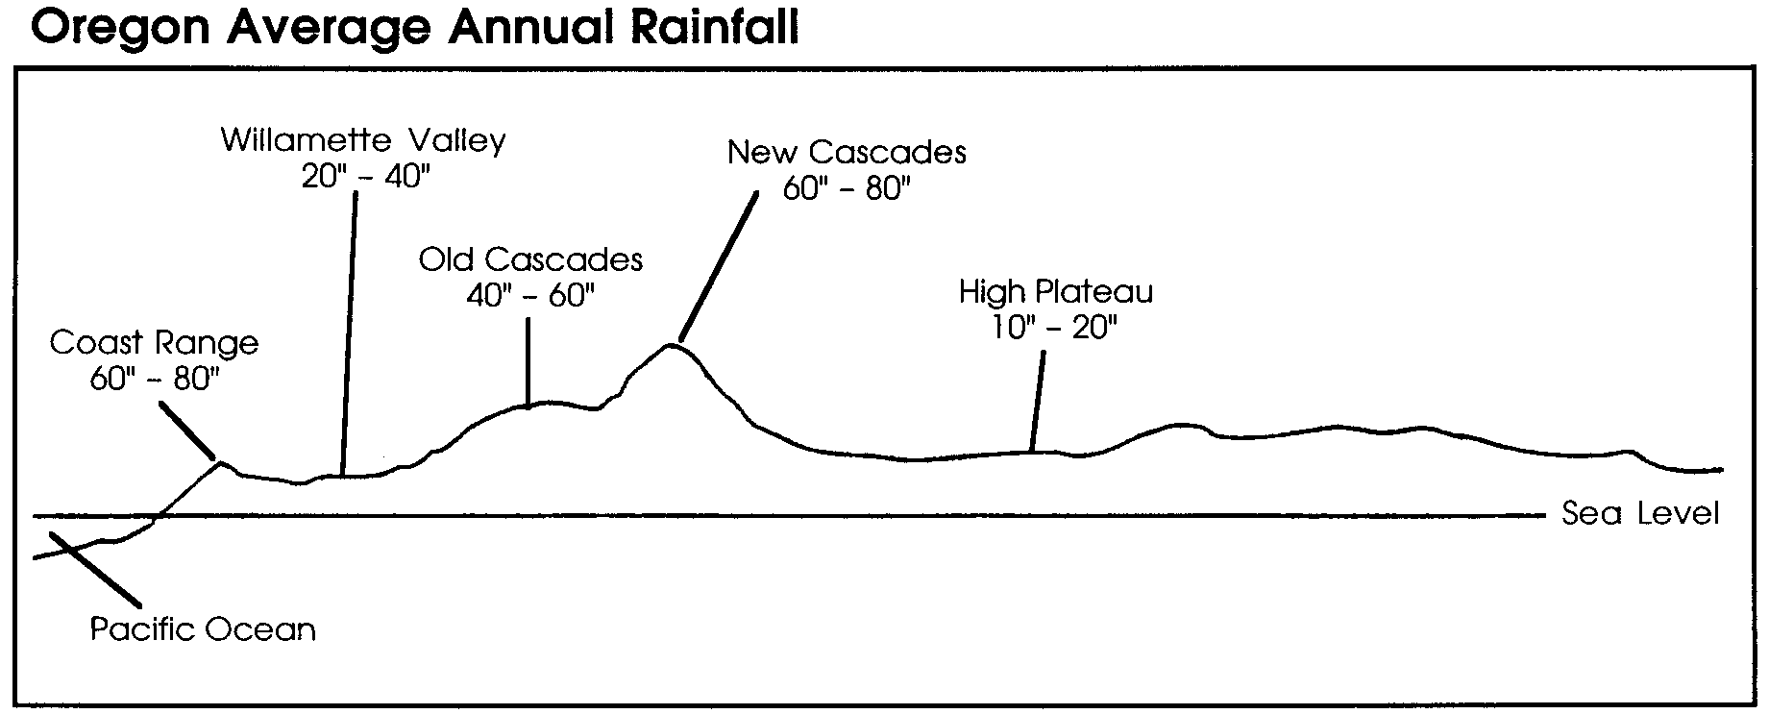

Materials

Part 1 - Water the Constant Traveler
For each student:

• “Water the Constant Traveler” water cycle diagram

Part 2 - Water Cycle Mobile

For each student:

• “Part 2 - Water Cycle Mobile” activity page

• water cycle diagram from Part 1

• scissors

• string

• coat hangers or 1/8" dowels

• optional: colored pencils, etc.

Part 3 - Transpiration

For each student:

• “Part 3 - Transpiration” activity pages

• clear plastic bag

• piece of string or twist tie

For the class:

• tree, shrub, or smaller plant; preferably an evergreen tree

• measuring cup

Teaching Hints

“Water: the Constant Traveler” provides an introduction to watersheds as student teams or individual students read a short story and complete a diagram of the water cycle. The short reading, questions, and the water cycle diagram provide material for discussion and set the stage for the rest of the watershed unit. While benefits accrue when students complete the assignment while working in small groups or even as a class, the activities may also be successfully completed by students working individually.

“Part 2 - Water Cycle Mobile” provides students a chance to turn their diagram into a mobile. Consider displaying their creations in your classroom or in the school library.

“Part 3 - Transpiration” provides students with a concrete experience of an important component of the water cycle. While the activity suggests using an evergreen tree out-of-doors, your students can witness transpiration using the technique with a house plant in the classroom. The optional “One step further....” sections provide students an opportunity to quantify their observations.

Key Words

cycle - a series of events that happen regularly and repeat

evaporate - change from a liquid to a gas

groundwater - water that is contained in the soil or ground and that supplies wells and springs.

Extensions

1. Make as a demonstration, or have each student build, a model water cycle in an easy-to-make terrarium. Cut the top off a one liter clear plastic soda bottle. Pull the bottom off, cover any holes with plastic wrap, and fill with soil. Plant radish or other seeds and moisten soil with a little water. Invert top and slip into the bottom to create a miniature greenhouse. As plants germinate and grow, watch for condensation and “rain”. If soda bottles with detachable bottoms are unavailable, use two bottles; one for the bottom, the other for the top. Make a half inch slit in the open end of the top to help ease it into the bottom.

2. Set up a standard distillation apparatus in which students can observe evaporation and condensation of water. Most basic science books describe ways this can be done.

3. The following activities from Project WILD can provide your students with additional insight:

• “How Wet is Our Planet?” Aquatic Project WILD, pp. 7- 9.

• “Where Does Water Go After School?” Aquatic Project WILD, pp. 75-79.

• “Water’s Going On?!” Project WILD, pp. 304-305.

Answer Key

Part 1 - Water the Constant Traveler
1. Water in the ocean is heated by the sun . When the water has taken in enough energy, it will evaporate and rise into the air . As it rises, the water cools, comes together (condenses) and turns into clouds . When the clouds hold enough water, it will probably rain or snow .

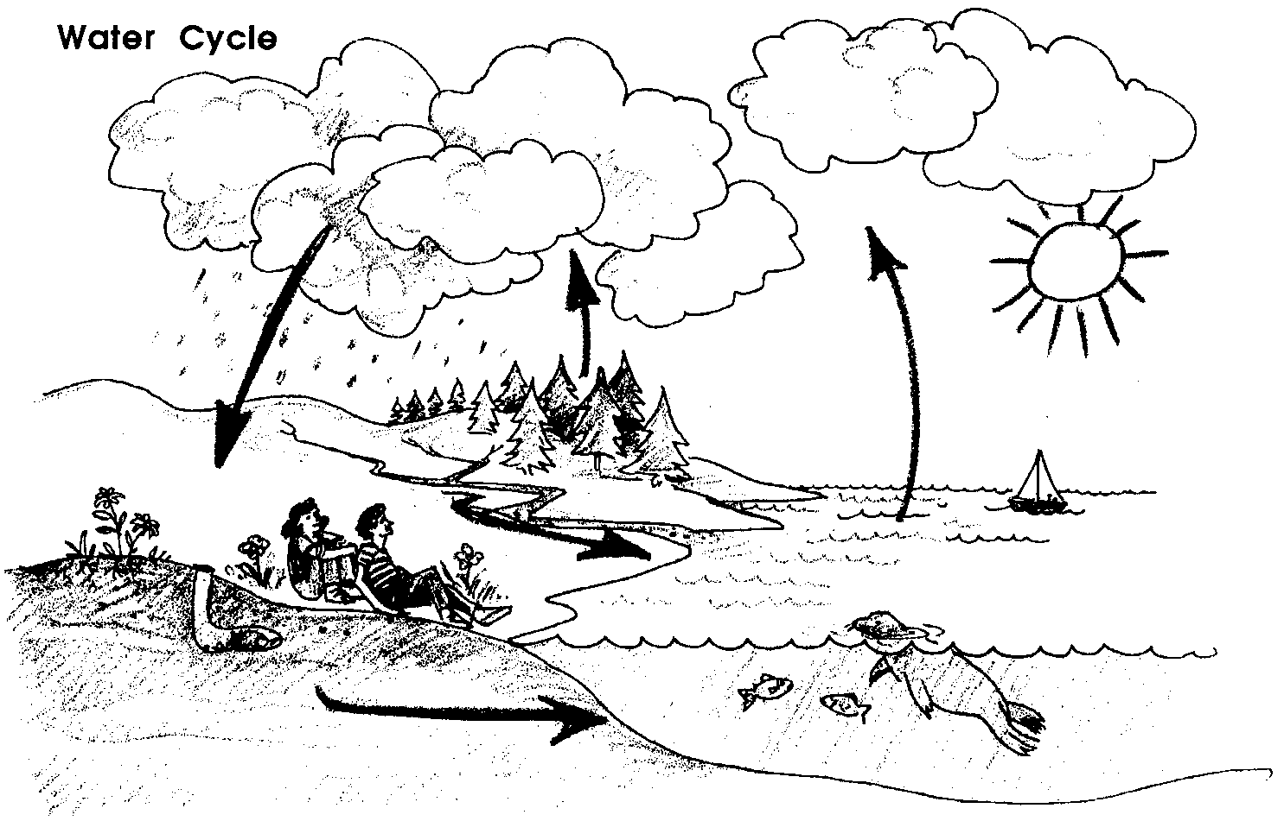
2.

4.a. During the spring and summer, these 78 spruce trees can transpire 15,600 gallons of water each day (i.e. 200 gallons per tree x 78 trees). This amount of water will more than fill an average backyard swimming pool. This amount of water is also more than most students can easily picture. Consider making the amount of water a single tree transpires more concrete by having students fill seven 30 gallon garbage cans, 40 five gallon buckets, 200 gallon milk jugs or the like to actually see how much volume 200 gallons occupies. Of course, when you’re finished use the 200 gallons to water the trees and plants in the school yard (as yet another part of the water cycle!).

b. This question calls for an opinion and, along with questions c. and d., is designed to inspire discussion of the effects our actions can have on the water cycle. Many students will answer that, if the trees are cut down, the water that the trees would have transpired will flow into streams.

c. If the water flows with enough force, the hill on which the neighbor’s house is located may begin to erode.

d. If all the trees in the area were cut down, more water would flow in rivers and streams. It might also flow faster causing increased erosion. The timing of the peak water flows would likely come sooner because the trees slow the flow of the water through the area. Timing of water flows is critical for some fish (like salmon) and a change in timing could therefore influence the composition of animals (similarly, it could change the composition of plants). If the area of the cut was large enough (like the temperate rain forests), local or global climate changes might occur. The intent of these questions is to spur thoughtful discussion about human impacts on the water cycle.

5. & 6. See completed water cycle diagram from question 2.

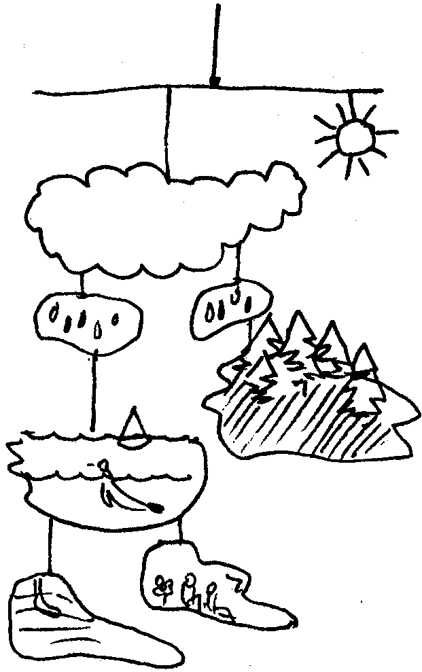
Part 2 - Water Cycle Mobile

A completed water cycle mobile would look similar to the following:

Part 3 - Transpiration
One step further....

5. Estimates will vary. The precision is not really critical. The exercise is meant to give an appreciation of the amount of water a single tree can transpire during the course of a day. It is also meant to get students thinking about techniques for measuring large quantities and dealing with issues on a global scale.

Day 2

1. The bag will likely look different from the previous day. Usually, the inside is covered with water droplets.

3. Answers will vary depending upon experimental results. Emphasize that the quantity represents the amount of water the branches transpired in one day and that transpiration is an important part of the water cycle.

One step further....

4. Answers will vary depending upon experimental results.

5. Encourage discussion and experimentation regarding what might happen to the results if students used a colored plastic bag.

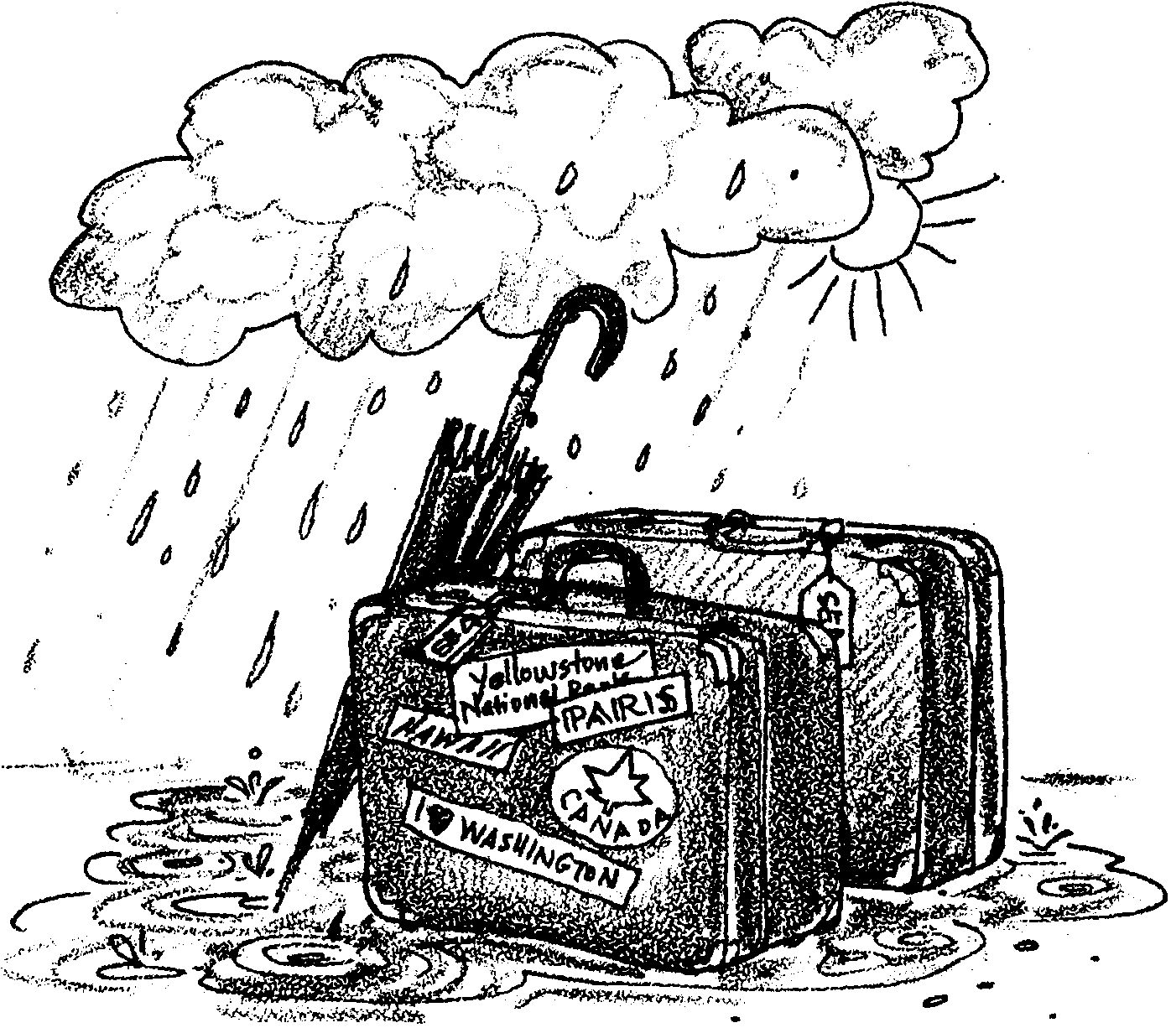
Water: The Constant Traveler

Have you ever seen the ocean? It is so big, you can’t think about it with just one thought. It takes lots of thoughts to take it all in. Sarah and her little brother Mario saw the ocean for the first time today. After looking at it for a long time, Mario said, “Where does all the water come from? It must take a lot to fill it up!”

“It must come from rivers and streams,” answered Sarah.

“And where does the water come from to fill the rivers and streams?” replied Mario. “Oh, from rain!” he said, before Sarah could answer.

“And snow too,” Sarah added.

“O.K. What about the rain and snow? The water to make them falls from the sky. Where does that water come from?”

This was a harder question. They both looked up at the bright, white fluffy clouds and blue sky.

“When it rains,” reasoned Mario, “The rain seems to come from the clouds. But there are clouds now, and it isn’t raining. So, only some clouds have water in them.”

“Rain clouds are darker, sort of gray and dark blue. ” replied Sarah, still thinking about where the water for rain and snow comes from.

“I think the clouds ARE water. Just like fog. And when there’s enough water in the clouds, it rains. Or if it’s cold enough, it snows.”

“Where does the water come from to make clouds?” questioned Mario. Sarah was getting a little tired of answering her brother’s questions, so her answer was a little sharp. “From the sun!” She really didn’t know the answer either. Do you?

Completing the Water Cycle

You can help Mario and Sarah solve the mystery of the water cycle. Here is how: Use the story above for clues. Then, try to figure out where the water comes from that makes clouds. (HINT: Have you ever seen steam rising over a pan of boiling water. The heat from the stove burner heats the water until steam is produced. The water would all be turned into steam if it was heated for a long time. The steam goes into the air. Now, think back about the big ocean. Is anything heating it up? (Hint: think of a source of heat that is in the sky.) If water gets enough energy, it does a surprising thing. Try and fill in the blanks below:

1. Water in the ocean is heated by the . When the water has taken in enough energy, it will and rise into the . As it rises, the water cools, comes together (condenses) and turns into . When the clouds hold enough water, it will probably or .

Were you able to fill in the blanks? Here’s some help. Water in the ocean is heated by the sun. When the water has taken in enough energy (heat), it will evaporate and rise into the air (just like heating it in a pan). As it rises, the water cools, condenses, and turns into clouds..

2. Obtain a “Water: the Constant Traveler” drawing. On the drawing, add arrows to show where the water goes.

3. ou have drawn what is called a WATER CYCLE. Add these words to the top of the drawing.

The water cycle is the way water gets around on our earth. All water, from the big ocean, to clouds, to rain and snow, to creeks, streams and rivers, and underground water (the water that we get from wells) is connected by the water cycle. The ocean is really a big reservoir (something that holds water) for this water cycle. This is because about 98 percent of all the water on the earth is in the oceans! The rest is fresh water, in streams and rivers, or locked up in polar ice caps and glaciers.

But there is a little more to this water cycle story. All plants give off water as a gas. This process is called transpiration. Transpiration is another way that water finds its way back into the sky to make clouds. Do plants give off enough water to make a difference? Think about this. An adult evergreen tree can transpire (give off) 200 gallons of water a day during spring and summer.

4. harlie Chambers is happy with his new home. It’s right near the ocean and the property is covered with trees. In fact, he counted 78 adult Sitka spruce trees on his lot. Charlie’s neighbor wants him to cut down the spruce trees. He lives on a hill behind Charlie. He says the trees block his view.

a. During the spring and summer, how many gallons of water can these 78 spruce trees transpire each day?

b. If the trees are cut down, what do you think will happen to the water that the trees would have transpired?

c. What do you think might happen to the hill?

d. Charlie doesn’t have the only trees in the area. What do you think might happen to the local water cycle if all the trees were cut down?

Again look at your drawing of the water cycle. One more important thing is missing. Some of the water that falls on the land, soaks in. This water, hidden in the soil and rocks below you, is called groundwater.
Groundwater is a way that the land can store water. Some of that groundwater comes back to the surface of the land. It supplies water for streams and springs. Springs provide places for animals and people to drink. Some of that water is used by trees, shrubs and grasses to grow. Some is pumped to the surface through wells for use as water for cities, farms, and other people needs.

Sometimes, too much water is pumped out of the ground. This is because people demand too much water for their needs. When this happens, streams often dry up. The land itself becomes less able to support plants.

5. On your drawing find the groundwater. Draw an arrow from the land to the groundwater. Draw another arrow to show how transpiration fits into the water cycle.

6. Don’t forget to draw the thing that powers the water cycle on your diagram. If you can’t remember what that is, review your work above!
Water: The Constant Traveler
Part 2 - Water Cycle Mobile

Make your diagram into a mobile. Here’s what you’ll need:
• your water cycle diagram
• scissors
• string
• coat hangers or 1/8" dowels
• optional: colored pencils, etc.

1. Cut out the major parts of the water cycle. Note: you may wish to color your diagram before cutting.

2. Use the parts to make a mobile that shows how water moves through the water cycle.

3. Hang your mobile for others to enjoy.

Water: The Constant Traveler
Part 3 - Transpiration

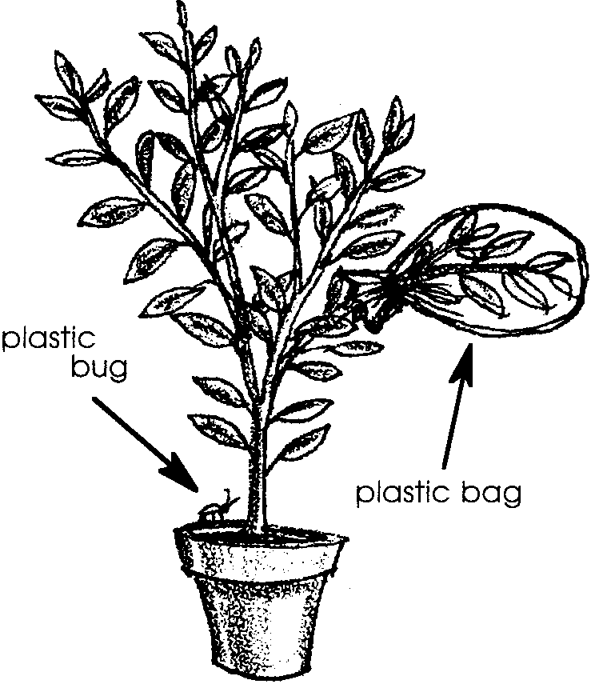
Still having trouble imagining that trees transpire (give off) water? Try this simple experiment.

Here’s all you need:
• clear plastic bag
• piece of string or twist-tie
• tree, shrub, or smaller plant; preferably an evergreen tree
• measuring cup

Here’s what to do:

1. Place the plastic bag over a few branches. Pick branches with needles or leaves!

2. Tie the end of bag together over the branch.

3. Record the date and time .

4. Plan to return the next day at the same time.

One step further....

5. Step back from the tree. Look at the whole tree. Look at your plastic bag. About how much of the tree is inside your bag?

This isn’t as hard as it sounds. Here’s one way you could use:

a. close one eye

b. look at the plastic bag.

c. hold your thumb between your eye and the plastic bag.

d. move backward or forward to find the place your thumb just blocks out the bag.

e.f rom that place, count the number of “thumb prints” you would need to cover the whole tree. Start by moving your thumb to block out the top of the tree, then move down the tree.

f. So, how much of the tree is in your bag? If it takes 100 “thumb prints”, you have 1/100 th of the tree in your bag.

Record your estimate here .

Day 2

1. Does the bag differ from when you left yesterday? How?

2. Your next challenge is to find out how much water is in the bag. Take the bag off the branches. Be sure to keep any water inside the bag.

3. Measure the amount of water.

Record your amount .

This is the amount of water your branches transpired (gave off) in one day. This water is an important part of the water cycle.

One step further....

4. Let’s say the branches you covered were like the other branches on the tree. How much water did the whole tree give off in one day?

(Hint: What part of the tree did your bag cover? See your guess from yesterday (question 4). If it covered 1/100th, you multiply the amount of water by 100.)

5. What do you think would happen if you used a colored plastic bag? Why don’t you try it and see?
