National Estuaries of Significance
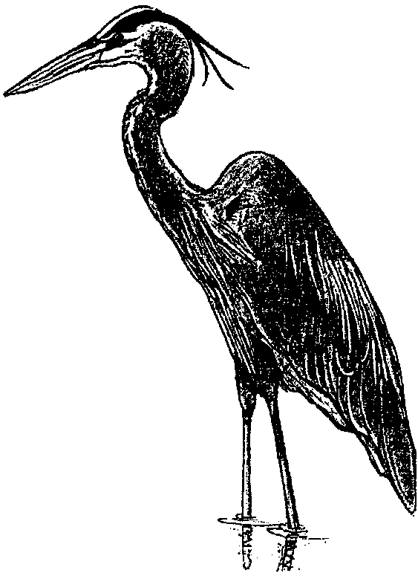
Lesson by Laurie Dumdie, Poulsbo, WA

Key Concepts
1. Estuaries are important nursery and spawning grounds.
2. Estuaries are economically important, supporting recreation, tourism, transportation and commerce.
3. The National Estuarine Research Reserve System is providing critical protection for irreplaceable natural resources in our estuaries.

Background

The National Estuarine Reserve Research System

In the late 1960’s the United States Congress recognized the need to protect coastal resources from pollution and the pressures of development. In particular danger were the nation’s estuaries; those valuable, yet fragile areas where rivers meet the sea. Many animals, including most of the sport species and commercially important shellfish and finfish taken in the coastal zone, depend on the estuary for food and shelter in the beginning of their life cycle. To address threats to these critical areas, the National Estuarine Reserve Research System was established as part of the Coastal Zone Management Act of 1972. The National Oceanic and Atmospheric Administration (NOAA) was given responsibility for designating estuarine reserves and administering the system.

The goal of NOAA’s program is to establish and manage, through federal-state cooperation, a national system of reserves representing different coastal regions and estuarine types that exist in the U.S. and its territories. The reserves serve as field laboratories in which studies are conducted on natural and human processes occurring within the estuaries. Education and research are primary objectives of the National Estuarine Research Reserve System.

The Reserve System

Twenty-two reserves are presently designated by NOAA. The reserves preserve nearly 450,000 acres of estuarine waters, marshes, shoreline, and adjacent uplands for estuarine education and research. The completed estuarine reserve system will represent all of the nation’s biological and geographical coastal regions. The reserves representing these regions range from the pounding surf on the barrier beaches of North Carolina’s four reserve sites west to the ethereal beauty of the Waimanu River Reserve of Hawaii, from the Wells Reserve on the shores of the cold Gulf of Maine south to the coral reefs protected in Puerto Rico’s Jobos Bay and the mangrove forest of the Rookery Bay Reserve in Florida. The estuaries exemplify the full range of variation possible in the unique environment where rivers and streams flow into the sea.

To contact one of the reserves, see the addresses and phone numbers on the sheet that follows.

The diverse estuarine environments represented by each reserve provide a complete profile of the nation’s estuarine system; an invaluable tool for decision-making not only in estuaries but for the entire coastal zone as well.

A Different Kind of Reserve

Unlike many “reserves,” the National Estuarine Research Reserve System is not designed strictly for preservation. Besides research and education, these wild and pristine estuaries will continue to provide locally important resources. For example, the oyster, shrimp, crab, and finfish industry supported by Florida’s Apalachicola Reserve generates $10 million annually and directly employs between 60 and 85 percent of the local community. Other reserves are open to recreational hiking, horseback riding, boating or hunting where these activities do not conflict with research and educational goals. New York’s Hudson River Reserve system alone is visited by over 1/2 million people annually.

Local, state, and federal decision-makers look to the National Estuarine Research Reserve System for critical resource management information. The scientific knowledge the reserve research programs produce supports management efforts in similar sites all along the nation’s coast. The protection of estuaries and our improved understanding about them help to assure these areas are available for generations to come.

Materials

For each student:

• “National Estuarine Research Reserves” student worksheet

For the class:

• transparency of the “National Estuarine Research Reserves”

For each group of 4 students:

• Clue Cards packet (cut apart the 4 clues and put them in an envelope)

Teaching Hints

Activity 1: Creating Metaphors

1. Explain that sometimes estuaries have been considered wastelands; their channels have been dredged, marshes and mudflats filled, waters polluted, and shorelines reconstructed to accommodate housing, transportation, and agricultural needs. Congress created the National Estuarine Reserve Research System in 1972 to protect significant threatened estuaries for their natural resources and aesthetic values.

Ask students why they think it is important and desirable to have estuarine reserves.

2. You may choose to divide students into small groups or to work with the class as a whole, depending upon their experience in such activities. Motivate them to think about the natural and aesthetic values of estuaries using metaphors. This is a perfect time to show students a video, movie or slide set on estuaries. Contact one of the reserves nearest you for potential loan materials. For example, Padilla Bay Reserve in Washington has produced an excellent video on their reserve. There is nothing like media to stimulate students’ creation of metaphors about estuaries.

Explain that a metaphor is a figure of speech in which a word or phrase describing one object or idea is used in place of another to suggest a likeness. Briefly practice the creation of metaphors to be sure students understand the concept.

Example: An estuary is like ...

...a nursery because many commercially-important fish and shellfish spawn, breed and feed in estuaries.

... a perfect sunset because the beauty and diversity found in estuaries have inspired poets, painters, and other artists to create objects of beauty.

3. Have each group record a list of metaphors for display to share their ideas. Webbing or mind-mapping might be a good way for students to proceed. Creativity is encouraged! Students may suggest estuaries are valuable because among other things they are:

• nurseries and fish hatcheries; favored breeding and feeding grounds for large numbers of fish and shellfish, including many commercially important species

• housing for wildlife; many species of birds, mammals, fish and invertebrates, including several endangered species, live only in coastal wetlands

• bird motels and diners; many migrating birds stop at salt marshes for food and rest on their long journeys

• job centers; often include a network of rivers for transporting goods for manufacturing and trade which provides many jobs; also may provide jobs for tour guides, fishermen, and nature or sports store workers, among others

• tourist attractions; provide numerous recreational opportunities (recreational harvest of fish and shellfish, boating, birdwatching, etc.)

• farms; salt marshes grow more green material per acre than our best-managed farms, fueling a complex food web

• water treatment plants; water pollutants can be filtered by salt marsh soils, then absorbed by plants and soil organisms

• schools, laboratories, recreation centers and mental health retreats; we make direct use of estuaries by visiting them and studying their inhabitants

Activity 2: Put Them On the Map

1. Explain that in this activity students will discover some of the estuaries included in the National Estuarine Research Reserve System and learn where they are located in the U.S. Be prepared to offer extra assistance to those students who are still grasping at the concept of city, state, country. Providing U.S. maps which include state names can be a great help in this regard.

2. Group students in teams of four. Distribute a copy of the worksheet, “National Estuarine Reserves” to each student. Distribute one packet of clue cards to each team. Each student in the group gets one of the clues from the packet. Have students take turns reading their individual clues aloud to their group to determine the location of the estuary described. Have them locate the estuary on the map worksheet.

3. When all groups have located their estuaries on their map worksheets, have each group present its information to the whole class. Have students complete their worksheets as the information is presented. Ask each group to share with the class the following information about the estuary:

a. What are the fresh and saltwater bodies that meet at the estuary?

b. What key species of plants and animals live there?

c. Interesting historical information.

d. How do people use the estuary today?

Key Word

metaphor - a figure of speech in which a word or phrase literally denoting one kind of object or idea is used in place of another to suggest a likeness or analogy between them

Extensions

1. Have students choose an National Estuarine Research Reserve of interest to them and write to get more information about that estuary. Addresses can be found on the sheet that follows. An excellent resource is the pamphlet, A Tour of the Reserves (see bibliography). Encourage students to create a poster or other visual display that addresses the same questions used in procedure #3 above.

2. Write a theme song or rap for an estuary.

3. In a chosen estuary, research the use of resources by the indigenous people past and present.

4. Collect idioms related to the estuary, e.g. “slow as snail”.

5. Read the poem “Sea Fever” by John Masefield.

6. A list of National Estuary Research Reserves is printed on the following page.

National Estuarine Research Reserve System
Jobos Bay NERR
Call Box B
Aguirre, PR 00704
(809) 853-9363

Narragansett Bay NERR
P.O. Box 151
Prudence Island, RI 02872
(401) 683-6780

North Carolina NERR
UNCW/CMSR
72205 Wrightsville Avenue
Wilmington, NC 28403
(919) 256-3721

North Inlet/Winyah Bay NERR
USC Baruch Marine Laboratory
P.O. Box 1630
Georgetown, SC 29442
(803) 546-3623

Old Woman Creek NERR
2514 Cleveland Road E.
Huron, OH 44839
(419) 433-4601

Padilla Bay NERR
1043 Bayview-Edison Road
Mount Vernon, WA 98273
(206) 428-1558

Rookery Bay NERR
10 Shell Island Road
Naples, FL 33962
(813) 775-8845

Sapelo Island NERR
Georgia Department of
Natural Resources
Sapelo Island, GA 31327
(912) 485-2251

South Slough NERR
P.O. Box 5417
Charleston, OR 97420
(503) 888-5558

Tijuana River NERR
301 Caspian Way
Imperial Beach, CA 91932
(619) 575-3613

Waimanu Valley NERR
Hawaii Division of
Forestry and Wildlife
P.O. Box 4849
Hili, HI 96720
(808) 933-4221

Waquoit Bay NERR
P.O. Box 3092
Waquoit, MA 02536
(508) 457-0495

Weeks Bay NERR
10936-B U. S. Highway 98
Fairhope, AL 36532
(205) 928-9792

Wells NERR
RR 2, Box 806
Wells, ME 04090
(207) 646-1555

ACE Basin NERR
P.O. Box 12559
Charleston, SC 29412
(803) 762-5437

Apalachicola NERR
261 7th Street
Apalachicola, FL 32320
(904) 653-8063

Chesapeake Bay NERR MD
Coastal and Watershed
Resources Division
Tawes State Office Bldg., B-3
580 Taylor Avenue
Annapolis, MD 21401
(410) 974-3382

Chesapeake Bay NERR-VA
Virginia Institute of Marine
Science
P.O. Box 1346
Gloucester Point, VA 23062
(804) 642-7135

Delaware NERR
DNREC
Division of Parks & Recreation
P.O. Box 1401
Dover, DE 19903
(302) 739-4413

Elkhorn Slough NERR
1700 Elkhorn Road
Watsonville, CA 95076
(408) 728-2822

Great Bay NERR
Sandy Point Discovery Center
89 Depot Road
Stratham, NH 03885
(603)778-0015

Hudson River NERR
c/o Bard College Field Station
Anandale-on-Hudson,
NY 12504-5000
(914) 758-5193
HUDSON RIVER

The Hudson River Reserve is in New York state.

This reserve is located along the Hudson River. The river flows into the Atlantic Ocean.

Wild rice grows here. Many water birds visit this reserve.

Blue crab and, snapping turtles are important animals here.

NORTH CAROLINA

The North Carolina Reserve is in the state of North Carolina. There are four estuaries in the reserve.

One of the estuaries is a barrier island in the Atlantic Ocean. The island helps protect the mainland from storms.

Cordgrass, blue crab, and sea turtles are important animals here.

Cattle and sheep of early English settlers ate the grass of the island.

APALACHICOLA BAY

Apalachicola Bay Reserve is in Florida. It is the largest reserve.

Part of the Apalachicola River is in the reserve. It flows into the Gulf of Mexico.

Oysters and black bears are important here.

Most of the oysters produced in Florida come from here.

ELKHORN SLOUGH

Elkhorn Slough Reserve is in California.

Freshwater flows here only part of the year. The slough is in a shallow bay of the Pacific Ocean.

Pickleweed, shorebirds, and leopard sharks are important here.

Scientists are working to restore the eelgrass beds of Elkhorn Slough.

OLD WOMAN CREEK

Old Woman Creek Reserve is in Ohio. The creek flows into Lake Erie. Lake Erie is a freshwater inland sea.

The estuary is a home for many kinds of young fish.

Cattails, bass, and swallows are important here.

Mosquitoes hatch in swarms in the estuary. They are great food for many birds.

WAIMANU VALLEY

Waimanu Valley Reserve is on Hawaii Island.

The freshwater from the Waimanu Valley flows into the Pacific Ocean.

The steep valley is covered with tropical forests.

Visitor have to hike 7.5 miles to visit here.

ROOKERY BAY

Rookery Bay is in Florida.

This reserve is a mangrove estuary.

Mangroves are tropical trees. They grow in swamps. Not many mangrove swamps are left.

Mangrove trees, bottle-nose dolphins, and manatees (“sea cows”) are important here.

CHESAPEAKE BAY

Chesapeake Bay is in Maryland, Virginia, and Washington, D.C. It is the largest estuary in North America.

Over 50 rivers or streams flow into the bay. The bay opens to the Atlantic Ocean.

Wild rice, water birds, blue crabs, and oysters are important here.

Many people make a living from the shellfish of the bay.

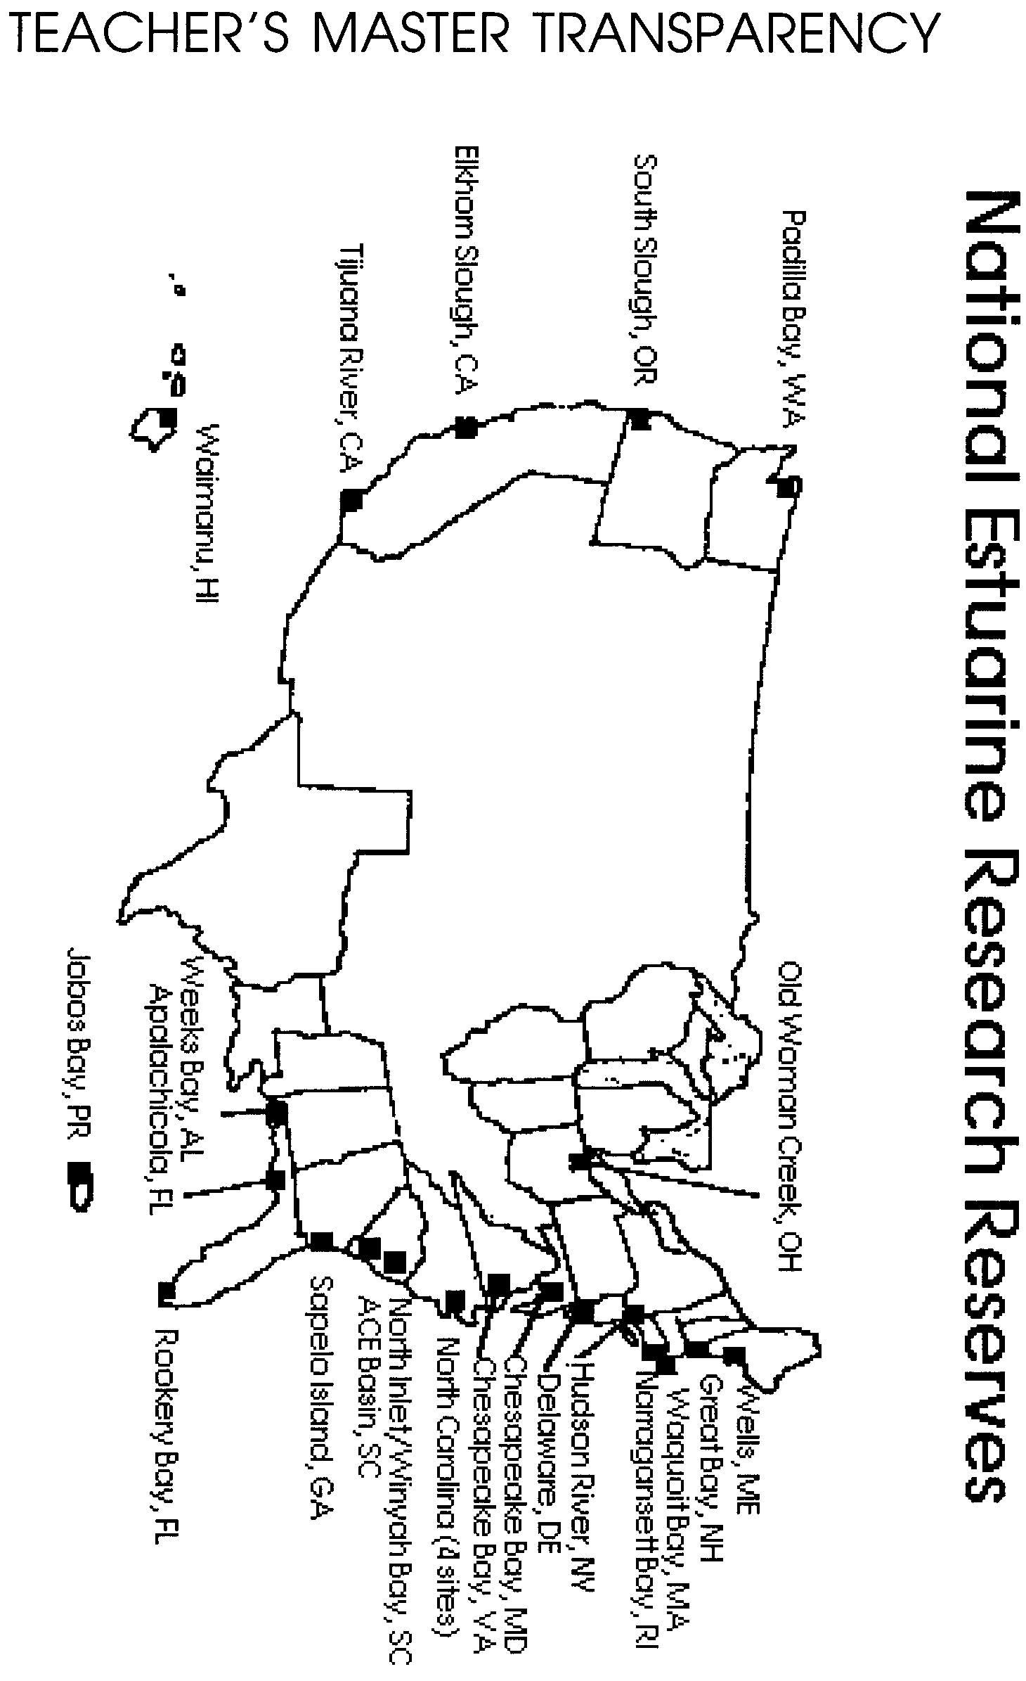
STUDENT WORKSHEET
