Where Have All the Salt Marshes Gone?
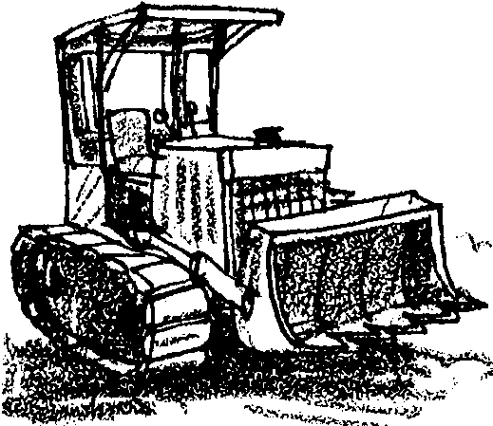
Lesson by Phyllis Schmitt, Santa Rosa, CA

Key Concepts
1. As natural habitats are developed by humans, animal and plant populations are often diminished.

Background

In the United States, nearly 35% of all rare and endangered species either depend upon or inhabit wetlands, which include fresh and saltwater marshes, swamps, mudflats, bogs, and vernal pools, as well as estuaries. Millions of waterfowl use wetlands as a migratory stopover or as breeding and nesting grounds. Wetlands are also home to an overwhelming number of species of marine, plant, and animal life. Over 50% of the total U.S. annual fish harvest is from our estuaries or is dependent upon our estuaries in at least some lifestages.

Despite their importance, coastal wetlands in the U.S. continue to be lost at a rate of 40,000 acres (64 square miles) a year. Sixty three percent of these losses are occurring in Louisiana through both natural and human changes. Everywhere else, coastal wetland loss is directly proportional to population density and urbanization. Ninety to ninety-five percent of the salt marshes around San Francisco Bay, for example, have been filled in. Wetlands of other regions have experienced similar degradation, and continue to be “improved” with construction projects. Much of this is attributable to the fact that historically, wetlands have been viewed as vast wastelands. Few people realize that the “wasteland” they may be dismissing is home to hundreds of living things.

Saltmarsh wetlands play a critical ecological role as the physical and biological connection between upland habitats and saltwater. It is because of their unique location in the landscape that salt marshes are so important.

This activity examines the relationship between wetland animals and the wetland habitat. The effects of habitat loss and food shortage on animals are observed.

Materials

For the class:

• transparency showing the 5 animals used in this simulation
• l long rope (to mark “wetland” boundaries)
• food pieces (use different items or colors to distinguish):
20 fish, 20 insects, 20 snails, 15 pickleweed plants and 15 small mammals and reptiles

For each student:

• 1 paper cup or small bag (to represent stomach)

Teaching Hints

This activity focuses on species found in northern California. You may wish to substitute species from another region. For example, in the Puget Sound region of Washington you might substitute chinook salmon, Dungeness crab, bald eagle, great blue heron and weasel.

1. Brainstorm a list of different kinds of wetlands and the plants and animals that may live there.

2. Display the transparency of the five animals (California clapper rail, raccoon, great egret, Northern harrier, and salt marsh harvest mouse) that live in the salt marsh and explain to students that in this activity they will pretend to be one of these animals. All of these animals live in and depend upon the marsh and two of them, the clapper rail and harvest mouse, are endangered species. When the salt marshes are destroyed, these animals need to find another marsh or lose their life.

3. Place the rope on the ground in any shape, as long as the ends of the rope meet. This identifies the salt marsh habitat. Have the class sit around the outside of the “marsh”.

4. Divide students into 5 groups of animals: California clapper rails, raccoons, great egrets, Northern harriers, and salt marsh harvest mice. Give each “animal” a container to use as his/her stomach. Using the food chart below, explain the specific diet of each animal. Note: for this activity, the diets have been simplified and the fact that some of these animals eat each other has been ignored.

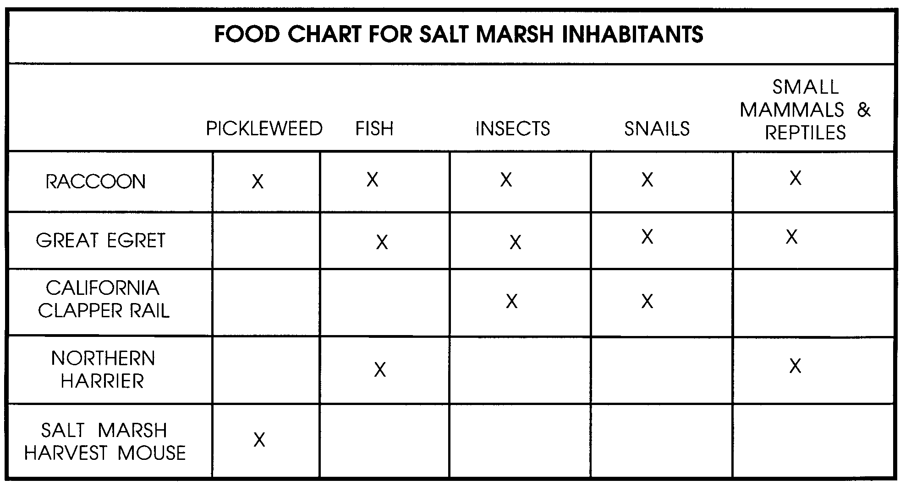
Make sure students understand that they can only eat the food that their animal eats. Their job is to forage (feed) in the marsh; they should put the food pieces in their stomachs as the pieces are collected.

5. For the first round, sprinkle all the “food” pieces throughout the marsh area. Allow the animals to forage for 30-60 seconds or until all the food is gone. When time is called, all animals must stop foraging and return to the outside of the marsh habitat. Check each stomach. If any are empty or only have one piece of food, those animals have starved to death and they should remain sitting around the marsh.

You may use this opportunity to explain that when the animals die they decompose and return to the bottom of the food chain and help other organisms grow. The “dead” animals could chant, “decompose, decompose, decompose...” Collect all the food pieces.

6. Now tell the class that part of the marsh is being filled in so that a road can go across it. Take in some of the rope to make the marsh smaller. You should also remove the following food pieces: 3 snails, 3 insects, 3 fish, 1 pickleweed and 1 small mammal and reptile; set them aside. Explain how loss of habitat also means loss of food for many animals.

Scatter the remaining pieces of food around the marsh and send the animals off to forage. Remember, the animals who starved to death do not forage again.

7. Repeat the feeding sequence shrink the marsh, remove food, and forage until only a few animals are left. Use different reasons for the shrinking of the marsh. Ask students what reasons they think might cause people to want to fill in the marsh. They may suggest:

• the marsh was filled to build houses, airports, ports, marinas, office buildings and/or garbage dumps

• the marsh is filling up with silt from developments and logging upstream

• a company dumps toxic waste in the marsh, thereby contaminating the food sources

• part of the marsh is bulldozed and filled in so a road can be built across it

• failing septic tanks

8. Discuss students reactions to the simulation with questions like:

What happens to animals that depend on a habitat, if the habitat gets smaller? (They lose shelter, food, water and space.)

Is it necessary to build marinas, housing developments or garbage dumps in wetland/salt marsh areas? What are some other solutions? (This is a sticky situation because if we don’t clear away some area, where will people live, dump their waste, etc.? Housing developments might take priority over marinas, but even then, a lot of discussion should occur before these decisions are made. We as humans should not take the fate of a species lightly simply because we have the ability to control that fate.)

Why don’t these animals go somewhere else to live, such as a forest? (Discuss the needs of each animal. Each species has specific requirements in order to live. These animals can find these in the marsh, but they may not be available in other ecosystems, such as a forest.)

Why can’t the animals exist in smaller, but more crowded marshes? (There would be a lot of competition for food, shelter, water and space, which would leave a number of the population to become diseased and die or subject to increased predation.)

What must be done to help animals such as these? (Education, heightened awareness, increased interest, passage of laws and regulations to protect these habitats and species, restoration of degraded habitats, etc.)

How can you help endangered animals? (Make efforts to learn more about them, write letters to your Senators and Representatives, participate in Adopt-an-Endangered Species, etc.)

Key Words

endangered species - a species of animal or plant threatened with extinction

salt marsh - a community within the estuary; a vegetation community where the plants tolerate high levels of salt in the flood waters as the tides pulse in and out

Extensions

1. Have students research other endangered species and shrinking habitats and report their findings to the class.

2. Publish an Estuary Gazette newspaper focusing on issues concerning estuaries, including serious and humorous reporting. Articles might include these suggestions adapted from Tideline, published by San Francisco Bay National Wildlife Refuge:

• Oil Spill Threatens Bay Aquatic Life

• Clams Die in Garbage Advance Over Mudflats

• Nudibranchs Caught in Algae Bloom

• Two Million Sea Cucumbers Die Suddenly

• Dear Salty (advice column)

• An Interview with Third Generation Clapper Rails about How Life Used to Be

• Sports: Fifth Annual Steelhead Migration

• Are Freshwater Flows Changing Our Salt Marshes?

• Your Garbage & Marshlands

• Soaps: As the Tides Turn

• Hot Music Video: Where Have All the Salt Marshes Gone?

• “I Can’t Eat Concrete” states Molly Mallard

• Ducks Arrive in Surprise, “Who Put the Highrise Here?”

• Salty Speaks Out: “Can we save the ...”

• How the got its .

3. Have students try their hand at community planning.

a. Have students list all the facilities that are important for a community: homes, various types of businesses, roads, libraries, water supply, sewage system, garbage disposal, police and fire departments, schools, churches, theaters, farms, airport, parking areas, parks and recreation areas, hospitals, etc.

b. Make and display a large map of a real or imaginary region that includes an estuary. Have students plan a community for the area. The facilities might be drawn on cards that can be taped or pinned onto the map.
Salt Marsh Animals Transparency
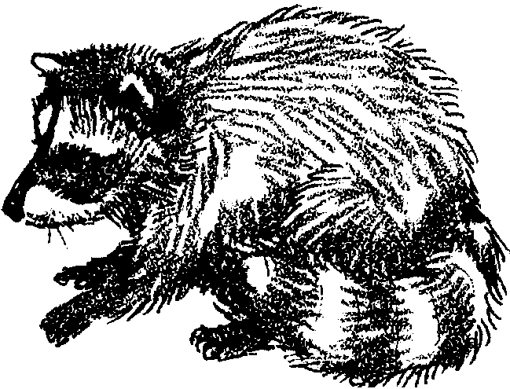
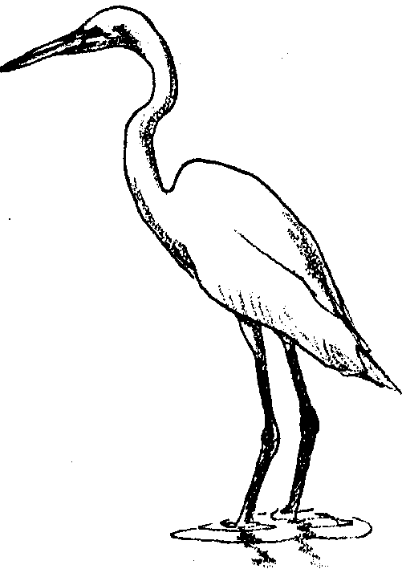

Racoon
I come to the salt marsh to hunt clams, crabs, fish and other animals.

great egret
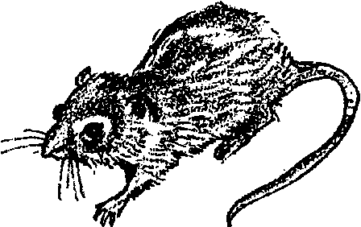
I am a large white heron. I have a yellow bill and blackish feet. I stalk my prey slowly. My population was greatly reduced by feather plume hunters. The feathers were used on hats. My population is now recovering.

salt marsh harvest mouse
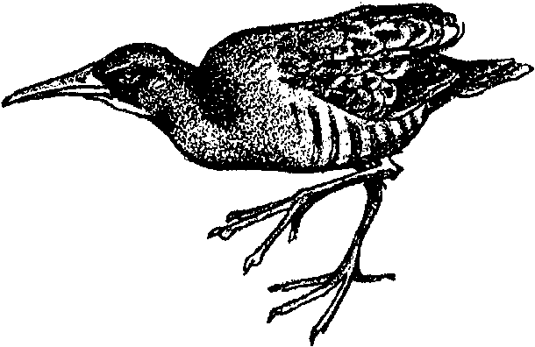
I live among the pickle weed. I nest in the pickleweed and also eat it. At high tide, I climb to the top of the pickleweed, that way I won't drown. I am an endangered species.

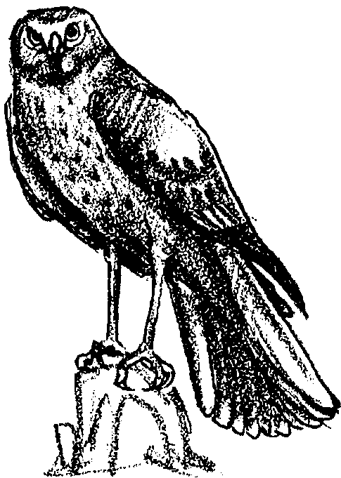
california clapper rail
You can find me mostly at low tides. Look for me along mud flats and creek banks. I lkie to eat fiddler crabs, worms, snails, small fish and other animals. I hide in the high marsh grass.

northern harrier
I fly close to the ground when I hunt. I eat mice, rats, frogs, rabbits, small birds and other prey. I alternate my wing beats with low long glides.

