Red Sea Star Cafe

A Seafood Restaurant Simulation
Lesson by Pat Williams, Eugene, OR 1993
Edited by Laurie Dumdie, Poulsbo, WA

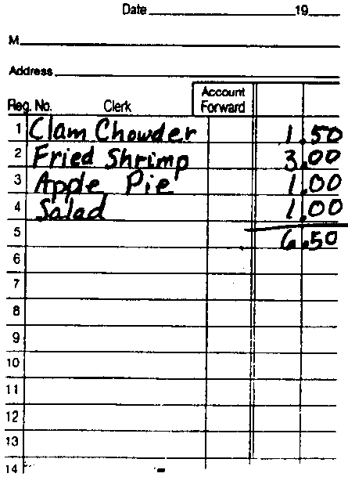
Key Concepts
1. The livelihood of many people depends on a healthy marine environment which can provide food resources.
2. Marine science instruction can be used as a vehicle to teach many other disciplines and skills.

Background

“Red Sea Star Cafe: A Seafood Restaurant Simulation” is a culminating activity which integrates many of the science and marine science concepts presented throughout the curriculum. Additionally, these skills are incorporated:

Mathematics handling money, making change, addition in columns with regrouping

Language arts spelling, writing, reading (menus, orders, signs)

Visual arts drawing, sculpture, graphic design

Problem solving brainstorming, decision making, cooperative work groups

Social studies occupational roles, profit motive, social interaction

Pat Williams, a Eugene, Oregon classroom teacher and original “proprietor” of the “Red Sea Star Cafe” writes, “This lesson began at a restaurant just off Interstate 5, somewhere near Red Bluff, CA. While looking at the laminated menu, with its pictures of fattening foods, I thought it would be fun to have menus like these for the classroom, where we could teach mathematics skills while playing restaurant. The original idea simmered and stewed into a classroom bouillabaisse; a successful integration of marine science, mathematics, art, language arts and group process in a developmentally appropriate unit. Kids love it!”

The whole process can (and probably should) involve a number of different sessions, spread over days or even weeks.
This restaurant has been extremely successful with parents as a culmination activity for a marine science unit. It can be part of a total marine experience including science experiments and displays.

Materials

For the class:

• order pads (available at a stationery or variety store)

• plastic utensils, paper plates, bowls, napkins

• play money

• adding machine with tape (cash register optional)

• boxes with dividers to serve as cash drawers

• calculators

• legal-size envelopes for wallets

• supplies for simulated food: paper, crepe paper, clay, foil, etc.

• drawing paper for menus (11" X 18" recommended)

• butcher paper for signs

• pencils, colored pens, crayons

• “Making Change Kit” for practice at home

Teaching Hints

Introduction

After completing a unit, or mid-way through a marine science unit, ask the “grabber” questions; something along the lines of:

“Have you ever played store?”

“Do you think it would be possible to set up a seafood restaurant instead of a store?”

Proceed by asking:

“What things will we need to open a restaurant?”

“What kind of jobs do people do in a restaurant?”

Solicit students’ ideas. Responses will probably include: order pads, money, cash register, wait persons, cooks, tables, food, a name, menus, signs, place mats, plates, silverware, etc.

“What shall we name the restaurant?”

This decision is a great group process exercise. Brainstorm name suggestions. Encourage students to use terms such as restaurant, cafe, diner, etc. in the restaurant name. Post all ideas for discussion.

To minimize disappointment, agree upon a scheme for selection (voting, lottery drawing, etc.) of the name beforehand. The children need to know that their favorite name may not win.

The final names for the restaurant will vary from year to year, and will range from interesting to bland. What is important is that the choice is the children’s, and is made cooperatively. In Eugene, Oregon, these have been among the choices over the years: The Red Sea Star Cafe, The Treasure Island Seafood Restaurant, Joe’s Fish and Chowder.

“What shall be offered on the menu?”

Again, conduct a group brainstorming. Choices may be simple or sophisticated, depending on your students’ experiences and regional tastes. These are some of the choices from past restaurants:
calamari fish sticks tuna sandwich
clam chowder lobster coke
milk fried shrimp soda
Italian soda coffee shrimp cocktail
salmon fish and chips salad
ice cream baked Alaska

After the brainstorming session, sort and categorize the suggestions into groups: appetizers, entrees, desserts, beverages, etc.

Prices for the menu items could be determined by the whole class or by the menu committee. Help students to set reasonable prices.

Working Committees

Refer to the students’ original list of what things were needed for a restaurant. Use this information to organize “working committees” to build the restaurant. Consider the following:

Menu Committee This committee designs the menu, including the cover and the lists of items to be served. This list could be copied on a copy machine and put inside the menus. As other students, not in the menu group, finish their projects, encourage them to design a menu cover of their own. Menu covers created on 11 x 18 drawing paper, folded in half, have worked well.

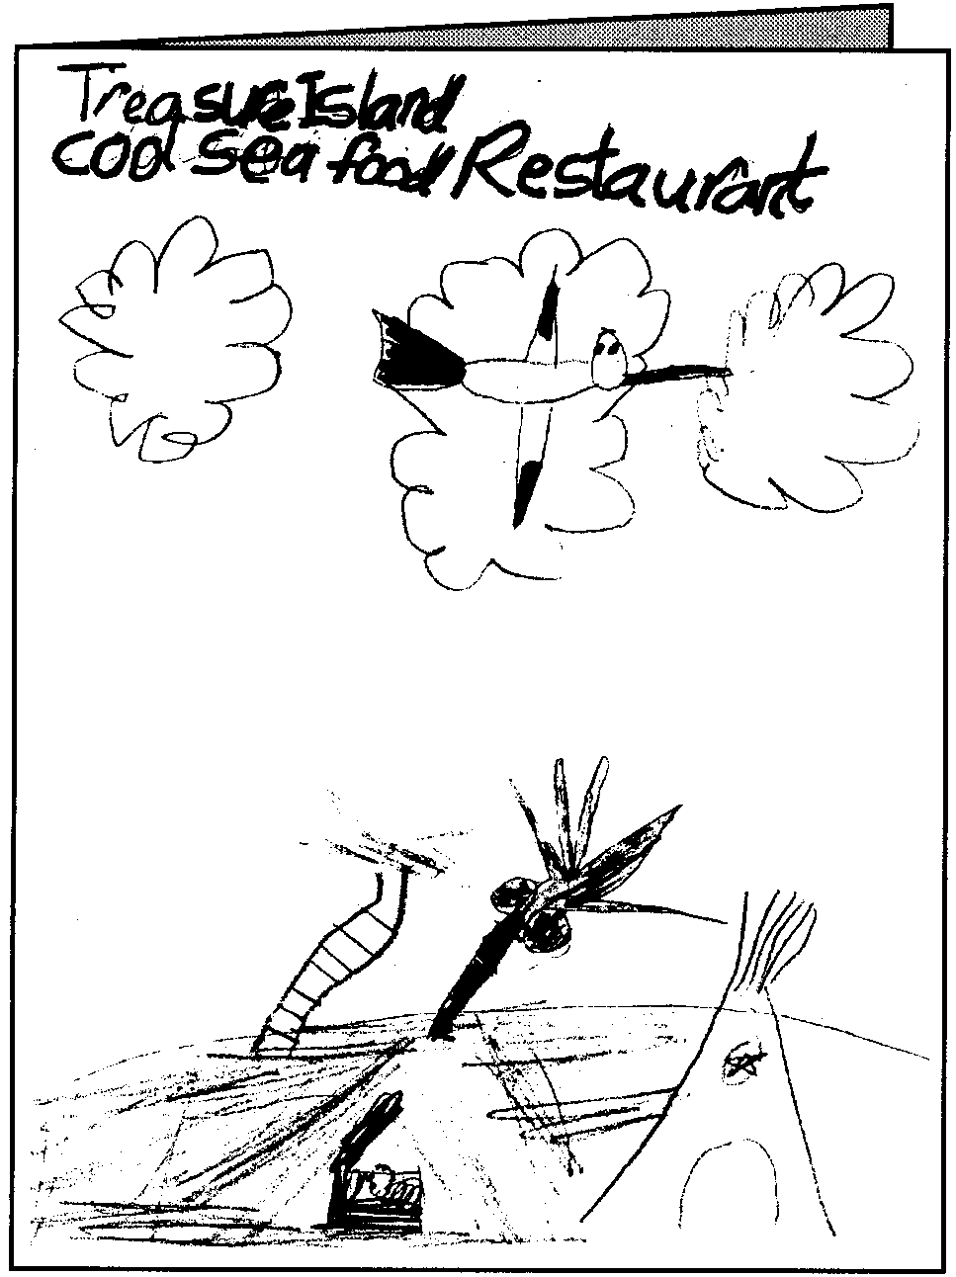

Consider laminating the menus when complete. It not only makes them more durable, it also makes thm look more authentic.

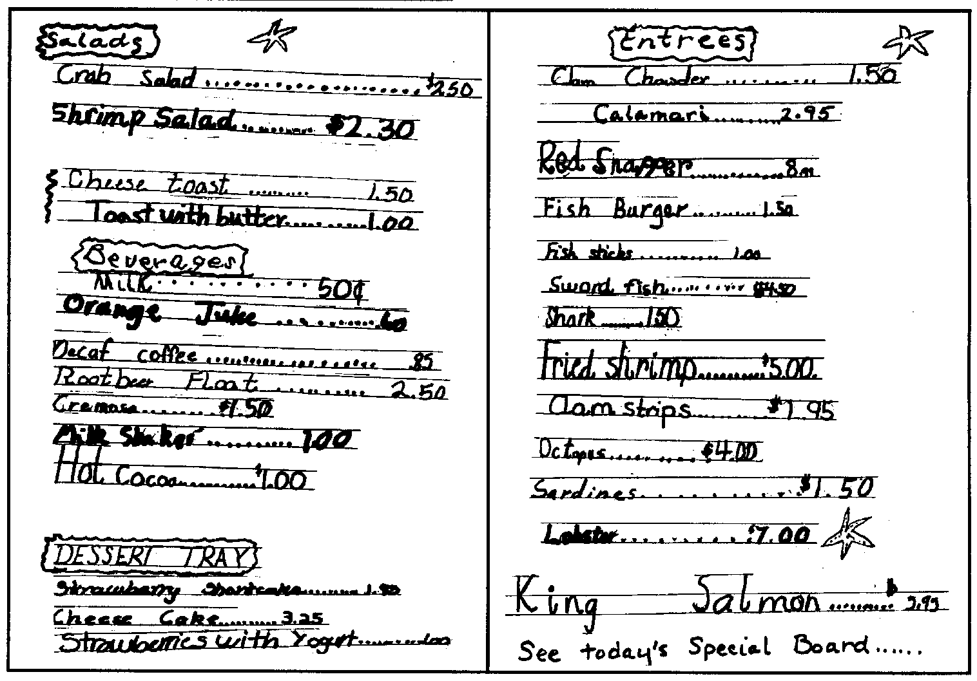
Sign Committee This committee’s main task is to construct a sign to hang over the restaurant entrance to identify the name of the restaurant. Allow students to create the design and the sign itself on their own. Other signs which could be made: Opening Soon, Closed, sale specials or advertisements.
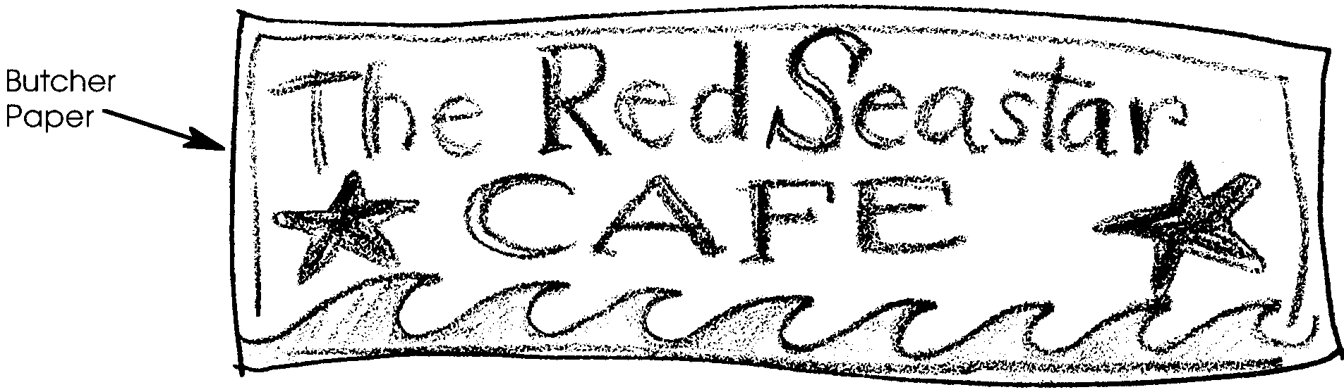

Food Committee This committee creates the simulated food offered on the menu, using a variety of materials: paper shapes (cut and stuffed), clay, crepe paper, any other materials available. Some of the students’ creations have included:

• Clam chowder from strips of white crepe paper

• Fish sticks from yellow rods

• Cardboard cut into fish shapes

• Green paper salads

Kitchen Committee The kitchen committee needs shelves or lots of table space for storing the food items. This group stores the finished food to complete orders.

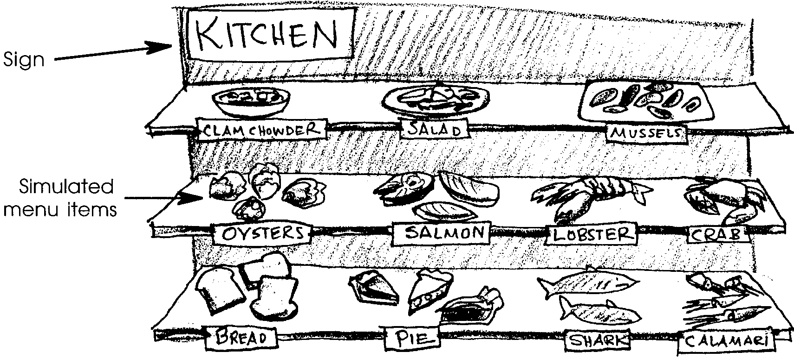
Cashier Station Committee This group sets up at least one cashier’s station; two or three are preferable. With only one area, there will be a backlog in calculating bills. Additionally, cashier is a popular role. More than one station spreads the wealth.

The cashier’s station should have an adding machine, preferably with tape, and divided boxes (like a cash register drawer) with play money.

This committee will also prepare the wallets for the customers; about 20 total. Customers entering the restaurant will be handled a “wallet,” a business size envelope containing play money, a $10 bill, two $5 bills, five $1 bills and some coins (quarter, dimes, nickel and pennies).

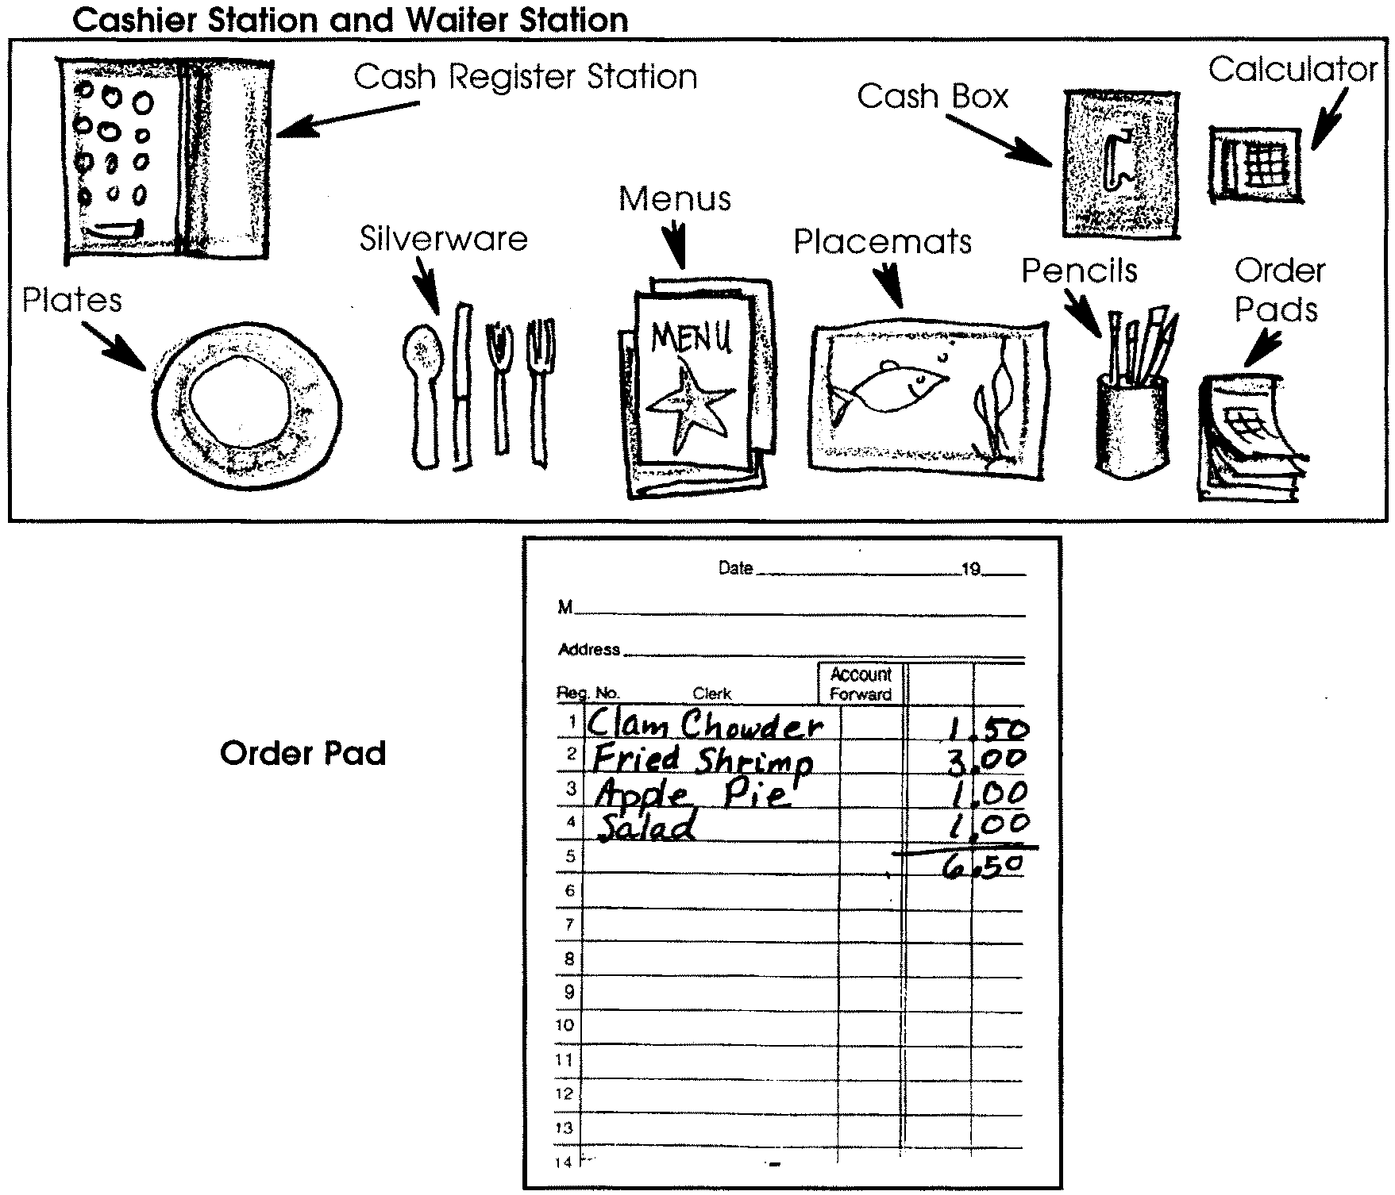
Waitperson Station Committee This committee organizes the waitpersons’ supply station. Included in this supply station are: menus, placemats, silverware, napkins, order pads and pencils. Members of this committee can also create some accessories for the waitpersons: name tags, hats, ties, etc.

Interior Decorating Committee Interior decorations can include art projects already done as part of the marine science unit as well as other creations. This committee can also be in charge of creating placemats.

Preparation

1. Developing Money Handling Skills

Students need to have solid money skills before they undertake several of the roles in this simulation. The following activities may help develop students’ money handling skills:

• Recycling - Begin a class recycling project. When enough cans or bottles are brought to class, divide them into 4 - 5 sacks of about equal refund value. Each sack should be roughly the same size. Ask the individual groups to estimate the refund value of the bottles/cans in their sack. Record each group’s estimate. Have someone from the group state the estimate out loud so students can learn to say money amounts correctly.

Write the estimates in column form, saying each amount out loud as it is written. Now add the estimates, reinforcing place value concepts and addition. After adding the estimates, have the children actually add up the money value of the cans/bottles in their sack. Once again, record and add the actual values on the board in columns. Which group(s) came closest to their estimate?

• Food shopping Provide an advertisement from a local grocery store to each group of 4-5 students. Have each group select several items (4-5) to “purchase” as a meal. Each group reports, to the class, the selected items and their price. Record this information for all students to see how the prices are listed in a column for addition. Have the class total each group’s shopping “bill.”

2. Room Set-Up

Separate areas of the classroom need to be designated as the:

• Kitchen - several shelves or long counters

• Cashier station/s - areas for cash boxes and calculators

• Tables - round tables or desks pushed together for customers

• Waitperson station - holds menus, order pads, utensils, etc.

• Entrance - area where the customers’ wallets can be picked up.

3. Practicing Roles

Some advice: MODEL, MODEL, LEAD, LET GO !

Each student will probably want to take on each role: waitperson, customer, cashier, and cook. Modelling is key to demonstrating expected behaviors and skill development. For example, children will need to know how to greet customers, take orders and write them down in columns so that the prices can be added, and how to make change. Skills to practice include:

• Making Change Model this skill for the whole class, with a student acting as the customer. For example, if the customer’s bill is $2.75, and the customer gives you a $5 bill in payment, demonstrate putting the $5 bill aside so the customer can see it. Say to the customer: “Your bill is two dollars, seventy five cents. Your change is $2.80 [handing the customer a nickel], $2.90 [handing the customer a dime], $3.00 [another dime], $4.00 [a one dollar bill], and $5.00 [a second dollar bill]. Thank you very much.”

Have the children partner to practice making change. Also, prepare a “Making Change Kit” to be sent home for practice. Include in this kit: copies of coins , $1, $5, $10 bills, and a letter explaining the purpose of the kit. A sample letter is attached.

• Writing Orders When the menus are completed, distribute a menu to each pair of children. Have them practice ordering and taking orders from the menu. Distribute copies of the ordering pad for practice. Save the real order pads for when the restaurant opens. Demonstrate how to abbreviate orders. Emphasize the need for the waitperson to write the prices down in straight columns to make addition of the sum easier.

For a successful restaurant, this exercise needs to be repeated for several days before the grand opening.

• Waitperson Skills Help students think about the fact that this is their restaurant. They are the owners. If customers don’t come back, the restaurant will not make money and will go out of business. How do they want their waitpersons to act so that customers will return?

Model appropriate behaviors; greet the customer at the door and show them to a seat. Make sure the customer has picked up a wallet at the door. Hand the customer a menu and say, “Welcome to the Sea Star Cafe. Here is a menu. I’ll be back soon to take your order.” The waitperson goes to their station to get the necessary supplies to set the table. The waitperson retrieves an order pad and pencil, returning to the table to ask, “May I take your order?” The waitperson may stand to the side and watch as the customer points to items on the menu. This helps with spelling.

When the ordering is done, the waitperson should say, “Thank you, I’ll be back with your order shortly.” The order is taken to the kitchen.

While the customer is eating, the waitperson should be adding up the bill so that when the customer has finished, the waitperson can deliver it saying, “Please pay the bill at the cashier’s station.”

The waitperson should then clear the table and return all items to their appropriate places.

• Customer Skills The children can learn social skills in the restaurant setting. You may model conversational skills and suggest possible topics for discussion. Discuss and model eye contact, listening skills, and asking questions of others. Table manners can be reviewed. You can discuss tipping. A percentage lesson can be used with older students.

• Cashier Skills The cashier takes the bill from the customer and uses an adding machine to check the total. They should say to the customer, “Your total is $______, please.” The methods taught for making change should be used. The cashier closes the transaction with, “Thank you, please come again.”

At clean up time, the cashier should collect all the wallets and make sure each has the right amount of money in it. All other money, including tips, should be returned to the cash register box.

• Chef Skills Because the orders come in all at once, there should be at least 3-4 cooks. The chef gets the order from the waitperson, reads the order, finds the food, puts it on a plate, and gets it back to the waitperson. The cooks will have to work carefully around each other, and the waitpersons will have to be patient while waiting for their orders!

Grand Opening

Finally, the big day has arrived! Make certain to record who plays what roles. A check off chart might be helpful. This means that the restaurant will be open more than once! The grand opening session requires about an hour. To begin with, have students play all roles, including customers. After each session, discuss with the class what went well. Ask what could be changed or made better for next time. Good ideas come out of these debriefing sessions.

When things start running pretty smoothly, invite outside guests as customers, including: school secretaries, principals, aides, parents and other classes.

[Sample parent letter]

Dear Parents:

You’ve probably been hearing about our plans to create a seafood restaurant! In order to be ready to open and successfully run our restaurant, we all need to know how to make correct change.

Please help your child by playing customer and cashier. You may use real money or the pretend money included in this kit.

Some hints:

• The cashier should restate the total bill before counting out change. For example: “Your bill is $6.47.” If payment is made by a $10 bill, say, as you return the change, “$6.48” (returning a penny), “$6.49” (another penny), “$6.50” (another penny), “$6.75” (handing a quarter), “$7.00” (another quarter), and then while handing back three dollar bills, “$8, $9, $10. Thank you.” Say the money amounts out loud, such as “six dollars forty nine cents.”

• Try different combinations. This is difficult for children and improves with practice.

Thanks. We hope to serve you real soon at our seafood restaurant!

