Shellfish at Risk

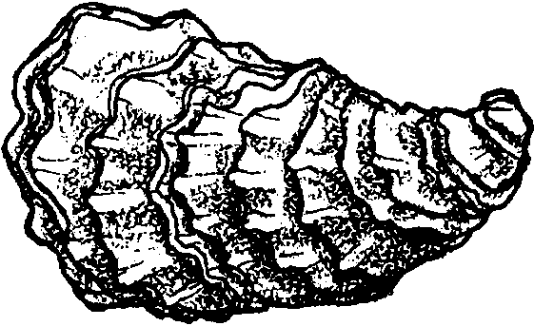
Key Concepts
1. Major sources of contamination affecting shellfish resources include: human and animal wastes, sediments, and toxic chemicals in the water column.
2. Just as people are the source of the major contamination problems, we can all contribute to the solutions for improved water quality and health of our estuaries.

Background

Water Quality
Water quality refers to the health of the water column, which includes water between the floor of the bay and the water surface. Poor water quality may affect shellfish directly or human health indirectly when contaminated shellfish are eaten. There are three types of potential threats to public health from consuming contaminated shellfish: pathogens (disease-causing organisms such as bacteria and viruses), paralytic shellfish poisoning (PSP), and chemical contamination. PSP is discussed at length in the preceding lesson, “Red Tides.”

Pathogens
Pathogens may enter the water in human and animal feces. The disease causing organisms can be absorbed by shellfish. In urban areas human wastes pass through sewage treatment plants before being released. Sewage treatment plants treat waste water to kill pathogens, but during heavy rainstorms, the waste water coming into the plants can back up and overflow directly into saltwater bays without treatment. In rural areas, septic systems treat human waste. Improperly maintained septic systems can be a source of non-point pollution. For example in Puget Sound, failing septic systems are suspected of being the major source of contamination of commercial shellfish beds. Human waste is also a problem in bays and estuaries with heavy boat traffic and marinas. Animal wastes can enter the water from runoff from feedlots and other agricultural land.
Bacterial contamination is usually monitored by conducting tests for the presence of fecal coliform. Although fecal coliform bacteria do not normally cause disease, their presence indicates contamination with fecal matter which can carry a variety of disease-causing organisms. Pathogen contamination in shellfish can vary seasonally, mainly as a result of rainfall and runoff patterns.
Chemical Contamination
There are more than 65,000 commercially available chemicals in the U.S. These chemicals are ingredients in many products we use every day and are also used in many industrial processes. Each year industries legally dump more than 500 million pounds of toxic chemicals directly into our waters. This type of pollution is called point source pollution.
Large amounts of chemicals also get into the water through non-point sources such as stormwater runoff. Stormwater runoff generally refers to runoff from urban and suburban areas: industrial, commercial and residential lands, highways, and related construction activities. In these areas, ground covered by pavement and concrete prevents stormwater from running its natural course and filtering into the ground. Water flows over the impervious surfaces, collects and carries an assortment of contaminants to the water. Some stormwater flows are treated; many are not. Runoff carries tons of oil, pesticides, heavy metals, and other chemicals into the water.

Other Contaminants
Sediments and other particles in the water are harmful in themselves. They can cloud the water, limiting light to plants. They can also smother animals, their larvae, or damage their gills. Sediments, and other particles, also serve as a pathway for the movement of other contaminants. Small particles are particularly effective in taking up other contaminants from the water and concentrating them on the surface of the particle. DDT, for instance, binds to tiny particles of wood waste and other organic carbon sources.

So What is the Problem?
Shellfish are filter-feeders, and pump great quantities of water through their gills. Heavy metals and other chemicals can accumulate in the tissues of animals and be passed through the food chain, eventually reaching toxic levels. This process is called bioaccumulation. The near extinction of Brown Pelicans and Peregrine Falcons are examples of the dangers of bioaccumulation of pesticides in the food chain.
All of these problems have solutions (difficult though they may be). It is not the point of this lesson to have students memorize sources and solutions, but merely to expose them to the idea that humans are an interconnected part of the world’s ecosystems, including its estuaries. As a generator of the sources of contamination, we must be part of the solutions. Positive or negative, each and every little action accumulates to make a big difference.

Materials

For each student:

• “Shellfish At Risk” student pages

For each group of 4-5 students:

• copies of the student worksheets containing the SOURCE pictures, PROBLEM and SOLUTION cards for the matching game

Teaching Hints

Part One
Read, “Shellfish At Risk” with students for background information.

Part Two
This activity can be presented as a mystery to heighten motivation. Who Really Killed Cock Robin?, by Jean Craighead George is an excellent book about watersheds, runoff, and the effects of chemical pollutants. Reading this book with students in the weeks prior to this discussion provides students with an excellent background for this activity.

The Contaminants Matching Game

1. Distribute copies of the worksheets containing the SOURCE pictures, PROBLEM and SOLUTION cards to groups of 4-5 students.

2. Direct students to cut apart the problem and solution cards.

3. Explain that they are to examine the pictures of contaminant SOURCES in each box, then match the corresponding problem and solution card by placing it in the appropriate box.

4. When all groups have finished matching their cards, discuss each SOURCE and its corresponding problem and solution. Encourage students’ own ideas, especially for solutions.

5. You can have students glue their cards in the appropriate boxes on the activity sheet.

Key Words

bioaccumulation - concentration or accumulation of contaminants through the food chain in the tissues of animals

contaminant - a substance that is not naturally present in the environment or one present in amounts that adversely affect the environment

heavy metals - metals such as arsenic, mercury, copper, lead, zinc, chromium and cadmium

non-point source pollution - pollution that enters water from dispersed and uncontrolled sources, such as septic tank failures and storm drains

pathogens - an agent of disease; such as bacteria or viruses

point source pollution - a source of pollution from a single point of conveyance, such as a pipe

Extensions

1. Get resources from your state’s Department of Fisheries or Dept. of Health that indicate beaches or commercial shellfish beds closed to harvest. Laminate a local map. Have students mark these areas of closure.

2. Visit a sewage treatment plant or learn how a septic system is built and works. Become familiar with how wastewater is handled in your community. Joanna Cole’s The Magic School Bus Goes to the Water Works is a helpful resource.

3. Construct a model of a sewage treatment plant or a septic system. Display these models with your students as “Interpreters” at a Back-to-School night or other school-wide function. You will be surprised how many people do not truly understand how we deal with wastewater.

Answer Key

Part One
1. Water quality is very important to clams, oysters and other shellfish because they constantly filter water and are susceptible to death and disease from exposure to toxins in the water.

2. Accept all answers. Students might suggest the people ate them all or that pollution has affected the decline of shellfish for harvest.

3. Answers will vary. Just as people should know were their drinking water comes from, we should all know what happens to the wastewater we produce. People tend to care about that which they understand.
4. The biggest source of shellfish contamination is human and animal wastes.

5. We could build more sewage treatment plants, repair septic systems and fence animals away from streams.

6. Students may suggest not removing all the plants in the first place; replant as soon as possible, and leaving buffers of vegetation.

7. The difference in harvest of oyster meat from 1929 to 1990 is 58 million pounds.

Part Two

Following are the contaminant matching game problem and solution cards matched to the pictures of sources:
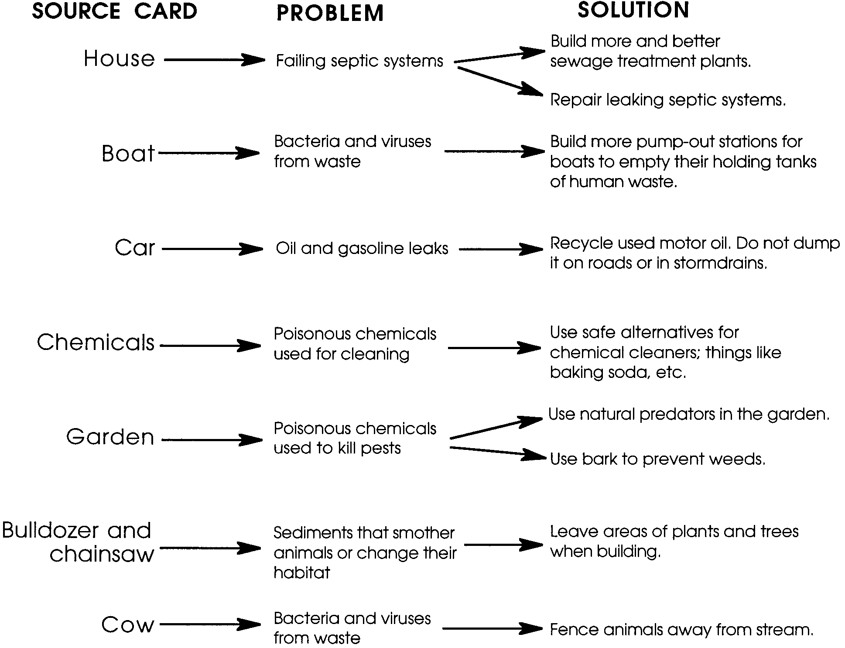

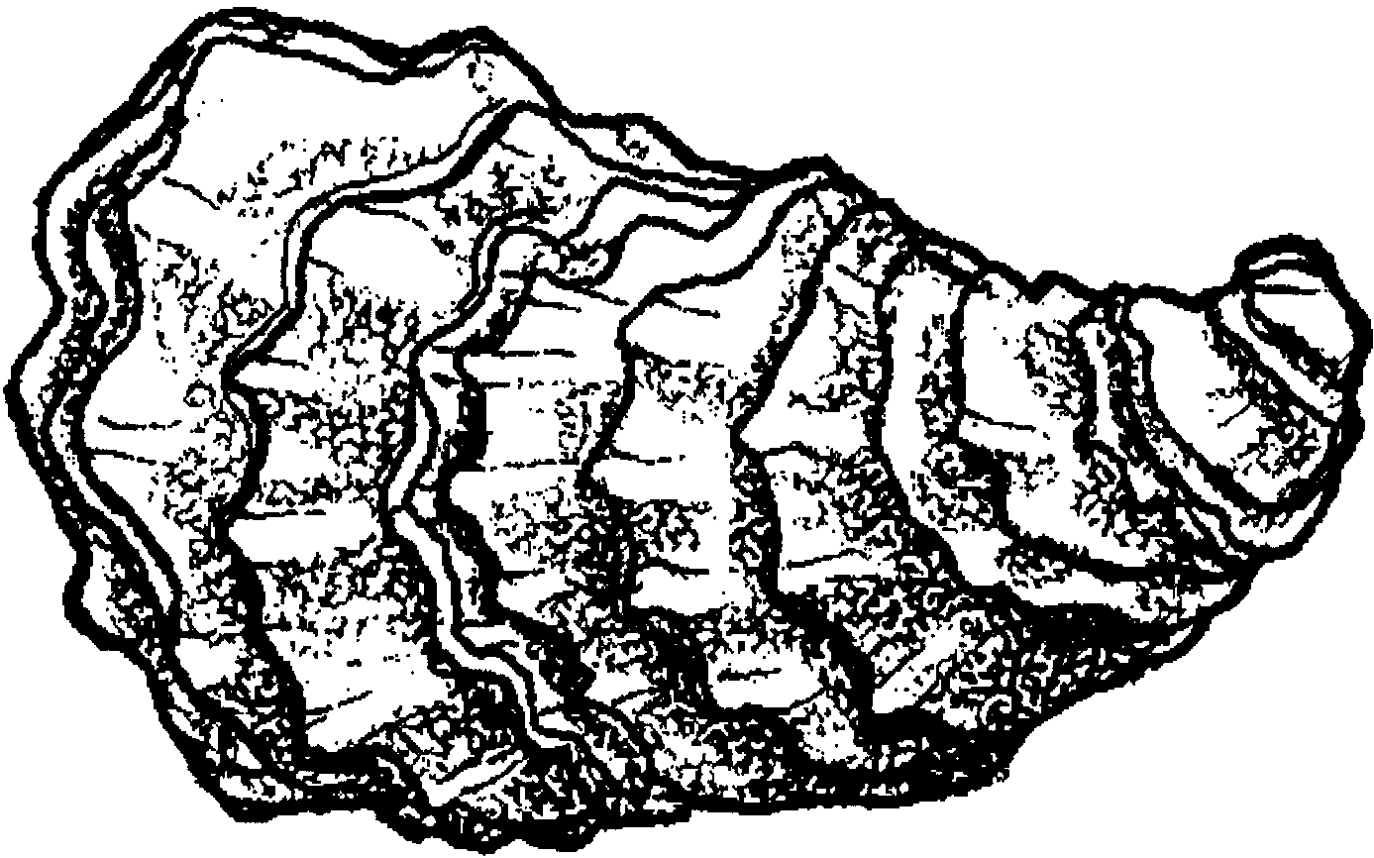
Shellfish at Risk

Clams, oysters and other shellfish filter seawater. For them, water quality is very important. Good water quality means the water is free of pollution. Poor water quality means the water is polluted. Poor water quality can make shellfish unsafe to eat. Grown clams and oysters can’t move when the water becomes polluted.

Shellfish and the water in which they grow are tested. What if they fail the tests? If they fail, people may not eat the shellfish.

1. Why is water quality so important for shellfish?

Many years ago only Native Americans lived along our coasts. Then people from other countries moved to the coasts. They brought their families and friends. They built small villages. More and more people moved to the coasts. Towns and cities were built. Today, almost 3 out of every 4 people in the U.S. live within one hour’s drive to a coast. All of us have an impact on our coasts and estuaries.

Places that used to have lots of shellfish, today have little or none. Signs on many beaches warn people that the shellfish are not safe to eat.

2. Why do you think there are fewer shellfish to gather?

Something is happening. Many people are worried. Scientists are investigating how pollution gets into the water. The pollution makes the shellfish unsafe to eat. People do things that affect the water quality. The way we work, live, and play can add pollution to our waters.

Human and animal waste pollutes many shellfish growing areas. These wastes make shellfish unsafe to eat. This is the biggest problem shellfish growers face. What happens to our body wastes? Sometimes wastes go to a sewage plant. The plant treats the water and releases it into bays. This is usually true for people in cities and towns. People who live in the country often do not have sewage plants. They usually have a septic system to handle body wastes.

3. What happens to wastewater from your school? Your home?

Sometimes sewage plants and septic tanks fail. When this happens, many bacteria and viruses get into the water. These can make people sick. Human sewage is a big problem.

Animal waste can also be a problem. Animals may leave their body wastes near streams. These wastes find their way into the water, too.

4. What is the biggest cause of shellfish pollution?

There is some good news. People can do things to protect and improve water quality.

5. What are some things you can think of to protect and improve water quality?

We can build fences to keep animals out of streams. Less animal wastes end up in the water. We can build better sewage plants. We can also fix broken septic tanks.

Chemicals and oils cause problems, too. People drive cars and boats that use oil, gasoline, and antifreeze. These chemicals can leak out. The leaking oil from a car goes onto the road. Rain can wash it down a storm drain. The storm drain carries it out into the water! This is a real problem. Sometimes people change the oil in their cars. They dump the oil onto the ground or in the storm drains. This should never be done. The oil quickly finds its way into the water.

Chemicals are part of our daily lives. Check the cleaning supplies at school or home. Check where cars are kept. Check where people work. All of this can end up in our water. What we can we do? Use fewer chemicals. Find out about safe chemicals which do the same things. Use them to protect our waters.

Sometimes we cut all the plants and trees down when we build houses. Bulldozers scrape off all the plants. Only dirt is left. Rain can wash large amounts of dirt into streams. Streams carry the dirt, called sediment, into bays and estuaries. Sediment smothers some marine plants and animals. Their habitats are changed.
6. What can you think of to keep sediment from reaching the water?

Here’s something to think about. In 1929 people in the U.S. harvested 90 million pounds of oyster meat. In 1990 only 32 million pounds of oyster meat were harvested.

7. What is the difference in harvest of oyster meat from 1929 to 1990?


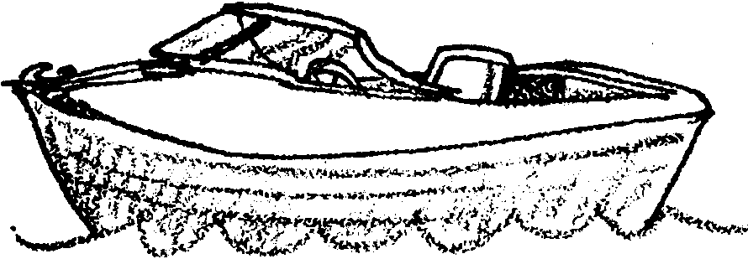
SOLUTION
PROBLEM
PROBLEM
SOLUTION
SOURCE
SOURCE

SOLUTION
PROBLEM
PROBLEM
SOLUTION
SOURCE
SOURCE
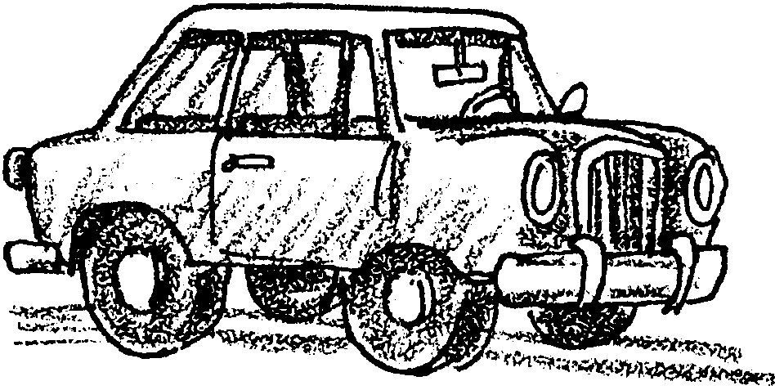
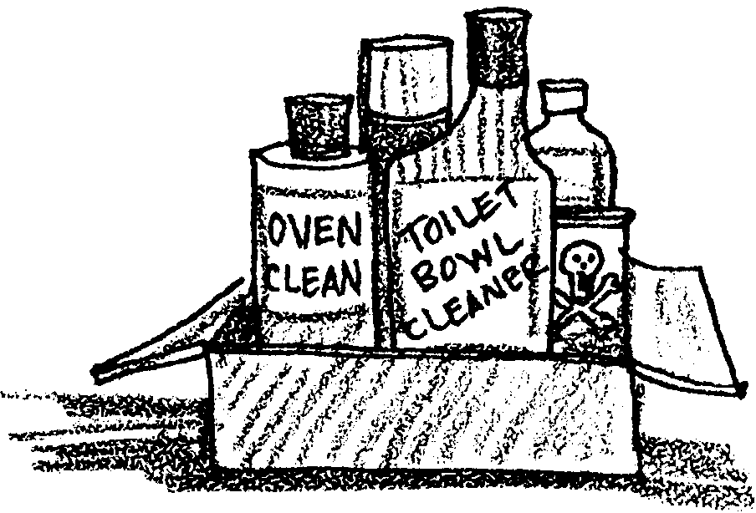

SOLUTION
PROBLEM
PROBLEM
SOLUTION
SOURCE
SOURCE
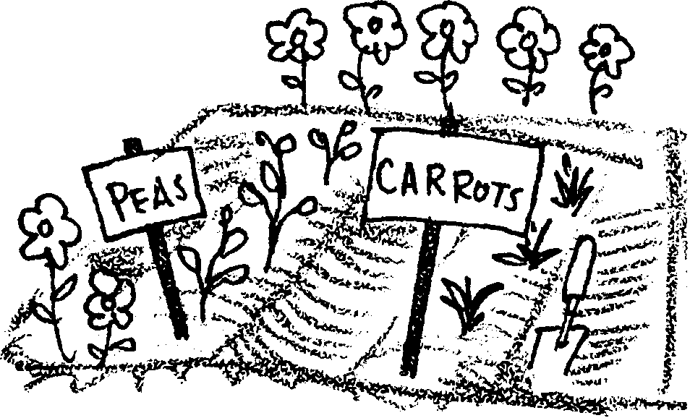
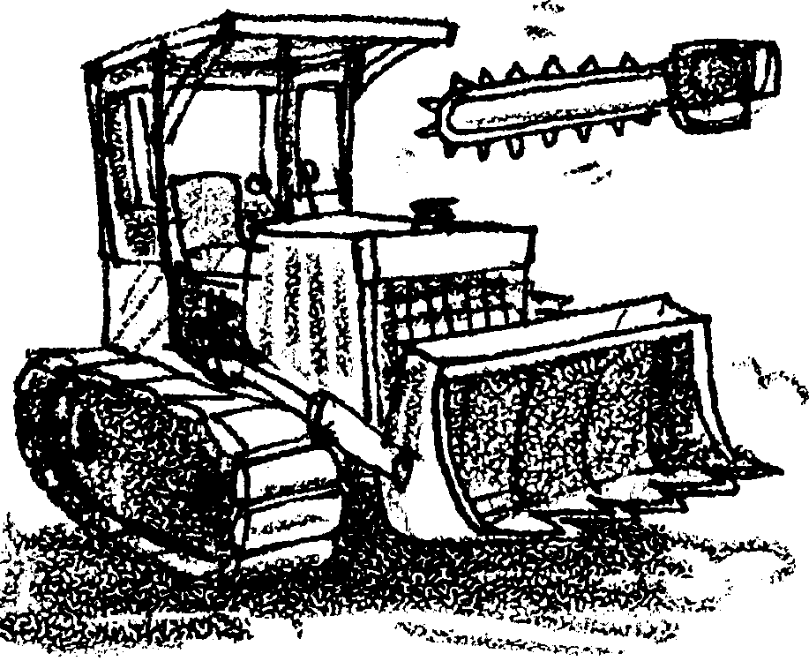

PROBLEM
SOLUTION
SOURCE
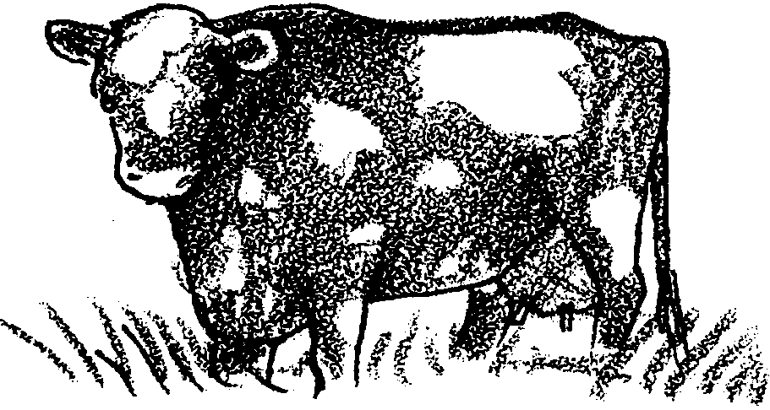
PROBLEM

BACTERIA AND VIRUSES
FROM WASTE
PROBLEM

BACTERIA AND VIRUSES
FROM WASTE
PROBLEM

FAILING SEPTIC SYSTEMS
PROBLEM

OIL AND GASOLINE
LEAKS

PROBLEM

POISONOUS CHEMICALS
USED FOR CLEANING
PROBLEM

POISONOUS CHEMICALS
USED TO KILL PESTS
PROBLEM

SEDIMENTS THAT
SMOTHER ANIMALS OR
CHANGE THEIR HABITAT
SOLUTION

BUILD MORE AND BETTER
SEWAGE TREATMENT
PLANTS
SOLUTION

REPAIR LEAKING
SEPTIC SYSTEMS
SOLUTION

RECYCLE USED MOTOR
OIL. DO NOT DUMP IT
ON ROADS OR IN
STORM DRAINS

SOLUTION

BUILD MORE PUMP-OUT
STATIONS FOR BOATS
TO EMPTY THEIR
HOLDING TANKS OF
HUMAN WASTE

SOLUTION

USE SAFE ALTERNATIVES
FOR CHEMICAL CLEANERS;
THINGS LIKE BAKING
SODA, ETC.

SOLUTION

USE NATURAL PREDATORS
IN THE GARDEN
SOLUTION

USE BARK TO
PREVENT WEEDS
SOLUTION

LEAVE AREAS OF PLANTS
AND TREES WHEN
BUILDING
SOLUTION

FENCE ANIMALS AWAY FROM STREAMS

