Red Tides
Lesson written by Katrina Ringrose, Seabeck, WA

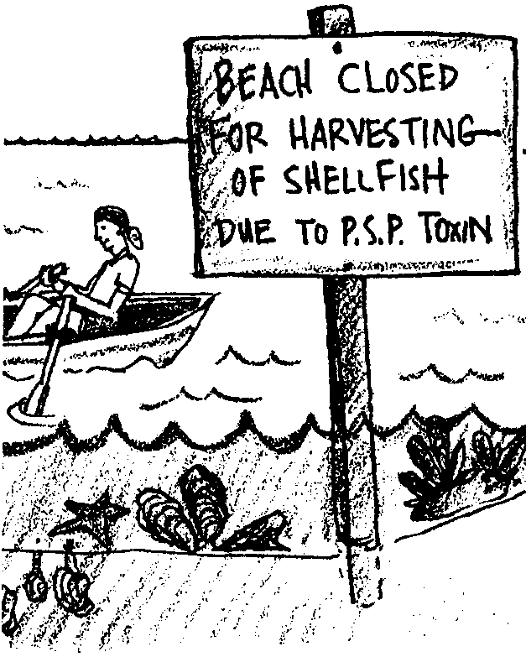
Key Concepts
1. Red tide is a bloom of plankton; a natural occurrence which gives the water a reddish tint.
2. Some of the red tide blooms are toxic and some are not. Blooms of toxic plankton may not turn the water red, yet they can be present in abundance.
3. Several types of shellfish can become toxic when a bloom of toxic plankton are filtered by the shellfish and the toxin accumulates in their tissues. While the shellfish are not harmed, the shellfish can be highly toxic to humans.
4. The toxic effect is called Paralytic Shellfish Poisoning or PSP.
5. People who gather shellfish to eat, as well as commercial harvesters, must know if the red tide is toxic.

Background

Red tides are unusually high concentrations, or blooms, of certain dinoflagellate plankton. Dinoflagellates are microscopic, one-celled organisms that swim like animals (with a whip-like tail) and usually photosynthesize like plants. They can reproduce asexually by division, and sexually in a process that is not fully understood. Dinoflagetllate cysts can be in a resting stage (inactive) until environmental changes in temperature or salinity initiate a bloom, or the cysts stay in a dormant stage which can rest on the bottom or flow about on currents and be transplanted by shellfish farmers inadvertently.

Red tides are created by the concentration of some species of dinoflagellates in numbers so large that the water appears a red or brown color; sometimes as red as tomato soup! The presence ofthe dinoflagellates that turn the water red, often, BUT NOT ALWAYS, indicates that toxic dinoflagellates are also in bloom. The confusion lies in the fact that some species of dinoflagellates that ARE toxic DO NOT turn the water red. The water can appear perfectly normal (no red color), yet the toxic dinoflagellates may still be present. In other words, color of the water is not a reliable indicator of toxic plankton blooms.
The toxins concentrate in shellfish that are filter feeders: mussels, clams, oysters, and scallops. Crab, abalone, and fin fish are not affected by the toxin. People can get Paralytic Shellfish Poisoning (or PSP) from eating shellfish tainted with the toxic dinoflagellates. Cooking does not remove the toxin, nor does the addition of garlic (an “old spouse’s tale”). The symptoms of PSP include tingling and numbness of the lips, fingers, and toes; difficulty in breathing; and loss of control in the arms and legs. Death can occur when the respiratory system becomes paralyzed. There is no known antidote.

In addition to the direct contamination of shellfish, extremely dense blooms of dinoflagellates can cause oxygen depletion when the bacteria that decay the dead dinoflagellates consume large quantities of oxygen from the water. This decrease in oxygen can kill fish and other marine organisms.

Red tides have occurred world-wide. Historical evidence dates back to 1799 in a documented case where Eskimos died within two hours of eating tainted mussels. Coast Indians were well aware of red tides. Darwin wrote in his journal about red tides, as did Joseph Banks who was on Captain Cook’s ship Endeavor. It is suggested the Red Sea got its name from the plankton blooms. Red tides are nothing new.

People have tried to control red tides with copper sulfate (an algicide), and predators. Results have created worse problems. Red tides are normal occurrences, and management of shellfish now includes: regulating harvesting areas, establishing shellfish “seasons,” and frequent testing of shellfish. Although red tides are a natural phenomenon, the frequency of their occurence seems to be increasing. Some scientists think that the “fertilizing” of coastal waters from nutrients added by sewer outfalls and in runoff from the land may be enhancing the problem. In the state of Washington a Red Tide Hotline informs the public of open and closed areas.

Materials

For each student:

• “Red Tides: What They Are and What They Aren’t” student worksheets
• a local shellfish regulations guide (usually available from stores that sell fishing licenses or an agency like the Department of Fisheries) or use the page included from the 1993-94 Dept. of Fisheries Regulations Guide from the State of Washington.
Teaching Hints

1. Begin with the student worksheet. Have students read the material as a whole group or as a jigsaw reading (assigning different sections to teams of students who will report on their section).

2. Introduce local shellfish guides or the page from the 1993-94 Washington guide included at the end of this section. Note that this may be difficult reading material for many third graders. It may be useful to make a transparency from the guide covering any material about PSP or other shellfish toxins.

Approaching the information like a scavenger hunt can be fun. This could be done as a whole class or in teams. Example: What is the Red Tide Hotline phone number?

Key Words

PSP (Paralytic Shellfish Poisoning) - disease people get when they eat shellfish affected by particular types of toxic dinoflagellates

toxic - poisonous, harmful

toxin - a poisonous substance

Extensions

1. Have students call the Red Tide Hotline and locate any beach closures on a map. Interested students may want to call and record information every month or every two weeks during the spring and summer.

2. Visit a local shellfish laboratory. They are very interesting and informative places.

3. Write a myth to explain why the sea would appear red.

4. Write a limerick or other poem to warn people of the danger of harvesting shellfish without knowing the status of the shellfish.

5. Create posters informing shellfish gathers how to educate themselves about the health of the shellfish in an area. Is there a Red Tide Hotline they can call?

6. Write a letter to the Department of Fisheries or a shellfish lab to request specific publications or information to answer questions raised by students.

Answer Key

1. People made up stories to explain what they didn’t understand.

2. When plankton grow and reproduce very quickly, it is called a bloom.

3. No. People should not assume that the shellfish are safe to eat even if the water is not red, especially during the season when most toxic plankton bloom, usually late spring and summer. Often toxic plankton blooms are associated with booms that turn the water red, BUT NOT ALWAYS.

4. The shellfish filter toxic plankton from the water. They ingest large quantities during a bloom. The toxin concentrates in the tissues of the shellfish.

5. The toxin can stay inside the shellfish for weeks to months at concentrations that are unsafe for human consumption.

6. The answers may vary depending on where you live. Use publications to know where and when it is legal and SAFE to harvest shellfish. Call the Red Tide Hotline for information. Be informed!

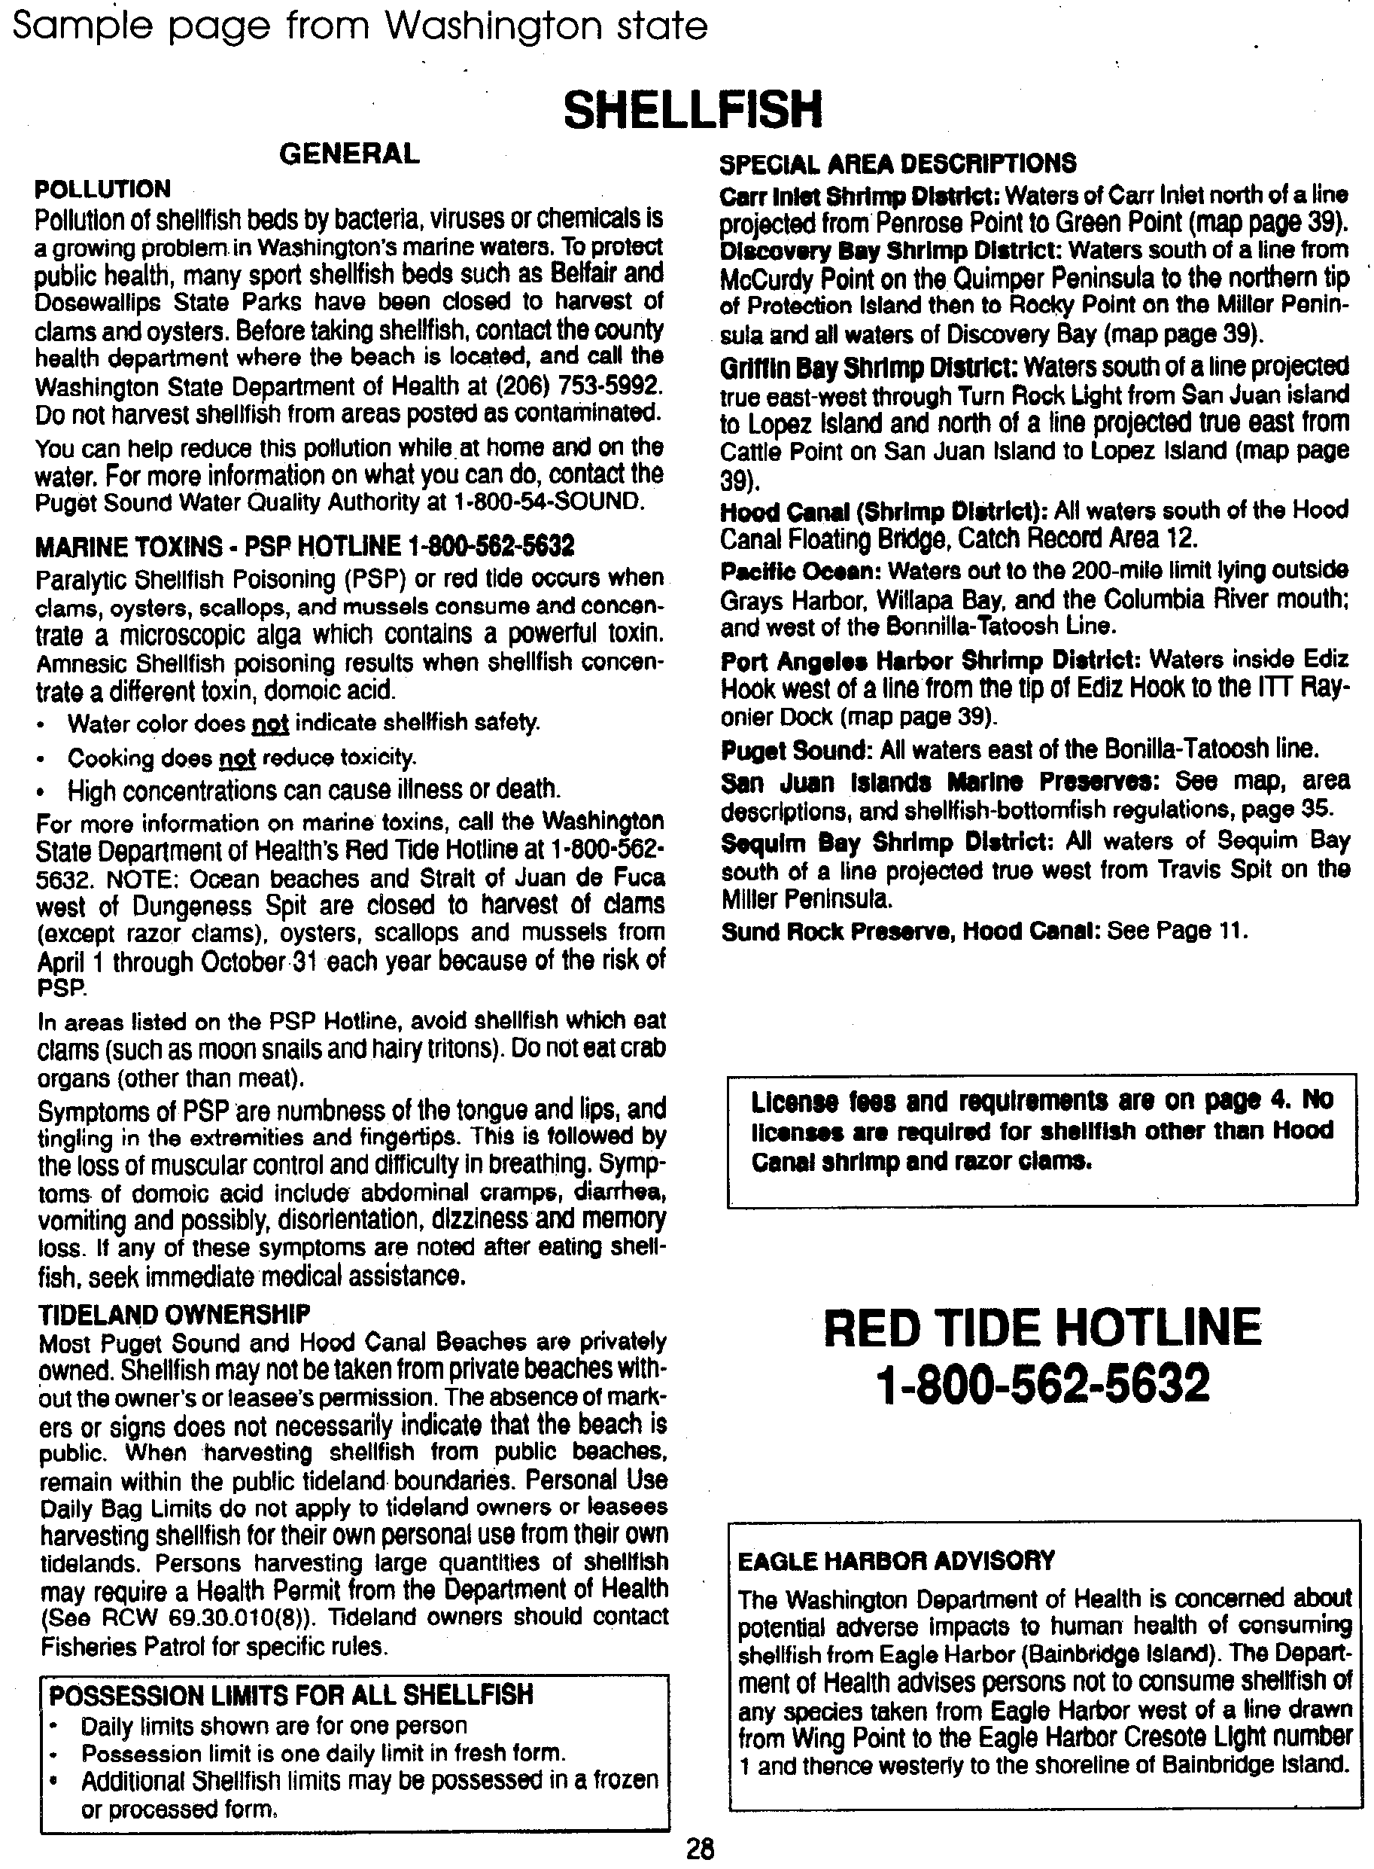

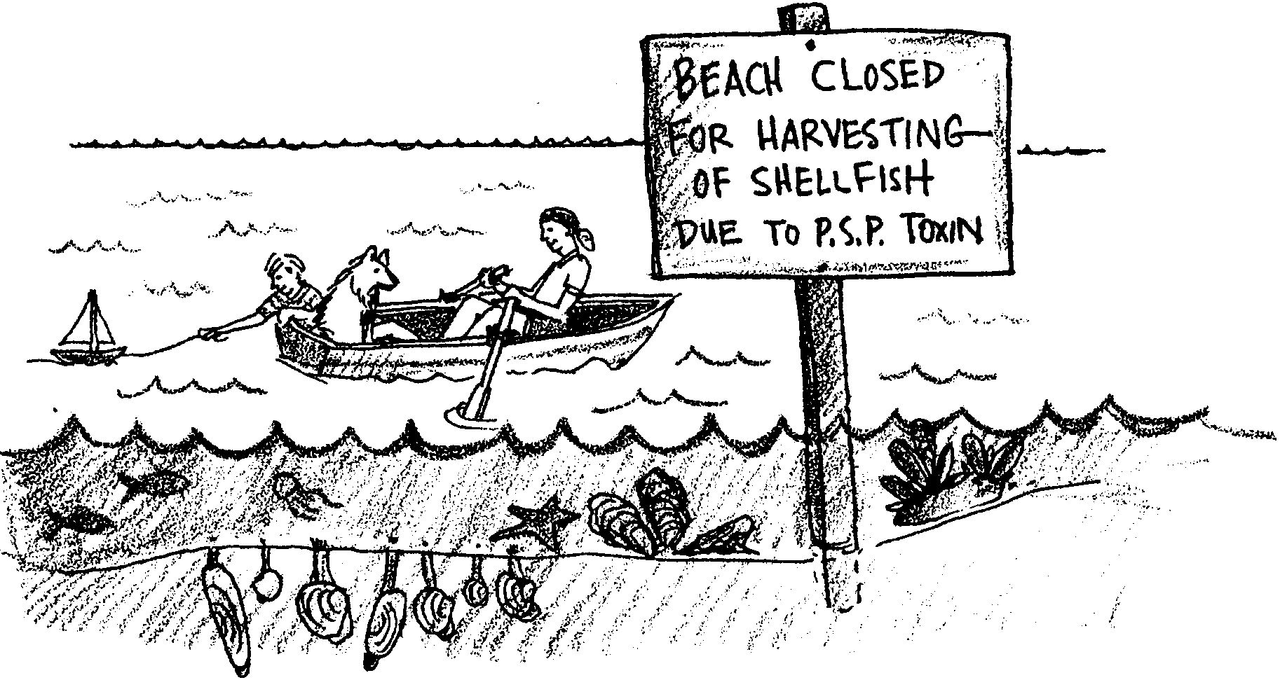
Red Tides

Many years ago, the seas turned red. People asked why. They told stories to explain what they saw. For example, Lake Morat in Switzerland turned red. People said that the red was the blood of soldiers drowned long ago.

Pacific Northwest Coastal Indians asked why their waters turned red. At the same time they saw “night lights” in the water. They did not eat shellfish when they saw these things.

1. In the past, how did people explain why the water turned red?

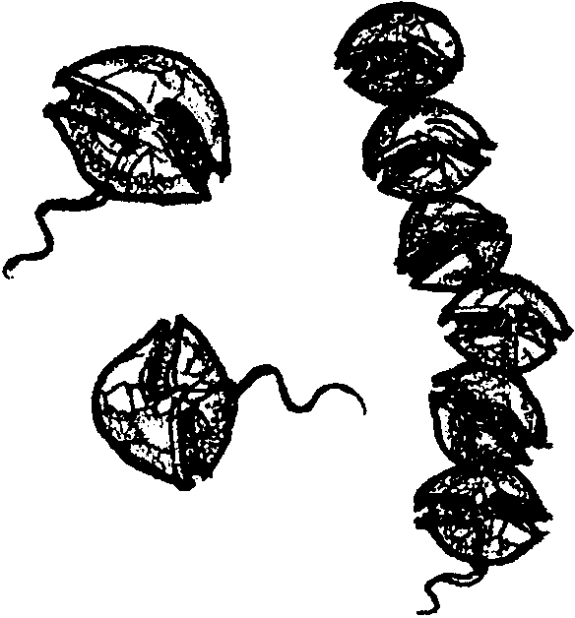
Today, we know that the red color comes from tiny plants. You can not see them by using just your eyes. These plants, called plankton, “bloom,” or reproduce quickly. Huge numbers can occur in a short time. The blooms are called red tides. They are often during late spring and summer. Some of the blooms are toxic (poisonous). Shellfish filter plankton from the water. The poison stays in the shellfish. People who eat these shellfish can get sick or die. People are wise to stop eating shellfish during red tides.
Not all red tide blooms are toxic. Worse yet, not all toxic blooms turn the water red. You can not be sure that the shellfish are safe to eat even if the water is not red!

2. What is it called when plankton reproduce very quickly?

3. Is it always safe to collect shellfish if there is no red color to the water? Why or why not?

Here is how a person could get sick from eating shellfish:.
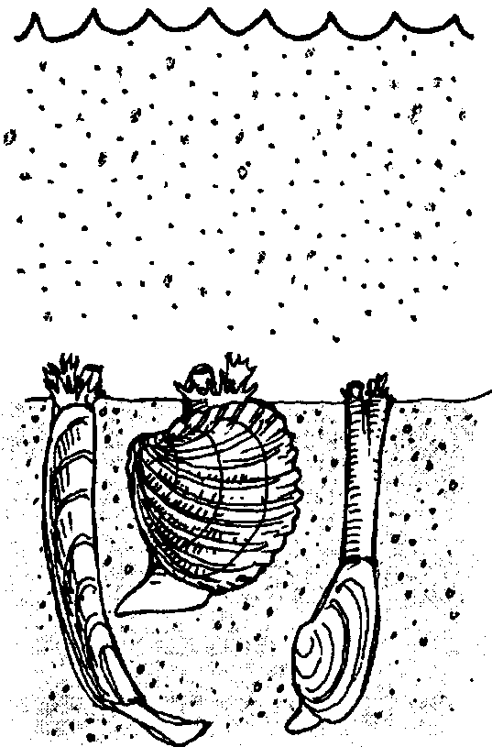
• There is a “bloom” of the toxic plankton in the water.

• The toxic plankton are eaten by shellfish. Shellfish eat a lot of plankton.

• The toxin (poison) builds up inside the shellfish meat. It can stay inside the shellfish for weeks or months. The toxin does not harm the shellfish.

• A person eats the toxic shellfish. The toxin causes the person to get sick. The sickness is called Paralytic Shellfish Poisoning (PSP).

One sign of PSP is tingling of the lips. People also have trouble breathing. They may lose control of their arms and legs. Some people die from PSP.

4. How do the shellfish become toxic?

5. How long can the poison stay inside the shellfish?

How can you be safe when collecting shellfish? The best thing to do is find out which beaches have safe shellfish. If your state has a Red Tide Hotline, call it. The Department of Health may also be helpful. The hotline and health departments list unsafe beaches. Beaches are closed where the shellfish are not safe to eat.

6. What is one way you can stay safe when collecting and eating shellfish?

