The Oyster Story

Key Concepts

1. Estuaries can provide perfect habitat for oysters which are very sensitive to water quality.
2. Oysters have structural and behavioral adaptations that help them survive in their habitat.
3. Estuaries provide a large concentration of edible resources, including oysters, utilized by aboriginal people to the present.
4. Humans use a variety of techniques for harvesting oysters from the estuary.

Background

Oysters are found in intertidal areas with very small particled bottoms (mud or sand or a mixture of the two). Chesapeake Bay, Apalachicola Bay in the panhandle of Florida, Great Bay in New Hampshire, North Inlet/Winyah Bay in South Carolina, and Puget Sound in Washington are a few of the estuaries which produce significant oyster harvests. Twenty three states have commercial oyster interests.

Background on the life cycle of an oyster can found in the preceding activity, “Oysters on the Half Shell.”

Materials

For each student:

• “The Oyster Story” student pages

Teaching Hints

“The Oyster Story” provides life history information and information about the economic importance of oysters. It is a logical follow-up to “Oysters on the Half Shell.”
Key Words

dredge - an apparatus usually in the form of an oblong iron frame with an attached bag net used especially for gathering fish and shellfish

midden - a refuse heap or pile of discarded garbage which, if old and from a special culture, can have archaeological value; often composed of assorted shells from common food sources like clams and oysters

shucker - person who opens oyster shells to remove the oyster meat

spat - a young oyster; one newly attached

Extensions

1. Challenge students to research what has happened to the oyster harvest in Chesapeake Bay.

2. Visit an oyster bed on a beach or an oyster processing plant.

3. Have a tasting party to sample assorted oysters: raw, smoked, steamed, or barbecued.

4. Invite a person who raises oysters commercially to speak.

Answer Key

1. Middens were the compost piles or trash heaps of old. Many middens are filled with shell debris. Archaeologists and others study the middlens for indications of village life. Foods eaten by the residents can be determined from the left over “hard parts” (bones, shells, etc.) of animals and plants.

2. The two factors mentioned as contributing to the decline of native oysters are over-harvesting and increased water pollution.

3. Japanese oysters were selected because of their rapid growth rate and their relative tolerance to pollution. The Japanese oysters were better adapted for the changing water conditions and increased harvesting.

4. During the only freely moving period in their lives, oyster plankton: eat plant plankton (phytoplankton); avoid being eaten or are eaten by predators; and grow.

5. This question solicits ideas from your students. Their ideas can provide fertile ground for discussion. In fact, some oyster growers do not string their oysters at all. They broadcast the shells on the beach. Others, string the oysters while young, then broadcast them on the beach. Others, leave the oysters on strings their entire life. There are some advantages to each of these strategies. Oysters on strings are easier to move, can be suspended from rafts, can provide more oysters in a smaller space, etc. However, stringing oysters requires a significant investment in time. Get your students thinking like oyster growers, assessing the benefits and drawbacks of their ideas.

6. Using the mentioned growth rate of one inch per year, oysters are from 2 years to 6 years old when harvested for sale. Three to four years is the actual age of most oysters when harvested for sale.

7. In its lifetime, an average oyster can filter 18,250 gallons of water (i.e. 25 gallons/day x 365 days/year x 2 years). This is the equivalent of two backyard swimming pools worth of water. Considering an oyster bed can have thousands of oysters filtering away, day and night, one can understand that oysters would be highly susceptible to even small concentrations of toxins which accumulate in body tissue.

8. Oyster growers in Washington and other areas do, in fact, raise their own oyster plankton and spat. Since the natural water conditions are not right, they control temperature, water quality and food availability in large tanks. This question calls for students to advance ideas about how they think oyster growers could solve the problem.

9. Factors which differ can include: bottom type, temperature, salinity, wind action, wave action, amount of sunshine, proximity to industry or housing, number of predators (oyster drills, moon snails, and seastars).

10. Three ways to harvest oysters include: boat (dredge), hand, and raft.

11. Walls or dikes keep the oysters submerged 24 hours a day. Oysters on a tidal beach are exposed to the air for some period each day. During that period, they do not eat. Oysters in empoundments can feed all day and, hence, might be expected to grow more rapidly.

12. “Swift” can shuck 6,250 gallons of oysters in one year (i.e. 25 gallons/day x 5 days/week x 50 weeks (2 weeks vacation)/year).

13. Answers will vary regarding the advice to give to the friend. A good argument can be made for returning the shells to the beach so they can become habitat for other oysters. Many other reasonable answers are possible. You may choose to use this as an opportunity to discuss waste disposal from cannery or other operations.

14. A few of your students will likely have eaten oysters in some form. A large number of jobs are involved in getting an oyster on someone’s plate including, but not limited to: oyster picker, boat operator, barge operator, shucker, canner, labeler, warehouse person, truck driver, grocer, restaurateur, cook.

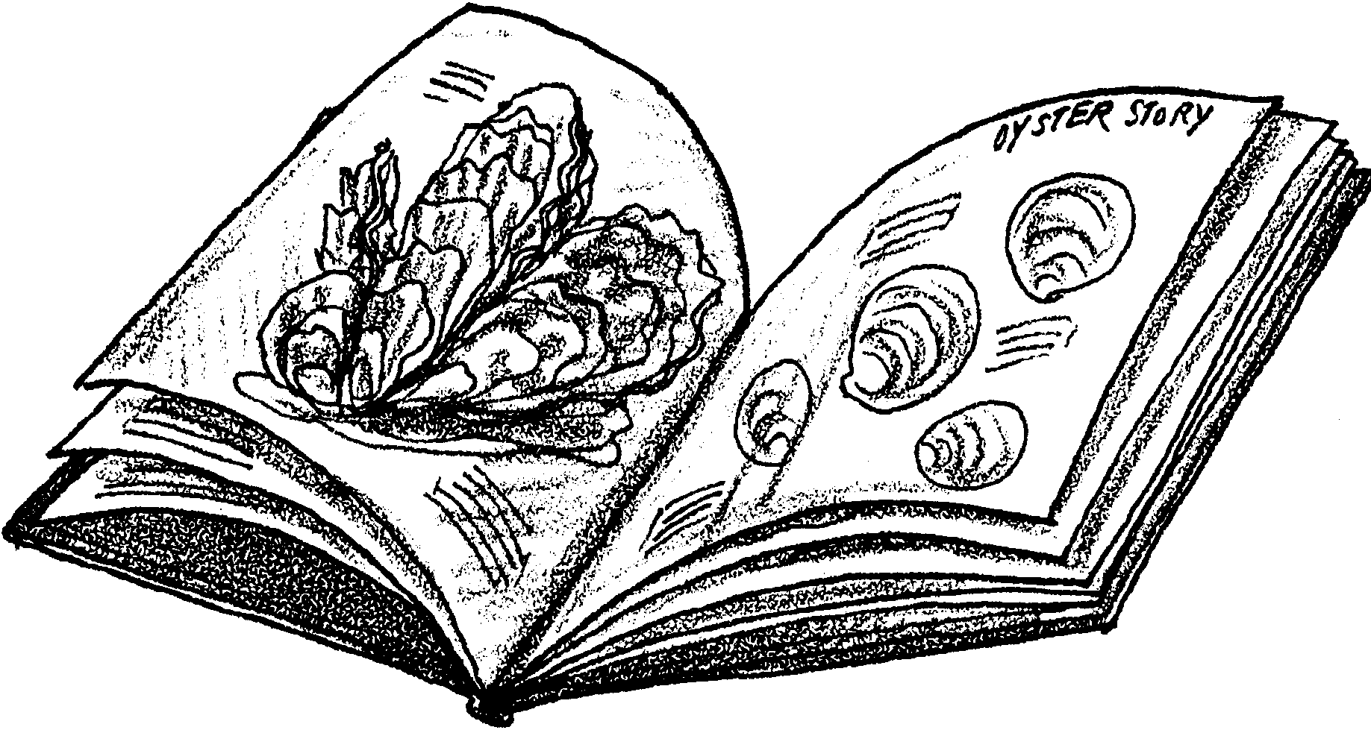
The Oyster Story

A Bit of History
For thousands of years, people have eaten oysters. Great heaps of oyster shells are found where Indian villages used to be. These shell mounds show oysters have been a popular food for a long-time.

1. How are shell mounds useful for finding out what people ate in the past?

Puget Sound is a very large estuary. It is in Washington State. It was great habitat for oysters. European explorers found beaches crowded with oysters. In the 1860’s, oysters were gathered by sail boats. Local people ate lots of oysters. Barrels of oysters were sent to San Francisco. In fact, too many oysters were gathered. People also polluted the water. Human waste, waste from paper mills, and silt from logging ran into the water. The native oyster soon was nearly gone.

2. What two things caused the decrease in native oysters?

What were oyster lovers to do? Oysters are “farmed” all over the world. In the early 1900’s a search began. People looked for an oyster that could live in the changed water. They looked for an oyster that grows quickly. They found the oyster they wanted in Japan. Pacific oysters were brought to Puget Sound about 1919. They have grown there ever since.

People have worked to reduce water pollution. Laws limit how many oysters people can take from the beach. People must leave oyster shells on the beach. The shells provide a home for tiny oysters. The Pacific oyster has done very well. Washington is the largest grower of oysters sold in the United States.

3. What made the Japanese Pacific oyster a good choice?

How Oysters Are Grown
Oysters grow well with tender loving care. Most baby oysters still come from Japan. Oysters begin their lives as tiny plankton. They are too small to be seen just with your eyes. For 2-4 weeks, oyster plankton swim about. They eat tiny plankton plants. They are also eaten by bigger animals. And, they grow.

4. What do oysters do as plankton?

After 2-4 weeks, oysters look for a place to settle. They swim over rocks or oyster shells. The tiny oyster makes a drop of glue. The glue attaches the oyster for life to its new habitat. The oysters are now called spat.

Some oyster growers drill holes in old oyster shells. They string the oyster shells into “necklaces.” The necklaces are a place for baby oysters to attach.

5. Why do you think oyster growers use necklaces instead of loose shells?

Now the oysters let their food come to them. They pump water through their body. They filter plankton from the water. Oysters can filter 25 gallons of seawater a day. They grow about one inch per year. Pacific oysters can grow to be 12 inches long. Most oysters sold are from 2-6 inches long.

6. About how old are oysters when sold?

7. Challenge: The average life span of an oyster is two years. How many gallons of water does an oyster filter in its lifetime?

Oyster spat are shipped from Japan in the spring. The spat grow on old shells. The oyster grower scatters the shells on the beach. In two to four years the oysters are ready to sell.

8. Puget Sound is usually too cold for the Pacific oysters to reproduce. How do you think oyster growers could raise their own spat?

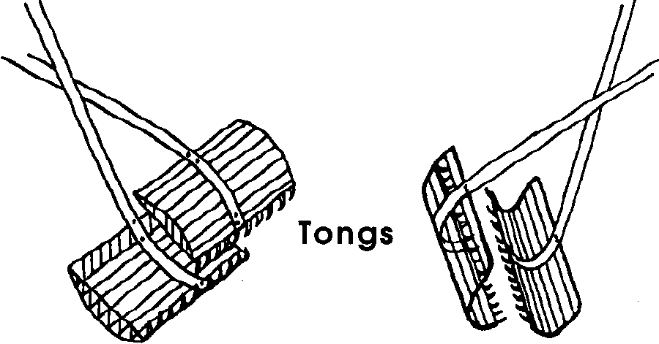
Harvesting Oysters
There are many ways to harvest oysters. People in Chesapeake Bay use tongs. Tongs open and close like scissors.

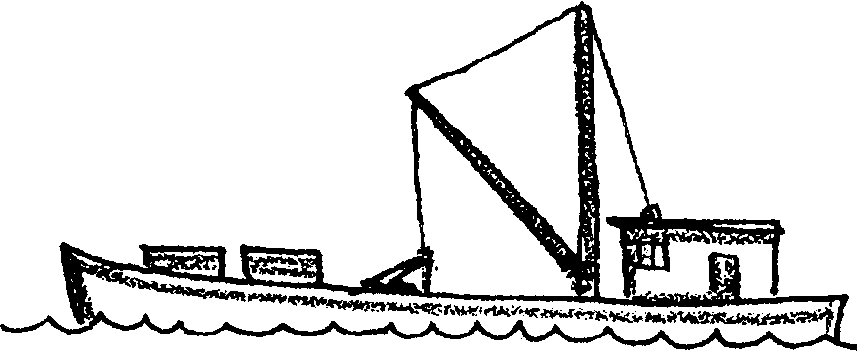

In Puget Sound most oysters are harvested by special boats. The boats are called oyster dredges.

Oysters live in areas called oyster beds. The dredge picks up oysters from these beds. It drags a heavy wire basket along the bottom.


Oysters are caught in the basket. The basket is lifted to the surface. The oysters are taken to shore. There the oysters are made ready for sale.

9. Not every part of Puget Sound is good for growing oysters. What things might differ from beach to beach?

Sometimes oysters are picked by hand. This is done at low tide. Oyster pickers put the oysters into baskets. Picking stops when the tide comes in. The baskets are taken to be made ready for sale.
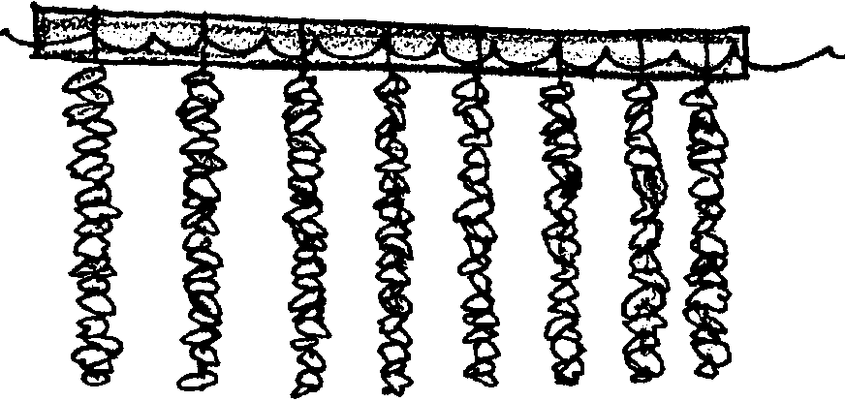
Some oysters are harvested from floating rafts. Spat covered shells are strung on wire.

The wires are hung from floating rafts. The oysters grow on the wires. The wires are then taken from the raft. The oysters are made ready for sale.

10. Three ways to harvest oysters are:

Some oysters are harvested within man-made walls. The walls keep seawater in shallow bays.

11. Why might oyster growers want to keep their oysters under water all day and night?

Marketing Oysters
When the oysters arrive at the processing plant they are sorted. The meat is removed from the shells by people called “shuckers.” They place each oyster on a wooden block. They open the shell with an oyster knife. A quick shucker can shuck 25 gallons of oyster meat a day.
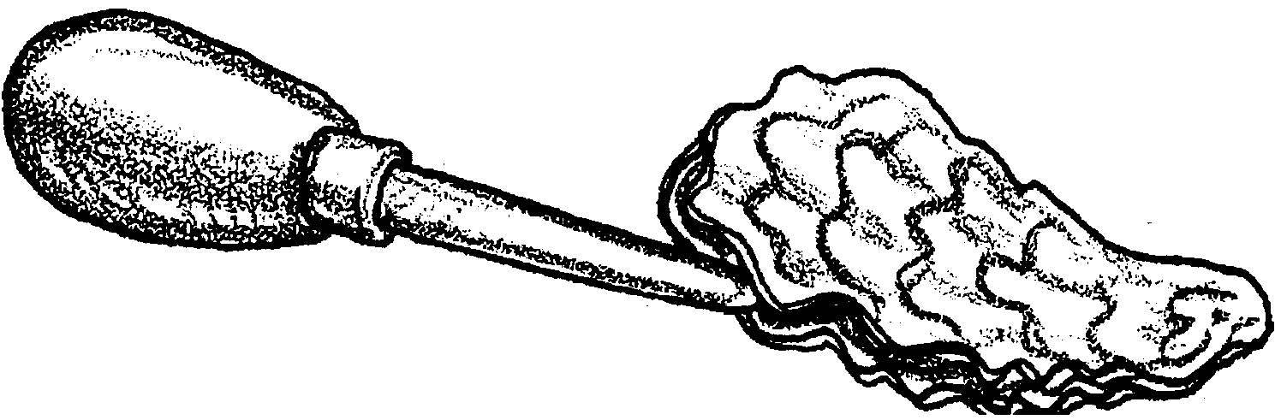
12. Challenge: “Swift” Shucker works for Evergreen Oyster Company. He works five days a week. He gets two weeks of vacation each year. How many gallons of oyster meat does “Swift” pick in one year?

The shucked oysters are washed. People look for damage. They sort oysters by size. Some are packed in jars. Some are packed in cans. Some are sold fresh. Others are frozen for use at a later date.

The empty shells may be strung on wire. These shells start the cycle again. They catch new oyster seed. Sometimes the shells are used in making roads. Sometimes they are ground and used in animal feed. Some shells are made into calcium pills for humans.

13. Your friend has just moved into a new house. A shucker used to live in the house. In front of the house is a giant pile of oyster shells.

What would you advise your friend to do with the shells? Why?

Have you ever eaten oysters? Think about all of the people who helped get the oyster to your plate.

14. What are four kinds of work these people do?

