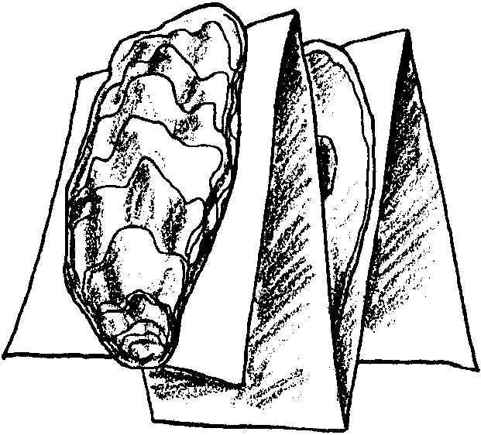
Folding Oysters

Key Concepts
1. Marine animals such as oysters are especially adapted to their environment.
2. Estuaries can provide habitat for oyster populations.

Background

Background for “Folding Oysters” may be found in the preceding activity, “Oysters on the Half Shell” and the following activity, “The Oyster Story.”

Materials

For each student:

• “Folding Oysters” student activity sheets

• scissors

• glue

• crayons or markers

• a sheet of 8 1/2" x 11" paper

Teaching Hints

“Folding Oysters” gives your students an opportunity to put together an oyster finger puppet while learning something about oyster anatomy and physiology. This is a fun activity and will reinforce many of the concepts introduced in preceding activities on oysters and clams.

The activity provides some information about the structures found inside the living oyster and about how those structures function. In addition to the items mentioned, consider pointing out the growth lines on the shell and the places for the attachment of the muscle which closes and opens the valves. A good source for additional information about oyster anatomy is: Barnes, Robert D. (1987.) Invertebrate Zoology; W.B. Saunders Company.

Duplicate the activity pages as needed for your students. It is important that your students follow the directions in the procedure section in the order given and that they answer the questions as they proceed. Provide time for a discussion of the activity and the questions as a follow-up. Consider displaying your students’ oysters by punching a hole in one of the shells and hanging them by a string through the hole.
Key Words

adductor muscle - muscle that hold a bivalve’s shells together

gills - feathery structures that absorb oxygen, excrete carbon dioxide, and filter plankton from the seawater pumped through the oyster

hinge - where the two shells are held together

mantle - the skin-like sack lining the shells; The mantle holds all the oyster’s insides and secretes the shells. The mantle adds rings of shell material to make the shells bigger.

spat - a young oyster; one newly attached

valve - shell

Answer Key

1. Microscopic, free-floating planktonic oysters are called spat. All animal plankton are called zooplankton (spat included) while plant plankton is called phytoplankton.

2. Oysters eat plankton, both tiny animals and tiny plants.

3. b. The oyster uses its adductor muscle to hold its valves together to avoid being eaten and to avoid drying out when the tide goes out.

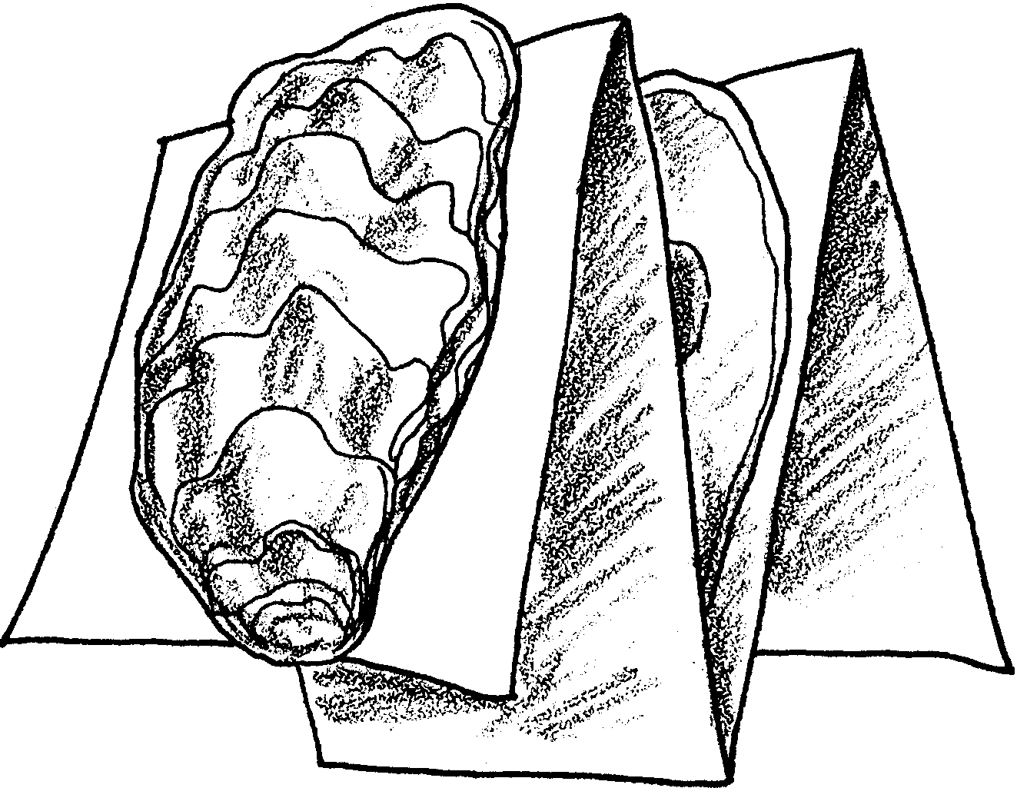
Folding Oysters

There are more than 100 different kinds of oysters. Many oysters live in estuaries. Oysters grow well in habitats with a mixture of freshwater and saltwater. They usually settle in shallow bays with sandy and mud bottoms.

Oysters begin their life as microscopic, free-floating plankton. Planktonic oysters are called spat. As they float, they eat and grow. Many get eaten.

1. What do we call microscopic, free-floating planktonic oysters?

Soon, the spat attach themselves to rocks or other older oyster shells. Once settled, oysters never move again. They sit on the bottom. They do not dig into the sand, like clams.

Oysters feed on plankton, both tiny animals and tiny plants. They filter the plankton from the water using gills; just like a clam. They pump large amounts of water through their bodies.

2. What do oysters eat?

Have you ever eaten an oyster? We eat the soft part within the shell. Next time you eat an oyster look carefully. The inside of the oyster is made up of several parts. To learn something about the oyster’s insides, make a puppet of an oyster.

Materials - Here’s what you’ll need....

• oyster sheet
• scissors
• glue
• crayons or colored markers
• sheet of paper

Procedure - Here’s what you do....

1. Obtain an oyster sheet. Look carefully at the four oyster drawings. Circle the letters from A to D on the drawings.

2. Drawings A and D show the outside of the oyster. Drawings B and C show what the oyster looks like when it is opened. The oyster’s body sits in the valve or shell that is shaped like a cup.

3. a. On drawing C, find the mantle. It is a special skin-like sac that lines the oyster shells. The mantle holds all the oyster’s insides. It also makes the shells. The mantle adds layers of shell material. The layers make the shells bigger and bigger to fit the growing oyster inside.

b. Find the adductor muscle. It is a very strong muscle. It holds the two shells of the oyster together.

When might the oyster want to hold its shells together?

4. On drawings B and C, color the adductor muscle. Color the adductor muscle scar the same color. Record the color you used in this space.

5. On drawing C, color the gills. Record the color you used in this space.

The gills have four functions, they:
• absorb oxygen.
• release carbon dioxide (the same gas we breathe out).
• catch the plankton from the water pumped through the oyster’s body.
• move the plankton, which is food for the oyster, to the oyster’s mouth.
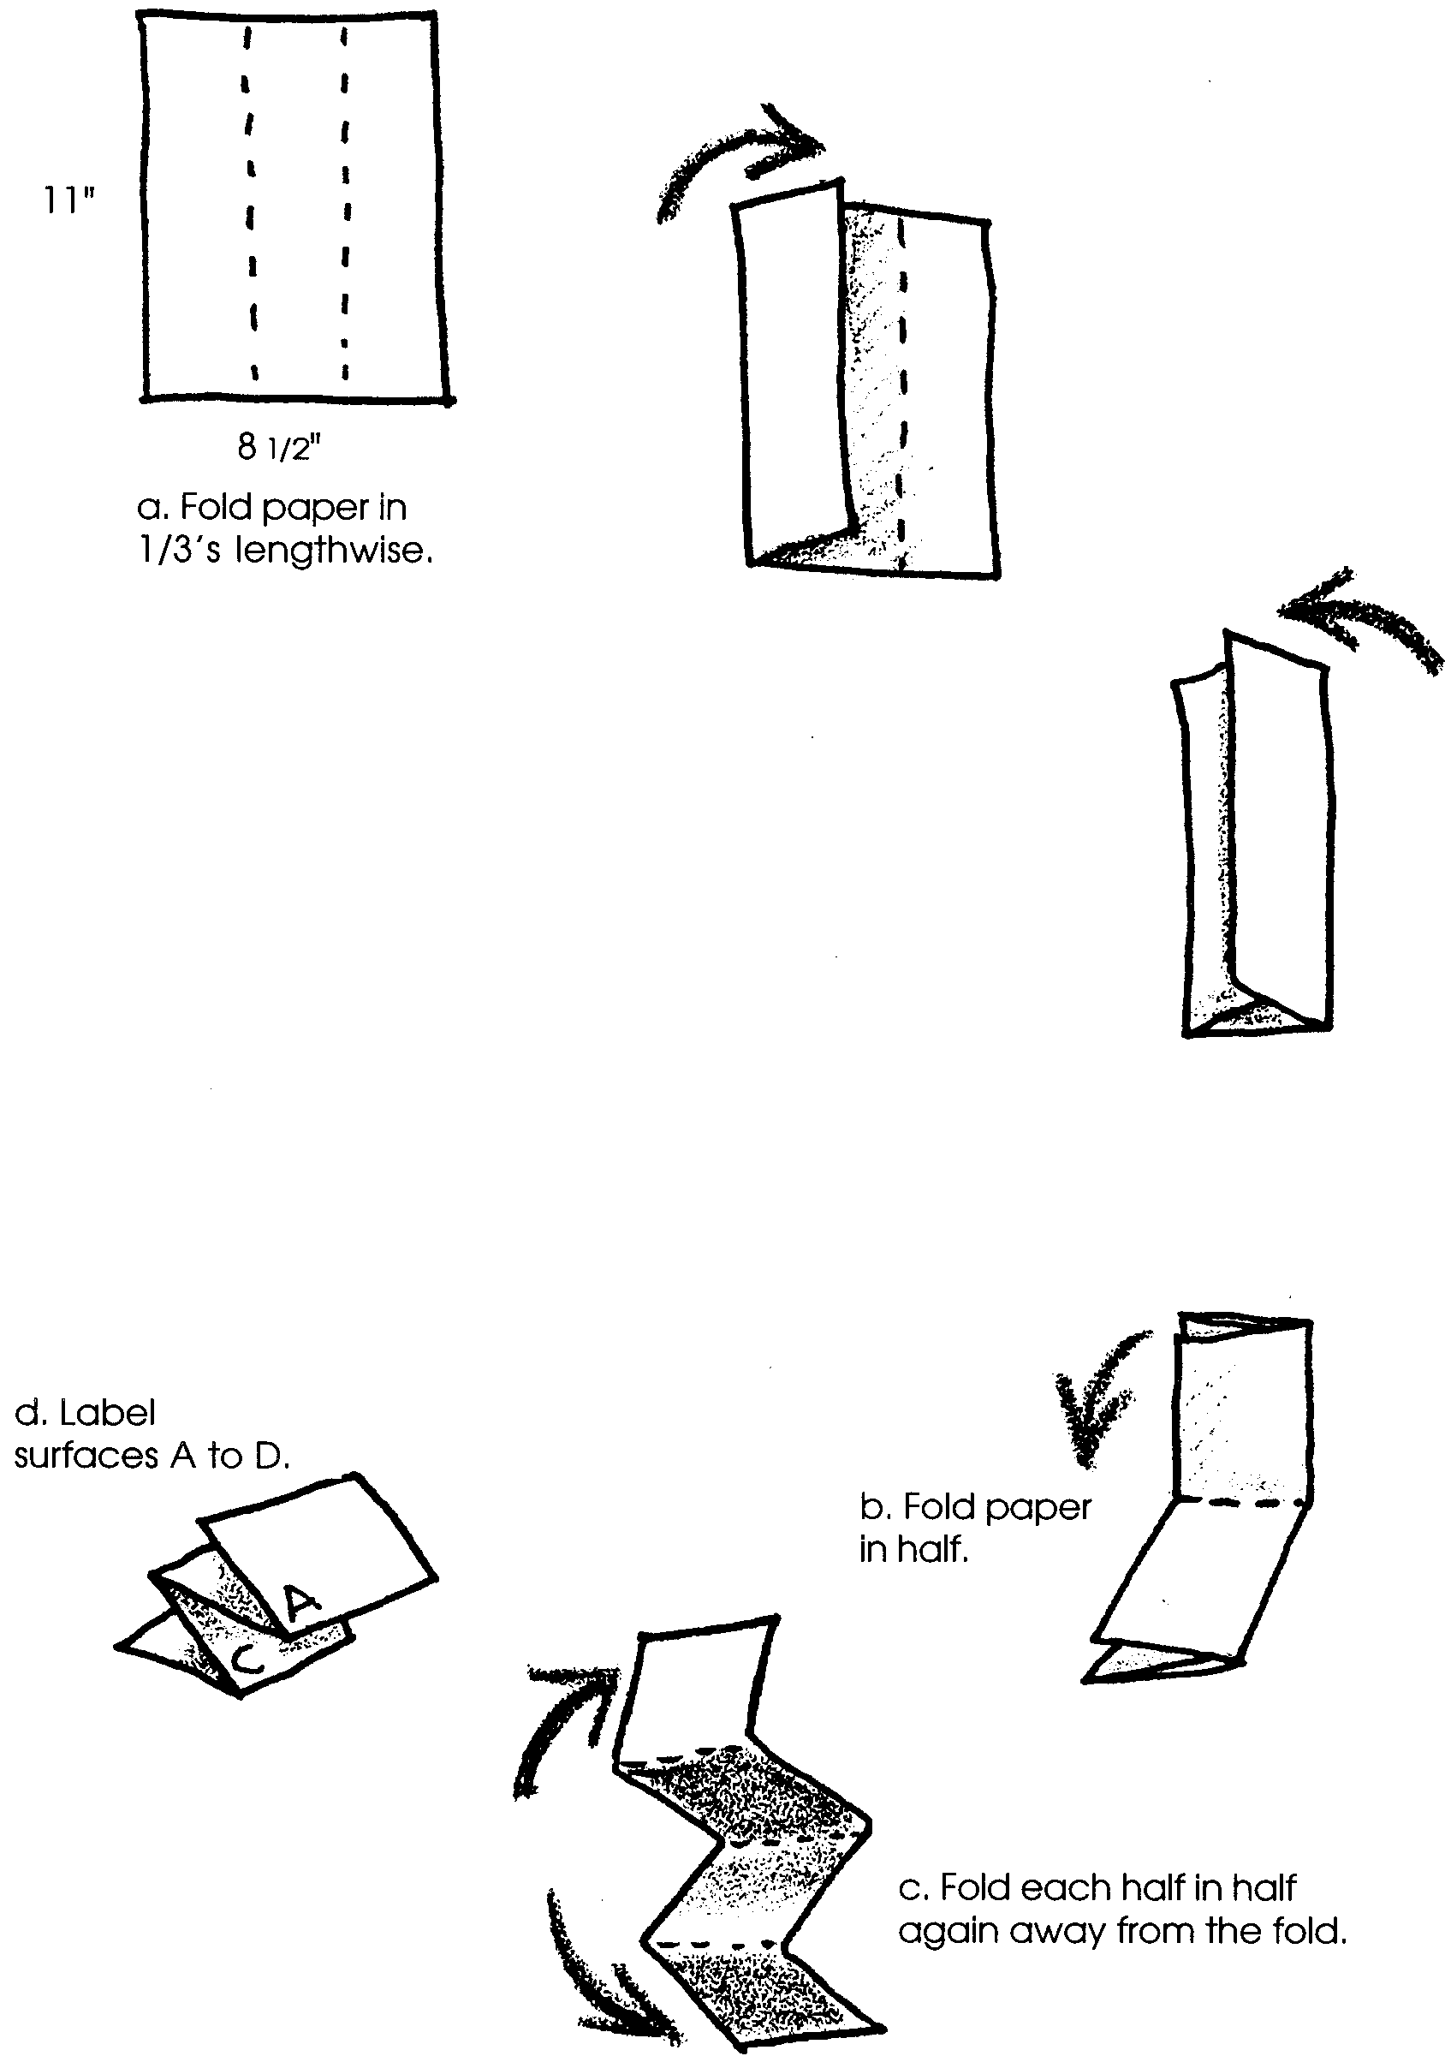
6. Obtain a plain sheet of paper. Fold the paper following the directions below.

7. Put your fingers in the pockets in the folded paper. With a pencil start on the top surface. Write a small A on the topside of the top “shell.” Write a B on the underside of the top. Write a C on the top side of the bottom “shell.” Write a D on the underside of the bottom.

8. Cut out drawing A. On the folded sheet, find your pencil letter A. Glue drawing A to this surface. Put the hinge toward your finger pocket. Next, cut out drawing B. Glue drawing B to the side with your pencil letter B. Again put the hinge toward your hand. Continue on through letter D.
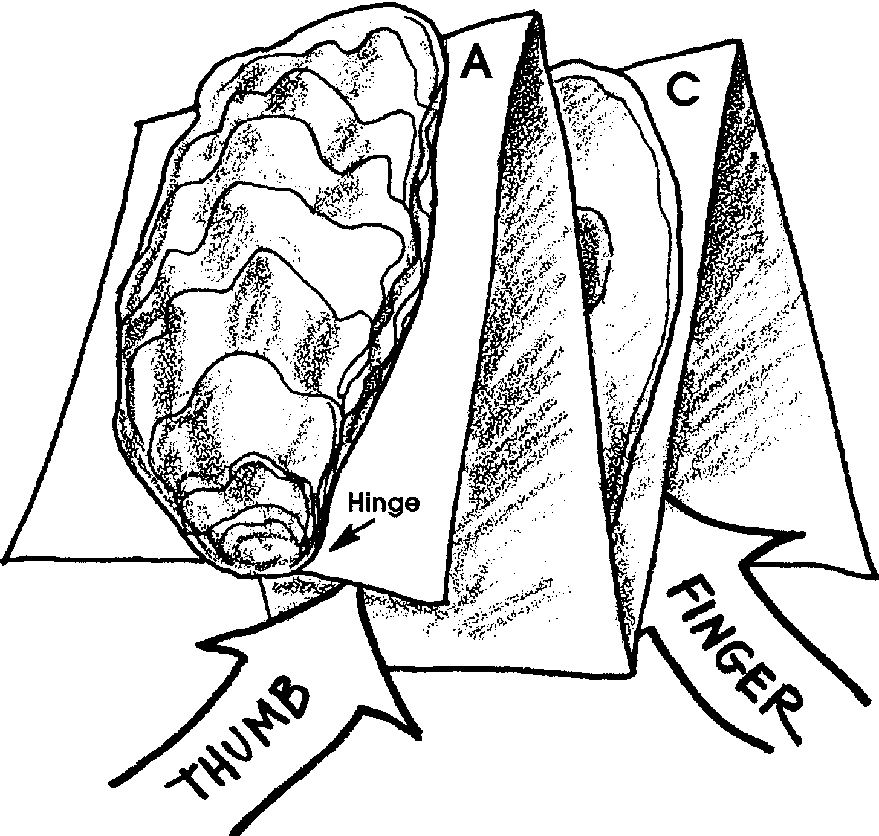

9. Put your fingers inside the two shells. Open and close your oyster. Amaze your friends with what you know about oysters!
