Oysters on the Half Shell
Lesson created by Laurie Dumdie, Poulsbo, WA

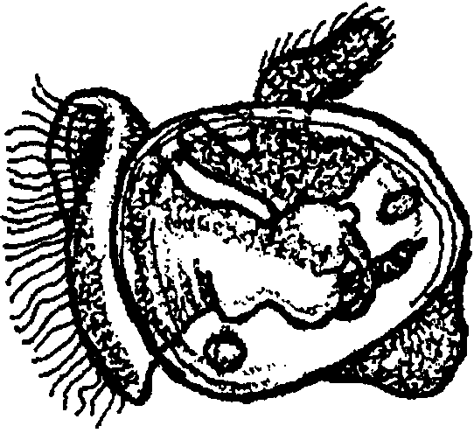
Key Concepts
l. Observations include what is seen, felt, smelled, heard or tasted. Inferences suggest explanations based on observations.
2. The observable, physical characteristics of an oyster shell can be used to draw inferences about its behavioral and structural adaptations.

Background

Life Cycle of the Oyster

Oysters begin their lives as feebly swimming members of the zooplankton (animal plankton). The beginning larva form of the oyster is a trochophore larva which changes into a veliger larva. Veliger larvae possess shells which enclose the body and a swimming organ called the velum. For two to four weeks, the veliger larvae move about eating microscopic phytoplankton (plant plankton), being eaten, and growing.

This is the only period of real mobility in the oyster’s life history. Just before settlement, the larvae swim over rocks, older oyster shells or some other solid surface. Veligers secrete a drop of cement that attaches them for life to their new habitat. These newly cemented larvae lose their velum and assume the form of adults. The oysters are now called spat or oyster seed. The spat stage is important economically because this is the stage at which many commercial oyster growers purchase their brood stock.

Unlike the veliger larva which pursued its food, newly attached oysters let their food come to them. Attached oysters feed by straining the plankton they eat from the water. Some estimates indicate that oysters filter at least 25 gallons of seawater a day. With an average life span of 2 years, an oyster may easily filter 18,250 gallons during its lifetime. In spite of all that water, a filter feeding life style like the oyster’s requires little expenditure of energy. As the oyster pumps water, plankton is strained from the water through holes in the oyster’s gills.

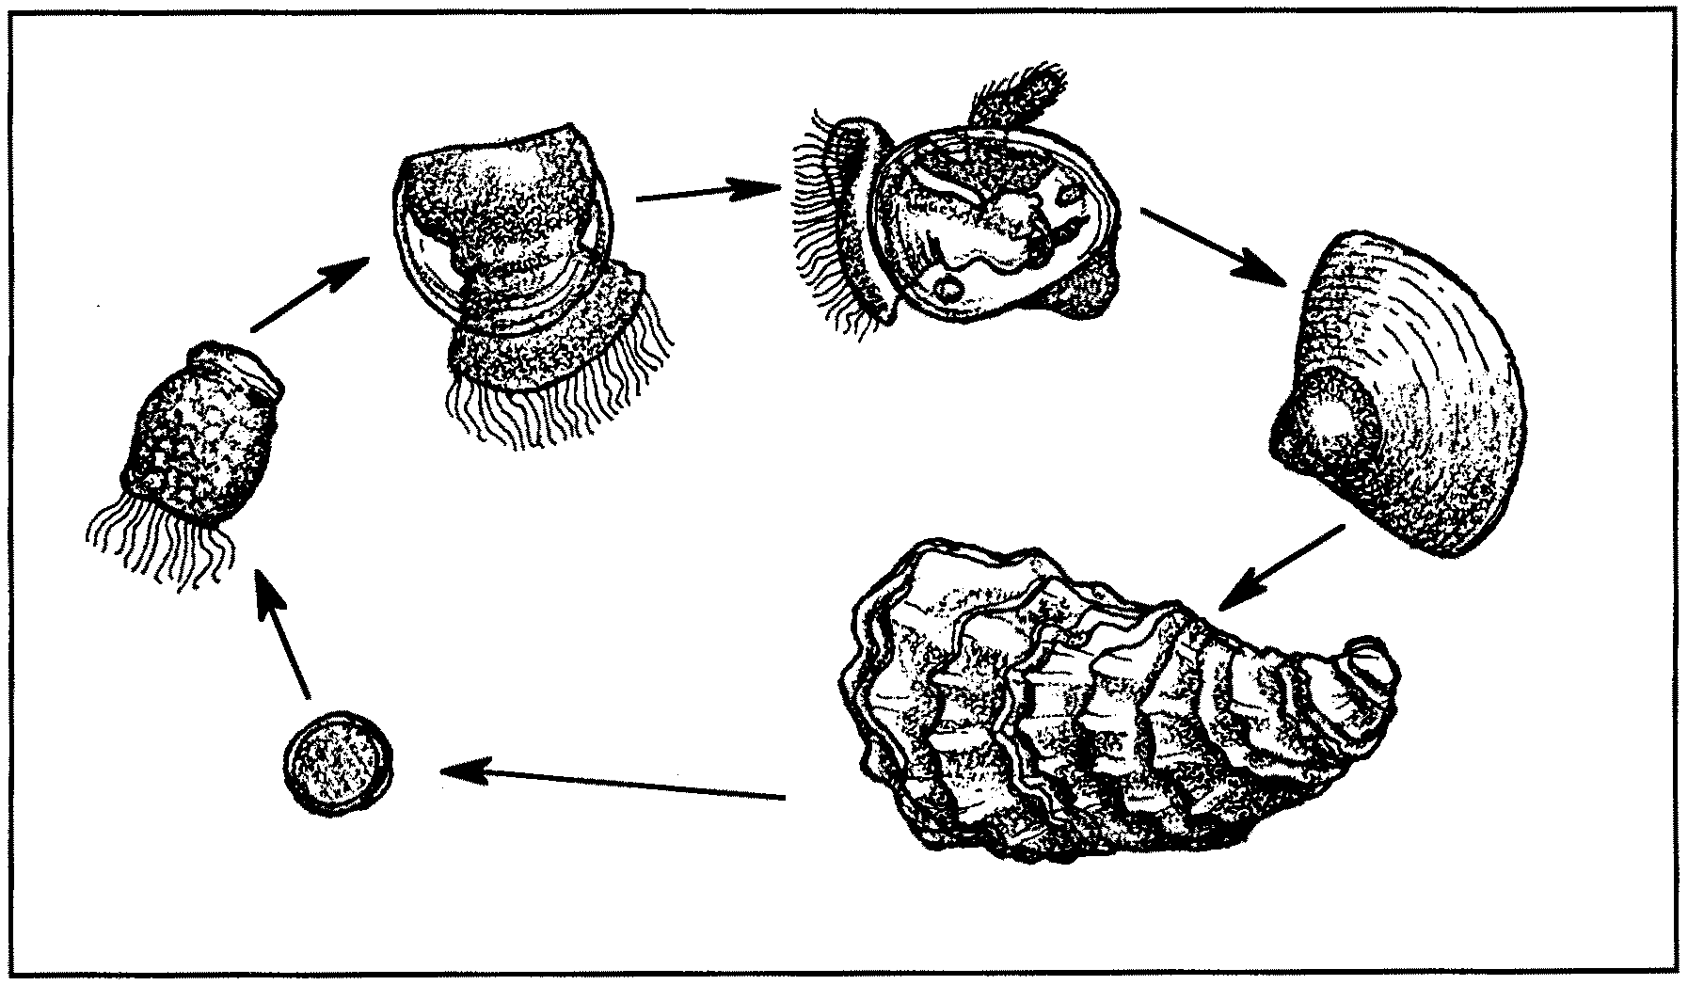
Oysters reproduce in spring and summer in warm water. An oyster is capable of functioning as a male at one time during “his” life and as a female at another period in “her” life. Oysters are not true hermaphrodites (both male and female sex organs) since a given individual does not typically produce eggs and sperm at the same time.

Oyster Life Cycle
Clockwise from left: egg; trochophore larvae; hinged or “D”-shaped larvae; veliger or “eyed” larvae; spat; adult.

Female oysters (or is it oysters in the female phase?) produce great quantities of eggs, from 250,000 to 60,000,000, depending on species and size. Fertilized eggs hatch within one or two days as veliger larvae and the life cycle begins again.

Oyster larvae are particularly sensitive to the quality of their water environment. Because of this sensitivity, oyster larvae are used by scientists to determine the impact of heavy metal, pesticide, oil, PCB and other pollution of bays, estuaries, and other coastal waters.

Materials

For each student:

• oyster shells; one (i.e.. half a shell) per student; matching sets are optimal*

• index cards (3 x 5 or similar size paper), one per student

For each group of 5 or 6 students:

• bags (large enough to hold 5 - 6 shells); one per group of 5 or 6 students

* Matching pairs of oyster shells (i.e. the top and bottom shell of the same oyster) work best for the success of this activity. The safest way to be sure you have matched pairs is to buy the oysters live and shuck them yourself or have a restaurant save matched shells for you. While matched pairs are ideal, most of the objectives can be met using unmatched shells.

Teaching Hints

This activity begins with students making careful observations of oyster shells (parts 1 & 2). Sets of shells are matched with the appropriate card containing recorded observations (part 3). Part 4 is intended to help students draw inferences about the structural and behavioral adaptations of an oyster.

PART 1. Finding Your Shell

1. Explain to students that they will begin learning about oysters, an important animal in many estuaries, by carefully observing a single oyster shell.

2. Distribute an oyster shell to each student and have them examine it carefully. You may wish to explain that the rough side of the shell is the outside of the shell and that the oyster lives in the hollow formed by the smooth, pearly inside of the shells. Explain that they will need to know their oyster shell well enough to pick it out from the whole group of shells. Be sure to alert students that they may not alter the shells in any way to aid in their identification.

3. Allow 3 - 4 minutes, then have each student put his or her shell in a pile with all of the shells. Assign a student to gently mix up the shells. Have each student relocate his or her own shell.

PART 2. Describe Your Shell

1. Each student begins this activity with his or her own shell from part 1. Divide students into groups of 5-6.

2. Distribute a 3 x 5 card (or similar size scratch paper) to each student. Instruct each to record, on the card, at least 5 observations for his or her oyster shell.

You may choose to explain that in this activity they will be attempting to match a group of shells with the correct description cards. Therefore, the quality of descriptions recorded for each shell is important. A brief discussion about observations that will be most effective for the matching exercise, may be useful.

3. Distribute a bag to each small group. Explain that when they have finished recording their observations, each student should place his or her shell and the card with the recorded observations in the bag.

4. Assign one student, in each group, to gently mix up the bag of shells and cards.

PART 3. Matching Shells and Recorded Observations

1. Have groups switch their bags of shells and cards.

2. Explain that, as a group, they should match each of the new shells with its correct description card. Instruct them to place the matched shell on top of the description card.

This activity can be challenging, depending on the quality of recorded observations. It is recommended you allow a specific amount of time (10 mins.) for students to match shells and cards, then encourage students to make their best guesses.

3. When groups have finished matching shells and cards, have the group that originally wrote the descriptions “check” the matching. How many students had their shell matched correctly with their card? At the end of this “checking” have students retrieve their own shell and card.

4. Discuss with students which recorded observations made identification most easy. Discuss pictures compared to written descriptions. Quantifiable observations (e.g. the number of barnacles on the shell, or the length of the shell and width in cm.), identification of unique characteristics (a hole drilled in the shell), and similes (looks like a boot) are usually most useful for identification.

PART 4. So What’s the Point?

1. Each student should have his or her own shell and description card. Ask students if their observations raised any “I wonder why...?” questions about oysters. The idea here is to help students draw inferences from their observations and learn science content through their own observations.

A question regarding how oysters grow (from the hinge) or how much they open when feeding (about 1/4 inch) or how the hinge works, provides the introduction to procedure #2.

2. Explain that each person has one of the two shells which protect an oyster’s soft body. Challenge each student to find the student that has the other shell that matches or “fits” his or her shell. To aid in their search, you might explain that one shell in the pair tends to be more flat while the other shell tends to be cupped. One may slightly overlap another.

3. To aid in management, encourage students that have found their matches to move to the perimeter of the room. Have students actively seeking a match stay in the middle of the room.

4. After the shells have been successfully paired, have those students with matching shells sit together and observe their complete oyster shell. From these and their previous observations, have students draw inferences about the structural and behavioral adaptations of an oyster. Questions you might use to facilitate this discussion include:

a. Which side of the oyster is “up” and which side is “down”? Why do you think so? (Solicit observations. The flatter shell is the “up” shell, the cupped lower shell retains water during low tides and helps anchor the oyster in the substrate. Sometimes, due to a restricted habitat, oysters grow so that both shells stick up horizontally from the substrate.)

b. How do the tight fitting shells of an oyster benefit the oyster? (Inferences are made from the observations of the tightly fitting shells. Possible benefits include protection from predators and resistance to drying when they are uncovered by low tide.)

c. Do other animals use the shells as habitat? What is the evidence? (Other animals that use oyster shells as habitat include: barnacles, tube worms, mussels, limpets, and snails. Evidence would include the observing of spat and smaller oysters on older, larger oyster shells.)

d. In what sort of habitat might the oysters have lived? What makes you think so? (The shape of the oyster shells are an indicator of the habitat. Long, thin shells may reflect crowding. Bits of rock or other substrate often adhere to shells giving clues as to the habitat type. Also, shells tend to be thicker in areas with surf or pounding waves.)

e. What adaptations can you see for oysters living along the edge of a mudflat? (The cup shape holds oysters out of the mud. Their rough surface increases their surface area also reducing the tendency to sink into the mud. Unlike clams, oysters will usually not survive if buried.)

f. If an oyster grows approximately one inch per year, how old were these oysters when they were harvested? (Have rulers available for this step. The rate of growth depends on lots of factors but is reflected on the surface of the oyster shell in the “layers” or “rings” which may be read and aged much as we determine the age of trees.)

Key Words

bivalve - a mollusk with two shells

mollusk or mollusc - any of a large phylum of invertebrate animals (oysters, clams, snails) with a soft body, usually enclosed in a calcareous shell

spat - a young oyster; one newly attached

univalve - a mollusk with one shell

valve - the calcareous shell of a mollusk

Extensions

1. To encourage students to compare different types of oysters, use the page included with the illustrations of several kinds of oysters.

2. Obtain a real oyster in the shell. Open it up and examine the oyster’s body in the shell.

3. Find the area of all the shells. Find the class average. Compare these figures with those from the activity, “Shell Sort”.

4. Have students write a paragraph that describes how clam shells and oyster shells are alike and different.

5. Challenge students to find out how pearls are made. Are oysters the only mollusk that make pearls?

6. Make up and sing songs about oysters such as the following:

(To the tune of “If You’re Happy and You Know It”)

If you’re a clam and you know it, dig a hole.

If you’re a clam and you know it, dig a hole.

If you’re a clam and you know it then your shell will surely show it.

If you’re a clam and you know it, dig a hole.

If you’re an oyster and you know it, make a pearl.

If you’re an oyster and you know it, make a pearl.

If you’re an oyster and you know it then your pearl will surely show it.

If you’re an oyster and you know it, make a pearl.

