A Creative Clam Story

Write All About It!

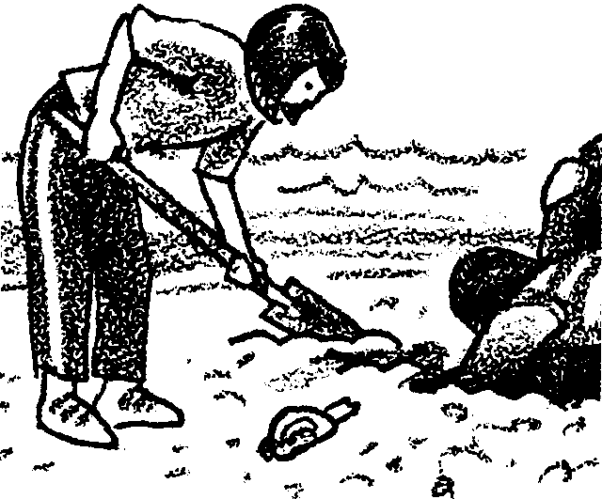
Key Concepts
1. There are many species of clams that live in estuaries and the ocean.
2. Clams have unique structural and behavioral adaptations.
3. Estuaries provide a large concentration of edible resources, including clams, utilized by aboriginal people to the present.
4. Humans use a variety of techniques for harvesting clams from the estuary and oceans.
5. The harvesting of food from coastal waters can impact marine habitats.

Background

This lesson is designed to fulfill three educational purposes:

1. It contributes to developing the child’s powers of awareness, observation, and sensitivity.

2. It contributes to the child’s ability to communicate in an interesting and effective manner.

3. It develops the child’s skill in using a creative approach to a task. This skill is fundamental to modern society and of particular value in a democratic society where every citizen must make decisions.

Teaching Hints

The story students create could be written from the perspective of the kids in the picture, or from the perspective of the clam for which they are digging, or from a different perspective that your students suggest.

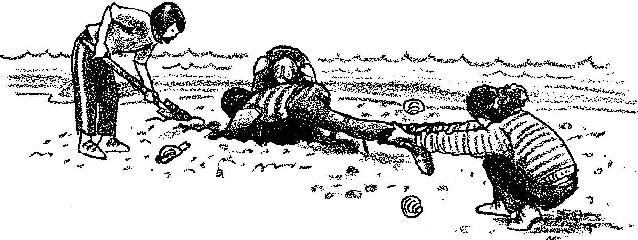
Write All About It – A Creative Clam Story

What's happening here? Use your imagination. Don't forget a title for your story.

