Open Sesame

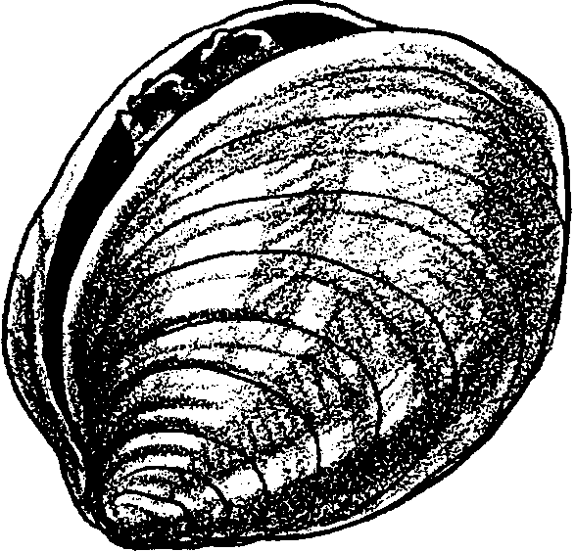
Key Concepts
1. Clams have unique structural and behavioral adaptations which help them survive and successfully reproduce in their habitat.
2. The form and function of body parts are related.

Background

Background information can be found in the preceding activity, “Insides Out.”

Materials

For each group of three or four:

• fresh clam (in the shell)

• shallow tray

• ruler

• 2 bamboo skewers (sold in grocery stores for making “kabobs”)

• copies of student activity pages, “Open Sesame”

Teaching Hints

The purpose of this activity is to give your students an opportunity to observe, in detail, the inside and outside of a clam. It is highly recommended students complete the preceding activity, “Insides Out” before doing this activity.

While it is possible to do this activity as a demonstration (certainly better than not doing the activity at all), it is best if you can obtain enough clams to permit groups of about 4 students to perform the activity.

Drawings of the internal organs of an organism and the real organs sometimes seem to have little in common. As such, it is recommended that you perform this activity prior to use with the class.

Clams, in the shell, may be obtained at the beach (if you are lucky) or at a fish market or supermarket near you. If you dig your own clams, and want to use them for chowder after the activity, you will want to clean them. Place them, for about twenty-four hours, in a gallon of seawater to which 2 tablespoons of corn meal has been added. REMEMBER, if you intend to use the clams for chowder after students have examined the body structures, make certain all students’ hands are clean and that they use only clean tools as they work with their clams.

Open the clams for your students by placing the clams in boiling water just long enough for the adductor muscles to relax and the shells begin to open. DO NOT OVERCOOK. Overcooking makes the internal structures contract causing them to be difficult to locate.

Notice that procedure #4 asks students to record the length and width of their clam in order to determine a class average. To facilitate calculation of a class average, advise students where they should post their measurements for length and width. Since calculating the average requires division, you may wish to determine the answer as a guided whole group exercise.

Distribute the clams and trays. Demonstrate how to snip the adductor muscles to gently lay the clams open and let the explorations begin.

Key Words

adductor muscles - muscles that hold a bivalve’s shells together

excurrent siphon - a tube that ejects wastes out of the clam’s body

gills - feathery structures that absorb oxygen, excrete carbon dioxide, and filter plankton from the seawater drawn into the clam through the siphon.

hinge - where the two shells are held together

mantle - a sac-like organ in mollusks; The mantle holds the internal organs of the animals and secretes the shells of shelled mollusks.

incurrent siphon - a tube that draws water into the clam’s body

valve - shell

Extensions

1. Help your students use the clams from this activity to make New England Clam Chowder!

Ingredients

12 medium size butter or steamer clams, chopped

3 diced bacon strips

1/2 cup chopped onion

2 1/2 cups diced potatoes

1 1/2 cups hot water

1 teaspoon salt

dash pepper

2 cups milk

1 tablespoon butter

parsley flakes

Method

1. Place the bacon in the soup pot and cook the pieces until crisp.

2. Add the onion. Cook until tender.

3. Add potatoes, water, salt, pepper, and clams.

4. Cover and cook slowly over medium heat for 15 - 20 minutes.

5. Blend in milk and butter.

6. Cook until heated.

7. Serve with parsley flakes on top.

Makes 12 half cup servings.

Answer Key

The Outside

1. - 5. Answers will vary depending upon observations.

The Inside

3. a. It may be easier to glide the skewer down the incurrent siphon. It is the siphon that brings water into the clam, containing the plankton.

b. If the skewers did glide all the way through the siphons, they will end inside the clam at the gills. The water brought into the clam provides oxygen to the gills. The gills also are covered with hair-like cilia that capture plankton from the incurrent water and move them toward the clam’s mouth. Carbon dioxide wastes leave the gills and are expelled, along with food wastes from the digestive system, through the excurrent siphon.
7.
_____a. adductor muscles - protection (holds shells closed)

_____b. hinge - protection (holds shells together)

_____c. mantle - protection (makes new shell)

_____d. incurrent and excurrent siphon - eating and breathing (brings water into the clam)

_____e. gills - eating and breathing

_____f. stomach - eating

_____g. mouth - eating

_____h. foot - protection (powerful digging tool)

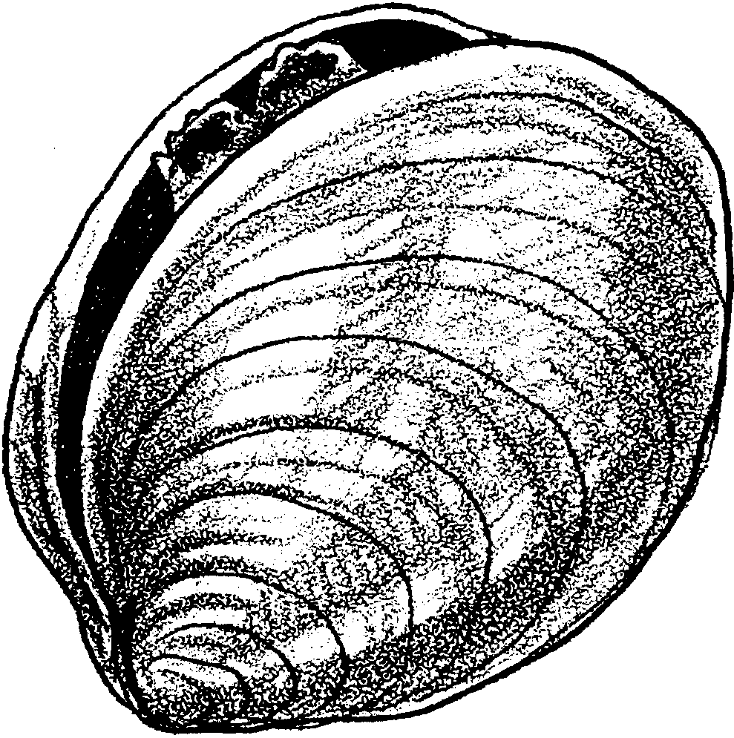
Open Sesame

Clams may seem like simple animals. However, they have many special adaptations to help them survive. Let’s look at some of these adaptations.

The Outside
Observe the clam carefully.

1. How many valves (shells) protect the soft body?

2. Describe the shape and color of the valves.

3. Measure the width and length of the clam in centimeters.
How wide is your clam? cm
What is the length of your clam? cm

4. Record the width and length of your clam for the whole class to see. Look at the results from all the groups.
The widest clam is cm
The shortest clam is cm
The longest clam is cm
Estimate the average length of the clams. cm

5. Challenge: Find the average length of the clams. cm
The Inside

1. Very carefully, snip the adductor muscles on both sides of the hinge. The adductor muscles are white, roundish and firm. Open your clam very gently, without ripping the body parts.

2. Find the thin, whitish flesh lining the inside of the shell. This material goes right to the edge of the shell. It is called the mantle.

From its location, what do you think the mantle does?

The mantle does two things. It forms a sack to hold the internal organs of the clam. The mantle also makes more shell for the clam as its body grows larger.

3. Find the siphon. The siphon is a firm tube with two openings. Let’s get a better idea of how the siphon works. Very slowly and gently place a skewer down the incurrent siphon (furthest away from the hinge). Begin at the outside (tip) of the siphon. Then move the skewer toward the inside of the clam. Notice how and where the siphon goes into the clam. Next, place a skewer down the excurrent siphon.

a. Did one of the skewers seem to go in more easily? If so, which one?

b. Look at where your skewers stop. Where do the siphons seem to end?

4. Next, study the picture below.
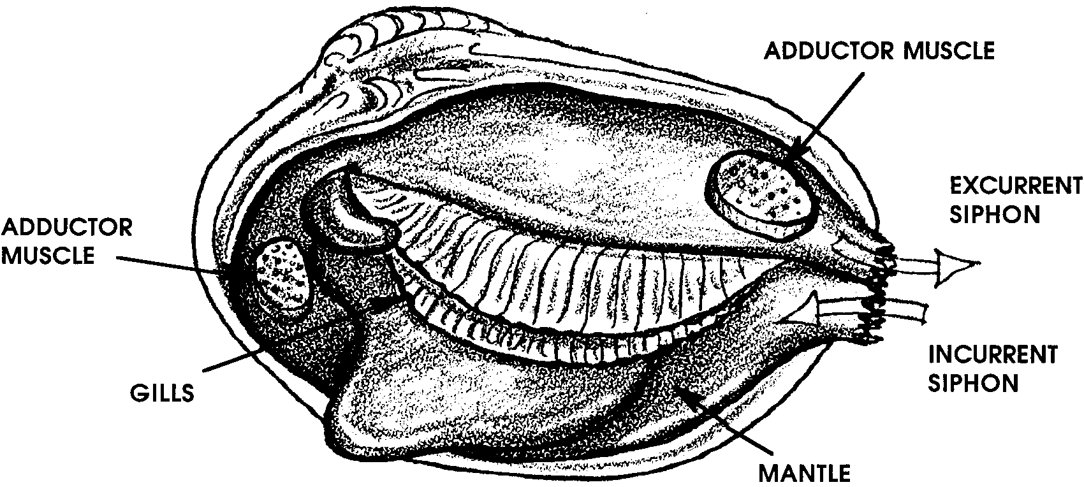
Use the picture to help locate the gills of the clam. Look on both sides. There are two sets of gills.
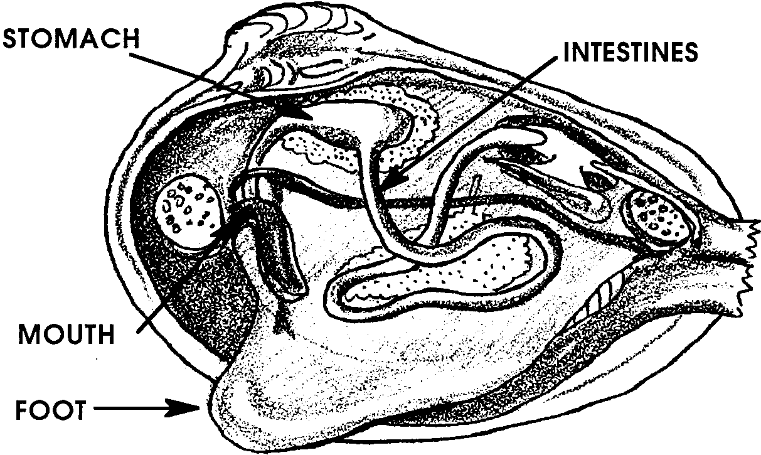
5. This now gets challenging. Study the picture below.

Very gently, lift the gills up from the other organs (use the skewer). Try to find the stomach and intestines.

Recall that water is brought into the clam through the incurrent siphon. It flows over the gills (Did you notice that the siphons end inside the clam, right at the gills?)

The gills have tiny hairs that catch the plankton. They move it with a beating motion down to the mouth. Look at the picture above. Try to find the mouth. If you think you see it, gently put the point of the skewer into the mouth. If it goes in easily, it is probably the mouth. The mouth empties into the stomach.

6. Find the foot. Remember it is a strong muscle. As such, it will feel somewhat hard. The foot is used for digging.

7. Check the body parts you found:
_____a. adductor muscles -
_____b. hinge -
_____c. mantle -
_____d. incurrent and excurrent siphon -
_____e. gills -
_____f. stomach -
_____g. mouth -
_____h. foot -

8. Look at each body part on the list above. Write beside each part whether it is used for: protection, eating, breathing, or moving.

9. Follow your teacher’s direction for saving the clam meat and shells.

