Insides Out
Lesson edited by Karen Mattick, Poulsbo, WA

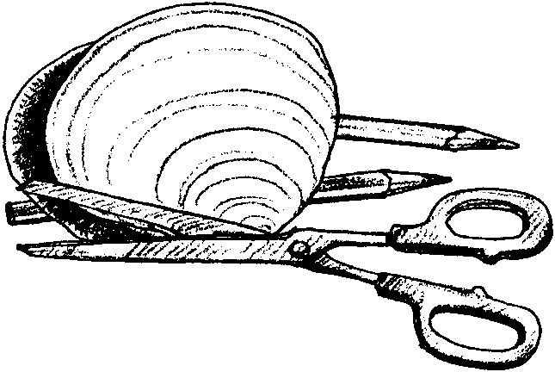
Key Concepts
1. Clams have unique structural and behavioral adaptations which help them survive and successfully reproduce in their habitat.
2. The form and function of body parts are related.

Background

Simple as they seem, clams are complex animals, well-designed for making a living in the sand. Clams are plankton feeders. They maintain a flow of water through their bodies with water entering through an incurrent siphon tube and leaving through an excurrent siphon. The water passes over their gills, feathery structures which strain out the plankton and permit the exchange of oxygen and carbon dioxide.

This feeding/filtering system works very well, with the only disadvantage being that water quality needs to be maintained to ensure clams as a resource. Metals or other pollution, as well as the naturally occurring toxins found in some red tides, concentrate in the tissues of clams and other filter feeding shellfish. Large amounts of water are exchanged, so the potential for a loss of resource due to poor water quality is a real problem.

The two shells, or valves, of a clam are secreted by a special organ, the mantle. The shells are joined at the hinge, and held together by powerful adductor muscles. Another powerful muscle, the foot, is used for digging.

The success of this basic plan is evidenced by the fact that there are over 20,000 different kinds of clams worldwide.

Materials

Foreach student:

• “Insides Out” student activity pages

• copies of the paper clam model (pages I-III)

• scissors

• stapler

• crayons, or markers, or colored pencils

• glue

For the class:

• 3 transparencies with the paper clam model (pages 1-3) labelled (optional)

Teaching Hints

Students will put together a model of a clam while learning something about clam anatomy. This is a fun activity and works well as a prelude to, or in lieu of, “Open Sesame”, the next activity.

The activity pages provide some information about the structures found inside the living clam and about how those structures function.

The labelled transparency masters have been included to use as is necessary to help students locate specific body parts.

The clam drawings are used with permission from “Ocean Study Activities K-5”, a science curriculum supplement of Almanac County Schools; Graham, North Carolina.

Key Words

adductor muscles - muscles that hold an animal’s shells together

excurrent siphon - a tube that ejects wastes out of the clam’s body

gills - feathery structures that absorb oxygen, excrete carbon dioxide, and filter plankton from the seawater the siphon pulls into the clam

hinge - where the two shells are held together

incurrent siphon - a tube that siphons water into the clam’s body

mantle - the skin-like sack lining the shells; The mantle holds all the clam’s insides and secretes the shells. The mantle adds rings of shell material to make the shells bigger.

valve - shell
Answer Key
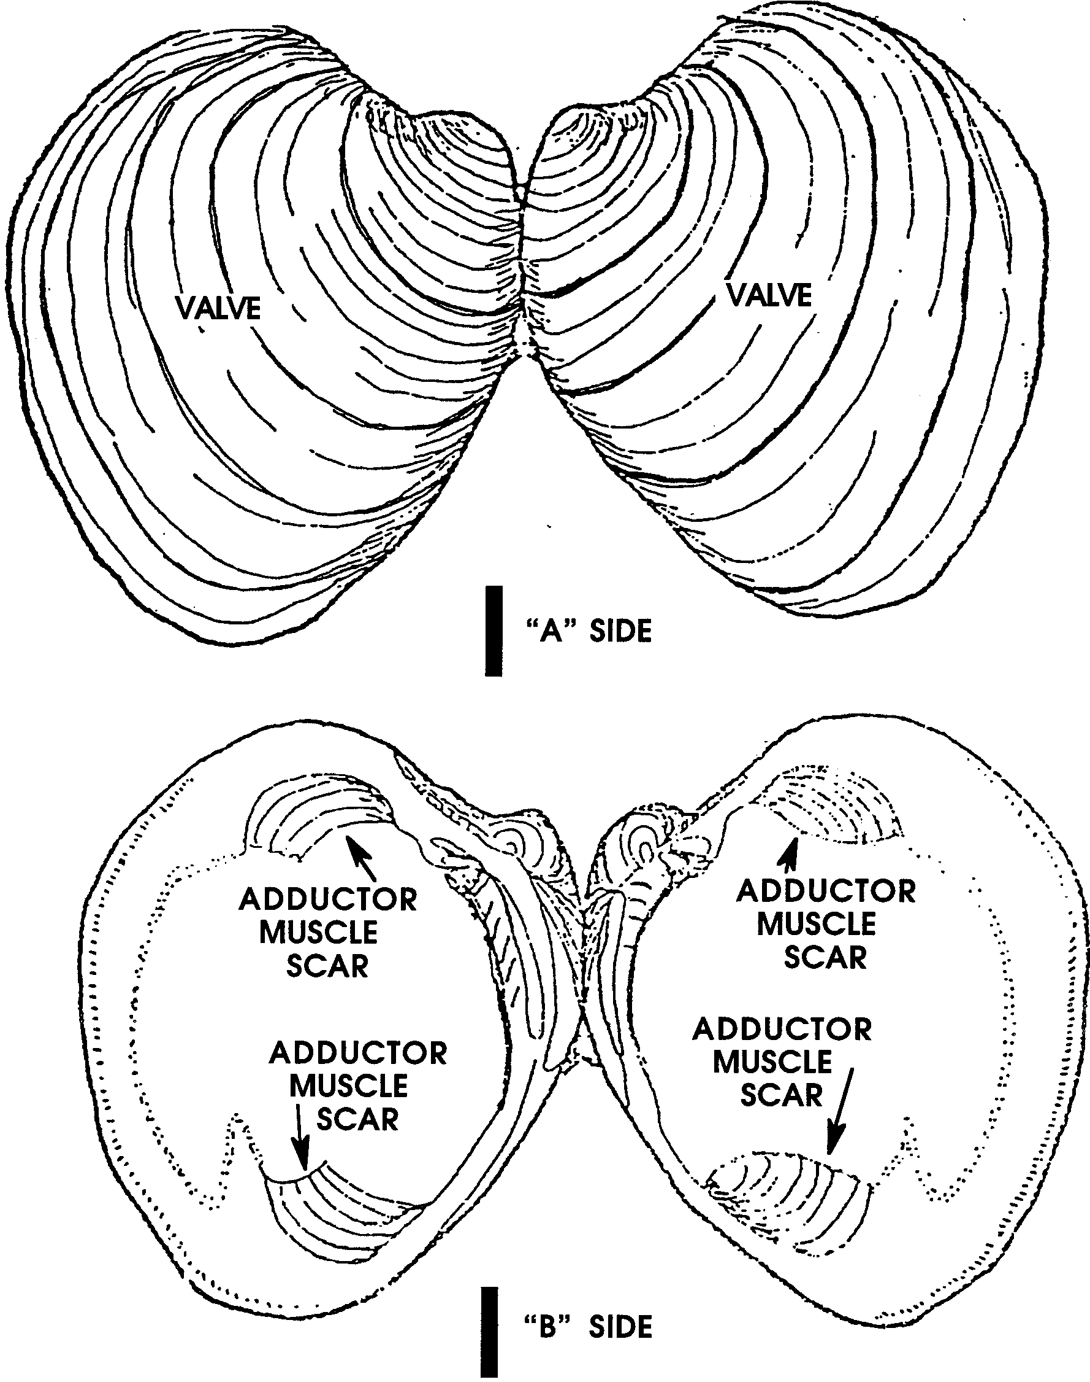

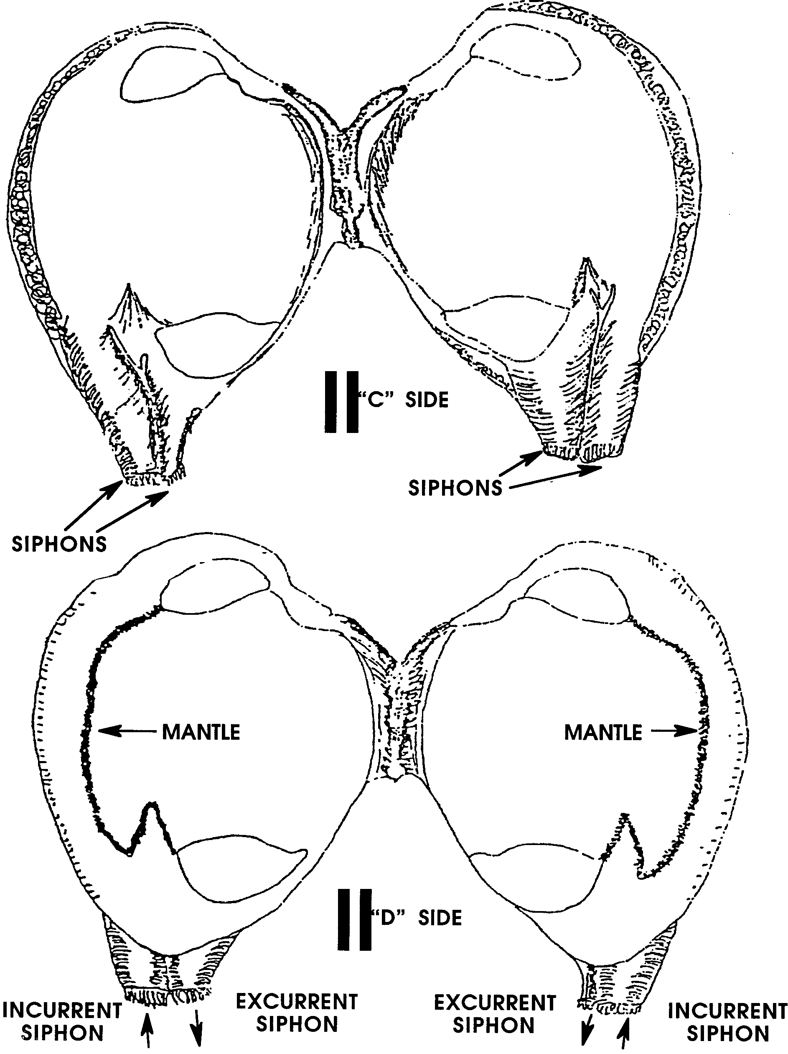

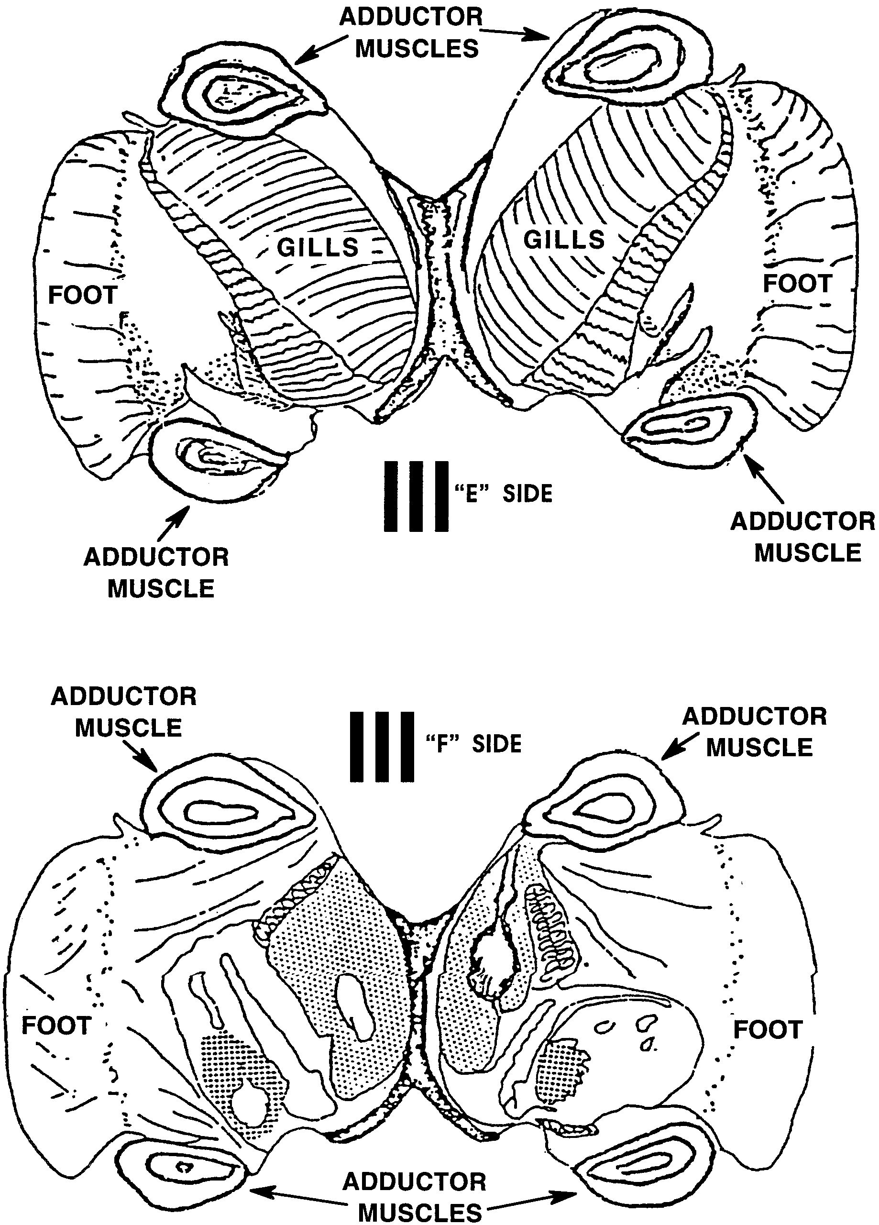

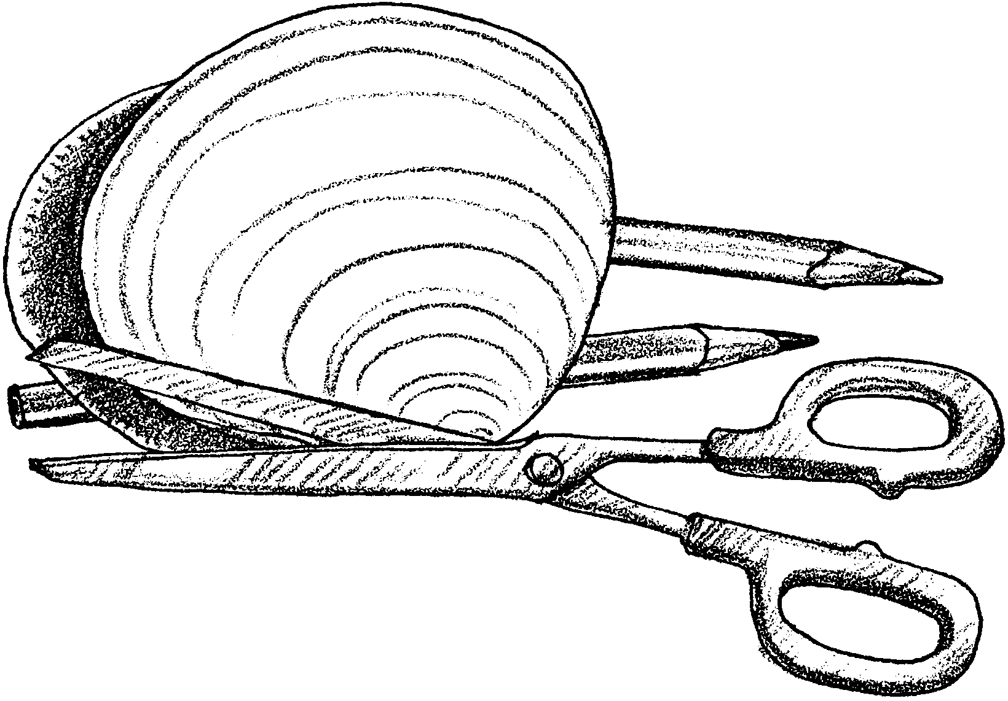
Insides Out
Clams are found in estuaries and other habitats, all over the world. How do they make a living in the estuary? In this activity you will construct a paper clam model to learn how it eats, moves, breaths, and protects its soft body.

Look carefully at the clam sheets. Notice that the drawings are in pairs. The pairs are front and back views. The arrows point to letters. The letters will tell you how to put the drawings together.

Protection
1. Let’s look at the body parts the clam uses to protect itself.

a. Find the A side of drawing I and the B side of drawing I.

b. The clam’s first defense is its two hard shells. Marine biologists also call the shells valves. On each drawing of the outside of the shells, print VALVE. Clams are called bivalves because they have two shells or valves. “Bi” means two.

c. When the clam is in danger, it uses its two very strong adductor muscles to hold the valves tightly closed. Color the adductor muscle scars on the drawings of the inside of the clam shells.

Record the color you used.

1. d. Cut out both the A and B side drawings. Glue them together back to back so you can see the writing.

2. Now, let’s find out what part of a clam makes its hard shells.

a. Find the C and D side on drawing II.

b. The clam shells are lined with a special skin-like sack called the mantle. The mantle holds all the clam’s insides. On the D side of drawing II, find and label the mantle. Print the word MANTLE on the drawing.

c. The mantle not only holds the insides of the clam, it also secretes, or makes the shells. The mantle adds rings of shell material. The rings make the shells bigger and bigger to fit the growing clam inside. Each thick ring on the clam equals one year of clam growth.

Estimate the age of the paper clam. years

Eating and Breathing
3. a. Drawing II also shows the siphons. The siphons are tubes that go into the clam. They take in water and plankton and squirt out wastes. On the C side of drawing II color the two siphons.

Record the color you used.

b. One siphon sucks in water so the clam gets food and oxygen. It is called the incurrent siphon. It is the siphon farthest away from the hinge. The hinge holds the two shells together. Draw an arrow on the incurrent siphon to show water going INTO the clam.

c. The other siphon is called the excurrent siphon. It removes wastes from the clam’s body. Draw an arrow on the excurrent siphon to show water going OUT of the clam.

d. Cut out sides C and D of drawing II. Glue them together, back to back, so you can see the drawings on the outside.

4. a. Find the E and F sides of drawing III. These drawings show the internal organs of the clam. They show the clam’s body cut down the middle lengthwise.

4. b. Find the gills on the E side. Color the gills a new color.

Record the color you used.

c. The gills do two important things:

1. The gills breathe. They absorb oxygen and release carbon dioxide.

2. They gills remove plankton from the water from the siphons. Estuaries have a lot of plankton. Clams in the estuary have a lot to eat.

Color some tiny dots on the clam gills. The dots will be the plankton the gills are getting out of the water.

There are tiny hairs on the gills. They pass the plankton to the clam’s mouth. The food goes into the mouth, then the stomach. What can you think of that a clam might suck in that could be bad for it?

More Protection Parts
5. a. Find both the E and F side of drawing III. Color the adductor muscles the same color you used in drawing I. What does the clam use its adductor muscles for?

b. Find the foot on sides E and F of drawing III. Color it a new color.

Record the color you used.

The clam uses its foot to bury itself in the sand. The foot is a strong muscle. The clam can push its foot out of its shells. It uses its foot to push and pull itself down into the sand. Why do you think the clam wants to be buried?

c. Cut out the E and F side of drawing III. Glue them together, back to back. The coloring will be on the outside.

Putting the Clam Together
6. a. Place drawing I down on the table with B side up. The B side shows the inside of the clam’s valves.

b. Place drawing II on top of drawing I. Have the D side up. The D side has the mantle labelled.

c. Place drawing III on top of drawing II. Have the F side up. The F side is the side that doesn’t show the clam’s gills.

d. Make sure the hinges line up. Fold the 3 drawings along the hinge line, like a book. Staple the folded drawings together at the hinge line. Congratulations, your paper clam is now finished.

