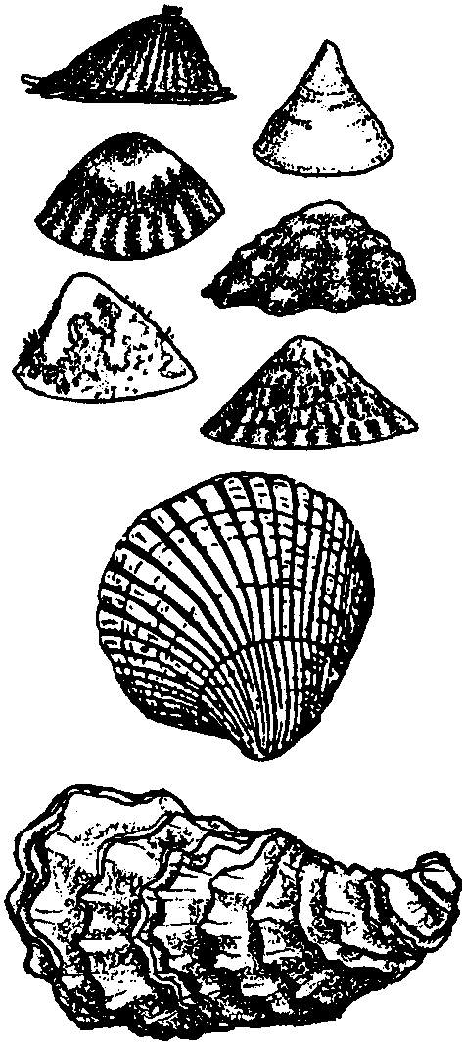
Shell Sort
Lesson by Katrina Ringrose, Seabeck, WA

Key Concepts
1. Seashells have unique physical attributes including: size, shape, texture, color, and weight.
2. Shells can be sorted and classified based on their unique attributes.
3. The unique attributes of a shell can be used to identify the animal that built the shell.

Background

Seashells can provide clues about the inhabitants of a beach. Unique physical attributes of shells are helpful for identification of the animal that made the shell. This skill is extremely important when shellfish gathering. Regulations regarding limits require the shellfish harvester to know the different types of univalves (molluscs with one shell, “snails”) and bivalves (molluscs with two shells, “clams”).

Shells are important historically, playing an important role in many cultures. Shells were often used as money and the piles of shells left as middens provide clues as to the diet of indigenous people.

Materials

For each group of four students:

• bag containing 6 different local shells

• a ruler (inches or centimeters)

• eraser, “pink pearl” or similar block-shaped eraser

• copies of “Shell Sort” student activity pages (one per student or group)

• a sheet of graph paper (1cm x 1cm squares)

• balance scale (not critical to the success of the activity)

Teaching Hints

This introductory activity is a good motivator for the clam unit. Students enjoy manipulating and observing shells. They can learn lots through their own observations. This activity is most successful when students work with and classify shells from local waters. For bivalves (an animal with 2 shells), try to collect both halves of the shell. Clam shells from your local area, if available, are perfect for inclusion in the sorting bags.

Cooperative learning tactics work well for this activity. It is recommended you distribute the shell bags to groups of students and allow free exploration time, before distributing the activity pages and rulers.

Key Words

area - in this activity, the number of squares (on graph paper) that the object covers

bivalve - mollusc with two shells; for example, a clam

dimensions - the length, width, height of an object

observation - using one or more of the senses in a personal experience of perception

mollusc or mollusk - any member of a large phylum of invertebrates with soft bodies

univalve - mollusc with one shell; for example, a snail

Extensions

1. Make plaster casts of the shells.

2. Have students draw a picture of what they think the animal that lived in the shell looked like.

3. Encourage students to use a shellfish guide (or other resource material) to find out about the animal that lived in the shell.

4. Play a guessing game. Have one group of students develop 3 clues to describe each shell. The other group must guess which shell the clues describe.

5. Construct a scientific “key” for the collection of shells.

6. Have students research the use of shells in different cultures.

Answer Key

1.-4. Answers will vary depending on individual shells used.

Adapted from an activity in the AIMS Newsletter and used by permission from the AIMS Education Foundation

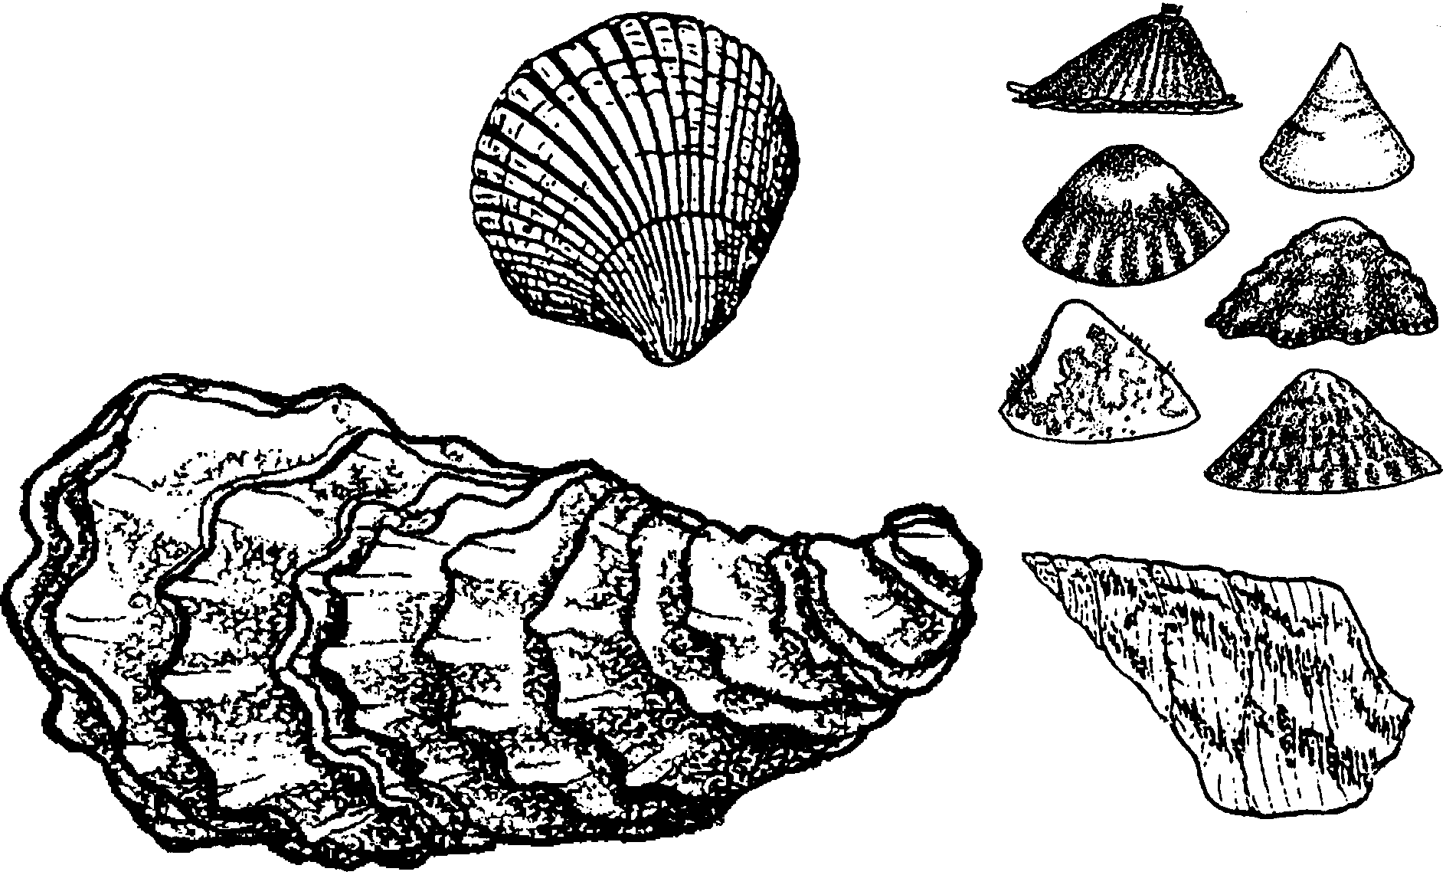
Shell Sort

1. Look at and touch the outside of the shells. Order the shells from smooth to rough. Draw a picture of each shell. Use as much detail as you can. The first picture should be the smoothest shell. The last picture should be the roughest shell.

2. Pick one shell and sketch it from three different angles.

top side bottom

3. Pick three shells. Order them from light to heavy. Use a balance to check your predictions. In the space below, sketch each shell. Be sure you sketch each shell under the right heading. Measure and record the length, width and height of each shell.

lightest next heaviest heaviest

Length Length Length
Width Width Width
Height Height Height

What no balance? Use the ruler and an eraser to make one. Here’s how:
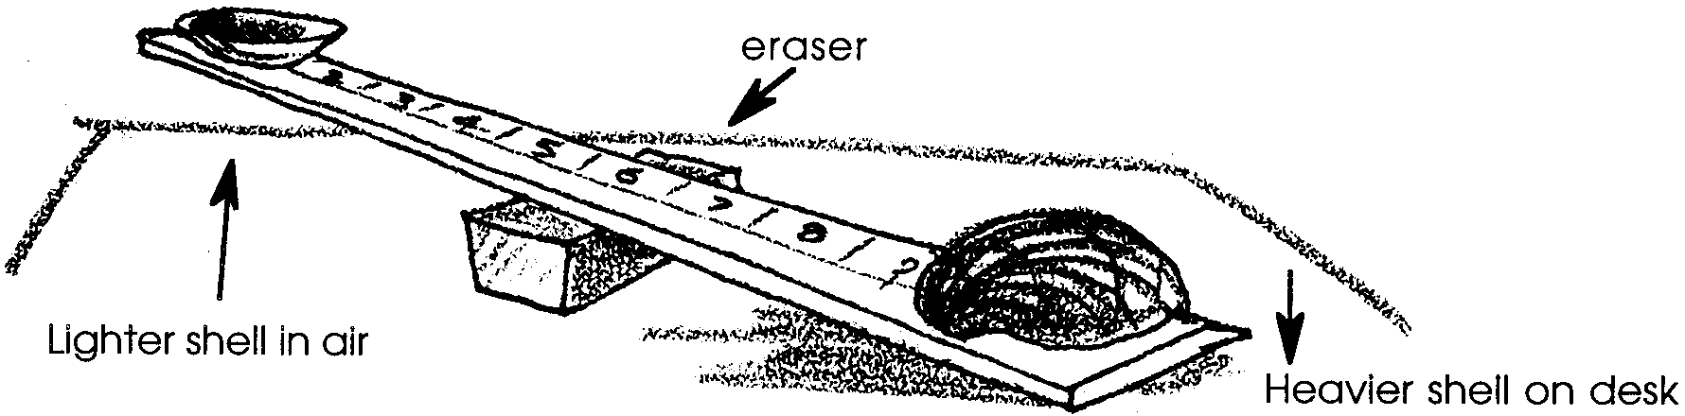

4. Estimate the area of each shell in square centimeters. Write your estimate. Now find the actual area of your shell. Place the shell on the graph paper. Draw a pencil line around the shell. Count each square with half or more of its area inside the line. The total number of squares you count is the area of your shell in square centimeters. Record the area.

