Construct an Estuary
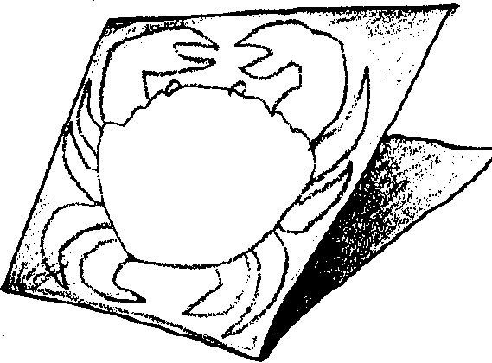
Lesson adapted by Phyllis Schmitt
from “Marsh Math” in the Salt Marsh Manual

Key Concept
1. Plants and animals are structurally and behaviorally adaptated for survival in an estuarine habitat.

Background

Estuaries are rich and dynamic places. A great diversity of plant and animal life is supported in these areas where fresh and saltwater mix. For additional background, see the activity “Where Rivers Meet the Sea.”

Materials

For the class:

• reference books

• a generous supply of art and junk materials for student creativity such as: construction paper, tissue paper, crepe paper, wrapping paper, light cardboard, other papers, cardboard tubes from toilet paper, pipe cleaners, wire, yarn, string, tape, toothpicks, sticks, glue (a glue gun can be a great tool for this project), scissors, hole punch, paints, brushes, crayons, markers, egg cartons, packing foam and cardboard, salt dough, modeling clay, plastic bags, paper bags, etc.

• copies of student activity sheet, “Stuffed Crabs” (optional)

Teaching Hints

“Construct an Estuary” can be an enjoyable, stimulating, hands-on learning activity in which students construct an estuary habitat and its creatures. Students have an opportunity to review what they’ve learned, and will hopefully be stimulated to do further research to find out what these organisms look like and where they fit into the habitat.

This activity works well as a cumulating activity, or any time after students have become familiar with the physical environment of an estuary and with some of its inhabitants. They can add more organisms as they continue the study.

Find an area in the room that has enough space to construct a dramatic model. Have students select which type of estuarine environment to construct in their room: salt marsh, mud flats, slough, eelgrass beds, mangrove swamp. They should also select the location of their estuary on: the Atlantic, Gulf, or Pacific coast. Their choices will determine the plants that will form much of the structure of the model as well as determining the animals they construct.

You may wish to use a technique like that outlined in the activity “Stuffed Crabs” that follows, to get things started, but encourage students to use their own ideas.

Extensions

Kids love secrets! Have a group of students create an audio cassette tape or video titled, “Secrets of the Salt Marsh (or eelgrass bed or slough, etc.)” The narrative could be presented as a choral reading.

