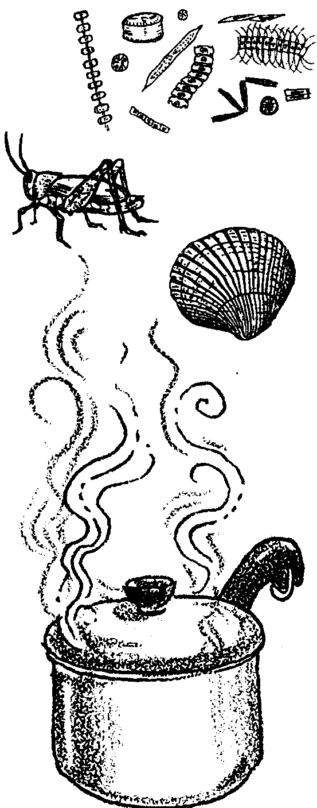
Who's For Dinner?
Lesson adapted by Phyllis Schmitt, Santa Rosa, CA
from “The Web of Life” in Discovering Puget Sound

Key Concepts
1. Organisms in an estuary can be classified as producers, consumers, or decomposers, depending on how they obtain their food.
2. Food chains show the relationships of organisms in an ecological community based on the order of who eats whom. Food chains are crosslinked into food webs.
3. The major source of energy in most marine food webs is the sun.
4. Detritus is an important source of energy in the food webs of an estuary community.

Background

Food chains and webs trace energy flow in an ecosystem and are handy tools for describing how an ecosystem functions.

The major source of energy for life systems on our planet is sunlight, yet only green plants can use this energy directly. They capture the sun’s energy chemically in molecules of sugars that only green plants can make. Other organisms get energy by eating plants directly or indirectly. Their bodies use most of the energy for basic life processes and store some of it. When eaten by other organisms, the stored energy is utilized further.

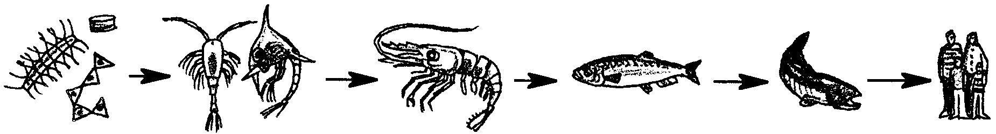
The relationships of who eats whom (the path of energy transfer) are outlined as food chains.
phytoplankton zooplankton shrimp herring salmon human

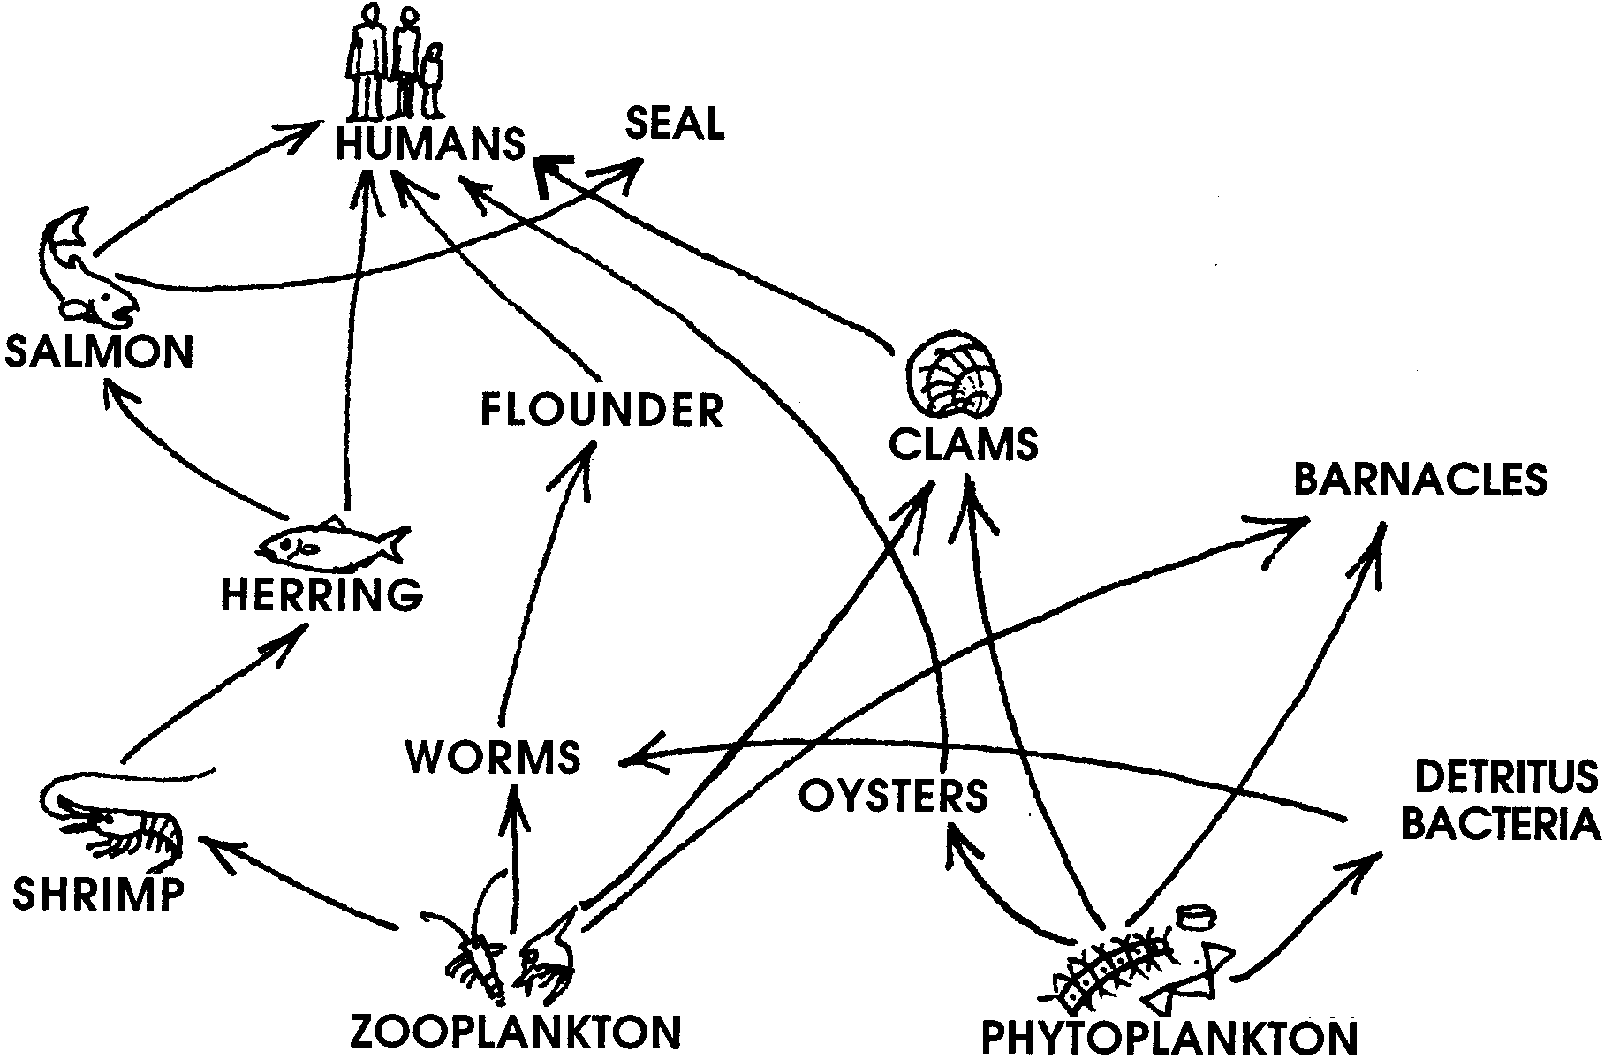
Since almost every organism eats more than one thing and is eaten by more than one other thing, food chains are cross-linked into food webs.

Plankton, which forms the base of many marine food chains, is also present in the estuary. Phytoplankton are called producers because they use the sun’s energy for photosynthesis. Zooplankton and other animals that eat the producers are called consumers. They cannot produce their own food. Organisms that eat the producers are called first order consumers. They, in turn, are eaten by second order consumers, and so on.

When the plants and animals die, they begin to rot, broken down by decomposers. Decomposing material, including body wastes, is called detritus. The decomposers eventually break down detritus into the nutrients used by plants for growth and food production, and so the cycle continues. Detritus is particularly important in the food chains/webs of estuaries. Large amounts of detritus enter estuaries providing food directly to detritus feeders of nearshore food webs, and indirectly to their predators. Detritus, not eaten, gets mixed in the sand or mud, enriching it to provide “food” for new generations of plants.
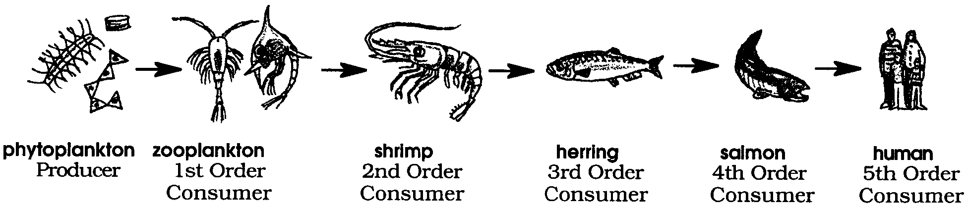

Materials

For each group of 4–6 students:

• packet containing 52 different marine organism cards

• 2 copies of game rules sheet

Teaching Hints

Introduction to the Marine Organism Cards
1. Divide students into small groups (4-6 students) and distribute a set of 52 marine organism cards to each group. Allow exploration time for students to examine and manipulate the cards.

2. Reinforce or introduce the basic concepts of producer, consumer, and decomposer. The Background section for the lesson “In the Eelgrass Bed” provides a good overview of this topic.

3. To help students become more familiar with the cards in preparation for playing the card game, ask them to find and hold up the card for an organism that:
• eats detritus

• is a first order consumer

• is a producer

• is a second order consumer

• is a consumer very near the top of a marine food chain or web

• is a decomposer

Students will see that there are a diversity of organisms that fit each of these roles.

Playing the Card Game

1. Distribute the game rules sheets; 2 to each group.

2. Demonstrate the game procedures: showdown, standoff and challenge with a small group of students.

You might choose to teach the game to one student from each group beforehand, letting them become familiar with it, so they can help others in their groups when the activity is done in class.

3. Be sure students understand the game rules, then have them play for about 20 minutes.

4. When all groups have finished playing the game at least once, ask:

If you wanted to avoid being eaten, which organism would you like to be? Why? (Encourage student discussion. Some students will likely focus on strategies to avoid being eaten, including speed, being poisonous or unappetizing, having big, sharp teeth or spines, or being invisible. Gradually, they should arrive at the idea that animals at the top of the food chain/web have no predators. Examples from the card deck include: Great Blue Heron, orca, river otter, gull, hawk, falcon, sunflower star, and big skate. Even some of these animals may be prey when they are young, and of course, humans have the technology to kill any of the animals in the card deck.)

Where do humans fit in the web of life? (Although our technology seems to make us the ultimate predator, we are still subject to the over-riding “rules of life” on this planet. For example, if the oceans become too polluted and all the phytoplankton die, the base of most of the ocean’s food chains disappears. This would have an obvious impact on humans.)

Key Words

consumer - organism that cannot produce its own food, but eats other organisms to obtain the energy necessary to sustain life

decomposer - organisms which feed on dead plants and animals

detritus - decomposing material, including dead organisms and waste body products

first order consumer - organism that eats producers

food chain - outline of who eats whom showing path of energy transfer in an ecological community

food web - interlocking food chains existing because most consumers eat more than one type of food and are themselves eaten by more than one consumer

organism - general name for any living thing

phytoplankton - plant plankton

plankton - the mostly microscopic plants and animals that drift in water

producer - organism that can make its own food, using inorganic nutrients and energy from the sun

second order consumer - organism that eats first order consumers

third order consumer - organism that eats second order consumers

zooplankton - animal plankton
Extensions

1. Form a food web.

This activity can be done with 32 students, but works better with about 15. Have students sit in a circle. Give each a “Who’s For Dinner?” card with the name and/or picture of an animal or plant that lives in the estuary. One child will take the role of the sun. Hand one end of a ball of yarn to the SUN. Explain to students that they will pass the yarn from one to another as energy from the sun passes to or from creatures in the food chain.

Ask: What uses the sun to make its own food? (Have the SUN pass the yarn ball to a plant while continuing to hold onto the end of the yarn.)

Ask: What eats the plant? (The plant passes the yarn ball to a creature such as a shrimp, while holding onto the yarn.)

Ask: What eats, or is eaten by the (shrimp)? (Continue asking questions and passing the yarn until all organisms are included. At this point the yarn should resemble a web.)

Then, while students are still all holding on to the yarn, dramatize what happens in an estuary if a bulldozer comes to fill the land for construction (or pesticides kill plants). The plants might be killed first. The plant person leans forward as if dead and pulls on the yarn to remind the plant- eaters that their food is gone and they too will die. Continue as additional organisms are affected.

Discuss the interrelationships of all parts of the food web.

2. Construct food chains in a mobile or as paper chains. Don’t forget the detritus and the sun.

3. Research symbiotic associations: commensalism (one organism benefits, the other is unharmed), mutualism (both benefit), and parasitism (one benefits, the other is harmed). Examples in The Marine Biology Coloring Book by Thomas M. Niesen:

page 19 - Innkeeper Worm with goby, clam, pea crab and worm

page 77- Cleaner shrimp and fishes

page 78- Anemonefish and sea anemone

This activity was adapted from "Investigating the Marine Environment and Its Resources", by Violetta F. Lien. Texas A & M University, Dept. of Educational Curriculum and Instruction.
WHO'S FOR DINNER? - Card Game Rules

Two to six people make a good game, however, more can play.

Decide at the beginning how long the game will last. Ask someone to be Timekeeper. Twenty minutes is generally a good time limit after everyone has learned to play.

Deal all 52 of the cards. (Some players may end up with more cards than the others). The game is started by the player to the left of the dealer. Player #l asks another player for a showdown - without looking at their hands, both players lay down one card each at the same time:

• If the organism on Player #1's card eats the organism on Player #2's card, then Player #l takes both the cards, keeping them in his hand.

• If the organism on Player #1's card is eaten by the organism on the other player's card, the other player takes both cards, keeping them in his hand.

• If neither organism eats the other, the cards are returned to the hands of the players. This is a standoff. A standoff also occurs when the organisms played eat each other.

Play now continues moving to the next player, clockwise around the table.

As the game progresses. the players will discover who holds certain cards. Then, rather than ask for a showdown, a player can challenge. In a challenge, the player asks another player for a certain card, and then shows the card with which he is challenging. If the other player has the card called for, the challenger takes it into his hand.

As long as a player wins by challenge, that player continues to play. However, the challenger cannot use the same card twice in a row. In a challenge, unlike a showdown, the challenger wins if the organisms eat each other. If the player who is challenged does not have the card called for, the challenger must give his challenging card to the player who was wrongly challenged.

When a player is not sure who holds certain cards, it is better to ask for a showdown.

The two Death & Decay cards are very powerful. However, their use is limited:

• Death & Decay can be used as a challenging card only once during a player's turn.

• In a showdown decay-consuming organisms (those who feed on detritus) cause a standoff with Death & Decay, but . . .

• In a challenge, the player challenging with a decay-consuming (detritus feeder) organism wins the Death & Decay card.

• A player may capture only one Death & Decay card during one turn by challenging.

When “time is up!”, the player with the most cards is the winner. GOOD LUCK!

