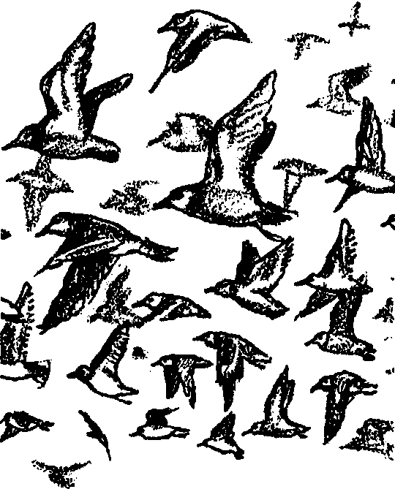
Migrating Down the Flyway
Lesson by Phyllis Schmitt, Santa Rosa, CA
adapted from “ Migration Madness” in the Salt Marsh Manual

Key Concepts
1. Without the feeding and resting areas provided by wetlands, many birds could not obtain sufficient food energy to sustain them throughout their migrations.
2. Many factors affect the success of bird migration.

Background

Bird migrations are truly amazing. Migrating birds can travel thousands of miles between wintering and nesting areas. Most birds do not fly continuously between these areas although they are capable of it. Generally, birds will fly for a few hours and then rest and feed for 1 - 3 days before resuming migration. As human activities fragment the landscape and customary resting and feeding sites are lost or degraded, birds must migrate further between stops. This results in higher mortalities.

The timing of migration is correlated with seasonal temperature changes. During the spring, most birds do not migrate north faster than warming temperatures push the 35°F isotherm northward. This isotherm (iso= same + therm = temperature) is an imaginary line that represents average low temperatures of 35°F across an area; north of this line is cooler than 35°F and south of this line is warmer than 35°F. Movement at this rate ensures that when the birds reach their nesting areas, the ground will not be frozen. In the fall, temperatures affect the amount of available food (i.e. insects and plants die off in cooler temperatures) so the birds keep moving south to places where food is abundant enough to sustain their migration to their wintering areas.

While all wetlands are important, coastal wetlands are especially important because they provide a place for migrating birds to feed and rest. Without these wetland areas, many birds would not get enough food energy to sustain them throughout their migrations.

The Pacific Flyway is the migration route chosen for this activity. Many of the shorebirds and water birds that we see migrate between their wintering areas in South America and their nesting areas in the arctic portions of Alaska and Canada via this flyway. In the United States portion of the Pacific Flyway, 28% of the total flyway wetlands are found in California, 15% in Oregon and 10% in Washington.

If a bird flies between Argentina and Alaska, it will cover 7,000 to 8,000 air miles. Most migrating birds fly at elevations below 10,000 feet; however, many have been observed at elevations of 29,000 feet by airline pilots. Birds fly faster as they approach their northern nesting grounds because the time to nest and raise young before freezing weather comes again is limited. Birds using the Central Flyway have been recorded flying 23 miles per day (mpd) up the Mississippi Valley, 40 mpd across southern Canada, 72 mpd to northern Canada, 116 mpd to arctic Canada and those going on to Alaska at 150 mpd. One duck was reported to have flown from Alberta, Canada to Venezuela, South America in one month (approximately 125 mpd); this trip usually takes 2 - 3 months!

Materials

For the class:

• transparency of map

For each group of four:

• a piece of string 20 cm. long

• crayons or marking pens

• copies of the student worksheet, “Migrating Down the Flyway”

• copies of the “Migration Map”

• a calculator

Teaching Hints

1. Display the transparency map. Familiarize students with the map.

2. Group students into working teams of four. Have students work together to list:
a) factors that could help migratory birds
b) factors that could make migration more difficult

3. Discuss students’ lists. Have students examine their lists to consider how some of the factors that make migration more difficult could be avoided. The lists on the following page may be ideas they suggest:

FACTORS AFFECTING MIGRATORY BIRDS

Factors Limiting Survival Factors Favoring Survival

* wetland drainage * preservation of wetlands

* drought * high rainfall

* pollution and contamination of water * restoration of habitat

* urban expansion; development * human action aimed at protecting
and restoring wetlands

* conversion of wetlands to farmland * human action aimed at protecting
and restoring wetlands

* illegal hunting * regulation of hunting

* lead shot in food supply * regulation of hunting

* disease * balance with predators

4. Have students work together in their study groups to read and complete the worksheet. Discuss their responses. Guide students, as needed, in following the instructions for the map activity. The “challenge” question requires division. Depending on the math skills of your class, you may wish to ignore the question, determine the answer as a group, or provide calculators for students to use in calculating the travel times on the chart. Provide the following relationship for calculating migration time:

time = distance
speed

Key Words

migration - the seasonal movement of animals from one region to another

nesting area - place where birds build their nests during the
breeding season

Pacific Flyway - the major pathway for bird migration along the Pacific coast and extending inland.

recorded - information has been collected and written or preserved in some way

temperature - the degree of warmth or coldness of an environment
Extensions

1. Have individuals or groups research the migration path of another bird that uses the Pacific Flyway, then draw its migration path on the Pacific Flyway map and label the path with the bird’s name.

2. Students create slogans for posters, bumper stickers, T-shirts, or maybe a rap song, with messages about the importance of coastal wetlands and estuaries for migrating birds.

3. Students create an original Migration Book of Records.

4. Read aloud the following poems: “Something Told the Wild Geese” by Rachel Field and “Wild Geese” by Tsumori Kunimoto.

Answer Key
1. Most birds stop on their flight north to rest and feed, to restore their energy.
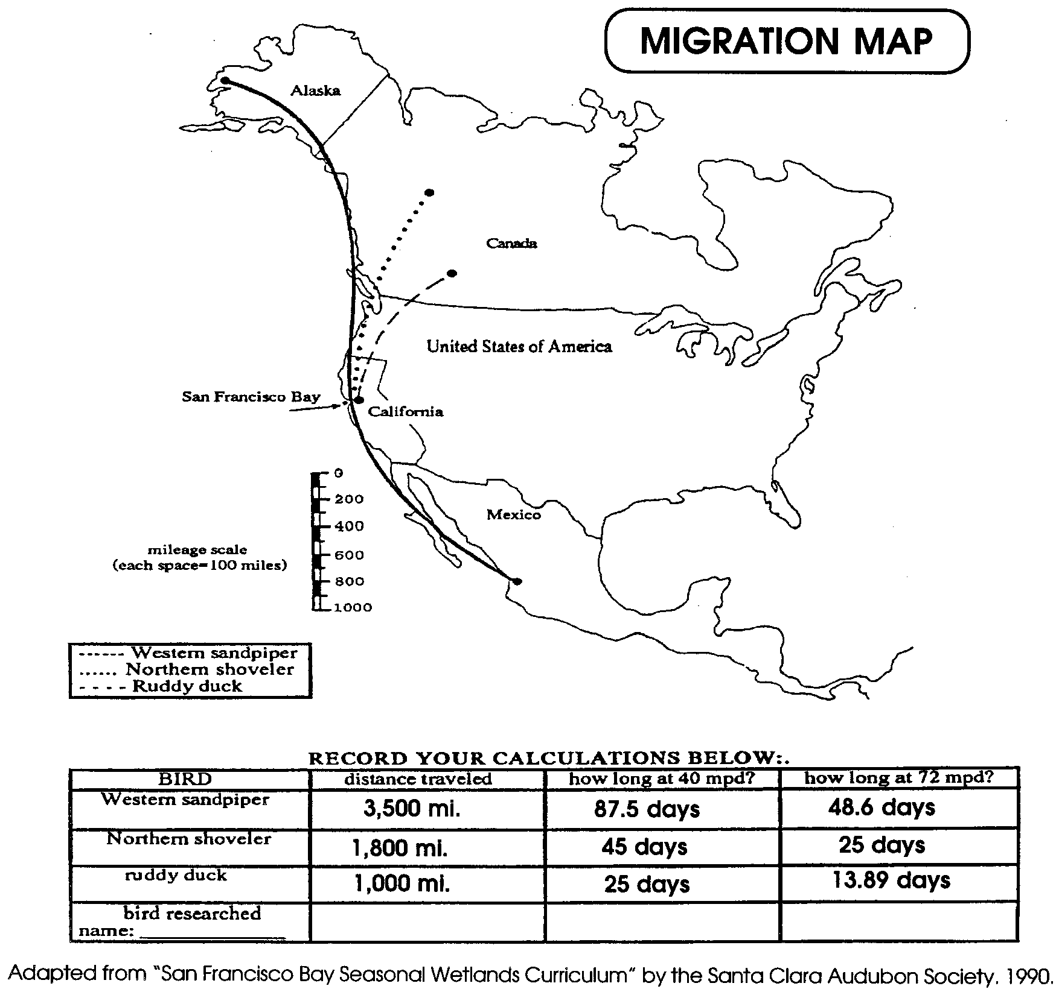
2. & 3. Asks for student opinions or creative ideas.

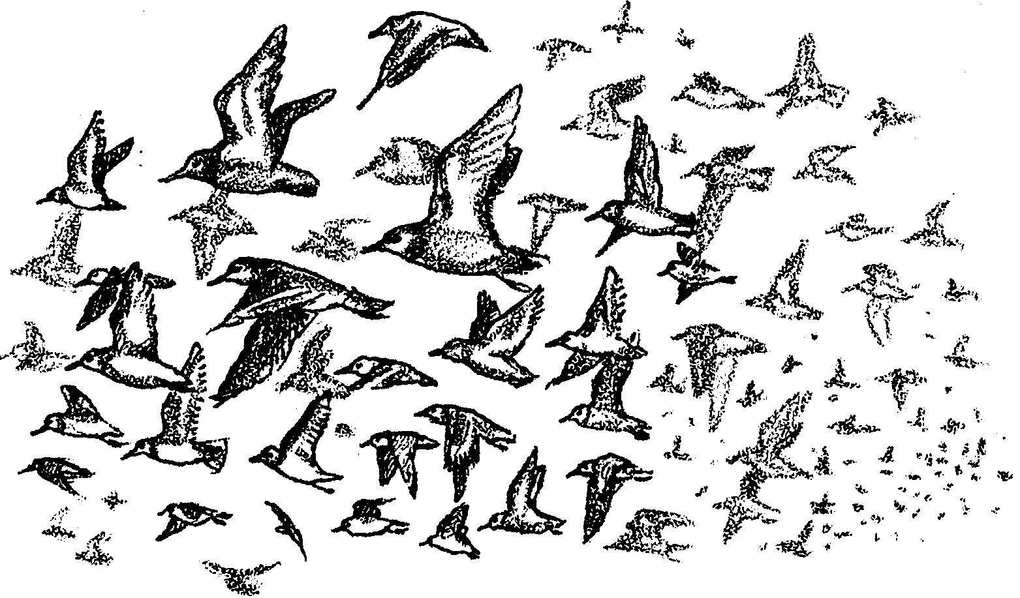
Migrating Down the Flyway

Each year many birds travel long distances. They fly from their winter homes to their summer nesting areas in the north. This seasonal movement is called migration. Some birds fly between winter homes in Argentina and nesting areas in Alaska. They travel over 7,000 miles each way! Some birds fly night and day. They stop only to quickly feed. Most will fly for a few hours and then rest and feed. They may wait for 1-3 days before flying on.

The birds don't always fly at the same speed. Nearer to their nesting areas they often fly faster. Birds that fly 23 miles per day (mpd) in Mississippi, fly 150 mpd across Alaska.

The birds sense the temperature as they head north. They cannot build their nests if the ground is still frozen. But they can't wait too long, either. Babies born late in the season will be too weak to make the long flight south. The birds can't stay in the north too long. They will not have enough to eat. The insects and plants they use for food die as the days grow colder.

Wetlands, including estuaries, are important in migration. Wetlands are often safe places. The birds can rest in the wetlands. They can also find the food they need to restore their energy.

1. What do most birds do when they stop on their flight north?

2. Why do you think many birds fly faster as they get farther north?

3. Pretend you are an older migratory bird. You are talking to a young pair of birds making the flight north. What will you tell them so they’ll have a safe trip and nesting season?

4. Use the “Migration Map” to find out how long it would take three different birds to reach their nesting areas.

Here’s what you’ll need:

• string
• a copy of the “Migration Map”
• 3 different colored markers

Here’s what to do.

1. Find the migratory paths drawn on the map. Hold one end of the string at the end of one of the paths. Lay the string along the path. Be sure to follow it exactly. On the string, mark the end of the path.

2. The string now shows the distance of the migratory path. Find the mileage scale next to the map. Compare the string to the mileage scale. How many miles did the bird travel?

3. Repeat steps 1 and 2 for the other paths shown on the map. Use a different color for each path. Write your answers in the spaces on the chart below the map.

4. Challenge: How long would it take each bird to reach its northern nesting grounds if it traveled at 40 miles per day (mpd)? at 72 mpd?

TIME = DISTANCE
SPEED

Write your answers on the chart.
