Dangerous Journeys
Lesson by Phyllis Schmitt, Santa Rosa, CA
Adapted from “Lucky Ducky” in the Salt Marsh Manual

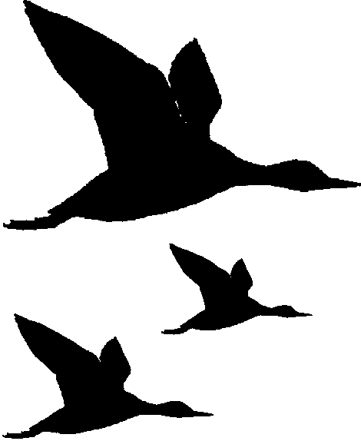
Key Concepts
1. Coastal and other wetlands provide birds with protected resting areas during migration.
2. Migration is an adaptation that provides birds with access to favorable weather conditions and a plentiful food supply
3. Birds face many hazards during migration.

Background

Migration Patterns
The migration of birds usually refers to their regular flights between summer and winter homes. Through natural selection, migration evolved as a beneficial behavior. There is considerable discussion and experimentation regarding whether the behavior is innate or learned.

In the northern hemisphere, birds migrate north to nest and breed because the competition for food and space is substantially lower there. Additionally, during the summer months, the food supply is much better in many northern climates. Migrant species are usually assured of adequate space and ample food upon arrival at their summer habitat. For those of you still thinking about the evolution of migration, here’s the next question: How did migration evolve when the food supply at the other end of the migration is unknown? Nonmigratory species, ones that stay behind to nest, also benefit from the migration because it reduces competition.

Several adaptations enable birds to migrate. Most migratory birds have very powerful flight muscles. They also have a highly developed respiratory system, hollow bones, internal air sacs, and specialized body shapes. All of these features enable them to fly high, fast, and for long periods of time. They recognize landmarks, follow weather patterns, sense the magnetic field of the earth (for direction), and follow strong inherited instincts.

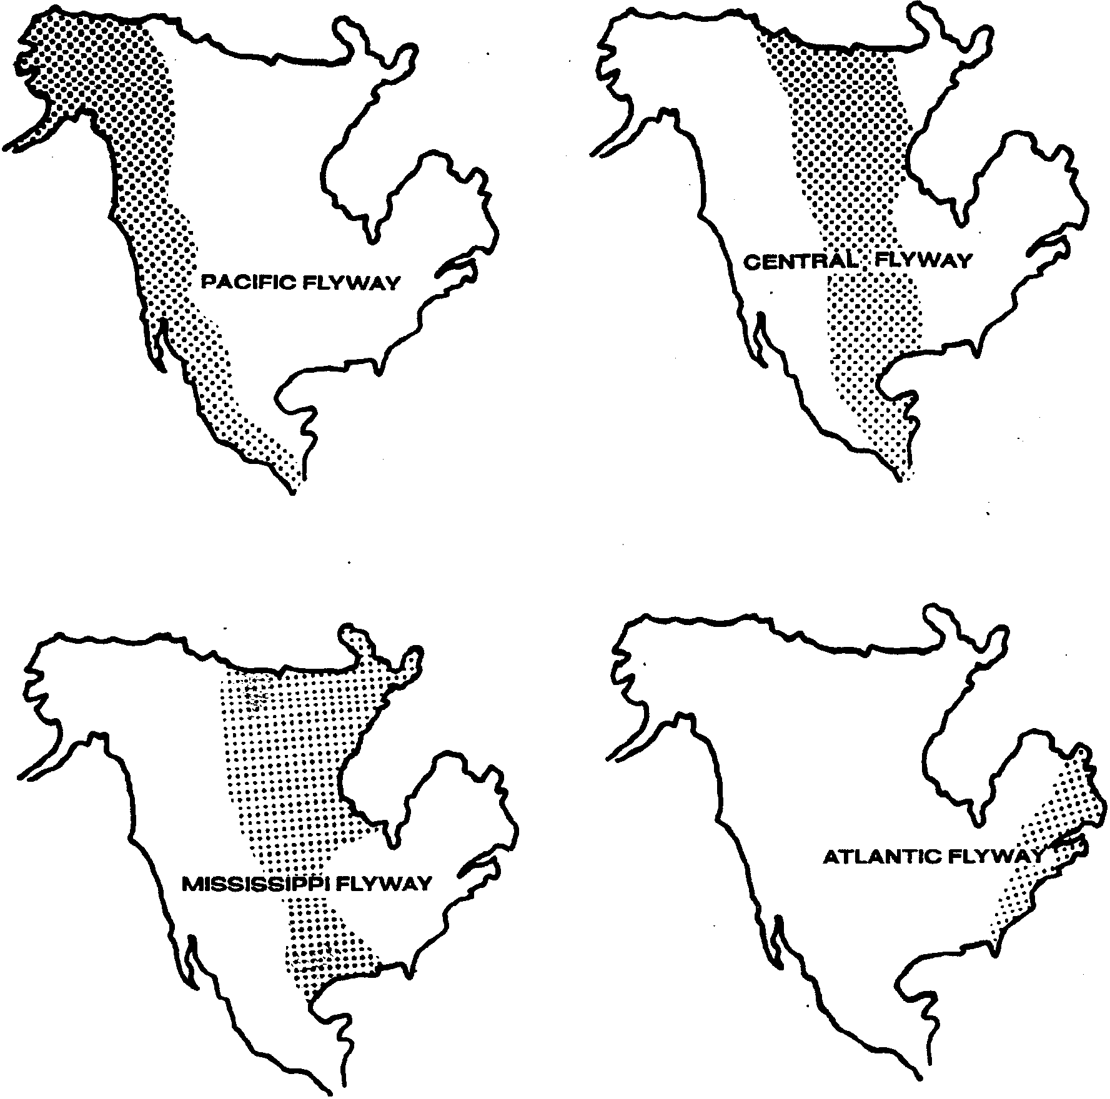
Times of annual migrations are not the same for all birds. Shorebirds begin their southern migration in early July, but other species, such as geese, do not begin until late fall. Some birds have a leisurely migration, while others fly swiftly to their destinations. Generally speaking, spring (northern) migrations are faster than fall (southern) migrations because of the stimulus to breed and nest. Migratory birds may travel during the day, night or continuously, depending on the condition and the bird species. Water birds and shorebirds utilize four major migration routes in the United States. They are the Pacific, Central, Mississippi and Atlantic flyways.

The open bays, salt marshes, mudflats and protected sloughs of estuaries typically provide plenty of food and shelter for migrating birds. Many spend the winter in estuaries while others pass through to winter in areas further south.

Migration Hazards
Birds face many hazards while migrating. Storms may blow them off course, cold weather may reduce the availability of food, and disease outbreaks may occur when large numbers of water birds and shorebirds feed and rest in the same area. Migratory birds face the risks of predation by hunters and predators, such as the fox. Humans have also created obstacles for these birds. Collisions with power lines, radio towers or even buildings, often occur because many birds migrate at night. Car and boat traffic and human noises increase risk of injury. Much of the traditional habitat used by migrating birds has been lost to development or farming. Lastly, pesticides and pollutants may become concentrated in wetland areas, thereby threatening the health of the birds. Despite all the hazards migrating birds encounter, many of them successfully migrate each year.

Migrating animals do not recognize political boundaries, traveling across both international and state borders. Protection of these birds within the United States is in the hands of the Department of the Interior U.S. Fish and Wildlife Service. Treaties with Canada and Mexico extend protection throughout the North American Continent. Protective laws regulating hunting of ducks and geese are established according to conditions in each of the flyways. Depending on population sizes, the hunting of certain bird species may be restricted or banned.

Migratory Bird Data Center
Banding, the attachment of identification tags to individual birds and other kinds of wildlife, has facilitated the determination of many migration routes. Amateur naturalists in Europe pioneered bird banding with biologists worldwide subsequently adopting the practice. There are several dozen banding centers throughout the world. We are fortunate to have a facility where many of these activities can be coordinated, the Department of the Interior Bird Banding Laboratory in Maryland. In cooperation with the Canadian Wildlife Service, this center coordinates the banding activities of about 4,000 professional and amateur ornithologists (those who study birds) throughout North America and several foreign countries.

Hunters and others send bands they find on birds and facts of their recovery to the Bird Banding Laboratory. The receipt of this information helps scientists understand the population dynamics and migration routes of birds. Thousands of recoveries come in each year. Computers help the scientists keep track of information.

How Can You Help?
Many birds are banded on a leg with a metal band. If you see a bird with a bird band, record the numbers on the band as well as the date and location of the sighting. Send this information to:

Fish & Wildlife Service
Bird Banding Laboratory
Office of Migratory Bird Management
Laurel, Maryland 20708
Materials

For the class:

• a large jump rope (windstorm)

• 2 cardboard boxes (represent boats)

• at least 30 each of 4 different colors of food tokens

• a large, open area

Teaching Hints

Students simulate water birds and shorebirds and the hazards they face in this highly active game that portrays an annual migration cycle.

Preparation
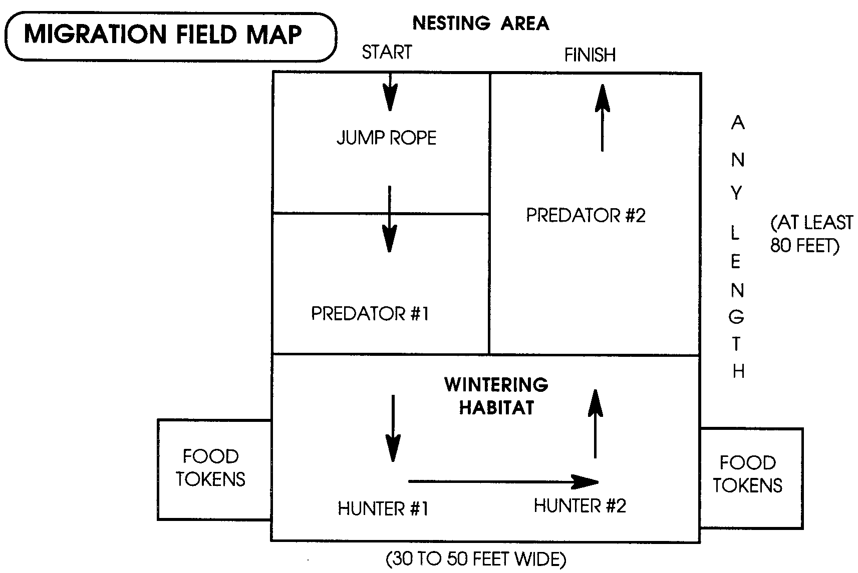
Set up a playing field as shown:

1. Choose students to play these roles:

- 2 students to operate the jump rope (windstorm)

- 2 students to be predators (a fox, a hawk, etc.)

- 2 students to be hunters

- 2 students to distribute food tokens.

The remaining students are ducks.
2. Explain that the challenge of this activity will be for the ducks to migrate from the nesting area to the wintering area and back again, without veering off course, falling prey to a predator, or being hunted.

As “ducks” move through the playing field they must pass through a windstorm (jump rope) without being hit, avoid being eaten (tagged) by a predator, and avoid being shot (tagged) by a hunter.

3. The game begins with the “ducks” at their nesting area in the north. The first obstacle is the windstorm. The ducks must fly through the jump rope without being hit (hit=death). Next, the ducks must pass the first predator and enter the wintering grounds without being tagged (tagged=death). During their stay in the wintering grounds, the ducks must avoid being tagged by the hunters (tagged = death).

The hunters may move around the area, but they must keep one foot inside a box at all times; the boxes are their boats. While in the wintering grounds, the ducks must travel east and west (back and forth) across the area to gather their food tokens. Ducks must gather 4 food tokens of any kind, but they can only receive one food token at a time. They are “safe” in the food token area but not while moving between them.

4. After the ducks successfully gather their 4 food tokens they must migrate back to the nesting area. In order to arrive safely at their nesting grounds, the ducks must avoid being tagged by the second predator, the last obstacle. When ducks are tagged or hit they “die” and go to the side of the playing area until the next round.

5. After all the ducks have either successfully migrated or died, choose one color of the food tokens to represent toxic food. Any bird who ate them has just become very sick and dies. Usually few, if any, of the ducks will survive the first round.

6. Adjust the obstacles as necessary to allow some of the ducks to survive. Change roles and repeat the migration as long as interest is high.

7. Conclude the activity with a review of migration cycles and the hazards they may face. Ask the students how they felt during the migration.

Key Words

annual - each year

bird banding - the attachment of identification tags to individual birds

hazards - dangers

migrant - an animal that moves from one region to another with the change of seasons

migration - movement from one region to another with the change of seasons

obstacle - anything that gets in the way or hinders

ornithologist - a specialist in birds

predator - animal that kills and eats other animals

wintering grounds - place where migrating animals spend the winter

Extensions

1. Plan a field trip to an estuary or wetland where water birds are stopping during migration or for the winter.

2. To prepare students for observing birds through binoculars, have them practice with the binoculars in the classroom. Do this by selecting about 6 bird silhouettes from the page included in this guide. Obviously, it is best to select birds they are most likely to observe during their visit to an estuary or wetland. Teach students the names of these six birds in silhouette. Cut the 6 selected silhouettes out and tape them in different places, all around the room. Call out the name of one of the birds, and have students use binoculars to focus on that bird, as quickly as possible. This simple drill really helps students learn to use binoculars for observations in the field.

3. Students can prepare a report on a bird and map its migration.

4. Original fiction stories can be written by the students telling of a bird’s adventures during migration.

5. Have students dramatize an estuary on one of the flyways during different seasons of the year. Which birds are resident? Which are migrants?

6. Have students create a travel brochure advertising the qualities of a particular estuary for migrating birds.

7. Have students create a jacket or cover for an estuary compact disc. What is the name of the CD? What are the song titles included? What are the pictures included?

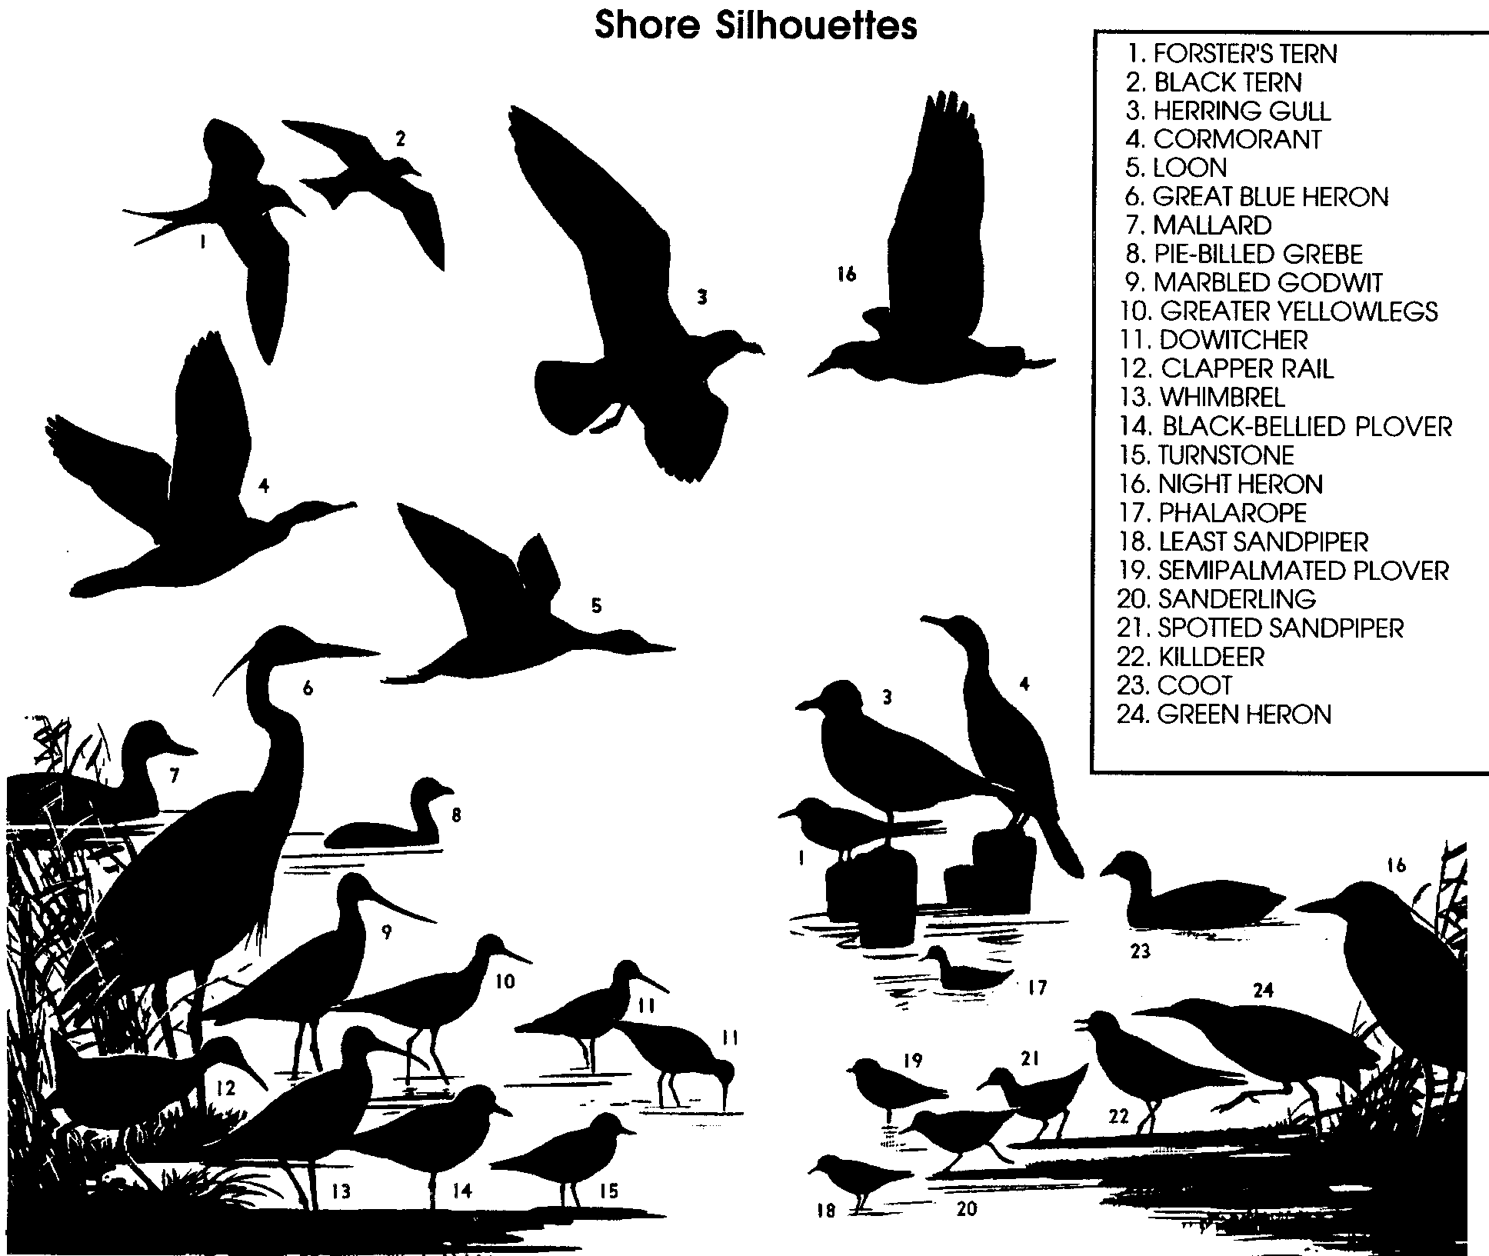

Adapted from the activity “Lucky Ducky” found in the Salt Marsh Manual - an educator’s guide to San Francisco Bay National Wildlife Refuge. 1992

Food Tokens Master

1. Duplicate on colored paper (at least 30 markers of four different colors required).

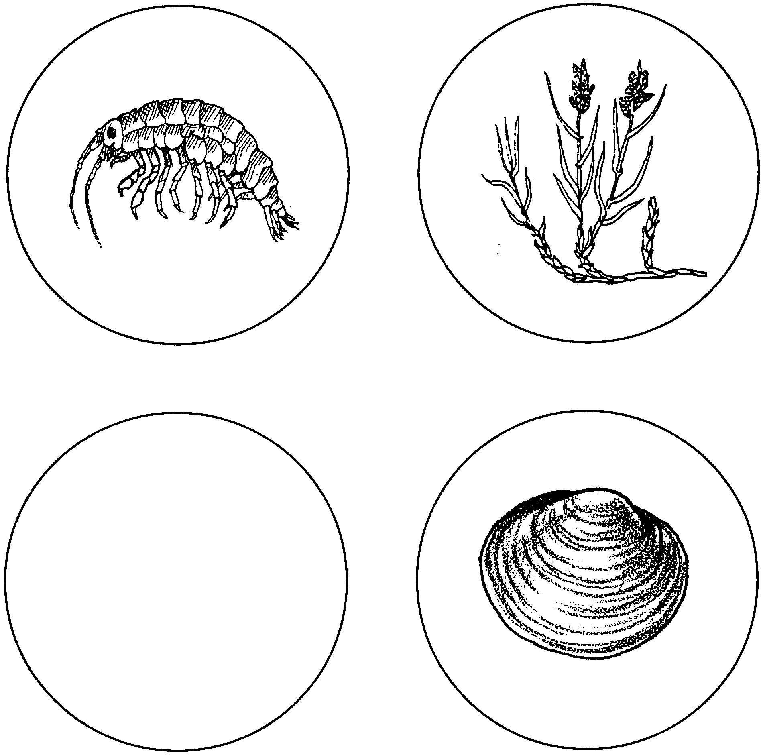
2. Laminate and cut out tokens.

