Beaks and Feet
Lesson by Laurie Dumdie, Poulsbo, WA

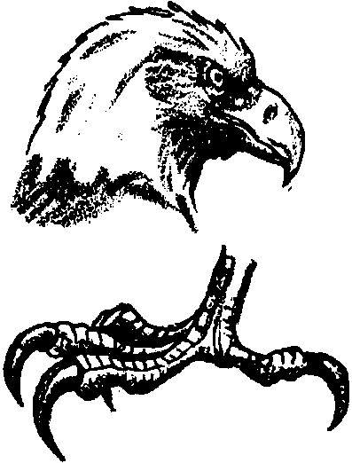
Key Concepts
1. Birds use their beaks and feet to search for food.
2. Observable characteristics of a bird's beak can be used to predict its feeding behavior in the estuary.

Background

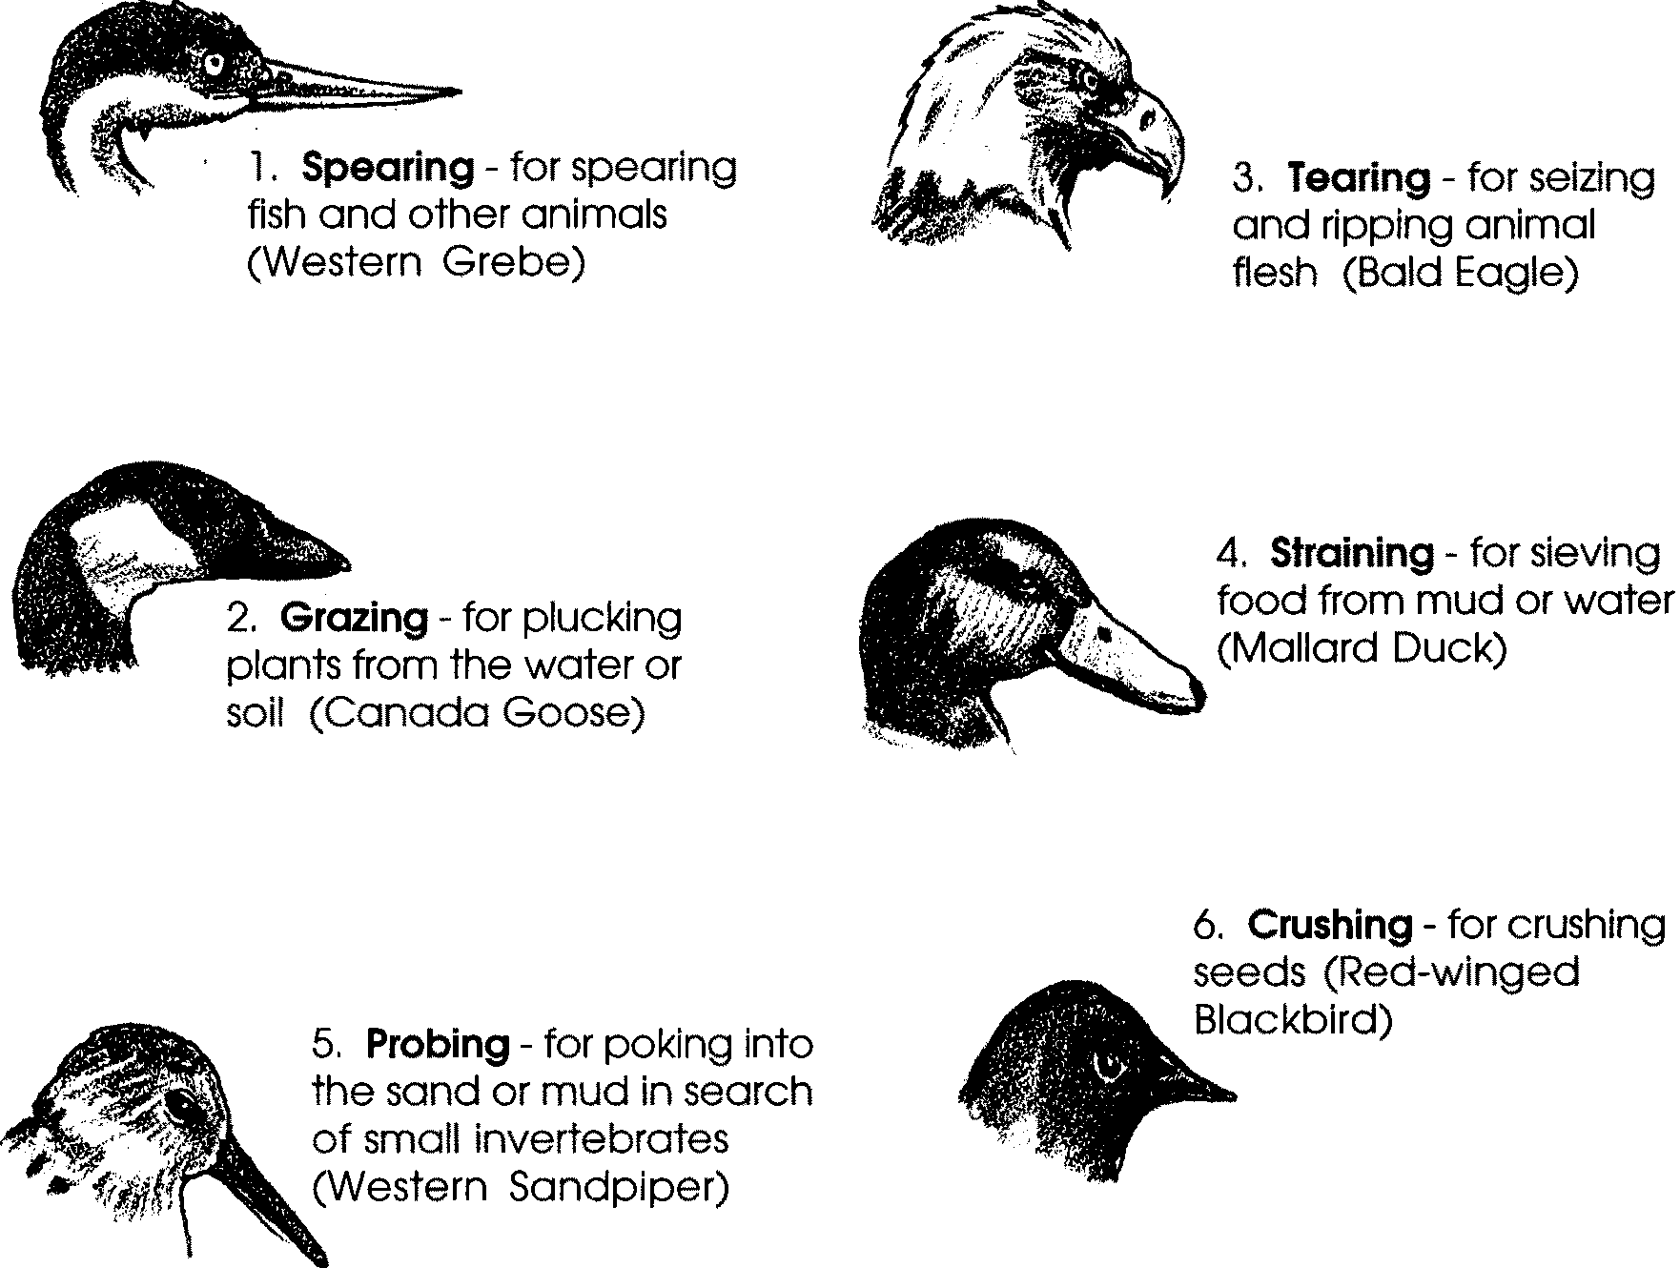
Estuaries provide homes for a wide variety of birds which possess special adaptations for feeding. Bird beaks especially come in a diversity of shapes and sizes reflecting different feeding techniques. Some common functions for bird beaks in the estuary include:

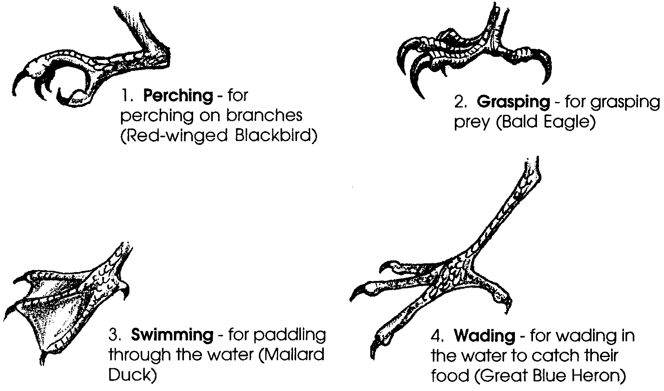
Bird feet also come in a variety of shapes and sizes reflecting different “lifestyles” including:

An excellent resource for this lesson is the poster: “How Birds Make a Living On the Coast” by Will Hon, University of Georgia, Marine Extension Service, Savannah, Georgia 31416

Materials

For each team of two students:

• copies of the beaks and feet sorting cards

• scissors

• spoon, scissor, clothespin, and tweezer (1 each); representing types of bird beaks and used in “An Assortment of Beaks”

Teaching Hints

1. “An Assortment of Beaks”, which preceded this lesson, ended with the question:

What other parts of a bird do you think are important to its feeding success?

Begin with a review of student responses, or re-solicit new responses. If students have not discussed adaptations of birds’ feet, explain that a bird’s legs and feet, like its beak, are adapted for living and feeding in a specific habitat.

2. Distribute a set of the beaks and feet sorting cards to each two students. Have them cut the cards apart on the dotted lines.

3. Have students put all the feet cards, aside, in a pile and spread out the beak cards. Explain that you will be asking some questions and they will answer by holding up the card(s) in response to your question. You may advise that each person take turns holding up the card(s). This technique allows a quick check around the room and provides help for students struggling for a response.

4. Display the spoon, scissors, clothespin and tweezer from the activity “An Assortment of Beaks” that represented bird beak types. Ask questions like:

Which beak(s) are most like the “spoon”? (These are the STRAINING beaks. Birds that have a spoon-like beak can scoop up large numbers of small fish or strain plant material from the water or mud. Specific birds are: Mallard duck (shown on beak card), Northern Shoveler, American Widgeon, White or Brown Pelican, Roseate Spoonbill.)

Which beak(s) are most like the “tweezer”? (These are the SPEARING AND PROBING beaks. A bird with a short “tweezer” beak eats animals near the surface of a mudflat, whereas a bird with a long “tweezer” beak can reach animals that burrow deep into the mud. Specific birds are: Western Grebe (spearing) and Western Sandpiper(probing; shown on beak card), Dowitchers, Great Blue Heron, Snowy Egret, Willet.)

Which beak(s) are most like the “scissors”? (These are the TEARING and GRAZING beaks. Some birds have scissor-like beaks that rip their food apart into bite-sized pieces. Specific birds are: Bald Eagle (tearing) and Canada Goose (grazing; shown on beak card), Northern Harrier, Owls, Osprey.)

Which beak(s) are most like the “clothespin”? (These are the CRUSHING beaks. Clothespin-like beaks are excellent for crushing the hard covering of seeds found in the forest behind the saltmarsh of the estuary. Specific birds are: Red-winged Blackbird (shown on beak card), Rufous-sided Towhee.)

5. Have students put the beak cards aside and spread out the feet cards. Ask questions like:

Which feet would be good for wading in the water and searching for fish? (the long-legged, wading feet; These birds usually catch their food by wading in the deep or shallow waters in marshes. Specific birds are: Dowitchers, Great Blue Heron (shown on feet card), Dowitchers, Snowy Egret, Willet.)

Which feet would be good swimming feet? (the webbed feet; Specific birds are: Mallard duck (shown on feet card), Northern Shoveler, American Widgeon, White or Brown Pelican, Roseate Spoonbill.)

Which feet would be good for perching? (the perching feet; Specific birds are: Red-winged Blackbird (shown on feet card), Rufous-sided Towhee.)

Which feet would be good for catching prey? (the sharp-clawed grasping feet; Specific birds are: Bald Eagle (shown on feet card), Northern Harrier, Owls, Osprey.)

Key Words

adaptation - a characteristic (body part, behavior, etc.) that helps a plant or animal survive

habitat - place where a plant or animal lives; home

Extensions

1. Challenge students to match each of the beaks and feet pictured on the sorting cards to actual birds.

2. Have students create a drawing or model of an imaginary bird that feeds in the estuary. Choose the habitat for the bird and then design a bird to fit their habitat. The following questions can be used to ensure that the bird has all the necessary “ingredients”:

a. How does it eat?

b. Is a predator or prey? (or both?)

c. How does it move?

d. What size is it?

e. What color is it?

f. What special adaptations does it need to live in the estuary?
g. Is it active during the day (diurnal) or at night (nocturnal)?

h. How does it relate to humans?

i. What is its name?

If time allows, have the students draw or create the bird’s habitat around it. As students share their bird with the class, encourage them to describe its unique adaptations.

3. Challenge students to make a flip-book or zoetrope strip that shows a pelican or eagle swooping down and scooping up fish from the water.

4. Read aloud the following poems: “Great Blue Heron” by Jane Yolen, “Duck’s Ditty” by Kenneth Grahame, and “Gull” by William Jay Smith.

