An Assortment of Beaks
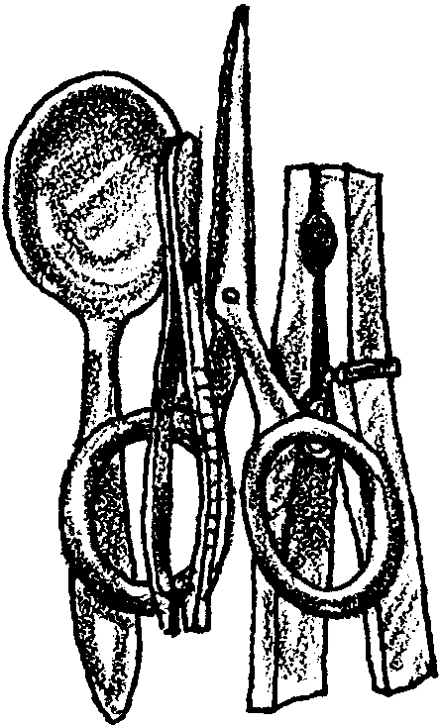
Lesson by Phyllis Schmitt, Santa Rosa, CA
Adapted from “What Can I Eat With This Beak?
from the Salt Marsh Manual

Key Concepts
1. Birds possess a number of special adaptations for feeding.
2. Different behaviors and feeding habits allow several species of birds to live in the same habitat at the same time.

Background

Estuaries provide a home (habitat) for many types of birds. A variety of species are all able to live in the same place, sharing the hundreds of food organisms that live in an estuary: worms, clams, snails, crustaceans, etc. The different types of birds have beaks that are especially adapted for different feeding techniques.

Each bird has a unique diet, reflected in its beak type. Bird beaks “match” the type of food they eat. For example, many birds have tweezer-like beaks. A bird with a short “tweezer” beak eats animals near the surface of a mudflat, whereas a bird with a long “tweezer” beak can reach animals that burrow deep into the mud. Some birds have scissor-like beaks that rip their food apart into bite sized pieces while other birds have clothes-pin-like beaks that are excellent for crushing the hard covering of seeds. Lastly, birds may have a spoon-like beak that can scoop up large numbers of small fish or strain plant material from the mud. Specific birds matched to each of these beak types are:

SPOON BEAK SCISSOR BEAK CLOTHESPIN BEAK TWEEZER BEAK
blue-winged teal perching bird American goldfinch great egret
Northern shoveler northern harrier marsh wren snowy egret
mallard duck caspian tern house finch great blue heron
white pelican white-tailed kite scrub jay hummingbird
owl seed eaters dowitcher
black-necked stilt
sandpiper

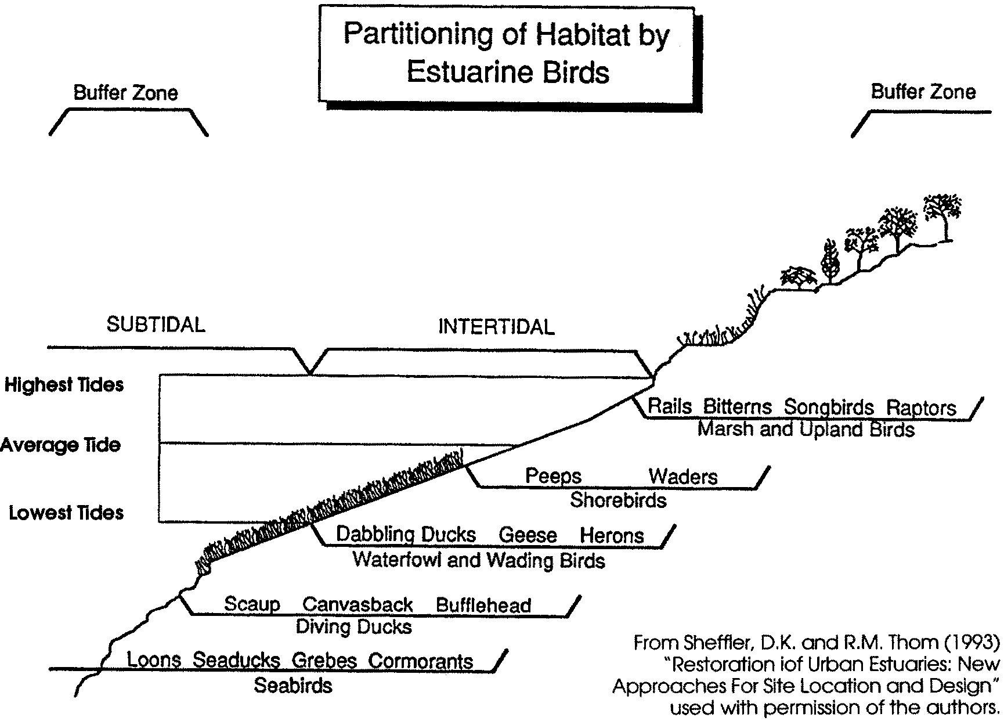
The diversity of beak types and diets enable numerous birds to live in the same area at the same time (coexist). This is why you may see many types of birds feeding together in one area of the estuary. The following diagram shows this partitioning of the estuarine habitat.

Materials

For the class:

• a small, plastic cup for each student participating (bird stomach)

• 8 spoons (bird beak)

• 8 scissors (bird beak)

• 8 tweezers (bird beak)

• 8 clothespins (bird beak)

• at least 30 marbles (snails)

• at least 30 pieces of pipe cleaners cut-up (worms)

• at least 30 metal washers (beetles)

• at least 30 paper clips (fish)

• at least 30 heavy paper or plastic strips (eelgrass leaves)

• a transparency of the data sheet or blackboard for recording results

Teaching Hints

1. Have students sit in a circle or in two lines facing each other. Begin the activity with a general discussion about bird beak types. Have students describe bird beaks they have seen. Pictures may be useful for this discussion.

2. Display the beak utensils one at a time: spoon, scissor, clothespin, and tweezer. Ask students for examples of food in the estuary that each beak type would be good for retrieving. Keep a list of their ideas.

3. Distribute randomly, one of the 4 utensils to each student. Now, have students imagine they are a group of birds flying into the estuary to feed. Explain the utensil represents their beak. Encourage them to think about their wings, feet, beak, and their empty stomach. Distribute a small plastic cup to each student, explaining this is their empty bird stomach. Explain that the area in the circle or between the two lines represents the estuary into which they will fly to feed.

4. Explain the following rules during the feeding session.

a. All birds must pick up their food, using only their beaks, and put it into their stomachs.

b. Food may not be scooped or thrown into the stomach - the stomach must be held upright.

c. Birds can only feed when given permission to do so.

d. As leader, you are a hawk that eats birds. Explain that unusual behavior of a bird often draws the attention of a predator and that you will notice birds exhibiting unusual behaviors and might choose to eat them. Unruly behavior or violations of the rules result in the hawk capturing the conspicuous bird and making it sit out for one round.

5. Spread one type of food (marbles, paper clips, pipe cleaners, or washers) over the feeding area. Choose a signal for stopping the action. Give the birds permission to leave their nests and feed. Allow the birds to feed for about 1 minute then signal them to stop feeding and return to their nests. Have similar beak- types get together to count the total number of food items they collected and record results on the data sheet.

6. Repeat the feeding steps for each food item. Then, for a more natural situation, mix all the food items; an area seldom has one type of food. Before feeding ask each “beak type” to state what they will spend their time eating. You may facilitate this discussion by sharing the following idea: birds spend the least energy by first eating the food they can gather the easiest (the results from the earlier rounds should have illustrated this point). As it gets harder to find their first choice, the birds switch to a secondary food item. Note that the ease of gathering a particular food item is a function of beak type. Record results.

7. Ask students to summarize results. Have them compare beak types. Ask them to rank the beaks for effectiveness and to provide reasons for their rankings.

Discuss questions like the following:

• Are some beaks better for eating a particular food item than other beaks? (refer to data sheet for results)

• What differences did you notice in feeding behavior when all food items were passed out? (Probably less fighting for food because there was enough for all birds.)

• In what part of the estuary does each beak type probably forage for most its food?
(tweezers = mudflats (egrets, herons) or upland (hummingbirds)
scissors = upland (hawks) or saltmarsh (terns),
spoon = slough or saltmarsh (ducks, pelican)
clothespin = upland or saltmarsh (wren))

• What other parts of a bird do you think are important to its feeding success? (This question is the transitional thought for the next lesson. Record students’ ideas and begin the next lesson, reviewing their responses to this question.)

Key Words

adaptation - a characteristic (body part, behavior, etc.) that helps a plant or animal survive

habitat - place where a plant or animal lives; home

Extensions

1. Construct a bar graph to chart the results of the activity.

2. Help set the mood with poems such as “The Reason for the Pelican” by John Ciardi, “Sandpipers” and “The Pelican” by Aileen Fisher.

