Who Flies There?
Lesson by Phyllis Schmitt, Santa Rosa, CA
adapted from the Salt Marsh Manual
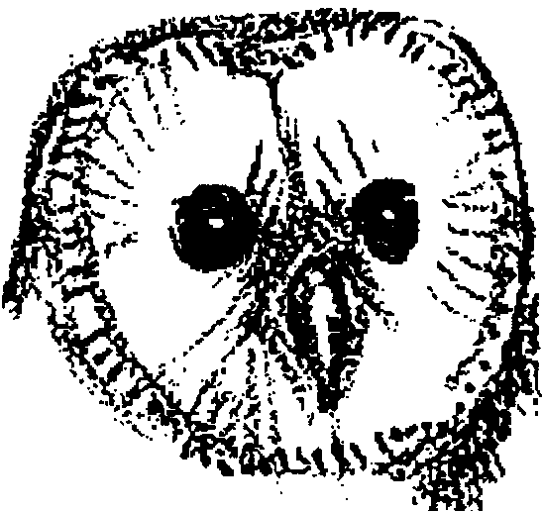

Key Concepts
1. A wide variety of birds utilize the resources of the estuary.
2. Observable characteristics can be used to sort and classify birds.

Background

Among the clearest indicators of the riches of the estuary are the great numbers and variety of birds that use this important habitat. Many make the estuary their year-round home, but far greater numbers use the environment as a winter refuge or as a temporary fueling station during migration.

Materials

For each group of four:

• a set of bird picture cards

Teaching Hints

1. Tell students that they will be receiving a set of cards showing pictures of very obvious creatures in the estuaries. If the students you teach live near an estuary, ask what creatures are very noticeable in the estuary. Elicit the response “birds”. Explain that each group will receive a set of pictures of some of these birds.

2. Distribute the picture sets and have students sort the bird pictures into groups of birds that are the same, based on observable characteristics. It is recommended you not identify a specific number of groups. Rather, have students study the pictures carefully to identify common and unique characteristics of the birds. Observable characteristics that students may use in setting up the classifications: shape or size of bill, types of feet, shape of tail, etc.

The purpose of this activity is to help students become aware of the diversity of birds in the estuary. It is not important that groupings reflect the classification systems used by scientists and bird watchers. Since the pictures show only one posture for each bird, and no behaviors, many characteristics used by bird watchers will not be visible.
3. Call on each group to share how they sorted the pictures. Create a list of their classifications and identify these features as characteristics of the birds.

4. Discuss student observations. To stimulate interest for the upcoming activities, ask questions such as the following :

• How do some of these characteristics help birds adapt for survival in the estuary?

• What eats these birds?

• How do some of these birds protect themselves from predators?

• What are these birds eating in an estuary?

• What are some ways they eat?

• How do tides affect the ability of birds to feed in the estuary?

• Where do shorebirds go at high tide?

• Why do you think so many and such a variety of birds use the estuary?

• Why do you think there are great differences in the numbers and types of birds in the estuary at some times of the year?

• How do you think development in the estuary affects birds?

Key Word

characteristic - a distinguishing trait or property

Extensions

1. Have teams of students research a species of bird that uses the estuary and report their findings in “An Interview With a Great Blue Heron” format. One student plays the reporter going into the estuary to interview some of the frequent, feathered visitors.

2. Have students describe how two different birds are alike and different by writing a pretend conversation between the two birds or creating a cartoon.

3. Have students record observations of a bird they observe on a field trip or near their home. Demonstrate the use of field guides so they can use one if they are interested in identifying the bird.

4. Help set the mood with poems such as “At the Beach” by Sandra Liatsos and “I Am the Fish” a Pygmy verse edited by Richard Lewis and found in Out of the Earth I Sing. 1968: W.W. Norton & Company.

“Who Flies There” is adapted from materials originally appearing in “The Salt Marsh Manual” developed at the San Fraqncisco Bay National Wildlife Refuge.

BIRDS OF THE REFUGE — UPLAND BIRDS
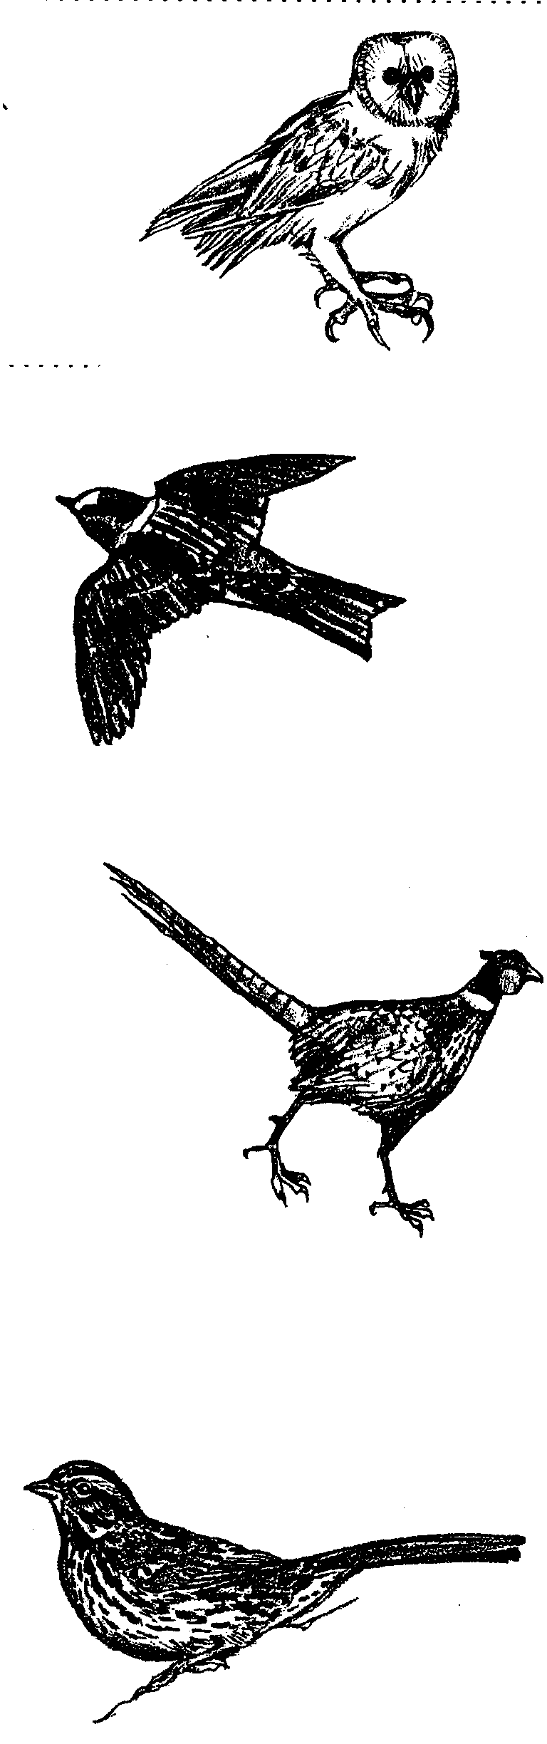
Barn Owl

My face is shaped like a heart. I have dark eyes and a white face. My back is brown. My chest is whte and brown. I spend my days in dark holes. Th eholes can be in trees, cliffs, or buildings. I hunt at night.

Cliff Swallow

My long, pointed wings make me a good flyer. I have a square tail and a pale rump. I have a short beak. Even so, I catch the insects I eat as they fly. I build mud nests on cliffs or buildings.

Ring-necked Pheasant

I come from Asia. I have a very long tail but short wings. I am the size of a chicken. I eat insects, seeds, and berries. I have a white ring and red eye rings. They show I am a male. My sisters are all brown.

Song Sparrow

My chest is streaked but has a spot, too. I have pinkish legs andfeet. When I fly, I pump my tail up and down. I live in dense brush. I eat insects and seeds. I make a grass cup nest in a bush.

BIRDS OF THE REFUGE—SALT MARSH AND SLOUGH BIRDS
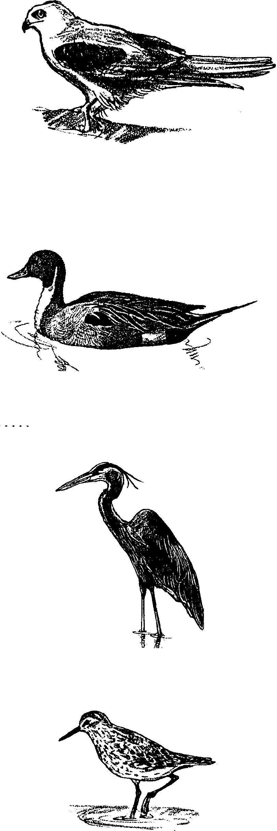
White-tailed Kite

My long tail gives me my name. It helps me soar, glide, and hover. My back is gray. i have black shoulders. You can see them when I fly. I am a good hunter. I catch mice and other small animals. I rest on dead trees near marshes.

Pintail Duck

I have a long, pointed tail. You can see it when I "tip over" to feed. I eat water plants. I have a brown head and a white neck. I also have dark stripes down my back. My sisters are spotted brown.

Great Blue Heron

I am four feet tall. I am one of the largest wading birds. My wings spread six feet. I am blue-gray. My head is white with a black stripe. I have a pointed yelow bill. I spear fish. Then I flip them and catch them in mid-air.

Western Sandpiper

I am the size of a sparrow. My legs, feet, and bill are black. In the summer I have a brown back. In the winter, my back is gray. I walk on sandbars and mudflats. I use my beak to probe for worms and other animals.

BIRDS OF THE REFUGE—SALT POND BIRDS
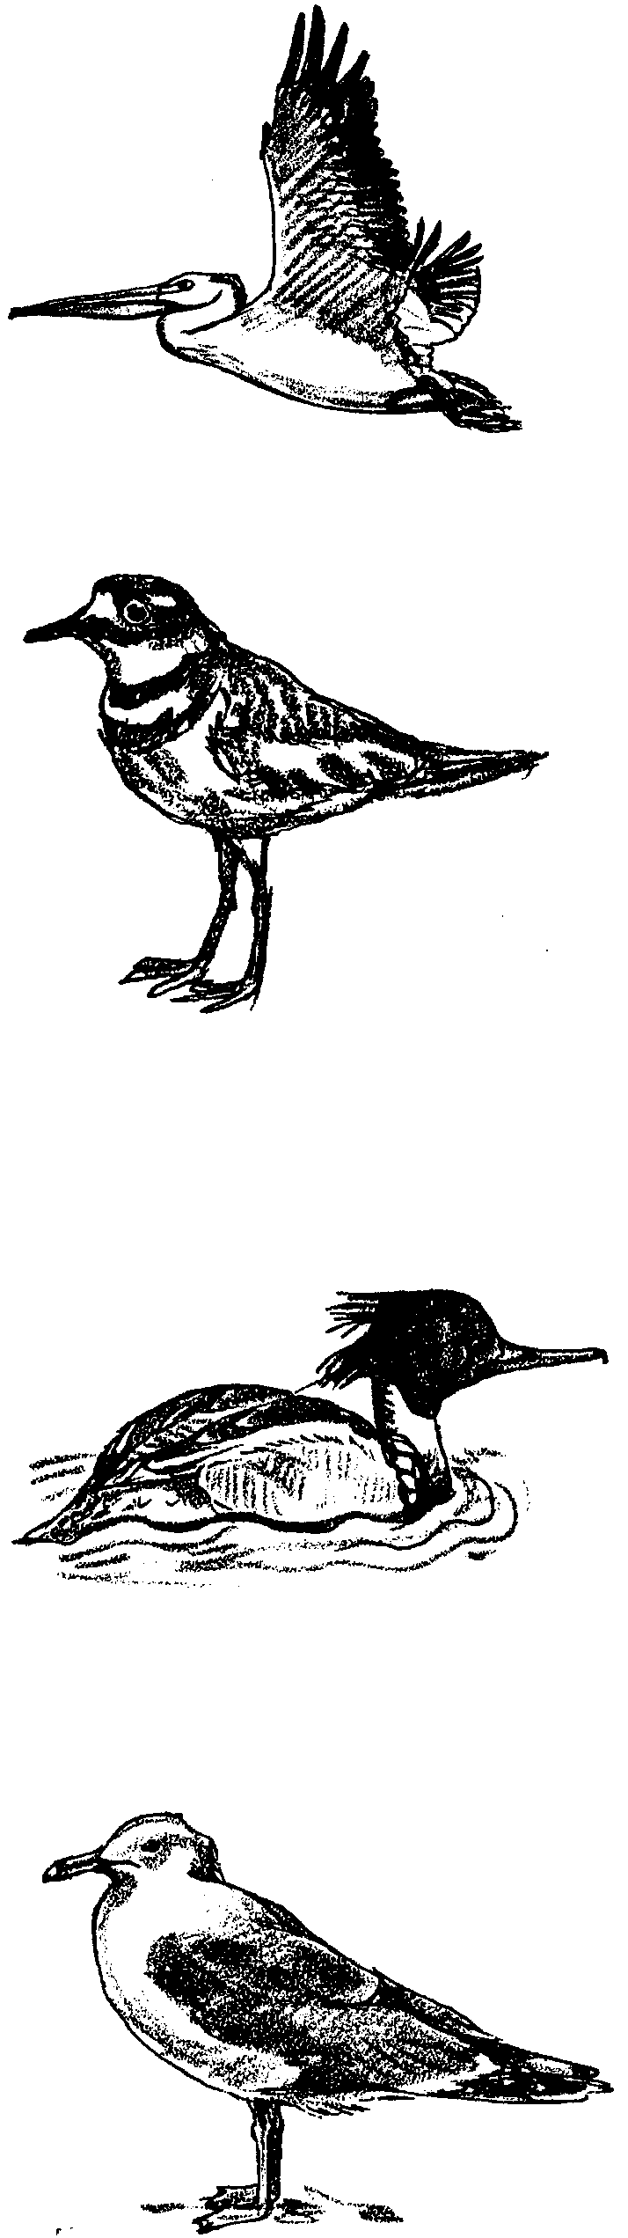
White Pelican

I am a huge water bird. I have a long, yellow bill. My bill and throat form a big sack. I scoop up fish while I swim. When I fly, I flap then glide. Sometimes I fly 150 miles from my nest to feed.

Killdeer

I am common in the field and on the shore. I have two black bands on my chest. I am a good actor. If something nears my nest, I play hurt. I eat insects and worms. You may hear me call "Kill-deeah".

Red-breasted Merganser Duck

My red bill is thin and hooked. I catch fish to eat. On my head, I have two crests. I am brown with a white chest. My brother has a green head. I spend winter in the estuary. I spend summers in lakes.

Ring-billed Gull

I am a seagull with a yellow bill. My bill has a black ring around it. My head and chest are white. My back is gray. I live most everywhere near water. I also live in cities and dumps. I eat most anything, too.

