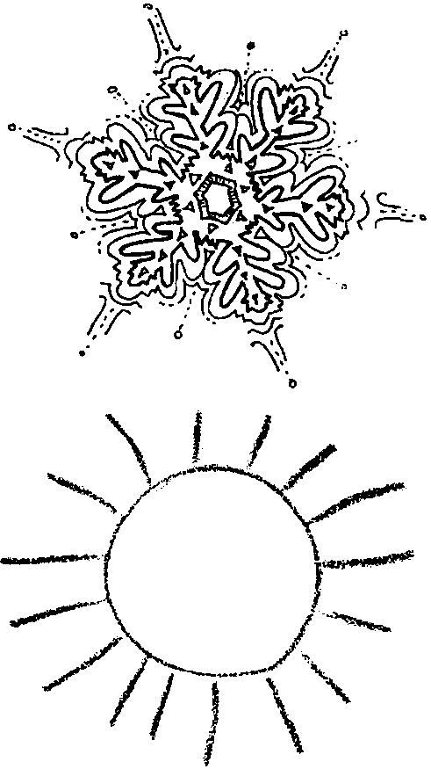
How Hot Is Too Hot?

Key Concepts
1. Brine shrimp have unique structural and behavioral adaptations which allow them to tolerate dramatic changes in the temperature and salinity of their environment.
2. Environmental factors (eg. temperature) affect the development and life of marine organisms.

Background

Living things must deal with changes in their environment. Many environmental factors, including temperature, may vary a great deal over time. Changes in temperature affect the rate of development of brine shrimp eggs.

Brine shrimp are remarkable little animals. They can live in evaporating salt ponds where salinity and temperature increase dramatically. When all of the water in the pond disappears, the brine shrimp populations survive by producing eggs in a sort of state of suspended animation called “diapause.” Brine shrimp eggs have adapted to a lack of water because many of the ponds where they live dry up during the summer. Eggs can lie dormant for up to 13 years! Dried-out eggs will hatch when rain water carries the “beached” eggs into the water. The dried up salt along the pond’s edge dissolves into the water and provides a ready-made supply of saltwater for the eggs to hatch.

The life cycle of the brine shrimp has three stages: egg, larva, and adult. The larva shrimp has a round body and two legs by its head. The legs help it swim. Even as an adult the brine shrimp is less than one inch long. They are often sold in pet stores as fish food.

Materials

For the class:
• refrigerator

• premixed, saltwater solution made from Instant Ocean or a similar product

• water to make saltwater solution (distilled water works best)

• containers to mix saltwater solution

For each group of three or four students:
• copies of student activity sheet, “How Hot is Too Hot?”

• brine shrimp eggs (Ask for the species that will grow the largest.)

• 3 baby food jars or similar containers

• marking pencil or labels

• thermometer

• hand lens or dissecting microscope

• coffee stirring stick

Teaching Hints

In “How Hot is Too Hot,” students hatch brine shrimp eggs. Students investigate the effect of changing one variable (temperature, in this case) on the development of brine shrimp eggs.

Planning Ahead
It is important to start the investigation when you are sure the class will meet for four consecutive days so that the necessary observations can be made. Brine shrimp eggs are easily obtained at tropical fish stores for a small sum. Likewise, products like Instant Ocean are available in pet stores that sell fish. Read the instructions on the container for making the salt solution needed. About a 3% salt solution is ideal. The shrimp will hatch in solutions from 1% to saturation.

Jar size, for hatching, is not critical. Baby food jars are usually readily available for the asking. It is important that each group of students doing the exercise have three jars of similar size. Groups of 3 students work well.

Jars should be filled to the same level. The number of eggs fitting on the end of a coffee stirrer is about the correct number to place in the jar. The eggs will float, so try to keep them from all sticking to the side of the container.

Observations should be made at the same time each day. The observations can be made in about 15 minutes. The students will take the temperature of the water and count the number of shrimp larva, during these daily observations. The absolute numbers are not critical.
Key Words

adult - a fully grown, mature organism

brine shrimp - a small, slender crustacean that lives in very salty water

dissecting microscope - microscope with two eyepieces which can view objects as three dimensional

environment - living and non-living factors surrounding an organism; surroundings

experiment - a process undertaken to discover something not yet known or to demonstrate something known

hand lens - a small magnifying lens held in the hand

hatching - to come forth from an egg

label - to name

larva - the early form of any animal that metamorphoses (changes structurally) when it becomes an adult

life cycle - the series of changes from an animal’s earliest stage of development to the same stage in the next generation

observe - to watch or notice

record - to set down, as in writing

relatives - individuals connected by blood

scale - a series of marks along a line

solution - a liquid in which another substance has been dissolved

temperature - the degree of hotness or coldness of anything

thermometer - an instrument for measuring temperatures

Extensions

Brine shrimp eggs are remarkable. Try freezing the eggs or boiling the eggs. Then place the eggs in saltwater at a normal temperature. Do they hatch?

Answer Key

1., 2. & 3. The answers depend upon the results. Usually the room temperature works the best, the refrigerator has the fewest. Discuss possible reasons for the results obtained. This is a good opportunity for creative hypothesizing by your students.

4. Again, depends on results. But usually high and low temperatures will have fewer hatching.

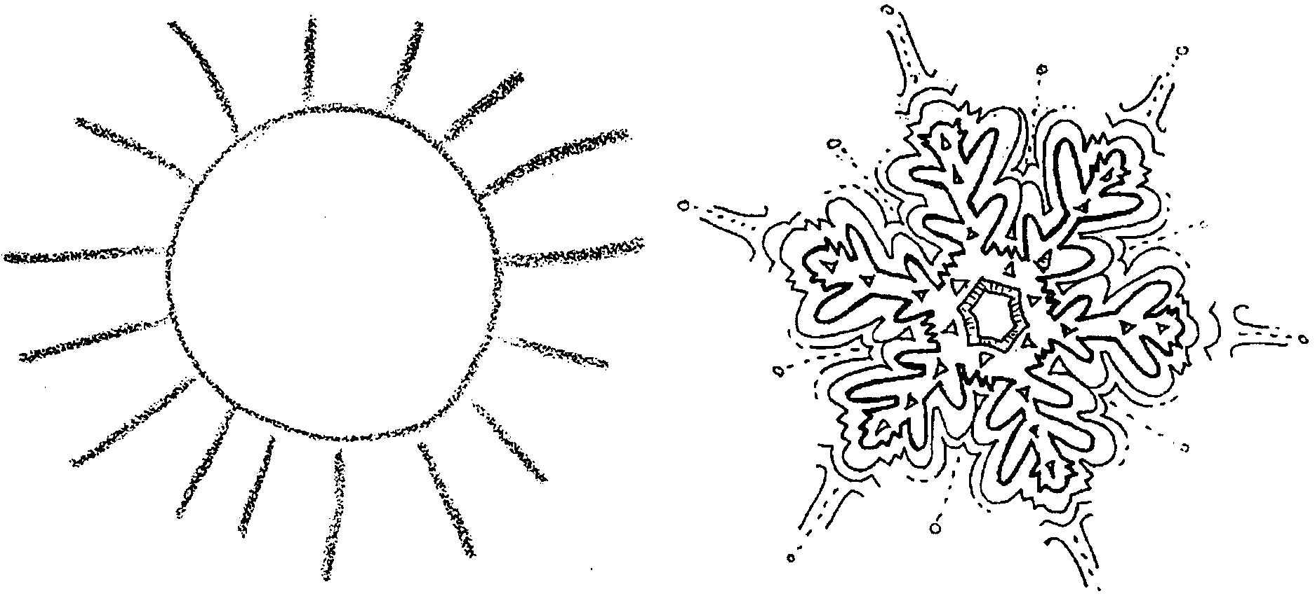
How Hot Is Too Hot?

Living things must deal with changes in their environment. Things such as temperature may change a great deal. Lets look at how different temperatures affect brine shrimp eggs.

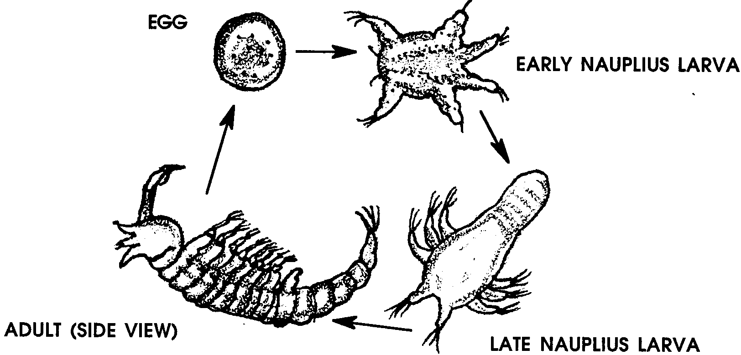
Brine shrimp are relatives of the shrimp caught for food. They are often used as a fish food by people with pet fish. The life cycle of the brine shrimp has three stages: egg, larva, and adult.

Even as an adult the brine shrimp is less than one inch long.

In this experiment you will be observing the hatching of brine shrimp eggs.

Method

1. Obtain three jars. Mark or label the jars: 1, 2 and 3.

2. Fill the jars about 3/4 full with saltwater solution.

3. Place into each jar as many brine shrimp eggs as you can put on the end of a small stick. Gently tap the stick against the side of the jar to remove the eggs from the stick.

4. Stir the eggs into the water in each jar.

5. Place jar #1 in the refrigerator.

6. Place jar #2 in the spot your teacher has provided for those jars to be left at room temperature.

7. Place jar #3 beneath the electric lamp.
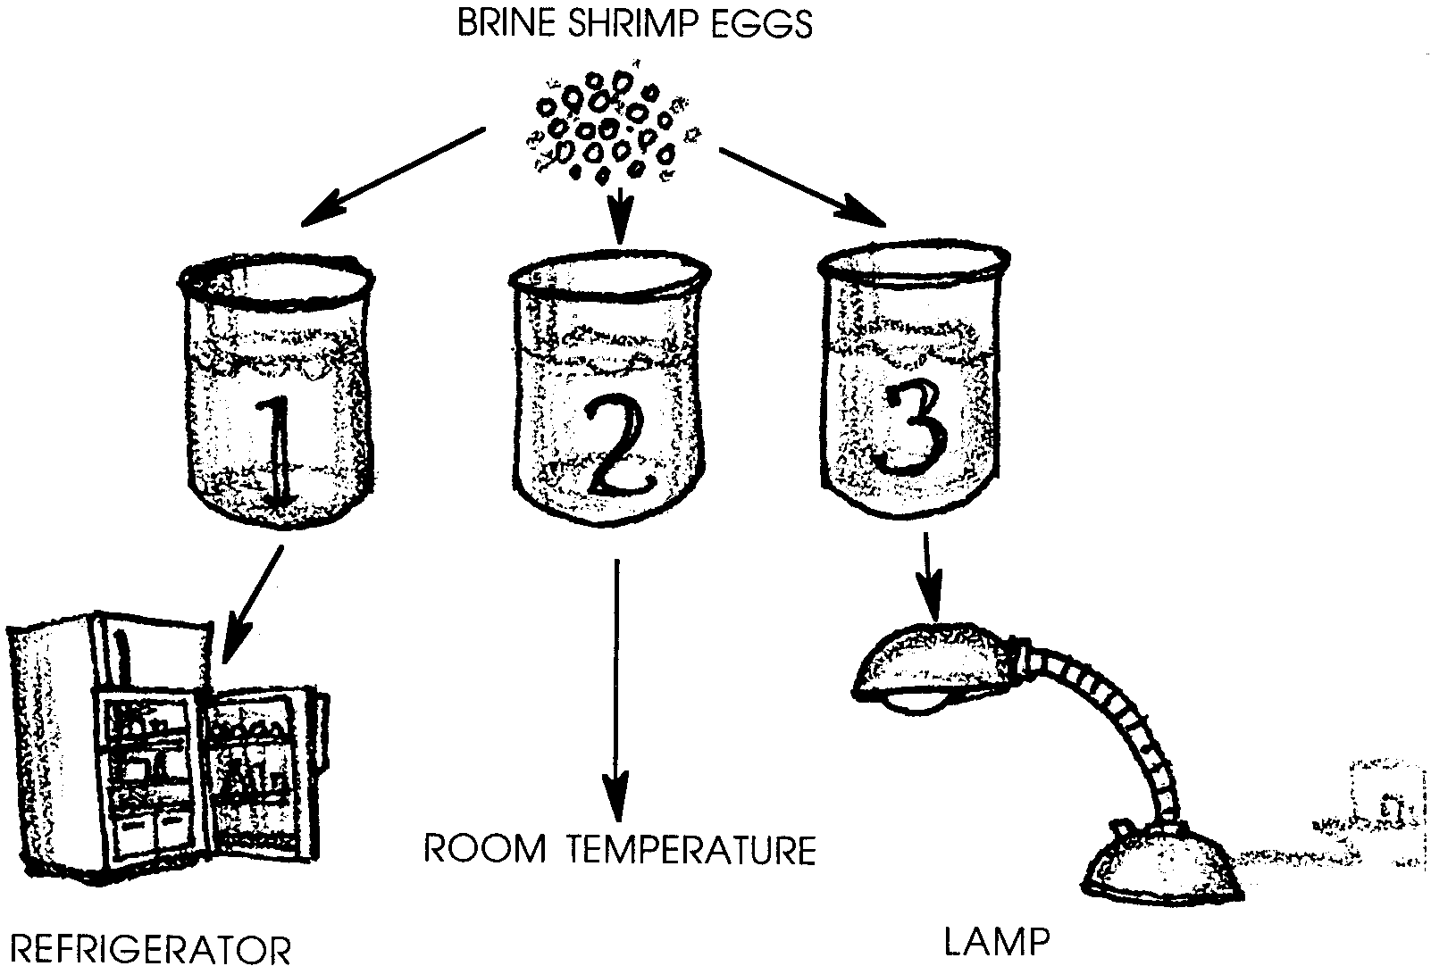

8. For the next 4 days, observe the jars using your hand lens. Record the findings in the DATA CHART on the next page. Record the estimated number of shrimp hatched and the temperature of the water. To find the temperature, put the thermometer into the jar for 1 minute then read the scale. Read the thermometer while it is still in the water.
Data Chart
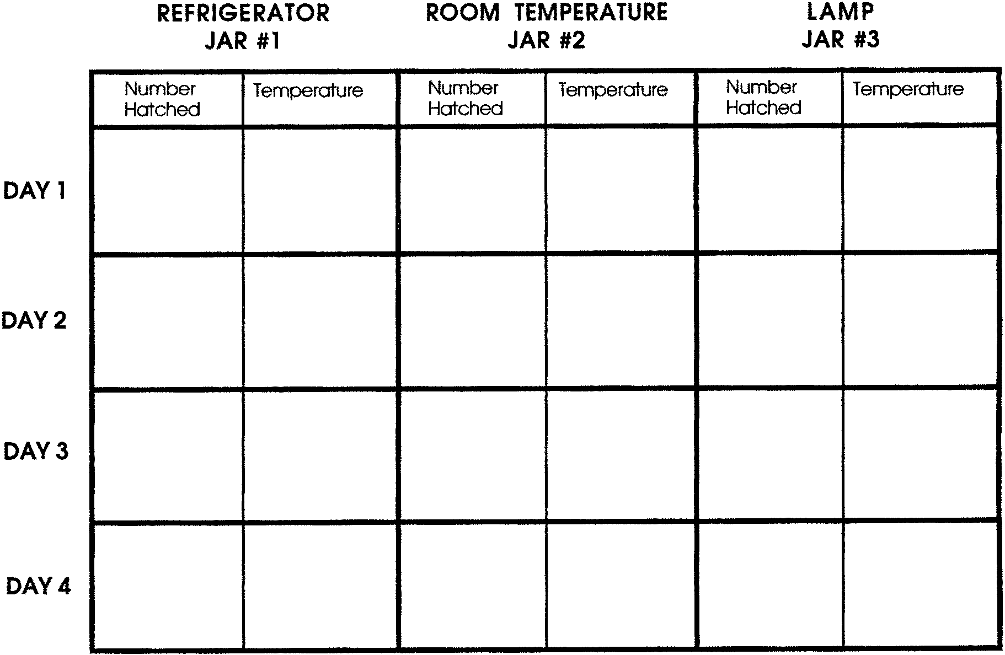
Hatching Results

1. a. Did any of the eggs hatch after the first day?

b. If they did hatch, in which temperature did they hatch?

2. a. Which jar had the most shrimp hatch?

b. What was the temperature of the jar with the most shrimp hatching?

3. a. Which jar had the fewest shrimp hatch?

b. What was the temperature of the jar with the lowest shrimp hatching?

4. Make a general statement about the effect of temperature on shrimp hatching. (Hint: a general statement might be, “More shrimp hatch in boiling water than in ice water.”)

