The Shrimp Boats Are A-Coming
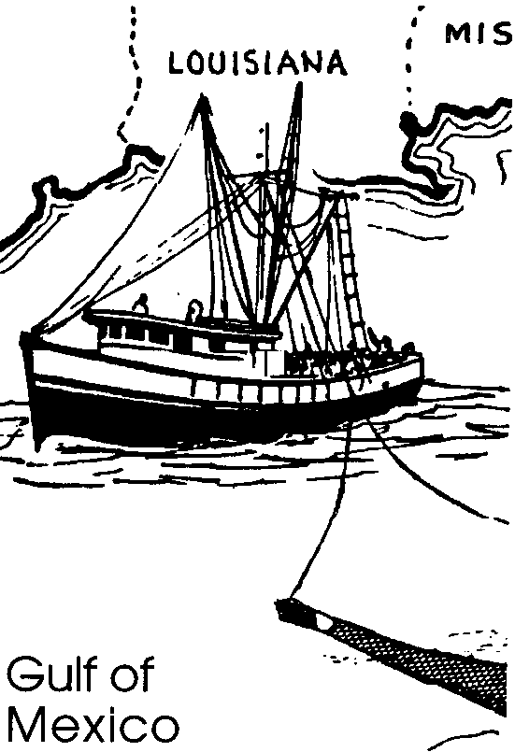

Key Concepts
1. The waters off the Gulf states produce most of the commercial shrimp sold in the U.S.
2. Shrimp are harvested with large trawl nets.
3. Commercial shrimp catching and processing provides livelihoods for many people.

Background

Background can be found in “Shrimp - No Small Wonder.”

Materials

For the class:
• calculators

For each student:
• “The Shrimp Boats Are A-Coming” student worksheet

Teaching Hints

“The Shrimp Boats Are A-Coming” provides your students with some additional information about shrimping while simultaneously providing practice with the set up and solution of simple word problems. The problems follow from the text material. Note that these problems require math skills that some third graders may not possess, especially at the beginning of the school year, including averaging and percentages. The use of calculators is recommended. Judge your students’ ability to be successful. You may choose to read the activity aloud and work through the problems with the entire class.

Key Words

average - the number obtained by dividing the sum of a group of quantities by the number of quantities in that group

behead - remove the head

discarded - thrown away

edible - can be eaten

Gulf states - states located along the Gulf of Mexico: Texas, Louisiana, Mississippi, Alabama, Florida

icing - to place perishable things on ice

percent - per hundred

processing plants - site where raw materials (shrimp) are prepared for marketing

trawl - to fish or catch with a trawl net

trawl net - a large, bag-like net dragged by a boat through or along the bottom of a fishing bank

Answer Key

1. A correctly labeled map of the Gulf of Mexico follows:
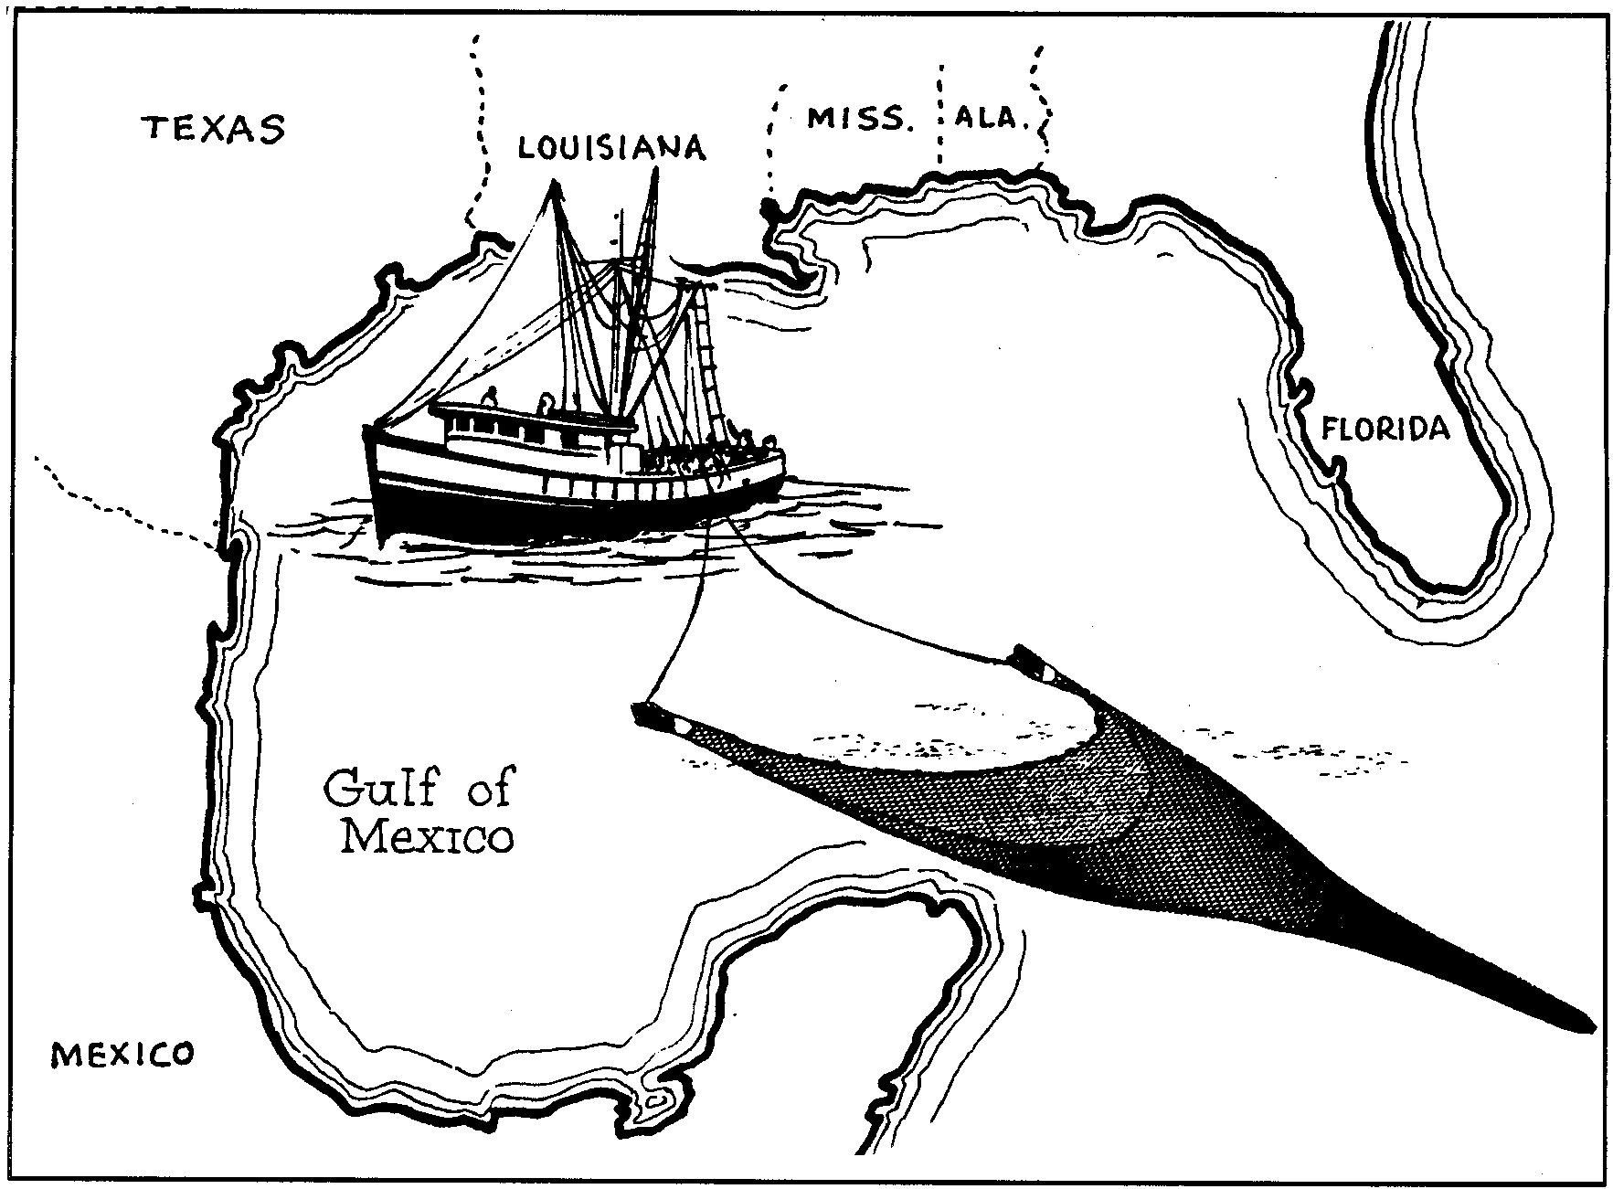

2. Florida, Alabama, Mississippi, Louisiana, and Texas are the states bordering the richest shrimp waters.

3. a. Using the range of lengths given, the average length of shrimp boats is 60 feet (i.e. 40' + 80' /2 boats = 60'/boat).

b. Using the range of water depths given, the average water depth is 47.5 feet (i.e. 5' + 90'/2 depths = 47.5 deep).

4. One thousand pounds of shrimp would be in the net (i.e. 50 of catch is shrimp x 2000 pounds total catch = 1000 pounds of shrimp).

5. Less than 1/2 or 40% of the shrimp is edible (i.e. 100% total shrimp - 60% head = 40% edible remaining).

6. Four hundred pounds of edible shrimp are left after cleaning (i.e. 40% edible shrimp x 1000 pounds of shrimp in net).

7. a. At best, the single trawl followed in the text is worth $800 (i.e. $2.00/pound x 400 pounds of edible shrimp = $800)

b. Since the catch had been improperly iced, the trawl would be worth $600 (i.e. 75% value of properly iced (i.e. 100% of value - 25% for spots) x $800 best price = $600 ) Students may require some help with this problem.

8. As shown in the paragraph preceding this question, many jobs are dependent upon and related to shrimp including: fisher, crew on fishing boat, fishing boat manufacturer, net maker, longshoreman, food handler, packager, trucker, cook, waitress, etc., etc. The point to emphasize is the interdependence of jobs in our coastal areas.

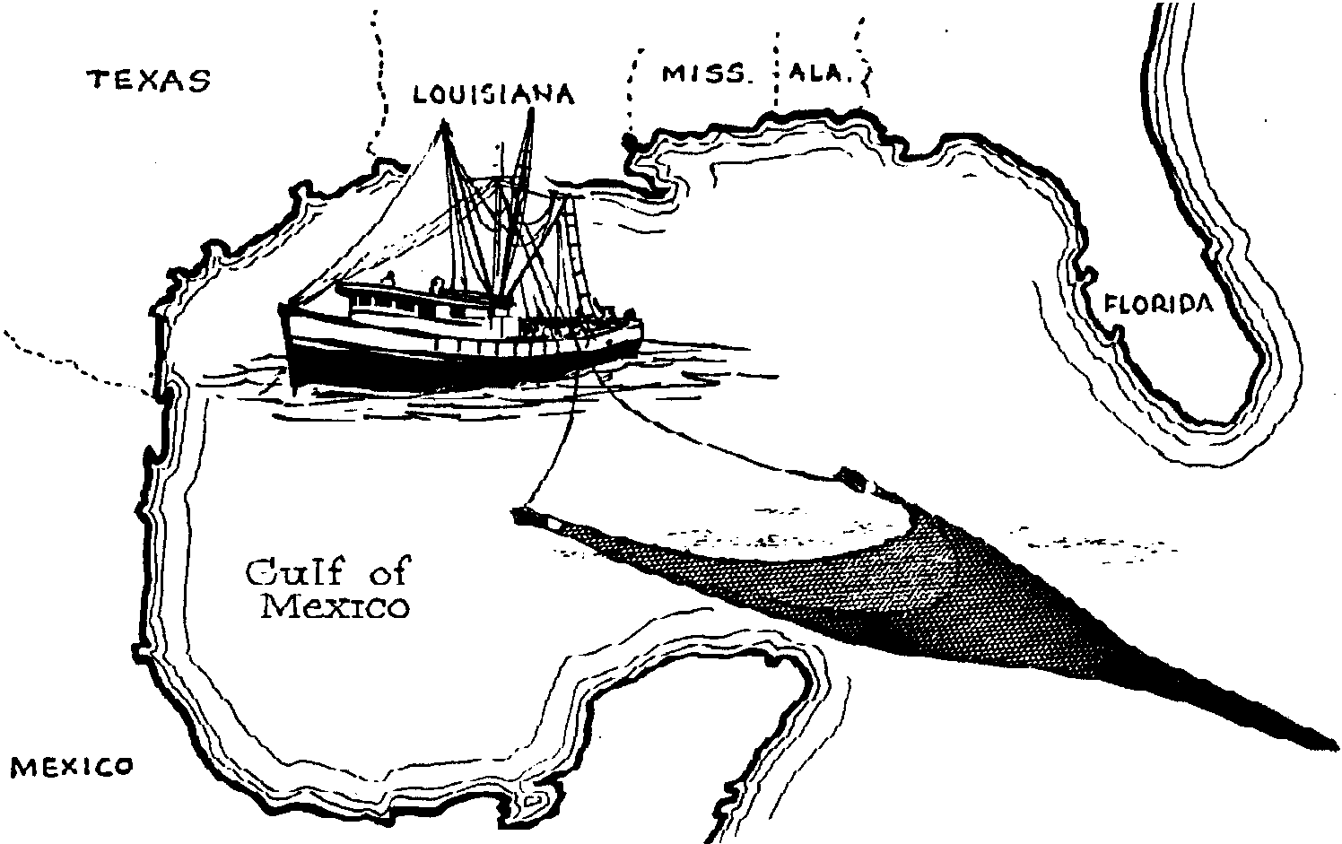
The Shrimp Boats Are A-Coming

Many shrimp live in the Gulf of Mexico. These areas produce most of the shrimp sold in the United States.

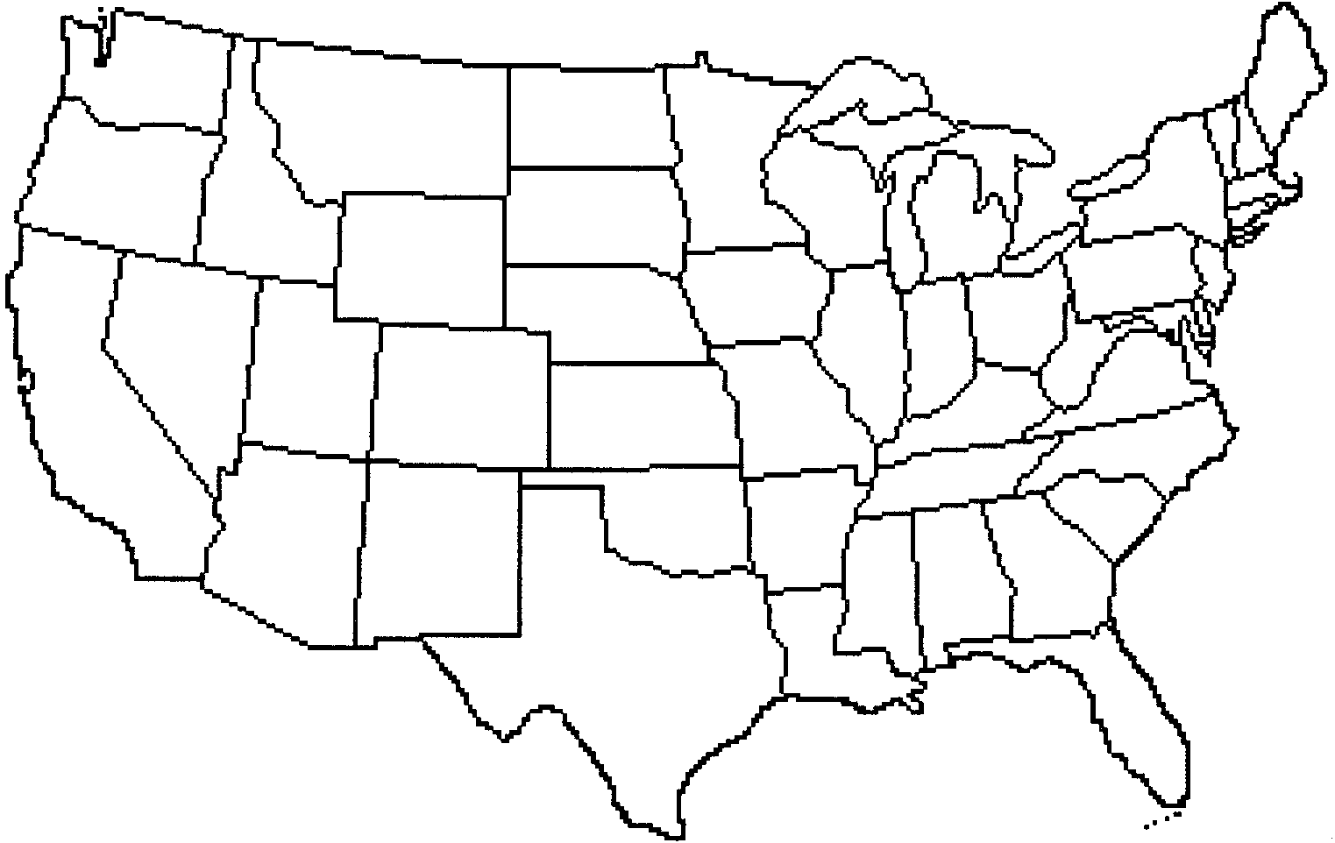
1. Label the Gulf of Mexico on the map below.

2. Which states border the richest shrimp waters?

Commercial fishers catch shrimp from boats. The boats are usually 40 to 80 feet long. These large shrimp boats use a huge trawl net. They drag the huge trawl net along the bottom. The water is from 5 feet to 90 feet deep.

3. a. What is the average length of shrimp boats? (Hint: you can find the average by using this formula:

sum of boat lengths
= average boat length)

number of boats

b. What is the average water depth at which shrimp boats trawl?

The shrimp boat Thomas James is fishing off the South Texas coast. She drags her net for one hour. The net is hauled in. As the net comes on board, the deck is alive with fish and shrimp. Two thousand pounds of live animals jump and dance in the net. Fifty percent (1/2) of the catch is shrimp.

4. How many pounds of shrimp are in the net?

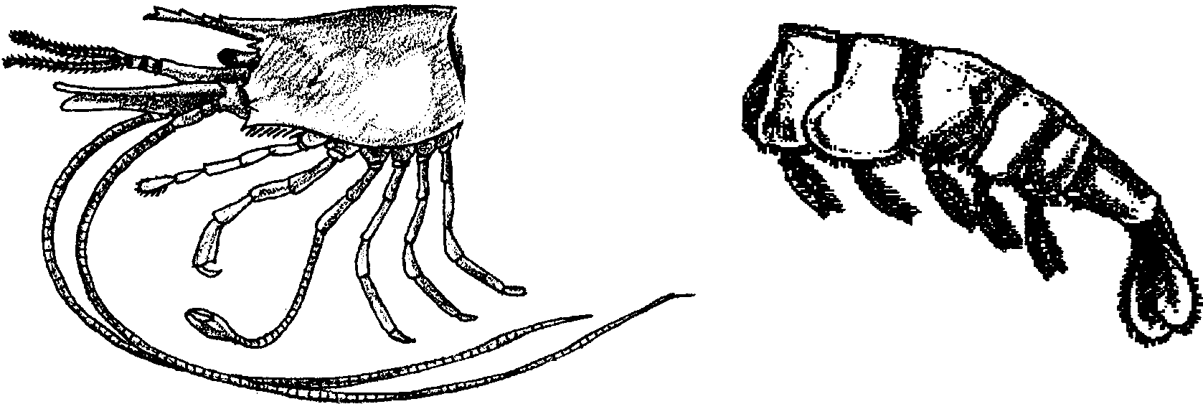
The other fifty percent of the catch is fish. The crew throws the fish back. Shrimp must be beheaded. The head is discarded. The discarded heads account for 60% of the entire shrimp. The headless shrimp must be immediately put on ice. The rest of the shrimp is edible.

5. What percentage of the shrimp is edible?

6. The crew has finished cleaning the catch. Challenge Question: How many pounds of edible shrimp are left? (HINT: use your answer from 3 as a starting point.)

Icing the shrimp is very important. Dark spots appear on shrimp that have been poorly iced. The spots are really a sort of sun tan. They do not hurt the taste of the shrimp. They do, however, reduce their sale value.

7. a. The Thomas James has returned to the dock at Corpus Cristi, Texas. The shrimp buyer is paying up to two dollars a pound. At best, how much was the catch worth?

b. The buyer pays 25% less for shrimp with black spots. Sad, but the catch has been improperly iced. How much is the trawl worth?

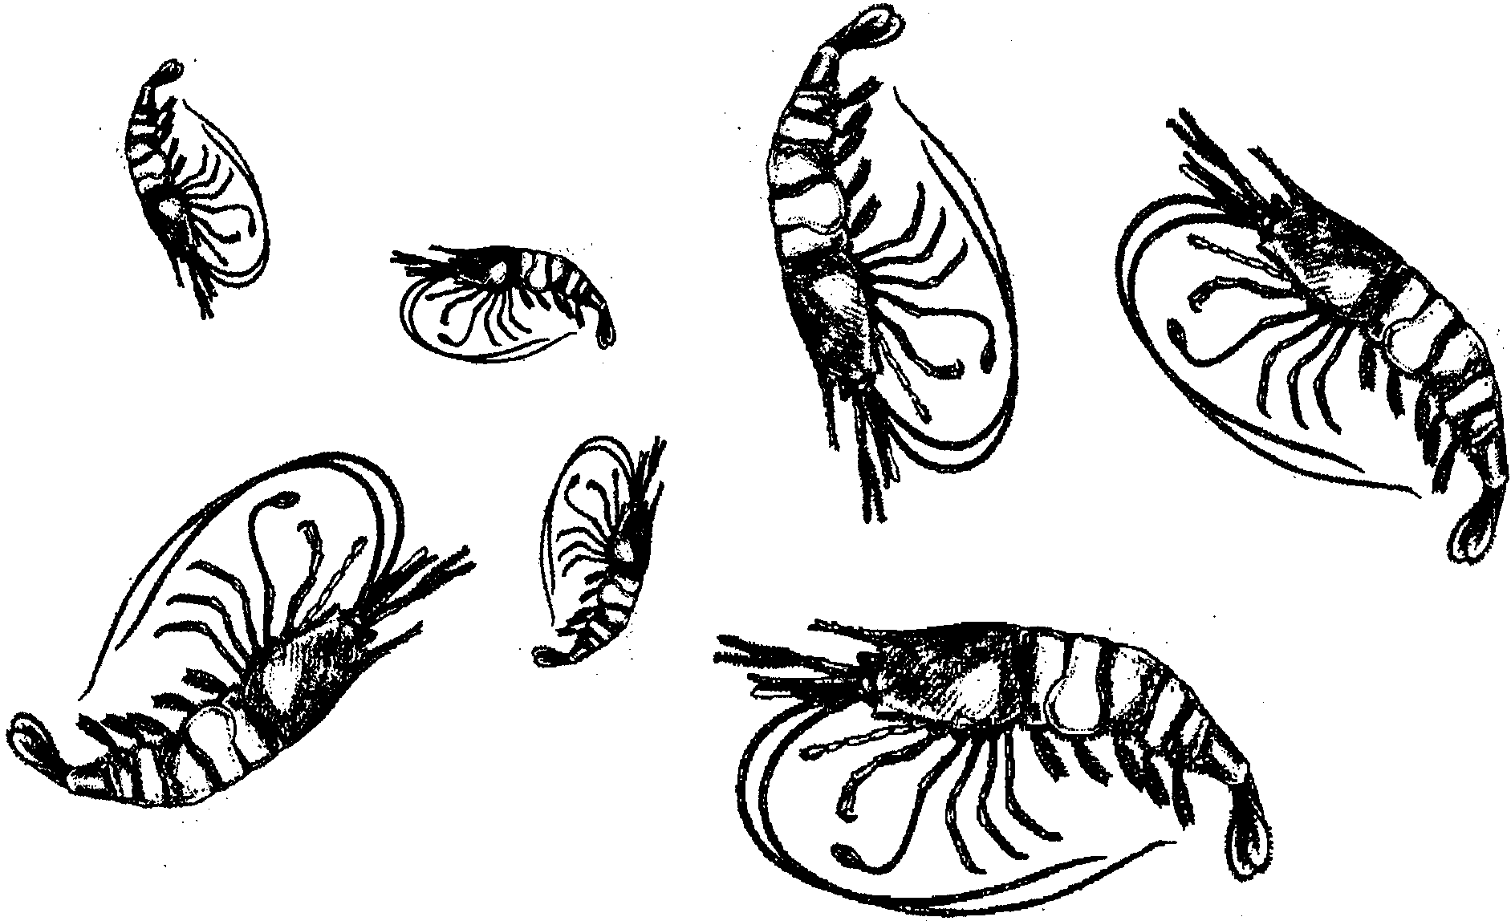

The shrimp leave the boats. Many other people will make a living from them. People working on the docks move the shrimp. People working in processing plants ready the shrimp for market. Shrimp are sold fresh, cooked, canned, or frozen. Other people transport the shrimp to stores and restaurants. Still other people, prepare the shrimp for their final destination: your stomach!

8. What are three jobs which depend upon shrimp?

