Only Half the Story

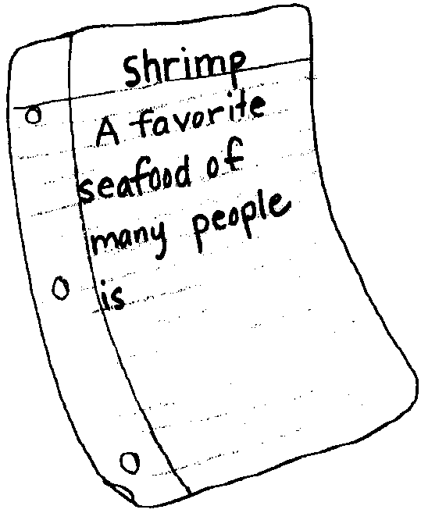
Key Concepts
1. Shrimp have unique structural and behavioral adaptations.
2. Life cycles of marine animals are predictable.
3. The oceans and coasts are a source of food for humans.
4. Humans use a variety of techniques for harvesting shrimp from coastal waters.

Background

Background can be found in “Shrimp - No Small Wonder.”

Materials

For each student:
• “Only Half the Story” student worksheet

Teaching Hints

This review activity helps to improve reading skills through the use of a modified CLOZE procedure. It also serves to reinforce some of the key vocabulary from the preceding activities.

Key Words

metamorphosis - the more or less sudden change in some animals as they develop through distinct stages such as larva, pupa, adult

plankton - plants and animals that swim weakly, or not at all, and drift with ocean currents

scavengers - animals that eat decaying plants and animals

Answer Key

A favorite seafood of many people is SHRIMP . Shrimp are SCAVENGERS , feeding on dead and decaying plants and animals.

Female shrimp lay eggs which hatch into free drifting PLANKTON .The baby shrimp remain as plankton for about one month. At the end of this time METAMORPHOSIS , which means changing form, occurs. Shrimp are very unusual. At about two years of age the male shrimp change and become FEMALE shrimp. Amazing!

Shrimp are captured in traps called SHRIMP POTS . The pots are filled with bait and placed on the ocean bottom. The shrimp can get into the pot but they can’t get out. Harvested shrimp are COOKED in rock salted water. Once they are cooked they are ready for your dinner table.

Only Half the Story
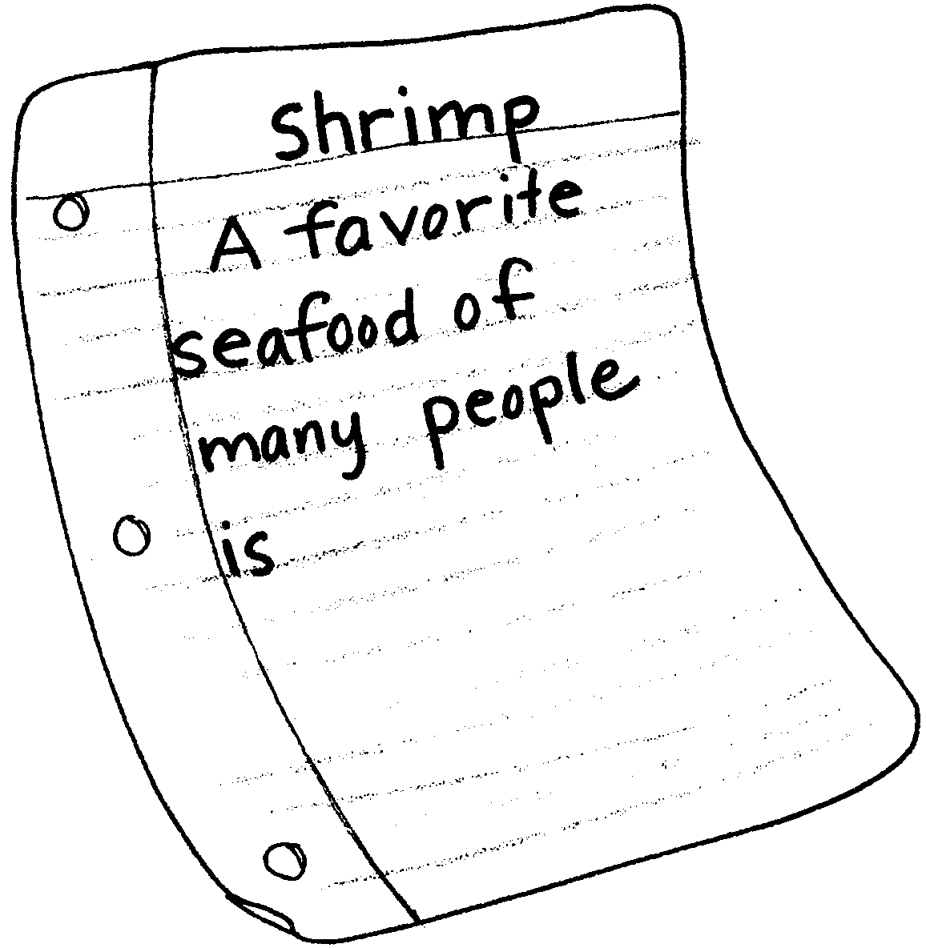

The story below needs your help. Several words are missing. Write in the missing words. Use the list of words below the story. Put the word that makes the most sense in each blank.

A favorite seafood of many people is . Shrimp are
, feeding on dead and decaying plants and animals.

Female shrimp lay eggs which hatch into free drifting . The
baby shrimp remain as plankton for about one month. At the end of this
time , which means changing form, occurs. Shrimp are
very unusual. At about two years of age the male shrimp change and become
shrimp. Amazing!

Shrimp are captured in traps called . The pots
are filled with bait. They are placed on the ocean bottom. The shrimp can get
into the pot but they can’t get out. Harvested shrimp are in
salted water. Once they are cooked they are ready for your dinner table.

shrimp pots plankton
scavengers female
cooked shrimp
metamorphosis

