Shrimp–No Small Wonder

Key Concepts
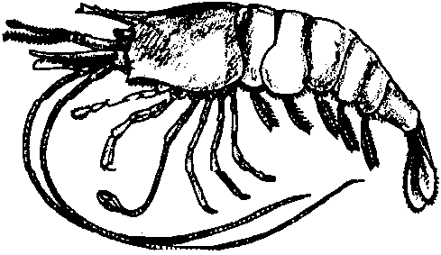
1. Shrimp have unique structural and behavioral adaptations.
2. Life cycles of marine animals are predictable.
3. The oceans and coasts are a source of food for humans.
4. Humans use a variety of techniques for harvesting shrimp from coastal waters.
5. The harvesting of food from coastal waters can impact marine habitats.

Background

For a large number of Americans, the word “shrimp” conjures up the image of a morsel of food and not that of a spectacular marine animal. Shrimp come in almost every color of the rainbow. Some are transparent, allowing us to view the heart and digestive system in action. They vary in size from less than your little finger in length to the width of your palm or larger.

Shrimp have developed ingenious mechanisms and behaviors to survive in the sea. The pistol shrimp makes a popping sound by snapping its oversized claw. The sound may be used to help these shrimp stake out their territory. Cleaner shrimp live in close contact with certain sea anemones, helping keep the anemone clean while the shrimp scavenge their meals. Other shrimp find their food by picking parasites from the scales, gills, and fins of certain fish. Although large enough to eat the shrimp, the fish, which benefit from this relationship, seldom do.

Some species of shrimp are harvested commercially. Demand for these species is high and the danger of over-harvesting exists.

Materials

For the class:
• copies of student pages “Shrimp - No Small Wonder” and “Puzzling Shrimp”
Teaching Hints

“Shrimp - No Small Wonder” begins a new unit. Judicious use of visual materials can help overcome the restricted view of the word “shrimp” as an image of a morsel of food rather than that of a spectacular marine animal.

Planning Ahead
Brine shrimp eggs must be obtained prior to “How Hot Is Too Hot?”. Three baby food jars (or similar containers) per group are required for “How Hot Is Too Hot?”. Ask members of the class with younger brothers and sisters to bring baby food jars. A note home to parents is also helpful in obtaining the jars.

Key Words

antennae - jointed sense organs on the head; feelers

buoy - a floating object anchored in a large body of water as a marker

coon-striped shrimp - a species of shrimp harvested in Puget Sound

metamorphosis - the more or less sudden change in some animals as they develop through distinct stages such as larva, pupa, adult

phytoplankton - plant plankton, including diatoms

plankton - plants and animals that swim weakly, or not at all, and drift with ocean currents

scavengers - animals that eat decaying plants and animals

shrimp - slender, long-tailed, crustacean

shrimp pots - traps used for catching shrimp

shrimper - one who harvests or catches shrimp

swimmerets - abdominal or swimming legs of shrimp

winch - a crank with a handle for transmitting motion

zooplankton - animal plankton

Extensions

1. Visit a shrimp boat.

2. Invite a shrimper into your classroom.

3. Have students imitate the movements of a shrimp.

4. Invent a new method for catching shrimp.

5. Make a model of a shrimp pot.

6. Write a story about a shrimp named “Pinkie.”
Answer Key

l. A scavenger is an animal that feeds on dead and rotting plants and animals.

2. Scavengers (along with decomposers) are important in all ecosystems as the “recyclers” of the nutrients stored in the bodies of dead plants and animals. They release the nutrients for use by other organisms. Scavengers also keep the number of dead things “lying around” to a minimum.

3. Plankton are small (usually), freely drifting animals and plants.

4.a. As babies, shrimp eat plankton.

b. As adults, shrimp are scavengers, eating dead and rotting plants and animals.

5. The correct order is:

1 The shrimp eggs begin to grow.

5 The female shrimp carries her eggs for 4 to 5 months.

2 Baby shrimp are part of the plankton for the first month after they hatch.

6 A female shrimp lays about 3,000 eggs at a time.

3 At 18 months the shrimp become mature male shrimp.

4 At 2 years of age the shrimp become mature female shrimp.

6. This question asks students to speculate on why the shrimp get caught in the pots even though the door is open. Entertain and discuss their ideas which may range from shrimp prefer cat food to freedom, to the shrimp are so busy eating they don’t notice that their “restaurant” is being raised to the surface. The hint is provided to yield one possible reason: while shrimp swim backwards, their eyes look forward. Since shrimp are always looking at where they’ve been when they swim, it may be hard for them to swim back through the opening. They could get into the trap by walking forward, walking out isn’t possible.

7.a. For her long line, Sally needs 400 feet of rope (i.e. 40 pots x 10 feet of rope/pot).

b. To tie on the pots, she needs 200 feet of rope (i.e. 40 pots x 5 feet of rope/pot).

c. All together she needs 600 feet of rope (i.e. 400 feet + 200 feet).

d. The rope will cost Sally $114.00 (i.e. 600 feet x $.19/foot).

e. In tax, Sally will have to pay an additional $9.12
(i.e. $114.00 x .08/dollar).
8. Shrimpers mark the location of the shrimp pots with a buoy.

9. Answers may vary since this question asks for an opinion regarding how the captain decides where next to set out the shrimp pots. Some pieces of information captains use come from: past experience, the success of the catch just made, what they hear on the radio from other boats, what they see on their sonar and other electronic equipment, their knowledge of tides and bottom shapes, etc.

10. Again, answers may vary. Use this question as an opportunity to get students thinking about the problems of “incidental catch” in all fisheries. Incidental catch are the animals that are captured which are not the intended species; these can range from sea cucumbers in shrimp pots to dolphins in tuna nets and can be a serious problem.

11. A large number of jobs are involved in getting a shrimp on someone’s plate including, but not limited to: shrimp pot maker, boat operator, boat crew person, cleaner, cooker, labeler, warehouser, truck driver, grocer, restaurateur, chef.

12. Your students may suggest a variety of reasons for declines in shrimp catches. Two principal areas involve over-harvesting and deterioration of habitat from pollution, siltation, dredging, etc.

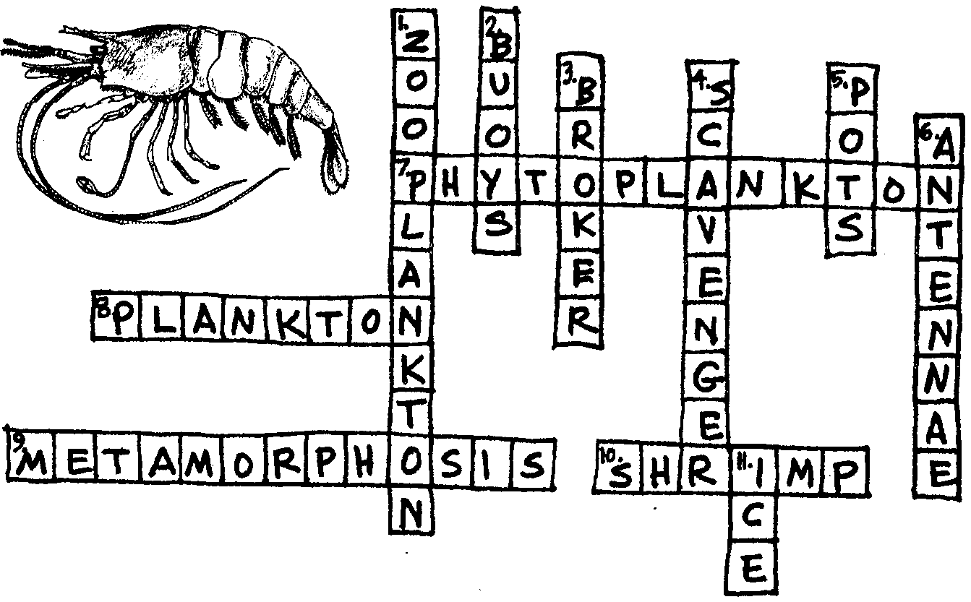
Puzzling Shrimp

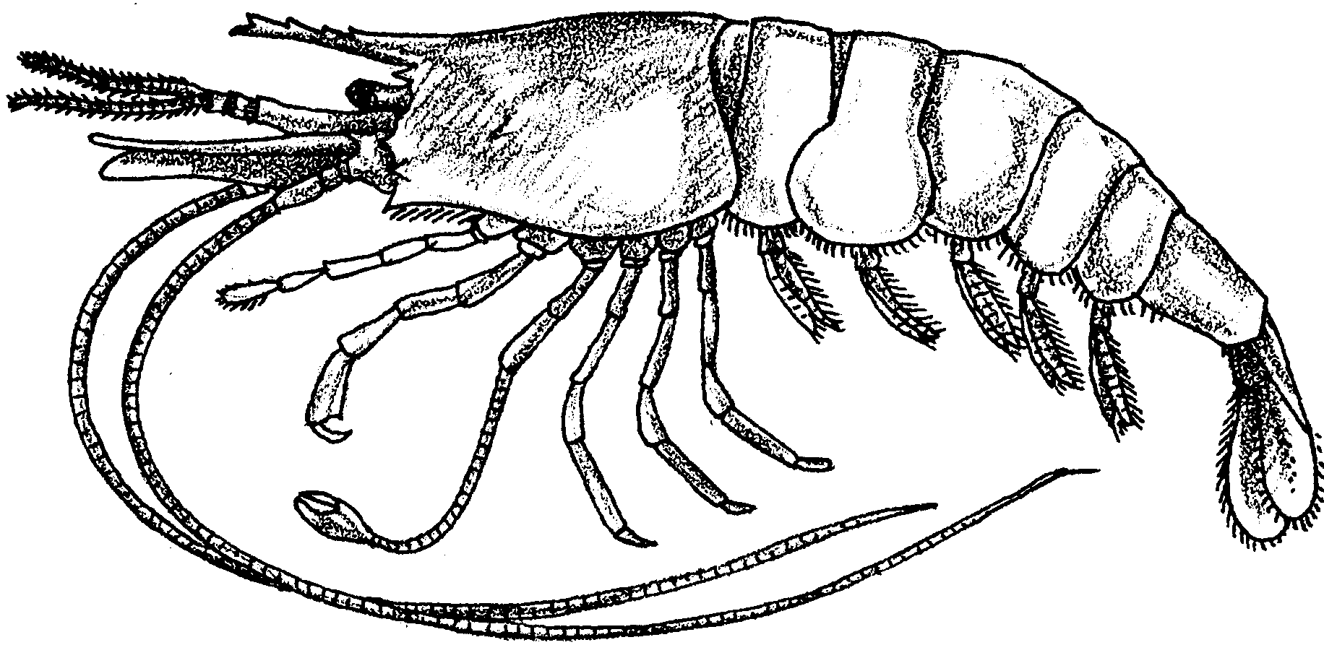
Shrimp–No Small Wonder

Are the only shrimp you have seen those that were in a salad? Then you are in for a surprise. Shrimp can be found in many places around the world. Shrimp come in many colors and sizes. Some shrimp are less than an inch long. Others are nearly twelve inches in length. Live shrimp come in lots of colors. Some are pink, some white, some brown. Whatever the color, they all turn pink with cooking.

Shrimp have long, thin antennae and legs. Many shrimp move themselves backward by rapidly bending their tails. They have 5 appendages on their abdomen, called swimmerets, used in swimming. Shrimp are scavengers, feeding on dead and rotting plants and animals.

1. What is a scavenger?

2. Why are scavengers important in a habitat?

The “spotted” or “coon-striped” shrimp is a favorite food of many people. It is found on the Pacific coast. A single spotted shrimp will produce as many as 3,000 eggs in one year. The female shrimp carries her eggs for about four to five months on the swimmerets. Once the eggs hatch, the small baby shrimp drift freely in the water as plankton. The baby shrimp will remain as plankton for about a month. They eat very tiny, drifting plants (phytoplankton) and tiny, drifting animals (zooplankton). These baby shrimp themselves are a form of zooplankton.

3. Phytoplankton and zooplankton together are called plankton. What is plankton?
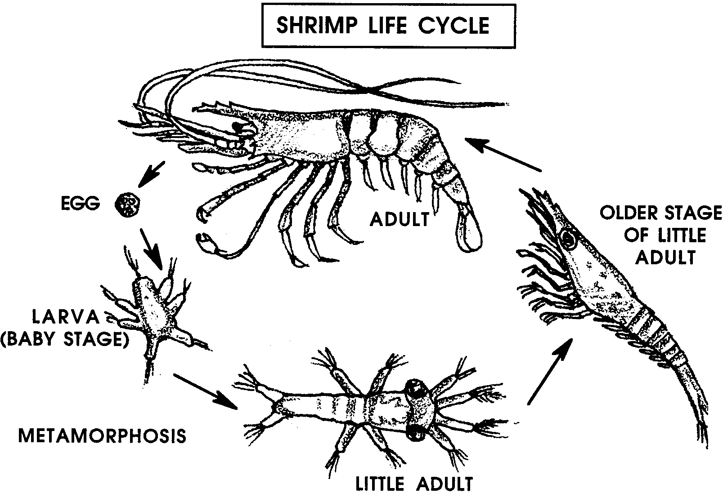

When the baby shrimp are about one month old, a big change occurs. Scientists call this change a metamorphosis. Some big word, eh? Don’t be fooled. It’s made from two old Greek words: “Meta” means “change.” “Morphos” means “shape.” Aha! Metamorphosis means “change of shape.” No problem.

After metamorphosis, the planktonic shrimp are little adult shrimp. At this time they become scavengers. At about 18 months the spotted shrimp become mature male shrimp.
4. a. What do shrimp eat as babies?

b. What do they eat as adults?

The change from plankton to adult was pretty amazing. The shrimp isn’t finished yet. Once they reach the age of two, the male shrimp change and become female shrimp. By the time they are three to four years old they are able to reproduce eggs. The cycle then begins all over again.

Shrimp have an interesting life cycle. The shrimp life cycle begins when the eggs start to grow. It ends when the female lays the eggs, only to start the cycle, again.

5. Arrange the following events in a shrimp’s life in the correct order. Write the number of the statement in the blank in front of the statement.

For example, the first event in the shrimp’s life would be 1 .

The shrimp eggs begin to grow.

The female shrimp carries her eggs for 4 to 5 months.

Baby shrimp are part of the plankton for the first month after they hatch.

A female shrimp lays about 3,000 eggs at a time.

At 18 months the shrimp become mature male shrimp.

At 2 years of age the shrimp become mature female shrimp.

Harvesting Shrimp
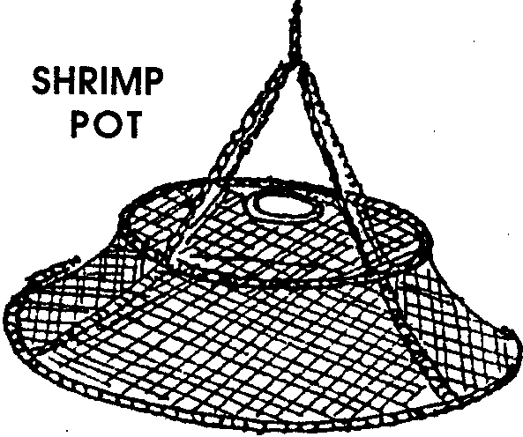
Some people earn a living catching shrimp. They catch shrimp in traps lowered from boats. A shrimp boat may have 40 to 200 traps. These traps are called shrimp pots. These pots are about 3 feet in diameter and 18 inches deep. They are of a heavy wire mesh. The mesh is stretched over a sturdy metal frame.

The shrimpers bait these pots. They place two or three jars of bait on the inside of each pot. Two jars are filled with ground fish. Often the third jar is filled with cat food. Surprisingly, this seems to attract the shrimp.

Shrimp enter the pot through a small hole. The hole doesn’t have a door. In spite of the open hole, shrimp get caught.

6. What do you think it is that gets the shrimp caught? (Hint: Think about the way shrimp are built and how they move.)

The shrimpers use short ropes to attach about 40 baited pots to one long line (rope). The pots are placed about seven to ten feet apart. The shrimpers lower the pots into the water at 40 to 600 foot depths. The location of the pots is marked by attaching floats or buoys to each end of the long line.
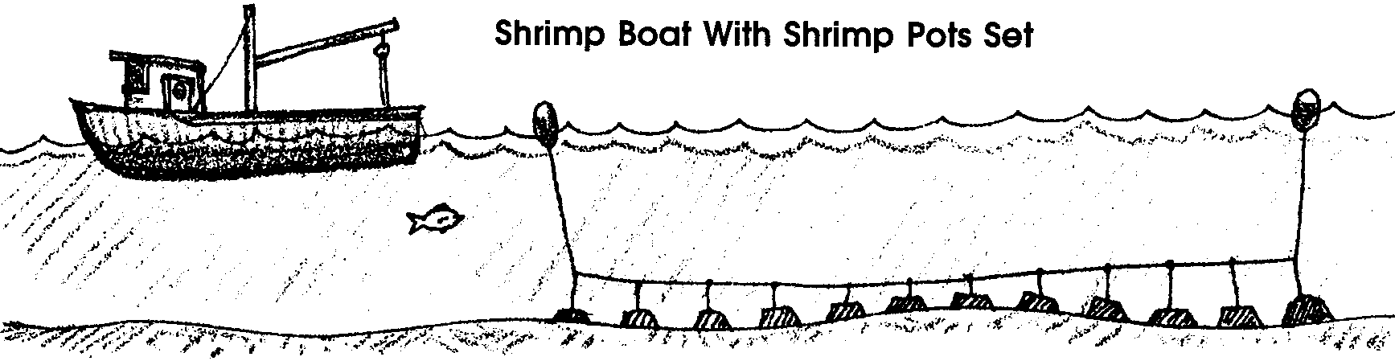
7. Sally Shrimper needs to buy line to connect her shrimp pots. She has 40 pots. She puts her pots 10 feet apart. She ties the pots to the long line with pieces of rope 5 feet long.

a. How much rope does she need for her long line?

b. How much rope does she need to tie her pots to the long line?

c. How much rope does she need all together?

d. Challenge: Sally pays 19 cents per foot for the rope she uses. How much will her new rope cost?

e. Challenge: Oops! Sally forgot that she has to pay tax on her rope. Tax in Shreveport is 8%, or 8 cents per dollar. How much additional money will Sally have to pay for her rope?
One shrimp boat may put out five or more sets of pots. They let the pots “fish” for a few hours or overnight. They then return to the same spot. The buoys help them find their pots. They begin collecting the equipment and the shrimp.

At this point, there is a lot of activity on the boat. Several jobs need to be done. One person pilots the boat. Other members of the crew attach a winch to the main line holding the shrimp pots. The winch is like a small crane. It helps pull the pots on board. Crew members guide the pots onto the boat. They open the pots. The shrimp are poured into the hold of the boat where they are packed in ice. The empty pots are then re-baited and stacked to one side. All the pots are brought up. The captain then decides where to replace the shrimp pots.

8. How do the shrimpers find their shrimp pots when they come back for them the next day?

9. How do you think the captain decides where to replace the shrimp pots?

Distribution And Marketing Of Shrimp

The lines are all checked and reset. Then the catch is brought to shore. Here the catch is sorted. Sometimes small fish and other marine animals are caught in the shrimp pots. They need to be separated from the shrimp. Some of the small fish and other marine animals are ground up. They are used for bait when the pots are set the next day.

10. What are some ways you think shrimpers could reduce the number of other marine animals they catch with the shrimp?

The shrimp are boiled in a salted water. Once they are cooked the shrimp are ready for the market. Some of the shrimpers sell their catch directly to a local fish market. Others sell theirs to a fish broker. Fish brokers buy many different kinds of seafood. They sell them to markets and restaurants in various locations. Many of the shrimp are sold fresh. Some are canned or frozen. Shrimp are a very popular food.

11. A lot of people are involved in getting those shrimp to your salad plate. What are four kinds of work these people do?

12. Shrimp are a lot of people’s favorite food. Over the years, it has become harder for shrimpers to catch shrimp. Many catch fewer than they used to. What are some possible reasons you can think of to explain the decrease in shrimp catches?

PUZZLING SHRIMP
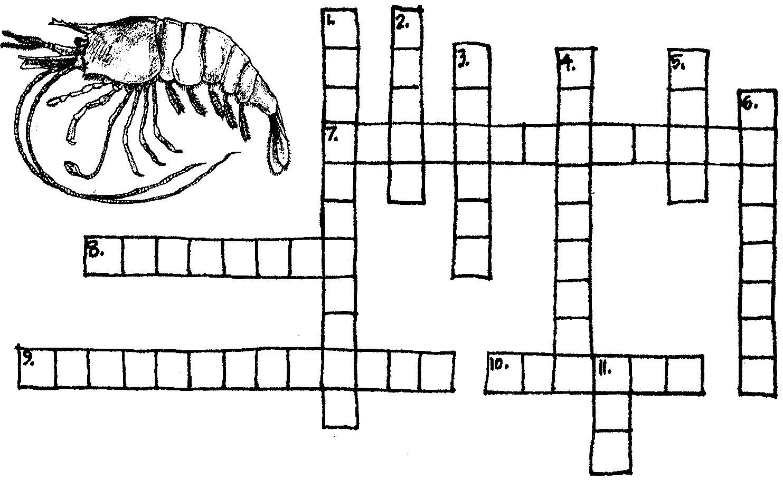

Across
7. Small, drifting plant
8. What a baby shrimp is
9. Changing form
10. A favorite sea food

Down
1. Small, drifting animals
2. Shrimpers mark pots with these
3. People who buy and sell shrimp
4. These feed on dead organisms
5. Some shrimpers use these
6. Long, whip-like sense organs
11. Shrimp are packed in this

