Observing the Living Crab

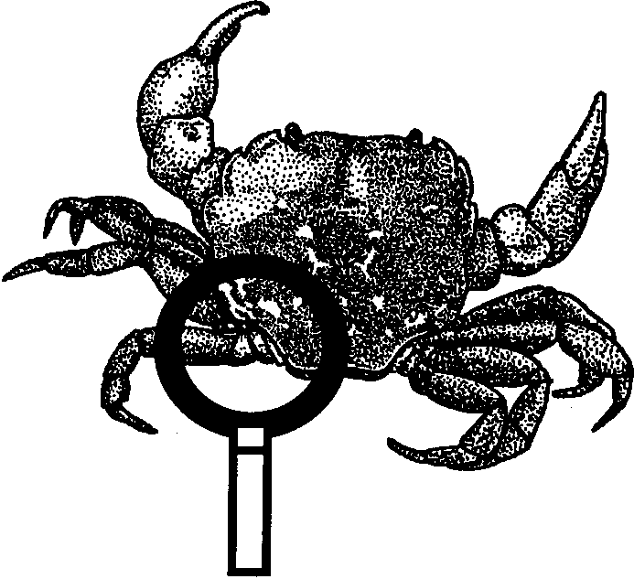
Key Concepts
1. Crabs have unique structural and behavioral adaptations which help them survive in their habitat.

Background

Where to Get Crabs
If you live near the coast, you may be able to obtain a permit to collect crabs. Call your state's Department of Fisheries to check on collecting regulations and permits required. Shore crabs are easily obtained by turning over rocks at low tide (please turn all rocks back to their original position). With a little work, larger crabs can be taken with a scoop or crab pot. Be sure to check local regulations for season, size and number limits. Crabs may also be obtained from fish wholesalers. A live crab is best, but a dead, whole crab will allow much of the exercise to be completed. Biological supply houses also supply live crabs at a reasonable cost. For example: Carolina Biological Supply, 2700 York Road, Burlington, North Carolina 27215. Most of the exercise could also be completed using hermit crabs.

Keeping Crabs Alive
It is important to remember that you must replicate the natural environment of the crabs to keep them alive and well. For example, shore crabs are not completely submerged in saltwater all the time. They need access to saltwater, but they also need a place to crawl out. Other crabs do very well totally submerged in saltwater.

Additional background information can be found in “Crab City”.

Materials

For the class:
• aquarium, 10 gallon
• saltwater
• sand for the bottom of the aquarium (to observe digging behavior)

For each group of three or four students:
• a clear container in which to keep the crab
• living crab (shore crabs are fine)
• ruler
• copies of student activity sheet, “Observing the Living Crab”
Teaching Hints

“Observing the Living Crab” may take one or two hours to complete. Crabs are an ideal laboratory specimen in most areas because:

1. They are easy to keep alive and are relatively available.
2. They are large enough so that the various parts can be seen without the aid of a microscope.
3. They show outstanding specialization of appendages (legs, pincers, etc.). Form and function can be easily related.

Note that crayfish may be used in lieu of crabs or in conjunction with crabs for a comparative study of a freshwater organism.

Crabs can have a strong grip. Avoid being gripped! Grasp the crab across the back. Watch the action of the pincers. Demonstrate proper handling methods to the students and observe the handling carefully. Help instill in your students a respect for life. The easiest way to do so is by modeling your excitement and interest in living things.

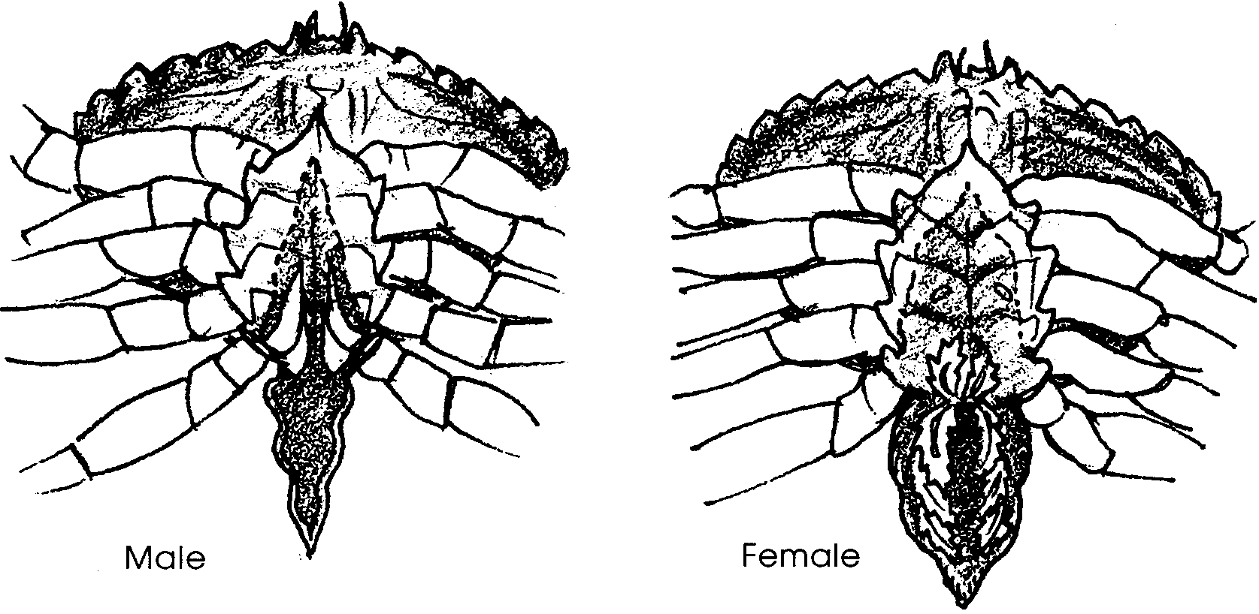
You may choose to show students the swimmerets, located under the abdomen flap. They are easiest to observe on a female crab. Get a good grasp on the crab. Turn her over and find the wide abdomen flap between the legs.

Gently pull back the flap (not too far) to observe the feather-like appendages below the flap. These are the swimmerets.

Key Words

antennae - a pair of jointed sense organs on the head of a crab, insect, lobster, etc.; feelers

appendage - any external part or organ joined on to the trunk or main body such as legs, arms, etc.

average - the number obained by dividing the sum of a group of quantitites by the number of quantities in that group

chitin - a stiff, cellulose-like material forming the shell of crabs

habitat - the place where a plant or animal lives; home

pincers - claws on a crab's front two legs

stalks - long, slender supports

structures - something made up of parts

survive - to continue to live in spite of difficult conditions

swimmerets - a series of small abdominal appendages in some crustaceans, used mostly in swimming and in carrying eggs

Extensions

1. Observe crab larva or eggs under a microscope.

2. Cook and eat fresh crab.

3. Research how crab chitin is being used in medical research.

Answer Key

1. Answers to this and following questions depend upon observation. Crabs walk sideways using specialized walking legs in “pull-push” style.

2. Generally, crabs have 10 appendages.

3. Some species swim quite well. Others barely swim at all.

4. Usually the crab uses all legs in walking except for those bearing the pincers.

5. Answers depend upon the particular crabs.

6. Most crabs dig using their back legs.

7. Crabs catch live food with their pincers.

8. Pincers also serve to move food to mouth.

9. While it is not always possible to see where water enters the gill chamber, close observation often reveals the location. A drop of food color placed near the mouth can be helpful in disclosing the opening. If you elect to use the dye technique, place the crab in clean saltwater before continuing with number 10.

10-15. Answers will vary depending upon crabs observed by class.

16. Most crabs can hold up entire weight with one pincer.

17. Few students can lift themselves up with one arm.

18. Pound for pound crabs are stronger than third graders!

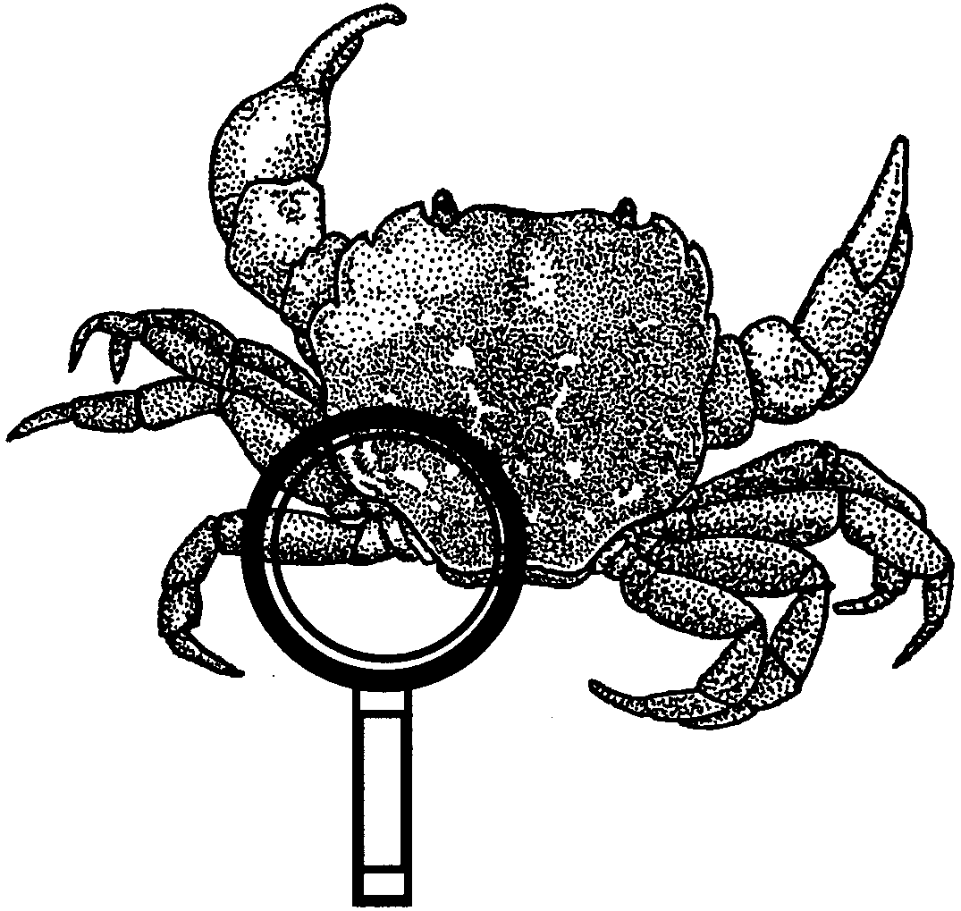
Observing the Living Crab

The crab is a very interesting creature. In this activity you will carefully observe this animal. As you watch, think about this question: How do a crab’s body structures and behaviors help it survive?

Observe a crab in the aquarium.

1. How does the crab move?

2. How many appendages (legs, etc.) does the crab have?

3. Can the crab swim?

4. What appendages does the crab use in walking?

5. Are any of the crabs forming new appendages?

6. How does a crab dig in the sand?

7. How does the crab catch live food?

8. What appendages are used in getting food to the mouth?

Collect one of the crabs in a small, plastic container for observation. Sketch the crab on the back of this page. Make your drawing large. Label body parts. Include details.

9. Can you see where water enters the crab’s body? The moving water carries the oxygen the crab needs to live.

10. Look at the shape of the triangular flap on the underside. What sex is your crab?

11. How wide is your crab (across the back)?

12. How wide is the widest crab in the class?

13. How wide is the narrowest crab in the class?

14. Estimate the width of the average crab. (Hint: a good guess would be a width about halfway inbetween the widest and narrowest crabs.)

15. Find the true average. Do the following:

a) Add all of the widths.

b) With your teacher’s help, divide by the number of crabs measured. The answer is the average.

Test the power of the crab’s pincers. DO NOT PUT YOUR FINGER IN BETWEEN THEM. Place your pencil in between the pincers. Try to lift up the crab using your pencil. Be careful not to lift the crab too high. You only need to see if it is powerful enough to lift its own weight.

16. Can your crab hold up its own weight with one pincer?

17. Can you lift yourself up from the ground with only one arm?

18. Pound for pound, who do you think is stronger?

