Scrambled Crab

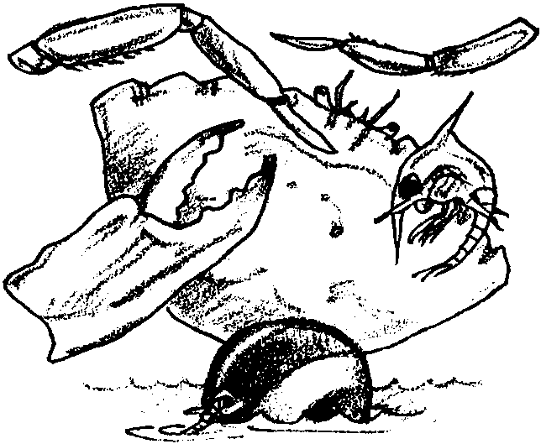
Key Concepts
1. Crabs have unique structural and behavioral adaptations.
2. Estuaries support a large concentration of edible resources, utilized by people from aboriginal times to the present.
3. Humans use a variety of techniques for harvesting crabs from the estuary and oceans.

Background

Background material can be found in “Crab City”.

Materials

For each student:
• “Scrambled Crab” student worksheet

Teaching Hints

“Scrambled Crab” is a review exercise which stresses vocabulary skills. The definitions are found in the text of “Crab City”.

Key Words

buoy - floating object anchored in a large body of water as a marker

crab pots - traps used for harvesting crabs

molting - shedding an outer skin or shell

pincers - claws on a crab’s front legs

plankton - plants and animals that swim weakly, or not at all, and drift with ocean currents; most are tiny

shakers - workers who remove crab meat from shells

Answer Key

1. molting

2. pincers

3. plankton

4. crab pots

5. Indians

6. buoy

7. shakers

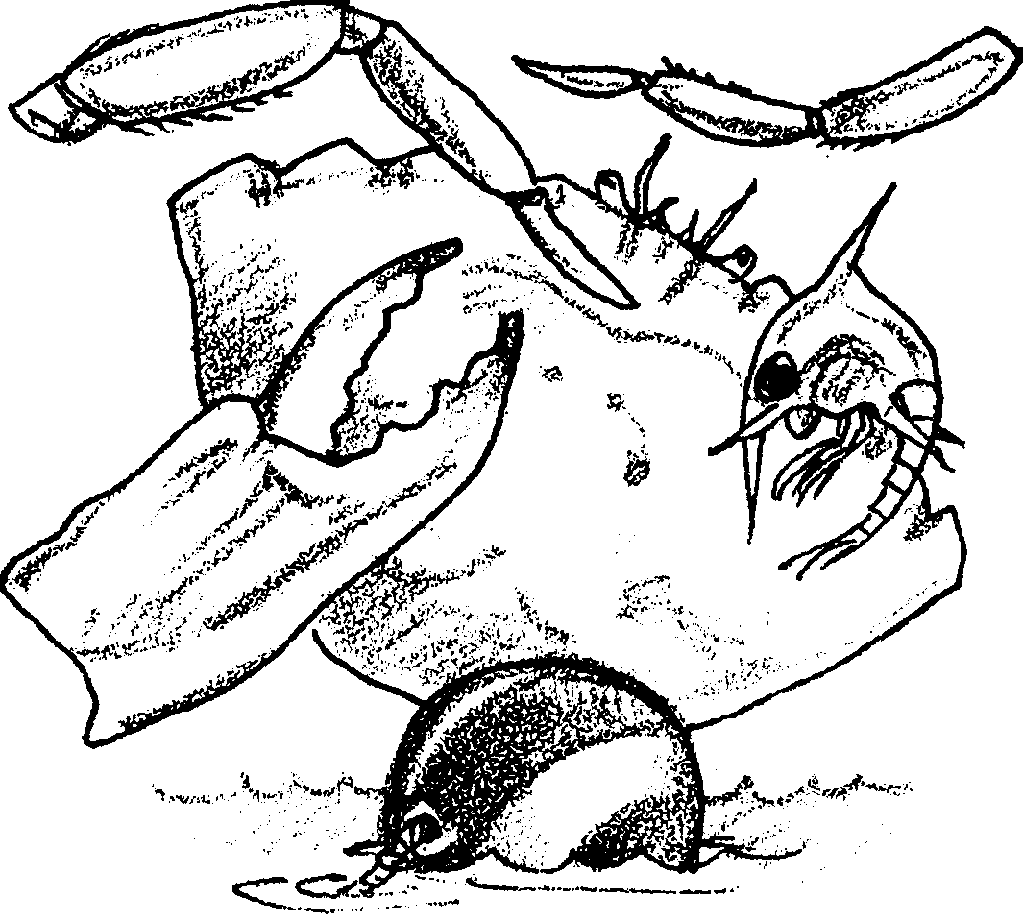
Scrambled Crab

Below you will find some crab terms. The letters of the terms are scrambled. Your task is to unscramble the words.

Sample: BRAC the animal this page is about Crab

LOMTING A crab’s shell does not grow with the crab. The crab sheds its old
shell in a process called .

SENIPCR Crabs use these to tear food into smaller pieces.

KALPNONT Baby crabs are free drifting animals called .

BRAC TOPS Fishermen use these to catch crabs

DIANNIS These people caught crabs long before Europeans arrived.

OYUB This brightly colored float shows a crab pot.

RAKEHSS Workers who remove crab meat from the shells.

