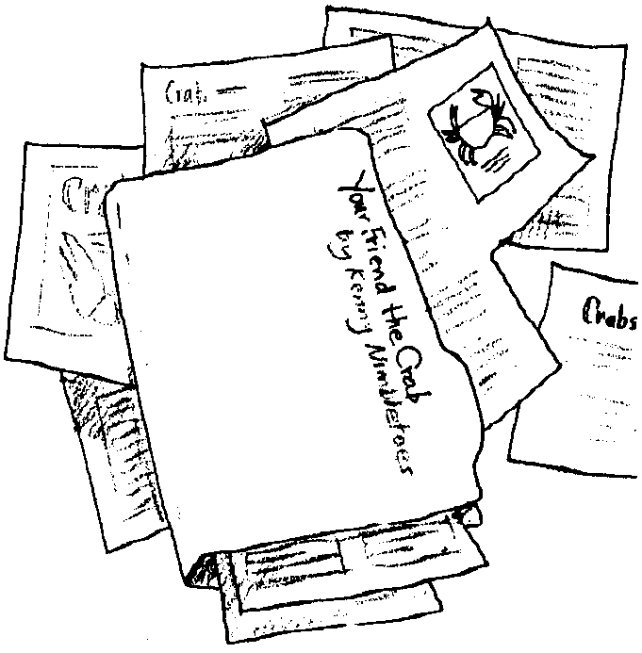
What a Story!

Key Concepts
1. Crabs have unique structural and behavioral adaptations.
2. Estuaries support a large concentration of edible resources, utilized by people from aboriginal times to the present.
3. Humans use a variety of techniques for harvesting crabs from the estuary and oceans.

Background

Background material can be found in “Crab City”.

Materials

For each student:
• “What a Story!” student worksheet

Teaching Hints

“What a Story!” helps develop the sequencing skills necessary to produce good readers. You may elect to have the students do this exercise individually or in small groups.

The statements in “What a Story!” are directly from the text of “Crab City”. Encourage students to skim to locate the statements and determine the proper order. The number of statements can be reduced to make this a simpler exercise.

Key Words

clippings - items cut out of a newspaper

collision - sudden, violent contact between two moving bodies

pressroom - the room where printing presses are located

reporter - one who collects information for publication or broadcast

underside - bottom side

Answer Key

__3__ As crabs grow their shell does not grow with them. Therefore, once or twice a year they must molt (shed the old shell).

__1__ The mother crab carries her eggs on her stomach in a large mass.

__9__ Your crab salad is ready to eat!

__6__ Shakers clean the meat from the shells.

__2__ The eggs hatch into free swimming larvae.

__7__ The crab meat is put into cans.

__4__ Fisherman Frank sets his crab pot.

__8__ The crab is taken to your neighborhood store by truck.

__5__ The crabs are placed in large tanks to cook.

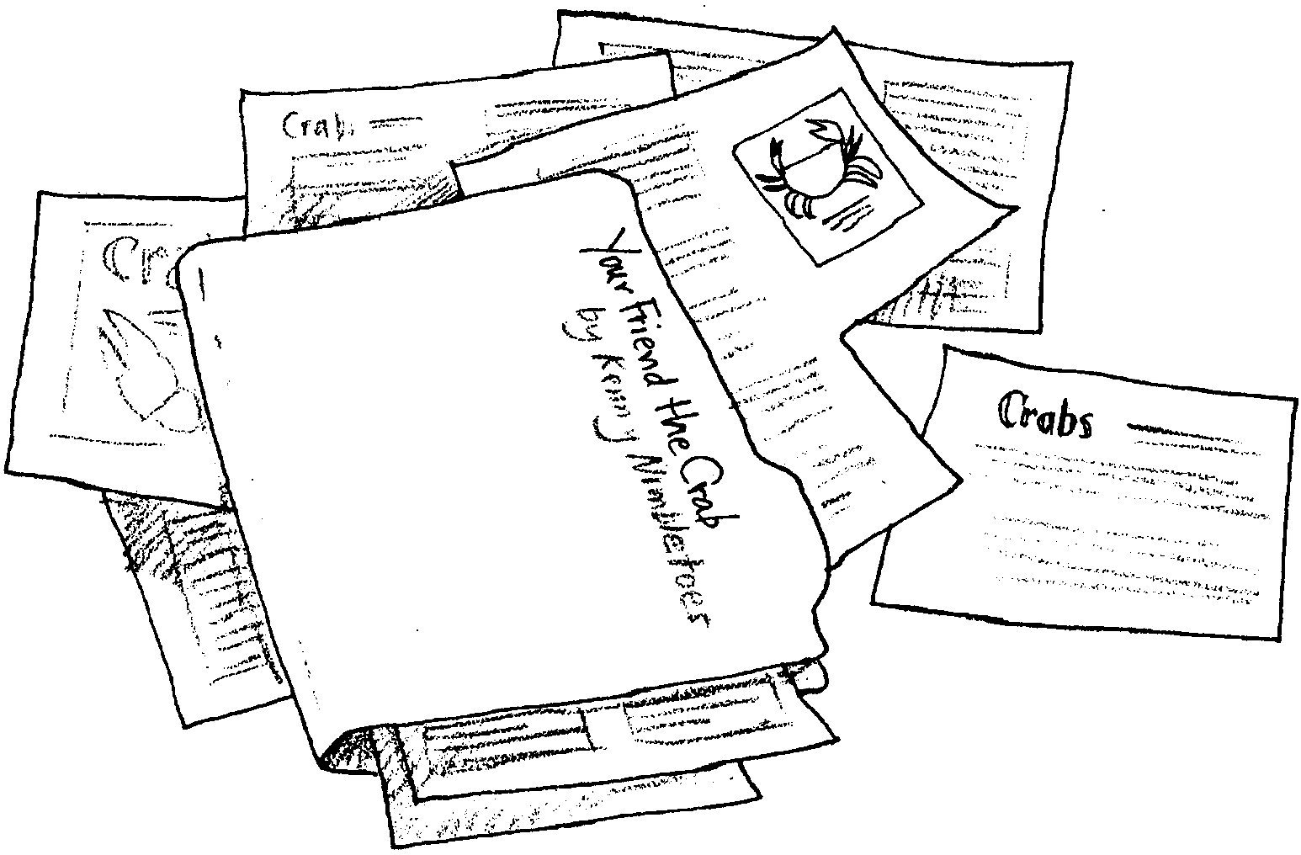
What a Story!
Kenny Nimbletoes, boy reporter, was on his way to the pressroom. He was carrying all the clippings for a feature story, “Your Friend the Crab.” Well, what should happen to Kenny? He had a collision with a fellow reporter. All of the clippings fell to the floor. The story below is the result. Help Kenny arrange the facts.

Number the statements in the correct order from crab eggs to crab dinner.

_____ As crabs grow their shell does not grow with them. Therefore, once or twice a year they must molt (shed the old shell).

_____ The mother crab carries her eggs on her stomach in a large mass.

_____ Your crab salad is ready to eat!

_____ Shakers clean the meat from the shells.

_____ The eggs hatch into free swimming larvae.

_____ The crab meat is put into cans.

_____ Fisherman Frank sets his crab pot.

_____ The crab is taken to your neighborhood store by truck.

_____ The crabs are placed in large tanks to cook.

