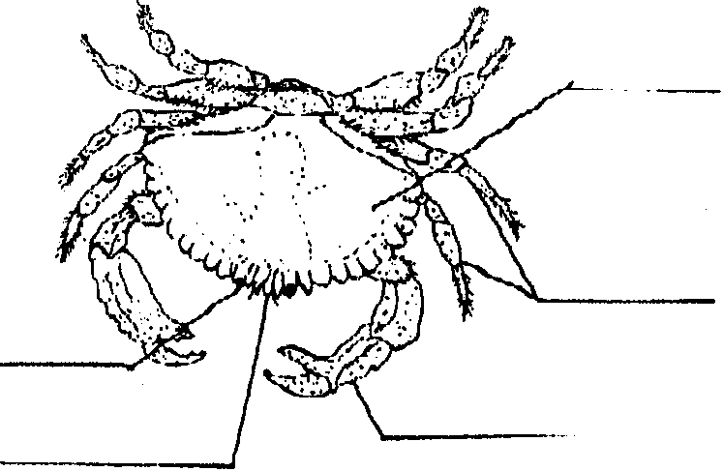
Crabs

Key Concepts
1. Crabs have unique physical structures that especially adapt them to their environment.

Background

Background material can be found in “Crab City”.

Materials

For each student:
• copies of the student worksheet, “Crabs”

Teaching Hints

“Crabs” reviews material introduced in “Crab City”. The first part of the exercise (labeling the crab) is designed to encourage the students to review the diagrams in the text. The questions test the recall of material from the text. Students may do this independently or in small groups.

Key Words

crab - crustacean with five pairs of legs, the front pair bearing pincers, and a short broad abdomen folded under its thorax

pairs - in sets of 2

pincer - claws on a crab’s front pair of legs

skeleton - hard structure supporting an animal’s body

Answer Key

1. Eyes, legs and pincers all come in pairs.

2. The crab’s skeleton is on the outside (an exoskeleton); it is the shell.

3.The crab grows by shedding its skeleton (molting) and replacing it with a new one.

4. No, we can’t tell the sex from the drawing.

5. To tell the sex, we’d need to turn the crab over and examine the width of the triangular flap between the legs. The female has a triangular flap with a broader base than the male.

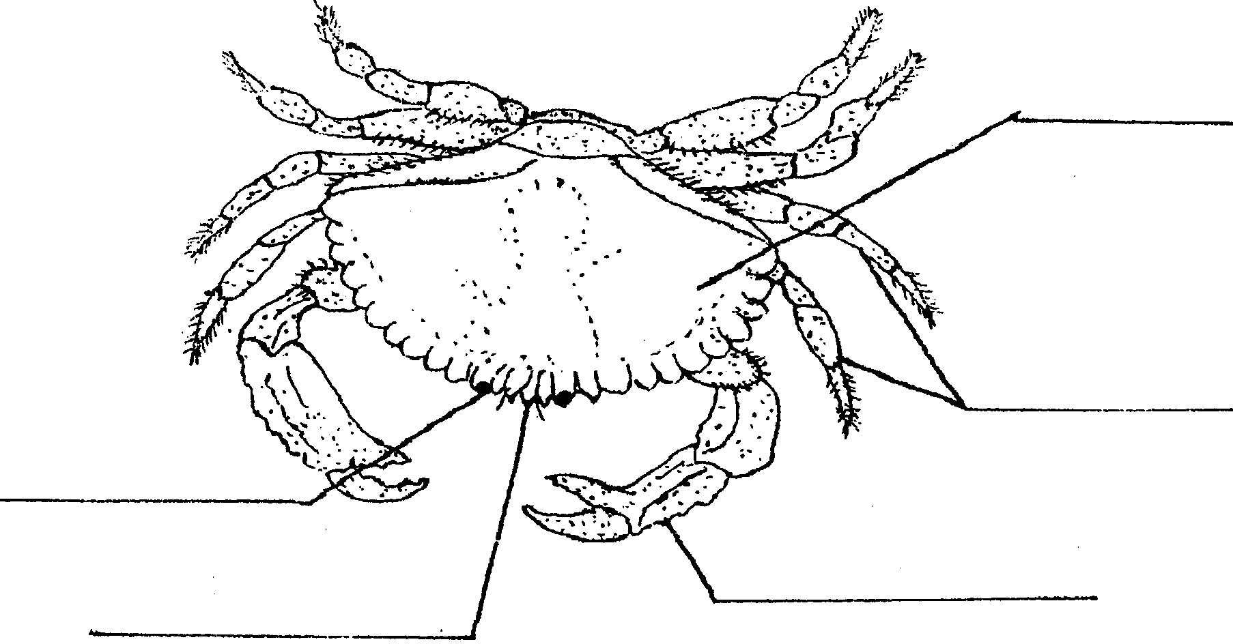
Crabs

Label the marked parts on the crab shown above.

1. What are the two labeled parts that come in pairs?

2. Where is the crab's skeleton?

3. How does a crab grow?

4. Can we tell the sex of the crab in the drawing?

5. How could we tell the sex of the crab in the drawing?

