Crab City

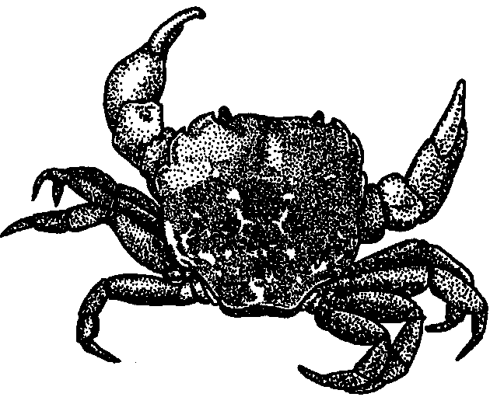
Key Concepts
1. Crabs have unique structural and behavioral adaptations.
2. Estuaries support a large concentration of edible resources, utilized by people from aboriginal times to the present.
3. Humans use a variety of techniques for harvesting crabs from the estuary and oceans.

Background

A look at crabs and crab harvesting provides an intersection for a study of how humans make a living along our coasts and how marine animals are adapted to their environments. Certain crabs are commercially important food items and interesting creatures.

Materials

For the class:
• salt

• copies of “Crab City” for each student or pair of students

Teaching Hints

The material in this section can be used to stimulate discussions on topics ranging from regeneration of body parts to conservation of marine resources. Encourage these conversations and direct them toward developing an appreciation of the factors facing organisms that live in the sea.

The unit of lessons focusing on crabs requires some advance planning. Arrangements should be made to obtain crabs (alive, if possible) for the activity, “Observing the Living Crab”.

Key Words

bait - food put on a hook or in a trap as a lure

blue crab - a edible crab of the Atlantic and Gulf coasts

buoy - a floating object anchored in water as a marker
commercial - designating something made or harvested for profit

crab - a crustacean with five pairs of legs, two with pincers, and a short, broad abdomen folded under its thorax.

crab pot - trap used in harvesting crabs

Dungeness crab - a crab commercially harvested along the Pacific coast

inflate - enlarge by filling with air or a gas

molting - shedding the outer covering or shell

pincer - claws or front set of crab legs

plankton - plants and animals that swim weakly, or not at all, and drift with ocean currents

regeneration - restoration of a body part after injury

rock crab - species of crab along the Pacific coast

scavengers - animals that eat decaying plants and animals and wastes

scoop - a net tied to the end of a long pole used in catching crabs

shakers - workers who remove crab meat from the shells

skeleton - the hard framework for an animal’s body

Extensions

1. Compare other species of crabs and/or crayfish to those studied in this activity. Students could present information in a “Natural History Line”. Students hang a string across a wall of the classroom. They research natural history information like: breeding, distribution, habitat, life cycle, food, etc. Each piece of information is put on a card or sheet of paper and hung on the line.

2. Create a game or other device to help identify the types of crabs found in a particular estuary or coast.

3. Invite a person who harvests crabs for a living to your classroom to talk about their work.

4. Make a model of a crab pot.

5. Make an electric board matching game for the body parts of a crab.

6. V isit a crab cannery or a vessel that is used to harvest/process crabs.

7. Make a small picture booklet on the steps in processing crabs.

8. Invent a crab dance. Try out some dances for other estuary creatures and have a swinging, hopping, moving event!

9. On a field trip, students might determine whether males and females are present in equal numbers. How many species can they locate? How are they distributed on the beach or mudflats?

Answer Key

1. a - b. Two things for which crabs use their pincers include: tearing food (eating); protection; and movement, using their pincers as “hands” to help them move up, down, and around.

c. Possible answers are found above. Since this question asks students to think about other uses, any reasonable answer is a good one.

2. Crabs eat old and dying marine life and living clams, worms, small fish and other living marine life when they can catch them.

3. Without scavengers, large and small, dead things would pile up in the ocean. Stored in the dead things would be all of the elements needed by living plants and animals. Eventually life itself would be threatened. Scavengers, the ultimate recyclers, are a critical component of any living system.

4. a. It takes several months for a pincer to regenerate.

b. A crab uses its pincers to help it eat, move, and protect itself.

c. The crab would have great difficulty in eating and protecting itself and some difficulty in moving if it lost its pincers. It would have to hide for protection and find small, harmless food to eat.

d. Hopefully, this exercise will convince your students to tell people it is not okay to remove pincers or legs from crabs, or any other living thing.

5. Yes, regenerating body parts would be valuable for humans. We could replace limbs or organs lost to accident or disease.

6. Molting is the periodic shedding of an outer covering, in this case the shell, and replacement with a new one.

7. Crabs molt in order to continue to grow. Adults apparently replace “old” shells also.

8. Being able to tell male and female crabs apart is important for anyone who collects crabs to eat, since regulations are often based on gender. Males are kept and females are released. Your students may have other ideas why the ability to distinguish between males and females is important.

9. Estuaries are often the nursery grounds for many species including many kinds of crabs. If nursery grounds are filled we will likely see a decrease in the number of adult crabs.

10. a. Carla Crab will lay 12 million eggs during her lifetime.

b. If Carla lived to be 20 years old, she would lay 36 million eggs (ie (20 years - 2 years to get to breeding age) x 2 million eggs/year).

11. Chances of a crab egg reaching adulthood are very slim. From this example, only one in over a million crab eggs reach adulthood.

12. Being eaten, lack of oxygen, being removed from the water, or otherwise landing in an inhospitable environment might keep an egg from growing into an adult.

13. a. The Dungeness crab has a more rounded shell.

b. The rock crab has the rougher shell and larger saw-tooth edges on its shell.

c. Dungeness has thicker legs and pincers.

14. Answers may vary. The blue crab belongs to the group of swimming crabs. The paddle-shaped outer segments of the rear legs can be rotated over the carapace, giving the crab the lift and propulsion to swim at speeds over one meter per second.

15. This question is included to provide an opportunity to get your students thinking about overharvesting and human impact on marine resources. They may have a number of ways to protect the crab populations including strict regulations against overfishing, letting small crabs and females go, and raising crabs in a hatchery.

16. a. In Washington state, the limit for Dungeness crabs is 6 males per day

b. The crabs must be at least 6 inches across at the carapace (6 1/4" in Puget Sound except Hood Canal).

c. No females may be collected. The females are left to reproduce.

17. Crabs are collected mostly for food, although some are collected for scientific research and some by people with collections of “things”. This question provides an opportunity to talk about leaving organisms and objects in their habitat.

18. Descriptions will vary, but a crab pot is a baited trap with a one-way entrance of some sort which is lowered to the bottom where it is allowed to remain until crabs walk in. The live crabs are removed when the trap is brought to the surface.

19. This question deals with the topic of “ghost fishing,” the entrapment of animals by lost or discarded nets and gear. This is a very serious problem. Fishing nets could model crab pots by having degradable strands of cord that would cause the net to fall apart when they rot. The issue for fishers is complex. Nets are expensive and they want them to last.

20. Answers will vary. Some of your students will probably have eaten crab. Use this as another opportunity to assess student experience with the topic.

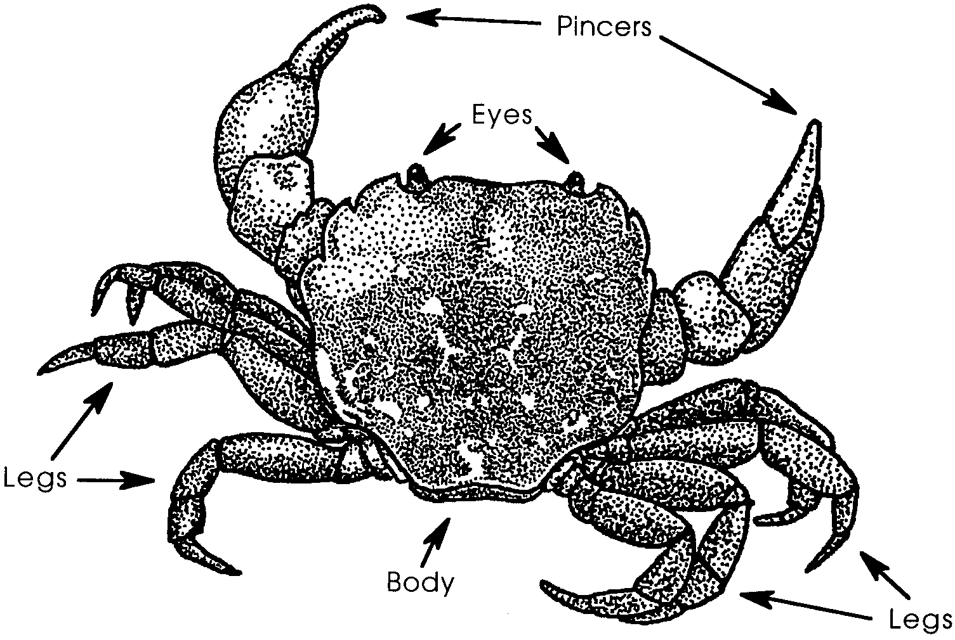
Crab City

Crabs are one of the first animals one discovers on the beach. They can be found on most beaches in an estuary. Crabs are some of the most interesting animals of the marine world.

Crab Adaptations
The crab’s head, neck, and chest are made of one piece. On this piece are two eyes on stems. This allows the crab to see in all directions without moving its body. This is a pretty handy feature. It helps the crab see any danger that may be coming its way.

A crab has eight legs and two pincers. The legs and pincers are attached to its body. A crab uses the legs on one side of its body to pull it along. The legs on the other side are used to push it in the same direction. This means crabs walk “sideways.”

Try walking like a crab. Get on all fours with your back facing the floor. Reach out with one hand and one foot. Use the hand and foot to pull you to the side. At the same time push with the other hand and foot. Repeat the “pull and push” movements until you get the hang of the crab walk.

The two pincers are used like two pairs of chopsticks. The pincers are very powerful. Crabs use them to tear food into smaller pieces. The pincers are also used for protection from their enemies. Don’t become a crab’s enemy because the pincers of a large crab can break a person’s finger!
1. What are two things for which a crab uses its pincers?

a.

b.

c. What is a third thing for which you think a crab might use its pincers?

Crabs are scavengers. This means they eat what they can find. They mostly eat old and dying marine life. But when they can catch them, they eat live clams, worms, small fish, and other small marine life. The Dungeness crab, for example, eats small clams. It uses its strong pincers to chip away at the shells.

2. What do crabs eat?

3. What would happen if there were no scavengers, like crabs, in the sea?

Crabs are sometimes injured by larger animals or in accidents. If a leg or pincer is broken off a new one will grow back. Crabs have special “weak” areas in their legs. When a crab is injured or when an enemy is holding on to a leg, the crab can help its leg break off. Muscles in the body keep the crab from losing much blood. The new leg or pincer starts as a tiny bump. It takes several months for the leg or pincer to re-grow. This is called regeneration.

4. Sometimes people don’t think very clearly. Some people think that since a crab can re-grow its pincers, it’s okay to break them off and take them home. Let’s think about this idea:

a. How long does it take for a crab to re-grow its pincers?

b. How does a crab use its pincers?

c. How will it do those things without pincers?

d. What would you tell someone who said it was okay to break off a crab’s pincers or legs?

5. How would re-growing parts be valuable for humans?

Crabs have another interesting feature. A crab “wears” its skeleton on its outside. The crab’s shell is its skeleton. Your skeleton is inside of you, under your muscles. When you grow, your skeleton grows. Not so for crabs. As crabs grow their shell does not grow with them. In order to grow, a crab must shed the old shell that is too small. This is called molting.
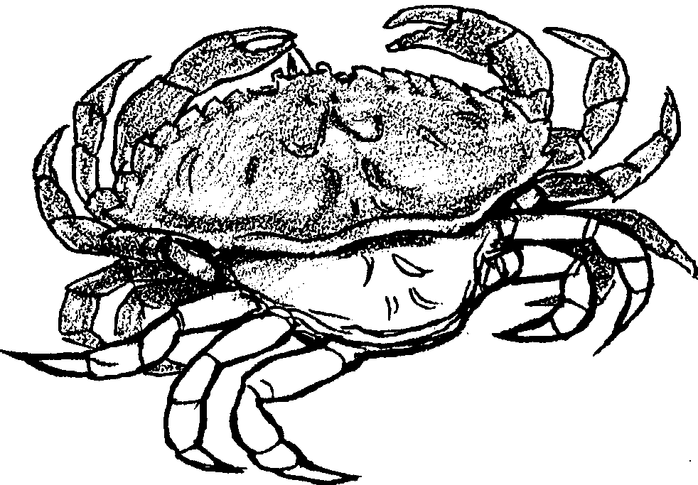

Before a crab sheds its shell, it grows a new shell under its old one. The crab splits the seams that join the top and bottom parts of its body shell. Then it backs away from its old shell. The old shell which is left behind looks just like a crab. Many of the “dead” crabs we find at the seashore are actually these old, molted shells.

6. What does “molting” mean?

The new shell is soft and flexible. The crab pumps water into the new shell. The water inflates it to the proper size. The new shell takes time to harden. The crab protects itself by burying itself in the sand. Adult crabs usually molt once or twice a year, often in early summer. Young, fast growing crabs may molt every few weeks.
7. Why does a crab molt?

Crab Life Cycle
Just by looking at them, you can tell lots about how crabs live. You can also tell if a crab is male or female. People who collect crabs to eat need to be able to tell the difference. In many areas, you can only eat male crabs. Here’s how you can tell the difference. Turn the crab over. Look at the triangle shaped flap on the underside. The triangle is between the two rows of legs. The triangle on the female crab has a wide base. The female’s wider flap is helpful because she carries her eggs on the flap.
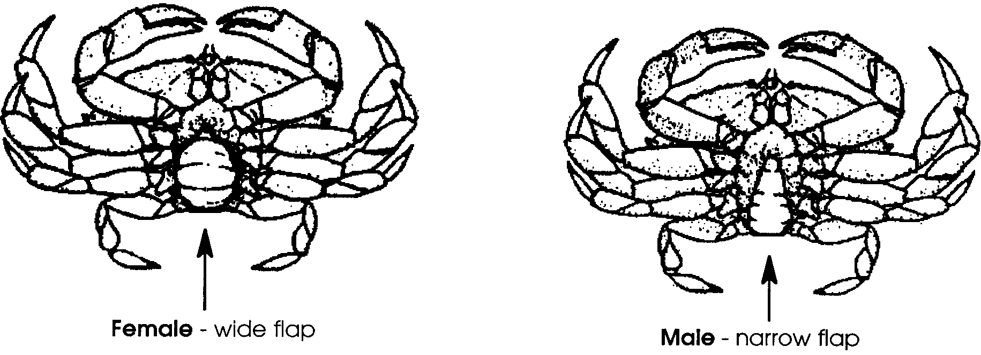
8. Why might someone want to be able to tell male crabs from female crabs?

A mother crab carries her eggs on her underside flap in a big mass. A medium sized female crab may have as many as 2 million eggs. For the crab eggs to successfully grow into adults, conditions have to be just right. Some kinds of mother crabs travel to an estuary to lay their eggs.

9. Many crabs lay their eggs in shallow areas of the estuary. What will happen to the number of crabs if humans fill in these shallow areas of the estuary?

10. Some adult crabs live to be 20 years old. Carla Crab, however, only lives to be eight years old. She starts to lay eggs at the age of two.

a. How many eggs will she lay in a lifetime? (Hint: she will lay 2 million eggs each year for six years.)

b. How many eggs would Carla have laid if she lived to be 20?

An adult female crab can lay millions of eggs in a lifetime. Why aren’t we up to our knees in crabs? Let’s think about that one. The number of crabs would stay the same if only two of these eggs grew into adults. One adult crab could replace the mother and one could replace the father. What happens to all of those crabs?

11. How good are the chances of a crab egg becoming an adult?

12. What are two things that might keep an egg from growing into an adult?

a.

b.

When the eggs hatch, they don’t look much like crabs. They drift freely in the water with other drifting plants and animals. These drifters are called plankton. Many of the drifting young crabs are eaten by fish and other marine life. In fact, only one in about five million grow up.
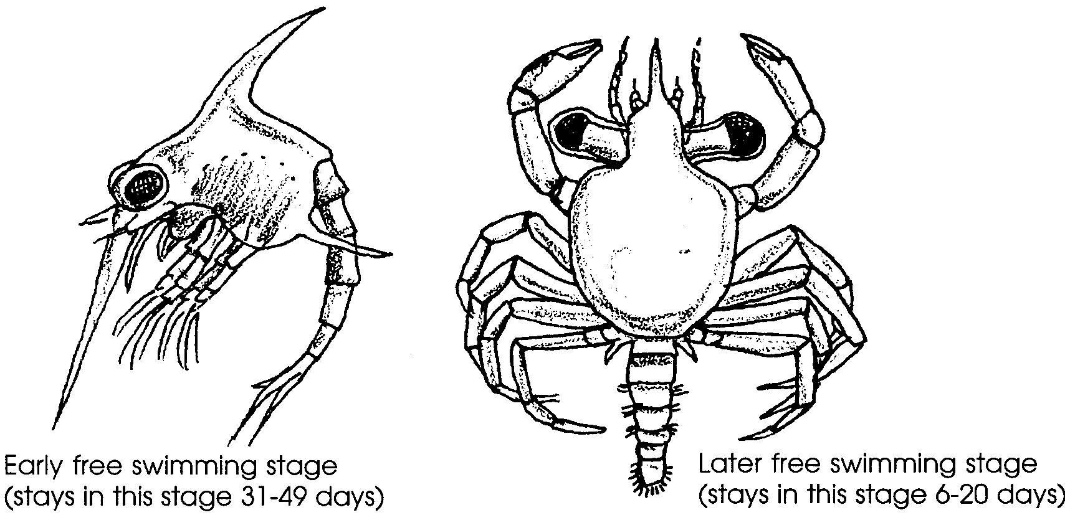

There are many different kinds of crabs. They come in many sizes. One kind found in Japan can have a shell 18 inches long and legs measuring 15 feet. Other crabs are very small. One kind is less than an inch in length. It often lives inside another animal such as a clam. You may have noticed crabs on beaches. These are often sand crabs or shore crabs.

Crabs Harvested Commercially
The Dungeness crab is one of the main crabs harvested commercially along the Pacific Coast. The Dungeness crab has a hard shell. It can be up to ten inches across. They are often found on sandy and grassy bottoms below the tide range. They are found in the oceans and in estuaries. Dungeness crabs are easily recognized by their large, thick legs and pincers. Rock crabs look a lot like Dungeness crabs. Why aren’t they harvested commercially? Rock crabs are smaller and have less meat than the Dungeness crab. However, rock crabs are gathered by beachcombers. They may be found in the inland waters along most kinds of bottoms. So while there are many kinds of crabs, only a few are taken commercially.

13. Use the drawings below to observe a Dungeness crab and a rock crab.
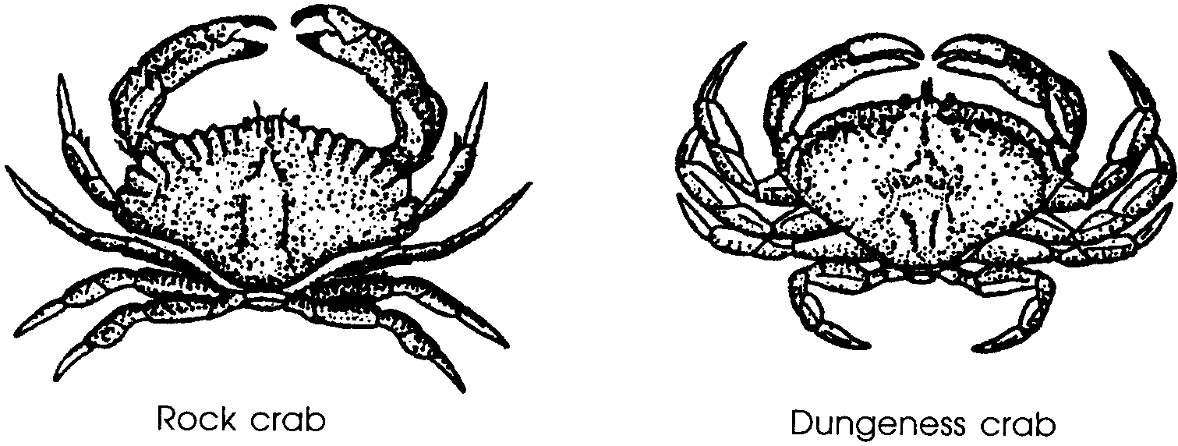

a. How does the shape of the Dungeness crab differ from the rock crab’s?

b. Which crab has a rougher shell and larger sawtooth-like edges on its shell?

c. Which crab has thicker legs and pincers?

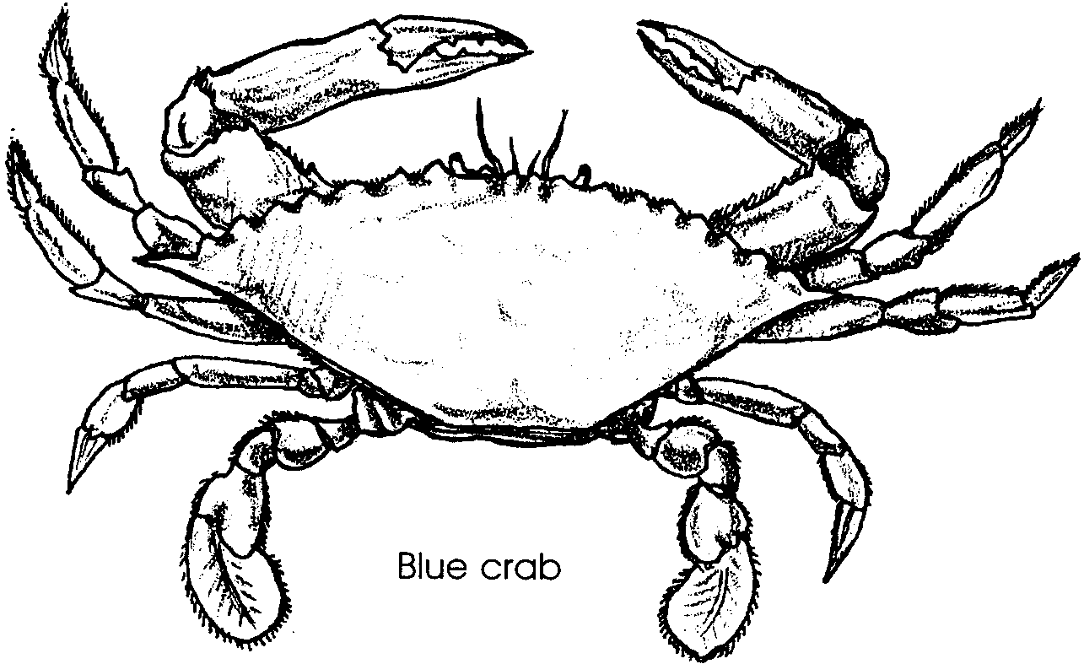
The blue crab is commercially harvested along the Atlantic and Gulf coasts.

Blue crabs are often harvested just after they molt. Before their new shells harden. They are marketed as “soft-shelled crabs.” When hunting for food, the blue crab buries itself in soft sand or mud. Only its eyes and antennae are exposed as it waits. It swiftly plucks its prey from the water.

14. Compare the drawing of the blue crab with the drawings of the other crabs. Notice the shape and positions of the rear legs. How do you think a blue crab uses these legs to move through the water?

15. Only a few kinds of crabs are caught commercially. As the human population increases, more people want to eat these few crabs. How might we protect the crab populations?

Collecting Crabs
People who collect crabs to eat must know the rules for collection. Below is a page from the Sport Fishing Guide for Washington State.
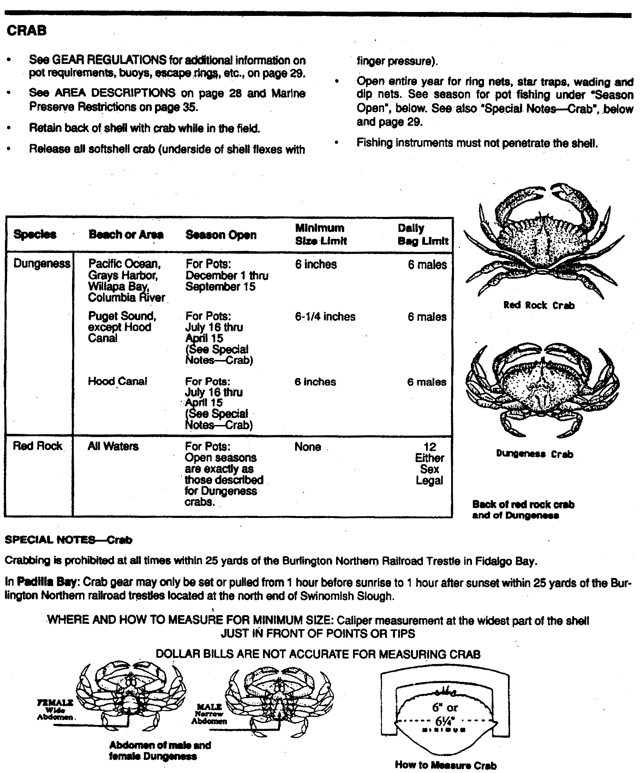

16. a. What is the daily limit of Dungeness Crabs?

b. What about size?

c. What does it say about taking females?

If you live in a different state, that regulates the harvest of crabs, find the rules for harvest for your state.

There are many ways to collect crabs for food. People who don’t collect crabs for a living are called “sport crabbers.” Sport crabbers use three main approaches. The most exciting is, of course, by hand. If you wish to catch crabs by hand, it is best to follow the shoreline. Wade through the shallow water as the tide goes out. If you look carefully, you’ll see the crabs scurry out of your way. Grab the crab with your hand. The crab should be held across the shell from the back, use your thumb and fingers. Watch those pincers. Don’t let them reach your hand.

17. Why do people collect crabs?

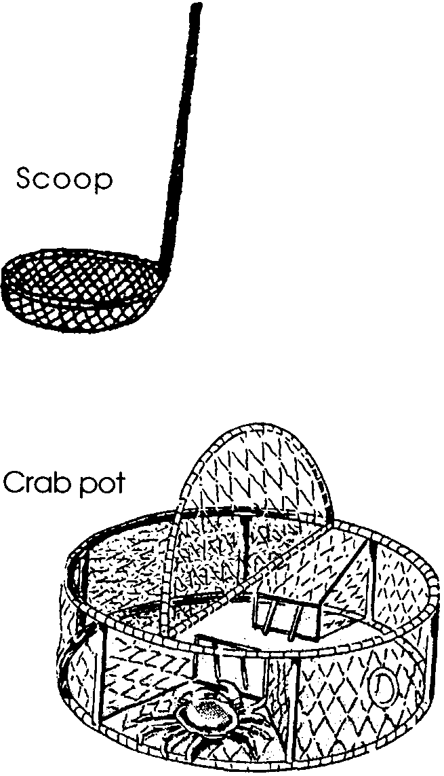
A scoop is another way used to catch crabs. A scoop is simply a net tied to the end of an 8 - 12 foot pole.

The sports crabber walks along the shoreline in a shallow area. The scoop is used to catch the crabs. A scoop can also be used from a drifting boat.

Traps called “crab pots” are by far the easiest way to catch crabs. This is the also method used in commercial crabbing. Crab pots are made of wire. They have a trap door which keeps the crabs from leaving the pot once they are inside.

Crab pots are set with bait. The bait is set in the center of the pot. It is wired down to keep the crabs from reaching it from the outside. The bait invites the crabs inside.

18. How does a crab pot work?

Commercial crab pots are bigger and stronger than those sold in sporting goods stores. Commercial crabbers harvest crabs as far as 600 miles off shore. Baited pots are dropped into the water and left. The location of each crab pot is marked by a brightly colored buoy. The buoy floats on top of the water. The pots are dropped in different spots. They are moved until the crabs are found. One boat can watch up to 900 pots. The pots are hauled, baited and reset every one to seven days.

What happens if a crabber loses his crab pot? The crabs in the pot die. They become bait for other crabs. New crabs enter the trap. They also die. This could go on for a long time. A lot of crabs would die. Crabbers do not want this to happen. They make a part of their trap out of screen that rots fast. If the trap is lost, the screen will rot out. Then the crabs can climb out.

Pieces of fishing net are sometimes lost from fishing boats. The net can go on catching fish. Fishers can take a hint from crabbers.

19. How could fishers prevent lost fishing net from fishing forever?

Processing Crab
Usually the collected crabs are taken to shore to be cooked. They are cleaned and cooked in large pots. The meat is removed from the shells by workers called “shakers.” The crab meat is then put in cans, sealed and labeled. Some cooked crabs are sold whole to stores and restaurants. Just think about all of the people involved in getting a crab salad or sandwich to your plate.

20. Have you ever eaten crab?

