What Grows There?
Lesson edited by Phyllis Schmitt, Santa Rosa, CA
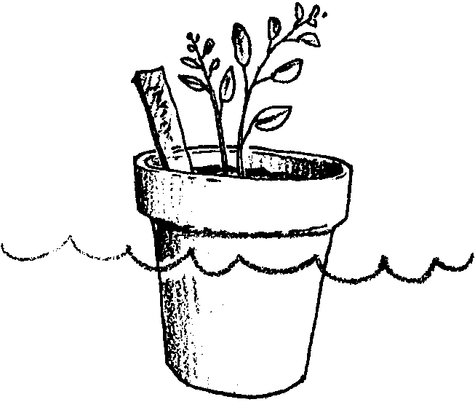
Adapted from “Sea What Grows”, FOSS Environments

Key Concepts
1. Plants are adapted to live in certain environments.
2. Most plants are not adapted to tolerate salt.
3. Some plants are adapted to be salt-tolerant.

Background

Water is essential for seed germination and plant growth. While some plants, such as seaweed, pickleweed, eelgrass and cordgrass grow in saltwater, most plants actually lose water from their tissues and wilt in saltwater. Salts enter the plant roots along with water, and, if concentrated, may become toxic to the delicate enzyme systems within the plant cells. Plants that can grow in saline soils, use a variety of techniques to deal with the salt. We call these salt tolerant plants “halophytes” from the Greek roots for “salt” and “plant.” Some halophytes are able to pump salts back into the soil; others take up the salts and deal with them internally. Pickleweeds, for example, build up high concentrations of salt in their outer sections. Succulent plants dilute the internal salts. Sea lavender and cordgrass excrete salts through specialized salt glands. The salt forms crystals on the undersides of their leaves. Saltwort and native ice plant have special leaves or bulb-like hairs where the salt can be concentrated without damaging growing tissues.
Halophytes do not need salt to grow; they usually do much better when watered with freshwater. However, they do not compete successfully with other plants in a freshwater environment.
Salt loving plants may play an important role in future agriculture. Much of the earth’s land is unsuitable for agriculture, because the supply of freshwater is low, or because there is a high concentration of salt in the soil and water for irrigation. Such is the case in many coastal areas even though other conditions make them desirable for farming: high light intensity, suitably high temperatures, long growing season, and soils rich in plant nutrients. Scientists are experimenting with many agricultural crops to find salt-tolerant varieties that will grow using salty water for irrigation. The use of saltwater for irrigating crops may one day have a profound influence on agriculture.

Materials

For the class:
• salt

• potting soil

• pitchers of water

• newspaper, tape, marking pen, labels

• two, identical potted-plants

• copies of the student data sheet, “What Grows There?”

For each group of 6 students:
• tray to hold planter cups

• 6 planter cups (with drainage holes)

• 30 salt-tolerant barley seeds; available from:

Delta EducationItem: 42-190-1217
Nashua, New Hampshire 03361
800-442-5540

• 15 corn seeds

• 3 pint-sized containers with lids; openings must be large enough to be dipped into with the plastic cup

• 1 small, plastic 2 ounce cup (to be used for watering)

• 1 teaspoon

• 2 Popsicle sticks, or other wood stirrers

Teaching Hints

Several weeks before beginning this activity:
1. Order salt-tolerant barley seeds.

2. Place the two potted-plants in a warm place, with plenty of sunlight, that is easily seen by the students. Treat the plants identically, except, water one with freshwater, the other with salty water. As one plant wilts, students can discuss what is happening and why.

Introduction

1. Tell this story:

Farmer Smith lives by an estuary. He usually irrigates his crops with river water, but there is a drought. The river is almost dry and he doesn’t have enough freshwater to grow the beans and barley he has planted. One morning he looked at the estuary and thought, “Why don’t I use estuary water to grow my beans and barley? There’s plenty of water there. It’s not as salty as the sea!”

2. Ask the students what they think about farmer Smith’s idea. If they say that plants won’t grow in saltwater, tell them that farmer Smith wants proof that what they say is correct.

3. Introduce the concept of a salt-tolerant plant. If you did the potted-plant watering demonstration, you might discuss whether that type of plant is salt-tolerant. Reinforce the idea that each kind of plant has special environmental requirements. Challenge your students to help farmer Smith decide what to do by conducting an experiment. Ask them for suggestions on how to design the experiment.

4. Incorporate students’ ideas in setting up the experiment. The following directions can serve as a guideline:

Planting

a. Cover the work area with newspapers for easy clean up.

b. Label three cups: BEANS and three more cups: BARLEY.

c. Label the tray; left, front: FRESH; the center: ESTUARY; right, front: SEA

d. Fill each of the 6 cups with soil, three-quarters full. Do not fill cups to the rim.

e. Use fingers to make a shallow hole in the soil of the 3 cups for the BEAN seeds. Put 5 bean seeds in each of these cups.

f. Place 10 barley seeds on top of the soil in the BARLEY cups.

g. Sprinkle about 2 cm. of soil over the seeds in all 6 cups.

h. Place the cups on the tray: beans in the back row, and barley in the front.

Illustration of set up follows:
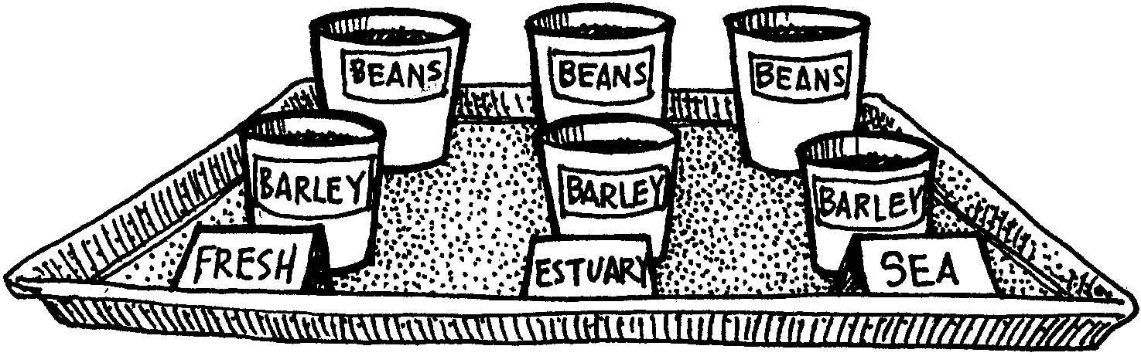
Watering directions are given below. Remember, water is one part of the environment of the seeds. Select an appropriate growing environment for the trays: light and warm with no direct sunlight.

Watering

a. Label the three pint-sized water containers: FRESH, ESTUARY and SALT.

b. Fill each container with the appropriate solutions:

Fresh water 0 teaspoonfuls salt / container of water

Estuary water 1 teaspoonful salt / container of water

Seawater 2 teaspoonfuls salt / container of water

Each spoonful of salt must be a level teaspoonful. Use one of the wooden sticks to level off each heaping spoon of salt before adding it to the container. Use the other stick to stir each saltwater solution.

c. “Irrigate” the plants on Day 1 and about every four days thereafter, or whenever the soil feels dry to the touch. Dip the plastic glass for watering into the pre-mixed, water solution. Fill it to the brim and pour it into the correct pot. Start with the freshwater and repeat this process for each planter cup, being very careful to put the water in the cup with a label that matches the label on the container. As the level of the watering solutions is lowered, fill the cup for watering by pouring the solution into the cup. It is important to water each cup with the same amount of water. All things must be kept the same in each of the cups, except the kind of water used for irrigation.

NOTE: There is enough prepared solutions to water plants on Day 1 and water them twice later. If further watering is required, prepare the three irrigating solutions again.

5. Have students write predictions of which seeds will grow best in each of the environments.

6. Plant shoots should appear in about 4-5 days. Have students make observations on Day 7 and Day 14.
Observations and Discussion

Day 7
Have students compare and chart the growth of the bean and barley seeds. Ask students if they feel they could use their results to offer farmer Smith advice at this point.

Day 14
Have the students again chart the growth of the bean and barley seeds. Ask them how the results differ from those of the previous week.

7. Have students write letters giving their advice to farmer Smith.

Key Words

drought - period of time with no rain; extended dry weather

environment - the living and non-living surroundings of a plant or animal

estuary - partially enclosed area where freshwater of a stream or river mixes with seawater

irrigate - to water

tolerant - ability to survive despite an unfavorable condition

Extensions

1. Try the same kind of activity using seedlings or cuttings.

2. Take a field trip to a nursery. Have students find other kinds of “tolerant” plants, i.e. shade-tolerant, drought-tolerant, cold-tolerant, etc.

Answer Key

1., 2. Answers will depend upon experimental results. Expected results would find barley growing better under the variety of conditions tested. Barley is somewhat salt-tolerant and, while it grows best in freshwater, it will also grow in saltwater. The beans, however, cannot grow in a salty environment. The point to make with your students is that each type of plant has its own particular environmental requirements for growth.

This activity is adapted with permission from the activity, See What Grows , from the Environments Module of the SAVI/SELPH Program, ©1981 The Regents of U.C., developed and distributed by The Center for Multisensory Learning, Lawrence Hall of Science, University of California, Berkekey, CA 94720.

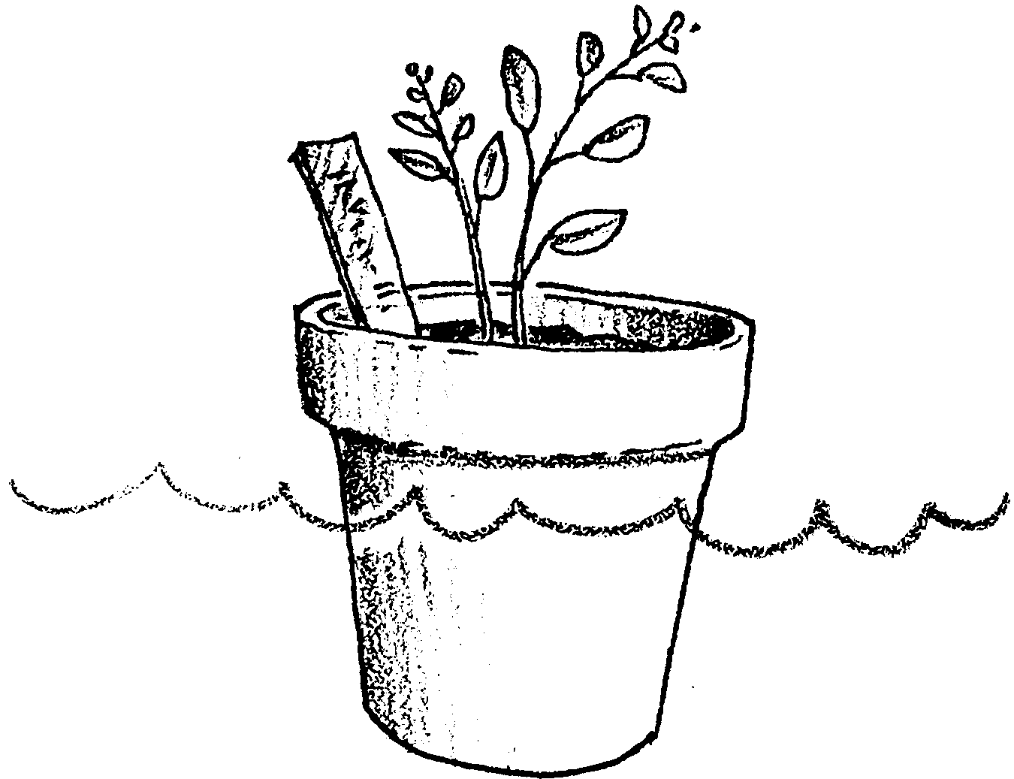
What Grows There?

1. What do you think will happen to the seeds in:

a. freshwater -

b. estuary water -

c. seawater -

2. What did happen? Write down what you see in the charts on the next page.

Number of Seeds Germinated

